UNIVERSITY OF ZAMBIA IN COLLBORATION WITH ZIMBABWE OPEN UNIVERSITY

Effects of Mergers and Acquisition on Financial Performance of Atlas Mara Bank - Zambia

By
Taonga Shawa
(Student No 717822670)

A dissertation submited to the University of Zambia and Zimbabwe Open University in partial fulfilment of the requirements for the award of the Degree of Masters in Business Administration (MBA).

The University of Zambia, Lusaka
2021

DECLARATION
I, Shawa Taonga, do hereby declare that this dissertation is a product of my own effort, and that it has never been done before. The sources of all materials referred to in this report have been acknowledged. Any misrepresentation of information that would arise from this report is purely my responsibility.
Signed: ..........................................................
Date: ..............................................................

COPYRIGHT
All copyrights reserved. No part of this dissertation may be reproduced, stored in any retrieval system, transmitted in any form or by any means, electronics, recordings, and mechanics photocopying or any otherwise without prior permission in writing, from the author or the University of Zambia and Zimbabwe Open University.

APPROVAL
This dissertation of Taonga Shawa has been approved as partial fulfilment of the requirements for the award of the degree of Master of Business Administration (MBA).
Signed: ………………………………… Date:………………………………………......
Signed: ………………………………… Date: ………………………………………......
Signed: ………………………………… Date: ………………………………………......

ABSTRACT
A merger is the process of combining two or more companies on the behalf so as to raise capital to survive in the industry. Commercial banks are expected to collect excess funds from fund sectors and lend to customers with insufficient funds. Changes in bank lending behaviour have an impact on the country’s economy. Banks are faced with problems that affect their ability to gain greater share on the market and reducing business risks. These problems include the entry of new products and new players with advanced technology, the change in customers’ behaviour pattern, and consumer’s needs for cheaper services. Therefore, Mergers and acquisitions are used by Banks to strengthen their position in the market place. Mergers and acquisitions are a fast way to expand to new markets and incorporate new technology. Shareholders and bank managers turn to mergers and acquisitions in the hope of improving financial performance in their banks. However, various studies have shown various results concerning mergers and acquisitions. This research will sought to investigate the effects on the performance of Banc ABC and Finance bank after merging to form Atlas Mara Bank by analysing the performance prior to the merger and comparing to performance after the merger of the banks using financial analysis, which is the audited financial statements that have been made public. The metrics used to measure financial performance for the purpose of this study were return on assets, return on equity and net income. According to this study, the main reason why organizations and mostly within the banking industry merge and/or acquire others, is to enlarge their market share and increase their profitability. Further, it was observed that mergers and acquisitions expand the capital base of the organization thus enabling the organization to access more resources and especially credit facilities that ensure that the business is liquid throughout the year. This enhances the stability and effectiveness of operations of the organization increasing the customer’s satisfaction. In return, the profits may rise in the short and medium term while the organization increases the chances of growth and expansion in the long term. The findings from the financial reports indicated that pre and post-merger measures of financial performance, i.e. ROA, ROE and Net Income, had statistical significance. The findings of the analysis of the financial statements can be said to be, however, inconclusive as the Bank has currently sold its stake to a Kenya’s Biggest Bank by assets (African Markets, 2019).The Merger and Acquisition between FBZ and Bank ABC had a significant impact on the financial performance of Atlas Mara bank.

ACRONYMS AND ABBREVIATIONS

ABC African Banking Corporation
FBZ Finance Bank Zambia Limited
M&A Mergers and Acquistions
ROE Return on Asset
ROE Return on Equity

DEDICATION
This Dissertation is dedicated to God, who gave me the grace to complete the programme successfully. In addition, I dedicate it to my Husband, Mr. Frank Kakoma and my children, Cairo and Valarie Kakoma, I cannot overemphasize the gratitude I have towards you. Himunza Mugwagwa, for your unwavering support

Last and most importantly, I dedicate this study to my late Grandfather Ackson Shawa and my late Mother, Matrine Shitima, who prior to their demise, had been my pillar of strength and knowledge towards to beginning of this study. I love and adore them even in death. May your Souls Continue Resting in Glory.

ACKNOWLEDGEMENTS
I wish to express my gratitude to my Supervisor Dr. Muchemwa, V. who has been enthusiastic and helpful in steering the path of my research. I wish to extend my gratitude to Atlas Mara Zambia, BancABC and Finance Bank employees for their generosity in providing me with the needed information / documents for my thesis.

To the above mentioned, I wish them nothing but the Lord’s abundant blessings all the days of their life.

Table of Contents
DECLARATION viii
COPYRIGHT ix
APPROVAL x
ABSTRACT xi
DEDICATION xii
ACKNOWLEDGEMENTS xiii
ACRONYMS AND ABBREVIATIONS xiv
LIST OF TABLES xvii
CHAPTER ONE 1
INTRODUCTION AND BACKGROUND 1
1.0 Introduction 1
1.1 Background 3
1.2 Statement of the Problem 4
1.3 Research Objectives 4
1.3.1 General objective 4
1.3.2 Specific Objectives 4
1.4 Null Hypothesis Formulation 4
1.5 Significance of the Research. 5
1.6 Scope of Research 5
1.7 Definitions of Key Terms 5
1.8 Limitations of the study……………………………………………………………………………………………………………..7
CHAPTER TWO 8
LITERATURE REVIEW………………………………………………………………………………………………………………………..8
2.0 Introduction 8
2.1 Emperical Framework 10
2.2 Theoretical Framework 12
2.3.1 Agency Theory 12
2.3.2 The User Cost of Capital Theory-(Q-Theory) 13
2.3.3 Efficiency Theory or Synergy Theory 13
2.3 Conceptual Framework 12
CHAPTER THREE 15
RESEARCH METHODOLOGY 15
3.0 Introduction 15
3.1 Research Design 15
3.2 Population and Sample Size 15
3.3 Instruments of Data Collection 15
3.4 Data Analysis 16
CHAPTER FOUR 17
PRESENTATION OF DATA AND ANALYSIS 17
4.0 Introduction 17
4.1 Data Presentation 17
4.1.2 Descriptive Statistics for Quantitative Variables under Financial Performance after the Merger and Acquisition of the Banks 18
4.1.2.1 Enlarged Market Share 18
4.1.2.2 Increase in Price of Shares 18
4.1.2.3 Change in Net Profit 19
4.1.2.6 Level of Influence on Merger/Acquisition Increasing Return on Capital 19
4.1.2 Descriptive Statistics for Factors of Financial Performance 20
CHAPTER FIVE 28
DISCUSSION OF THE FINDINGS,CONCLUSION AND RECOMMENDATION 28
5.0. Introduction……….. 28

5.1 Discussions 31
5.2 Conclusion………………………………………………………………………………………………………………………………….32
5.3 Recommendations of the study………………………………………………………….32
6.0 REFERENCES 33
APPENDICES 35
Appendix 1: Financial statements and Reports Before and After the Merger/Acquisition of the Bank 35
Appendix 2: QUESTIONNAIRE 46

LIST OF TABLES

Table 4.1: Enlarged Market Share
Table 4.2: The price of shares has increased due to Merger/Acquisition
Table 4.3: Change in Net Profit after Merger/Acquisition Process
Table 4.4: Level of influence on Merger/Acquisition has increased Net Profit
Table 4.5: Factors of Financial Performance
Table 4.6: Summary on the Key findings on Mergers and Acquisition of the Banks
Table 4.7: One Sample t-test and Paired t- tests statistics for significance
Table 4.8: Paired Samples Test
Table 4.9: One-Sample Test

CHAPTER ONE

INTRODUCTION

1.0 Overview
A merger is the process of combining two or more companies on the behalf so as to raise capital to survive in the industry. Commercial banks are expected to collect excess funds from fund sectors and lend to customers with insufficient funds. Changes in bank lending behaviour have an impact on the country’s economy. Banks are faced with problems that affect their ability to gain greater share on the market and reducing business risks. These problems include the entry of new products and new players with advanced technology, the change in customers’ behaviour pattern, and consumer’s needs for cheaper services. Therefore, Mergers and acquisitions are used by Banks to strengthen their position in the market place. Mergers and acquisitions are a fast way to expand to new markets and incorporate new technology.
Shareholders and bank managers turn to mergers and acquisitions in the hope of improving financial performance in their banks. However, various studies have shown various results concerning mergers and acquisitions. Some studies have suggested that bank mergers lead to better performance than when the bank run on an individual basis. Saple (2000) found that bank mergers did not lead to an improvement in bank performance as measured by profitability. The various findings make it difficult for the players in the banking sector to say with certainty whether merging two banks is worthwhile (Athanasoglou & Brissimis, 2004).
This research will seek to investigate the effects on the performance of Banc ABC and Finance bank after merging to form Atlas Mara Bank by analysing the performance prior to the merger and comparing to performance after the merger of the banks using financial analysis, which is the audited financial statements that have been made public. The metrics used to measure financial performance for the purpose of this study are return on assets, return on equity and net income. Return on assets (ROA) is a measure of a company's profitability in relation to its total assets. ROA informs a manager, investor, or analyst about a company's management's efficiency in generating earnings from its assets. ROA is expressed as a percentage; a greater ROA indicates a better investment. The return on equity (ROE) is a financial performance metric that is derived by dividing net income by shareholders' equity. Due to the fact that shareholders' equity equals a company's assets less its debt, ROE is referred to as return on net assets. ROE is a metric used to determine a company's profitability in relation to its stockholders' equity. Whether ROE is seen to be positive or negative will depend on what is considered usual among a stock's peers. For instance, utilities have a large balance sheet of assets and debt but a modest amount of net income. A typical ROE in the utilities business is around 10% or less. A technological or retail company with lower balance sheet accounts in comparison to net income may have a typical ROE of 18% or greater.
A reasonable rule of thumb is to aim for a ROE that is equivalent to or slightly over the peer group average. As an example, suppose a business has consistently maintained a ROE of 18% for the last few years, compared to the industry average of 15%. An investor may infer that the business’ management is above average at profitably utilizing the company's assets. ROE ratios that are relatively high or low will vary substantially amongst industrial groups or sectors.
ROE is presented as a percentage and may be computed for any firm with a positive net income and equity. Net income is determined before common shareholders receive dividends and after preferred shareholders receive dividends and lenders receive interest.
Net income is the sum of a company's revenue, net costs, and taxes for a particular time. The average shareholders' equity is determined by beginning the period with zero equity. The period's start and end dates should correspond to the time during which net income is earned.
The income statement—a summary of financial activities during the preceding fiscal year or trailing 12 months—contains net income for that time. The balance sheet—a running balance of a company's complete history of asset and liability changes—provides the source of shareholders' equity. Net income — also known as net profit, net earnings, or the bottom line — is the amount earned by an individual after taxes and other deductions are deducted from gross income. Net income is the amount of revenue remaining after all expenses, taxes, and charges have been deducted.
This chapter introduces the research problem by looking at the background of the effects of mergers, and introduces the research objectives, defines the key variables, states the research problem, and provides a background on Atlas Mara Bank.

1.1 Background
On June 30th, 2016 Atlas Mara Limited completed the acquisition of Finance Bank and merged with its Zambian subsidiary-Banc ABC- to create one of the largest banks in the country. The acquisition positioned the combined banks as fifth largest banks in Zambia by asset value with pro forma combined assets as at 31stDecember, 2015 of approximately US$567 million. The number of physical infrastructure also increased from 23 branches to 65 branches, 176 ATMs and 23 agencies, (Atlasmara, 2019).
Finance Bank Zambia was incorporated in Zambia on September 23rd, 1986. FBZ was licensed by the Bank of Zambia to conduct banking business in Zambia in August 6, 1986. (Finance bank, 2019).The central bank seized Finance Bank from its shareholders in 2010 for legal violations, including insider lending. It was sold at $5.4 million sale of Finance Bank to South Africa’s First Rand; however, this decision was reversed on 7th October, 2011.
Banc ABC, officially known as ABC Holdings Limited, is a pan-African financial services provider, headquartered in Gaborone, Botswana. (Bancabc, 2019). The establishment of ABC Holdings Limited commenced with a merger between First Merchant Bank (FMB) and Heritage Investment Bank (HIB) in 1997.BancABC is a financial services provider in Southern Africa and Eastern Africa. As of December 2015, the bank's group assets were valued at about US $1.81 billion, with shareholders' equity valued at US $115.75 million. Banc ABC has subsidiaries in Botswana, Mozambique, Tanzania, Zambia, and Zimbabwe. Banc ABC has been operating in Zambia for over a decade under its predecessor name African Banking Corporation.
Atlas Mara Limited, formerly referred to as Atlas Mara Co-invest Limited is a financial services holding company formed to undertake the acquisition of target banks in Africa. Atlas Mara was founded on November 28, 2013 by former Barclays Bank Executive Bob Diamond and entrepreneur Ashish Thakkar through Atlas Merchant Capital LLC and Mara Group Holdings Limited as their investment vehicles respectively. Atlas Merchant held 80% while Mara Group held 20% of the venture upon incorporation. The Group's geographical area of focus is on the African continent, (Bancabc,2019).

1.2 Statement of the Problem
Zambia has experienced a substantial number of mergers and acquisitions. The existing studies on the effects of mergers and acquistions concentrate on the regulatory framework of the statutory body responsible for consumer protection, i.e. the Consumer and Competition Protection Commission (CCPC), and very little is known about the effects they have on shareholder returns. Hence, in Zambia mergers and acquisitions raise an important issue on the impact of mergers and acquisition on the financial position of the organizations. There are very few studies in Zambia that look at financial performance after M&A in the banking sector. The Study sought to determine the effects of mergers and acquisitions on the financial performance of banks in Zambia: a case study of Finance Bank and Banc ABC.
Atlas Mara Limited completed the acquisition of Finance Bank and merged with its Zambian subsidiary called BancABC on June 30, 2016.Atlas Mara and BancABC have since been operational countrywide. There have been many studies on mergers despite that, there is still a relative deficiency of empirical evidence clarifying the specific impact of M&As involving Commercial banks. Alas Mara and BancABC have since been operational countrywide However, there is lack of knowledge on the effects of the M&A on the financial performance of Atlas Mara Bank.

1.3 Research Objectives

1.3.1 General objective
The general objective of this study was to investigate the effects of Mergers and Acquisition on Financial Performance of Atlas Mara Bank - Zambia

1.3.2 Specific Objectives
The specific objectives of this study were:
- To ascertain the effect of mergers on Return on Assets.
- To determine the effect of mergers on Return on Equity.
- To establish the effect of mergers on Net Income

1.4 Hypothesis Formulation
- H₀: There is no significant difference between pre and post-merger Return on Assets at Atlas Mara Bank
H₁: There is a significant difference between pre and post-merger Return on Assets at Atlas Mara Bank
- H₀: There is no significant difference between pre and post-merger Return on Equity at Atlas Mara Bank
H₁: There is a significant difference between pre and post-merger Return on Equity at Atlas Mara Bank
- H₀: There is no significant difference between pre and post-merger Net Income at Atlas Mara Bank
H₁: There is a significant difference between pre and post-merger Net Income at Atlas Mara Bank

1.5 Significance of the Research.
The study will provide m
ore insight on the relationship among mergers, acquisitions, and the performance of banks. The research will also be helpful for policy makers, strategy makers and implementers, Human Resource Management, bankers, researchers, and scholars in understanding more about mergers and acquisitions in the banking industry. This is why it was essential to study the effects that mergers and acquisitions have on financial performance of corporate organizations.
Rather than being used as a strategic tool, it was important to establish the impact of M&A’s on liquidity, profitability, and solvency. By analyzing the financial performance of Atlas Mara Bank, the research was able to determine if M&A’s affect the ability of these firms to meet their short-term obligations. Additionally, it was important to analyze if mergers and acquisitions had any effect on profitability efficiency of Atlas Mara over a given period. Further, the study will contribute to the body of knowledge at the University and financial institutions as it can be used as a basis for reference by business and management students as well as the financial sector for any future studies and references.

1.6 Scope of Research
The scope of the study was the entirety of Atlas Mara Bank – Zambia and its entire branch network nationwide.

1.7 Definitions of Key Terms
Return on Assets (ROA)
Return on assets (ROA) is an indicator of how profitable a company is relative to its total assets. ROA gives a manager, investor, or analyst an idea as to how efficient a company's management is at using its assets to generate earnings. Return on assets is displayed as a percentage.
Return on Equity (ROE)
Return on equity (ROE) is a measure of financial performance calculated by dividing net income by shareholders' equity. Because shareholders' equity is equal to a company’s assets minus its debt, ROE could be thought of as the return on net assets.
ROE is considered a measure of how effectively management is using a company’s assets to create profits. ROE is expressed as a percentage and can be calculated for any company if net income and equity are both positive numbers. Net income is calculated before dividends paid to common shareholders and after dividends to preferred shareholders and interest to lenders.

Profitability
This is the degree to which a business or activity yields profit or financial gain or the state of yielding profit or financial gain.

Government Policies
A Government policy is a plan or course of action, as of a government, political party, or business, intended to influence and determine decisions, actions, and other matters. Government Policies can also be defined as the general principles by which government is guided in its management of public affairs or the legislature in its measurements.

Financial Performance
This is the measure on how a company carries out its activities to achieve set financial goals. In other words, financial performance measures how well companies do in terms of financial returns (Weston 2011).
Merger
A merger is an agreement that unites two existing companies into one new company.
Acquisition
Acquisitions are transactions in which the ownership of companies, other business organizations, or their operating units are transferred or consolidated with other entities.
Investment
An investment is an asset or item acquired with the goal of generating income or appreciation. Appreciation refers to an increase in the value of an asset over time. When an individual purchases a good as an investment, the intent is not to consume the good but rather to use it in the future to create wealth.

Portfolio
A portfolio is a collection of financial investments like stocks, bonds, commodities, cash, and cash equivalents, including closed-end funds and exchange traded funds (ETFs).
1.8 LIMITATIONS
The major limitation was accessing the financial reports, it was difficult to access the data given as the records were not well kept and the ones published online had some information missing.

CHAPTER TWO
LITERATURE REVIEW

2.0 Introduction
This chapter describes the literature review; it also contains the empirical, theoretical, conceptual frameworks of this study.

2.1 Empirical framework
Global Perspective
In the corporate world today mergers and acquisitions (M&As) have become an important strategic tool to achieve business objectives (Sudarsanam, 2003). M&A happen when two legal entities’ assets and liabilities are combined to become one legal entity. When acquisition is defined independently of mergers it will mean that a larger company will absorb a smaller company. Thus, the smaller company will either become a subsidiary of the larger company, or with the smaller company combined into the larger company. This will mean that the smaller company will lose its identity while the larger company will go on to take control of smaller company’s assets and liabilities. On the other hand, when merger is defined separately from acquisition it reflects the consolidation of two companies on an equal status basis. However, M&As are being used interchangeably, this is because mergers and acquisitions basically lead to the same outcome. (Ibid)
There are different types of M&As and these are as follows: horizontal, vertical, or conglomerate. Horizontal M&A happens when two companies that are to be merged come from the same industry and are most likely competitors, (Chunlai, Chen and Findlay, 2003). This is done to achieve cost saving, increase the market or to tap into a new market segment. As the world continues to liberalize and become more globalized the horizontal way of merging companies is becoming more popular. In 1999, Glaxo Wellcome and SmithKline Beecham used the horizontal method to create a new company called GlaxoSmithKline, (Manda, 2007).
However, when firms or companies have a business relation of upstream supplier and downstream buyer in the value chain vertical M&A is used. In vertical M&A the aim is to reduce dependencies and the reduction of overhead cost and to gain the economies of scale. For example, if a soft drink company bought a bottle manufacturing company, this would be considered vertical M&A. Whereas, conglomerate M&A happens when two companies are from irrelevant industries with the purpose to diversify capital investment thereby, diversifying the risk as well as achieving economies of scale, (Gaughan, 2002).
The facts that mergers are a part of today’s business particularly the financial institutions such as banks there have been number of studies that have been conducted. Some of these studies have been conducted to examine whether merger and acquisition are solutions to bank problems. One of the studies carried out by Caprio and De-Nicolo, explored the linkage between banks merger and acquisition and profitability. They concluded that mergers and acquisitions have positive impacts on most of the banking efficiency. They also found that after banks are merged there will be a significant profit efficiency Stiroh, (2003) conducted a M&A study on United States banks and suggested that as a result of merger and acquisition, there may be more considerable scale of efficiency from larger size of banks.
Khan et al (2018) conducted a study to find out the effect of Mergers and Acquisitions on the financial performance of banks in Pakistani markets. For the performance analysis, Gross Profit Margin, Operating Profit Margin, Net Profit Margin, return on Capital Employed, return on Equity and Debt to Equity Ratio were selected to analyze financial performance. Paired sample T-test was selected to find out the effects before and after the merger. The study observed that the merger had no significant effects on all mediums of financial performance.
Furthermore, Jallow et al conducted a study to determine effect of merger & acquisitions on financial performance on United of Kingdom firms. Their study was carried out mainly to examine and analyze the effects of mergers and acquisitions on the financial performance of UK companies in 2011, in which the variables taken are Return on assets, return on equity, Earning per share and net profit margin. The sample size of 40 companies that had undergone mergers and acquisitions in United Kingdom is selected from the 610 mergers and acquisitions transactions. The initial objective was to examine the impact of mergers and acquisitions on ROA and by referring to the paired sample test, the results shows that the total mergers and acquired firms used in as sample size encounter significant reduction on return on assets before and after mergers. They concluded that mergers and acquisitions will significantly affect the performance of firm hence returns on assets. The second objective was to examine the impact of merger and acquisition on return on equity and as for the paired sample analysis; the results signified that the merged firms in the sample size encounter a reduction in return on equity before and after mergers. Furthermore, the sample on the other hand ROE found a sophisticated level of significant than ROA, which means return on equity have more effects on financial performance. Thus, it can be finalized that if the value of return on equity is significant then it’s having an effect on mergers and acquisition activities.
Hassan (1992) studied changes in performance resulting from bank merger by measuring post-merger accounting data and concluded that newly merged bank stock outperforms the industry average in terms of improvement in the ability to attract loans and deposits, productivity, and growth of profitable assets. Another similar study was carried out by Burner (2002), who reviewed the question, ‘Does mergers and acquisitions pay?’ The review suggested that target shareholders earn market returns that bidders with interesting exception earn zero adjusted returns and that bidders and targets combined earn positive adjusted returns. Whereas Forcarelli (2002), studied if banks merge to improve performance using Italian data and concluded that merging firms did not show evidence of income improvement due to higher staff costs.
Subhashree and Kannappan(2018 )stated that overall operations of banks can be enhanced with the adoption of merger and acquisition strategy from their study the maid argument is that mergers and acquisitions enhance the economies of scale.Ahmed,Manwani and Ahmed 2018 in their journal critically analyzed the performance and productivity of banks can be improved through mergers and acquisitions.

Regional Perspectives
Synergistic and wealth effects are the theoretical reasons for merger and Acquisition. The synergistic effect suggest that merged organization should in many respects, perform better than when they were operating independently. The wealth effect contends that mergers and acquisitions enhance shareholders value. Adedipe (2004) argues that domestic mergers improved profitability and operational efficiency. A study was conducted by Ahmed et al (2015) to determine the effects of Mergers and Acquisitions on Profitability and Earnings Per Share of Selected Deposit Money Banks in Nigeria. The statistical technique used to select the sample size were cluster and Random sampling techniques. The study utilized secondary sources of data obtained from the banks’ annual reports, Nigeria Stock Exchange (NSE) quarterly bulletin and Nigeria stock market guide. The data were organized using descriptive statistics. In order to differentiate between the pre- and post-merger periods, a figure dummy column was created. For the pre-merger period, a figure of zero (0) was assigned and one (1) was post-merger period.
In order to test the significance difference, when the t-value was greater than two (2), it was significant at 5% level of significant and when the t value was less than 2 at the same level of significance difference and the null hypothesis was accepted. From the results of the studied banks, it was revealed that there has been an evidence of improvement in the Earnings Per Share of the banks as a result of the mergers as well as acquisitions. This resulted in the immediate increase in the share price of the banks which invariably maximize share holders’ wealth. While the study conducted by Ahmed et al used Earnings Per Share as a measure of Financial Performance, this study will employ the use of Return on Equity, Return on Assets and Net Income as measures of financial performance.
Mugnai and Gawai conducted a study in 2015 to find the effect of Mergers and Acquisitions on Financial Performance of Banks in Kenya. The findings of their study revealed that majority of the banks i.e. 42% merged or acquired other banks between 4 and 7 years ago. The recent mergers i.e. those that are below 4 years since they merged accounted for only 20% of all the mergers and acquisitions in the banking sector. On the main aim of merging or acquiring in the banking sector, it was established that most banks merged to raise their profitability through enlargement of their market share. The banks that merged or acquired for the purpose of enlarging their market share and raise their profitability accounted for about 76% of all the mergers and acquisitions in the banking industry in Kenya. The study further established that the mergers and acquisitions among the banks in Kenya raised the shareholder’s value through raising the demand, price and earnings per share. However, the mergers and acquisitions did not have a significant effect on the amount of dividends declared to the shareholders and the frequency of issuing dividends.
On the profitability of the banks, the mergers and acquisitions had a significant positive effect since the majority of the banks increased their market share, gross profit and net profit significantly. The number of account holders in the majority of these banks notably increased. Finally, it was found out that all the two independent variables in the study, namely; shareholders’ value and bank’s profitability contributed significantly to the changes in return on capital of the banks that had gone through merger/acquisition processes. The two independent variables affected the return on capital of the banks positively, that is, an increase in the variable led to an increase in the return on equity of the bank. Similarly, this proposed study will also use shareholder value as an independent variable alongside Profitability. Profitability measured using Net Income, Return of Equity, return on Assets and Shareholder Value will be used as proxies for financial performance.

Local Perspectives
Simpasa (2010) In his study established that instability in the macroeconomic environment created uncertainty in the banking market.as a result banks failed to perform efficiently this was evidenced by the positive impact of the rate of inflation on cost inefficiency. This study concentrated more on performance of banks in the post liberalization period evidence on cost efficiency, competition and market power, nothing was done on performance after mergers and acquisitions. Furthermore, Mulenga (2020) stated that mergers and acquisitions have a positive impact on performance of banks. He showed that corporate restructuring positively affected capital adequacy ratio.

2.2 Theoretical Framework
There are many theories that explain why companies choose mergers and acquisitions to improve their financial position. Value creating theories explain that managers of a firm make every effort to create value of the firm and look after shareholder interest, (Leepsa and Mishra, 2018). It is also expected that the target firm would also get positive returns because of synergistic benefits; this is explained by the hubris and agency theories. Other theories include value decreasing mergers where a firm overpays for a particular target to prevent a competitor from gaining advantage, merger creates no value (Molnar, 2000). According to Weston et al. (2011) as stated by Leepsa and Mishra (2011), theories of mergers and tender offers are based on three aspects namely (1) the reason behind occurrence of merger, (2) the expected impact of the mergers and tender offers on the value of the firm and (3) explaining the merger process.
There are many theories that explain why mergers occur but for the purpose of this research I will explain them based on two types of explanations: value maximising and non-value maximising explanations. The value maximising explanations are;
Efficiency theories like synergy gains and agency cost reduction. The efficiency theory views mergers as being planned and executed to achieve synergies. These synergies can be in the form of reduction in cost or increase in sales.The theory suggests there is something that results in merged entities to create shareholders value. The wealth transfer theories include bondholder expropriation, expropriation from labour, market power and tax benefits while,the inefficiency theories like under-pinning and tax benefits. Whereas, Non-value maximising explanations include; Diversification, Self-aggrandisement, Free cash flow, and, Hubris and the winner’s curse (Leepsa and Mishra, 2018)

2.3.1 Agency Theory
According to this theory, shareholders may not have the necessary skills, expertise and time that are required to manage a company. They therefore, appoint other parties also referred to as management to run the company on their behalf. This theory occurs when management wants to increase their wealth at the expense of the shareholders. This may result in a reduced value of the predator firm (Jensen, 1986).
This theory is also called the principal agency theory. This theory explains that a cooperation form of two or more subjects with their own interests, both try to achieve their best goals. It is a management and economic theory that attempts to explain relationships and self-interest in business organizations. It describes the relationship between principals/agents and delegation of control. It explains how best to organize relationships in which one party (principal) determines the work and which another party (agent) performs or makes decisions on behalf of the principal (Jensen and Meckling, 1976; Schroeder et al., 2011).
But there are two problems: The first problem, the agency problem, occurs when there is a goal conflict between the principals and the agents and it is problematic or costly for the principals to verify the agents’ actions. The second problem, risk sharing, occurs when both parties have different preferences towards taking risks. The theory is based on the following assumptions concerning “people (e.g., self-interest, bounded rational, risk aversion), organizations (e.g., goal conflict among members) and information (e.g., information is a commodity which can be purchased)”.

2.3.2 The User Cost of Capital Theory-(Q-Theory)
The Q-theory of mergers as formulated by Jovanovic and Rousseau (2001) proposes that the same forces driving firms’ direct investments also drive their decisions about merging with other firms, and views mergers in a macroeconomic sense as devices for solving an economy-wide problem of reallocating capital.
This theory is from the concept that capital used by firms is not rented but owned by the firms that use it. For the firms to acquire other firms or merge, a firm must consider this theory in making a decision. That is, to continue using its own capital, collaborate with another firm in using it or sell it. The limitations of this theory is that it does not figure out any mechanisms through which expectations affect the change in capital and it doesn’t cater for the adjustment of cost of capital, (Jovanovic and Rousseau, 2001).

2.3.3 Efficiency Theory or Synergy Theory
The efficiency theory views mergers as being planned and executed to achieve synergies. These synergies can be in form of reduction in cost or increase in sales. Synergies are reactions that occur when two substances combine to create a greater effect. The theory suggests that there is something that results in merged entities to create shareholder value. This occurs because two firms have different strengths and weaknesses as different efficiency levels. Through the merger the efficiency of management of one company is transferred to an inefficient management which results in both social gain and private gain because it not only improves the performance of the poorly performed company but also saves the resources of the economy. Efficiency is enhanced by taking advantage of specialized skills or target management, eliminating the idle resources sharing expensive technologies between the acquirer and target, promoting products that are complementary to both companies, reducing transaction cost and re-allocating existing expenses (Wolfe et al,2011). Therefore, this theory suggests that more efficient firms will acquire less efficient firms and realize gains by improving their efficiency.

CHAPTER THREE

RESEARCH METHODOLOGY

3.0 Introduction
This chapter describes the methods that were employed in providing answers to the research objectives as stated in chapter one. The following aspects of research methodology are discussed; research design, population, sample size, sampling technique, data collection and data analysis

3.1 Research Design
The research adopted a mixed method consisting of qualitative (descriptive) and Quantitative (positivist) design in order to determine the relationship between mergers and acquisitions and the financial performance of Atlas Mara Bank. By using a descriptive study, the research was able to depict whether mergers and acquisitions do have an impact on the financial performance of Atlas Mara Bank. Descriptive research is a quantitative research method that attempts to collect quantifiable information for statistical analysis of the population sample. In descriptive research, none of the variables are influenced in any way. This uses observational methods to conduct the research. Hence, the nature of the variables or their behavior is not in the hands of the researcher.

3.2 Population and Sample Size
The target population of this study was all 223 managers from all Atlas Mara Branches nationwide. The sample size employed was 67 managers from a total of 223 managers representing 30% of the population.
Convenience sampling was used to select participants of the study. Convenience sampling is a method of collecting samples by taking samples that are conveniently located around a location. In this instance, the researcher selected managers that were conveniently located within Lusaka to reduce on travel costs and ensure that most participants respondents within the specified research time frame.

3.3 Instruments of Data Collection
A semi structured questionnaire was employed to collect primary data. Secondary data was also used to meet the desired objectives of this study. Secondary data was sourced through published articles, books and Bank’s financial statements related to the periods of pre and post-merger and acquisition. The secondary data included information on the following: Return on Equity, Return on Assets, Debt Equity ratio and Return on Investment from the bank. The data was collected from the central bank-BOZ and Security and exchange commission.

3.4 Data Analysis
The study focused on the financial performance of the merged Atlas Mara before and after the merger. The comparative analysis for the pre- and post-merger periods was carried out to establish if mergers led to improved financial performance. The T-test, a special case of ANOVA was used to test whether there are significant differences between two means derived from two groups at a specified probability level, (Mugenda 1999). The analysis was made using SPSS version 21.0.

3.5 RELIABILITY AND VALIDITY
Reliability and validity can be defined as the process of ensuring that data collected remains relevant, reliable, and valid for the intended audience. To ensure the data is reliable and valid, the research was conducted and collected using questionnaires that elicit responses directly from the target population, making it more accurate. The data was then analyzed using SPSS, which will detail the data collected and analyzed for easy comprehension (McLeod 2019)

3.5.1 Reliability
When collecting data with a tool or technique, it is critical that the results are precise, stable, and reproducible. Assessing test-retest reliability entails administering the measure to a group of people once, administering it to the same group of people again later, and comparing the two sets of scores. This was accomplished through the use of a scatterplot and the computation of Pearson's R. (McLeod 2019)
To determine internal consistency, the Cronbach's alpha test was used in conjunction with the reliability command in SPSS. Cronbach's alpha is a measure of internal consistency, or how closely related a collection of objects is. It is regarded as a measure of scale dependability. A "high" alpha value does not imply that the measure is unidimensional. Additional analyses may be conducted if the researcher wishes to demonstrate the scale's unidimensionality in addition to testing its internal consistency. Exploratory factor analysis is one method for determining dimensionality. Cronbach's alpha is a reliability coefficient, not a statistical test (or consistency). A widely accepted rule is that a value of 0.6-0.7 indicates an acceptable level of reliability, and 0.8 or greater indicates an extremely high level of reliability. (McLeod, 2019)

Reliability Statistics
Cronbach's Alpha | N of Items
1.037 | 4
Cronbach Alpha was found to be 1.037, indicating extremely high reliability.

3.5.2 Validity
Validity is a term that refers to the degree to which a method accurately measures what it is intended to measure. If research has a high degree of validity, it produces results that are consistent with the physical or social world's real properties, characteristics, and variations. A high degree of reliability is one indicator of the validity of a measurement (McLeod 2019)
The study concluded that the data was extremely reliable, implying that it had a high degree of validity.

CHAPTER FOUR

PRESENTATION OF FINDINGS

4.0 Introduction
There are three objectives in data analysis; getting a feel for the data, testing the goodness of the data, and answering the research questions. In addition, , establishing the goodness of data lends credibility to all subsequent analysis and findings because it measures the reliability and the validity of the measures used in the study. Descriptive and quantitative tools of analysis were applied to the questionnaire responses on the type of measurements postulated in the research questions and objectives. Data presentation was undertaken using Statistical Package for Social Sciences (SPSS) version 21.0. The data was presented in the form of frequency tables, cross tabulations and descriptive tables.

4.1 Data Presentation
Both quantitative and qualitative methods were used to describe and analyse variables. This section shows key measures of central tendency, variability and distribution. Precisely, the focus was on computing the mean, standard deviation, skewness and kurtosis of each variable. According to Pallat (2005), skewness provides an indication of symmetry of the distribution, whereas kurtosis provides information about the ‘peakedness’ of the distribution. Perfect normal distribution has skewness and kurtosis index of zero. Negative skewness indicates that scores are clustered at the right hand side of the normal distribution graph. When scores are clustered to the left at the lower values, then the distribution is positively skewed. Negative kurtosis implies that the negative values are relatively flat with many cases in the extremes. Positive kurtosis suggests that positive values are more pointed than the normal distribution and scores are clustered in the centre of the distribution with long thin tails. The values of asymmetry and kurtosis between -2 and +2 are considered acceptable in order to prove normal univariate distribution (George and Malley, 2010).
A 1-5 Likert scale was used to measure the variables, with 1-None, 2-Slight, 3-Moderate, 4-Large, and 5-Very Large. Therefore, mean values significantly less than 3 imply that on average, the respondents completely or slightly disagree with the variable towards mergers and acquisition of the banks. Whilst mean values significantly greater than 3 implies that on average, the respondents agree to a great or very great extent with the variable towards mergers and acquisition of the banks. Mean values around 3 imply that on average, the respondents were moderate on the effect of the variable on mergers and acquisition of the banks.

4.1.1 Descriptive Statistics for Quantitative Variables under Financial Performance after the Merger and Acquisition of the Banks

4.1.1.1 Enlarged Market Share
Table 4.1: Enlarged Market Share
 |  | Frequency | Percent | Valid Percent | Cumulative Percent
Valid | Very Large | 14 | 20.9 | 20.9 | 20.9
Valid | Large | 15 | 22.4 | 22.4 | 43.3
Valid | Moderate | 32 | 47.8 | 47.8 | 91.1
Valid | Slight | 6 | 9.0 | 9.0 | 100.0
Valid | Total | 67 | 100.0 | 100.0
Source: Author (2021)
The outcome of Table 4.1 shows that, the total cumulative percent for those who agreed to a Large and Very Large extent with the variable was 43.3% and the percent for those that indicated moderate with the variable was 47.8% and for those who indicated slight with the variable was 9%. This means that, most of the respondents were of the opinion that at the moment there is no significance difference in the market share. However, looking at the slight differences in the great accumulation and moderate responses, it may suffice to say that to some extent, after the merging, there is a considerable increase in the market share.

4.1.2.1 Increase in Price of Shares
Table 4.2, shows the distribution of responses on the price of shares has increased due to merger/acquisition.
Table 4.2: The price of shares has increased due to Merger/Acquisition
 |  | Frequency | Percent | Valid Percent | Cumulative Percent
Valid | Very Large | 5 | 7.5 | 7.5 | 7.5
Valid | Large | 1 | 1.5 | 1.5 | 9
Valid | Moderate | 31 | 46.3 | 46.3 | 55.3
Valid | Slight | 23 | 34.3 | 34.3 | 89.6
Valid | None | 7 | 10.4 | 10.4 | 100.0
Valid | Total | 67 | 100.0 | 100.0
Source: Author (2021)
The study findings above revealed that the total cumulative percent of respondents who indicated that increases in the price of shares due to the M&A played a “Large” and “Very Large” role was 9%, 46.3% indicated ‘moderate’ and the total cumulative percent of those that indicated ‘slight’ and ‘none’ was 44.7% on the assertion that the price of shares had increased due to the merger/acquisition. This means that most respondents were moderate with a bias towards a slight significant impact on increase of shares.

4.1.2.3 Change in Net Profit
Table 4.3: Change in Net Profit after Merger/Acquisition Process
 |  | Frequency | Percent | Valid Percent | Cumulative Percent
Valid | Very Large | 10 | 14.9 | 14.9 | 14.9
Valid | Large | 28 | 41.8 | 41.8 | 56.7
Valid | Moderate | 22 | 32.8 | 32.8 | 89.6
Valid | Slight | 7 | 10.4 | 10.4 | 100.0
Valid | Total | 67 | 100.0 | 100.0
Source: Author (2021)
Table 4.3 above, shows the distribution of responses on the Net Profit of the Merger/Acquisition has significantly changed after the process. It shows that the total cumulative percent for those who agreed with the variable by indicating that the change in Net Profits attributed to the M&A was “Large” and “Very Large” was 56.7% and the percent for those that indicated “moderate” with the variable was 32.8% and for those who indicated “slight” with the variable was 10.4%. This means that, most of the respondents felt there was a change in Net Profit after the process of Merger/Acquisition.

4.1.3 Level of Influence on Merger/Acquisition Increasing Return on Capital
Table 4.4: Level of influence on Merger/Acquisition has increased Return on Capital
 |  | Frequency | Percent | Valid Percent | Cumulative Percent
Valid | Very Large | 7 | 10.4 | 10.4 | 10.4
Valid | Large | 28 | 41.8 | 41.8 | 52.2
Valid | Moderate | 6 | 9.0 | 9.0 | 61.2
Valid | Slight | 24 | 35.8 | 35.8 | 96.0
Valid | None | 2 | 3.0 | 3.0 | 100.0
Valid | Total | 67 | 100.0 | 100.0
Source: Author (2021)
Table 4.4 above shows the distribution of responses on the perceived level of influence on Merger/Acquisition has increased Return on Capital. The outcome revealed that the total cumulative percent for perceived Large and Very Large effect on the return on capital was 52.2% of the respondents, 9% perceived the effect as moderate, the total cumulative percent for those that perceived the effect as slight and none responses was 38.8%. This means that, most of the respondents agreed that the level of influence on Merger/Acquisition has increased Return on Capital.

4.1.4 Descriptive Statistics for Factors of Financial Performance
Table 4.5: Factors of Financial Performance
 | Item | Mean | Std. Deviation | Skewness | Kurtosis
1 | There has been an enlarged market share after the Merger/Acquisition | 3.89 | .875 | .447 | -.343
2 | The price of shares has increased due to merger/acquisition | 3.10 | .781 | .207 | -.479
3 | The Net Profit of the Merger/Acquisition has significantly changed after the process | 4.34 | 1.215 | .468 | -.772
4 | The level of influence on Merger/Acquisition has increased Net Profit | 4.39 | .870 | .142 | -.585
5 | Level of influence on Merger/Acquisition has increased Gross Profit | 4.61 | .984 | .661 | -.074
6 | The level of influence on Merger/Acquisition has increased Return on Capital | 3.51 | 1.003 | .905 | .724
7 | After the Merger/Acquisition number of clients has increased | 4.93 | .773 | .494 | .009
Source: Author (2021)
The descriptive statistics for variables on factors of branding that affect sales are shown in Table 4.5 indicating the mean, standard deviation, skewness and kurtosis for each of the variables. In coming up with the calculations, the five point (1 – 5) Likert Scale format was used. On the scale 1 = None, 2 = Slight, 3=Moderate, 4=Large and 5=Very Large. The mean ranged from 3.10 to 4.93 while the standard deviation ranged from 0.773 to 1.215, Skewness ranged from 0.142 to 0.905 and the Kurtosis values ranged from -0.772 to 0.724. This shows that the skewness and kurtosis of all the variables were within the range of -2 and +2, meaning that all variables did not seriously deviate from normality.
- There has been an enlarged market share after the Merger/Acquisition: Statistics from the data on this variable indicated an average mean of 3.89. This means that on average the respondents agreed with the statement that There has been an enlarged market share after the Merger/Acquisition.

- The price of shares has increased due to merger/acquisition: Statistics from the data on this variable reflected an average mean of 3.10. This means that on average the respondents were moderate with the statement that the price of shares had increased due to merger/acquisition. However, it should be noted that moderate response was more bias towards the slight and none responses, suggesting that the price of shares has not significantly increased after the process of merger/acquisition.

- The Net Profit of the Merger/Acquisition has significantly changed after the process: Statistics from the data on this variable indicated an average mean of 4.34. This means that on average the respondents agreed with the statement that The Net Profit of the Merger/Acquisition has significantly changed after the process.

- The level of influence on Merger/Acquisition has increased Net Profit: Statistics from the data on this variable indicated an average mean of 4.39. This means that on average the respondents agreed with the statement that the level of influence on Merger/Acquisition has increased Net Profit.

- Level of influence on Merger/Acquisition has increased Gross Profit: Statistics from the data on this variable indicated an average mean of 4.61. This means that on average the respondents slightly agreed with the statement that Level of influence on Merger/Acquisition has increased Gross Profit.

- The level of influence on Merger/Acquisition has increased Return on Capital: Statistics from the data on this variable indicated an average mean of 3.51. This means that on average the respondents were moderate on the statement that the level of influence on Merger/Acquisition has increased Return on Capital.
- After the Merger/Acquisition number of clients has increased: Statistics from the data indicated that an average mean of 4.93. This means that on average the respondents agreed with the statement that after the Merger/Acquisition number of clients has increased.
The findings in Table 4.9 show a mean range of 3.10 to 4.93. This means that merger/acquisition has a positive significant impact on financial performance at the banks. The findings of this study are in line with the secondary data collected from the bank statements before and after the mergers/acquisition (refer to the appendices).
Table 4.6: Summary on the Key findings on challenges arising from Mergers and Acquisition of the Banks
 | Yes | No | Other
Were you aware about the Merger & Acquisition of Finance Bank Zambia Plc and Bank ABC? | 100% | – | –
Do you know the motive behind this Merger & Acquisition? | 78% | 32%
Do you think there is risk involved in this Merger & Acquisition? | 79% | 21%
Is there any difference in operating system of the Bank after Merger & Acquisition? | 80% | 15% | 5%
Did the employees of merged or acquired Bank face any problem? | 68% | 18% | 14%
Did the facilities provided to the customers become better after merger? | 91% | 2% | 7%
Have the customers of merged Bank faced any problem after merger? | 56% | 11% | 33%
Did Merger & Acquisition affect the NPA & B/D of merged bank? | 67% | 21% | 22%
Did the merged Bank’s senior position employee get affected after M&A process? | 82% | 17% | 1%
Do you think the Merger & Acquisition has had any impact in the foreign Market? | 60% | 35% | 5%
Do you think the Merger and Acquisition is beneficial for the Banking sector in Zambia? | 92% | 4% | 2%
Does the Merger & Acquisition affect the costing? | 78% | 17% | 5%
What do you think about the Merger & Acquisition curbing a competition in banking sector? | 73% | 5% | 22%
Can you state how the Merger & Acquisition overall impact on the performance of merged bank? | 89% | – | 11%
From the research findings of the summarised key findings on the mergers and acquisition of the banks most of the respondents indicated yes on each construct.

Table 4.7: One Sample t-test and Paired t- tests statistics for significance
 |  | Statistic
 |  | Statistic | Bias | Std. Error | 95% Confidence Interval
 |  |  |  |  | Lower | Upper
Pre-Merger Return on Assets | N | 2 | 0 | 0 | 2 | 2
Pre-Merger Return on Assets | Minimum | -3.30
Pre-Merger Return on Assets | Maximum | 3.72
Pre-Merger Return on Assets | Mean | .2100 | -.0386 | 2.5150 | -3.3000 | 3.7200
Pre-Merger Return on Assets | Std. Deviation | 4.96389 | -2.54648 | 2.48235 | .00000 | 4.96389
Pre-Merger Return on Equity | N | 2 | 0 | 0 | 2 | 2
Pre-Merger Return on Equity | Minimum | -103.70
Pre-Merger Return on Equity | Maximum | 123.00
Pre-Merger Return on Equity | Mean | 9.6500 | -1.2469 | 81.2169 | -103.7000 | 123.0000
Pre-Merger Return on Equity | Std. Deviation | 160.30111 | -82.23447 | 80.16355 | .00000 | 160.30111
Pre-Merger Net Income | N | 2 | 0 | 0 | 2 | 2
Pre-Merger Net Income | Minimum | -114102.00
Pre-Merger Net Income | Maximum | 135312.00
Pre-Merger Net Income | Mean | 10605.0000 | -1371.7770 | 89354.3184 | -114102.0000 | 135312.0000
Pre-Merger Net Income | Std. Deviation | 176362.33072 | -90473.87566 | 88195.46385 | .00000 | 176362.33072
Post-Merger Return on Assets | N | 2 | 0 | 0 | 2 | 2
Post-Merger Return on Assets | Minimum | -.28
Post-Merger Return on Assets | Maximum | 6.40
Post-Merger Return on Assets | Mean | 3.0600 | -.0367 | 2.3932 | -.2800 | 6.4000
Post-Merger Return on Assets | Std. Deviation | 4.72347 | -2.42314 | 2.36212 | .00000 | 4.72347
Post-Merger Return on Equity | N | 2 | 0 | 0 | 2 | 2
Post-Merger Return on Equity | Minimum | -2.30
Post-Merger Return on Equity | Maximum | 25.60
Post-Merger Return on Equity | Mean | 11.6500 | -.1535 | 9.9954 | -2.3000 | 25.6000
Post-Merger Return on Equity | Std. Deviation | 19.72828 | -10.12061 | 9.86574 | .00000 | 19.72828
Post-Merger Net Income | N | 2 | 0 | 0 | 2 | 2
Post-Merger Net Income | Minimum | -16885.00
Post-Merger Net Income | Maximum | 189000.00
Post-Merger Net Income | Mean | 86057.5000 | -1132.3675 | 73759.7482 | -16885.0000 | 189000.0000
Post-Merger Net Income | Std. Deviation | 145582.67964 | -74683.91466 | 72803.14287 | .00000 | 145582.67964

The mean values for the measures of performance before and after merger are displayed in the one sample and paired sample statistics table below. The paired samples T test procedure compares the mean of two variables for a single group. It computes the difference between values of the two variables for each case and tests whether the average differs from 0.
Table 4.8 Paired Samples Test
 |  | Paired Differences |  |  |  |  | t | df | Sig. (2-tailed)
 |  | Mean | Std. Deviation | Std. Error Mean | 95% Confidence Interval of the Difference |  | t | df | Sig. (2-tailed)
 |  |  |  |  | Lower | Upper | t | df | Sig. (2-tailed)
Pair 1 | Pre-Merger Return on Assets - Post-Merger Return on Assets | -2.85 | .24042 | .17000 | -5.01005 | -.68995 | -16.765 | 1 | .038
Pair 2 | Pre-Merger Return on Equity - Post-Merger Return on Equity | -2.00 | 140.57283 | 99.40000 | -1264.99675 | 1260.99675 | -.020 | 1 | .987
Pai 3 | Pre-Merger Net Income - Post-Merger Net Income | -75452.50 | 30779.65108 | 21764.50000 | -351996.69298 | 201091.69298 | -3.467 | 1 | .179

Table 4.9: One-Sample Test
 | Test Value = 0
 | T | Df | Sig. (2-tailed) | Mean Difference | 95% Confidence Interval of the Difference
 |  |  |  |  | Lower | Upper
Pre-Merger Return on Assets | .060 | 1 | .962 | .21000 | -44.3888 | 44.8088
Pre-Merger Return on Equity | .085 | 1 | .946 | 9.65000 | -1430.5983 | 1449.8983
Pre-Merger Net Income | .085 | 1 | .946 | 10605.00000 | -1573947.6740 | 1595157.6740
Post-Merger Return on Assets | .916 | 1 | .528 | 3.06000 | -39.3787 | 45.4987
Post-Merger Return on Equity | .835 | 1 | .557 | 11.65000 | -165.6016 | 188.9016
Post-Merger Net Income | .836 | 1 | .557 | 86057.50000 | -1221950.9811 | 1394065.9811

4.1.5 Summary and Interpretation of the Findings (Results of hypothesis Testing)

As shown in Table 4.9 the findings of pre and post-merger ROA from the one sample t- test indicate there was slight increase in t -value from 0.060 to 0.916 indicating that there was an increase in the Return on Asset after the merger. There is high significance for the paired t - test (0.36) indicating that there is a significant difference between the increase of financial performance before and after merger in terms of Returns on Assets

The results of pre and post-merger ROE from the one sample t- test table above indicate that there is a slight increase from 0.085 to 0.835. A high significance value for the paired t- test (0.987) indicates there is a significant difference between the measures of financial performance before and after merger in terms of Returns on Equity.

Finally, the results of the pre and post-merger Net Income from the one sample t-test indicate that there is a slight increase from 0.085 to 0.836. However, a high significance value for the paired t-test (0.179) indicates that there is a significant difference between the measures of financial performance before and after the merger in terms of Net Income.

The findings showed a pre-merger ROA mean of 0.21%, a pre-merger ROE of 9.65% and a pre-merger net income of 10,605.00 m kwacha. There was an increase in post-merger ROA from 0.21% to 3.06%, post-merger ROE mean increased to 11.65% while post-merger net income increased to 86,657m kwacha.

CHAPTER FIVE

DISCUSSION OF THE STUDY, CONCLUSION AND RECOMMENDATION

5.0 This Chapter discusses the findings, conclusion and recommendations of the study

5.1. Discussion of the Study
According to this study, the main reason why organizations and mostly within the banking industry merge and/or acquire others, is to enlarge their market share and increase their profitability. This is achieved through two or more banks coming together, combining their resources together with one agenda to raise their profitability. Such resources as skills, management systems, equipment, processes and procedures are strengthened through the mergers and acquisitions with an aim of raising their productivity. In such a scenario, unless otherwise, the productivity is most likely to rise hence justifying the mergers and acquisitions in the banking sector. Further, mergers and acquisitions expand the capital base of the organization thus enabling the organization to access more resources and especially credit facilities that ensure that the business is liquid throughout the year. This enhances the stability and effectiveness of operations of the organization increasing the customer’s satisfaction. In return, the profits may rise in the short and medium term while the organization increases the chances of growth and expansion in the long term.
The findings from the financial reports indicated that pre and post-merger measures of financial performance, i.e. ROA, ROE and Net Income, had statistical significance. The findings of the analysis of the financial statements can be said to be, however, inconclusive as the Bank has currently sold its stake to a Kenya’s Biggest Bank by assets (African Markets, 2019).The Merger and Acquisition between FBZ and Bank ABC had a significant impact on the financial performance of Atlas Mara bank.
While mergers and acquisitions have brought enormous success for some companies, it has been a costly mistake for others. Strategy should come before size when entering any new industry. A business strategy can be defined as a combination of all the business decisions taken and actions carried out to achieve business goals and to secure a competitive market position. It is the backbone of the business as it is the roadmap that leads to the desired objectives. Any mistake in this roadmap can cause the business to get lost in the crowd of overwhelming competitors. The broad purpose of any Mergers & Acquisitons deal is twofold: Growth from acquiring new products, markets, and customers and; Increased profitability based on the strategic potential of the deal.
According to Growthplay, up to 70% of M&A transactions don’t achieve the financial and strategic results expected of them. The reasons for failure, from flawed assumptions to insufficient planning, poor execution, and cultural conflict, are numerous and well known. A KPMG study indicates that 83% of merger deals did not boost shareholder returns. Robert Sher suggests this is because of the mismanagement of risk, price, strategy, cultures, or management capacity.
According to collated research and a recent Harvard Business Review report, the failure rate for mergers and acquisitions (M&A) sits between 70 percent and 90 percent. The reasons for such a high rate of failure include: Inadequate Due Diligence: Once a deal gets started, the expectations for a quick execution are high. This is dangerous because it results in oversight during the due diligence process. When you’re supposed to be uncovering the good, bad and ugly of a company, it’s imperative you assign the right person who knows what to look for and allow them the adequate time to complete their investigation; False Sense of Security: Mergers and acquisitions are laced with the promise of synergies that strengthen companies. Promises are sure to be made in order to keep a consistent brand name and CEOs will collaborate to deliver results. However, the reality is that after a merger the real power struggle ensues. Those promises are not kept and the prospective synergies and unities collapse and fall by the wayside; Lack of Low-Level Management Involvement: Often times the people with the most say in a merger are the ones least involved with a company’s day-to-day operations. When evaluating due diligence, synergies and costs, the people with the most insight are often lower-level managers.
The sale of the bank’s assets despite significant results on financial performance post merger observed in this study could be as a result of post merger integration failure. Post-merger integration failure is displayed in the Penn Central merger. After six years of negotiation, the Pennsylvania Railroad and the New York Central Railroad merged in 1968 to form Penn Central, the largest corporate merger ever in US history at that time. Its vision was a seamless passenger and freight service along the east coast of the United States. The newly-formed company had assets valued at $6.3 billion and annual sales of around $2 billion. Penn Central was losing an estimated $1 million per day when it filed for bankruptcy on June 23, 1970. Its bankruptcy helped wipe an entire industry from the US business landscape. Reasons for the merger's failure include poor morale, incompatible computer systems and signals, poor maintenance, low customer demand, unreliable service, unmanageable debt burden, a national liquidity crunch, and regulatory interference and congressional indifference. Under these circumstances the merge should have been foreseen as a failure.
Managing the human factors associated with mergers is essential and mistakes occur in even the most successful and value-creating mergers. The pain must be acknowledged and addressed, while the gain is identified and realized. Good leadership will boost employees' self-confidence as their ability to cope with stress and adapt to change increases and as they are involved in building the new: generating ideas, working proactively with counterparts and customers, and living out the values and behavior of the desired culture. Executives must keep planning and maintaining review sessions to develop methods for monitoring progress of communication over time. Keeping the human factors of a merger at the forefront of the strategy will separate the failures distinctly from the successful mergers of tomorrow.

5.2 conclusion

In conclusion it is safe to say mergers and acquisitions really do contribute to financial performance of banks as seen with atlas mara which is now the fourth largest bank in Zambia. M&As also contribute to the stability and reputation of banks. Merger and Acquisition is the useful tool for growth and expansion in the banking sector. It is helpful for survival of weak banks by merging into larger banks.

5.3. Recommendations
From the findings of the study I recommend that for M&A to be successful the smooth running of the business should be secured. It is the task of the personnel department to keep these disruptions to a minimum. The integration planning during the due diligence phase and it is important for priorities be set in accordance with the strategy and integration tools such as timetables and organizational structures.
The acquisition of a company results in capital growth only if the value of the acquired company and the value of synergy effects on the one hand exceed the purchase price plus liabilities such as company pensions, which are also passed on to the purchaser. It is also necessary for the personnel department to be integrated in the M&A process as they play an important role in the acquisition process.
Further research on M&A should include other variables such as the market share and the performance of the economy. This study only looked at two years pre and post M&A a study should be carried out covering a longer period of time. Financial ratios are not the only reliable way to evaluate financial performance. Production measures can be used as the reveal factors that are identified as the cause of inefficiency. An interview with key informants would be very helpful in further studies.
The researcher recommends that further study should be carried out on the effect of mergers and acquisitions on financial performance of different sectors such as manufacturing and processing industries to enable in drawing a parallel with the effects in the banking sector. Key factors that determine success in mergers and acquisitions should also be established in order to provide critical insight to the merging and acquiring organizations before, during and after the process. This would be important since this study revealed that there is a percentage of organizations, though small, whose financial performance did not improve after the merger and acquisition. On the other hand, mergers and acquisitions should be well thought about processes which in view of this study should not necessarily be a one-time process. The process can be elongated to ensure that there is complete mutual understanding between or among the merging or acquiring organizations. This implies that intensive and extensive feasibility studies should be carried out before the merging or acquiring process is undertaken.

6.0. REFERENCES
Athanasolgue, P. &Brissims, S. 2004. The impact of mergers and acquisitions on the efficiency of banks in Greece, Bank of Greece Economic Bulletin, 22, 734.

Burner, F.B. 2002. A survey of evidence for the decision maker: Does Mergers and acquisitions pay? Journal of applied finance 2002 volume: 12 Issue: 1 Publisher: Financial management association, pages 48

Chunlai Chen, Z., and Findlay, C. 2003. A Review of Cross-border Mergers and Acquisitions in APEC. Asian-Pacific Economic Literature.

Gaughan, P. A., 2002. Mergers, Acquisitions, and Corporate restructuring. 3rd ed. New York: John Wiley & Sons, Inc.

Harvey, Charles and Jenkins, Carolyn.1995. ’Interest rate policy, taxation and risk’, World Development, 22 (12): 1869-1879.

Harvey, Charles, 1991. ’On the perverse effects of financial sector reform in Anglophone Africa’, South African Journal of Economics, 59 (3): 258-286.

Manda, 2007. Institute of Mergers and Acquisitions and Alliances.

Musokotwane, S, ’Domestic resource mobilisation and development in Zambia: 1970-1986.

Saple, 2000. “Diversification, Mergers and their Effect on Firm Performance: A Study of the Indian Corporate Sector,” Unpublished Ph.D. thesis submitted to IGIDR, Mumbai.

Sudarsanam, 2003. Value from Mergers and acquisition. Pearson Education.

The Companies Act, Chapter 388 of the Laws of Zambia.

Weber, Y., & Fried, Y. 2011. Guest Editors' Note: The role of HR practices in managing culture clash during the post-merger integration process. Human Resource Management, 50(5), 565-570.

Focarelli, D., Panneta, F., & Salleo, C. 2002. Why do banks merge? Journal of Money, Credit and Banking,34(4),1047-1066.

George, D. and Mallery, P. 2010. SPSS for Windows Step by Step A Simple Guide and Reference17.0Update.10th Edition, Pearson: Boston.

Saunders, M., Lewis, P. and Thornhill, A.2012. Research Methods for Business Students.PearsonEducationLtd.Harlow

IOSR Journal Of Humanities And Social Science (IOSR-JHSS) Volume 20, Issue 5, Ver. VI (May. 2015), PP 28-31 e-ISSN: 2279-0837, p-ISSN: 2279-0845. www.iosrjournals.org

http://www.bancabc.com.

http://www.financebank.com

http://www.atlasmara.com

APPENDICES

Appendix 1: Financial statements and Reports Before and After the Merger/Acquisition of the Banks
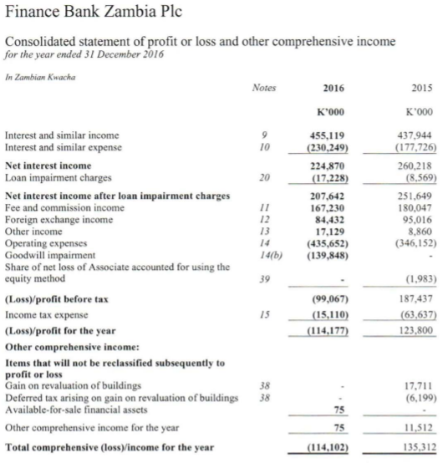
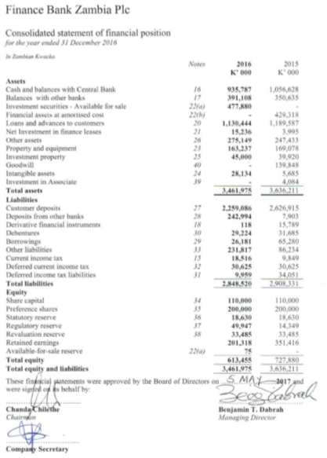
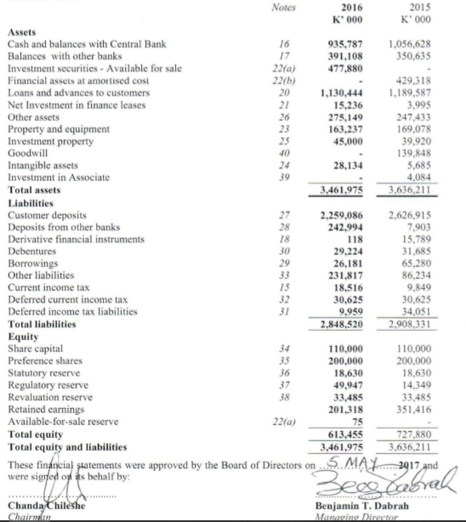
1.2 Statement of the Problem
- Atlas Mara Limited completed the acquisition of Finance Bank and merged with its Zambian subsidiary called BancABC on June 30, 2016.Atlas Mara and BancABC have since been operational countrywide.
- There have been many studies on mergers despite that, there is still a relative deficiency of empirical evidence clarifying the specific impact of M&As involving Commercial banks.
- Alas Mara and BancABC have since been operational countrywide
- However, there is lack of knowledge on the effects of the M&A on the financial performance of Atlas Mara Bank.

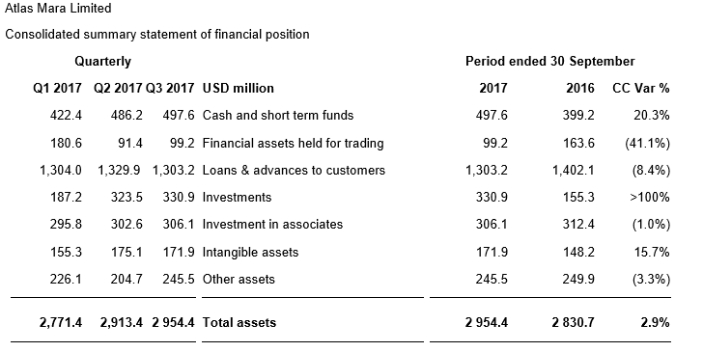
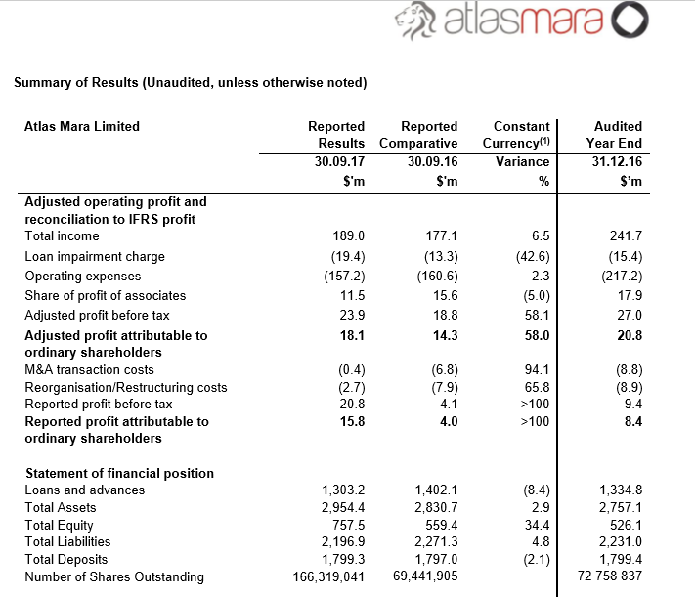
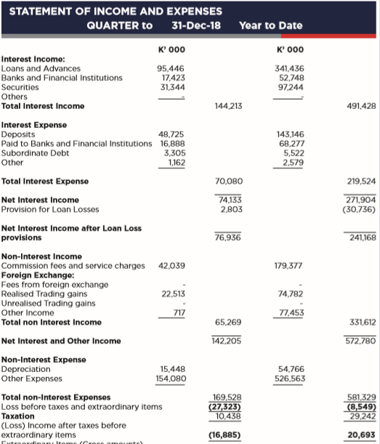
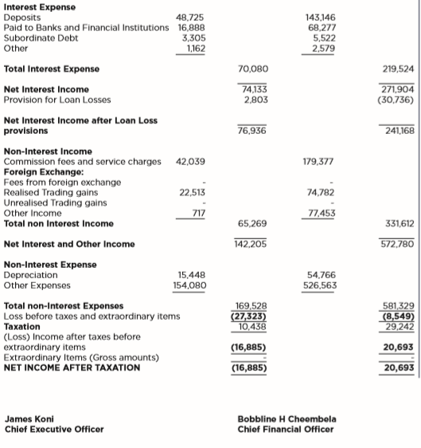
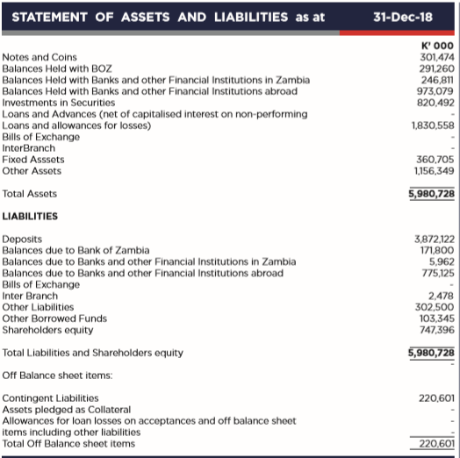

Atlasmara
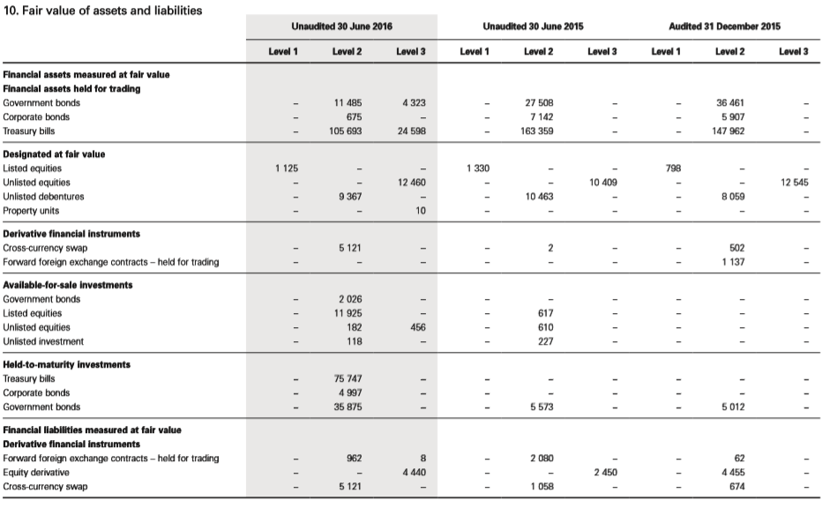
BancABC
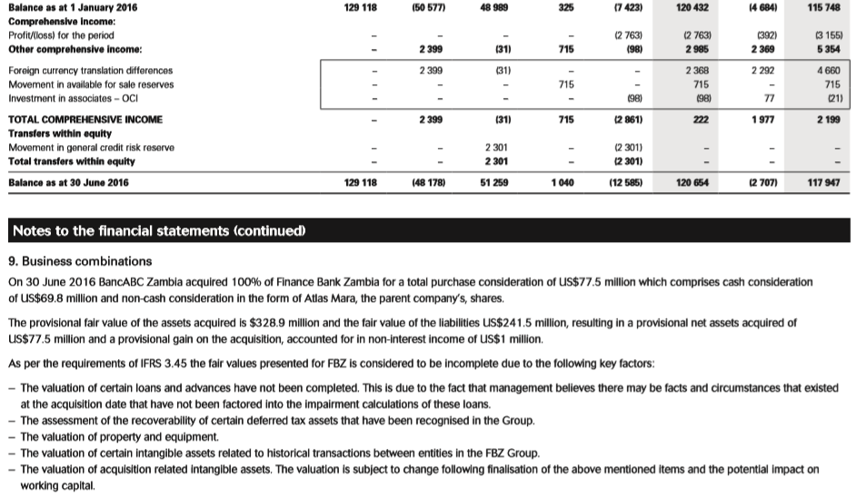
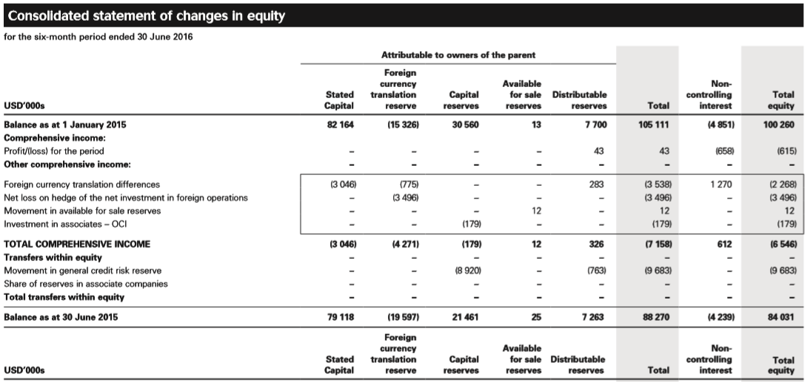
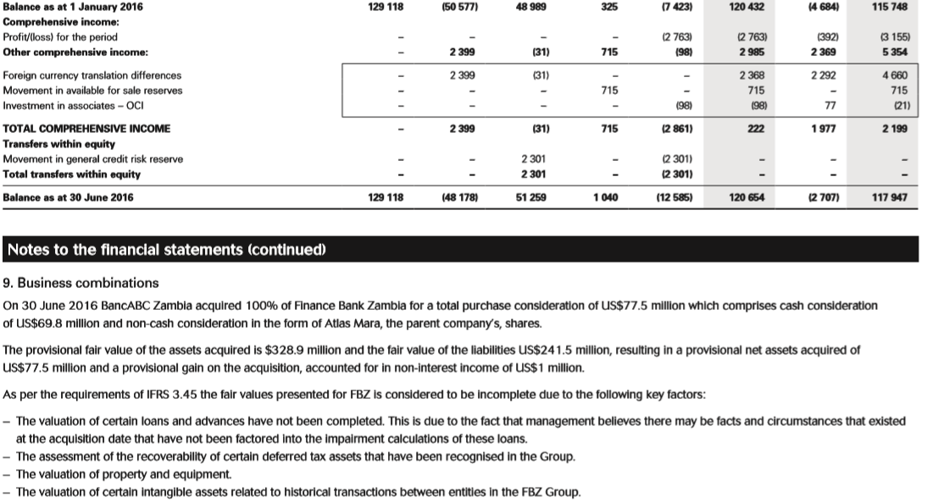
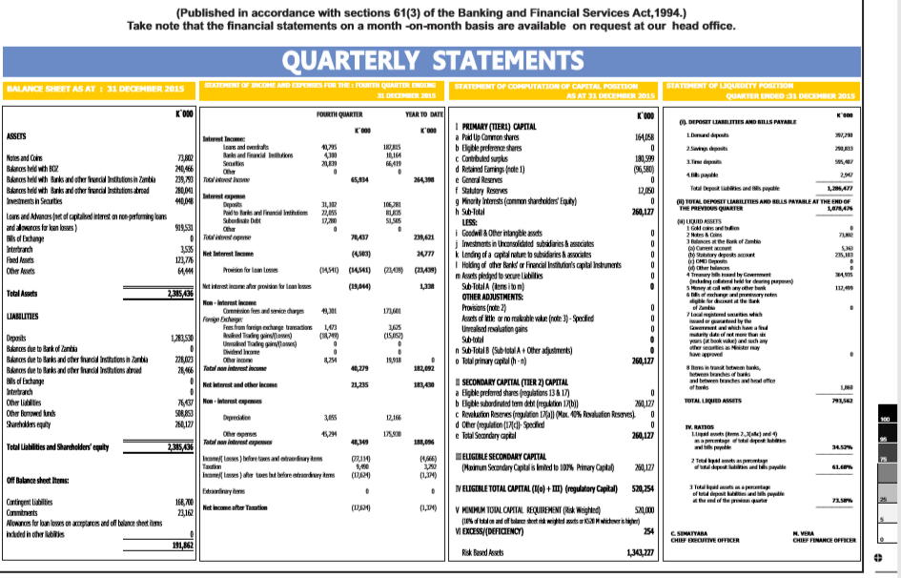

Appendix 2: QUESTIONNAIRE
General questions
1. Working Experience
(a) 1-5
(b) 6-10 years
(c) 10-14 years
(d) 20 +
2. Age-group
(a) 20 - 30 years
(b) 31 -40 years
(c) 40 - 50
Specific Questions
3. How do you rate the mergers effect in enlarging the market share?
a) Very Large
b) Large
c) Slight
d) Moderate
e) None
4.How do you rate the effect of the merger on affecting the market price of shares?
(a) Very Large
(b) Large
(c) Moderate
(d) Slight
e) None
5. How do you rate the effect of the merger on the bank’s net profit?
(a) Very Large
(b) Large
(c) Moderate
(d) Slight
e) None
6. Do you agree, strongly agree or somewhat disagree with the fact that mergers and acquisition
increases the banks size, ratings and value when combined?
(a) Strongly agree
(b) Agree
(c) Somewhat agree
(d) Disagree
7. Do you agree, strongly agree or disagree that “mergers and acquisition have an impact on
introduction of new service and facilities for the customers in the local and global market”?
(a) Strongly agree
(b) Agree
(c) Somewhat agree
(d) Disagree
8. Do you agree, strongly agree or somewhat disagree that mergers and acquisition exercise helps
the bank expand its location in rural and urban areas?
a) Strongly agree
(b) Agree
(c) Somewhat agree
(d) Disagree
9. Are Communication-related challenges the major reason for the failure of mergers and
acquisitions in banking sector?
(a) Strongly agree
(b) Agree
(c) Somewhat agree
(d) Disagree
10. Please tick the most approporate response
 | Yes | No | Other
Were you aware about the Merger & Acquisition of Finance Bank Zambia Plc and Bank ABC?
Do you know the motive behind this Merger & Acquisition?
Do you think there is risk involved in this Merger & Acquisition?
Is there any difference in operating system of the Bank after Merger & Acquisition?
Did the employees of merged or acquired Bank face any problem?
Did the facilities provided to the customers become better after merger?
Have the customers of merged Bank faced any problem after merger?
Did Merger & Acquisition affect the NPA & B/D of merged bank?
Did the merged Bank’s senior position employee get affected after M&A process?
Do you think the Merger & Acquisition has had any impact in the foreign Market?
Do you think the Merger and Acquisition is beneficial for the Banking sector in Zambia?
Does the Merger & Acquisition affect the costing?
What do you think about the Merger & Acquisition curbing a competition in banking sector?
Can you state how the Merger & Acquisition overall impact on the performance of merged bank?

11. In your own understanding what are the reasons of implementing mergers and acquisition
12. Do you think, more and more banks in Zambia are following mergers and acquisition exercise
strategies for advancing their performance? If yes kindly elaborate.
13. Do you feel that mergers and acquisition implementations come with certain challenges? If
yes kindly elaborate the challenges faced.

