RADIO SPECTRUM UTILIZATION IN ZAMBIA: ESTABLISHING AVAILABILITY OF WHITE SPACE, AS ENABLERS FOR ICT SERVICES NETWORK ROLLOUTS

BY

CORNELLIUS CHISUMBE

A DISSERTATION SUBMITTED TO THE UNIVERSITY OF ZAMBIA IN PARTIAL FULFILMENT OF THE REQUIREMENTS OF THE DEGREE OF MASTER OF ENGINEERING DEGREE IN INFORMATION COMMUNICATION TECHNOLOGY POLICY, REGULATION AND MANAGEMENT

The University of Zambia
Lusaka
2020

DECLARATION
I, Chisumbe Cornellius hereby declare that this work is my own, and that to the best of my knowledge, it has never been produced or submitted before at this university or any other institution for academic purposes, and that all sources of information have been duly acknowledged.

Author
Full name: Chisumbe Cornellius
Signature:…………………………………. Date:………………………………….

Supervisor:
Full name: Dr. Simon Tembo

Signature:…………………………………. Date:………………………………….

APPROVAL

DEDICATION
I dedicate this research work to my wife Elizabeth and my children, Emmanuel and Natasha for their support and time that they committed to ensuring that this research is a reality and to the Almighty God for giving me the time and pleasant experience during the study.

ACKNOWLEDGMENTS
Firstly, I acknowledge my awesome God Jehovah, for the blessings and life he continues to bless me with. He has made this piece of work a success, and most definitely this thesis will remain an accolade of success granted to me from above.
A word of gratitude to my wife Elizabeth for the encouragements and motivation to enroll for the Degree program, to Emmanuel and Natasha my children for their time and love. God Richly Bless you always
Sincere thanks to Mr. & Mrs. Sampa Chisumbe for their contribution to this research and time they sacrificed towards the study. My brothers and sisters; Fr Bavu, Chama, Mumba, Ethel, Chanda, and Chali. Thank you very much for your support.
My supervisor (Dr Simon Tembo)
Special thanks for the guidance and insights throughout the research and entire course work. Your timely advice and encouragements pushed me to work even harder and this has profoundly empowered me with a deeper understanding of how policy and regulatory fuse together in the engineering practice.

ABSTRACT
Recently, the use of Television White Spaces (TVWS) for broadband communication has raised interest world over. TVWS refers to regions of radio spectrum in the Ultra High Frequency (UHF) band that are not used all the time in a specific geographical location. TVWS spectrum brings with advantageous propagation properties inherent to UHF spectrum and has been identified as an alternative for providing commercial wireless services other than broadcasting. This study focused on investigating the current utilization of the UHF band in Zambia to establish availability of TVWS, as well as its subsequent usage for transmission of alternative ICT services. Qualitative and Qualitative approach was adopted with data collected using signal drive tests, structured questionnaires and interviews. The research population included the Zambia Information and Communication Technology Authority as a regulator, Information Communication Technology service providers, and Television/Radio broadcasters. The aim was to establish whether Zambia has TVWS resource and whether there are secondary services currently deployed on the UHF band as opposed to Television broadcasting which is the primary service. The research established that only 10.2% of the UHF band in Zambia is being utilized and this is due to limited number of licensed signal distributors, and Television broadcasting companies in Zambia depend on the signal distributors for propagation of content via the air waves. The regulatory framework in Zambia as guided by the Digital Migration Policy, limits the number of signal carriers to two thereby limiting access to UHF frequencies to only the two signal distributors. The study also revealed some of the potential ICT solutions and application that can be implemented over TVWS resource. Zambia has no standards of its own but rather reference to the available various ITU standards governing the broadcast of wireless services. The research, therefore, recommends sensitization on TVWS resource to be carried out to encourage planning and research by both the service providers and the regulator towards implementing technologies that will be able to handle the anticipated increased demand for ICT services and M2M applications.

LIST OF FIGURES

Figure 2.1: Shows the sweep tests for frequency 546MHz from Livingstone to Kitwe. 15
Figure 2.2: XTASI-RF Analyzer 25
Figure 2.3: Rhode & Schwarz ETC Compact TV analyzer (source: Rhode & Schwarz site) 26
Figure 2.4: Rhode & Schwarz ETL spectrum analyzer 26
Figure 2.5: Rover HD TAB7 EVO (source: Rover Instruments site) 27
Figure 3.1: Livingstone test point (Google Earth) 32
Figure 3.2: Ndola test point (Google Earth) 32
Figure 3.3: Chingola Test point (Google Earth) 33
Figure 3.4: Kabwe Test point (Google Earth) 33
Figure 3.5: Kitwe Test Point (Google Earth) 34
Figure 3.6: Lusaka Test point (Google Earth) 34
Figure 3.7: Solwezi Test point (Google Earth) 35
Figure 4.1 Lusaka UHF band Sweep Test results taken from the ETC Analyzer 44
Figure 4.2 Channel 44 TV analyzer results taken from the ETC 45
Figure 4.3 Ndola UHF band Sweep Test results taken from the ETC 46
Figure 4.4 Channel 32 TV analyzer results taken from the ETC 47
Figure 4.5 Chingola UHF band Sweep Test results using the ETL Analyzer 48
Figure 4.6 Livingstone UHF band Sweep Test results using the ETL Analyzer 49
Figure 4.7 Kitwe UHF band Sweep Test results using the ETL Analyzer 50
Figure 4.8 Kabwe UHF band Sweep Test results using the ETL Analyzer 51
Figure: 4.9 Potential ICT application via TVWS Spectrum 54

LIST OF TABLES
Table 2.1: SADC Regional Frequency Allocation Plan for 470MHz-862MHz 12
Table 2.2 SADC Regional Frequency Allocation Plan for 470MHz-862MHz (post Digital Migration) 13
Table 3.1: Summary of the target group together with the justification of sampling methods adopted 39
Table 3.2: Summary of Population Sizes and Response Rates 40
Table 3.3: Summary of the sample frame 41
Table: 4.1 Spectrum sweep results 52
Table: 4.2 TVWS availability in Zambia. 53

TABLE OF CONTENTS
DECLARATION i
APPROVAL ii
DEDICATION iii
ACKNOWLEDGMENTS iv
ABSTRACT v
LIST OF FIGURES vi
LIST OF TABLES viii
LIST OF ABBREVIATIONS xiv

CHAPTER ONE: INTRODUCTION 1
1.1 Background 1
1.2 Problem Statement 2
1.3 Research Justification 3
1.4 Significance of the Study 4
1.5 Research Questions 4
1.6 Objectives of the Study 6
1.7 Scope of the Research 6
1.8 Chapter Synthesis 6
1.9 Conclusion 7

CHAPTER TWO: LITERATURE REVIEW 7
2.1 Introduction 8
2.2 Ultra-High Frequency (UHF) Band 9
2.3 Spectrum as a Resource 9
2.4 Television White Space in Zambia 11
2.4.1 UHF Frequency Plan post Digital Migration 11
2.4.2 TV License framework and its impact on spectrum utilization 13
2.4.3 Previous studies on TVWS in Zambia and in the neighboring countries 14
2.5 Challenges affecting Implementation of TV White Space 16
2.5.1 Technical complexity 16
2.5.2 Market and Manufacturing Complexity 16
2.5.3 The Challenge of Coordination and Harmonization 17
2.5.4 Institutional Capacity 17
2.6 Benefits, Trials and Solutions of ICT implementation over TV White Space 18
2.7 Need for Adoption and Sensitization of TV White Space 20
2.8 Standards 21
2.8.1 ECMA-392a: Focuses on Media Access Control (MAC) and Physical layer for Operation in TVWS 21
2.8.2 IEEE 1900.4a: Standard for Architectural Building Blocks Enabling Network Device Distributed Decision Making for Optimized Radio Resource Usage in Heterogeneous Wireless Access Networks 22
2.8.3 IEEE 802.11af: A standard for TV white space spectrum sharing 22
2.8.4 IEEE 802.22-2011: Cognitive Wireless RAN Medium Access Control (MAC) and Physical Layer (PHY) specifications: Policies and procedures for operation in the TV Bands 23
2.8.5 IEEE P802.19.1: IEEE Draft Standard for Information Technology; Telecommunications and Information Exchange between Systems. Part 19: TV White Space Coexistence Methods Amendment: Coexistence Methods for Geo-Location Capable Devices Operating Under General Authorization 23
2.9 Test Equipment for Measuring the TV Band 24
2.9.1 XTASI-RF Device 24
2.9.2 R&S ETC compact TV analyzer 25
2.9.3 R&S ETL Spectrum analyzer 26
2.9.4 The Rover HD TAB7 EVO automatically detects and selects Rover HD TAB7 EVO 27
2.10 Conclusion 27

CHAPTER THREE: METHODOLOGY 29
3.1 Introduction 29
3.2 Research Approach 30
3.3 Methods of Data Collection and Instruments 30
3.3.1 Case study to Establish TV White Space availability 30
3.3.2 Literature Surveys 35
3.3.3 Interviews 35
3.3.4 Questionnaires 36
3.4 Reliability 37
3.5 Target Population 38
3.5.1 The Regulator – ZICTA 38
3.5.2 Television and Radio Broadcasters 38
3.5.3 Mobile Communication/Internet service providers 38
3.6 Sample 39
3.6.1 Sampling Frame 41
3.7 Data Analysis and Presentation 41
3.8 Conclusion 42

CHAPTER FOUR: FINDINGS AND DATA PRESENTATION 43
4.1 Introduction 43
4.2 Background to the Findings 43
4.3 Case study: UHF Band Spectrum Sweep finding 43
4.3.1 Lusaka Test Results 43
4.3.2 Ndola Test Results 45
4.3.3 Chingola Test Results 47
4.3.4 Livingstone Test Results 48
4.3.5 Kitwe Test Results 49
4.3.6 Kabwe Test Results 50
4.5 Sample Sizes and Response Rate (Questionnaires) 51
4.6 Findings and Presentations 52
4.6.1 TVWS Availability and Utilization in Zambia 52
4.6.2Summary of Spectrum Sweep Results 52
4.6.3 Potential TVWS Application and Technology Solutions 53
4.6.4 Standards Governing the Management of TVWS in Zambia 54
4.7 Conclusion 55

CHAPTER FIVE: DISCUSSION OF FINDINGS…………………………………………56
5.1 Introduction 56
5.2 TVWS Availability in Zambia 56
5.3 Standards Governing the Management of TVWS in Zambia 57
5.4 Potential TVWS Application and Technology Solutions 57
5.5 Conclusion 58

CHAPTER SIX: CONCLUSION AND RECOMMENDATIONS………………………..59
6.1 Introduction 59
6.2 Chapter Recapitulation 59
6.3 Research Questions Review 60
6.3.1 What is the availability of TV White space on the Radio Spectrum in Zambia? 60
6.3.2 What benefits can be drawn from using TV White Space in ICT network rollouts? 61
6.3.4 What are the available regulations supporting the use of TV White space in Zambia as an enabler for ICT rollout? 61
64 General Conclusion 62
6.5 Recommendations 63
6.6 Area for Further Research 63

REFERENCES……………………………………………………………………………….64
APPENDICES 73
Appendix 1: Survey Questionnaire – Internet Service Providers 73
Appendix 2: Survey Questionnaire – Radio and Television Broadcasters 79
Appendix 3: Survey Questionnaire – ZICTA The Regulator 85

LIST OF ABBREVIATIONS
DTT Digital Terrestrial Television
DTV Digital Television
FCC Federal Communications Commission
Gbps Gigabits per second
ICT Information Communication Technology
ISP Internet Service Provider
ITU International Telecommunication Union
MBB Mobile Broadband
MFN Multiple Frequency Network
OFCOM Office of Communication
RFID Radio Frequency Identification
SFN Single Frequency Network
TVWS Television White Space
UHF Ultra High Frequency
VHF Very High Frequency
Wi-Fi Wireless Fidelity
WSD Whitespace Devices
ZICTA Zambia Information Communication Technology Authority
ZNBC Zambia National Broadcasting Corporation

CHAPTER ONE: INTRODUCTION

1.1 Background
In many emerging markets, wired technologies, especially in rural areas, are simply not practical. The rollout cost of network infrastructure is comparatively high, and often not practical in lower-income countries, even less so in sparsely populated rural areas. Fiber optic infrastructure is another important connectivity technology especially for national and international communication backbones, but it is currently only viable as a consumer solution in wealthy communities. “Thus, when talking about affordable, ubiquitous access to communication in developing countries and especially rural areas, wireless technologies offer the most hope for effectively bridging the digital divide” [1]. Fernando et al., 2018 [2] asserts that the ever-increasing demand for myriad of wireless services poses two major challenges in the wireless network paradigm. One is the spectrum scarcity and the other is the demand of high data rates, up to tens of Gigabits per second.
The Electromagnetic Spectrum resource makes modem communication possible through the propagation of Radio waves as a medium of connectivity and transmission in wireless networks. The portion of the Electromagnetic spectrum, which is being used in Most Telecommunication services and applications, is the Radio Spectrum. “The Electromagnetic spectrum is always available in infinite abundance except for the portion which is being used and when that portion of the spectrum is no longer in use, it is instantly renewable” [3]. Compared to other natural resources, the Electromagnetic resource can also be wasted or abused where there is no proper management and regulation and it has lately been called a limited natural resource because, given the present technological advancements, there is only a finite portion available for beneficial uses at any one time. Some commercial applications and technologies promoting the sharing of bandwidth and efficient usage of the Spectrum resource are emerging. The term “White Space” refers to frequencies that are currently, not being used, by existing licensees, at all times or at locations or to spectrum which is made available by changes in use [4]. Television White Space Spectrum (TWVS) is therefore defined as frequency spectrum in the UHF (TV) bands that are not being fully utilized by licensed services, such as TV broadcasting, and are made available for other users on secondary basis provided the secondary users do not interfere with the licensed services. These TV spectrum “gaps”, with advantageous propagation properties inherent to UHF spectrum have been identified as an alternative for providing commercial wireless services other than the traditional television broadcasting [4].
This evolution of dynamic spectrum approaches to spectrum management is creating new possibilities for accessing the resource, especially to developing countries where there is a lack of affordable access to ICTs in rural areas and where television spectrum is comparatively lightly occupied. The successful adoption of wireless technologies to run on TV white space depends mainly on manufacturers of technologies, communication regulators, and standards formulating institutions working together.
This research aims at establishing the availability of TV White Space resource in Zambia, and more so seek to identify the benefits of utilizing the TV White space as an enabler for the rollout of ICT services and discuss available standards for regulating White Space resource. This will be achieved using both qualitative and quantitative research methods.

1.2 Problem Statement
The area of breakthrough in telecommunications has been shifting for the past decade from wire line to wireless systems and networks. However, this shift from wire line to wireless will continually require access to the electromagnetic spectrum for transmission of content to be possible. Zambia Information Communication and Technology Authority (ZICTA).
[5] [6] [7], through the published ICT survey reports from 2015 to 2018; confirms that Zambia has been recording substantial development in the rollout and implementation of ICTs and ICT Technologies, with a corresponding increase in the number of active mobile broadband users being 9,825,716 at the end 2019, when compared against 3,741,615 year end of 2014. The 2018 ICT Survey report indicated that Mobile Penetration per 100 Inhabitants in 2019 was 99.1%. It can be argued from the ICT survey reports that 21% of the country does not have network coverage and that there is an urgent need for extensive network rollouts to not only bridge the urban to rural digital divide, but also to ensure the urban areas have sufficient network coverage. ITU report on Harmonization of Policies Governing the ICT Market in the West African Economic and Monetary Union and ECOWAS Space stated that the constantly increasing demands for use of the electromagnetic spectrum will eventually constrain the extent to which it can be exploited without unacceptable interference [8]. “The Radio Spectrum, a portion of the electromagnetic spectrum is however, a limited natural resource and at least for the present, a scarce resource. “Over-use and over-crowding cause interference and lead to situations where the use of the radio spectrum is severely impaired [9].” Equitable and careful management of the spectrum resource is crucial at the national and international levels. The radio spectrum if not efficiently managed, is not enough to go around meeting everybody's requirements every time there is a need for the resource. TV white space frequencies possess inherent advantage of longer coverage distance and excellent signal penetration capability during propagation and therefore has a potential to provide resource capacity for ICTs rollout with the rapid development of Mobile Broadband (MBB) and quick adaptation of Machine-to-Machine (M2M) in the practical applications, capacity on mobile networks is expected to be a challenge with regards meeting the exponentially growing demand for cheaper and available Mobile Broadband services in both urban and rural parts of Zambia.
The assertion of the problem statement for this research therefore reads as follows;
The growing demand for voice call service, wireless data transmission and data access imposes the search for alternatives to the current spectrum exploitation schemes. This also emphasizes the need to take advantages of spectrum that permits a much wider coverage reach to benefit both rural and urban areas indiscriminately, including providing a cheaper rollout solution.

1.3 Research Justification
Without communication systems, commerce is limited, extra pressure is placed on other less advanced (and more expensive) infrastructure and the sense of national community disintegrates. On the other end, communication systems reduce the need for people to travel to maintain contact, which at once reduces the pressure on roads and other transport infrastructure. It develops a broader sense of community and family, by extending the distances over which communication is practical. Furthermore, Telecommunications and Broadcasting can efficiently and effectively put across a sense of national purpose, significantly contribute to a sense of national culture and identity. In times of emergency, broadcasting provides a means of rapid communication with the people, facilitating the movement of goods (i.e. mobile communications); the timely availability of services; better public safety and; enhanced national defense capability. It also means better personal communications and faster business decisions. The radio frequency spectrum is available to everyone intending to use it. But when one service uses an available portion of the spectrum, that section is no longer available for other services without mutual interference. Eventually, as users demand access, the scarce resource will be fully used and depleted if it is not efficiently managed. The demand for access to the spectrum resource will inevitably increase as the reality of technological advancement becomes more actualized in our society. It is therefore time to evaluate the systems and frameworks currently being deployed in spectrum management in relation to the increasing demand for the resource. It is anticipated that the commercializing of White Space Spectrum will open-up bandwidth and provide a platform for ICTs to roll out services and applications. To provide additional Spectrum the Federal Communications Commission [10], Office of Communication [11], Independent Communication Authority of South Africa [12] and other spectrum regulators worldwide are exploring techniques to reuse unoccupied TV channels (white spaces) for data communication. Traditional spectrum regulation and management rules, such as the command and control with their respective spectrum allocation techniques (exclusive licensing and common rights or license-exempt) need to be reviewed to allow more efficient spectrum utilization [13].

1.4 Significance of the Study
The significance of the study is to bring about awareness to the body of knowledge on the availability of TVWS Spectrum in Zambia and the possible benefits that can be actualized by using the resource for ICT network rollouts. TVWS resource therefore provides additional and alternative spectrum for the many telecommunications services which continue to demand for the frequency spectrum resource.

1.5 Research Questions
The research questions are:
- What is the availability of TV White space on the Radio Spectrum in Zambia?
- What are the available regulations supporting the use of TV White space in Zambia as an enabler for ICT rollout?
- What benefits can be drawn from using TV White Space in ICT network rollouts?

1.6 Objectives of the Study
The objectives of the study are:
- Establish the availability of TV White space on the UHF band in Zambia
- Establish the availability of regulation supporting the use of TV White space in Zambia
- Outline the benefits that can be drawn from utilizing TV White space spectrum

1.7 Scope of the Research
The study will focus on establishing the availability of TV White Space resource in Zambia, as an enabler for ICT services network rollouts with emphasis on the management of the TV white space spectrum and efficient usage of the resource. The research will define what TV white space Spectrum is and more so outline some of benefits that can be drawn from utilizing TV White space spectrum resource for ICTs services. Appropriate research methodological procedures and relevant techniques shall be employed.

1.8 Chapter Synthesis
This dissertation consists of six chapters which are organized as follows:
Chapter one introduces the research topic, justifies the research, outlines the research problem, and states the objectives and importance of the study. It also states the research questions, scope and significance of the study.
The second Chapter reviews literature on TV White space as a resource, outlining the benefits that can be drawn from utilizing TV White Space in ICT network rollouts as well as establishing the availability of TV White space on the UHF band in Zambia. It defines Radio Spectrum as a resource and builds on to discuss the UHF band and TV White Space. Further, the chapter discussed TV white space in Zambia and why the resource is attractive for development of ICTs. Lastly, examples of technology applications and trials on TV white space resource, and the standards that are being used in the management of the resource have been discussed.

Chapter three discusses the methodology employed in this research; this was achieved by outlining the research approach, design and target population, the sample size as well as the justification given in ensuring representativeness of the research population. More so, data collection methods and instruments used were discussed as well as research reliability and validity.
Having laid the basis for the study, Chapter four presents the actual findings as obtained from the respondents through interviews and questionnaire administered to respondents as well as through UHF Band Spectrum Sweep tests. This is to satisfy the first and third research objectives which aim at establishing the availability of TV White space on the UHF band in Zambia as well as establishing the availability of regulation supporting the use of TV White space in Zambia as an enabler for ICT rollout.
Chapter five is a discussion and analysis of the findings in relation to the existing body of knowledge on the subject matter of Radio Spectrum Management and Utilization in Zambia: Promoting Usage Efficiency and Commercialization of Television White, As Enablers for ICT Services Network Rollouts.
Lastly, the sixth Chapter provides the discussion, conclusions and recommendations of the research based on the literature review, findings and analysis in line with the set objectives.

1.9 Conclusion

This chapter has introduced the study and presented the research problem and the problem background and its justification. The chapter has further highlighted the aim and objectives of the study and has also discussed the significance of the study. The final part of this chapter has briefly defined the scope of the research, as well as presenting the chapter synthesis for this dissertation.
CHAPTER TWO: LITERATURE REVIEW

2.1 Introduction
Management of the Spectrum resource is a very complex undertaking, which takes into account: the technical, legal, administrative and economical aspects of ensuring Telecommunication efficiency. Regulators world over are faced with the challenge of not only ensuring that there is harmonious use of the radio spectrum by services and systems without interference but also make available the valuable resource for the ever-increasing demand and advancements in technology. “The range of services for which spectrum is used, continues to grow, while the demand for such services has seen a phenomenal increase in recent years. In the past decade, ITU has recorded more frequency assignments than during the entire previous history of radio” [15].
The White space technologies area is of paramount value in the information, technology and communication field, due mainly to the possibility of having cooperating radios with robust flexibility operating, with the capability to optimize the transmission parameters to achieve the best possible performance and also promote efficient utilization of the resource. “Today we are beginning to witness a third phase of significant growth in wireless devices, marked by a proliferation of devices using not licensed spectrum, but unlicensed spectrum” [16]. This development is means that secondary services can now be deployed on frequency bands where the services are not designated but still not interfere with the primary (licensed) services. In this study the focus is on promoting the usage of TV White Space for ICTs and cheaper network rollouts. Fadda et al [17] asserts that within the cognitive radio paradigm, as a highly praised alternative for overcoming the inherent limitations of the Radio Frequency spectrum, the current worldwide situation of the VHF and UHFTV channels is an excellent application scenario.
This chapter discusses and defines TV White Space in relation to the UHF band and the Radio Spectrum in general. The first part defines Radio Spectrum a resource and builds on to discuss the UHF band and TV White Space. The second part looks at the Benefits, Trials and Solutions of ICT implementation over TV White Space, Previous studies on TVWS in Zambia and in the neighboring countries, Standards for managing TVWS and, also the TV License framework and its impact on spectrum utilization in Zambia. Lastly the chapter lists different types of equipment that can be used to carry UHF sweep tests to establish spectrum utilization. The aim of the review is to draw valuable and impeccable lessons relevant to this research study.

2.2 Ultra-High Frequency (UHF) Band
The Radio Spectrum has been defined by Blackman and Srivastava [18], as a range of the radio spectrum in the band extending from 300 MHz to 3 000MHz. The frequency range (470MHz-862 MHz) has been traditionally used for terrestrial broadcasting for many decades, as designated by the ITU and this is what is referred to the UHF band. UHF television broadcasting is the use of Ultra-high frequency (UHF) radio for over-the-air transmission of television signals.
UHF frequencies are used for both analog and digital signal transmission services. Channels and sub bands within the UHF portion of the radio spectrum are allocated by the International Telecommunication Union (ITU) and, regulatory at both regional and country level reference to the ITU band assignment. The UHF band is extensively used for satellite communication and broadcasting, in cellular telephone and paging systems, and by third generation (3G) wireless services. The ITU Regional Radio communications Conference held in Geneva in 2006 (RRC06) [19], adopted the GE06 Agreement, which contains a plan (GE06 Plan) and associated procedures for the implementation and the modification of this plan. The GE06 Plan achieved a situation of equitable access between 119 countries (118 countries from ITU Region 111, and the Islamic Republic of Iran) in the VHF and UHF frequency bands. Each country party to the Agreement has received a set of entries in the GE06 Plan, which define a right to use certain frequencies with certain characteristics within certain specified areas. For reasons of continuity with previous agreements concluded in 1961 and 1989, the UHF frequency band has been divided into 49 channels of 8 MHz bandwidth, numbered from 21 to 69 starting from frequency 470MHz, and the VHF band has been divided into eight channels of 7 MHz bandwidth, numbered from 5 to 12 [19].

2.3 Spectrum as a Resource
Analog to digital TV transition presents the countries with a unique opportunity to efficiently use the frequency spectrum in the UHF band. This is because one traditional analog TV channel typically allows up to 20 or more standard definition digital television (DTV) signals or services to be transmitted using the DVB-T2 standard for digital video broadcast [20]. Excess spectrum after digital migration, has being freed as countries continue with the migration and therefore more UHF frequencies are becoming available (example of TV White Space). The Terrestrial TV networks in the UHF bands have been by tradition planned as Multi Frequency Networks (MFNs), in order to support regional TV planning and to facilitate international frequency coordination. In this type of arrangement, there are locations within a country where some UHF channels are not used in order to avoid interference to TV services in adjacent regions. In MFN networks setup only one frequency in a particular location at a given time can carry television services and therefore renders the use of that frequency/including adjacent ones unusable in neighboring regions.
“ITU [21], defines TV white space as “portions of spectrum left unused by broadcasting, also referred to as interleaved spectrum”.TV Channels in VHF/UHF bands have highly favorable propagation characteristics for long-distance reach. Many administrations including the United States are moving towards establishing regulations that allow opportunistic license-exempt usage of the spectrum on a non-interfering basis with the TV receivers using cognitive radio techniques [22].
Carlson Wireless Technologies [23], the global leader in TV White Space technology defines TV White spaces are vacant, unused or interleaved frequencies located between broadcast TV channels in the Very High Frequency / Ultra High Frequency (VHF/UHF) range, which can be found between 54MHz and 806MHz.
The propagation characteristic in TV bands is more favorable for wide area coverage or indoor/outdoor coverage than most of the spectrum bands used for mobile communications (e.g., the Universal Mobile Telecommunications System (UMTS) bands. Therefore, the abundant spectrum in the TV bands has attracted enormous attention from industry and academic alike, where tests have been conducted, case of Malawi [24], South Africa [25], India [26].
Countries across have been encouraging development of Technologies and solutions that can be deployed on the TVWS resource. In 2004, the Federal Communication Commission (FCC) in the United States issued the first Notice of Proposed Rule Making in view of allowing unlicensed wireless networks to utilize vacant TV channels, referred to as TV “white space.” In 2012, FCC issued the Third Memorandum Opinion and Order proposing the White Space device operation rules in the TV Band White Spaces.” [27] The idea of white spaces was to make unused TV channels available for unlicensed use, with the expectation that the favorable propagation of sub700 MHz frequencies would unleash innovative applications not otherwise possible. With regards the TVWS resource FCC said, “Access to this spectrum could enable more powerful public Internet connections – super Wi-Fi hot spots – with extended range, fewer dead spots, and improved individual speeds as a result of reduced congestion on existing networks. The potential uses of this spectrum are limited only by the imagination.” Industry proponents said the technology would “benefit consumers in ways yet unimaginable.” [5]

2.4 Television White Space in Zambia
The Zambia national frequency allocation plan by ZICTA allocates 8MHz bandwidth for each UHF TV channel which gives a total of 49 available channels sitting from 470MHz to 862MHz as reviewed in section 2.2 and this also is in line with the SADC radio frequency plan [28]. Analogue television broadcasting services in Zambia are offered in bands III (174-230MHz), IV (470582MHz) and V(614-854MHz) in accordance with the ITU Geneva 1989 (GE-89) [29] and Stockholm 1969 (ST-69) [30] broadcasting plans. After 1990, the Government liberalized the airwaves, and this has seen the number of broadcasters both radio and television increase from one (ZNBC TV1) to over 15 television broadcasters and over 50 radio broadcasting stations on the Zambia Spectrum resource [31]. Some of the television broadcasters or content providers include ZNBC 1, ZNBC 2, ZNBC 3, DSTV, GOtv Broadcasting, Diamond TV (former Mobi TV), Muvi TV, CBC TV, Prime TV, Chipata TV, North-West TV, Kwese Star sat TV, Fresh TV, ABN TV, Lumen TV, KNC TV, Healing Centre TV, Hope TV, Revelation TV, CAMNET TV, Parliament TV, City TV, QTV, Life TV and TBN. To give a background on TVWS resource in Zambia, the UHF Frequency Plan post Digital Migration has been reviewed in line with the SADC plan, together with the TV License framework and its impact on spectrum utilization. Previous studies on TVWS in Zambia and in the neighboring countries have been reviewed equally.

2.4.1 UHF Frequency Plan post Digital Migration
Bright [32], defines Digital Broadcasting Migration as a process by which television broadcasting services offered on analogue networks are transferred to digital based networks over a specific period. Significant of which is the efficiency in the utilization of the scarce and limited frequency spectrum which is used for transmitting different telecommunication. Typical example is that Topstar and GOtv currently carrying at-least 25 different TV services on one frequency channel when checked on their decoder units. The SADC Frequency Allocation Plan organ, on which Zambia a member, met in Johannesburg 2016, following up on the meeting held in 2013 in Maseru with 15 countries in attendance, to develop a framework for the harmonization across SADC countries on the use of the radio frequency spectrum. The meeting acknowledged the challenges that new technologies are posing on frequency assignments and emphasized the need for harmonization among the member nations. More so, the meeting was meant to implement the changes made to the ITU Radio Regulations as a result of the resolutions at the 2012 ITU World Radio Communication Conference in Geneva.
Prior to the 2012 conference, the frequency allocations on the frequency Band range 470- 862MHz were mainly reserved for TV broadcasting services as per table 2.1, which is an extract of the SADC Regional Frequency Allocation Plan for 20-3100MHz [28]. This allocation was in principal translating to 49 frequency channels, each with 8MHz bandwidth available for TV broadcasting, hence the frequency band is sometimes referred to as the TV band.
Table 2.1: SADC Regional Frequency Allocation Plan for 470MHz-862MHz
SADC Frequency Allocation | Main Allocations | Sub Allocations
470MHz -520MHz | Broadcasting | TV Broadcasting
520MHz -640MHz | Broadcasting | TV Broadcasting
520MHz -640MHz | Radio Astronomy | Radio Astronomy
640MH - 760MHz | Broadcasting | TV Broadcasting
760MHz-862MHz | Broadcasting | TV Broadcasting

Zambia as a member of ITU, and SADC, always endeavors that all allocations in the National Frequency Plan by ZICTA are aligned to the allocations in the ITU Radio Regulations and SADC Frequency Allocation Plan. The frequency allocations on the frequencies band 470MHz to 862 MHz, an extract of the SADC Frequency Allocation Plan of 2016, are as presented in table 2.2 below.
- Prior to the 2016 frequency plan, Frequency range 470MHz-694MHz was used for analogue TV broadcasting and Radio Astronomy, and now the spectrum resource is reserved for Digital Terrestrial Television (DTT) broadcasting Licensing,
- The Frequency range 694MHz-790MHz and 790MHz-862MHz, prior to 2016 was earmarked for TV broadcasting as primary services and mobile telephone as a secondary service, but the band is now reserved for IMT services post Digital Migration. This

2.4.2 TV License framework and its impact on spectrum utilization
Table 2.2 SADC Regional Frequency Allocation Plan for 470MHz-862MHz (post Digital Migration)
Source: SADC frequency plan (2016)
In the light of recent technological progresses and the need to migrate Television broadcast service to Digital technologies from analogue system, Zambia developed the Digital Migration Policy in 2014 to facilitate the smooth migration of the tv services. The Zambia Digital Migration policy [31], outlined the current licensing framework, which separates content production license from signal distribution license. In the current policy, it is clearly stated that only two signal distributors can be licensed to transmit tv content to all parts of the country on the UHF band, and these are categorized as Public signal distributor (government owned) and a Private signal distributor. The role of a content producer is therefore only to create content and send it to the preferred signal distributor or both for transmission to all parts of the country.
According to the Policy [31], a content producer cannot operate or act as a signal distributor or carrier and cannot be licensed for the later.
The Public signal Distributor is Star times Zambia, while the Private signal distributor is GOtv Zambia limited, and the two have a mandate to transmit tv content to all parts of Zambia for Broadcast. The effect of this license framework on frequency utilization is that only the two signal distributors are eligible to apply to ZICTA and have access to the TV broadcast frequencies throughout the country. As an example, if Star times applies to operate on 3 frequencies for their content distribution and GOtv also gets 3 frequencies for transmission, the frequency utilization in this case will be 6 frequencies out of the total 49 available frequencies on the UHF band, taking into consideration of the frequency plan for the TV Band in table 2.4.2 this translates to 6 used frequency out of the available 28 frequencies. The policy also indicates that the signal distributor should provide transmission capacity indiscriminately to interested content producers, which therefore means that the signal distributor cannot provide more transmission capacity or TV Services in Lusaka and provide less is another province, town or city, from a transmission point of view to ensure consumers of TV have the same available programming throughout the country. .

2.4.3 Previous studies on TVWS in Zambia and in the neighboring countries
There has been very little study on TVWS resource in Zambia, especially in relation to its potential usability for ICT rollouts. However, there have been studies and pilot TVWS practical application in Malawi, Kenya and South Africa, which were geared towards enabling connectivity in rural areas and removing barriers for small businesses interested in Internet service provision [33]. The pilot project in cape Town, South Africa was a collaboration between Google and Independent Communications Authority of South Africa (ICASA), while Microsoft collaborated with the Ministry of Information and Communication in Kenya.
“In Malawi, the partnership team between the regulator MACRA and the University of Malawi-Chancellor College developed the TVWS rules and regulations, investor side business model and a performance analysis of the network in the mid of December 2013” [34]. “The deployment of the pilot was completed in September in partnership with the Abdus Salam International Centre for Theoretical Physics (ICTP) from Trieste, Italy”. “The goals for the Malawi TVWS Pilot are similar to that of the Cambridge Trial that is, to help industry understand the capability of TV white spaces to serve a wide range of applications, through key factors such as the coverage and performance that can be achieved” [34].
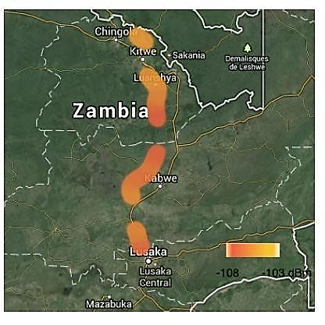
Mikeka et al [35], carried out signal drive tests, on frequency 546MHz of the UHF band, from Lusaka to Kitwe covering a total distance of 352km. Figure 2.1 below shows the test results for frequency 546MHz also known as channel 30 of the UHF band represented by the orange color on the hit map, which from the receive power of -108dBm to -103dBm indicate lack of activity on the frequency. The average receive power level from the measurement was -105.5dBm also indicating lack utilization of the spectrum resource. This test was meant to consolidate the findings that TV spectrum is underutilized not only in Malawi but also in surrounding countries.
Figure 2.1: Shows the sweep tests for frequency 546MHz from Livingstone to Kitwe.

2.5 Challenges affecting Implementation of TV White Space
Digital Terrestrial Television (DTT) in the UHF bands has been implemented fully in some countries, but in others the implementation process has been slower or has not started yet. For regions or countries where channel utilization by the primary DTT service is still undergoing planning and coordination, there is still a degree of uncertainty with regards the “final” DTT coverage footprint [30]. An example of such situation can be found in the African continent, part of the Geneva 06’ agreement for regional coordination of digital broadcasting, and where DTT transition is still ongoing. Such situation implies that, since the full coverage objectives of DTT have not been reached or implemented yet in some areas, TVWS that appears as currently vacant may not be available for use in the future [21].
Here are just a few of the dimensions in which spectrum is a challenge to understand and manage.

2.5.1 Technical complexity
What we understand about wireless spectrum is influx. Eighty years ago, the only way to manage spectrum was to give exclusive rights to a spectrum holder and ensure that significant "guard bands" or gaps between spectrum holders existed in order to prevent interference [36]. Transmitters were obliged to operate at comparatively high-power outputs in order to reach the comparatively "deaf" receiver devices. Today wireless communication technology continues to increase in efficiency and in its ability to mitigate interference. There are limits to this, however, and understanding how to maximize the efficient use of spectrum is an ongoing technical challenge which attracts a lot of R&D investment. Understanding the trends and changes in spectrum technology is essential to understanding how to regulate it.

2.5.2 Market and Manufacturing Complexity
Spectrum usage is dependent on having technology capable of using a given set of frequencies and this, in turn is entirely dependent on manufacturers producing transmitters and receivers for those frequencies. Many technologies only become practical when manufactured at scale so there is a kind of catch-22 with new technologies that requires commitment from manufacturers to support specific standards and frequencies. In the past, the trend in spectrum allocation has been to tie a spectrum band to specific technologies [37]. This has led to chunks of spectrum lying fallow because the markets and manufacturers did not follow the path that regulators expected. Today, there is an increasing emphasis on technological neutrality in spectrum allocation, but this can be challenging because some technologies, for example those that require paired spectrum, are dependent on spectrum allocations being organized in a particular manner [37].

2.5.3 The Challenge of Coordination and Harmonization
Spectrum Harmonization means defining technical conditions, including spectrum, band plan and technology, at a global and regional level, to ensure efficient spectrum use, seamless services over wide areas including roaming, system co-existence and global circulation of user equipment across borders [38]. According to SADC Frequency Allocation Plan 2013 [28],“Africa is a large continent with diverse country requirements and needs in the use of the radio frequency spectrum, and since individual countries are at different levels of implementation of new wireless technologies, harmonization and coordination within Africa and even between SADC countries is quite challenging. Regulators today find themselves in a challenging situation where they recognize the need to harmonize spectrum but are tempted to act individually because the pace of international coordination is so slow. Prior to the advent of mobile telephony and wireless broadband technologies, the availability of spectrum exceeded demand and incentives to coordinate spectrum allocation existed but were often trumped by local or regional priorities [36]. Regulators now sit with a challenge of making sure the regulatory frameworks are keeping up with the rapid advancements in technology development.

2.5.4 Institutional Capacity
When it comes to effective regulation of spectrum, there is a clear need for the technical, economic, legal, and administrative capacity within every country to address the issues relating to spectrum licensing effectively and efficiently. For developing countries, this is often the most significant challenge as communication regulators are typically under- resourced and sometimes insufficiently independent of state and industry alike. Because so much money is on the table, regulators are often out matched by their wealthy industry counterparts.

2.6 Benefits, Trials and Solutions of ICT implementation over TV White Space
The most pronounced benefit and advantage of TVWS is that low-frequency signals can travel longer distances translating into longer coverage radius (average 30km), making the technology well suited to provide low cost rollouts [40]. UHF TV band characteristics are relatively low levels of industrial noise and ionospheric reflections, reasonable antenna sizes, and good non-line-of-sight (NLOS) propagation and its large distance coverage can be suitable for wireless data connectivity in rural and remote areas [41]. With the above characteristics of UHF frequencies, it is possible to setup a Wi-Fi hotspot of coverage radius exceeding 5,000m depending on the transmitter power, which is by far more than the average 100m to 1,000m coverage radius of Wi-Fi hotspots operating on the 2GHz to 5.5 GHz frequencies. According to Fortune Sibanda a policy manager for Google South Africa
[33] "TV white space signals can also penetrate physical obstacles like trees, buildings, and rugged terrain, common in most parts of Africa, and can transmit wireless Internet over longer distances”. He continues to submit that white space usage may open up opportunities for cheaper broadband deployment by smaller ISPs across the continent, with the attendant benefits of economic growth and development that come with increased Internet penetration." A lot of notable technology Trials and solutions have been implemented on tv white space spectrum across the world covering Broadband internet access, internet of things, schools and library solution connectivity, machine to machine communication and public safety/security solutions, as presented in the following examples.
- In November 2013, The Tertiary Education and Research Network of South Africa (TENET) and partners announced that the outcomes of a successful TV White Spaces (TVWS) trial with 10 schools in the Cape Town area that began in March the same year [42]. The trial partners included CSIR Meraka Institute, the Wireless Access Providers' Association, Google, e-Schools Network, and Carlson Wireless. The participating schools experienced quality broadband access over TV channels. There was confirmation from both Teachers and students that they were able to use videos in lesson plans, make Skype calls to other schools, and more frequently update their Web sites and access research rich-media educational materials.
- “Microsoft partnered with Terabit, Bhutan Telecom and the Asian Development Bank (ADB) to connect a remote health unit in the Bhutanese village of Tang to Bumthang Hospital. The TV White Space link, established in February 2014, connects the villagers to quality healthcare and ensures treatment is received quickly and cost effectively” [43]. The pilot is being used by ADB for designing an ICT Development loan instrument to leverage the cost effectiveness of TV White Space technology. This Solution has enabled villagers to receive medical advice and book appointments without traveling to the City.
- Rural wireless broadband networks: “In California, a rural ISP, Cal.net, built a TVWS service using Rural Connect, a set of base station antennas and white space broadband radios made by the manufacturer Carlson. The installation has demonstrated speeds between 6-16 Mbps. In difficult terrain, this technology can also be used for backhaul i.e. connecting access points to the core transmission network” [44].
- Machine to machine applications: “In California, TV Bands White Spaces enable “Smart Grid” technologies that manage applications such as supply-and-demand of electricity and system control and data acquisition of substations and provide broadband Internet access to underserved areas. In smart grids for utilities, TVWS can be used to improve meter to meter communication, especially in grids across difficult terrain, making it possible to manage the utilities system remotely [45].
- West Virginia University recently became a pioneer when it launched a Wi-Fi network based on unused spectrum in the TVWS band. This service is being offered in conjunction with AIR (Advanced Internet Regions), a consortium of Higher Education Groups with Microsoft and has been created to deploy bandwidth to underserved college communities [46].
- The Microsoft 4Afrika initiative continued its pilot trial by setting out another deployment of TV white space in partnership with the Tanzania Commission for Science and Technology (COSTECH) and their local ISP UhuruOne, to provide internet access to university students in Dares Salaam, Tanzania [47].
- The University of Malawi, in partnership with the Malawi Communications Regulatory Authority (MACRA), and the International Centre for Theoretical Physics in Trieste, has launched a white-spaces pilot project in the city of Zomba, in southern Malawi. The pilot, which got underway in September 2013, has connected, different institutions including a school, a hospital, an airport and a research facility [48]
- According to ZDNET [49], the Housing & Development Board (HDB) in Singapore in 2013 deployed TVWS to support video surveillance for rooftop security and car park rules enforcement, as well as access real-time video from lift systems in HDB buildings. The use of real-time video recordings allows real-time video analytics and, also allows multiple departments to share the same surveillance resources. After recording success in the trials, has since released its regulatory framework for TV white space (TVWS), effective from November 2013, to facilitate the deployment of the technology and ease demand for more bandwidth amid a growing number of mobile and online users.

2.7 Need for Adoption and Sensitization of TV White Space
According to Stratistics MRC, “the Global TV White Space Spectrum Market is accounted for $1.12 million in 2015 and expected to grow at a Compound annual growth rate (CAGR) of 75.3% to reach $57.11 million by 2022” [50]. COMESA Official gazette of 2015 [51], encouraged the members of the regional body to; recognize the potential contribution which TV white spaces and database enabled spectrum access can make to improving spectrum efficiency. It stated that member States should come up with policy incentives to encourage the utilization of the spectrum that will be available due to the ongoing digital migration to provide wireless broadband internet to Academic, Research, Health and Agricultural institutions to catalyze innovations, especially in the rural areas. Further, that member states should coordinate to ensure best practices on the deployment of white space is achieved through development of a model policy framework to guide member states in developing local regulations and policies to enhance the utilization of “white spaces.”
More so, the African Internet Governance Forum (AfIGF), a platform for an inclusive multilateral, multi-stakeholder and multilingual discussion on issues pertinent to the Internet in Africa in general and Internet Governance issues in particular, recommended that TV white spaces should be released for internet deployment to underserved areas and at affordable rates [52], also emphasizing the need for countries to open up the white space resource.
In UK white Space devices were given access to be deployed on the UHF band to co-exist with the primary users of the frequencies, being digital terrestrial television, local TV and programmed making and special events (PSME). This was supported by a number of successful industry trials on the usage of white where recorded [53], and from this background UK regulator Ofcom announced in February that it would allow wireless technology access to unused white-space spectrum in the 490 MHz to 790 MHz frequency band [54]. Zambia Research and Education Network (ZAMREN) [55], reported that “There will be need for ZAMREN to lobby Government through ZICTA to use TV white spaces at concessional rates. This will enhance the provision of ICT services.”

2.8 Standards
To exploit this unused TVWS spectrum for improved spectrum efficiency, regulatory agencies have begun developing regulations to permit the use of TVWS by unlicensed wireless devices if they do not interfere with any licensed services. Cognitive Radio technology and use of White Spaces will provide ubiquitous wireless connectivity and support many other Machine to Machine applications [56]. For secondary services to be deployed on unused UHF band frequencies, such services are not supposed to interfere with the primary licensed services. ITU [1] defines cognitive radio systems as a radio system employing technology that allows the system to obtain knowledge of its operational and geographical environment, established policies and its internal state; to dynamically and autonomously adjust its operational parameters and protocols according to its obtained knowledge in order to achieve predefined objectives; and to learn from the results obtained. Cognitive radio technology facilitates for many wide ranging, and independently operated; wireless networks to utilize the TVWS resource
A series of standards have been created to support White Space development and these include the following:

2.8.1 ECMA-392a: Focuses on Media Access Control (MAC) and Physical layer for Operation in TVWS
This Standard specifies a medium access control (MAC) sub-layer and a physical (PHY) layer for personal/portable cognitive wireless networks operating in TV bands. This Standard also specifies a MUX sub-layer for higher layer protocols [57].
This Standard specifies several incumbent protection mechanisms which may be used to meet regulatory requirements. Conforming devices implement the MUX sub-layer, MAC sublayer and the PHY layer as specified herein and support at least one of the device types (master, peer, or slave) and at least one of bandwidths (6 MHz, 7 MHz, 8 MHz), and may support multiple antennae modes [57]

2.8.2 IEEE 1900.4a: Standard for Architectural Building Blocks Enabling Network Device Distributed Decision Making for Optimized Radio Resource Usage in Heterogeneous Wireless Access Networks
Additional components of the IEEE 1900.4 system are defined in this amendment to enable mobile wireless access service in white space frequency bands without any limitation on used radio interface (physical and media access control layers, carrier frequency, etc.). 1900.4a uses the existing IEEE standard 1900.4 as a basis and defines additional interfaces and entities to add efficient operation of white space wireless systems [58].

2.8.3 IEEE 802.11af: A standard for TV white space spectrum sharing
802.11af was formed in January 2010 to adapt 802.11 to TV band operation. Based on the IEEE 802.11ac physical layer, supports multiple concurrent downlink transmissions utilizing MU MIMO (multi-user multiple-input, multiple-output). The Standard defines international specifications for spectrum sharing among unlicensed white space devices (WSDs) and licensed services in the TV white space band using White Space Maps. White space map (WSM) describes available channels and their respective Maximum Transmit power allowed [59].
Spectrum sharing is conducted through the regulation of unlicensed WSDs by a geo- location database (GDB), the implementation of which differs among regulatory domains. The main difference between regulatory domains is the timescale in which WSDs are controlled by the GDB, resulting in different TVWS availability and WSD operating parameters. The IEEE 802.11af standard provides a common operating architecture and mechanisms for WSDs to satisfy multiple regulatory domains. This standard opens a new approach to treat spectrum as a single entity shared seamlessly by heterogeneous services [59].
Under this Standard Enabling stations are allowed, to enable dependent stations for operation in the TV white space (TVWS). Enabling stations must have TV database access and must know their position. They grant access to certain channels. Dependent stations must, after being enabled, perform sensing for a certain period before they can access the channel. Dependent stations are not mandated to know their geographical position (which is inconsistent, regarding the fact that enabling stations may be set apart). Procedures and timing have been defined. The standard will support 5, 10, 20 and 40 MHz bandwidth in the TVWS (set by the enabling station according to TVWS availability). Allowance for 2.5 MHz bandwidth operation is currently under discussion.

2.8.4 IEEE 802.22-2011: Cognitive Wireless RAN Medium Access Control (MAC) and Physical Layer (PHY) specifications: Policies and procedures for operation in the TV Bands
The development of the IEEE 802.22 Wireless Rural Access Network (WRAN) standard is targeted at using a CR approach to allow sharing areas of television broadcast service spectrum that are unused. These areas of spectrum will be allocated based on geographical location and can only be used on a non-interfering basis. The aim of this standard is to bring broadband access to rural environments which are hard to reach using traditional broadband technologies [60].
Other incumbent broadcasts could be in operation within the designated TV White Space (TVWS) bands (i.e. Digital and Analogue TV broadcasting and low-powered wireless microphones) and the 802.22 WRANs are designed to operate with no harmful interference to them [60].

2.8.5 IEEE P802.19.1: IEEE Draft Standard for Information Technology; Telecommunications and Information Exchange between Systems. Part 19: TV White Space Coexistence Methods Amendment: Coexistence Methods for Geo-Location Capable Devices Operating Under General Authorization
The draft standard specifies radio technology independent methods for coexistence among dissimilar TV Band Devices (TVBDs) and dissimilar or independently operated networks of TVBDs. The purpose of the standard is to enable the family of IEEE 802 Wireless Standards to most effectively use, frequency bands such as TV band White Spaces, the 5GHz license-exempt bands and the general authorized access in 3.5GHz bands by providing standard network-based coexistence methods among dissimilar or independently operated networks of unlicensed devices and dissimilar unlicensed devices with geo- location capability [61]. This standard address coexistence for IEEE 802 networks and devices and will also be useful for none IEEE 802 networks and devices. This amendment to IEEE 802.19.1-2014 defines the network-based coexistence information exchange among networks and devices to enable network-based coexistence management. It specifies procedures and protocols for collection and exchanging coexistence information of heterogeneous networks, spectrum resource measurements and network performance metrics, such as packet error ratio, delay, etc. and information elements and data structures to capture coexistence information [61].

2.9 Test Equipment for Measuring the TV Band
In order to establish availability of TVWS resource on the UHF band, reliable Test equipment is required. The test equipment should have the capability of sweeping through the UHF frequency band, interacting with each of the 49 frequency channels available on the band by means of being able to demodulate different types of signal formats and confirm whether the frequency channel has active traffic or not. The Study has looked at some of the available Radio Frequency Measurement Equipment that can be used for purposes of Testing for TVWS availability. Equipment readily available for spectrum measurements include; the ETL Spectrum Analyzer, ETC Spectrum Analyzer, Rover HD Flash Field Strength Meter (FSM), DiviCatch RF DVB-T/T2 DVB-C/C2 Professional RF Receiver, and XTASI-RF receiver. Below is a brief description on the operation of the listed test equipment for the spectrum measurements.

2.9.1 XTASI-RF Device
XTASI has an operational Frequency range of 46.5MHz-870 MHz for TV measurements and analysis. XTASI-RF modules is controlled through 4T2 Content-Analyzer application and this provides internal connection to the computer being used. The XTASI has a 75ohm RF BNC input connection port for connectivity to the receiving antenna and USB port for connectivity to the controlling computer [62]. The measured parameters can only be viewed through an output device (computer). The equipment is powered off the USB port connection to the computer during measurements and does not come with an inbuilt battery supply. The XTASI- RF receiver is connected for signal measurements as shown in figure 2.2 The RF connection to the antenna is through the red cable and the white USB cable connects the XTASI to the computer for software interaction and outputting of the measurement results using the XTASI pc suite.
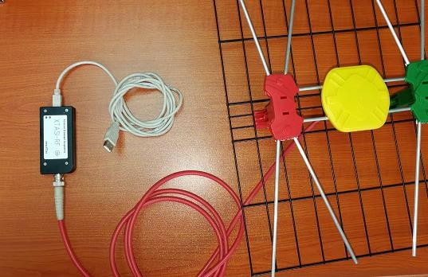

Figure 2.2: XTASI-RF Analyzer

2.9.2 R&S ETC compact TV analyzer
The R&S ETC compact TV analyzer offers a comprehensive set of measurement functions for DVB-T2, DVB-T/ DVB-H and ISDB-T digital TV transmitter testing. It is also useful for service and maintenance of TV transmitters as [63]. The Rohde and Schwarz ETC Analyzer is specialized in TV analysis and, also performs spectrum and scalar network analysis as well as power measurements and comes with a touch screen input capability. The ETC can demodulate 8 MHz QPSK, 16QAM, 64QAM, 256QAM modulation schemes and comes with a USB which can be used for real time storing of the measurements as captured on the device. The test instrument has the advantage of ease storing of measurement results and does not require an output screen device. The equipment is portable, but does not come with an inbuilt battery, therefore it has to be plugged to mains supply during operation.
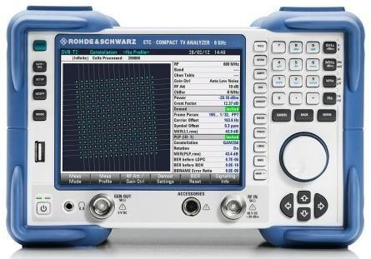

Figure 2.3: Rhode & Schwarz ETC Compact TV analyzer (source: Rhode & Schwarz site)

2.9.3 R&S ETL Spectrum analyzer
The Rhode & Schwarz ETL Spectrum analyzer combines the functionality of a TV (analog and digital) and FM (radio) signal analyzer, a video and MPEG TS analyzer and a spectrum analyzer in a single instrument [64]. The ETL Spectrum analyzer also contains generators to create analog video signals, audio signals and MPEG-2 transport streams.
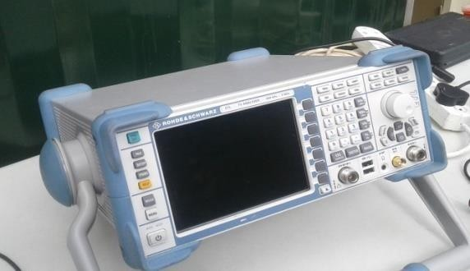

Figure 2.4: Rhode & Schwarz ETL spectrum analyzer

2.9.4 The Rover HD TAB7 EVO automatically detects and selects Rover HD TAB7 EVO
The Rover HD TAB7 EVO is a test instrument capable of taking in analog and digital COFDM/QAM TV signals in both measurement and spectrum mode [65]. The equipment has a frequency range of 230MHz-2340MHz for Terrestrial TV measurements, an extended Satellite Tuner frequency range of 930-2.610MHz for Satellite TV measurements, and a GSM extended band of 860-1.000 MHz for telephone repeater installation measurements.
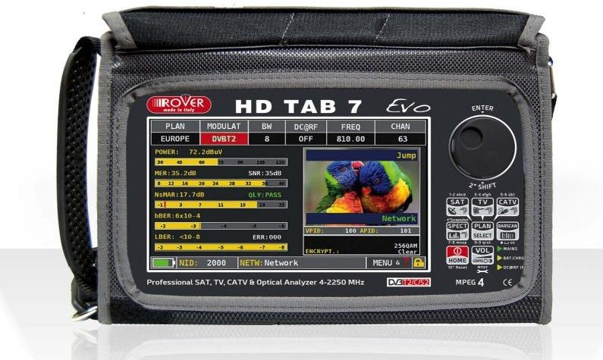
Figure 2.5: Rover HD TAB7 EVO (source: Rover Instruments site)

2.10 Conclusion
From the literature reviewed the chapter established that, there has not been a lot of studies carried out previously, on TVWS resource in Zambia. However, there been studies and implementations of ICT technology solutions on TVWS is the neighboring SADC countries and other parts of the world. From the case study, it is revealed that in three different Provinces of Zambia, frequency 546MHz was found not to be carrying traffic, indicating lack of activity on the frequency resource and also confirming availability of the same for use. Machine to Machine communication for Telemetry applications and Wi-Fi solutions for internet access, are the ICT solutions that have been implemented on TVWS resource, with the review presenting examples of working ICT rollouts on TVWS. Furthermore, the study reviewed the frequency allocation plan in Zambia and SADC countries, to establish primary services that have traditionally been licensed to operate on the UHF and, also to bring into perspective the future frequency plan for the same frequency band. More so through the review, the study identified and discussed available standards for managing the frequency resource to ensure secondary (unlicensed) services do not cause interference to the primary (licensed) services. Lastly, the chapter discussed some of the available signal spectrum analyzers relevant for carrying out on the ground sweep tests to establish availability of TVWS in Zambia and this was done to ensure the most reliable and user-friendly equipment was selected for this study.

CHAPTER THREE: METHODOLOGY

3.1 Introduction
Dawson [66], defines research methodology as the philosophy or general principle which guides the research. “The Methodological question is the question of ‘how’ (how can the reality be studied?)” [67], which therefore regards the technical instruments of the cognitive process. Research methodology is a way to systematically solve the research problem, which may be understood as a science of studying how research is done scientifically. Methodology outlines the various steps that are generally adopted by a researcher in studying his research problem along with the logic behind them. Research methods may be understood as all the methods/techniques that are used to collect and analyze useful data of the research study. Methods look at the ‘which’ question. This answers the question which precise procedures and instruments are going to be used in acquiring knowledge. Methods is defined as a systematic procedure, technique, or mode of inquiry employed by or proper to a named discipline or art, also as a systematic plan followed in presenting material for instruction [68].
In this research the adopted approach includes the application of both qualitative and quantitative methods of Identifying, Collecting and analyzing of data relevant to the above subject. According to Kothari [69], Qualitative methods are essentially descriptive and inferential in character. Qualitative Methods carry out an investigation where other methods, such as experiments are either not practicable or not ethically justifiable; investigates situations where little is known about what is there or what is going on; and also, explores complexities that are beyond the scope of more 'controlled' approaches. Quantitative methodologies shall be used by means of Spectrum Sweep measurements to investigate, analyze and compile the required quantitative information to achieve the objectives set out for this research.
In previous chapter, literature was reviewed aimed at; Outlining the benefits that can be drawn from utilizing TV White space spectrum resource for wireless networks and emphasize the need for a standard to manage the resource in Zambia which is in line with the ITU recommendations, TV white space was defined as well as its potential application in ICT rollouts. Having laid the basis for the study, this chapter discusses research methodology. It entails reformulating the problem to be investigated, selection of a suitable research design, appropriate procedures for data collection, findings and analysis. The research problem is encapsulated in the research objectives earlier mentioned in section 1.6 of chapter one.

3.2 Research Approach
This study will apply both qualitative and quantitative methods earlier to facilitate the collection of information. Interviews and questionnaires offer an opportunity to make use of the experience of others. Interviews/questionnaires shall be conducted/employed with targeted professionals especially those in the regulatory industry in the Zambia (ZICTA), Service providers and resource persons relevant to the TV broadcast industry and field of study in general.
Secondary data sources include, information from textbooks, journals, reports, dissertations, dictionary and published articles. Secondary data sources have also been used to review the literature in the research, and this shall involve the use of extensive secondary data such as journals, internet, dissertations etc. Spectrum Sweep measurements will also confirm the presence or availability of TV white space on the UHF band in Zambia.

3.3 Methods of Data Collection and Instruments
The term method in a research study can be understood to relate principally to the tools of data collection: techniques such as questionnaires, experiments, instrument measurements and interviews [70]. Therefore, instruments that were used to collect data for this study include desk top surveys and both structured and unstructured interviews. It also included administration of structured questionnaires to selected organizations and UHF Band spectrum sweeps with a spectrum analyzer in selected towns.

3.3.1 Case study to Establish TV White Space availability
In order to satisfy the research objective one, whose aim is to establish the availability of TVWS in Zambia, Signal sweep drive tests were carried out as a case study in selected towns along the line rail. Livingstone, Lusaka, Kabwe, Ndola, Kitwe, Chingola and Solwezi towns were purposively selected for the drive tests. Zambia currently can only license two signal distributors as earlier discussed in chapter 2 under licensing framework and this therefore means that only the two signal distributors in this case being Top Star and GOtv Zambia can access the UHF frequency for TV signal transmission across all parts of Zambia. The regions where we have most frequency used, are the ones where we have both Top Star and GOtv Zambia present, however, GOtv Zambia has transmission stations only along the line of rail i.e. Livingstone, Choma, Lusaka, Kabwe, Copperbelt, Solwezi and outside the line of rail in Chipata and Kasama. This therefore justify the selecting of Livingstone, Lusaka, Kabwe, Ndola, Kitwe, Chingola and Solwezi towns purposively for this research study.
According to Crowe, et. al, [56] “the focus for the case study is often on testing and refining theory on the basis of findings”. The instruments used in the tests for this study were the Rohde & Schwarz ETC Compact Analyzer and the Rohde & Schwarz ETL Spectrum Analyzer respectively due to easy downloading of the measurement results to a portable memory device and user-friendly graphical representation of the output.
The Rohde & Schwarz ETC compact TV analyzer and the Rohde & Schwarz ETL Spectrum Analyzer offers a comprehensive set of measurement functions for DVB-T2, DVB- T/DVBH and ISDB-T digital TV transmitter testing discussed in the literature review. The equipment is also useful for service and maintenance of TV transmitters as well as for testing modulators in Research and Development or quality assurance environments. Rohde & Schwarz is a leading supplier of solutions in the fields of test and measurement, broadcasting, radio monitoring and radiolocation, as well as secure communications. To emphasize the accuracy of the test results, the equipment used is re-calibrated every 2 years at the test lab in South Africa. For this study, the tests were purposively carried out in Lusaka, Livingstone, Chingola, Kabwe, Kitwe and Ndola on the UHF band.
The following test points have been considered for the Spectrum Sweep tests and the consideration was that the point had to be in the central business district where signal strength is expected to be strong and, also because of the favorable number of people covered.

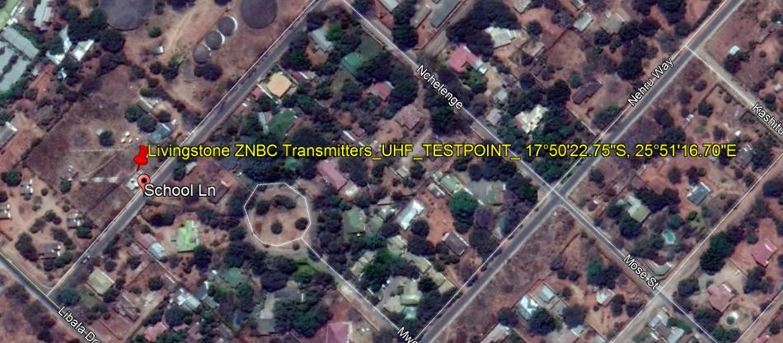
Figure 3.1: Livingstone test point (Google Earth)
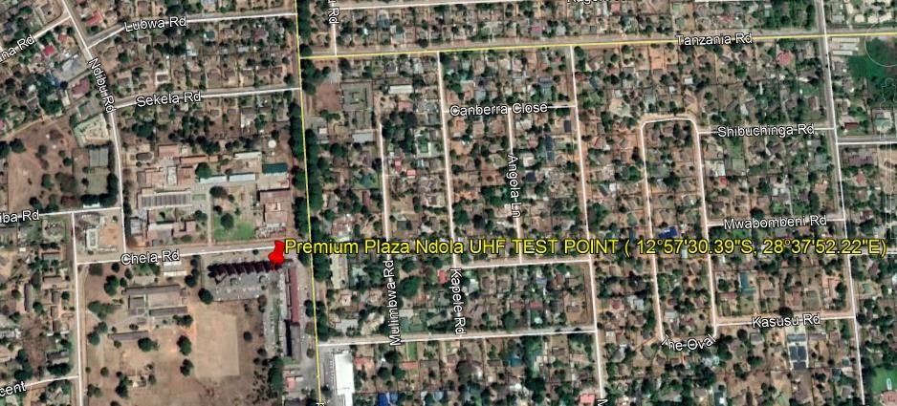
Figure 3.2: Ndola test point (Google Earth)

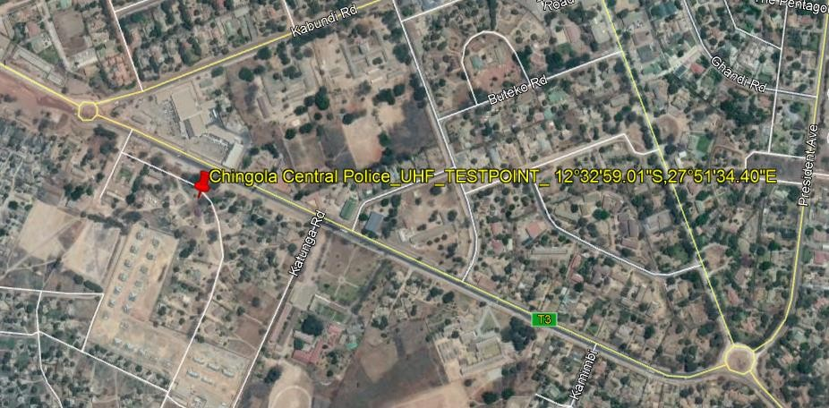
Figure 3.3: Chingola Test point (Google Earth)
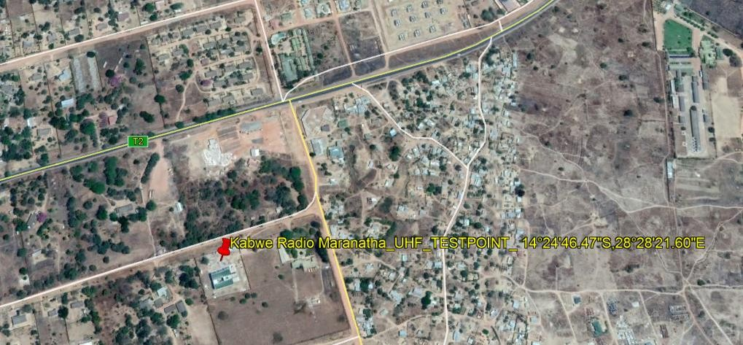
Figure 3.4: Kabwe Test point (Google Earth)

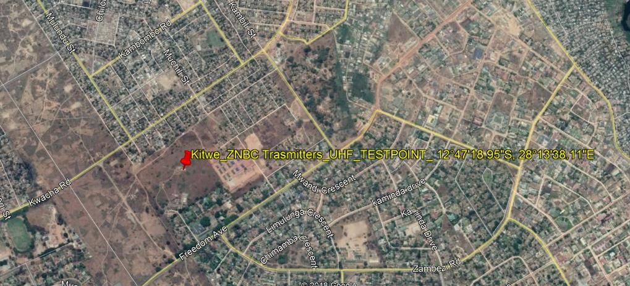
Figure 3.5: Kitwe Test Point (Google Earth)
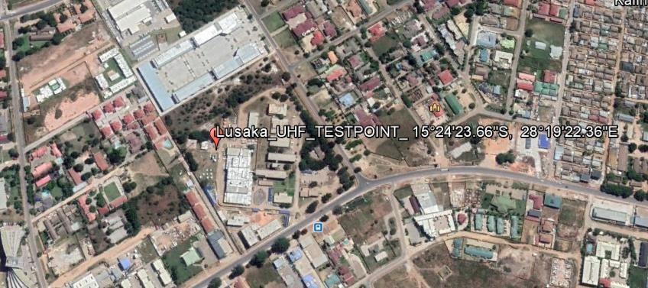
Figure 3.6: Lusaka Test point (Google Earth)

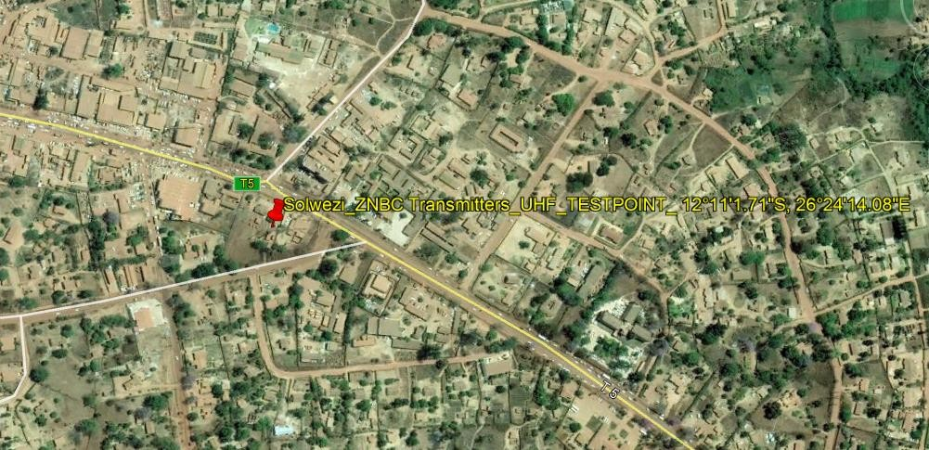
Figure 3.7: Solwezi Test point (Google Earth)

3.3.2 Literature Surveys
Literature surveys consisted of an extensive review of relevant available literature, using desktop surveys, analysis of theories on Radio spectrum management, tests that have been carried out in other countries on Technologies that can be deployed on white space spectrum, and both the recorded and projected dividend of using white space spectrum resource. Literature surveys were also carried out, seeking to establish the available standards and regulatory framework available for administering TV White Space resource. Among the literature surveyed includes textbooks, academic journals, conference proceedings, dissertations, government documents, reports from regional bodies, websites etc.

3.3.3 Interviews
Structured interviews were used to obtain information from respondents that the researcher could easily reach and arrange meetings with whereas unstructured interviews were used with the view to obtain information to questions that require respondents to give detailed but yet extensive explanations.

3.3.4 Questionnaires
Considering the aim and objectives of this study, a population divided into three categories, which includes the Regulator, Television/Radio Broadcasters and Mobile Communication/Internet service providers in Zambia, was considered for the study. The Regulator for Radio Spectrum is Zambia Information and Communication Technology Authority and they are responsible for management and administration of the resource. Under Television/Radio Broadcasters category, the following organization were considered; Zambia National Broadcasting Corporation, MUVI Television, Radio Christian Voice, Radio Maranatha, Hot FM, QFM, Radio Icengelo, Prime Television, Sun FM, Multichoice Zambia, YAR FM, and Trinity Broadcasting Network. The last category is for the mobile communication/ internet service providers, who included the following, ZAMNET, MicroLink, Paratus Telecommunication, Hai Telecommunication, CEC Liquid, MTN Zambia, Airtel Zambia, ZAMTEL and IConnect. Broadcasters and Mobile communication/Internet service providers are the main users of the Radio spectrum resource for their broadcast and transmission of their services. This population was also targeted in order to help in establishing whether there is enough awareness on TV white space spectrum resource, if the service providers have enough frequency capacity for the current service they are offering to enable them expand their networks when need arises and more so confirm the increase in demand for ICTs and access to information in general. Furthermore, the target population is directly affected by the impact that the changes in Technology bring with regarding availability and usage of Radio spectrum resource.
1. Questionnaire for the Regulator
The objective for administering the questionnaire was to collect both qualitative and quantitative data for developing a detailed and contextual understanding of how the TV white space spectrum is being managed in Zambia, whether the current Spectrum standards and regulations are able to keep up with the changes in technology and its subsequent impact on spectrum resource utilization. Furthermore, questionnaires were distributed to investigate if the regulator issues TV white space for the deployment of other service beside the band being reserved for Digital Television.

2. Questionnaire for Television and Radio Broadcasters
The purpose of this questionnaire type was to investigate the levels of awareness of TV white space spectrum and its inherent radio propagation advantages, establish if there is adequate interaction with regulator and whether organizations feel there is adequate sensitization on TV white space spectrum as a dividend of TV Digital Migration.
3. Questionnaire for Internet Service Providers and Mobile communication operators
The purpose of this questionnaire type was to investigate the levels of awareness of TV white space spectrum and its inherent radio propagation advantages, especially when used to deploy wireless networks, establish if there is adequate interaction with regulator and whether organizations feel there is adequate sensitization on TV white space spectrum as a dividend of TV Digital Migration.

3.4 Reliability
The reliability refers to a measurement that supplies consistent results with equal values [71]. According to Chakrabartty [72], Reliability measures consistency, precision, repeatability, and trustworthiness of a research. It indicates the extent to which it is without bias (error free), and hence insures consistent measurement cross time and across the various items in the instruments (the observed scores). Some qualitative researchers use the term ‘dependability’ instead of reliability. It is the degree to which an assessment tool produces stable (free from errors) and consistent results. “Heale and Twycross [73], states that the three attributes of reliability are; Homogeneity (or internal consistency) that is the extent to which all the items on a scale measure one construct; Stability the consistency of results using an instrument with repeated testing; and Equivalence which is consistency among responses of multiple users of an instrument, or among alternate forms of an instrument. In other words, the extent to which a research instrument consistently has the same results if it is used in the same situation on repeated occasions”.

3.5 Target Population

3.5.1 The Regulator – ZICTA
ZICTA was considered in this research because it is the sole regulator of Information and Communication Technology in Zambia. It is the only board responsible for issuing out radio frequencies for all communication and transmission applicants in Zambia. Therefore, having considered ZICTA as a sample makes this research well represented and reflective of the Zambian situation.

3.5.2 Television and Radio Broadcasters
These were targeted because they are among key consumers of frequencies for radio and Television broadcast or propagation of the content in Zambia. Therefore, their inclusion in this study makes the research well represented and relevant.

3.5.3 Mobile Communication/Internet service providers
These were targeted this is because; besides transmitting the communication signals via fiber optic, the largest percentage of the traffic is pushed over wireless transmission which uses radio frequencies from the radio spectrum in Zambia issued by ZICTA the regulator.

Table 3.1: Summary of the target group together with the justification of sampling methods adopted
No | Target Group | Sampling Method | Justification
1 | ZICTA | Purposive | Regulatory body responsible for issuing out radio frequencies for communication and Transmission services
2 | Television and Radio Broadcasters | Stratified | Key users of frequencies for Radio and Television broadcast/content propagation
3 | Mobile Communication/Internet Service providers | Stratified | Largest percentage of their communication signals/traffic is transmitted via radio frequencies

Source: Author, 2015

3.6 Sample
A perfect representative sample is one that exactly represents the population from which it is taken. Therefore, obtaining as high a response rate as possible to ensure that a sample is representative becomes a need [57]. The sample should be representative of the population to ensure that we can generalize the findings from the research sample to the population as a whole [58]
The summary of the population sizes and the response rates for this research is presented in table 3.2 below. The table is basically highlighting the target categories for the research indicating both the population or total number of licensed operators and the sample size that was considered. The table further presents the successful response after conducting a field survey for the sample sizes that were drawn.

Table 3.2: Summary of Population Sizes and Response Rates

Target Group | Population Size | Sample Size | Successful Response | Response Rate
Category 1
Regulator | 1 | 1 | 1 | 100%
Category 2
Television/ Radio Broadcasters | 31 | 12 | 9 | 75%
Category 3
ICT Service Providers | 21 | 10 | 7 | 70%

From the table 3.2, a total number of 23 questionnaires were administered and the overall response was at 17. Thus, the general response rate after the field survey was:

$$Response rate=\frac{Total successful response}{Total sample size} ×100 Eq. 1$$
$$Response rate=\frac{17}{23} ×100=73.91\%$$

Therefore, the response rate was 73.91% of the circulated questionnaires.

3.6.1 Sampling Frame
The sampling frame is very similar to the population being studied and may be exactly the same. When selecting units from the population to be included in your sample, it is sometimes desirable to get hold of a list of the population from which you select units. This list can be referred to as the sampling frame [61]. The summary of the sample frame used in this study is as shown in table 3.3.
Table 3.3: Summary of the sample frame
(Source: ZICTA, 2015)

3.7 Data Analysis and Presentation
“Data analysis consists of examining, categorizing, tabulating, testing, or otherwise recombining both quantitative and qualitative evidence to address the initial propositions of a study” [77] as cited in Chisumbe [78]. In general, data analysis refers to the computation of certain measures along with searching for patterns of relationship that exist among data groups [79]. Kohlbacher [80] further states that once a pattern is identified, it is interpreted in terms of a social theory or the setting in which it occurred and that the qualitative researcher moves from the description of a historical event or social setting to a more general interpretation of its meaning.
Frequency distribution data analysis technique was adopted for this research. Frequency distribution is a data analysis technique which allows the research to get a big picture of the data from frequency distribution, the researcher can see how frequently the specific values are observed and what their percentages are for similar variables [80]. Histogram is a great tool in Excel for computing the frequencies for numerical variables.

3.8 Conclusion
In this chapter the methodology adopted for this research has been discussed, outlining the appropriate research approach, Methods of Data Collection and Instruments and target population, thereafter, the sample size, sampling process as well as its reasonable justification. This was important in ensuring representativeness of the research population relevance to meeting the objective of the study and answering the research questions. Furthermore, the methods and instruments of data collection employed have been discussed thoroughly together with appropriate research methodological reliability and validity.

CHAPTER FOUR: FINDINGS AND DATA PRESENTATION

4.1 Introduction
The previous chapter discussed the following areas; research methodology adopted for this study to satisfy the research objectives as set out in chapter one, research approach, research Methods of Data Collection and Instruments, research population, the sample population and justification. This is important as it provides the basis on which the findings of the research can be generalized and authenticated.

4.2 Background to the Findings
The information that was obtained from respondents during the field research is presented and analyzed in order to draw conclusions and recommendations for the research. The presentation of findings was aimed at meeting the overall objective of the study which is to Establish the availability of TV white Space in Zambia, how it can subsequently be used as an ICT rollout enabler, besides TV Licensing and also establish the availability of standards that inform the review and formulation of regulatory framework and standards that can be employed in efficiently managing the optimal usage and subsequent commercialization of the TV White Spaces.

4.3 Case study: UHF Band Spectrum Sweep finding
In order to establish utilization of the UHF band in Zambia and TVWS availability in general, sweep tests on the UHF band and particularly the TV band were carried out. The instruments used in the tests were the Rohde & Schwarz ETC Compact Analyzer and the Rohde & Schwarz ETL Spectrum Analyzer.

4.3.1 Lusaka Test Results
The sweep test in Lusaka was carried out on a span of 420MHz, with 450MHz as the Start Frequency and 870MHz as the Stop Frequency for the measurement. The sweep results as shown in figure 4.1 revealed that only 5 channels on the UHF band were in use, as indicated by the markers M1 at frequency 482MHZ at power level -49.6dBm, M2 at frequency 498MHZ at power level -48.5dBm, M3 at frequency 520MHZ at power level -44.3dBm, M4 at frequency 658MHZ at power level -39.3dBm and M5 at frequency 682MHZ at power level -39.9dBm. Power level of -93dBm on the flat represent frequencies not in use.
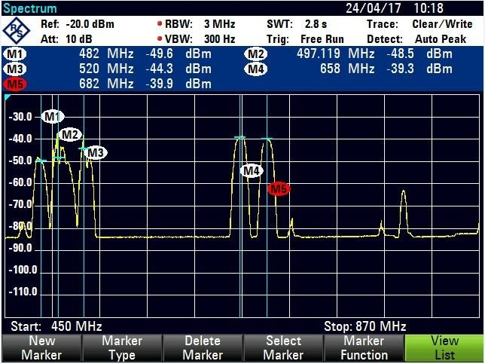
Figure 4.1 Lusaka UHF band Sweep Test results taken from the ETC Analyzer
Frequency 658MHz for Lusaka also represented by M5 on figure 4.1 and known as channel 44 on the UHF band was considered for further investigation to confirm if indeed there was traffic on the Channel. The spectrum analyzer was able to lock (tune) to channel 44 as well as decode the service on the channel as shown in figure 4.2 which represents the characteristics of the transmitted signal stream on the frequency under consideration

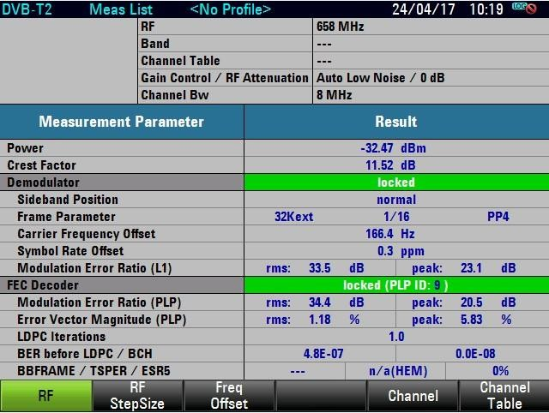
Figure 4.2 Channel 44 TV analyzer results taken from the ETC

4.3.2 Ndola Test Results
In Ndola a span of 405MHz was considered representing 465MHz as the Start Frequency and 870MHz as the Stop Frequency for the measurement. The test results revealed that only four (4) of forty-nine (49) UHF channels are being used and these are represented with Markers M1 to M4 as shown in figure 4.3.

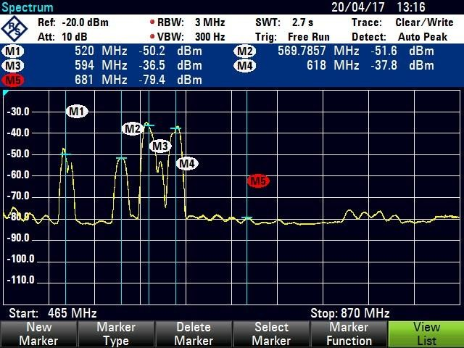
Figure 4.3 Ndola UHF band Sweep Test results taken from the ETC
Similarly, to prove how an unoccupied channel responds on the ETC TV analyzer mode, Frequency 564MHz in Ndola also represented by M5 on figure 4.3 and sitting within channel 32 on the UHF band, was considered for further investigation to confirm if indeed there was traffic on the Channel. The spectrum analyzer was not able to lock (tune) to channel 32 as well as decode the service on the channel as shown in figure 4.4 which clearly revealed that there was not traffic or transmission on the frequency under consideration

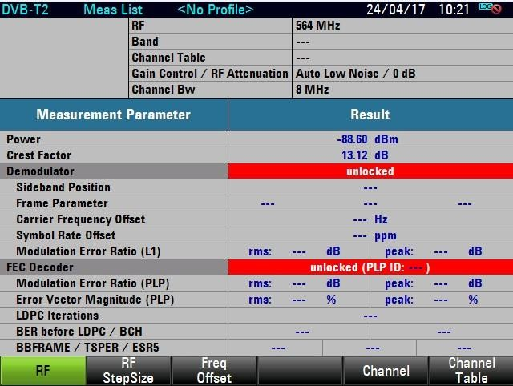
Figure 4.4 Channel 32 TV analyzer results taken from the ETC

4.3.3 Chingola Test Results
The sweep test in Chingola was carried out on a span of 400MHz, i.e. 470MHz as the Start Frequency and 870MHz as the Stop Frequency for the measurement. The sweep results as shown in figure 4.5 revealed that only 4 channels on the UHF band were in use, as indicated by the markers M1 to M4 with the corresponding frequencies 570MHz, 594MHz, 618MHz and 642MHz respectively.

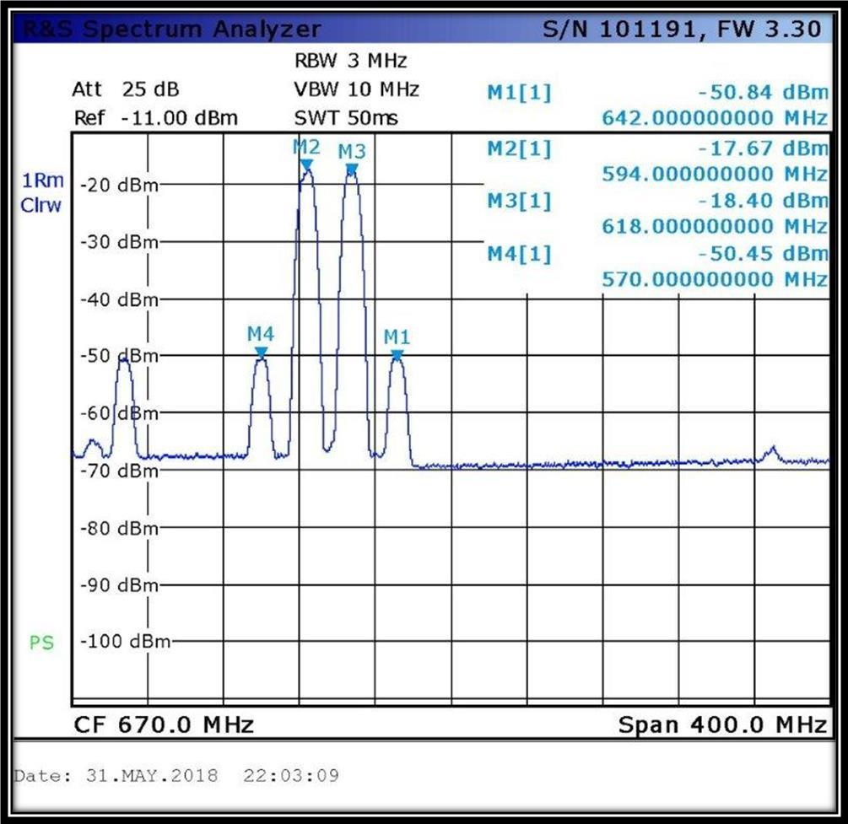
Figure 4.5 Chingola UHF band Sweep Test results using the ETL Analyzer

4.3.4 Livingstone Test Results
The sweep test in Livingstone on the UHF band was carried out on a span of 420MHz, i.e. 450MHz as the Start Frequency and 870MHz as the Stop Frequency for the measurement. The sweep results as shown in figure 4.6 revealed that only 4 channels on the UHF band were in use, as indicated by the markers M1 to M4 with the corresponding frequencies 514MHz, 546MHz, 578MHz and 602MHz respectively.
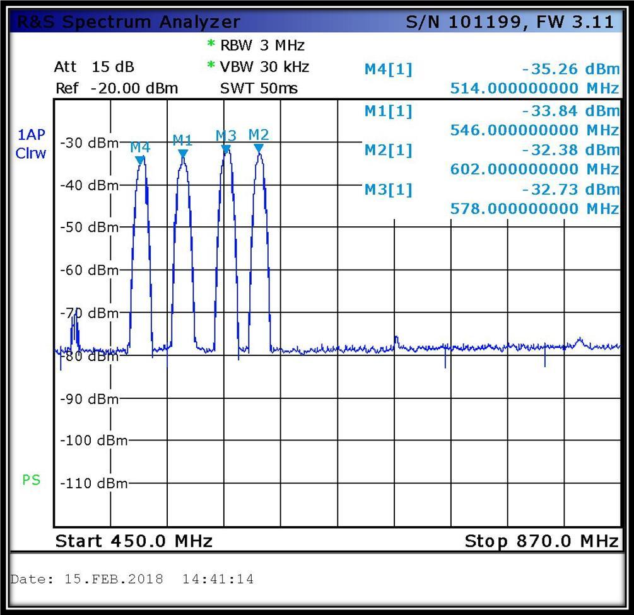
Figure 4.6 Livingstone UHF band Sweep Test results using the ETL Analyzer

4.3.5 Kitwe Test Results
The sweep test in Kitwe on the UHF band was carried out on a span of 400MHz, i.e. 470MHz as the Start Frequency and 870MHz as the Stop Frequency for the measurement. The sweep results as shown in figure 4.7 revealed that only 4 channels on the UHF band were in use, as indicated by the markers M1 to M4 with the corresponding frequencies 498MHz, 522MHz, 570MHz and 642MHz respectively. (Indicate the total number).
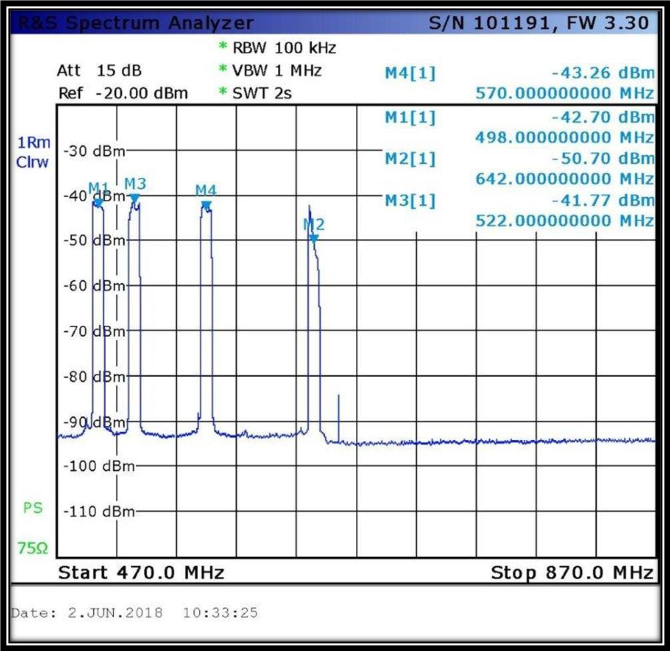
Figure 4.7 Kitwe UHF band Sweep Test results using the ETL Analyzer

4.3.6 Kabwe Test Results
The sweep test in Kabwe on the UHF band was carried out on a span of 400MHz, i.e. 470MHz as the Start Frequency and 870MHz as the Stop Frequency for the measurement. The sweep results as shown in figure 4.8 revealed that only 4 channels on the UHF band were in use, as indicated by the markers M1 to M4 with the corresponding frequencies 482MHz, 522MHz, 610MHz and 658MHz respectively.

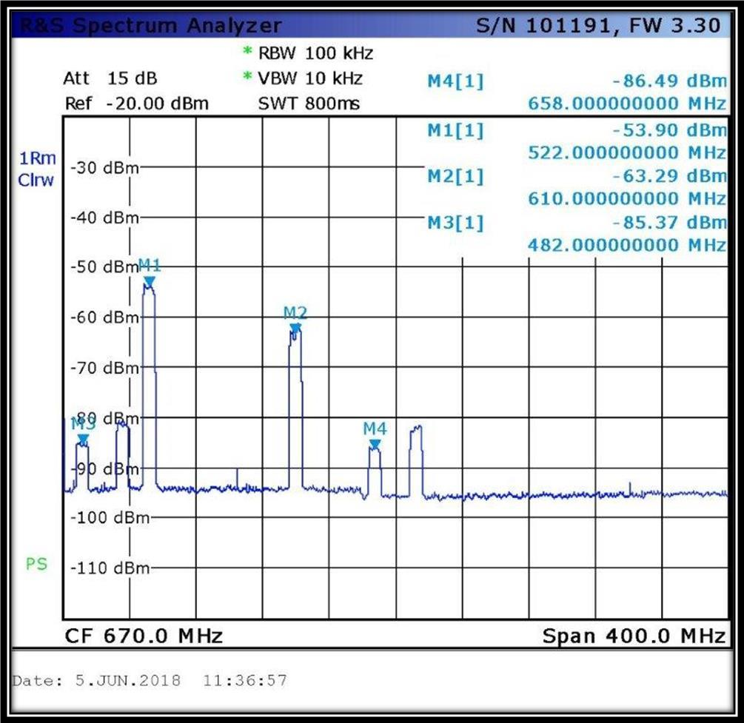
Figure 4.8 Kabwe UHF band Sweep Test results using the ETL Analyzer

4.5 Sample Sizes and Response Rate (Questionnaires)
For this research a total number of 23 questionnaires were administered and the successful response rate of 73.91%% was recorded, translating to 17 successfully completed questionnaires.

4.6 Findings and Presentations

4.6.1 TVWS Availability and Utilization in Zambia
On the availability of TVWS in Zambia the research revealed from the Spectrum sweeps that out of the total UHF band channels in Zambia an average of 89.9% is unused, translating 5 used channels out of the total 49 frequency channels available on the UHF Band. The results of the sweeps confirmed the availability of TV White in Zambia.

4.6.2Summary of Spectrum Sweep Results
Table: 4.1 Spectrum sweep results
Town | Test-point Coordinates | Used frequencies (UHF Band) | Number of used frequencies
Lusaka | 15 24 23.66S, 28 19 22.36E | 482MHz, 498MHZ, 520MHz, 658MHz, 682MHz | 5
Kitwe | 12 47 18.95S, 28 13 38.11E | 498MHz, 520MHz, 570MHz, 642MHz | 4
Chingola | 12 32 59.01S, 27 51 34.40E | 570MHz, 594MHz, 618MHz, 642MHz | 4
Ndola | 12 57 30.39S, 28 37 52.22E | 520MHz, 570MHz, 594MHz, 618MHz | 4
Livingstone | 17 50 22.75S, 25 51 16.70E | 514MHz, 546MHz, 578MHz, 602MHz | 4
Kabwe | 14 24 46.76S, 28 28 21.60E | 482MHz, 520MHz, 610MHz, 658MHz | 5

Table: 4.2 TVWS availability in Zambia.
UHF Band | Number of Channels | Bandwidth (8MHz per Channel) | Percentage
Total Capacity | 49 | 392MHz | 100%
Used Capacity | 5 | 40MHz | 10.2%
Unused Capacity | 44 | 352MHz | 89.8%

The results from the spectrum sweeps also reveal that there is a Single frequency that has been implemented on frequency 570MHz for Kitwe, Chingola and Ndola. In a, SFN setup the same frequency is assigned to all transmitters in a given transmission region or network that covers all, or part of a service area [80]. A major advantage of using SFN is the possibility to increase the frequency efficiency.

4.6.3 Potential TVWS Application and Technology Solutions
With regards to the potential application of TVWS and technology solutions in Zambia, the research established through the review of literature that there are several ICT Application that can be implemented on TV White Space which include;
- Mobile Broadband connectivity through creation of Super Wi-fi networks with longer coverage radius
- Machine to Machine communication through Telemetry platforms
- Rural Internet service and this is cheaper to rollout due to favorable coverage reach for UHF frequencies and therefore translating to fewer network transmitters
- Video Surveillance for metro security camera systems

- E-learning and E-health transmission via mobile broadband
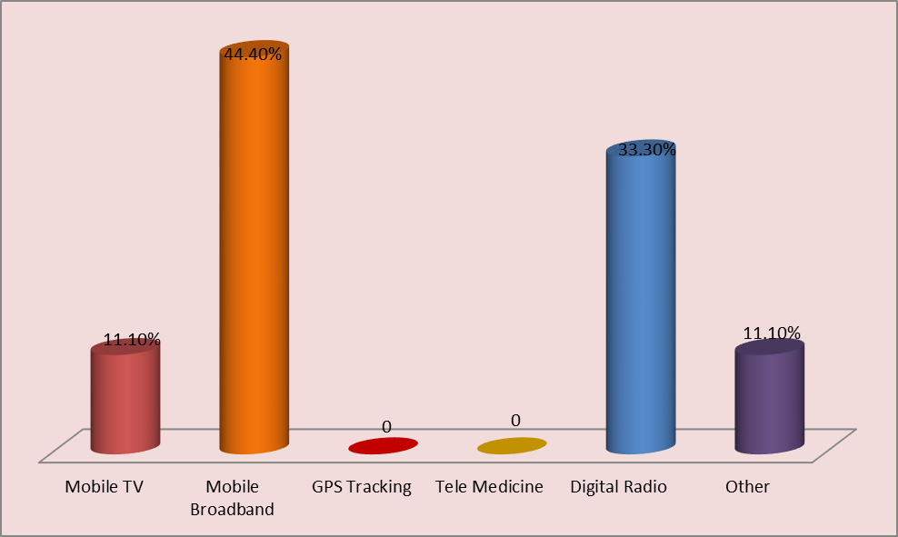
Also, from the questionnaire results the service providers indicated that of the total respondents 44.4% would consider using the white space resource to setup mobile broadband data services. 33.3% indicated that they would consider using TVWS for digital radio broadcast (Radio over IP network/internet), while 11.1% stated that they would consider it for mobile TV services as shown in figure 4.9

Figure: 4.9 Potential ICT application via TVWS Spectrum

4.6.4 Standards Governing the Management of TVWS in Zambia
An assessment was carried out to establish as to whether Zambia has any standards governing the management of TVWS. The literature reviewed confirm the availability of TVWS Standards, however, the condition is that secondary services should not cause interference with the primary licensed services. Some of the available standards include IEEE 1900.4a, EMCA 392a, IEEE 802.11af, IEEE 802.22-2011 and IEEE P802.19.1.
Interview with ZICTA the regulator reviewed that Zambia has no standards of its own but rather reference to the available various ITU standards governing the broadcast of wireless services. Further, standards specific to TVWS are under at ITU by various working groups.

4.7 Conclusion
In establishing the availability of TV White space on the UHF band in Zambia, the research finding revealed that there is TV White available and that less than 15% of the UHF is utilized. This confirms that there is room for deployment of two-way data communications network and other ICT networks solutions and applications which have been outlined in the discussion. To ensure the secondary services do not cause interference to the primary services, the research has established the availability of standards require for the management of the resource.

CHAPTER FIVE: DISCUSSION AND ANALYSIS

5.1 Introduction
This chapter discusses and analysis the findings in relation with the existing body of knowledge on the availability and subsequent management of TVWS in Zambia. Discussing of findings with literature was important in determining how this research fits in the existing body knowledge on the subject. It further provides a basis for comparison on how the research has contributed to the filling of the previous missing gaps in the body of knowledge. This was carried out in sync with the research objectives and questions.

5.2 TVWS Availability in Zambia
On the availability of TVWS in Zambia the research revealed that out of the total UHF band channels in Zambia 89.8% is unused, translating to 44 frequency channels out of the frequency plan of 49 or 352MHz bandwidth, suggesting that there is available TVWS in Zambia. Furthermore, the UHF Spectrum sweep test supports the afore assertion on the availability as confirmed from the results obtained along the line of railway which included Livingstone, Lusaka, Kabwe, Ndola, Kitwe and Chingola. Where the results obtained indicated that an average of five frequency channels are currently being used for digital broadcast as presented in the findings. This agrees with Mikeka et., al. [30] signal drive test on frequency 546MHz to confirm the presence of active traffic, covering the distance Lusaka to Kitwe which revealed lack activity or non-utilization of the frequency. In traditional networks all the nearby stations, uses different frequencies. The study also revealed that with the coming of Digital Video broadcast for terrestrial television, service providers are already employing efficient ways of using the frequency using single frequency Network (SFN) technique, as is the case for Kitwe, Ndola and Chingola sites sharing frequency 570MHz. With SFN technology it is possible to form the cluster of nearby stations using the same frequency and the resultant effect is that more frequency resource is freed and this eventually to the TVWS available capacity in Zambia.

5.3 Standards Governing the Management of TVWS in Zambia
An assessment was carried out to establish as to whether Zambia has any standards governing the management of TVWS. ZICTA the regulator revealed that Zambia has no standards of its own but rather reference or mirror to the available various ITU standards governing the broadcast of wireless services, cognitive radios and Television white space frequencies. Further, that standards specific to TVWS are under construction at ITU by various working groups. However, there are standards already as reveal in chapter 4 • The available standards include the following; ECMA-392a: Focuses on Media Access Control (MAC) and Physical layer for Operation in TVWS, IEEE 1900.4a: Standard for Architectural Building Blocks Enabling Network Device Distributed Decision Making for Optimized Radio Resource Usage in Heterogeneous Wireless Access Networks; IEEE 802.11af: A standard for TV white space spectrum sharing; IEEE 802.22-2011: Cognitive Wireless RAN Medium Access Control (MAC) and Physical Layer (PHY) specifications: Policies and procedures for operation in the TV Bands; IEEE P802.19.1: IEEE Draft Standard for Information Technology; Telecommunications and Information Exchange between Systems. Part 19: TV White Space Coexistence Methods Amendment: Coexistence Methods for Geo-Location Capable Devices Operating Under General Authorization. This answers to the question which was seeking to establish the availability of standards or regulations supporting the use of TV White space in Zambia as an enabler for ICT rollout.

5.4 Potential TVWS Application and Technology Solutions
On the potential application of TV White Space and technology solutions in Zambia, the findings established that 44.4% of the respondents would consider using the white space resource to setup mobile broadband data services. This agrees with Federal Communications Commission (FCC) ruling as cited in Surampudi and Mohanty [78] that “making TV White space bands for secondary users has opened a new and very promising market to meet this demand for broadband wireless services and products”. In addition, Carlson, et., al [77] asserts “that Television White Spaces can be used to provide wireless broadband Internet access on a “no-interference no protection (NINP) basis”.
Further, on the use of TV White Space for digital radio broadcast (Radio over IP network/internet) 33.3% indicated that they would consider using it. According to Surampudi and Mohanty [78], “White Spaces frequencies, include attractive properties such as good non – line – of sight propagation characteristics as well as low industrial noise and reasonable antenna sizes for fixed and nomadic broadband applications”. According to Carlson, et., al. [77] with TV White Space low-frequency signals can travel longer distances translating into longer coverage radius, making the technology well suited to provide low cost rollouts. It has a superior range and ability to penetrate obstacles such as trees, buildings and rough terrain and makes it a suitable resource for network rollouts and longer coverage reach also translates to reduced transmission sites per given location.

5.5 Conclusion
The findings of this research agree with existing literature which states that in Zambia the UHF spectrum is not fully occupied both in urban as well as in rural areas, accounting for considerable TVWS capacity that could be used for rolling out or setting up ICT application. It further asserts to the fact that with TV White Space “low-frequency signals” can travel longer distances translating into longer coverage radius, making the technology well suited to provide low cost rollouts. It has a superior range and ability to penetrate obstacles such as trees, buildings and signal propagation has a better performance even on undulating and rough terrain.
The research further established that Zambia has no standards of its own, for governing the use of TV White Space spectrum, however, rather references to the various available ITU approved standards governing the broadcast of wireless services and cognitive radio technologies.

CHAPTER SIX: CONCLUSION AND RECOMMENDATIONS

6.1 Introduction
Chapter six essentially gives the conclusion and recommendations of the study. The preceding chapters have expanded on the importance and need for harnessing the benefits ICT technologies over the TV White space resource, one of which is the benefit of reducing network cost rollouts. Various literature sources have been reviewed outlining the benefits that can be drawn from utilizing TV White Space in ICT network rollouts as well as establishing the availability of TV White space on the UHF band in Zambia. as well as establishing the availability of regulation supporting the use of TV White space in Zambia as an enabler for ICT rollout.
This final chapter aims at outlining the conclusions from the research carried as well as making appropriate recommendations on promoting the usage efficiency and commercialization of television white, as enablers for ICT services network rollouts. The first part gives a recapitulation of the whole study followed by reviewing of research questions. Then the last part offers the conclusion as well as recommendations with regards to the problems identified from the research findings and analysis before suggesting an area for further research.

6.2 Chapter Recapitulation
This thesis is divided into six chapters. Chapter one introduced the whole study on Radio Spectrum Utilization in Zambia: Establishing availability of White Space, as enablers for ICT services network rollouts. It provided the justification, formulated the research problem statement, stated research objectives as well as significance of the study. Further, research questions, scope and relevance of the study were outlined in line with the study. And in meeting the set-out objectives the following chapters were discussed.
Chapter two is a literature review which satisfied the second objective and part of the first objective which aimed at; outlining the benefits that can be drawn from utilizing TV White Space in ICT network rollouts as well as establishing the availability of TV White space on the UHF band in Zambia. The first part defines Radio Spectrum a resource and builds on to discuss the UHF band and TV White Space. The second part looks at TV white space in

Zambia and why the resource are attractive for development of ICTs. Lastly the chapter outlines some examples of technology applications and trials on TV white space resource, and the standards that is being used in the management of the resource.
Chapter three discussed the methodology employed in this research; this was achieved by outlining the research approach, design and target population, the sample size as well as the justification given in ensuring representativeness of the research population. More so, data collection methods and instruments used were discussed as well as research reliability and validity.
Having laid the basis for the study chapter four presented the actual findings as obtained from the respondents through conducting interviews and questionnaire administration to relevant research samples as well as through UHF Band Spectrum Sweep tests. This was to satisfy the first and third research objectives which aimed at establishing the availability of TV White space on the UHF band in Zambia as well as establishing the availability of regulation supporting the use of TV White space in Zambia as an enabler for ICT rollout.
Chapter five discussed and analysis the findings in relation with the existing body of knowledge on the subject matter of Radio Spectrum Management and Utilization in Zambia:
Promoting Usage Efficiency and Commercialization of Television White, As Enablers for ICT Services Network Rollouts.
This final chapter provides the conclusion and recommendations based on the findings and analysis of the research relative to the existing literature on the subject.

6.3 Research Questions Review

6.3.1 What is the availability of TV White space on the Radio Spectrum in Zambia?
On the availability of TVWS in Zambia the research through UHF Spectrum sweep test that out of the total UHF band channels in Zambia 89.8% is unused, translating to 44 frequency channels or 352MHz bandwidth (44 channels x 8MHz bandwidth per channel), suggesting that there is a lot of available TVWS in Zambia. Furthermore, the UHF Spectrum sweep test supports the afore assertion on the availability as confirmed from the results obtained along the line of railway which included Livingstone, Lusaka, Kabwe, Ndola, Kitwe and Chingola. Where the results obtained indicated that only four channels are currently being used for digital broadcast as presented in chapter four. This agrees with Mikeka et., al. [80] signal drive test on frequency 546MHz to confirm the presence of active covering the distance Lusaka to Kitwe which revealed lack activity or non-utilization of the frequency.

6.3.2 What benefits can be drawn from using TV White Space in ICT network rollouts?
The benefits which can be drawn from using TV White space in ICT network rollouts includes the following; low-frequency signals can travel longer distances translating into longer coverage radius, making the technology well suited to provide low cost rollouts of quality broadband access over TV channels. Further, TV White space resource can be used to improve machine to machine communication, through the implementation of robust telemetry systems, especially across difficult terrain, making it possible to manage the machines and system remotely. More so, TVWS can provide bandwidth for alternative capturing of real- time video transmission and surveillance systems. The use of real-time video recordings allows real-time video analytics and, also allows multiple sharing of the same surveillance, e-learning and conference resources.

6.3.4 What are the available regulations supporting the use of TV White space in Zambia as an enabler for ICT rollout?
Zambia has no standards of its own but rather reference to the available various ITU standards governing the broadcast of wireless services. A series of standards have been created to support White Space development and these include the following:
- ECMA-392a: Focuses on Media Access Control (MAC) and Physical layer for Operation in TVWS; [46]
- IEEE 1900.4a: Standard for Architectural Building Blocks Enabling Network Device Distributed Decision Making for Optimized Radio Resource Usage in Heterogeneous Wireless Access Networks; [47]
- IEEE 802.11af: A standard for TV white space spectrum sharing; [48]
- IEEE 802.22-2011: Cognitive Wireless RAN Medium Access Control (MAC) and Physical Layer (PHY) specifications: Policies and procedures for operation in the TV Bands; [49]
- IEEE P802.19.1: IEEE Draft Standard for Information Technology; Telecommunications and Information Exchange between Systems. Part 19: TV White Space Coexistence Methods Amendment: Coexistence Methods for Geo-Location Capable Devices Operating Under General Authorization [50].

64 General Conclusion
Conclusions made in this chapter are derived from the literature review, data collected and analyzed in the previous chapters in relative to the research objective. The following conclusions are made based on the results of the study:
- In establishing the availability of TV White space on the UHF band in Zambia research established that there is a lot of available TV White. Out of the total UHF band channels in Zambia 89.79% is unused and that there is room for deployment of two-way data communications networks using these frequencies.
- An outline of the benefits that can be drawn from utilizing TV White space spectrum resource for wireless networks (Super Wi-Fi) include larger coverage radius, making the technology well suited to provide low cost rollouts of quality broadband access over TV channels. Further, it can be used to implement machine to machine communication (M2M) solutions; through the implementation of robust telemetry systems, especially across difficult terrain, making it possible to manage machines and systems remotely. More so, TVWS can provide bandwidth for alternative capturing of real- time video transmission and surveillance systems.
- On the availability of regulation supporting the use of TV White space in Zambia as an enabler for ICT rollout. The research revealed that Zambia references to the available various ITU standards governing the broadcast of wireless services and Television white space resource. Further, that standards more specific to TVWS are under construction at ITU by various working groups.

6.5 Recommendations
Having confirmed the availability of TVWS in Zambia, identified the benefits that can be actualized by using TVWS for secondary services on the UHF band and more so establishing the availability of regulations required for licensing of secondary services on the UHF band, where TV is the Primary services, the study therefore recommends the following;
- ZICTA the regulator for Information Communication Technologies should carry out sensitization workshops and conferences to educate and share information on the TVWS resource subject and the inherent signal propagation capabilities that come with the UHF band frequencies. The target population for the sensitization should include companies, organizations and business dealing in ICTs.
- The study recommends the adoption of TVWS resource for rollouts of cheaper ICT solutions and networks as, the resource has a much wider signal propagation coverage reach, translating to reduced number of transmission sites and maintenance costs

6.6 Area for Further Research
- Institutions of learning, such as the University of Zambia and ICTs service provider carry out experimental projects focused on harnessing the benefits of using TVWS in the area of building super Wi-fi networks for machine to machine communication, real time video transmission for online classrooms and even
- Identify the challenges with the regulation and standards which are currently being used to manage TV White space resource in Zambia.

REFERENCES
Fernando, X., Sultana, A., Hussain, S., & Zhao, L. (2018). Cooperative Spectrum Sensing and Resource Allocation Strategies in Cognitive Radio Networks. Springer. (2-1.0).
Kumar, A., & Lloyd, D. (2014). White Space Communication. Springer: Advances, Developments and Engineering Challenges
International Telecommunication union, “spectrum monitoring evolution”, Geneva, 2013. pp.2, Available: http://www.itu.int/dms_pubrec/itu-r/rec/sm/R-REC- SM.2039-0-201308I!!PDF-E.pdf [Accessed: 24 June 2017]
B P. Freyens and M. Loney, “Emerging issues in white space regulation.” Telecommunications Policy, Vol 37, pp. 208-218, March 2013
ZICTA ICT Survey Report, “Survey on access and usage of information and communication technology by households and individuals in Zambia, 2015 , available: https://www.zicta.zm/Views/Publications/2015ICTSURVEYREPORT.pdf [Accessed: 8 July 2017]
ZICTA ICT Survey Report, “Survey on access and usage of information and communication technology by households and individuals in Zambia, 2018 , available: https://www.zicta.zm/Views/Publications/2015ICTSURVEYREPORT.pdf [Accessed: 8 July 2017] ZICTA, ICT Statistics Portal, Available:¨http://onlinesystems.zicta.zm:8585/statsfinal/ICT%20Indicators.h tml
International Telecommunication union, “Common Market Project: Harmonization of Policies Governing the ICT Market in the UEMOA-ECOWAS Space”, Ouagadougou, Burkina Faso, Dec 2004
C.A. Herter, “The Electromagnetic Spectrum: A critical natural Resource,” Journal university of New Mexico, School of Law Vol 25, pp 651-663, Available: http://digitalrepository.unm.edu/cgi/viewcontent.cgi?article=2312&context= nrj [Accessed: 18 May 2017]
Federal Communications Commission press release, FCC Adopts Rules for Unlicensed Use of Television White Spaces. Washington, DC 20554, 2008.
Office of Communication, Implementing TV White Spaces. United Kingdom, 2015. Available:https://www.ofcom.org.uk/ data/assets/pdf_file/0034/68668/tvw sstatement.pdf
Independent Communications Authority of South Africa, Regulations on the use of Television White Spaces, Electronic Communications Act: Act No. 36 of 2005. Johannesburg, 2018
[13] B P. Freyens, “A policy spectrum for economics” Emerging issues in white space regulation”. Information Economics and Policy, Vol 21, pp. 128-144, 2009
[14] M. Bashar, “Spectrum management system for developing countries,” ITU regional seminar on efficiency of frequency use in Arab region, Jordan, Dec 2011 http://www.itu.int/en/ITUR/seminars/rrs/Documents/Tutorial/SM_Fundame ntals_Part1.p df [7-January 2016]
International Telecommunications Union, “Workshop on radio spectrum management for a converging world,” Geneva, February 2004,
R. Thanki, “The economic value generated by current and future allocations of unlicensed spectrum,” Perspective Associates, Final Report, 2009, report
M. Fadda, M. Murroni, C. Perra and V. Popescu, “TV white spaces exploitation for multimedia signal distribution,” Signal Processing: Image Communication, Vol 27, pp. 893-899, February 2012
C. Blackman and L. Srivastava, Telecommunications Regulations Handbook, 10th ed. Washington DC, The World Bank,
OECD 2013, Competition Issues in Television and Broadcasting, OECD Digital Economy Papers, No.213, p. 15, 23, available at http://www.oecd.org/daf/competition/TV-and-broadcasting2013.pdf
J.M Paquet, The Geneva 1989 Agreement, International Telecommunications Union, Radiocommunication Bureau, Revised 2006
International Telecommunications Union, Digital Dividend: Insights for Spectrum Decisions, Telecommunication Development sector, pp 41, August 2012 Available:http://www.itu.int/ITU-
D/tech/digital_broadcasting/Reports/DigitalDividend.pdf [Accessed 12 February 2016]
Malcolm Johnson, Research Paper on White Space for Digital India, NTA ICT World Communication Awards, December 2014, page 4 Available: https://www.whitespacealliance.org/documents/Research%20Paper%20on% 20White%20 Spaces_final2.pdf, [Accessed 16 June 2017]
Carlson Wireless Technologies, TV White Space – Breakthrough Technology, What exactly is “TV White Space, California. Available: http://www.carlsonwireless.com/tv-white-space/ [Accessed 18 October 2016]
[24]C. Mikeka, J.S Mlatho, M. Thodi, J. Pinifolo, D. Kondwani, L. Momba, M. Zennaro,
Moret, C. Fonda and E. Pietrosemoli, “Perliminary Performance Assessment of TV White Space Technology for broadband communication in Malawi.” Procedia Engineering, Vol. 78, pp. 149-154, 2014
[25]M.T Masonta, T. M Ramoroka and A.A Lysko, “ Using TV White Spaces and e-Learning in South African Rural Schools,” IST-Africa 2015 Conference Proceedings, Tshwane University of Technology, Pretoria, 2015
[26]Malcolm Johnson, Research Paper on White Space for Digital India, NTA ICT World Communication Awards, December 2014, page 4, Available: https://www.whitespacealliance.org/documents/Research%20Paper%20on% 20White%20 Spaces_final2.pdf, [Accessed 16 June 2017]
[27]O. Holland, H. Bogucka and A. Medeisis, Opportunistic Spectrum Sharing and White Space Access: The Practical Reality, John Wiley & Sons, 2015
[28]Southern Africa Development Commission, Frequency Allocation Plan, pp 41,42, 2013 Available:https://www.crasa.org/common_up/crasa-setup/12-03- 2015_SADC%20FREQUENCY%20BAND%20%202013.pdf
[29]J.M Paquet, The Geneva 1989 Agreement, International Telecommunications Union, Radiocommunication Bureau, Revised 2006
International Telecommunications Union, Digital Dividends: Insights of Spectrum Decisions, Telecommunication Development Sector, August 2012
Ministry of Information and Broadcasting Services 2014, Zambia Digital Migration Policy, available: http://www.iba.org.zm/wp-content/downloads/Digital- Migration-Policy.pdf
B. Nkaka, B. Mukumbwa, “Digital Terrestrial Television Migration Challenges – A Case Study of Zambia”. International Journal of Networks and Communications, Scientific & Academic Publishing. 2016 p-ISSN:168-4936
PCWorld, 2013. Google, Microsoft pilot TV white space projects in Kenya and South Africa [online] Available:https://www.pcworld.com/article/2036390/google-microsoft-pilot-tv-white-space- projects-in-kenya-and-south-africa.html
C. Mikeka, J.S Mlatho, M. Thodi, J. Pinifolo, D. Kondwani, L. Momba, M. Zennaro,
Moret, C. Fonda and E. Pietrosemoli, “Perliminary Performance Assessment of TV White Space Technology for broadband communication in Malawi.” Procedia Engineering, Vol. 78, pp. 149-154, 2014
C. Mikeka, M. Zennaro, E. Pietrosemoli, A. Arcia-Moret, J. Pinifolo, C. Wang, AND S. Song, “TV white spaces, I presume? the quest for TVWS in Malawi and Zambia,” in conf. International Conference on Information Communication Technologies and Development, Cape Town, 2013
E. Pietrosemoli and M. Zennaro, “Spectrum and Development.” Trieste: Abdus Salam International Centre for Theoretical Physics T/ICT4D Lab, 2013, 35- 40
M. Buddhikot, "Understanding dynamic spectrum access: Models, taxonomy and challenges." New Frontiers in Dynamic Spectrum Access Networks, 2007. DySPAN 2007. 2nd IEEE International Symposium on. IEEE, 2007.
P. K. Garg, T. R. Dua and Ashok Chandra, “Spectrum Challenges for Modern Mobile Services.” Global ICT Standardization Forum for India (GISFI), Journal of ICT Standardization, Vol. 1, 137–158. 2013
D. Henkel, S. Engländer, M. Kretschmer and C. Niephaus, "Connecting the unconnected- Economic constraints and technical requirements towards a back-haul network for rural areas," 2011 IEEE GLOBECOM Workshops (GC Wkshps), Houston, TX, 2011, pp. 1039-1044
A. K Mishra and D. L Johnson, White Space Communication: Advances, Developments and Engineering Challenges. Switzerland: Springer, 2015
A. Hart, “TENET participates in successful TV White Spaces trial,” iTWeb Broadcasting, Nov. 8 2013. [Online], Available: http://www.itweb.co.za/index.php?option=com_content&view=article&id=6 8832
“Worldwide Commercial Deployments, Pilots, and Trials: Bhutan TVWS trial connects remote health unit”, Dynamic Spectrum Alliance, Feb 2014, [Online], Available: http://dynamicspectrumalliance.org/pilots/
J. Brodkin, “Rural California ISP launches white spaces broadband for remote customers,” arsTechnica, April 19, 2013, [Online], Available: https://arstechnica.com/information-technology/2013/04/rural-california-isp- launcheswhite-spaces-broadband-for-remote-customers/
Metering, “First TV white spaces smart grid trial launched”, smart energy international, June 25 2010, [online], Available: http: https://www.metering.com/regional-news/north-america/first-tv-whitespaces-smart- grid-trial-launched/

West Virginia University, “Nation's first campus 'Super Wi-Fi' network launches at West Virginia University.” July 9 2013, [Online], Available: http://wvutoday.wvu.edu/n/2013/07/09/nation-s-first-campus-super-wi-fi- networklaunches-at-west-virginia-university#sthash.d6LbgNfE.dpuf
I. Opawoye, N. Faruk, O.W. Bello and A.A Ayeni, “Recent Trends on the TV White Space Deployments in Africa,” Nigerian Journal of Technology, Vol. 34 no. 3 , pp. 556563, 2015, Available: https://www.ajol.info/index.php/njt/article/viewFile/122389/111869
D. Johnson and C. Mikeka, “Malawi and South Africa Pioneer Unused TV Frequencies for Rural Broadband,” IEEE Spectrum, 2016, Available: http://spectrum.ieee.org/telecom/internet/malawi-and-south-africa-pioneer- unused-tvfrequencies-for-rural-broadband
E. Yu, “Singapore releases TV white space regulatory framework,” ZDNET, June 16 2014, Available: http://www.zdnet.com/article/singapore-releases-tv-white- spaceregulatory-framework/
Stratistics Market Research Consulting, “TV White Space Spectrum - Global Market Outlook (2017-2023),” Dec 2017, Available http://www.strategymrc.com/report/tvwhite-space-spectrum-market accessed 24.05.2017
COMESA official gazette, Science Technology and Innovation, volume 20 pp19, 2015
The African Internet Governance Forum - AfIGF 2016, Durban International Convention Centre (ICC), Republic of South Africa [Online], Available: http://afigf.org/sites/default/files/2016/docs/REPORT%20AFIGF%202016%20Draft %20 outcome%2018102016_evening_rev1.pdf
Office of Communication, White Space Database Operators, United Kingdom,2016 [Online], Available: https://tvws-databases.ofcom.org.uk/ Office of Communication, Implementing TV White Spaces. United Kingdom, 2015. Available:https://www.ofcom.org.uk/ data/assets/pdf_file/0034/68668/tvw sstatement.pdf
Zambia Research and Education Network, Changing the Education and Research profile through ICT, Strategic plan 2015-2018
C.X. Wang, F. Haider, X. Gao, X.H. You, Y. Yang, D. Yuan, and E. Hepsaydir, Cellular architecture and key technologies for 5G wireless communication networks. IEEE Communications Magazine, 52(2), 122-130. 2014
Emca international, “MAC and PHY for Operation in TV White Space,” Standard Emca 392, 2nd ed, 2012 Available: http://www.ecma- international.org/publications/files/ECMA11ST/ECMA-392.pdf
IEEE Standard Association, “Architecture and Interfaces for Dynamic Spectrum Access Networks in White Space Frequency Bands,” Standard IEEE 1900.4a, 2012Available:https://standards.ieee.org/findstds/standard/1900.4a- 2011.html
A. B. Flores, R. E. Guerra, E. W. Knightly, P. Ecclesine and S. Pandey, "IEEE 802.11af: a standard for TV white space spectrum sharing," in IEEE Communications Magazine, vol. 51, no. 10, pp. 92-100, October 2013.
IEEE Standard Association, “Policies and procedures for operation in the TV Bands,” StandardIEEE802.22,011Available: https://standards.ieee.org/findstds/standard/802.222011.html
IEEE Draft Standard for Information Technology, “Telecommunications and Information Exchange Between Systems-Local and Metropolitan Area Networks, Specific Requirements - Part 19: TV White Space Coexistence Methods," in IEEE P802.19.1/D3.06, October 2013 , vol., no., pp.1-301,
20 Nov. 2013 Available: https://ieeexplore.ieee.org/document/6671921/XTASI-RF DVB T/T2 input analyzer, Data sheet. Available: http://www.4t2.eu/Datasheet-XTASI-RF-input.pdf
Rhode & Schwarz ETC Analyzer, product data sheet, Economical TV transmitter testing, Available:https://scdn.rohdeschwarz.com/ur/pws/dl_downloads/dl_common_lib rary/dl_brochures_and_datasheets/pdf_1/ETC_bro_en_3606-6970- 12_v0500.pdf
Rhode & Schwarz ETL Analyzer, product data sheet ,The universal reference receiver for broadcast signal analysis. Available: https://scdn.rohde- schwarz.com/ur/pws/dl_downloads/dl_common_library/dl_brochures_and_data sheets/pdf_1/ETL_bro_en_5213-7748-12_v0600.pdf
Rover HD TAB7 EVO, Rover Instruments. Available https://www.roverinstruments.com/en/prodotti/master-sat-evo/
C. Dawson, Practical Research Methods; A user friendly guide to mastering research, Oxford, How to Books, pp 14, 2002
A. Bhattacherjee 2012 Social science Research: principles, methods and practices, 2nd ed, Florida, USF Open Access Textbooks Collection. Book 3 University of South Florida Link, pp 1-2, 2012. Available:http://scholarcommons.usf.edu/cgi/viewcontent.cgi?article=1002 &context=oa_ textbooks
C.R. Kothari, Research methodology: methods and techniques, 2nded, New Delhi, New Age International, pp -7, 2004
C.R. Kothari, Research methodology: methods and techniques, 5th ed, New Delhi, New Age International, 2011
N. Mujere, Sampling in Research, chapter 6, 2016, Available: https://www.researchgate.net/publication/313471921 Accessed [14 September 2017]
L. Blaxter, C. Hughes and M. Tight , How to Research, 2nd ed, Philadelphia, Open Press University, 2001 B. Blumberg, D.R.Cooper and P.S. Schindler, Business Research Methods, Maidenhead, McGraw Hill Education, 2005
S.N. Chakrabartty, “Best Split-Half and Maximum Reliability”, IOSR Journal of Research & Method in Education, Vol 3(1), pp. 1-8. 2013
S. Crowe, K. Cresswell, A. Robertson, G. Huby, A. Avery and A. Sheikh, “The case study approach,” BMC Medical Research Methodology, June 2011
Saunders L, Lewis P and Thornhill A (2009), Research Methods for Business Students: Fifth edition, Pearson Education Limited.
M.Q. Patton, Qualitative evaluation and research methods, 2nd ed. Newbury Park, CA: Sage, 1990
J.W. Creswell, Research Design Qualitative, Quantitative and Mixed Methods Approaches, 4th ed. Thousand Oaks, CA Sage, 2014
R.K. Yin, Case study research, design and methods, 3rd ed, Vol. 5, Thousand Oaks: Sage, 2003
S. Chisumbe, “An Evaluation Of Workers Welfare Facilities And Its Effects On Productivity In The Zambian Construction Industry,” M.E thesis, University of Zambia, Zambia, 2016
C.R. Kothari, Research Methodology. Methods and Techniques, 2nd ed, New Age International Publishers, 2004
A. Mattsson, "Single frequency networks in DTV," in IEEE Transactions on Broadcasting, vol. 51, no. 4, pp. 413-422, Dec. 2005, doi: 10.1109/TBC.2005.858419.

APPENDICES

Appendix 1: Survey Questionnaire – Internet Service Providers

THE UNIVERSITY OF ZAMBIA SCHOOL OF ENGINEERING
DEPARTMENT OF ELECTRICAL AND ELECTRONICS
ENGINEERING

P.O.BOX 32379, LUSAKA, ZAMBIA
RESEARCH TOPIC:
RADIO SPECTRUM UTILIZATION IN ZAMBIA: ESTABLISHING AVAILABILITY OF WHITE SPACE, AS ENABLERS FOR ICT SERVICES NETWORK ROLLOUTS.
The information in this questionnaire shall be used solely for academic purposes and will be treated in strict confidence.
Please answer all questions. Choose only appropriate answer by ticking or explaining where necessary.

- GENERAL INFORMATION
  - Name of respondent (optional) ii.
Profession/trade ………………………………………………………………………..
iii. Job Position/Title.………………………………………………………...…………….
Research Subject Brief: The term “White Space” refers to frequencies that are not being used by existing licensees at all times or at all locations or to spectrum which is made available by changes in use. Television White Space Spectrum is defined therefore as currently unoccupied portions of spectrum in the terrestrial television frequency bands in the VHF and UHF TV spectrum. These TV spectrum “gaps”, with advantageous propagation properties inherent to UHF spectrum have been identified as an alternative for providing commercial wireless services other than broadcasting. Very High Frequency Band (VHF) ranges from 174 – 240 MHz of the electromagnetic spectrum, providing a frequency spectrum bandwidth of 66 MHz. and Ultra High Frequency Band (UHF) ranges from 470 – 862 MHz, providing a frequency spectrum bandwidth of 392 MHz. The merit of propagating at a lower frequency is that lower frequencies propagate better over distance and through walls giving a much wider coverage reach
B. Radio Spectrum Management
- How did the business perform in terms of demand and consumption for data services by customers, comparing the years 2014 and 2015 respectively?
On a scale of 1 to 5 to mean, 1 demand/consumption reduced, 2 No change recorded, 3 demand/consumption increased, 4 very high demand/consumption recorded and 5 other
1 | 2 | 3 | 4 | 5
- Has the business got plans to expand its Data Network coverage both in rural and urban areas?
Yes | No

- Has the business got a dedicated team/resource person that is responsible for frequency acquisition from the regulator and frequency planning for the transmission network?
Yes | No
- If the answer in (iii) is yes, how often does the team/resource person interact with the regulator?

On a scale of 1 to 5 to mean, 1 monthly, 2 quarterly, 3 Bi-annual, 4 once yearly, 5 other
1 | 2 | 3 | 4 | 5
Comment if option chosen is (other):
……………………………………………………………………………………….…
- Is the business aware of the TV White space spectrum and transmission properties inherent to UHF frequencies?
Yes | No
- If the answer in (iii) is yes, is the business already using TV white Space spectrum to transmit ICT services.
Yes | No
- What services would the business consider implementing over TV white space spectrum in the future should the need arise
- Mobile Broad band (4G)
- GPS for tracking services
- Tele Medicine solutions
- Mobile TV Services
- Other

If the option in the question above is other, kindly list the type of service(s)
………………………………………………………………………………………………
………………………………………………………………………………………………
………………………………………………………………………………………………
- Has the business got enough frequency spectrum bandwidth/capacity on the already licensed capacity with ZICTA to meet the anticipated increase in demand for ICT and data services, including future network expansion works?
Yes | No
- What is the average coverage radius for wireless data services on a BTS/NodeB/Access Point?
- Less than 1Km
- 1 to 2Km range
- Up to 5Km radius
- Beyond 5Km radius
- Has ZICTA marketed the TV white space spectrum to the ISPs/Mobile communications providers?
Yes | No
- If the answer in (viii) is YES, has the business got plans to apply for white space frequency spectrum license at ZICTA and rollout ICT services over TV White space in future
Yes | No

- How often do you hold stakeholder briefings/meetings with the regulator (ZICTA) on Spectrum related subject?
- Every 6 months
- Once per year
- Every 2 years
- Every 5 years
- None
If others specify………….………………………………………………………………
- Has ZICTA started type approving broadcast and user access equipment for secondary services with the capability to be transmitted over TV white space spectrum?
Yes | No

- Does the business think there is adequate interaction and information flow between the regulator (ZICTA) and the Communication services providers (ISPs)? On a scale of 1 to 5 to mean, 1 No interaction, 2 Below Required level, 3 At required level, 4 Above required level, 5 other
1 | 2 | 3 | 4 | 5
- In your own opinion can you confirm that there is adequate sensitization on spectrum utilization and how changes in technology are affecting its availability to service providers?
Yes | No

- Give comment (optional) on the White Space Spectrum as a resource for future network rollouts and expansion works)?
…………………………………………………………………………………
…………………………………………………………………………………
…………………………………………………………………………………

Thank You

Appendix 2: Survey Questionnaire – Radio and Television Broadcasters
THE UNIVERSITY OF ZAMBIA SCHOOL OF ENGINEERING
DEPARTMENT OF ELECTRICAL AND ELECTRONICS
ENGINEERING
P.O.BOX 32379, LUSAKA, ZAMBIA
RESEARCH TOPIC:
RADIO SPECTRUM UTILIZATION IN ZAMBIA: ESTABLISHING AVAILABILITY OF
WHITE SPACE, AS ENABLERS FOR ICT SERVICES NETWORK ROLLOUTS
The information in this questionnaire shall be used solely for academic purposes and will be treated in strict confidence.

Please answer all questions. Choose only appropriate answer by ticking or explaining where necessary.

- GENERAL INFORMATION
i. Name of respondent (optional) …………………………………………………
ii. Profession/trade ...……………………………………………………………..
iii. Job Position/Title.……………………………………………………...……...
Research Subject Brief: The term “White Space” refers to frequencies that are not being used by existing licensees at all times or at all locations or to spectrum which is made available by changes in use. Television White Space Spectrum is defined therefore as currently unoccupied portions of spectrum in the terrestrial television frequency bands in the VHF and UHF TV spectrum. These TV spectrum “gaps”, with advantageous propagation properties inherent to UHF spectrum have been identified as an alternative for providing commercial wireless services other than broadcasting. Very High Frequency Band (VHF) ranges from 174 – 240 MHz of the electromagnetic spectrum, providing a frequency spectrum bandwidth of 66 MHz. and Ultra High Frequency Band (UHF) ranges from 470 – 862 MHz, providing a frequency spectrum bandwidth of 392 MHz. The merit of propagating at a lower frequency is that lower frequencies propagate better over distance and through walls giving a much wider coverage reach

Radio Spectrum Management
- How did the business perform in terms of demand and consumption for Television/Radio services by customers, comparing the years 2014 and 2015 respectively? On a scale of 1 to 5 to mean, 1 demand reduced, 2 No change recorded, 3 demand increased, 4 very high demand recorded and 5 other
1 | 2 | 3 | 4 | 5

- Has the business got plans to expand its Television/Radio Broadcast Network coverage to other parts of the country?

Yes | No
- Has the business got a dedicated team/resource person that is responsible for frequency acquisition from the regulator and frequency planning for the service being provided?
Yes | No
- If the answer in (iii) is yes, how often does the team/resource person interact with the regulator?

On a scale of 1 to 5 to mean, 1 monthly, 2 quarterly, 3 Bi-annual, 4 once yearly, 5 other
1 | 2 | 3 | 4 | 5

Comment if option chosen is (other):……………………………………………………
……………………………………………………………………………………………
- Is the business aware of the TV White space spectrum in the UHF band?
Yes | No

- If the answer in (iii) is yes, is the business already using TV white Space spectrum to transmit ICT services.

Yes | No

- What other services would the business consider implementing over TV white space spectrum in the future should the need arise
- Mobile TV Services
- Mobile Broad band
- GPS for tracking services
- Tele Medicine solutions
- Digital Radio (IP broadcast)
- Other
If the option in the question above is other, kindly list the type of service(s)
………………………………………………………………………………………………
………………………………………………………………………………………………
………………………………………………………………………………………………
- Has the business got enough frequency spectrum bandwidth/capacity on the already licensed capacity with ZICTA to meet the anticipated increase in demand for Television/Radio broadcast services, including future network expansion works?
Yes | No
- Has Zicta adequately marketed the TV white space spectrum to the Broadcasters and transmission services prior to Digital Migration and after?
Yes | No

- If the answer in (vii) is YES, has the business got plans to apply for white space frequency spectrum license at Zicta and rollout additional Television/Radio and ICT services over TV White space in future

Yes | No

- How often do radio spectrum management standards and regulations reviews communicated to the service providers by the regulators?
- Once per year
- every 6 months
- Every 2 years
- Whenever there are reviews
- other
If others specify ………………………………………………………………………..
- Has Zicta started type approving broadcast and user access equipment for secondary services with the capability to be transmitted over TV white space spectrum
Yes | No
- Is the organization carrying out research or tests in ICT Technologies capable of being deployed on White Space Spectrum?
Yes | No

- Does the business think there is adequate interaction and information flow between the regulator (ZICTA) and the Communication services providers (ISPs)? On a scale of 1 to 5 to mean, 1 No interaction, 2 Below Required level, 3 At required level, 4 Above required level
1 | 2 | 3 | 4 | 5
- In your own opinion can you confirm that there is adequate sensitization on spectrum utilization and how changes in technology are affecting its availability?
Yes | No
- In your own opinion, how accessible is the Zambia Information and Communication Technology to the service providers?
…………………………………………………………………………………
…………………………………………………………………………………
…………………………………………………………………………………
…………………………………………………………………………………
- Give comment (optional) on the White Space Spectrum as a resource for future network rollouts and expansion works in Digital media broadcast?
…………………………………………………………………………………
…………………………………………………………………………………
…………………………………………………………………………………
…………………………………………………………………………………

Thank You

Appendix 3: Survey Questionnaire – ZICTA The Regulator
THE UNIVERSITY OF ZAMBIA SCHOOL OF ENGINEERING
DEPARTMENT OF ELECTRICAL AND ELECTRONICS
ENGINEERING

P.O.BOX 32379, LUSAKA, ZAMBIA

RESEARCH TOPIC:
RADIO SPECTRUM UTILIZATION IN ZAMBIA: ESTABLISHING AVAILABILITY OF WHITE SPACE, AS ENABLERS FOR ICT SERVICES NETWORK ROLLOUTS.
The information in this questionnaire shall be used solely for academic purposes and will be treated in strict confidence.

Please answer all questions. Choose only appropriate answer by ticking or explaining where necessary.
- GENERAL INFORMATION
i. Name of respondent (optional) ………………………………………………….
ii. Profession/trade …………………………………………………………………
iii. Job Position/Title.……………………………………………………………….
iv. Name of Organisation/Business………………………………………………...

Radio Spectrum Management
- Does Zambia have standards and regulations on Management of TV White Space Spectrum?
Yes | No
- If the answer in (i) is NO, how does the lack of regulation likely to impact access to TV White Space Spectrum?

On a scale of 1 to 5 to mean, 1 greatly reduce, 2 barely reduce, 3 no effect, 4 Slightly improves and 5 greatly improves
1 | 2 | 3 | 4 | 5

- Are the current Frequency Spectrum standards and regulations able to keep up with the changes in technology and its subsequent impact on spectrum resource utilization?
Yes | No

- Are there challenges that can be drawn from the current standards and regulation on the management of Frequency Spectrum?
Yes | No

If the answer in (iv) is YES, kindly give comments on areas of concern?
…………………………………………………………………………………
…………………………………………………………………………………
…………………………………………………………………………………
- Does the radio spectrum management standard conform to the international Telecommunication union recommendations?
Yes | No

- In your own opinion can you confirm that there is adequate sensitization to service providers and broadcasters on radio spectrum utilization and how changes in technology are affecting its availability?
Yes | No

- Give reason for your answer in (vi)
…………………………………………………………………………………
…………………………………………………………………………………

- Is ZICTA issuing licenses for White space spectrum to ISP and broadcast services in Zambia?
Yes | No
- If the answer in (viii) is No, Is ZICTA considering opening up White Space spectrum for ICT and other broadcast services in the future as a means of efficiently utilizing the spectrum resource?
Yes | No

- If the answer in (viii) is yes, kindly give a list of service currently running on TV White Space Radio Spectrum?......................................................................
……………………………………………………………………….…………
…………………………………………………………………………………..
- Are there organizations in Zambia known to the regulator who are carrying out research or tests in ICT Technologies capable of being deployed on White Space Spectrum?
Yes | No

- Is the standard for TV white space spectrum capable of keeping up with the advancements is technology and the increasing demand for spectrum?
…………………………………………………………………………………
…………………………………………………………………………………
…………………………………………………………………………………

- Has ZICTA started type approving broadcast and user access equipment for secondary services with the capability to be transmitted over TV white space spectrum?
Yes | No
- How often are the radio spectrum management standards and regulations reviewed at National level?
- Once per yeaar
- every 6 months
- Every 2 years
- every 5 years
- other
If others specify …………………………………………………………………..……
…………………………………………………………………………..………..…….
- Has ZICTA conducted carried out audits to establish the capacity of the TV White Space spectrum that is or will be available during and after Digital Migration exercise?
- YES
- NO
- Planned for later
- In progress
Comment if possible……………………………………………………………………...
……………………………………………………………………………………………

- To what extent are the standards for Radio Spectrum Management being applied and enforced in Zambia?

On a scale of 1 to 5 to mean, 1 little or not applied, 2 below average, 3 average, 4 above average and 5 much
1 | 2 | 3 | 4 | 5

- In your own opinion, how accessible is the Zambia Information and Communication Technology to the service providers?
…………………………………………………………………………………
…………………………………………………………………………………
…………………………………………………………………………………
…………………………………………………………………………………
- Is there adequate interaction and information flow between the regulator (ZICTA) and the Communication services providers (ISPs)?

On a scale of 1 to 5 to mean, 1 No interaction, 2 Below Required level, 3 At required level, 4 Above required level
1 | 2 | 3 | 4 | 5

Thank You

