FINANCING OF PRIVATE SELECTED SECONDARY SCHOOLS IN KITWE DISTRICT.

BY
James Pemba Yamba

A dissertation submitted to the University of Zambia in partial fulfilment of the requirements for the award of Masters Degree in Education Management.

THE UNIVERSITY OF ZAMBIA
LUSAKA

2021

COPYRIGHT
All rights reserved. No part of this dissertation may be reproduced, stored in any retrieval system, or transmitted in any form or by any means, electronic, mechanical photocopying, recording, scanning or any other-except for brief quotations by other scholars, without the prior written permission of the author or the University of Zambia.
©Yamba, P.James 2021

DECLARATION
I, JAMES PEMBA YAMBA do hereby solemnly declare that this dissertation represents my own work, except where otherwise acknowledged, and that it has never been previously submitted for a degree or any other qualification to the University of Zambia or any other university for similar purpose.

Signed: ______________________________________
Date: ________________________________________

APPROVAL
This dissertation of JAMES PEMBA YAMBA has been hereby approved as fulfilling the requirements for the award of Master degree in Education Management by the University of Zambia.

Examiner 1 Name: ………………………………...............
Signature: …………………………………… Date: …………………………
Examiner 2 Name: ……………………………………….
Signature: …………………………………… Date: ……………………………
Examiner 3 Name: ……………………………………….
Signature: ……………………………………… Date: ……………………………
Chairperson, Board of Examiners
Name: ………………………………………….
Signature: ……………………………………… Date: …………………………..
Supervisor
Name: ………………………………………
Signature:……………………………………………Date: ………………………

ABSTRACT
Despite the policy shift in secondary education in Zambia from public provision to promoting private secondary schooling in response to the exponential growth in secondary school enrolment, , funding has emerged as a major constraint to this policy aspiration. The purpose of this study was to assess the financing of private secondary school education in Kitwe district. A descriptive survey research design was employed in this research. The study targeted 3 schools out of a sample of private secondary schools in Kitwe district. A purposeful sampling technique was used. An interview schedule was used to collect data from the schools in addition to an observation schedule and document analysis.
The major findings of the study seem to suggest that the income sources in private secondary schools were not only inadequate in providing learning resources to enhance quality of education, but also unreliable in providing resources to Private secondary schools. The implications of these findings were that, as long as the funding issues are not adequately addressed, the quality of learning will continuously be affected. Currently private secondary schools are experiencing reduced enrolment which has triggered reduced income since these schools are highly dependent on fees from students. It is therefore recommended that; to enhance quality in private secondary schools, several sources be harnessed and the existing ones to be strengthened
.

DEDICATION
This dissertation is dedicated to God my creator and provider. To my dad Jameson Yamba and my mum Margret Pemba for laying a firm foundation of increasing my human capital and their encouragement during the study. My deepest sense of gratitude goes to my great wife Mary Chileshe and our lovely children Ebenezer Yamba and Prosper Yamba for their patience, and perseverance throughout the period of this study. I also wish to extend my gratitude to the Ndila’s and the Nondo’s, and their families for all the support rendered to me during my studies. Your support and love will always be appreciated.
.

ACKNOWLEDGEMENTS
Preparation of a thesis for research in any university is a tedious process that requires concerted effort involving a number of people and instructors. The first is getting excited about new ideas. The second is when the study is finally done and can be put aside. The process entails efforts trying to make use of the data and writing the thesis over and over. Therefore having finished this thesis, I would like to thank the many people who contributed positively to the success of this work.
First and foremost, my sincere thanks go to Dr. Masaiti Gift for guiding me in this study. I am greatly indebted to his timely advice and the scholarly support rendered to me during my study. I have learnt a great deal from you Dr. Masaiti and you are indeed my mentor and your efforts are not in vain. I will live to appreciate your humility and can only thank my God that at the right time you were nominated to be my supervisor. I am also indebted to you for the support and encouragement rendered to me in ways that I will always appreciate.
I would like to express my sincere gratitude and appreciation to the examining team for their contributions and insights that have shaped the outcome of this dissertation. My heartfelt appreciation goes also to my fellow classmate for their, constructive and scholarly advice and support throughout this work. I am also greatly indebted to Mr. Chuuma Brenda close colleague of mine for the support and encouragement rendered during my studies. I also recognize the support and encouragement that I got from my officemate and colleague Mrs. Chata Suzan, my Head of Department Mr. Kangwa Peter and colleagues in social sciences department. My gratitude also goes to the respondents and informants for the cooperation they rendered to me during data collection for this work.

TABLE OF CONTENTS
COPYRIGHT............................................................................................................. i AUTHOR’S DECLARATION ................................................................................ ii APPROVAL.............................................................................................................. iii DEDICATION .......................................................................................................... v ACKNOWLEDGEMENTS..................................................................................... vi LIST OF TABLES .................................................................................................... x LIST OF FIGURES ................................................................................................... xi ACRONYMS .......................................................................................................... xii
CHAPTER ONE: INTRODUCTION.................................................................... 1 1.1 Overview ..............................................................................................................1 1.2 Background of the Study.................................................................................... 1 1.3 Statement of the Problem ...................................................................................4 1.4 Purpose of the Study............................................................................................5 1.5 Objectives of the study........................................................................................ 6 1.6 Research Questions............................................................................................. 6 1.7 Significance of the Study..................................................................................... 6 1.8 Limitation of the Study. ..................................................................................... 6 1.9 Delimitation of the Study................................................................................... 7 1.10 Theoretical Framework.................................................................................... 7 1.11 Conceptual Framework.....................................................................................8 1.12 Operational Definition of terms......................................................................11 1.13 Organisation of dissertation................................................................................12
CHAPTER TWO: LITERATURE REVIEW .................................................... 14 2.1 Overview ............................................................................................................ 14 2.2 Definition of private Secondary Schools.......................................................... 14 2.3 History of private Secondary Schools in Zambia........................................... 15 2.4 The sources of financing in Education ............................................................17 2.5 The planning for school financial resources....................................................22 2.6 Varieties of revenue generation activities....................................................... 24 2.7 Summary............................................................................................................ 27 CHAPTER THREE: RESEARCH METHODOLOGY........................................ 28 3.1 Overview ............................................................................................................ 28 3.2 Research Paradigm........................................................................................... 28 3.3 Research Design................................................................................................. 28 3.4 Study Site............................................................................................................ 29 3.5 Target Population.............................................................................................. 29 3.6 Sample Size......................................................................................................... 29 3.7 Research Instruments ...................................................................................... 30 3.7.1 Interview Schedule ........................................................................................ 30 3.7.2 Observation Guide.......................................................................................... 31 3.7.3 Document Analysis......................................................................................... 32 3.8 Trustworthiness................................................................................................. 33 3.9 Research Procedures..........................................................................................34 3.10 Data Analysis................................................................................................... 34 3.11 Ethical Considerations.................................................................................... 35 3.11.1 Informed Consent.........................................................................................35 3.11.2 Voluntary Participation............................................................................... 36 3.11.3 Research Description ....................................................................................36 3.11.4 Non Maleficence............................................................................................36 3.11.5 Benefits...........................................................................................................37 3.11.6 Confidentiality ............................................................................................. 37 3.11.7 Anonymity..................................................................................................... 37 3.12 Summary............................................................................................................ 38
CHAPTER FOUR: PRESENTATION OF FINDINGS............................................39 4.1 Overview........................................................................................................... 39 4.2 Findings on sources of financing revenue diversification ...............................39 4.3 Findings on Utilization of Finances in the Provision of School Facilities..........42 4.4 Findings on challenges experienced in mobilization resource strategies......44 4.5 Findings on enhancement financing in schools ..............................................46 4.6 Respondents opinion regarding the financing of the school activities............49 4.7 Summary...............................................................................................................50
CHAPTER FIVE: DISCUSSION OF FINDINGS ..............................................52 5.1 Overview........................................................................................................... 52 5.2 Discussion on sources of financing revenue diversification ..........................52 5.2.1 Diversifying Income sources............................................................................52 5.2.2 Adequate and reliable income sources..............................................................54 5.3 Discussion on Utilization of Finances in the Provision of School Facilities.......55 5.3.1 Quality of Physical facilities.............................................................................56 5.4 Discussion on challenges experienced in mobilization resource strategies...58 5.4.1 Poor fee payment.......................................................................................... 58 5.4.2 Community fundraisings..................................................................................60 5.3.3 Mismanagement of school funds.......................................................................63 5.5 Discussion on enhancement financing in schools................................................65 5.5.1 Resource mobilization through user fees payment.......................................67 5.5.2 Community fund-raisings as a financial resource........................................69 5.6 Summary...............................................................................................................71
CHAPTER SIX CONCLUSION AND RECOMMENDATIONS
6.1 Overview..............................................................................................................73 6.2 Summary of the findings....................................................................................73 6.3 Conclusion ..........................................................................................................75 6.4 Recommendations for the study........................................................................75 6.5 Proposed areas for Future Research.....................................................................76
REFERENCES ......................................................................................................77 APPENDICES............................................................................................................81 Appendix I: Confirmation of the study..................................................................81 Appendix II: Permission letter to conduct MDEA research in your school..... 82 Appendix III: Letter requesting headteacher to participate in the study...........83 Appendix IV: Interview guide................................................................................ 84 Appendix V: Observation schedule........................................................................85 Appendix VI: Document analysis guide................................................................86 Appendix VII: Photos depicting for some structure in the study........................87 Appendix VIII: Map of Zambia showing Copperbelt and Kitwe .............................94

LIST OF TABLES

Table 1: Classification of Schools.......................................................................42
Table 2. Payment instalments...............................................................................49
Table 3: The Observation Schedule......................................................................93
Table 4: Document analysis guide........................................................................94

LIST OF FIGURES
Figure 1: Conceptual Framework................................................................................9 Figure 2: Photos depicting for some structure in the study.......................................95 Figure 3: Map of Zambia showing Copperbelt and Location of Kitwe District.....102

ACROYMNS
CSC Community Selection Committee
EFA Education for All
FMS Financial Management System
FTSE Fee Tuition secondary Education
FRC Fundraising committee
FME Financial Management in Education
GDP Gross domestic product
ICTS Information and Communication Technologies
IGAS Income Generating Activities
MOE Ministry of Education
MOU Memorandum of Understanding
NGO Non-governmental organisation
PSS Private Secondary Schools
PTA Parents Teachers Association
UNZA University of Zambia
CHAPTER ONE
INTRODUCTION
1.1 Overview.
The chapter presents the background to the study, statement of problem, the objectives and the research questions. The purpose and Significance was also discussed. The theory informing the study and a conceptual framework showing the relationship between variables involved in the study are also part of this introductory chapter. The delimitations and finally, operational definitions of significant terms concluded the chapter.
1.2 Background of the Study.
This study explored the experiences of private secondary schools with regards to their financial viability and accessibility in the provision of education to children in urban areas of Kitwe District. The rationale to focus on secondary private schools is premised on the understanding that secondary education is the foundation on which all other levels of education are laid. Etor et al., (2015) contend that secondary education provides main structural framework on which the quality of other level of education is anchored. Education at secondary level therefore strengthens the learning feet and mind for one top climb the educational ladder to the Zenith of academic excellence if a good foundation is laid.
Provision of private education involves mobilization and consumption of resources. The act of resource mobilization can be seen as a concerted effort to generate finances for a specified entity to fulfil a planned purpose. Such resources include, finance, human, material, machines, time, and nature itself (Brown, 2017). Financial capital is a significant resource often assumed to be a part of physical capital. It is actually the basis for procurement, utilization, and maintenance of all types of resources. Without a strong financial base, it will be difficult to produce the right types of goods and services in desirable quantity and quality. Since the human economy is monetary, the availability of funds in any organization or institution is vital to its productive process and quality of its products and services. Specifically, resources are mobilized to achieve sustainability, non-dependency on single sources of funding, supplementary sources to existing funding, support to institutional overheads, alternative resources for new projects and to build reserve within the organization to allow for long-term investments such as infrastructure equipment or purchase of land (Omukoba et al, 2015).
The largest potential source of funds for private schools is payment of fees for tuition and related instructional services such as registration, examinations, computers and access to library services. There can be a considerable variation both among institutions and regions in terms of fee payments. (Gogo, 2019). However, the delays experienced by the stake holders to disburse the funds and her inability to cover all costs of private secondary education showed that even the state is financially fatigued (Richard, 2012). The 2019 National Budget was approved by the National Assembly on 21st December 2018. The total National Budget stands at K86.8 billion, which is 28.9 percent of projected GDP. This budget comes at a time when the Government has undertaken austerity measures to decelerate the debt burden. Consequential to this, the education sector allocation has reduced from 16.1 per cent in 2018 to 15.3 percent in 2019 (MOE, 2019).
Private schools are administered directly by a senior or head teacher. School policies, including the pay scale of teachers and fee structure, are determined by a board of directors that includes the founder or owner, who figures pre-eminently in decision making. An important distinction between government and private school administration, and one that bears on their relative cost effectiveness is their different methods of procuring teachers. All government teachers are hired on a full-time salary basis. Private school teachers are made up of both full-time and part-time teachers who are paid on an hourly or per-class basis. This allows high-demand teachers to teach part time for two or more schools. It is not uncommon for a quality government school teacher to teach full time at a government school during the day and then teach part time at one or more private schools in the evenings or on weekends. In this way, quality teachers maximize their income. This arrangement is also advantageous to private schools because they are able to advertise to parents and students that they have on their teaching staff the best math and science teachers in the district, even though they may only teach one or two classes per week at their school (Kippra 2016).
Although some students and parents consider the part-time teaching dynamic that exists in many private schools a disadvantage to students in establishing close relationships with their teachers, others provide an alternative viewpoint. They argue that having part-time teachers allows students the opportunity to associate with and learn from some of the district’s top teachers. This opportunity would not be possible if only full-time teachers were employed at private schools, largely because most private schools cannot afford to hire the best teachers on a full-time basis.
Private schools require working capital to fund routine operating costs such as teacher and administrator salaries and benefits, academic and athletic programs, utilities, repair and maintenance, printing, copying and office supplies, IT supplies, software and services, student transportation and the like. The sources of such working capital are typically tuition, auxiliary fees and revenues, development dollars and investment income. When private schools face the need for a major new facility, renovations to an existing facility or other major capital expenditures, some schools, but not many, have the option to fund such costs from cash reserves, endowment funds or contemporaneous gifts. More frequently, in lieu of deferring the project, schools turn to debt financing (Lant and Deon 2007).
This clearly shows that enrolment in private secondary schools has been increasing since mid 2000. It is also evident that the Zambian private secondary school education has been increasing. The categorization of schools favoured urban schools in financial mobilization. Private secondary schools have not been financed by government. However, the private secondary schools might be facing budgetary constraints because private resources are not adequate to meet the physical infrastructure demand, education, wide spread poverty has reduced household ability to finance education and there is lack of sustainable private sector financing framework (Brown, 2017).
Therefore, we can argue that private education plays an important role in emerging market countries with limited education capacity by providing quality schooling at all levels, from early childhood development to tertiary education and lifelong learning. By strengthening connections between education providers and private enterprises, it helps equip students with skills needed for successful employment, thereby creating additional potential for development. Private education also play multiple roles in supporting child’s education by publishing learning materials and developing assessment tools and educational software, building and maintaining schools, and enabling financial support for students in need of it. As a result, private education can help support all education institutions and maximize their contribution to education outcomes (Lant and Deon 2007). For this reason, we want to understand different modalities private schools have adopted or adapted for sustainability.
We can further argue that the provision of education involves a broad spectrum of activities and actors far beyond the classroom. Infrastructure maintenance, learning materials and software, student meals, housing, and transportation are obvious examples of goods and services essential to the sector, and are all dominated by private providers. Financing of private secondary education, management of human resources and retraining are other, less known examples. Yet all of these involve some degree of partnering based on complementarily that benefits both parties while improving education access, quality and relevance.
A good education financing system generates an adequate level of funding while promoting efficiency and equity aimed at optimizing the distribution of education quality and its benefits among the members of society. Adequate levels of expenditure lead, all other things being equal, to optimum educational outputs and outcomes, while allowing for a balanced pursuit of other, competing social goals.
In short, financing is an important dimension in any relationship of accountability, as without financing, the agent lacks the means to perform the delegated tasks. When education services fail clients, an analysis of the manner in which the government spends money offers solid initial steps in isolating the underlying problem. If politicians and policy makers spend more money than they can sustain, public services deteriorate. If budgets are misallocated, basic services remain under funded, and frontline providers are handicapped. And if funds are misappropriated, service quality, quantity, and access suffer (Frederickson, 2011).
1.3 Statement of the Problem.
There is a problem of funding private secondary education in Zambia. The problem appears to have its roots in the global emphasis on the improvement of basic (primary) education, which is articulated through the ratification of international commitments to the Millennium Development Goals (MDGs) and Education for All (EFA). In view of these commitments (focusing on critical issues of access, equity and quality relating to basic education), Zambia as well as other developing countries, find themselves in a difficult financial position. While on the one hand the government has to meet its financial obligations to take its share of commitment to the right to basic EFA (UNICEF, 2015). On the other hand it has to deal with serious backlogs in addressing pre-existing colonial disparities in education provision. The challenges which shift the government’s attention away from the equally important spending on the private secondary education sector. Such a situation has serious implications for the country in that it has the potential to derail the country’s progress towards sustainable development, which is dependent on secondary education. There is already evidence o f a negative outlook in this regard, manifesting itself in the form of a rising learner dropout from secondary schools (UNICEF, 2015).
In the recent past, Zambia has experienced the unprecedented mushrooming of private schools of varying characteristics in both urban and in some parts of rural areas. In Kitwe, these private schools are striving to provide quality education to children of members of the urban communities at a fee. Most of these schools are run and sustained solely through the tuition fees which children pay. However, due to the socioeconomic constraints Zambia is faced with, the study sought to establish whether the private secondary schools in Kitwe’s urban areas were able to sustain themselves financially and let alone promote access to this foundation level of education. The study therefore sought to explore experiences which private secondary schools were going through in their quest to promote access to affordable secondary education amid financial challenges to children income families in urban communities in Kitwe. Against this background the study attempts to understand the income sources responding to quality demands of Private Secondary School in Kitwe District. The Financing sustainability has implications on access, quality, equity and efficiency which are major goals for the current aspirations in Zambia Education Skills Sector Plan (ESSP).
1.4 Purpose of the Study.
The purpose of this study was to understand the current arrangements of financing private secondary schools in Kitwe district.

  - Objectives of the Study.
The objectives of this study were to;
- Identify sources of financing revenue diversification strategy in selected of private secondary schools in Kitwe district.
- To assess the utilization of existing income sources in the teaching and learning process in private secondary schools in Kitwe district.
- To establish the challenges experienced by selected private secondary schools in Kitwe as they employ the different resource mobilization strategies.
- To devise strategies on how the income sources in private secondary schools can be improved to enhance the teaching and learning resources in private secondary schools in Kitwe district.
  - Research questions.
The study sought to have the following research questions answered;
- What are the income sources of financing revenue diversification strategy in selected of private secondary schools in Kitwe district.
- How is the income sources utilized in financing teaching and learning resources in private secondary schools in Kitwe district.
- What are some of the challenges you experienced as you employ the different resource mobilization strategies to achieve effective use of the resources mobilised by the schools?
- How can the income sources in Private secondary schools be improved to enhance adequacy of resources and quality of learning in kiwe District?
1.7 Significance of the Study.
The research is important as it inform the school managers of the major research findings about financial resource adopted by schools and their effect on school internal efficiency. It will also attempt to identify the gaps in knowledge and understanding of financing of private secondary schools and the measurable aspects of internal efficiency.
1.8 Limitation of the study
Limitations are potential weakness of the study and they are out of the control of the researchers (Kothari, 2004). The biggest limitation was difficult to make generalization to other context. Financial information was sensitive as a result some principals were reluctant to give information thus it took the researcher to provide intensive briefing of the purpose of the study.However, the researcher ensured that these limitations were minimized to ensure quality and value of the study.
1.9 Delimitation of the study.
The study was confined to three private secondary schools in Kitwe district in the Copperbelt province. These three private secondary schools at the time of research were well established and offered grade 8 to grade 12 education to students who were considered to produce skilled and efficient labour so as to meet the country’s labour need. In relating to the implications on learning, the study was focused on physical facilities, teaching and learning facilities in the private secondary schools since the financial sources have a direct bearing on the adequacy of resources.
1.10 Theoretical Framework.
This study was guided by Neo-Liberalism theory. This theory is an off shoot of Liberalism. In grounding its definition, Thorsen and Lie (2007) indicate that neo-liberalization is a combination of ideas of how the relationship between the state and individuals should be. Blomgren 1997 also defines neoliberalism as a political philosophy that gives priority to individual freedom and the right to private property. From these definitions, it can be seen that this freedom can be both enhanced as well as curtailed by various rules and regulations that government puts in place. This is despite the inherent thinking in neoliberalism that state intervention be as minimal as it can be.
With regard to policy origins, neoliberal theory correctly anticipates the key role that top government officials play in the development of performance funding. Neo liberal is in the first instance a theory of political economic practices that proposes that human well-being can best be advanced by liberating individual entrepreneurial freedoms and skills within an institutional framework characterized by strong private property rights, free markets and free trade. The role of the state is to create and preserve an institutional framework appropriate to such practices. The state has to guarantee, for example, the quality and integrity of money. It must also set up those military, defence, police and legal structures and functions required to secure private property rights and to guarantee, by force if need be, the proper functioning of markets. Furthermore, if markets do not exist in areas such as land, water, education, health care, social security, or environmental pollution then they must be created, by state action if necessary. But beyond these tasks the state should not venture. State interventions in markets once created must be kept to a bare minimum because, according to the theory, the state cannot possibly possess enough information to second-guess market signals (prices) and because powerful interest groups will inevitably distort and bias state interventions particularly in democracies for their own benefit” (Harvey 2005:2).
Neoliberal theory correctly notes the important role of monetary incentives as policy instruments and the obstacles posed by gaming on the part of agents. At the same time, this paper demonstrates that the implementation of performance funding also involves the use of other policy instruments as well. Moreover, the performance funding experience points to a host of obstacles beyond gaming to the effectiveness of performance funding. Finally, with regard to outcomes of neoliberal policymaking, the paper demonstrates that outcomes fitting the neoliberal focus on organisational effectiveness and efficiency are only weakly produced by performance funding, but performance funding is associated with a host of unintended impacts that neoliberal theory ignores. The paper concludes with recommendations for how to improve performance funding and how to construct policy models that that go beyond the narrow imaginings of neoliberal theory (Krippner, 2005).
This theory is important to this study as it analyses the current education trends associated with private schools in Zambia. This is considering that private schools came about as a consequence of liberalization of the education sector (Ministry of Education, 1996). As a theory neoliberalism brings to the fore the role of the state in providing regulatory environment for business in education. This business includes the running of schools by private individuals and organizations but it also includes government intervention especially in ensuring that private individuals and organizations thrive in order to continue to serve the people.

1.11 Conceptual Framework.
A conceptual framework is a set of coherent ideas or concepts organized in a manner that makes them easy to communicate to others. It is the schematic diagram which shows the variables included in the study. It illustrates the relationships between the independent and dependent variables as well as provides a comprehensive understanding of the problem under study. The concepts that constitute a conceptual framework support one another, articulate their respective phenomena, and establish a framework of specific a philosophy (2009; 120). Figure 1.1 illustrates the conceptual framework for this study.
QUALITY OF EDUCATION

ENHANCING THE TEACHING AND LEARNING RESOURCES

FINANCING OF PIVATE SCHOOLS

REVENUE DIVERSIFICATION STRATEGY

CHALLENGES OF INCOME SOURCES MOBILISATION

UTILIZATION OF EXISTING INCOME SOURCES

Figure 1: Illustration of the conceptual framework
Resources available in and around the schools can be used to create wealth which is eventually ploughed back to support the budget and ensure internal efficiency in schools. As a process, resource mobilization entails all attempts to exploit both physical and human aspects of the school to meet educational outcomes. The conceptual framework explains how the inputs (school resource base) and processes (resource mobilization strategies) interact to ensure outputs (internal efficiency). In developing the conceptual framework for the study depicted in Figure 1.1; the following variables guided the design of the study. The independent variables are;
i. The sources of income for schools.
ii. Inadequacy of inputs in schools.
iii. The quality of inputs
iii. Revenue diversification strategy
The dependent variable for the study is the quality outcomes of the schools measured as performance. Samer (2003) in a study that explored the relationship between private education spending and education outcomes at secondary school level in developing countries demonstrated that improving the private expenditure management system is important in strengthening the link between private spending and education outcomes. This study though done at secondary school level does not show the effect of various school inputs.
The study rests on the assumption that educational sector is engaged in a production process hence children, families, schools, community, staff, physical resources, instruction materials, buildings, teacher quality and class size are viewed as inputs to a productive function. Neoliberal theory correctly notes the important role of monetary incentives as policy instruments and the obstacles posed by gaming on the part of agents. At the same time, this paper demonstrates that the implementation of performance funding also involves the use of other policy instruments as well. Moreover, the performance funding experience points to a host of obstacles beyond gaming to the effectiveness of performance funding. Finally, with regard to outcomes of neoliberal policymaking, the paper demonstrates that outcomes fitting the neoliberal focus on organisational effectiveness and efficiency are only weakly produced by performance funding, but performance funding is associated with a host of unintended impacts that neoliberal theory ignores.
Further, it is a must to test the level of productivity of inputs at the current level of application besides testing whether they are “inputs” at all (Lant and Deon 1997). Schools are also subject to influence of external forces that affect their functioning. For example, the wealth of a society and its attitude towards education affect the quality of the resources that are devoted to education and their management within schools.
The study conceptualizes the financing of educational inputs as a partnership between the parents, school and other partners. The outcome of school financing is a joint responsibility between stakeholders. Figure 1.1 shows the conceptual framework on which this study was based. It identifies the various stakeholders involved in financing of private secondary. These include; parents, community, donors and the institutions. The framework conceptualizes the school community as a complex partnership involved in the financing of education and whose contribution will determine the quality of learning.
The financial demands of the school system are diverse and shared among the stakeholders. The parents are supposed to pay fees, buy uniforms, textbooks and provide food for the learners. The school is supposed to pay salaries and assist in putting up physical facilities. Institutions are supposed to source for income through income generating activities, donations and fundraisings. While the other “partners” who may include non-government organization sponsors and well wishers may provide donations to supplement financing in schools. The sourcing of funds from partners depends on initiatives taken by the institutions and communities.
According to World Bank (2010) the quality of a school is defined by the performance of students and graduation. In practice however, quality is often gauged by inputs. Through recent studies, there is increasing evidence that increasing the provision of institutional materials is the most cost effective way of raising the quality of education. The study concluded that the safest investments in educational quality in most countries are to secure adequate books and other supplies. This study conceptualizes that the resources provided by the stakeholders are utilized to improve the quality of learning through purchase of necessary equipment and physical facilities.

1.12 Operational Definition of Terms
Budget rationalization: Used to mean reducing expenditures on the aspects of the school which are core to teaching and learning processes.
Cost effectiveness: This refers to making rational expenditures. It involves giving value to money that is, spending the least on an item without sacrificing quality.
Cost Sharing: is the system practiced in Zambia where government and the beneficiaries of education share the educational expenses.
Financing: This is the raising of resources to support or pay for goods or services. The resources may be in cash or kind like labour and materials.
Internal efficiency: Refers to the ability of a school to produce school graduates within the stipulated time and at an affordable cost. It was measured by the use of dropout and repeater rates and national examination performance index.
Learning environment: is the environment for education which includes the physical and human aspects of the school that affect the learning process.
Learning Resources: are facilities required in schools to facilitate the learning process.
Mobilization: Refers to efforts made to exploit the available resources to initiate, sustain, and improve teaching and learning programs.
Non Governmental Organizations: these are institutions outside the government involved in financing day secondary education.
Private schools: These are schools that are provided and run by voluntary agencies such as missions or private individuals. In private schools tuition fees are charged. They may or may not benefit from any government subsidies.
School resources: These are the physical, monetary, human, periodic, and material entities, which a learning institution can use to support its core functions.
Strategies: These are long-term plans instituted to enhance school productivity.
Supplementary Income Sources: are the extra income sources of income besides the government and parents‟ contributions mainly institutional based infrastructures.
Sustainable development: is defined as “development that meets the needs of the present, without compromising the ability of future generations to meet their own need.
1.13 Organisation of Dissertation.
The dissertation has been divided into six chapters. The first chapter explains the introduction and in it the main problem that this study sought to address was described, the significance of the study, the theoretical framework for the study, including key words used in the study.
In chapter two, the literature review was discussed and was aimed to scrutinize the trends in private secondary particularly in understanding financing of private secondary education competency acquisition so as to establish a gap that this study was trying to fill. Hence, the literature was purposely searched and reviewed on the basis of its relevance to the main themes and the references consulted were not exhaustive since financing of private secondary schools was a growing discipline.
In chapter three, the methodology that was used to solicit data was explained and it comprised of the following sub-sections; research paradigm, research design, study site, population of the study, sample size, demographic characteristics of respondents, sampling techniques, data collection instruments, procedure for data collection, validity, reliability, trustworthiness, pilot study, data collection procedure, data analysis and ethical considerations.
In chapter four, the findings of the research questions based on a number of themes that emerged from the data were presented. Qualitative data was analysed using thematic analysis. The findings were discussed in chapter five.
Chapter six was comprised of the conclusion and recommendations of the study and all of which were based from the findings of the study. The proposed areas for future research in the same field of this study were presented.

CHAPTER TWO
LITERATURE REVIEW
2.1 Overview
Kombo and Tromp (2006) defined literature review as the written materials that a researcher has consulted so as understand and investigate a research problem. Literature review includes books, journals, dissertations, magazines and other sources that have a bearing on the study. Therefore, in this study, literature related to financing of private secondary schools was reviewed. In order to achieve that, the literature was reviewed with a focus on financing of secondary schools. Since this study was centered on private secondary schools, it was important to begin with its concept and historical development in the Zambian context so as to understand the trends and position of financing in private secondary schools in Zambia. This section also provides a review of literature related to the topic under study, it shows the knowledge gap and essence for the current study financing of private secondary schools education in Kitwe District.
2.2 Definition of Private secondary Schools.
According to Tooley & Longfield, (2015), “in Zambia the term private school refers to an institution which receives no manifest state support but which is financed entirely from private sources mostly from fees paid on behalf of the students.” Private schools are also defined as schools that are dependent on user fees to cover all or part of their operational and development costs, they are managed largely independent of the state and owned and funded independently of the state (Tooley & Longfield, 2015). Low cost private primary schools on the other hand, are schools serving low income households with low running costs per student and low cost families (Lewin, 2016). In Zambia therefore it can be said that the private secondary schools are those schools which cater for children from grade 8 to grade 12 which are not government funding institution. These schools charge tuition fees which are higher than or slightly above half the Zambian Minimum Wage per term. According to Statutory Instrument No.46 0f 2012, the monthly minimum wage for workers who are not unionized in Zambia is K1, 132.4.
As indicated in literature above, communities in Zambia, like other African countries are very communal. The concept of financing becomes very crucial in considering the community as a stakeholder in the education financing framework in Zambia. Research and literature show that there are currently resource constraints within both the urban and rural communities in Zambia. However, this does not mean that there aren’t any resources that can be tapped into. For instance, the literature review documented a model, such as participatory budgeting, that shows various ways the community can play a role in producing education quality and access. In a country infested with corruption, engaging communities in the financing strategy of a crucial public service such as education will create a foundation for transparency and accountability.
2.3 History of Private Secondary Schools in Zambia.
The countries of post-colonial Africa share similar experiences in the funding of education. Education provision in the colonial period was meant for the elite. Colonial masters realized the capability of education which enlightened and transformed societies; hence, education provision was kept away from the majority of the people. The phenomenon of rapid expansion of education occurred in many countries in Africa soon after attaining independence, to address the past imbalances and Zambia is not exceptional (Chung & Ngara, 2015).
The Bantu Education Act in South Africa during apartheid denied many people of colour quality education while whites enjoyed a better curriculum and well-resourced schools (Organisation for Economic Cooperation and Development [OECD], 2008). This is also true of countries such as Zimbabwe, Kenya, Nigeria and Zambia. Rodney (2016) in the article “Colonial Education in Africa” discusses the role of education in producing Africans to serve the colonial system and subscribe to its values, where poor funding for African education was perpetrated by the colonial governments in order to achieve domination by white people. Rodney further states that in colonial Zambia, government avoided provision of education to its citizens because of the cost implications; rather, the missionaries played a leading role in the provision of education. A “bottleneck” education system was carried out in these states in the colonial period.
Funding was allowed for a few who were intended to carry out the interests of the colonial masters. “Colonial education, therefore, created a black elite to succeed it and perpetuate its political and economic interests in the post independence period” (Rodney, 2016). Provision of education in the said states in post-independent Africa has been at the expense of the state. In Kenya, the government is the main financer of secondary education; however, there is existing partnership between the state, households and communities (Njeru & Orodho, 2014). Post-independent South Africa adopted a quintile funding model. Schools are classified in quintiles which try to bridge the gap between former advantaged schools and those from poor economic backgrounds. Funding to these schools by government depends on the number of the quintile (OECD, 2015). Financing of public schools is 6 based on partnerships between the government and the community, where school operating costs are funded partly by subsidy, and partly by income-related school fees paid by parents who can afford to pay. Poor parents apply for exemption from paying based on their income. The World Bank (2008) states that the Nigerian federal government provides funding for direct providers of education.
In Zambia until recently, within the context of free primary education in Zambia, few private schools existed, apart from those catering for the international community and for special religious groups. Such schools attracted students of good academic potential and they served to provide some educational opportunities for the children of better off classes who failed to enter or remained within the network of government and aided schools (Ugwulashi, 2017). The private schools which existed around that time thus were not many and their overall contribution to educational provision was negligible.
Currently we can argue that, private schools catered for a restricted segment of the society, especially the middle class. Private schools were also denied access to educational resources mobilized from within or outside the country. In addition, private entrepreneurs were not given any special consideration to access land and plots for educational purposes. In the past, no clear channel of communication and relationship between the Ministry of Education and providers of private education was ever established (Ngwane, 2017).
As such, due to lack of support from government in the 1990s, private sectors provision of education was stifled and accounted for less than 1% of the enrolment in primary schools. With the entrenchment of democratic principles and economic liberalism in the education sector, a number of private schools have mushroomed in Zambia. For instance, the Ministry of Education National Policy on Education, Educating our Future (MOE, 1998), clearly acknowledges and stipulates the role of the private sector in education provision. It clearly stipulates that the establishment and running of private schools by individuals and organizations is a growing mode of community participation in education which should be embraced by all Zambians (Simatwa & Ayodo, 2017).
On the other hand Oduogi, (2015), he argued that private institutions that currently provide educational facilities include institutions run on profit basis. These are schools established for profit purposes, by individuals or companies and charging market value fees. These are schools that cater for children of privileged families. There are also some schools established and operated by local or international companies. Some private schools are said to serve very need children from the poor houses. It is also worth noting that in Zambia some parents take children to schools that are different from government schools and are able to pay the required school fees. It is also true that the diversity of private schools makes the sector unique, interesting and enriching to the educational environment in the country.
The number of private schools has thus tremendously increased and serves people of different social classes in Zambia. Education plays a multifunctional role in shaping moral, ethical and social values of society in preparing young people for the world of employment and for being fit members of society, and in fostering mutual respect, social cohesion and cultural integration in society. Knowledge and innovation are vital in this century as drivers of economic growth which brings about sustainable development, which is in turn dependent on education (Riep & Machacek, 2016) thus enabling Africa and the developing world to have a competitive edge over the rest of the world. Therefore, knowledgeable and informed decision-makers are prerequisites to sustainable development as these are the people who comprehend complex and interrelated economic-social and environmental matters which affect society. Secondary private education funding that results in equity and quality will ensure that ultimately, sustainable development will take place.
2.4 The sources of financing in Education
The defining distinction between public and private schools is their different sources of support. Public schools depend primarily on local, state, and federal government funds, while private schools are usually supported by tuition payments and sometimes by funds from other non-public sources such as religious organizations, endowments, grants, and charitable donations. In some states, private schools receive public funds for certain services (e.g., transportation). Tuition at private schools varies considerably by grade level (Ngwane, 2017).
Having explored how the government funds state schools, the way in which private schools get funding needs to be examined. Non-governmental schools receive most of their revenue from school levies, fees, donor funds and private charges. On average, independent schools receive 42% of their finance from government, while 58% of their revenue comes from parents through levies and fees (ISCA, 2013). Parents in these non-governmental schools choose to spend their money on the education of their children, which requires many sacrifices (McMorrow & Connors, 2011). Fees charged by these schools vary, depending on the community in which the school is located and the level of schooling, namely, pre-primary, primary or secondary education level (ISCA, 2013).
Secondary education appears to be the most expensive, given the specialisation of subjects and the materials required for teaching and learning (ISCA, 2013). In 2013 private contribution in non-governmental schools accounted for 82%, while 18% of their revenue came from donor funding, money generated through fundraising and interests from investments (ISCA, 2013). Contribution by parents relieves the state of the pressure of financing secondary education.
Provision of secondary education is public good. Therefore, many governments see it as their obligation to provide funding, given the economic development that it generates thereafter. In a paper for the World Bank, Saavedra (2015) observes three main sources of education finance, namely public, private and international. Public finance is allocated by government to institutions of learning, while private funding comes from individuals or local philanthropists; international funding comes from international organisations. Vegas and Coffin (2016) regard the core areas of education financial systems as being school conditions and resources, allocation mechanisms, revenue sources, education spending and fiscal control and capacity. These systems ensure that funding to the school and students is catered for. When these education finance systems are in place, this enables the system to ensure adequacy, equity and efficiency and thereby promotes learning.
The financial resources at the school disposal can be exploited in order to supplement government and community contributions. It is worth noting that budgetary constraints can cause remarkable decline in the proportions of the gross national product (GNP) allocated to education in the developing world (Lusk-Stover and Patrinos, 2016). Earlier, Mcloughlin, (2015), had observed that rather than succumbing to pressure to abandon mass education, ideal social equity and participation through expanded high quality education, decision-makers should develop strategies like alternative resources for supplementing public finance for education.
There are a wide variety of ways of financing educational investments. Governments which are sufficiently determined can devise strategies for shifting some of the financial burdens of education to individual students and their families through tuition fees or student loans, to employers through levies and payroll taxes or to local communities through self-help building or help with operation costs (Simatwa & Ayodo, 2017). In addition, they may devise taxes earmarked for education such as graduate or professionals surtax. All these are in realization of the fact that central government funding is not only or necessarily the most desirable way to finance education investments.
Globally, there are a number of means and ways of creating resources for learning institutions. Such strategies encompass the prudent use of existing school financial resources and mobilizing even more for sustainability. A research conducted in Zambia by Kelly observed that apart from public finance, other sources of financing education need to be considered. Such sources include, encouraging private entrepreneurs to develop private schools, establishing income generating schemes in schools, encouraging community-run schools and requesting for support from international development partners. The findings however, did not give premium to particular financial resource mobilization strategies and their likely prospects and problems (Lewin, 2016).
However, the capacity and ability of the schools to be self- supportive need to be assessed and documented. Leighninger & Rizzolo, (2016), observed that emphasis on education in terms of allocation from the budget not only generated disequilibrium in socio-economic development ,but affected education adversely , in that the education system produces graduates at a higher rate than the economy can absorb resulting into educated unemployment. To release resources to other sectors he did recommend that cost sharing and generation of extra funds by institutions be encouraged. Nevertheless, the findings did not unveil the nature of the financial resources available to the schools for exploitation.
I have observe from the literature above that the emphasis should be on education in terms of allocation from the budget not only generated disequilibrium in socio-economic development ,but affected education adversely , in that the education system produces graduates at a higher rate than the economy can absorb resulting into educated unemployment. To release resources to other sectors he did recommend that cost sharing and generation of extra funds by institutions be encouraged. Nevertheless, the findings did not unveil the nature of the financial resources available to the schools for exploitation as stated by Johnstone, (2016).
Therefore, we can agree with Howell & Miller, (2017:76), who argued that “in existing payment for schooling are the most obvious indicators that many parents are willing to pay for schooling”. This willingness is particularly evident in countries where governments do not make satisfactory quantitative provision. We can further establish that in addition to demonstrated demand, in some countries, some households are willing to spend even more for secondary education. For example the views of parents whose children live close to secondary schools have been compared with views of parents whose children have to travel two or more hours each day to attend school and found out that households in the second group were willing to pay fees that would more than cover the costs of opening new schools in their village.
Heyneman and Stern, (2016:21), citing further examples of community financing of education, in South East Asia, parents or other family members within the Public education system pay official fees demanded by secondary schools besides paying for uniforms, transport and other items. In addition to the already mentioned fees, parents in many third world countries pay levies to Parents Teachers Association (PTA) and in rural areas households contribute labour and materials in lieu of cash. In addition to direct costs, families must bear opportunity costs, which is the time their children devote to school. Hearn, (2015:123), in a case study of Swaziland on education financing and budgetary reforms in Africa, “observed that despite the government provision of almost all expenditure, other sources are utilized to finance education”. We can notably argue that secondary education is a crucial stage for the education system. This is where future students of higher education are scheduled and taught. Whereas universal primary education is significant to national development, as countries develop this is the most accessible form of higher education.
I can notably say school conditions and resources should meet minimum quality standards that include teaching inputs, instructional conditions and other resources to attract teachers and students besides providing adequate environment conducive for learning. Education spending, the amount invested in education provides the basis for achieving the learning goals. Revenue sources, the sources of funding and the mechanisms through which revenue are reused have implications for adequacy, quality and equity in education finance and allocation mechanism denotes that the rules that govern revenue flow and the amount allocated affect the level of performance (Frederickson, 2015)
While Van Deventer and Kruger (2016) assert that education is mainly funded by the following two sources: Private or individual funding: this includes school fees contributed by parents and various costs paid by learners and parents, e.g. transport, textbooks and school uniforms; and Public funding: This refers to the responsibility of the state to fund public schools from public revenue on an equitable basis.
On the other hand, Joubert and Prinsloo (2015) explain that the state bears primary responsibility from the funding of public schools out of public revenue. Public funding refers to the responsibility of the state to fund public schools from public revenue on an equitable basis. Anderson and Lumby (2015) state that in attempting to build a national system for schools, the South African government is confronted by two challenges in particular, in respect of school funding:
One of the key points set out in all these researches is that all stakeholders in education must accept their responsibilities concerning the organisation, governance and funding of schools (Joubert & Prinsloo, 2016). A further basic aim of the financing is that the quality of education of all learners must be improved by way of better facilities, better trained educators, and better methods of teaching, as well as better school conditions (Bisschoff & Mestry, 2017). From the areas stated, it can be concluded that assessment of education finance systems should be in terms of ensuring adequacy, promoting equity and quality.
Relying on public finance alone for the sustenance of secondary education may not be adequate. Therefore, other funds are generated from private sources to augment government effort in the provision of education. Private sources of finance in some developing countries may take a significant slice of the money needed to fund secondary education. This form of funding comes from the individual households who send their children to schools, communities, civil society organisations and the private sector (Saavedra, 2002).
Households pay a significant amount by incurring direct costs and indirect costs. The direct costs are tuition fees, payment of transportation to and from school, school uniforms, teaching and learning materials. The money which is forfeited by children being in school, rather than at work generating money for the family, becomes the indirect cost. In disadvantaged families (farming communities), the income generated by the child going to work is significant for improving that child’s life. The inability of families to pay school fees (private costs) has a bearing on quality, access and equity to the provision of secondary education. The goal of EFA is compromised when a female child is sacrificed for secondary education for early marriage, allowing the male child to pursue his studies because of the financial inability of the family to send all their children to school. Kenya has been successful in reducing the monetary barrier for those in marginalized populations in pursuit of secondary education, by having “fee-free secondary education” boosting enrolment by 50% since its inception in 2008 (Malala Fund, 2013).
2.5 The Planning For School Financial Resources
The rationale behind planning for school financial resources relies in the need for ensuring effective expenditure and management. In fact, schools need effective and efficient expenditure management systems, capable of delivering resources to service delivery units, on a timely and predictable basis, whilst ensuring compliance with policy directives and expenditure limits.
A school like any other institution has a mission and goals to be achieved in a time bound limit. In this way, financial resources play the basic role. An effective and efficient use of financial resources is important in the application of scarce resources to the attainment of school’s developmental objectives. Therefore, planning for school financial resources becomes a good exercise which shows clearly the sources of financial resources and the area of expenses. The information that it provides gives a look into how to achieve the school mission and objectives and where additional funds may be got from (Day-Ashley, etal. 2017).
Private schools rely on personal initiatives to raise funds from their supporters within the local communities as well as international bodies. Government-aided schools often receive foreign aid through the MOES, particularly for building infrastructure such as classrooms, laboratories, teachers’ houses, laboratory equipment, textbooks, and so on. Government aided schools also receive capitation grants from the state budgets. A few private schools receive some government-sponsored teachers. Many private schools in our study had established student work programs, but only a few offered a program that offset fees. Community participation has been very significant in the construction of buildings for private schools and some government schools. It has been the government’s strategy to encourage parents and communities to support school construction through brick making, carpentry, and land donation. This strategy reduces cost and provides an avenue for expanding the education sector at a much faster pace. Teachers in private schools tend to carry larger teaching loads than their counterparts in government schools, thus reducing the instructional costs of private education (Tooley and Longfield, 2015).
In fact, taking into account the fact that the school’s current and future life is based on finance, there is a great need to put on it much emphasis so as to enable the school to run effectively its academic, administrative and technical services. Hence, school staff must understand and use financial information when they are delivering, monitoring, evaluating and planning activities and programmes. The school Board of Management is also required to know how to oversee the finances of the school (Ugwulashi, 2017).
Indeed, planning for school financial resources provides an understanding of what is going on financially in the school. Financial statements are the starting point for school managers to plan for a better and reliable system to run and develop the school. Truly, the school may be earning much money through allowances, gifts and other earnings. However, there must be a control of how this money is spent by setting priorities on their spending; control immediate gratification in favour of important goals; and balance income, spending and saving (Baum et al. 2017). In short, knowing how to plan and manage the school’s money is an important skill for the school manager because it enables him or her to create the school financial plan, create the school budget, propose a school saving and investing plan, select strategies to use in handling credit and managing their debt, demonstrate how to use various financial services, and create a school insurance plan.
2.6 Varieties of Revenue Generation Activities
Revenue diversiﬁcation can be achieved through a vast range of activities (Hearn 2016) Instructional Initiatives International students provide an increasingly important revenue stream, especially in the number of countries that charge higher tuition fees to foreign students. Several European countries have recently either introduced or expressed their intention to launch new measures to further differentiate between local students and non EU students (Woodhall, 2015)
We can say opening a foreign campus is another possibility for higher education institutions to tap foreign students’ resources as well as to increase institution’s visibility internationally and exploit academic opportunities. These branch campuses attempt to match the curriculum of the parent institution and offer an identical degree. New student audiences, both national and international, can be also attracted through distance education.
After successful developments in online learning in the United States (Newman et al. 2015), case-studies conducted in Europe also showed that establishing online courses is part of institutional revenue generation activities (Shattock 2018). On a domestic market, opportunities for instructional initiatives include non-degree programs offered to the general public to upgrade their skills or acquire new competencies for the labour market. Test-preparation can be yet another opportunity to raise additional revenue. Higher education institutions may also rethink their academic programs’ offer and tailor their courses according to students’ demand. This is especially the case in professional Master’s and some doctoral degrees where tuition fees are usually less dependent on government regulations.
I feel there is mixed evidence on the degree and the impact of revenue diversiﬁcation activities across institutions and countries. According to Beyani, (2015), he argued that institutions in most countries do not seem very dynamic in seeking external sources of funding. Resources raised externally, typically represent a minor fraction of institutional budgets, which most often reﬂects insufficient awareness of the potential for diversifying and increasing revenues as well as the lack of drive to build commercial or philanthropic incomes. However, other studies into the changing nature of university income have demonstrated that institutions all over Europe have taken considerable steps towards income diversiﬁcation. Innovation and entrepreneurial is mare not spread evenly across all institutions and national systems of higher education, but empirical evidence shows that different kinds of institutions generate different kinds of innovation and entrepreneurial activity, and generalizations can oversimplify the real situation (Estermann and Pruvot 2017). Therefore, we argue that success in attracting alternative sources of funding depends on several factors.
Incentives Revenue diversiﬁcation can also be stimulated through a system of incentives. One way to provide monetary incentives is, for example, to give faculty members some share in the overhead that university charges on externally funded projects. Another important but often overlooked incentive is entirely non monetary. It refers to the devolution of decision-making, including ﬁnancial decision making, to lower levels of the organization. Being involved in decisions in such a way that one’s voice does make a difference serves as a powerful motivating factor (Ayodo, 2016). Matched funding schemes, in which government fully or proportionately matches the amount of earned income, can be another measure to encourage income diversiﬁcation. Such schemes have been implemented in the United Kingdom and Norway, while Finland has designed a one-off matching scheme for the newly created foundation universities (Estermann and Pruvot 2016).
There are a number of means and ways of creating resources for learning institutions such sources include, encouraging private entrepreneurs to develop private schools, establishing income generating schemes in schools, encouraging community-run schools and requesting for support from international development partners. The findings however, did not give premium to particular financial resource mobilization strategies and their likely prospects and problems. The World Bank (1998) recommended various strategies such as bearing education costs by students and their parents. It was further observed that institution related tasks assigned to non-teaching staff could be done by students to save costs. Nevertheless, the report did not delve into proper means of implementing such strategies without compromising the quality of teaching and learning. Historically, Indian students used to solicit funds from the communities to pay their teachers.
Christian (2018), found out that in the Caribbean Islands extra resources were raised by selling crops and animals, making furniture for sale, cooking food in large meetings and making clothes for sale, undertaking typing and word processing assignments. The fecundity of such attempts in Kenyan school system needed an assessment for rationalization and adoption. Numerous schools in both developed and developing countries have found innovative ways to mobilize additional financial resources to support their activities, ranging from producing items for sale, running small shops to hiring out their facilities and expertise(Sigh, 1988).He however, noted that income-generating activities in most countries covered by United Nations Educational Social and Cultural Organization(UNESCO) tended to be opportunistic in their choice of activities, uncoordinated across education institutions and limited in scale.
For three decades after the founding of the People's Republic of China, public expenditures on education were consistently low in terms of both fiscal-effort and national-effort measures. The substantial increase in government expenditure on education in the 1980s represents a major turning point in public investment in education. But public expenditure on education in China today is still relatively low compared to higher-income countries. In order to develop human resources in support of further economic development, the Chinese government had to keep on increasing public expenditures in education in the 1990s and beyond. In China, creation of income in schools has its origins long before her cultural revolution. But from 1981, the program was incorporated into the Chinese government’s five-year development plan with clear guidelines (Ngh, 2015).Although this experience resulted into many positive outcomes, increasing private sector competition combined with loss of government tax breaks led to close down of school- run factories. The Chinese situation was farfetched but can be used to streamline such innovations in Kenya.
2.7 Summary
From the literature reviewed the following gaps in knowledge are evident that the present study filled. Secondly, studies done on supplementary income source are centered on public primary, tertiary and secondary education level while this study specifically focused on private secondary schools.
Thirdly, limited studies have been done to investigate the effects of finances on quality on day secondary school. A study by Ogachi (2002) centered on the role of the community financing. This study was done in Primary school level and methodically it was a comparative study of schools from public institutions. The present study focused on private secondary schools and no study has been done so far to determine the impact of existing sources on financing private secondary school in Zambia.

CHAPTER THREE
RESEARCH METHODOLOGY
3.1 Overview
In this chapter the methodology used in the study is discussed. The chapter is presented under the following sections: research paradigm, research design, study site, population of the study, sample size, demographic characteristics of respondents, sampling techniques, data collection instruments, procedure for data collection, validity, reliability, trustworthiness, pilot study, data collection procedure, data analysis and ethical considerations.
3.2 Research Paradigm
Firstly, it is important to discuss the underlying philosophical research framework that formed the foundation of this study before discussing the research design and methodology. Pring (2000) argued that research paradigms inherently reflect beliefs about the world we live in and want to live in. In this research, an interpretivist paradigm was implored and its view is that there is single reality or truth, and therefore reality needs to be interpreted (Cohen, Manion, & Morrison, 2003). This paradigm enabled the researcher to investigate financing of private secondary school in real-life setting.
Therefore, this research was guided by the qualitative methods approach. A Qualitative method in a single study or a series of studies to understand a research problem (Creswell & Plano, 2011). Further, Creswell (2012) suggested that the basic assumption is that the use of qualitative method provides a better understanding of the research problem under investigation than quantitative method. He further explained that qualitative methods research is a good paradigm to use because it builds on the strengths the qualitative data. A qualitative method was sufficient by itself to capture the trends and details of financing of private secondary schools in Kitwe district.
3.3 Research Design
This study employed the descriptive survey design. According to Mugenda & Mugenda (2010), the descriptive survey design enables a researcher to investigate the status of a given phenomenon, compare the status with the expectation and suggest ways of improving the condition. Further, qualitative design method allows for collection of data from a large number of people and relies on individual self-reports for their knowledge, attitudes or behaviour. The purpose of a narrative research is to provide information that describes existing phenomenon by asking individuals about their perceptions, attitudes, behaviours or values. This design is therefore relevant to this study because it is through examining the head teachers‟ self-reports, their knowledge, attitudes, perceptions, beliefs and values that the researcher will find out the status, prospects and challenges of financial resource mobilization strategies secondary school management and development.
The respondents in the study included head teachers. In data collection, interview schedule were administered on the school head teachers, while documents related to funding be exploited. Observation checklists were used to give a view of the reality. These instruments yielded statements of references concerning the population; which enabled the researcher to draw valid and objective answers to research problem.
3.4. Study Site.
The study was carried out in Kitwe District; Hub of the Copperbelt province where the research was undertaken is located in the central part of Zambia. Kitwe is one of the major cities in Zambia. It is about 645km2 in terms land area with a population of over a million according to the 2010 census.
3.5. Target Population.
Braun & Clarke, (2006) stated that a population refers to a complete set of elements, persons or objects that possess some common characteristics defined by the sampling criteria established by the researcher. The target population for this study was three private day secondary schools in Kitwe District, The 3 principals of the sampled schools were purposively sampled in the study since the Principals are the ones charged with the responsibility of managing the school finances, 3 Bursars o school accountants, 3 deputy headteachers were also purposively sampled in the study since they are involved in the provision of physical facilities. The Bursars Officers were involved in the study to provide information on school quality and the state of financing education from the existing data yielding a total sample size of 9 respondents. All school heads were targeted. Considering the target population, all the members had a chance to be selected as participants in the study.
3.6. Sample Size
Bryman (2008) defined a sample as the segment of the population that is selected for investigation. Hence, the most important thing in sampling is to identify an appropriate sample from which to acquire data. In order to justify the sample size, Dellinger (2005) stated that the sample population should be within reach and accessible. In this study, the sample population from three private secondary schools was (9) which was within reach and accessible. The participants were purposively sampled for the selection of headteachers to be interviewed.
Table:1 Classification of Schools
SCHOOL | Category | Category | Category | Category
A | Preschool | Primary school | Secondary school | A level
B | Preschool | Primary school | Secondary school | A level
C | Preschool | Primary school | Secondary school

3.7. Research Instruments
In order to collect reliable qualitative information for this study, the following instruments were used; interview schedules and observation checklist. Observation checklist was also used for triangulation so as to supplement information that was collected from interviews on the availability and use of instructional materials, physical facilities and the teaching and learning process. A brief description of each research instrument and the type of data that was collected is presented in the sections that follow.
3.7.1. Interview Schedules
Interviews are crucial means of gathering information that has direct bearing on the research objectives. Interviews can also be used as an explanatory device to help identify variables and relationships besides being used in conjunction with other methods in research undertaking to validate other methods, and to follow up unexpected results (Cohen and Manion, 1995). In the present study the head teachers were interviewed, since the role of the head teacher include resourcing for school funds for development. An interview schedule was administered to the head teacher since many would have been too busy to answer questions.
One interview schedules was designed and was used to collect information from the headteachers. Although this method of collecting data is time consuming, it was very effective in such a way that topics and issues that were covered were specified in advance and the outline increased the comprehensiveness of the data. Also, interviews remained fairy conversational and situational in a more clearly and comfortable language. This is what is advocated by Cohen, Manion and Morrison, (2011).
The initial questions were loosely based on the guiding question, and subsequent questions were projected from there, which link to the leading question in the study (Punch, 2004). Depending on the response given to the researcher about the subjects in question, this warranted further enquiry by way of interviews to get clarity on the issues under study. In this study, the interview session was long enough to capture the attention of the participants. The researcher ensured that it took a maximum of 20 minutes regardless of how eager participants were to carry on the interview. This kept the discussion focused and enabled the researcher to collect the most vital information. The duration of the interview was long enough to give the participants the leeway to explain the issues in question from their own perspectives. Based on the central question, a number of key sub-questions were put to the interviewees.
3.7.2 Observation Guide
Cohen, Manion and Morrison, (2011) suggested that the distinctive feature of observation as a research process is that it offers an investigator the opportunity to gather ‘live’ data from naturally occurring special social situation. In the same way, the researcher can look directly at what is taking place in a situation rather than relying on second-hand accounts. Observation was similarly used to observe how the funding system was affecting the quality of education, availability of specialized rooms, and appropriate teaching and learning materials, as well as facilities in different schools. Creswell (2008) views observation as the process of gathering open-ended, first-hand information by observing people and places at a research site. Field notes were taken at the different secondary schools where the researcher carried out interviews. Of particular interest to this study, two observation checklists were designed as indicated in the following sections.
This instrument sought information on:
- The quality of physical facilities.
- Adequacy of the learning resources.
- School based income-generating activities.
Observation makes the observer to detach himself from the social setting being investigated and allows him to gain a more objective view of the reality being investigated (Scott and Usher, 2004). The current study observed the physical manifestation of the financing of private schools and then assessed the effects of the revenue on quality. Therefore observations of school physical conditions, learning resources and teaching facilities are a subject of this study. Examination of the quality of school buildings, adequacy and availability of learning resources benefited this study. (See Appendix IV).
3.7.3 Document Analysis
Official documents are an example of secondary data that can be used to collect qualitative data. Johnson and Christensen (2004) state that official documents are written, photographed, or recorded by some type of public or private organization. This is existing data originally produced for a different purpose, which the researcher will use. In this study, the documents related to the sources of funding from different organizations for funding of selected private secondary school. This answered the research question, how adequate and reliable are the income sources in financing Private Secondary in Kitwe District?
Creswell (2008) notes that documents are valuable sources of qualitative data. These may be both private and public. They can include newspapers, minutes of meetings, personal journals, emails, comments, and website data (Creswell, 2008). In this case, documents will be analysed from the perspective of the central research question. A major strength of using these documents as tools of data collection is that they present a good source of text data which is ready for analysis in a qualitative study, unlike observation and interviews which need transcription (Creswell, 2008). However, the use of documents has its own challenges, as not all were easy to locate or made available for public consumption. The subject of money is sensitive. This information was not readily available in the public domain for these private secondary schools. However, having obtained an ethical clearance from the University of Zambia (UNZA), the researcher persuaded the authorities that the information disclosed regarding funding from these documents would not be used to prejudice their operations since it was purely for academic purposes.
3.8 Trustworthiness
Issues of ensuring data trustworthiness in research have become very significant and a source of concern of many researchers. The trustworthiness of the research findings depends on the strategies a researcher employs as ways of ensuring accuracy and credibility. According to Joppe (2000) the extent to which results are consistent over time and an accurate representation of the total population under study is referred to as reliability or trustworthiness and if the results of a study can be reproduced under a similar methodology, then the research instrument is considered to be reliable.
It was extremely important to ensure that the credibility of research findings for this study was addressed. Although there are arguments to accept the trustworthiness of qualitative findings, yet, criteria for ensuring rigour in this form have been in existence for many years which include credibility, transferability, confirmability and dependability (Shenton, 2003). These criteria are extremely important in a qualitative approach and the following is a description of each criteria and strategies that were employed as to meet them. This entails that the instruments used will have measured what they are supposed to measure. The instruments such as observation schedules and interview schedules were triangulated to ensure that any obstacles were cleared before the actual tool was used in the study.
A member check is critical to ensure credibility in a research study (Cohen et al., 2007) Checks relating to accuracy of data may take place “on the spot”. In this case, the researcher asked informants to check whether the transcriptions were recorded accurately and whether the words used matched what they actually intended to say. Data triangulation which involves time, space, and persons; Investigator triangulation which involves multiple researchers in an investigation; Theory triangulation which involves using more than one theoretical scheme in the interpretation of the phenomenon; and Methodological triangulation, which involves using more than one method to gather data, such as interviews, observations, questionnaires and documents to enhance confidence of the data. Therefore, to confirm reliability of this study, the researcher used methodological triangulation, which enabled the researcher to collect data through interviews, discussions, observations, document review and visual materials. Triangulation of data sources employed by this study ensured the accuracy of findings obtained. All the research instruments used in this study were validated for content by both the researcher and the supervisor.
3.9. Research Procedures
Research procedures in this research determined the plan and the direction of the research in advance. Since the collection of information was largely dependent on research instruments and the voluntary participation of the sampled respondents, it was of significance to seek permission from all relevant authorities which included; the UNZA IDE were the clearance letter was obtained. Further, the researcher got permission from the headteachers for institutions before carrying out a research in selected private secondary schools (see Appendix I, II and III). After the permission was granted from relevant authorities. Then the researcher made appointments in advance with the school officials for face to face interviews. Immediately the research was done and the information was collected, the research draft and final report was written so as to show how the deliberations were conducted.
3.10. Data Analysis
Data analysis refers to examining what has been collected in a survey or experiment and making deductions and inferences as defined by Kasonde-Ng’andu (2013). The data generated by interview schedules were of qualitative nature and were analyzed through interview transcriptions and thematic analysis. The dominant themes were captured and were supported through narrative and direct quotes. The information that was obtained from the participants using interviews and an observation checklist was structured to suit analysis and interpretation.
The analysis of data begun immediately the researcher started conducting the interviews and filling in the competency observation list. Punch (2014) stated that qualitative data analysis is a process of continuous search for patterns and explication of their meanings, through progressive focusing, reflexive iteration and grounded interpretation, which aims to generate rich accounts of the phenomena, studied and link them to literature. In this study, qualitative data from semi-structured interviews was transcribed from audio recordings into text. The common verbatim from the participants interviewed were grouped according to each research question and this made it easier to analyse and interpret the emerged themes. Then, thematic analysis was further used where themes were drawn from the grouped verbatim in line with the research questions. Some responses were also isolated that were used as original quotes for verbatim to highlight important findings of the study. This was also done by carefully listening to the recorded conversations in order to interpret, reduce and code key responses into major and sub-themes that emerged for later discussion.
3.11. Ethical Considerations
Ethical issues weave throughout the whole research process, from defining the problem, stating research questions to collecting and analyzing data up to the research write-up (Creswell, 2008). All research participants were informed of the nature of the research and its intention, how to fund private secondary education, given the scarce resources, to yield sustainable development in Zambia through a consent form. In this form, participants were informed that their participation was voluntary and that they could withdraw at any time. Participants were assured of the confidentiality of the information they furnished to the researcher which cannot be shared with other participants or individuals outside this study.
In that case, the high value of knowledge gained through research, knowledge should not be pursued at the expense of human dignity. Thus, ‘Ethics’ refer to rules of conduct, typically to conformity to a code or set of principles (Robson, 2011). There are many sets of principles that should be considered when carrying out a research on human beings and in this research, principles such as; informed consent, voluntary participation, research description, Non-maleficence, benefits, anonymity and confidentiality were addressed. The following sections give the description of the principles and how they were addressed.
3.11.1. Informed Consent
Diener and Crandall (1978) defined informed consent in Cohen, Manion and Morrison (2011) as the procedures in which individuals choose whether to participate in an investigation after being informed of facts that would be likely to influence their decisions. Similarly, Cohen, Manion and Morrison (2011) argued that informed consent is a cornerstone of ethical behaviour, as it respects the right of individuals to exert control over their lives and to take decisions for them. Informed consent was addressed in this study by firstly obtaining an introductory letter from the Assistant Dean Post Graduate in the School of Education and then ethical clearance from UNZA Ethics Committee. Further permission was obtained and letters addressed to three private secondary sampled were given to the researcher. In addition, the headteachers of private secondary schools were briefed about the significance of the study before meeting. For this reason, the researcher had gotten informed consent from the participants sampled in this research before the questions were administered and those sampled for interviews such as headteachers and bursars of the schools, were communicated to in advance prior to scheduled interviews. The researcher got consent from the respondents on whether to record the interview as well as requesting the 3 interviewees to sign a consent form. Specifically, the participants were informed about the significance of the study and their participation was purely voluntary and by no any restrictions the participants were free to withdraw at any time in the course of the study.
3.11.2. Voluntary Participation
Cohen, Manion and Morrison (2011: 78) suggested that ‘voluntary participation entails applying the principle of informed consent and thus ensuring that participants freely choose to take part or not in the research and guarantees that exposure to risks is undertaken knowingly and voluntarily’. The participants were informed in advance that their participation in the research was on voluntary basis and they could withdraw from the study at any time if they felt uncomfortable. Voluntary participation in the study, no harm to the participants, anonymity and confidentiality was guaranteed (Babbie, 2008). In protecting the identity of individuals, roles, and incidents in the analysis of the findings right up to report-writing, pseudonyms for individuals were adopted (Creswell, 2003).
3.11.3. Research Description
In order to adhere to this principle, the researcher gave a brief description of his identity as a way of an introduction to respondents. The researcher also highlighted the purpose of the study and its significance of financing private secondary schools.

3.11.4. Non-maleficence
This is a guiding precept in research of doing no harm as stated by Cohen, Manion and Morrison (2011). Therefore, in this research all the participants involved were assured that there were no risks in any kind that could damage them physically, professionary, socially, psychologically, emotionally and spiritually. The researcher also clarified the precise nature and scope of the research so that fear in participants could be minimized.
3.11.5. Benefits
This was a critical issue which needed to be addressed with caution particularly to participants in the study. Patton (2002) argued that the issue of whether or not to compensate research participants in cash or kind as a way of reciprocity is controversial because compensation can affect the level and quality of data. The researcher explained that the research problem involved examining the lack of funding in private secondary education, and that it would be to the benefit of individuals in schools once sound funding was available, to bring about quality, equity and access in education provision. The purpose of the research was clearly communicated to the participants who wanted to be in this study. Data was ethically collected as the researcher respected individuals who took part in the study at the different research sites where observation took place.
3.11.6. Confidentiality
In order to ensure confidentiality in this research, it was explained to the respondents that the information to be provided would be purely for academic purposes and by no means would the information be revealed to anyone or any organisation without the consent from the University of Zambia. In particular, all the responses from the interviews were not availed to anyone but only presented in the document. In a similar manner Punch, (2014) suggested that confidentiality arises from respect for the right to privacy and functions as a precautionary principle.
3.11.7. Anonymity
To address anonymity in this research, the interview schedule and observation checklist only contained the serial number and participants were sincerely requested not to write any name, address, or any identified symbol that could review their identity. To support this view, Cohen, Manion and Morrison (2011: 91) suggested that, ‘The principle means of ensuring anonymity, then, is not using the names of the participants or any other personal means of identification. In that case, anonymity was highly ensured.
3.12 Summary
In this chapter, qualitative method approach was adopted to describe the methodology that was used in the study. The methodology was further presented under the following sub-titles: study site, target population, sample size, sampling techniques, demographic characteristics of respondents, instruments for data collection, data analysis, trustworthiness, and research procedures and finally some ethical principles were explained. In the next chapter, the research findings are presented.

CHAPTER FOUR

PRESENTATION OF THE FINDINGS
4.1 Overview
In the previous chapter, the methodology which was employed to collect data was described. Chapter Four presents the findings of the study under investigation. Data presented in Chapter Four of this study was obtained using various research instruments that included interviews, observations, document and observation. The data is also presented in accordance with research questions in which themes emerged in line with the objectives of the study. The objectives of the study were: to identify sources of financing revenue diversification strategy in selected private secondary schools in Kitwe district, to analyze the utilization of existing income sources in the teaching and learning process in private secondary schools in Kitwe district, to establish the challenges experienced by selected private secondary schools in Kitwe as they employ the different resource mobilization strategies and to devise strategies on how the income sources in private secondary schools can be improved to enhance the teaching and learning resources in private secondary schools in Kitwe district. The chapter also descriptively presents, as much as possible, the actual words said by respondents (verbatim), while other words have been paraphrased.
4.2 Findings on Sources of Financing
The first objective of the study was to Identify sources of financing revenue diversification strategy in selected of private secondary schools. This was significant because it was these sources which schools depended on to finance the resources in private schools. The findings are presented in themes and verbatim. The results showed that various themes emerged from the interviews.
In order to adhere to the ethical principles, the participants who were interviewed were coded. Responding to the question, what are the income sources of financing private secondary schools in the headteachers’ interview schedule?
All the schools indicated that their funds came from two major sources, the school fees, and fundraisings. All private schools indicated that their funds came from parents as fees and fundraisings, whereas some private schools received finances from a combination of fees and PTA levies and community organisation in which they operated from. All the Respondents reported that the funds available are less than the amounts they need. In an effort to quantify the financial gap that existed in the schools, the Headteacher were asked to indicate amounts needed and amounts available. The biggest average resource gap was seen in schools. Despite the fact that fees are charged, the private schools were unable to balance the amounts they needed and what was available. For other recurrent and investment costs, private school principals rely very much on local voluntary contributions. Two Headteachers of private schools indicated that for supplies like chalk, duplicating paper and ink, he relied on newly admitted students (every new student had to bring either a ream of duplicating paper, two boxes of chalk or a packet of duplicating ink). Moreover, private schools depend on PTAs, which play prominent roles in financing school projects.
In responding to the question, respondent in School A, who was interviewed, had this to say;
Financing of education underlies the themes of the current education policy of quality access and efficiency. However, the spending on education is notably low. The ambitious plan of fee paying education in public schools has increased the number of the pupils completing secondary education in private secondary schools and failure to expand secondary education will compromise quality and consequently jeopardize economic recovery and development. According to him, school fees from parents are the main sources of revenue to private secondary schools, while donors, Sponsors, indicate insignificant and highly fluctuating revenue. (Headteacher II, Oct, 2020)
While respondent for school B who was interviewed had this to say;
He gave an accurate contribution of each source of revenue. He went on to explain that the main sources of private secondary school funding are households which is the school fees while the other sources of funds include private sector, religious organizations, and Community sources mainly fund for provision of suppliers and equipment, operations, maintenance, repair and physical infrastructure. (Accountants VII, Oct, 2020)
In an attempt to supplement the financial resources of the schools there is need to engage in income generating activities. Depending on the resources available in specific schools the Income Generating Activities are varied. Income can be generated profitably in an area where the school has a competitive advantage. It was therefore important to find out the Income Generating Activities resources available in the schools; the different activities the schools are involved in income generation to the schools.
While respondent for school A who was interviewed had this to say;
A number of physical resources can be found to be available in our schools. Considering the availability of resources, the schools Headteacher said the school owned school farms as the major physical resource. He went on saying the school had school buses, Fish ponds and the schools also owned tuck shops. It was therefore evident that the schools had the capacity to support their budgets through divergent income generating activities. (Deputy Headteacher IV, Oct, 2020)
In responding to the same question in another separate interview, the respondent from school B stated that;
The main Income Generating Activity in the schools is the school garden which was used to produce food crops to supplement the supply cash in the schools. This was identified by the respondents who also mentioned that school bus which was hired out to help in generating income for either maintenance or budget support. There was also hire of school buildings like halls, classes and Hire of fields for sporting activities which the school used to create revenue as was identified by the respondents. ((Headteacher I, Oct, 2020)
While respondent for school C who was interviewed had this to say;
The school has typing, printing and photocopy services as income generating activities. Hire of fields for sporting activities was indicated.. The school bus project has also become popular with schools though the overhead running costs are quite high and might not be profitable in the long run. (Headteacher III, Oct, 2020)
Another theme that emerged from the findings was the issue of adequate and reliable income sources.
Responding to the question how adequate and reliable are the income sources in financing your School? The respondents reported that the income sources were inadequate and unreliable. Resources for schools can be raised in a variety of ways but the major sources of funding should be based on sources that generate stable and growing revenue to schools. Sources that generate small and highly fluctuating revenues are not desirable for supporting the major operational expenses of schools. With the increasing demand for private secondary school as a result of quality learning, it is becoming increasingly important to improve programs of income sources that reduce the financial barriers to secondary schooling.
Clearly, from the above verbatims, near themes analysis were generated from common or key words. The following themes emerged under the sources of financing private schools were the diversified sources of financing private secondary schools and the issue of adequate and reliable income sources
4.3 Finding on Utilization of Finances in the Provision of School Facilities
The second research question analysed how the income were utilized in providing adequate teaching and learning resources in Private secondary schools?
Respondents said incomes generated by the schools were basically to support the teaching and learning activities. The benefits varied from one school to the other. From the data collected it was indicated that classroom construction and salaries consume most of the finances. The study further established from the interview schedule that schools had ongoing projects of various types. It was evident from the interview report and observation the fact that the schools had classroom projects. This meant that the main reason why schools organize fund raisings is to develop new physical facilities. All the respondents said the same money from school fees is used in helping them to pay salaries to employed teachers. Schools engaged the community organizations in initiating infrastructure development.
In the interview, the respondents from school B stated that;
The construction of the physical facilities in the school was done with the money collected from fundraisings and the institutions school fees. Others projects like completion of payment of school bus, cultivation of school farms, paying school debts was realized by other respondents. (Headteacher I, Oct, 2020)
In responding to the same question in another separate interview, the respondent from school A stated that;
The money collected from fundraisings was used in various ways as Completion of classrooms had the highest percentage while teaching and learning activities were realized by a small amount of the schools. He also said the money from contribution and fundraisings saw them the completion of administration blocks. Construction of school hall was done though the money from school fees. Completion of libraries, and bathrooms was done by the same money from the institutions school fees. (Headteacher II, Oct, 2020)
Another theme that emerged from the findings was the provision of school facilities. In Responding to the question how is the income sources utilized in financing the school activities in your school?
There are other important facilities that support the use of all private schools finances and in this study the following were among the facilities that were investigated; electrical power, water supply and sanitation, staff room for teachers and sporting facilities. An observation checklist for instructional material and facilities (see Appendix VII), was used to check on the use of finances availability, adequacy and appropriateness of the facilities.
- Electrical Power
It was observed that the three private schools were all connected to the national hydro electrical power and the supply was consistent. They had no challenges of load shedding at the time of the visit.
b) Water Supply and Sanitation
At the time of the visit, all the three schools had their own source of water from boreholes. It was also observed that all the schools had water taps in strategic places where most of the students could access water. Further, it was observed that all the toilets in the schools visited had enough water taps inside and had running water in all of them that was been used for flashing. The toilets were clean and adequate for all students and rubbish bins as well as pits were available and placed in a strategic place for easy access by students.
c) Staff Room for teachers
It was observed that all the three school visited had good staffrooms with good furniture’s. At the time of the visit, teachers were writing their lessons plans and preparing teaching aids from staff rooms. This was an indication that the staff rooms were utilised by the lecturers.
d) Classrooms
It was observed that all the three school visited had good classrooms with good furniture. At the time of the visit, pupils were well seated and two pupils per desk. This was an indication that the class rooms were well furnished and painted as the rooms were spacious for learners. From the observation checklist it as observed that in all the schools visited the classrooms were of extremely good quality.

e) Sporting Facilities
At the time of the visit, all the three schools had poor sporting facilities. One of the institutions had no football or netball ground and the other one had a football ground which was poorly maintained. This indicated that sports activities were not on top of administration priority.
f) Tuck shop
At the time of the visit, all the three schools had tuck shops which were in good conditions and operational. One of the school had a restaurant which were in good conditions and operational and it was well maintained. This indicated that tuck shops were on top of schools priority.
g) Production Unit and the school bus
At the time of the visit, all the three schools had no evidence of production unit facilities in school. One of the schools had shown me a bare land with nothing on it and the other schools had few cops around which was poorly maintained. This indicated that production unit were not on top of the schools priority. At the time of the visit, all the three schools had evidence of having school buses which is used in transporting learners to and from school.
h) Laboratories
At the time of the visit, all the three schools had good Laboratories facilities. The quality of science and computer laboratories was extremely good; home economics room was in good condition while the workshop was on average. Science equipments were extremely good in two schools while one school it was on average. One of the schools had no workshop and the other one had a workshop which was poorly maintained. This indicated that workshops were not on top of administration priority.
Clearly, from the above verbatims, near themes analysis were generated from common or key words. The following themes emerged under Utilization of finances in the provision of school facilities is provision of school facilities and Quality of Physical facilities.

  - Findings on Challenges Experienced in Mobilization Resource Strategies.
The second objective of this study was to establish the challenges experienced by selected private secondary schools as they employ the different resource mobilization strategies. The findings showed various themes that emerged from this objective.
Mobilisation of resources in schools through different strategies is faced by a number of challenges. Usage of the resources so mobilised also pose some difficulties. An attempt was made to identify the challenges. The fourth research question sought information from principals, on the constraints facing the income sources in financing private secondary school. Before the strategies for improving the financing of education, in response to the fourth question, it was necessary to establish the constraints facing the income sources.
Another great theme that emerged from the findings with regard to challenges experienced in mobilization resource strategies was the issue of fee payment. In response to this question on the issue of fee payment most participants stated that there is nothing they are doing to develop themselves.
And most participants stated that one of the challenges faced by schools is poor fee payment. Learners expect services and would wish to be in school regularly but cannot meet both the direct and opportunity costs of secondary education. This directly impact on school internal efficiency as seen in performance, retention and repetition. All the respondents said that the mushrooming of schools leads to student nomadism causing of poor fee payment in the schools. The students accumulate fee arrears and then move to another school and continue to the next class.
In responding to the same question, the respondents stated that; Completion of fees payment was a major problem in their schools. Less than half of the students completed the payment of fees at the end of the year in school A. While in the remaining sampled schools more than half of the students completed fee payment.
Another great theme that emerged from the findings with regard to challenges experienced in mobilization resource strategies was the issue of Community Fundraisings. Lack of support was also raised as one of the challenges experienced by headteachers. Participants argued that they do not receive any professional and monetary support from community.
It was explained that the community fund raising as a resource mobilisation strategy had a number of challenges as said by the respondents. According to the head teachers the main challenge experienced while organizing a fundraising is the low turnout and general poverty making the collections to be very minimal. Most of them said that most of the stakeholders showed lack of interest in the whole process which at times was forced on the locals by the state machinery. High expenses while organizing a fundraising session was experienced by the school administrators. This entailed gifts to guest of honour and other costs like advertisements.
In some cases the money used in organization of the event turned out to be higher than the amount realized. Ultimately, it was indicated that lack of enough time as one of the challenges while organizing a fundraising. Many a times they are scheduled to fit in the diary of the chief guests rather than the school calendar. This can interfere with the school learning programs.
Further, another great theme that emerged from the findings with regard to challenges experienced in mobilization resource strategies were the issue of poor management of School Fund. Participants stated that there is too much of Mismanagement of School Fund. In order to find out the problems leading to poor financial management of the schools the head teachers were interrogated and the responses were presented as follow;
The major cause of financial mismanagement is lack of financial management and accounting skills by the staff as identified by the respondents. A number of the schools actually did not have finance officers while some had unqualified ones. This meant that the financial records cannot be kept up to date resulting into either misappropriation or embezzlement of school funds. Poor budgeting was also mentioned by respondents while poorly maintained accounts were considered. If the books of accounts are poorly maintained then the financial sickness of an institution cannot be established in time. The problem of skewed tendering and procurement also emerged among some of the respondents. It was highlighted that poor supervision of school bursars and accounts clerks by head teachers who might end up embezzling school funds.
The head teachers stated that during the course of their daily work, the head teachers typically fulfil several roles. A role is a set of expected patterns of behaviour associated with a given position in an organisation or a school. According to some head teachers the head teachers under the direction of their directors, take a leadership role in the daily operation of a school. Principals are responsible for the organisation and management of individual schools but in terms of financial matters, the directors always take control of the finances. They said the schools should have various kinds of school accounts and records kept properly and should make the best use of funds for the benefit of learners in consultation with the appropriate structures. The head teacher sees to the day-to-day management of the schools but in terms of financial matters, the directors are always in charge.
One of head teacher respondents said that a head teacher as leader of the school needs to employ all the management functions and principles in order to properly manage the funding received by his/her school but this is not the case with them in private schools. From the researcher’s point of view, in private schools finances for education are derived from fees and allocation is done at the level of the school and the proprietor. Purchases are made by local officials of the school, as well as contractors who deal directly with the school for payment. There are no long bureaucratic procedures to be followed. There is flexibility in the use of funds and this gives the school authorities the opportunity to allocate and spend their resources according to their particular needs, and their own priorities.
Clearly, from the above verbatims, near themes analysis were generated from common or key words. The following themes emerged under the challenges experienced in mobilization resource strategies: was the issue of fee payment, the issue of community fundraisings and poor management of school fund.
4.5 Findings on Enhancement Financing in Schools
The third objective of this study was to devise strategies on how the income sources in private secondary schools can be improved to enhance the teaching and learning resources in private secondary schools. The findings showed various themes that emerged from this objective.
The schools considered in the research had a number of strategies they used to mobilise resources for sustainable learning and infrastructure development. These included payment of user fees by students, community donations, fundraising activities, community fund raisers, use of foundations, use of student labour and income generating activities. Further time and human resources were also rationalised to accumulate and sustain resources in the schools. The study identified the following strategies on improving quality of financing private secondary schools. In order to stabilise the resource base of the schools and improve internal efficiency there was need to address the challenges.
Another theme that emerged from the findings was the resource mobilisation through user fees payment; they gave divergent views as presented on below. The respondents when asked to give suggestions about how fee payment could be improved.
The study revealed that fee payment in most schools was done in three instalments while the remaining preferred a payment in two instalments as shown in table 1.1. Fee payment schedules. The three instalments were found to be popular because of the convenience it gave to the parents who pay the fee. If the total fee was to be paid at once poor parents would likely default and deny the schools a chance to provide the relevant facilities. However, block payments would improve certainty and predictability of school programmes.
Table 2. Payment instalments
SCHOOL | TERM 1 | TERM 2 | TERM 3
A | 50% | 25% | 25%
B | 50% | 25% | 25%
C | 50% | 50%

To improve fees payment, the respondents said that the parents need to be sensitized more on the importance of fees payment. Another respondent suggested that the fees can be paid through supplies or in kind instead of cash. Getting sponsors for needy students and/or providing bursaries while instituting strict policies on fees payment and collection was highlighted by some respondents. Income generating activities was indicated by all as a way of raising funds.
Another theme that emerged from the findings was the community fund-raisings as a financial resource.
In order to supplement the school financial resources, community members could be mobilised to pool up their monetary resources in form of contribution. The schools have to increase its school fees. This was in view that the amount has remained constant over the years despite the high inflation and rising costs of services and facilities. Cost sharing policy has to continue at a minimal level and parents need to be sensitized on the need to supplement the Private Secondary school income. Schools have to establish a department of school enterprises which needs to take responsibility of fundraising, proposal writing for funding, liaising with Banks to organize fundraisings and managing the school Income Generating Activities. PTA contributions have to be continuous as a source of community mobilizing to provide resources to Schools.
In responding to the same question, the respondent from school A stated that;
The alternative sources through which money can be realized to run secondary schools include: Parents Teachers Association (PTA). The school has Parents Teachers Association that helps the school in one form or the other in managing the affairs of the school. Normally, every student termly pays the PTA levy which is managed by the school authority in conjunction with the PTA officials. In many cases, PTA money is used in providing PTA teachers and some school facilities and repairs. This goes a long way to encourage hard work and commitment in the school. The Chief executive makes use of direct labour in carrying out school projects in order to reduce expenses instead of using contractors. This is a good source of financing education. (Deputy Headteacher V, Oct, 2020)
In another separate interview, the respondent from school C stated that;
School organized extra lessons for students after the official school hours. The proceeds are used to do some works in the school by the school authority after compensating the teachers for their extra efforts. School activities represented another good source of financing the schools. They include such activities as sales of students hand crafts, sales of books and stationery, staging of school plays and raffles, sales of farm products from the school farm, funds raising activity are organized by the school authority where parents could be invited to raise money for school projects. (Deputy Headteacher VI Oct, 2020)
In another separate interview, the respondent from school B had this to say;
The school authority usually appealed in writing to wealthy persons in the community where the school is located for financial assistance in order to develop their school. This practice is well articulated and it has yield good results in the school. The school administrator successfully runs the school with the involvement of the community people. The community help the school in carrying out its policies especially in the area of discipline and settlement of disputes involving both the students, staff and community. The community is used to supply both free and cheap labour to the school because of the cordial relationship which exists between the school and the community. A school principal has a good relationship with the community and for that reason it attracts both financial and material donations from the people of the community where this school is located. The principal know when and how to organize fund raising in the school so as to get people’s donations to his school. (Headteacher III, Oct, 2020)
Since the financing of education is a joint responsibility and involves the private sector, it was discovered by some respondents that some school administrator avail themselves the opportunity of involving any of the NGOs in the district in funding their schools in any form. Thus, every school principal had learnt how to blow their trumpet and execute their school projects.
Clearly, from the above verbatims, near themes analysis were generated from common or key words. The following themes emerged under strategies on how the income sources in private secondary schools can be improved to enhance the teaching and learning resources in private secondary schools: were the improvement of fee payment and the involvements of community in fundraisings and management of school fund.
4.5 Respondent’s opinion regarding the financing of the school activities
The respondents when asked whether there were any other comments they would like to share regarding the financing of the school? They gave divergent views as presented on below.
Private schools require working capital to fund routine operating costs such as teacher and administrator salaries and benefits, academic and athletic programs, utilities, repair and maintenance, printing, copying and office supplies, IT supplies, software and services, student transportation and the like. The sources of such working capital are typically tuition, auxiliary fees and revenues, development dollars and investment income. When private schools face the need for a major new facility, renovations to an existing facility or other major capital expenditures, some schools, but not many, have the option to fund such costs from cash reserves, endowment funds or contemporaneous gifts. More frequently, in lieu of deferring the project, schools turn to debt financing.
The participants also provided various responses that are listed here:
In another separate interview, the respondent from school B had this to say;
Some mentioned that their success regarding the financial management in the school is getting better. They still have much to learn, but as time goes on they will become more confident with managing the finances at their schools. (Accountant IV, Oct, 2020)
While the respondent from school A had this to say;
The finance committee should be formed in private’s schools to approve items in advance and according to the auditor’s report, so that everything is in order and as a result their school financial management will be very good. They are able to account on actual purchases made rather than complaining about outstanding orders because of their correct financial practices and procedures. (Deputy Headteacher IV, Oct, 2020)
In another separate interview, the respondent from school C had this to say;
The day-to-day payment or administration should be well done as methods of payment and strictly followed and adhered to. All headteachers should be financial administration and better record keeping should also be maintained. There should be an improvement on recording and timeous finance reporting to stakeholders, and training on finances must be arranged by the school itself. (Headteacher II, Oct, 2020)
On the other hand, the respondent from school B had this to say;
One of the participants mentioned that they attributed their success to the financial accountants of their school because of hard work and as a result other schools are copying from them. (Headteacher III, Oct, 2020)
The responses from participants indicated that although steps in the right direction are made in terms of sound financial management at schools, certain areas still need attention. For schools to really function effectively, headteachers should be in a position to assist the directors of the educational institutions in all financial endeavours.
Some participants stated that when funds are used one of the criteria should be a certain financial qualification or capacity, especially members that serve on the finance committee to be involved. This will allow them to scrutinize financial documents with knowledge and they will be able to actively participate in financial meetings. Relatives of the directors seem to want to be more involved in the financial matters of their schools. It is essential that the financial matters of schools be in the hands of the head teachers, and not with directors. A mutual co-operation should exist between them. It is not always possible to elect a member to the member of the family who has no financial knowledge, to run the financial services in the school.
4.6 Summary
Chapter Four has presented findings of the study. This study reported on the data gathered from the participants in the study and the findings on views and opinions were reported on in the narrative way. The findings of the study were presented according to themes that emerged in line with the specific objectives of the study. The next chapter presents discussion of the findings. By using qualitative approaches, it was made possible to draw valid inferences that showed similar outcomes.

CHAPTER FIVE
DISCUSSION OF THE FINDINGS
5.1. Overview
In this chapter, a discussion based on the analysis of the data presented in the previous chapter is done. In the light of the theoretical literature reviewed in chapter three and the factors that influence the ability and willingness to pay for education discussed in chapter four, the findings will be presented according to themes or headings. These themes are those deemed relevant to accomplish the specific research tasks set out at the end of Chapter five.
  - Discussion on Sources of Financing
The first research objective of this study focused on identifying sources of financing revenue diversification strategy in selected private secondary schools. In the quest to address this objective the research question: The first research question focused on the various source of income which private secondary schools resourced. ? How adequate and reliable are the income sources in financing your School? How is the income sources utilized in financing teaching and learning resources in your school? The purpose of these questions was to enable the researcher to establish the various sources of revenue to private secondary schools. This was significant because it was these sources which schools depended on to finance the resources in private schools. The researcher was also able to establish the adequacy and reliability and trend of income. This enabled the researcher to determine the income amount, reliability, adequacy and trend of revenue and expenditure.
5.2.1 Diversified Income Sources
The first research question of this study was to find out what are the income sources of financing private secondary schools? In the quest to address this research question, the question sought to establish the sources of financing private secondary schools in Kitwe District.
As established by the study, all the private schools their funds came from two major sources, the school fees, and fundraisings. All private schools indicated that their funds came from parents as fees and fundraisings, whereas some private schools received finances from a combination of fees and PTA levies and community organisation in which they operated from. All the Respondents reported that the funds available are less than the amounts they need. The biggest average resource gap was seen in schools. Despite the fact that fees are charged, the private schools were unable to balance the amounts they needed and what was available. For other recurrent and investment costs, private school principals rely very much on local voluntary contributions. Two Headteachers of private schools indicated that for supplies like chalk, duplicating paper and ink, he relied on newly admitted students (every new student had to bring either a ream of duplicating paper, two boxes of chalk or a packet of duplicating ink). Moreover, private schools depend on PTAs, which play prominent roles in financing school projects.
This finding is also in line with the findings of Oluyele and Kunene (2001), in a case study of Swaziland on education financing and budgetary reforms in Africa, observed that despite the government provision of almost all expenditure; other sources are utilized to finance education. These included: Local communities in the form of school construction and land donations, foreign aid mainly in the form of scholarships and capital investment, families and individuals in the form of grants, donations, fees and PTA contributions, enterprises, corporations and estates and Non-governmental organizations and missionary institutions. The study though done in public government schools it relates to the current study which assessed the contributions of various income sources financing private secondary schools in Kitwe district.
Riechi (2003) carried a study of Revenue Diversification in Public Universities. He established that non-governmental sources contributed between 19% and 40% of the recurrent expenditure budget. Further, revenue diversification initiatives increased the amount of income of public universities hence enabling them to meet part of their rising budgetary deficits in their institutions. The study revealed that diversification of revenue sources appears to have a stabilizing effect on universities by reducing their vulnerability to fluctuation in government funding and by broadening the range of stakeholders so that the influence of any single interest group is being lessened. The study though done in universities relates to the current study which looked at financing of private secondary schools in Kitwe district.
A study done by Olembo (2006) investigated the methods by which schools are financed. The study revealed that a larger amount of money needed to run a school come from the school fees and the government which is in line finding of this study. The study regretted that there was not always enough funds for school requirement. It also found that head teachers of schools were involved in fundraisings to supplement money from school fees sources. Sifuna (2010) and Bogonko (2012) made similar observations. The generation of supplemental funds is of interest to this study. The study though done in government schools it relates to the current study which assessed the various income sources financing private secondary schools in Kitwe district.
However, the researcher concluded that, education finance needs to account for the fact that households are filling gaps and spending significant amounts on education out of their own pockets. In private secondary schools, this spending is estimated to amount to almost three quarters of total domestic public expenditures.
5.2.2 Inadequate and unreliable income sources
In the quest to address this research question: how adequate and reliable are the income sources in financing your School. The question sought to establish how adequate and reliable the income sources are in financing the Schools are. The researcher under the same objective sought to ascertain whether the various income sources were reliable and adequate to sustain the quality of learning in Private Secondary Schools. It was determined that the reliability and adequacy of income sources from parents were reliable. The researcher found that parents were to pay levies like lunch, development fee and even extra fees. The head teachers indicated from the interview schedule that parents were to pay in cash while the respondents agreed that funds from donors were very reliable, while others said funds from sponsors they were unreliable. The study found that funds from school income generating activities or sources were reliable. The researcher found that of the respondents reported that funds from PTA were very reliable.
This finding is also in line with the findings of Abu-Ghaida (2010), argues that the amount of resources are not available for current, non-teacher salary items may have important effect on education quality. In most cases the pressure of teachers’ salaries squeezes out other inputs especially non-salaried expenditures. In countries experiencing large growth in the school age population like Nigeria, capital investments must be sufficient for physical infrastructure and maintenance of school buildings. Spending on ICTs should be considered, due to their potential role in improving learning outputs. The study though done in government schools it relates to the current study which assessed the various income sources financing private secondary schools in Kitwe district.
On the adequacy, the study revealed that from the interview schedule administered to them. On the reasons of the inadequacy of finances, it was cited that the funds does not provide for inflation hence incomplete projects, high prices of goods is the reason for inadequacy of income sources. The study revealed that a larger amount of money needed to run schools come from the school fees and is raised through community participation which is not adequately and reliable and is used in maintaining the schools infrastructure, paying teachers’ salaries and buying the learning and teaching materials. The study regretted that there was not always enough funds for school requirement. It also found that head teachers of schools were involved in fundraisings to supplement money from school fees sources.
In this study, the school fees as a source of income was also found to be inadequate. This finding agrees with the findings of Homing (2000) who in his study pointed out that: the ability of schools to create income positively correlates to the schools status. It was established that high status schools engaged in activities based community. The study further pointed out that high status schools normally make profits because they are supported by alumni, influential parents and large enterprises.
However, the researcher concluded that, PTA as a source of income to be inadequate. This was attributed to poverty of the households. The overall adequacy and reliability of the income sources was found from this study to be inadequate. However, this is not the reality on financial demands. The income from other sources is minimal and shows a fluctuating trend. The income and expenditure trends show a deficit, there is significant difference between income and expenditure.
5.3 Discussion on Utilization of Finances in the Provision of School Facilities
In the quest to address this research question: How is the income sources utilized in provision of school facilities? The question sought to establish the answer on how is the income sources utilized in provision of school facilities.

5.3.1 Provision of School Facilities
From the findings of the study, it was observed though the observation checklist for instructional material and facilities nature of physical facilities. These were other important facilities that supported the use of all private schools finances and in this study the following were among the facilities that were investigated; electrical power, water supply and sanitation, staff room for teachers, classrooms, laboratories and sporting facilities among others. An (see Appendix G), was used to check on the availability, adequacy and appropriateness of the facilities. The researcher noted also that most of the facilities were available by the time the research was carried though some of things were missing. The quality of school facilities seemed to have an indirect effect on learning, an effect that is hard to measure. This study found out that of all the schools in the study had buildings, toilets, electricity, school library and school bus. In this case, the quality of learning environment was strongly correlated with learners’ environment.
The findings of Lemaster (1997) continue to verify that educational resources and facilities have an impact on the learning environment and learners’ achievement (Stevenson, 2001). This finding is also in line with the findings of Wesonga (2006) studied utilisation of funds for secondary education in Kakamega District. The purpose was to identify school based economic activities, and to find out the uses of the money accruing from the sources. The study revealed that all the schools had made an effort and were generating funds from school based economic activities to supplement existing sources. The study though done in public schools it relates to the current study which looks at the various income sources in financing private secondary schools.
5.3.2 Quality of Physical Facilities
A study by Getange (2005) on institutional initiatives in supplementing the financing of secondary school education in Kisii District revealed that schools initiated diversified income generating and resourcing activities. The funds realized from the activities were spent in supplementary efforts in financing education. This study covered all categories of schools while the present study focused on private secondary schools.
However, the researcher noted that, the prevailing situations on financing private schools is that most funds comes through partnership between the communities financing which arise from demand for alternative forms of education and the beneficiaries of education who are pupils through school fees. Parents have been left to meet the rest of the recurrent costs, which include maintenance, physical facilities development, vehicles, electricity, water and other services as well as employments for all support staff. In private schools finances for education are derived from fees and allocation is done at the level of the school and the proprietor. Purchases are made by local officials of the school, as well as contractors who deal directly with the school for payment. There are no long bureaucratic procedures to be followed. There is flexibility in the use of funds and this gives the school authorities the opportunity to allocate and spend their resources according to their particular needs, and their own priorities.
Taking into account the need to develop other vital aspects of the economy such as agriculture, road infrastructure and to provide social amenities such as health care, water, electricity, housing etc, it is clear that government cannot invest more in education without sacrificing these sectors. In fact, without development in these areas, it will be difficult for education to really develop in qualitative terms" (Njeuma, 1986 p.1139)
Further, the researcher noted that, the Principals did answer the question asking for information about what the community had done within the previous three years. This can be explained by the fact that at that time, community might have had much role to play in the affairs of most of the schools. Furthermore, subventions made by the community to private schools were still not available then. The few who answered the question indicated that community had been involved in the provision of stationery, building and the installation of utilities like water and electricity and community had been involved with building and repairs of some infrastructure.
The study concluded that resources are vital factors that make a system function. Therefore, resources are very important in the development of qualitative education. The success of an educational system depends on manpower, money and materials available to it. Bell and Rhodes (1996) noted that school facilities include administrative offices, staff rooms, classrooms, laboratories, workshops, equipment, stores, libraries, staff houses, offices and the school grounds. Consequently, for quality learning the school has o utilize these facilities.
5.4 Discussion on Challenges Experienced in Mobilization Resource Strategies
In trying to inquire from the headteachers on their views about the challenges they could have been facing in improving the finances in a headteachers’ question was designed in an interview schedule. Headteachers responded to this question and their responses are summarised and the third objective of this study was to establish the challenges experienced by private secondary as they employ the different resource mobilization strategies. In the quest to address this objective the research question: Which constraints do you face whenever engaging in income-generating activities in financing your school was to be answered.
The study found that there were several constraints facing the financial sources to private secondary schools. The study found out that the sources of revenue to private secondary school were inadequate, and that the parents owe the schools fees arrears. This is due to poor home background which affects the ability of parents to pay the levies required by the schools. The funding is inadequate and it is disbursed to schools late, hence affecting the operations of the schools thus affecting the quality of learning. The school income generating initiatives were affected by land, lack of funds and entrepreneurial skills.
This finding concurs with a study by Omukoba, Simatwa & Ayodo (2011) on income generating activities to finance secondary education in Kenya. The study found that mobilisation of resources in schools through different strategies is faced by a number of challenges such as poor home background which affects the ability of parents to pay the levies required by the schools and the funding is inadequate and disbursed late, lack of land for production unit hence affecting the operations of the schools and affecting the quality of learning. Usage of the resources so mobilised also pose some difficulties.
5.4.1 Poor Fee Payment
One of the challenges faced by schools is poor fee payment. Learners expect services and would wish to be in school regularly but cannot meet both the direct and opportunity costs of secondary education. This directly impact on school internal efficiency.
Furthermore, this finding is also in line with the proposition of the network theory as the network theory stipulates that, policy and service delivery is formed and implemented in a network of interdependent actors. One of the challenges faced by schools is poor fee payment. Learners expect services and would wish to be in school regularly but cannot meet both the direct and opportunity costs of secondary education. This directly impact on school internal efficiency as seen in performance, retention and repetition. All the respondents said that the mushrooming of schools leads to student nomadism causing of poor fee payment in the schools. The students accumulate fee arrears and then move to another school and continue to the next class.
In responding to the question, all the headteachers stated that; Completion of fees payment was a major problem in their schools. The headteachers from the study said that less than half of the students completed the payment of fees at the end of the year. The parent’s contributions had constraints as shown by all responses that parents owe schools arrears and all the headteachers felt that their contribution is inadequate to meet their financial obligations, it was reported that parents delayed in their fee payment and others were reluctant to pay. Parents contribution is dwindling, parents have arrears, delayed payment and reluctant to pay.
This finding is in line with the findings of Kattan & Burnett (2004) Increasing access to education, in particular, has not been easy. In many countries, one of the major barriers to education for the poor proved to be the existence of user fees. The realisation that user fees in primary education were a serious obstacle to enrolment and completion led many governments to abolish primary school user fees, and in Zambia’s case this resulted in a surge in enrolments.
This finding is also in line with the findings of Omukoba, Simatwa & Ayodo (2011) on income generating activities to finance secondary education in Kenya. The study found that mobilisation of resources in schools through different strategies is faced by a number of challenges such as poor home background which affects the ability of parents to pay the levies required by the schools and the funding is inadequate and disbursed late, lack of land for production unit hence affecting the operations of the schools and affecting the quality of learning. Usage of the resources so mobilised also pose some difficulties.
From the researcher’s point of view, another major issue identified was the delay in disbursement. This makes the process of budgeting very difficult. It was also noted that the amount of money voted per child was quiet low and had remained stagnant since its inception. With time the value of the money had been eroded by inflationary tendencies. While the remaining recognized mismanagement as one of the problems facing the schools. User fees was poorly paid by parents due to COVID 19 which made schools to be closed and indirectly affected the financial capacity of the schools large number of schools were vulnerable as a result of COVID 19, negative attitudes towards fee payment, high cost of living, student nomadism and localisation of schools.
To mobilise more resources for the schools, the study concluded that the schools needs to increase the capitation per child; the schools should involve in appropriate income generating activities, establish alumni organizations and engage positively with NGOs. The schools should also ensure the effective use of student labour to save for the schools, rationalise their human resource and encourage teachers to use their entrepreneurial flair to support the school programmes.
5.4.2 Community Fundraisings
Another great theme that emerged from the findings was the issue of the community fund raising as a resource mobilisation strategy which had a number of challenges.
The first and most obvious fundraising challenge is how to pick the right crowd funding platform for your fundraising fundraiser. There are several steps involved, and it can be difficult to compare features when sites present themselves in different ways. To break the cycle in which the absence of conditions for fundraising success lead to short tenures and volatility in the development function, which in turn prevent the organization from sustaining the revenue streams needed for success, the report calls for nonprofits and their stakeholders to embrace development as a critical organizational function, think creatively and leverage technological innovation to strengthen and diversify the talent pool, and share accountability for fundraising results.
This study shows that the fundraising problems facing private schools are more extensive and more entrenched than anyone imagined. As a sector, they need to elevate the importance of fund development as a leadership issue, invest in a stronger talent pool, and strengthen the ability of nonprofits to develop the systems that enable fundraising success. While an easy donation process can encourage your current donors to give, you also need to keep in mind the potential donors you haven’t reached. Finding new donors is a true challenge for many organizations! But, with the right tools and resources, you can overcome this issue.
This finding is also in line with the findings of It is in line with pattson (2009) the main challenge experienced while organizing a fundraising is explicitly asking for donations. Making asks can feel awkward or self-promotional, but actually asking is an absolute must if you’re going to raise the funds that you need to work toward your mission. If you bury your requests in your content or if you’re not clear about what you’re asking donors to do, your fundraising will suffer.
It is also in line with Frederickson, B. (2015) One of the simplest ways to steward donors is to optimize your donation process. Offering options on your donation form like recurring giving and suggested gift amounts often encourages donors to give more than they initially intended. If you make the giving process convenient and simple, donors are more likely to interact with your nonprofits and give in larger amounts.
According to the study, another challenge experienced while organizing a fundraising is the low turnout from general public making the collections to be very minimal. The nonprofits industry is evolving. Prospects and donors are changing their behaviour, the way they communicate, and of course, the way they give. This was followed by of them who said that most of the stakeholders showed lack of interest in the whole process which at times was forced on the locals by the state machinery. High expenses while organizing a fundraising session was experienced by the school administrators. This entailed gifts to guest of honour and other costs like advertisements. In some cases the money used in organization of the event turned out to be higher than the amount realized. Ultimately, the study indicated lack of enough time as one of the challenges while organizing a fundraising. Many a times they are scheduled to fit in the diary of the chief guests rather than the school calendar. This can interfere with the school learning programs.
This finding is also in line with the findings of Day-Ashley, etal. (2017) the right platform, you can create a peer-to-peer fundraiser that expands your outreach by more than you thought was possible. Through events and social media, you’ll be able to build more awareness around your community fundraising campaigns and keep people involved in your cause. All it takes to overcome the challenge of finding new donors is being consistent in your approach and outreach. Forge those connections and find new supporters for life!
From the researcher’s point of view, Community donations as income sources showed that the payment is delayed and the fund was unreliable, respondents felt that the fund was inadequate that the fund was irregularly disbursed. The study indicated lack of sponsor support and so the respondents felt that they had the responsibility to seek for funds. Institutional income generated activities as a source of income had the following constraints all responded that there are no funds set aside for income generated activities, the study showed no land for expansion all felt that they lacked entrepreneurial skills to carry out the income generated activities in the schools. Community as a method of financing education all respondents felt that poverty was a cause affecting this method and all of the respondents felt that community lacked awareness on the need to supplement school income.
Further, all the three private school principals thought that community should be more involved with the building or repairs of some infrastructures like the library and dispensaries. Infrastructure is one of the things on which the greater proportion of income in schools is spent. It is therefore not surprising to note that principals in private schools wished that community be more involved in this aspect. On the whole, the above shows those principals see community as a necessary supplementary source of finance and would like them to do more. The Community source of income was irregular and unreliable while Institutional income activities were not fully exploited to generate income to support education.
This finding is also in line with the findings of Ayodo, T.M. (2016) who agrees that schools should attempt to address their problems by involving the community some schools have adopted fundraising ventures as a way of supplementing resources. There is a lack of information about the adequacy of such measures and no institutional framework to guide their implementation. Some schools have adopted different methods of fundraising and resource mobilisation as a means of addressing some of their identified funding gaps. This study is of relevance as it deals with the different strategies adopted by schools to address their funding challenges.
In an attempt to bridge the funding gap schools have adopted different forms of fundraising ventures to rise supplementary funding for their schools. These modes of resource mobilisation can be divided into direct and indirect modes. The direct modes are those in which the pupils are directly involved and the school directly receives funds, while the indirect modes involve donations and contributions from non-school participants (outside entities), and do not necessarily imply cash transactions
It is clear from this study that a combination of all the fundraising modes could contribute significantly to raising the financial status of schools if managed strategically. There was, however, a general argument from respondents that schools’ must not engage in fundraising as a major source of funding, but as a supplement to school funding. Planning, executing and managing fundraising activities require a lot of time and effort, which can come at the expense of quality service delivery.
5.4.3 Mismanagement of School Funds
Another great theme that emerged from the findings was the issue of mismanagement of School Fund. In order to find out the problems leading to poor financial management of the schools the head teachers were interrogated and the study presented that the major cause of financial mismanagement is lack of financial management and accounting skills by the staff as identified. A number of the schools actually did not have finance officers while some had unqualified ones. This meant that the financial records cannot be kept up to date resulting into either misappropriation or embezzlement of school funds. Poor budgeting was also mentioned by the respondents while poorly maintained accounts were considered. If the books of accounts are poorly maintained then the financial sickness of an institution cannot be established in time. The problem of skewed tendering and procurement also emerged among the respondents. Another issue which was highlighted is the poor supervision of school bursars and accounts clerks by head teachers who might end up embezzling school funds. In most schools finances was controlled by the relatives of the directors relatives who are not trained as accountants.
Furthermore, the study find out the problems leading to poor financial management of the schools is that the head teachers were not given power to run and control school finances. The major cause of financial mismanagement is lack of financial management and accounting skills by the staff as identified by the respondents. A number of the schools actually did not have finance officers while some had unqualified ones. This meant that the financial records cannot be kept up to date resulting into either misappropriation or embezzlement of school funds. Poor budgeting was also mentioned by some of the respondents while poorly maintained accounts were considered as also mentioned. If the books of accounts are poorly maintained then the financial sickness of an institution cannot be established in time. The problem of skewed tendering and procurement also emerged among some of the respondents. Another respondent highlighted poor supervision of school bursars and accounts clerks by school directors who might end up embezzling school funds.
This finding is also in line with the findings of Chisholm, Motal and Vally (2003:246) state that although decentralisation allows school stakeholders to participate at a level in which they can have direct impact on matters that concern them, it also allows different capacities and inequalities of power and influence at that level to be expressed more strongly. According to Mestry (2006:28), management of school finances is an integral part of effective school management and it is essential that school principals and members of the schools are trained to deal with these financial issues.
From the researcher’s point of view, the financial management of a school must be organised by the headteachers if it is to be effective. An organisational structure must be put into place if one does not already exist. It is also wise to re educate existing structures, particularly in the context of the many changes that have occurred in the education system. A school headteachers must function within such an organisational structure. This implies that there must be an understanding of authority in the school as well as a delegation of authority. The concept of authority goes hand in hand with the concept of responsibility. Responsibility means that people will carry out given duties to the best of their ability. The persistence of the financial mismanagement is a sign that current strategies must be checked. In order to facilitate the above, Owen (2006:54) mentions that financial numeracy is a core skill for all managers. Most financial management skills involve the allocation of resources and the setting of targets, expectations and priorities. The core financial skills required by all managers allow them to successfully set budgets, manage budgets and manage costs.
This finding is also in line with the findings of Bisschoff and Mestry (2007:3) mention that financial management in education is the performance of management actions (regulatory task) connected with the financial aspects of schools, with the main aim of achieving effective education, and carried out by a person in a position of authority. Financial management is a process of several activities, such as identification, measurement, accumulation, analysis, preparation, interpretation, and communication of information both financial and operational. Financial management at a school is a process of ensuring that the principal as head plan, organise, delegate and control the funds of the school in such a way that it achieves its goals.
The key findings were that headteachers wish to play an important role in financial management in schools, but lack financial management power to do so. The lack of financial management power was more evident on the side of the headteachers. The result of this lack of financial management power has the effect that other types of financial problems arise at schools. The researcher noted also that one of the participants under the study said that the principals must ensure that all the funds that are received by the school are controlled and used properly.
Therefore the researcher concluded that all the money that the school receives must be written into journals or books of first entry. This can be done either manually or electronically. For this will ensure that the principal as head plan, organise, delegate and control the funds of the school in such a way that it achieves its goals.
  - Discussion on Enhancement Financing in Schools
The second objective of this study was to devise strategies on how the income sources in private secondary schools can be improved to enhance the teaching and learning resources in private secondary schools. The study analyzed the strategies on the improvement of income sources in enhancing adequacy quality of learning in Private Secondary School. The researcher found out this question necessary for investigation because it was important to find out the various ways in which financing can be improved to enhance quality in Private Secondary School. The recommendations were analyzed by the researcher as; principal’s recommendations which were analyzed on the frequencies of the themes which emerged on each of the income sources.
The schools considered in the research had a number of strategies they used to mobilise resources for sustainable learning and infrastructure development. These included payment of user fees by students, community donations, fundraising activities, community fund raisers, use of foundations, use of student labour and income generating activities. Further time and human resources were also rationalised to accumulate and sustain resources in the schools. Engaging in income-generating activities as a strategy can also create funds to schools. This can help make them become self-sustainable. Agricultural activities can heavily support the school budgets.
This finding is also in line with the findings of Saavedra, (2002) ho explained that relying on public finance alone for the sustenance of secondary education may not be adequate. Therefore, other funds are generated from private sources to augment government effort in the provision of education. Private sources of finance in some developing countries may take a significant slice of the money needed to fund secondary education. This form of funding comes from the individual households who send their children to schools, communities, civil society organisations and the private sector.
From the researcher’s point of view, mobilization of resources available to schools can help bridge the financial gaps in education budget. A number of strategies can be used to ensure effective and efficient exploitation of resources available in the schools. The private schools can expressed the need to cost-effectively use the available resources in schools like land, finance, human resources, time, facilities and equipment to ensure provision of quality and relevant education. In addition to cost effectiveness, another strategy which can be used to mobilize resources is cost recovery. The structures in the school and other facilities can be put on hire to recover costs. This can provide money not only for maintenance but also for expansion.
Further, schools can request for donations and grants from various development partners to sponsor school programmes and projects. To try and streamline this strategy, all monies got from donors need to be used transparently. Financial resources mobilised through Income Generating Activities were found to be positively related to internal efficiency of the schools. The proceeds were used to subsidize the budgets hence releasing more funds for tuition related activities.
This finding is also in line with the findings of Wesonga (1996) in Kakamega district, who explained that Income Generating Activities has a potential of supporting learning programmes if not underutilised. Similarly, Singh (1988) reported that the Income Generating Activities in most UNESCO member countries tended to be opportunistic in their choice of activities which were uncoordinated across education institutions and limited in scale. As had been observed by Ngware (2007), mobilisation of resources through entrepreneurial ability students and staff would maximise returns as it enables schools to create financial resources and provide practical learning experience.
The following strategies emerged on each income source:
5.5.1 Resource Mobilization Through User Fees Payment.
Payment of user fees was found to have a positive but insignificant relationship with internal efficiency. That meant that an increase in school fees would increase student performance though minimally. An attempt to provide tuition fee education will increase school retention rates. This corroborates to the findings of Thobani (1983) in Malawi where open door policy of admission was implemented. Nevertheless, increased demand for education due to reduced cost is likely to affect internal efficiency negatively.
This finding is in line with the ideas of Bray et al. (2013). The authors outlined that in South East Asia, existing payment for schooling are the most obvious indicators that many parents are willing to pay for schooling. This willingness is particularly evident in countries where governments do not make satisfactory quantitative provision. He further established that in addition to demonstrated demand, in some countries, some households are willing to spend even more for secondary education. In Peru for example the views of parents whose children live close to secondary schools have been compared with views of parents whose children have to travel two or more hours each day to attend school and found out that households in the second group were willing to pay fees that would more than cover the costs of opening new schools in their village.
The study recommended the use of parents, fundraisings and sponsors in improving financing. This is in line with Kappa (2007) suggestion that out of the school direct cost, the parents should meet such costs as uniform, transport and personal effects. In addition, parents and private sector avenues to be explored devoid of abuse as a strategy of raising revenue to support the development of the school infrastructure. This concurs with the ministry of general education (2016), which suggested that schools start income generating activities where there are none, and improvement of existing to generate income which will be utilized for infrastructural development. Schools also need to diversify their income sources in order to generate supplementary income to finance learning in schools.
Historically, Christian (1987), found out that in the Caribbean Islands extra resources were raised by selling crops and animals, making furniture for sale, cooking food in large meetings and making clothes for sale, undertaking typing and word processing assignments. The fecundity of such attempts in Kenyan school system needed an assessment for rationalization and adoption
Kelly (1991), in a research conducted in Zambia observed that apart from public finance, other sources of financing education need to be considered. Such sources include, encouraging private entrepreneurs to develop private schools, establishing income generating schemes in schools, encouraging community-run schools and requesting for support from international development partners. The findings however, did not give premium to particular financial resource mobilization strategies and their likely prospects and problems.
From the above, the strong belief is that revenue raised from fees could be used to improve on the quality and quantity of schools, especially in rural areas. This would also be helpful to rural parents who could not afford transportation costs to send their children to far away schools. Another advantage of charging fees, particularly at the higher level, is that some of the revenue could be used to expand the primary level, which has the highest social rate of return of all the other levels of education (Woocthall, 2005).
From the researcher’s point of view, the prevailing situation is that there is a positive correlation between fees charged and performance; fees and level of school participation in co-curricular activities and finally between fees and breadth of curriculum offered in schools. From the study it is therefore recommended that individual schools be allowed to develop their own fees structure. This will address the needs of each school while at the same time holding school managements accountable for the performance of their schools. Secondly, decisions on the amount of fees levied are determined at school level with the Ministry of Education's involvement for guided decision.
From the researcher’s point of view, it is the belief of the writer that these sources are far greater than what the students tuition fee could yield if students are asked to be paying tuition, and not only that, it places the school administrator in a better position to make use of the money realized from alternative sources. With the above sources available to school heads, the writer concludes that the sky is just the only limit of every private secondary school in Kitwe district to successfully achieve the goals of secondary education.
Another approach would be to modify the fee structure, bearing in mind that this may affect affordability. Alternatives to full cash payments need to be considered. For example, the fee payment structure can be made more flexible, by accepting payments in instalments, over a period of time. In some areas, availability of money may be seasonal. Access to educational institutions may be improved by setting charges to correspond to seasonal factors. Since there are variable sources of income, the nature of fees could be suited to local circumstances for example, accepting in kind payments like foodstuffs that could either be sold in return for cash, or be used by the school for feeding boarding students.

5.5.2 Community Fund-raisings as a Financial Resource.
Community resource mobilisation was found to have a positive influence on school internal efficiency. More resources got through Community resource mobilisation was used to acquire teaching and learning resources to boost student performance.
A community forms another source of private finance. Bray (1988) has defined community as "a group of people who share social, economic and cultural interests". Community financing is very common in developing countries, and carried out by various groups. It is based on the philosophy of self-help, and the underlying principle is that communities use locally generated resources to provide the goods and services they need. Community financing can range from unpaid labour to direct cash payments.
This finding is also in line with Kaluba, (1988) stipulates that in many developing countries, community involvement has led to the building of classrooms and even schools as in Zambia. Psachoropolous and Woodhall (1985) have cited evidence from Nepal and Kenya where schools are built and maintained by communities, and from Tanzania where the government provides the materials, and the communities provide the labour. Brodersohn (1978) has also cited evidence from Trinidad and Tobago, Honduras, Panama and Cuba. In Cameroon communities have also contributed to building schools (Bude, 1985).
Furthermore, this finding is also in line with the proposition of the network theory as the network theory stipulates that, policy and service delivery is formed and implemented in a network of interdependent actors. In order to supplement the school financial resources, community members could be mobilised to pool up their monetary resources in form of contribution. .
This finding is also in line with the findings of Bray (1996) citing further examples of community financing of education, in South East Asia, parents or other family members within the Public education system pay official fees demanded by secondary schools besides paying for uniforms, transport and other items. In addition to the already mentioned fees, parents in many third world countries pay levies to Parents Teachers Association (PTA) and in rural areas households contribute labour and materials in lieu of cash. In addition to direct costs, families must bear opportunity costs, which is the time their children devote to school.
Supporting the above alternative sources of financing secondary education in Ebonyi State of Nigeria, Ndu, Ocho and Okeke (20077) indicated that one of the sources of improving funds for educational development is though community fund raising. Nwoye, Febabor and Onoja (2009), stated that education could be funded by means of endowments. While Ocho (2005) believed that the payment of landed property tax should be one of the reliable sources of funding secondary education.
This study suggests that the following strategies to be adopted to enhance financial resources provision in private secondary schools. In sum, a proper utilization of the discussed alternative sources of financing private secondary education in Kitwe by the school head teachers will take care of all the inadequacies in the private secondary schools. Socio-cultural and socio-economic backgrounds have been known to influence community participation. For example, a rich and well informed community will place higher social value on education than a poor, less well informed community. The success of community financing therefore depends on the community's motivation and participation.
Most of the participants agreed that a fundraising committee is necessary, as it raises additional funds that can be used to meet some of the financial needs of the school. Some of these participants said that the fundraising committee is necessary because it raises funds for items that are not budgeted for. The fundraising committee should ask the parent community to assist in raising funds. Many of these participants also mentioned that raising funds in their community is a difficult task as parents do not have any reserve funds to provide to the school.
Another participant mentioned that there is no fundraising committee in their school and that they have different committees in the school that aim to raise funds for the school. It is clear from the responses of the participants that the fundraising committees have the responsibility of taking measures to supplement resources provided by the state.
The study concluded that fund-raising is an important aspect of organising and adding to school funds. School headteachers have the responsibility of taking measures to supplement resources supplied by the state to improve the quality of education provided by the school to all learners at the school. The Study indicates that school headteachers should think creatively of other means of supplementing their financial resources.
  - Summary
In this chapter, the results of the study in question and the findings of the study have been discussed. The discussion was done under themes emerging from the findings of the study which are informed by the objectives and conceptual framework. Subsequent themes that emerged in relation to the objectives were presented from what the study established from the findings. In the next chapter, conclusions of the study and some recommendations based on the research findings are presented.

CHAPTER SIX
CONCLUSION AND RECOMMENDATIONS
6.1. Overview
In this chapter, the researcher summarises the appropriate research findings and draws the conclusion. As a remainder, the main purpose of the study was to establish financing of selected private secondary schools in Kitwe district. The financing delivery system requires different stakeholders (students, parents and the community) to commit their social responsibility to assist private secondary schools and in that vein, the researcher presents summary of the findings, conclusion and significant recommendations to such stakeholders and some possible suggestions for future research in the following sub-sections.
6.2. Summary of the Findings.
This study was intended to address the issue on financing of selected private secondary schools in Kitwe district. The study was also designed with a focus on three objectives as stated in section 1.4, in chapter one. The study focused on income sources used in financing of selected private secondary schools in Kitwe district, therefore, the research findings could not be generalised to all the private secondary schools in the country because income sources did not give the overall representation of all private schools in the district. The sub-sections that follow give the summary of the findings in relation to the themes that emerged.
The analysis of the principals‟ responses that were in the study sample regarding the source of income in the Private Secondary School indicated that the major source of income to Private Secondary School is the parents, through PTA and paying of school levies were represented. Donations, income generating activities were also represented. The income of the parents to Private Secondary School showed a declining trend. This decline was due COVID 19 with the introduction of new normal which gave relief to parents, the financing responsibility was shifted to the school hence the decrease in the income to support private secondary School. Community as sources of income are not reliable methods as they are given for special projects identified by committee; hence they are not continuous and constant income sources to Private Secondary School. The research found out that schools which charge and collect more fees on average perform better academically. The schools also had high retention rates and low wastage rates hence high internal efficiency.
To determine the reliability and adequacy of income source, the findings indicated that the reliability of income from the community was shown as an unreliable due to delayance in disbursement hence affecting the operation and quality of learning. The reliability of income from parents was shown to be unreliable due to arrears and reluctance of parents to pay the money in full to the schools also donations as a source of income was shown to be unreliable. The income generating activities as a source of income was shown to be unreliable due to lack of land entrepreneurial skills and funds to implement the income generating activities. The PTA as a source of income was shown to be unreliable due to consistence of parents. The overall reliability of the income source was not adequate‟.
The analysis of the resources regarding the utilization of the income resources in providing the teaching and learning indicate that all schools in the study did have the required classroom resources provided from the income sources. The findings indicated adequate wall displays, sitting space security and class environment. From the study most schools use electricity as a source of lighting and the expenditure showed maximum usage of electricity. The responses from the sample showed that more schools had offices for principal and deputy principals which were well furnished. Further, the response from the study showed that laboratories, science equipments, school field facilities, office and resource for administration ranged between good and very good quality.
Community contributions to private secondary schools are inadequate and delayed in disbursement. Parents contribution is dwindling, parents have arrears, delayed payment and reluctant to pay. The other sources of income to private secondary schools in most schools are irregular and fluctuating and schools have low population of students which also affected amount of funds to be collected.
Suggestions on the improvement of financing of Private Secondary School to enhance adequacy and quality of learning. The study made suggestions on how financing can be enhanced to improve quality on private secondary schools such as parents to embrace cost sharing, institutions to diversify income, community mobilization, seeking donor support, organizing fundraising, utilization of Income Generating Activities and Parents to increase contribution.
6.3. Conclusion
From the foregoing research findings, the following conclusion and generalizations emerged. Specifically, in view of the objectives that were set and from the summary findings given, and the discussions presented on the financing of private secondary school education in Kitwe district. The conclusion of the study is that, the main sources of income to private secondary school are the parents; the other possible income sources were irregular, fluctuating and had minimal contributions. There is a strong relationship between projected and actual expenditure in private secondary school. The income sources to private secondary school are unreliable and inadequate to meet the learning needs. The trend of income sources shows a gradual dwindling of the parents’ contributions. Parents contribution is dwindling, parents have arrears, delayed payment and reluctant to pay and community contributions is also dwindling off. This is due to the relaxation of the community that the parents will meet all the education costs. All private secondary school have a deficit in their annual budgets.
6.4. Recommendations for the Study.
Arising from the findings, discussions and the conclusions made in this study guides the following recommendations were made for policy:
1. The financial sources in private secondary schools are unable to meet the required facilities for enhancing quality education. The funders’ needs to increase the amount disbursed to schools due to inflation and the high cost of living.
2. The parents should be encouraged to continue to support education and be sensitized on the need to provide the supplementary resources required in education.
3. The community involvement needs to be harnessed more to provide such support like land, contributions in kind for construction and through mobilizing of community contributions.
4. Entrepreneurial education should be inculcated into the teaching profession in private secondary schools.
5. The study recommends that cost sharing as a method of financing education be strengthened so as to enhance the quality of education.
6. Private schools need to design proposals for securing donor support and also the sponsors’ contribution is minimal.
6.5 Proposed Areas for Future Research.
While there are still many areas left unanswered which include financial inability of the financial income sources to meet the demands of education in private secondary schools, these areas could have provided additional information to improve on financial income sources to meet the demands of education in private secondary schools. It is therefore essential to propose the following as areas of further research in this section. The following recommendations for further research were made:
1. The findings of the study indicated the financial inability of the financial income sources to meet the demands of education in private secondary schools. Further research is therefore necessary to determine the strategies of boosting the income sources to meet the costs of private secondary education.
2. The findings also indicated problems affecting the private secondary education policy in sourcing funds. Further research is necessary to establish the impact of fee education policies in meeting the financial requirements of the schools.
3. Further research is carried out in more districts with varying socioeconomic status to determine the strategy of boosting the income sources in order to enhance quality.

REFERENCES
Ayodo, T.M. (2016). Contribution of income generating activities to financing secondary school education in Kenya: A case study of Eldoret municipality. Education Research, 2(2), 884-897.
Baum, et al. (2017). Making Schools Work: New Evidence on Accountability Reforms. World Bank;
Beyani, C. (2015). Zambia: Effective Delivery of Public Education Services. A Review by AfriMAP and the Open Society Initiative for Southern Africa. Johannesburg: Open Society Foundations.
Bryman, A. (2008). Social Research Methods (3rd Ed). Oxford: Oxford University Press.
Bušljeta, R. (2013). Effective Use of Teaching and Learning Resources. Czech-Polish Historical and Pedagogical Journal, 5(2), 55–69.
Carmody, B. (2004). The Evolution of Education in Zambia. Lusaka: Book world Publishers.
Cohen, L., Manion, L. & Morrison, K. (2007). Research Methods in Education (6th Ed). London: Routledge.
Cohen, L., Manion, L. & Morrison, K. (2011). Research Methods in Education (7th Ed). London: Routledge.
Cohen, L., Manion, L., & Morrison, K. (2003). Research Methods in Education, 5th edition. London: Routledge
Creswell, J. W. (2012). Educational Research: Planning, Conducting and Evaluating Quantitative and Qualitative Research (4th Ed). Lincoln: University of Nebraska.
Creswell, J. W., & Plano, C. V. L. (2011). Designing and conducting mixed methods research (2nd Ed.). Thousand Oaks, CA: Sage.
Creswell, J.W. (2012). Educational Research: Planning, Conducting, and Evaluating Quantitative and Qualitative Research. 4th Ed. New Jersey: Pearson Educational Ltd.
Day-Ashley, etal. (2017). The Role and Impact of private Schools in Developing Countries: A Rigorous Review of the Evidence. Final Report. Education Rigorous Literature Review. Department of International Development.
De Vaus, D. (2001). Research Design in Social Research. London: Sage Publications.
Frederickson, B. (2015). Education Resource Mobilization and Use In Developing Countries Scope for Efficiency Gains Through More Strategic Use of Education Aid, Results for Development Institute.
Gasson, S. (2004). Rigor in grounded theory research: An interpretive perspective on generating theory from qualitative field studies. In M. E. Whitman & A. B.
Hatch, J.A. (2002). Doing Qualitative Research in Education Settings. New York: State University of New York Press.
Hearn, J.C. (2015). Diversifying campus revenue streams: Opportunities and risks. Washington, DC: American Council on Education, Center for Policy Analysis. Washington, DC: Oxford University Press.
Heyneman, S. P and Stern, J.M.B (2016). “Low Cost private schools for the Poor: What public policy is Appropriate? International Journal of Educational Development. Vol.35, pp.3-15
Howell, P. L., & Miller, B. B. (2017). Sources of funding for schools. The future of children, London: Sage Publishers.
Johnson, B. and Christensen, L. (2008). Educational Research: Quantitative, Qualitative, and Mixed Approaches. 3rd Ed. London: Sage Publishers.
Johnstone, D.B. (2016). Challenges of ﬁnancial austerity: Imperatives and limitations of revenue diversiﬁcation inhighereducation.WelshJournalofEducation11 (1): 18–36.
Kelly, M. J. (1996). The Origin and Development of Education: From Pre- Colonial Times to1996. Lusaka: Image Publishers Limited.
Kelly, M. J. (1998). Original and Development of schools in Zambia. Lusaka: Image Publishers.
Kombo, K. D & Tromp, A. L.D. (2006). Proposal and Thesis Writing: An Introduction. Nairobi: Pauline’s Publications Africa.
Kothari, R. C. (2004). Research Methodology: Methods and Techniques. (2nd Ed). New Delhi: New Age International Publishers.
Leeds-Hurwitz, W. (2009). Social construction of reality. Encyclopedia of communication theory, 892-895. Lusaka, Pages 38-46 (abridged). The Hague. CESO.
Leighninger, M. & Rizzolo, A. (2016). Voices of the Governing Institute: Participatory Budgeting’s Promise for Democracy.
Lewin, K. M. (2016). Making Rights Realities: Does privatizing educational Services for the poor Make Sense? Centre for International Education, University of Sussex.
Lusk-Stover, L and Patrinos, G. (2016). “Education for all: the private sector can contribute.” Private Sector & Development: PROPARCO’s Magazine 20 (December): 22-24;
Mcloughlin, C. (2015). Low-Cost Private Schools: Evidence, Approaches and Em `erging Issues. Economic and Private Sector Professional Evidence and Applied Knowledge Services.
McMahon, M. (1997). Social Constructivism and the World Wide Web - A Paradigm for Learning. Paper presented at the ASCILITE conference. Australia: Perth.
MoE. (1996). Educating Our Future: National Policy on Education. Lusaka: Zambia Education Publishing House.
MoE. (2007). Teacher Issues in Zambia: Summary – Principal Challenges Only. Lusaka: Ministry of Education, Republic of Zambia.
MoE. (2008). 2008 Educational Statistical Bulletin. Lusaka: Ministry of Education, Republic of Zambia.
MoE. (2009). 2009 Ministry of Education Annual Progress Report. Lusaka: Ministry of Education, Republic of Zambia. MoFNP (Ministry of Finance and National Planning) (2002) Poverty Reduction Strategy Paper. Lusaka: Ministry of Finance and National Planning, Republic of Zambia.
MoFNP. (2006). Fifth National Development Plan. Lusaka: Ministry of Finance and National Planning, Republic of Zambia.
MoFNP. (2006). Vision 2030. Lusaka: Ministry of Finance and National Planning, Republic of Zambia.
MoFNP. (2011). Sixth National Development Plan. Lusaka: Ministry of Finance and National Planning, Republic of Zambia.
Morrow, L. S. (2005). Quality and Trustworthiness in Qualitative Research in Counselling Psychology. Journal of counselling psychology, 52 (2004), 63-755.
Mukudi, E. (2004). ‘The Effects of User-Fee Policy on Attendance Rates among Kenyan Elementary School Children’, International Review of Education, 50 (5-6): 447–6
Mulder, M., Pink, H., & Akkermas, L. (2011). Design, implementation and effectiveness of capability-oriented work place learning in East Africa. Netherlands: Waeningen University.
Ngandu-Kasonde, S. (2013). Writing a Research Proposal in Education Research. Lusaka: The University of Zambia Press.
Ngwane, M.W. (2017). Financing Secondary Education in southern Africa; Cost reduction and Financing options. Washington, DC: Oxford University Press.
Oduogi, A.A. (2014). Income Generating Activities in Secondary schools; a Case study of Suba district 1988 -2003. Kenya: Kenyatta University Press.
Onsomu, E.N. (2016). Financing Secondary Education: Costs and Options. Washington DC: Oxford University Press.
Orodho, J. A. (2014). Policies on free primary and secondary education in East Africa: Are Kenya and Tanzania on course to attain Education for All (EFA) by 2015? International Organization of Scientific Research (IOSR) Journal of Humanities and Social Sciences (IOR-JHSS).Vol.19.
Pring, R. (2000). Philosophy of Educational Research. London: Continuum.
Punch, K. A. (2014). Introduction to Research Methods in Education. New York: Sage Publications.
Republic of Zambia. (2006). Vision 2030. Lusaka: Republic of Zambia.
Riep, C., & Machacek, M. (2016). Schooling the poor profitability. The innovations and deprivations of bridge international academies in Uganda.
Robson, C. (2011). Real World Research. UK: John Wiley and Sons Ltd.
Shenton, K. A. (2004). Strategies for ensuring trustworthiness in qualitative research projects. Education for information, 22 (2005), 63-75.
Shunk, D. H. (2000). Learning theories: An educational perspective (3rd Ed). Upper Saddle River, NJ: Prentice-Hall.
Simatwa, E.M. & Ayodo, T.M. (2017). Contribution of income generating activities to financing secondary school education in Kenya: A case study of Eldoret municipality. Education Research, 2(2), 884-897.
Smith, H. W. (1975). Strategies of Social Research: The Methodological Imagination. London: Prentice Hall.
Tooley, J and Longfield (2015). “The Role and Impact of Private Schools in Developing Countries: A Response to the DFID-Commisisned “Rigorous Literature Review”, London: Pearson Press.
Ugwulashi, C.S. (2017). Financing of School in Nigeria: Problems and Prospects. Department of Educational Management, Nigeria: University of Port Harcourt Press.
Woodhall, M. (2015). Financial Diversification in higher education: A review of International experience: London: Oxford University Press.

APPENDIX I: CONFIRMATION OF THE STUDY


APPENDIX II: PERMISSION LETTER TO CONDUCT MDEA RESEARCH IN YOUR SCHOOL
C/O JAMES YAMBA,
P.O BOX 21O25,
KITWE.
15TH AUGUST, 2020
To the Director,
..................................................................
Dear Sir/ Madam
REF: REQUEST FOR PERMISSION TO CONDUCT MDEA RESEARCH IN YOUR SCHOOL
TITLE: FINANCING OF PRIVATE SECONDARY SCHOOLS IN KITWE DISTRICT’.
The above subject matter bears reference.
I, James Yamba, under the supervision of Dr. Masaiti Gift. in the department of research studies am doing research towards master of education in educational management at the University of Zambia. I hereby request your permission to conduct a study, “financing of private secondary schools in Kitwe district at your school.
The study will entail interviewing headteachers of selected schools within Kitwe. The expected duration of the interview is between 10 to 20 minutes.
I also undertake to ensure confidentiality and anonymity during the study will be maintained and that data will be kept in a safe place upon completion of the study. Participation will be voluntary at all times.
Hoping for your positive response.
Yours faithfully,
James Yamba.
APPENDIX III: LETTER REQUESTING THE HEADTEACHER TO PARTICIPATE IN THE STUDY
C/O JAMMES YAMBA,
P.O BOX 21O25,
KITWE.
15TH AUGUST, 2020
To the Headteacher,
..................................................................
Dear Sir/ Madam
REQUEST TO PARTICIPATE IN THE STUDY.
I am a Masters student at the University of Zambia under the supervision of Dr. Masaiti. Gift. I hereby request your consent to participate in my research study entitled is ‘Financing of private secondary schools in Kitwe district’.
Your participation will involve you answering questions regarding financing of your school. The interviews will take 10 to 20 minutes to complete. I also request your permission to use a tape recorder during the interview to ensure that accurate information is collected and later transcribed for analysis.
I will ensure that anonymity and confidentiality are upheld at all times. Your name and your school’s name will remain confidential. Participation in this research is completely voluntary and you may withdraw from the research without consequence. However, with your permission, anonymous quotations will be used in the research document. Data collected during this study will be kept safely throughout my study. There are no known or anticipated risks in this study.
It is my hope that your participation will provide long-term benefits to you as a school headteacher.
Your cooperation will be greatly appreciated.
................................................................... ................................. (Signature) (Date)
APPENDIX IV: INTERVIEW GUIDE
POSITION..................................... DATE OF INTERVIEW........................

PLACE OF INTERVIEW................ TIME OF INTERVIEW..........................
- What are the income sources of financing private secondary schools?
- How adequate and reliable are the income sources in financing your School?
- How is the income sources utilized in financing teaching and learning resources in your school?
- Which constraints do you face whenever engaging in income-generating activities in financing your school?
- Analyzed the strategies on the improvement of income sources in enhancing adequacy quality of learning in Private Secondary Schools.
- Give your opinion about efficient financial management which is central to internal efficiency of the schools.
- Are there any other comments you would like to share regarding the financing of the school?

APPENDIX V: OBSERVATION SCHEDULE

THE UNIVERSITY OF ZAMBIA
The Observation Schedule will be used to verify the existence of school facilities and extent of usage. The researcher while administering and collecting Data from Head teacher, he will observe the following with the help of the Head teacher.
Table 3: Physical resources
Facility | Extremely good | Good | Average | Poor | None
Classrooms
Electrical Power
Staff room
Water Supply and Sanitation
Tuck shop
Laboratories
Production Unit and the school bus
Sporting Facilities

Comments from the institution. …………………………………………………………………………………………………………………………………………………………………………………… ………………………………………………………………………………………………………………………………………………………………………………………………………………………………………………………………………………Name: Jams P. Yamba. Student Computer Number: 718000077.

APPENDIX VI: DOCUMENT ANALYSIS GUIDE
THE UNIVERSITY OF ZAMBIA
Table 4:
TYPE OF DOCUMENT | AVAILABLE | NOT AVAILABLE
Fee registers
Class registers
Cash book
Stores ledger
Production Unit Records
Work tickets book
Local purchase order
Payments voucher
Other income sources

Comments from the institution. …………………………………………………………………………………………………………………………………………………………………………………… ………………………………………………………………………………………………………………………………………………………………………………………………………………………………………………………………………………Name: Jams P. Yamba. Student Computer Number: 718000077.

APPENDIX VII: PHOTOS DEPICTING FOR SOME STRUCTURE IN THE STUDY
Figure 2: STRUCTURE OF SCHOOL; A
Figure 2.1: Administration block
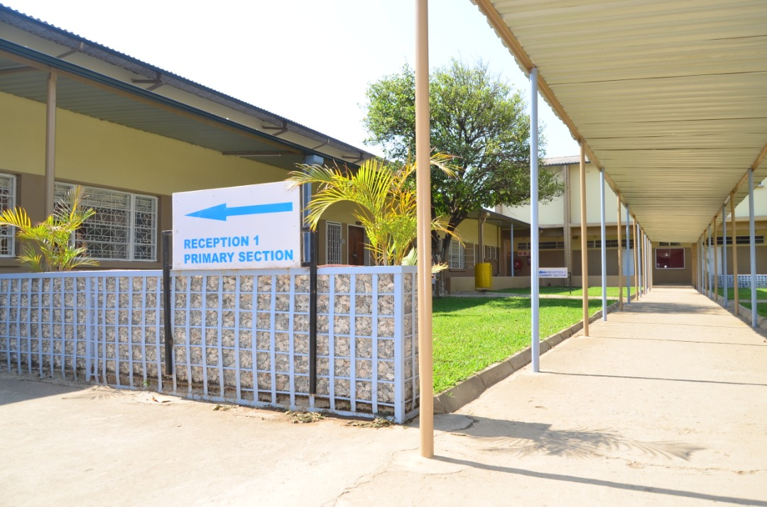
Figure 2.2: Classrooms
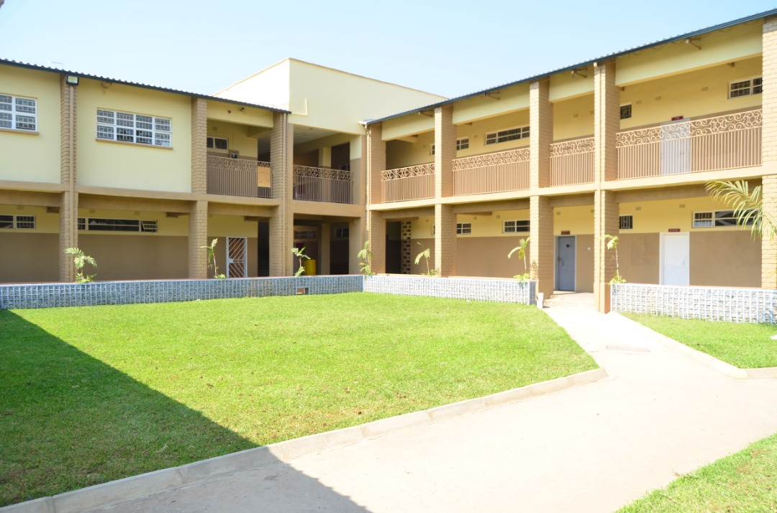

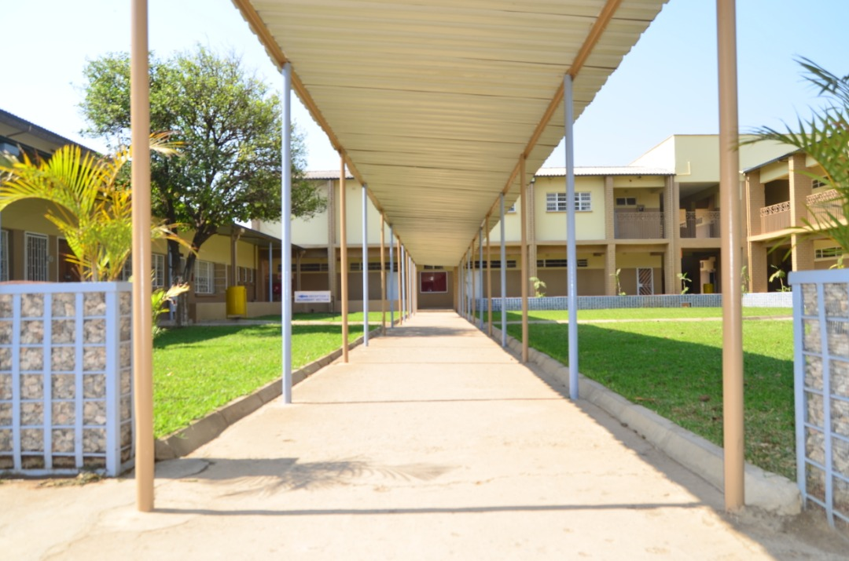

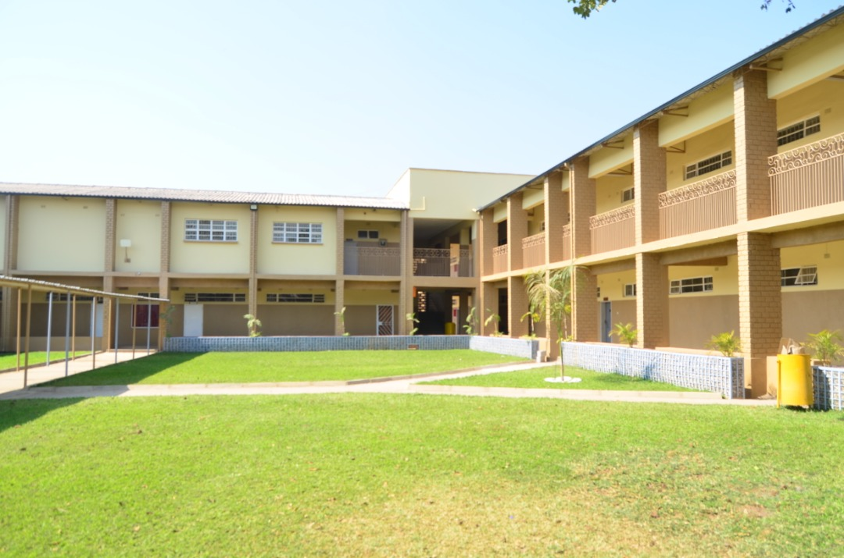

Figure 2.3: STRUCTURE OF SCHOOL; B
Figure 2.3.1: Administration block

Figure 2.3.2: Classrooms


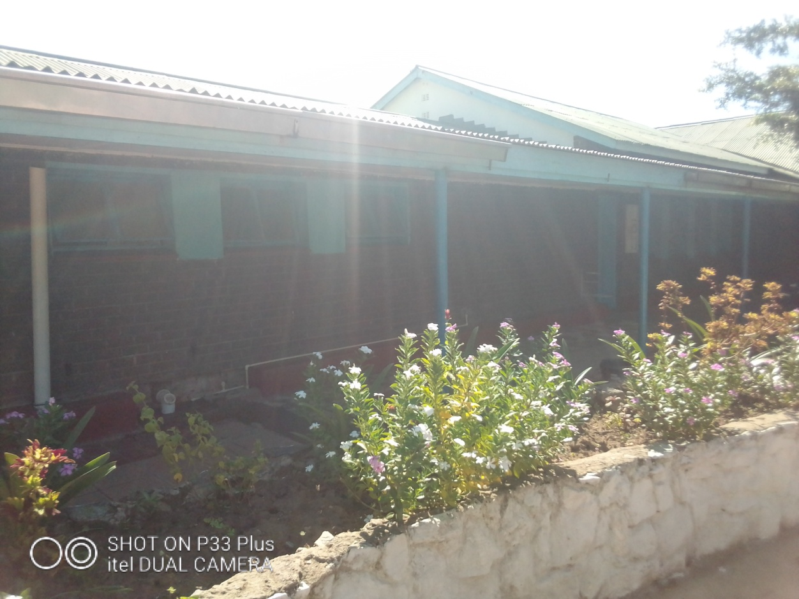

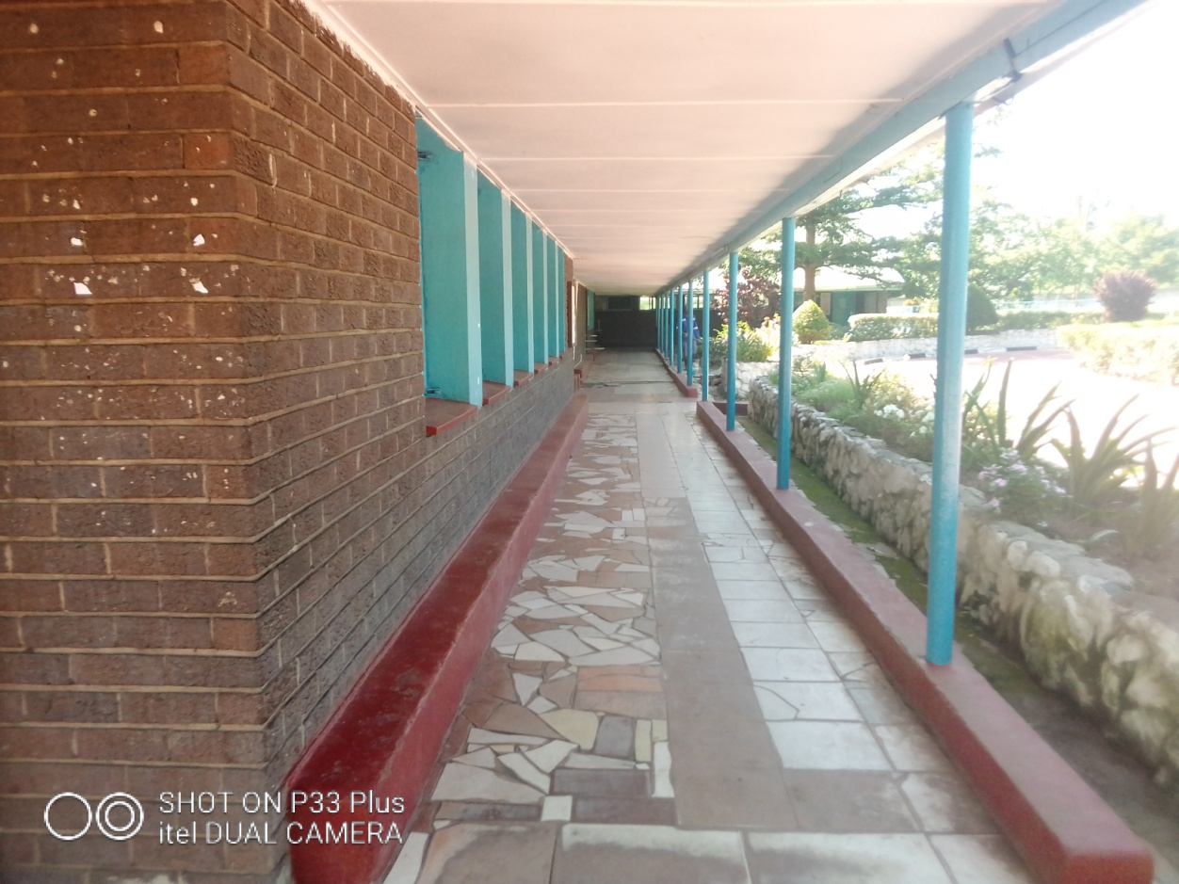


Figure 2.4: STRUCTURE OF SCHOOL; C
Figure 2.4.1: Administration block
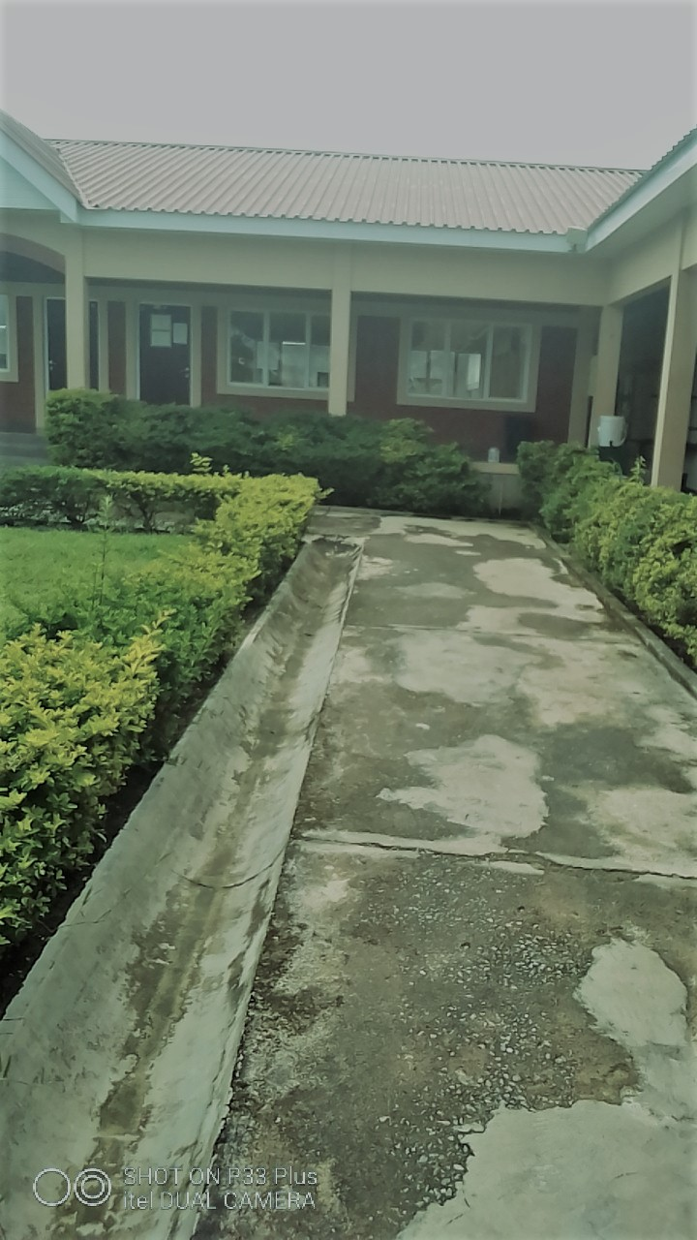

Figure 2.4.2: Classrooms
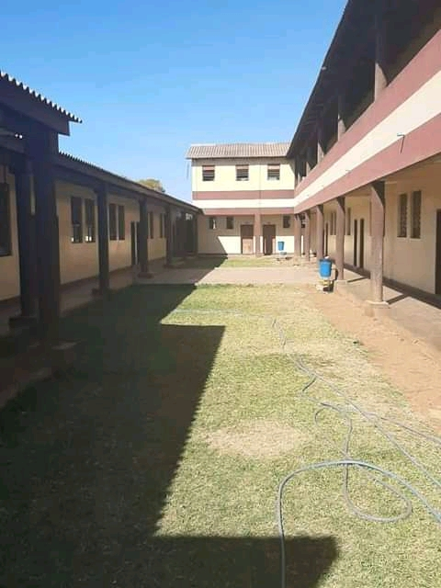
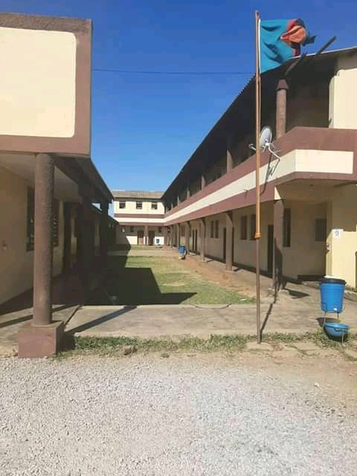

Appendix VIII: Map of Zambia showing the Study Site (Kitwe)
Figure 3.
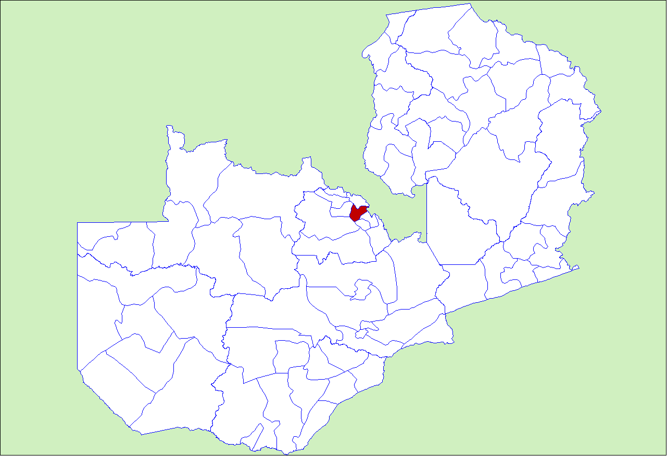
File:Zambia Kitwe District.png
From Wikipedia, the free encyclopedia


