CHAPTER ONE

INTRODUCTION

Background information

1.1.1 General Overview
Worldwide, millions of people suffer from communicable infections such as S. aureus and non-communicable infections caused by poor environmental conditions, poor food hygiene practices and poor food safety. They also create an enormous social, cultural and economic burden on communities and their health system (Mackenzie et al., 2002). The true incidence is difficult to evaluate especially in Africa, since many countries like Zambia do not have an epidemiological surveillance system for food safety in place, and whereas system exists, mild and sporadic cases are not usually reported or even recorded. In countries with a reporting system, the number of outbreaks has increased considerably in recent year (Acha and Szyfres, 2001).

1.1.2 Staphylococcus
Staphylococcus is a genus of gram-positive bacteria in the family Staphylococceae and the order Bacillae. Under the microscope, they are sphere-shaped (cocci), and form grape-like clusters. Staphylococcus species are facultative anaerobic organisms which are capable of growing both aerobically and anaerobically (Timothy et al., 2015).

The genus Staphylococcus is classified into two groups, namely coagulase positive staphylococci (CPS) and coagulase negative staphylococci (CNS) depending on the ability or inability to produce the coagulase enzyme and to clot blood plasma. Further, the genus has been further classified also based on clinical and epidemiological characteristics (Becker et al., 2014). The CPS include S. aureus, S. intermedius and S. hyicus; CNS include S. epidermidis, S. haemolyticus, S. simulans, S. warneri, S. capitis, S. homis, S. pettenkoferi, S. carnosus, S. felis, S. caprae and S. lentus (Becker et al., 2014). S. aureus is the most important species among the CPS because of its ability to cause disease and food poisoning.

1.1.3 Staphylococcus aureus
Staphylococcus aureus can be identified by means of several simple procedures, for example using Gram staining. S. aureus is a Gram-positive coccus and occurs singly, in pairs, or clusters of grapes. There is also a catalase test, for Staphylococci which is catalase-positive and distinguishes it from Streptococci which is catalase-negative (Tong et al., 2015).

S. aureus is known to cause skin infection, impetigo, pneumonia, gastroenteritis, localized gathering of pus (known as an abscess), food poisoning, vomiting with intermittent abdominal cramping and urinary tract infections (UTIs). Bacteraemia in an event that high levels of food safety is not practiced can be seen and even be life threatening, especially in immunocompromised persons (Neel, 2012).

1.1.4 Antimicrobial resistance of S. aureus
Antimicrobial resistance is a term used when bacteria is resistant or cannot respond to commonly used antibiotics in treating a prescribed bacteria. In this case AMR to S. aureus means the commonly used drugs in the treatment of S. aureus are resistant. According to Lowry (2003) in a study conducted in 2003, the researcher describes S. aureus isolates from intensive care units and from blood culture isolates worldwide as being increasingly resistant to a greater number of antimicrobial agents. Unsurprisingly this has left fewer effective bactericidal antibiotics to treat these often life-threatening infections. Lowry further explains that as rapidly as new antibiotics are introduced, Staphylococci have also developed efficient mechanisms to neutralize them (Lowry, 2003). The Lowry study also reviewed the historical evolution of resistant strains, their spread, the molecular mechanisms of resistance for selected antibiotics, and progress toward the development of alternative drug targets or novel approaches for therapeutic or prophylactic intervention (Lowry, 2003).

1.1.5 Methicillin Resistance Staphylococcus aureus (MRSA)
According to Tong et al, (2015), Staphylococcus aureus is a major human pathogen that causes a wide range of clinical infections. It is a leading cause of bacteremia and infective endocarditis as well as osteoarticular, skin and soft tissue, pleuropulmonary, and device-related infections. Antimicrobial resistant (AMR) Staphylococcus is resistant to commonly used antibiotics and usually takes a multi drug resistance pattern.

MRSA stands for methicillin resistance Staphylococcus aureus. Methicillin resistance requires the presence of the chromosomally localized mecA gene responsible for synthesis of a penicillin-binding protein 2a (PBP2a; also called PBP2′) a 78-kDa protein. The PBPs are membrane-bound enzymes that catalyze the transpeptidation reaction that is necessary for cross-linkage of peptidoglycan chains. Their activity is similar to that of serine proteases, from which they appear to have evolved. The PBP2a substitutes for the other PBPs and, because of its low affinity for all β-lactam antibiotics, enables Staphylococci to survive exposure to high concentrations of these agents. Thus, resistance to methicillin confers resistance to all β-lactam agents, including cephalosporins (Lowry, 2003).

Methicillin, introduced in 1961, was the first of the semi synthetic penicillinase-resistant penicillin. Its introduction was rapidly followed by reports of methicillin-resistant isolates. For clinicians, the spread of these methicillin-resistant strains has been a critical one in that the therapeutic outcome of infections that result from methicillin-resistant S. aureus (MRSA) is worse than the outcome of those that result from methicillin-sensitive strains according to Baillargeon et al., (2004). The difference between the two has been attributed to the underlying medical problems of the often sicker, immunocompromised, and older MRSA-infected patients as well as the less effective bactericidal drugs available to treat these infections, rather than to enhanced virulence of the MRSA strains (Baillargeon et al., 2004).

Staphylococcus aureus is often found on human hair and in the nose and throat, and the bacteria is usually transmitted from unwashed or improperly washed hands to kitchen surfaces or directly on foods as salads or deli meats, which are consumed raw (Acha and Szyfres, 2001). Kitchen establishment is mostly associated with improper food handling, ineffective cleaning and poor personal hygiene by food handlers. These practices could lead to the introduction and spread of Staphylococcus aureus bacterial contamination in the kitchen and if not subsequently removed could present a contamination or risk for humans working in the kitchen. Even though many bacteria are killed during the cooking process, environmental contamination may occur from other sources after the cooking process through cross-contamination of foods and subsequent toxin production during food storage. These bacteria produce toxins that are not deactivated by cooking and lead to staphylococcal gastroenteritis. (Acha and Szyfres, 2001).

Acha and Szyfres (2001) further states that some microorganisms such as Staphylococcus aureus may come from the food handlers themselves through poor personal hygiene practices and working in unsanitised kitchen environments. This therefore means that Staphylococcal infections may cause disease due to direct infection or due to the production of toxins by the bacteria in the body. Boils, impetigo, cellulitis, and toxic shock syndrome are all examples of diseases that can be caused by different varieties of staphylococci.

Staphylococcus aureus are among the microorganisms that cause foodborne infections associated with improper food safety worldwide. In another research on Staphylococcus transmission (CDC, 2003a), it was alluded that the transmission of AMR S. aureus and MRSA, by contaminated hands from person to person and that lack of access to products for hand hygiene may also increase the risk of AMR Staphylococci transmission from hands to environmental surfaces, contaminated surfaces to contaminated hands and then the cycle continues. This makes environmental hygiene a source of serious concern.

In Zambia, Staphylococcus aureus has been causing recurring outbreaks of staphylococcal infections, especially in Lusaka District as seen by the number of cases at the OPD clinic at Lusaka Central Correctional facility (Anonymous, 2019). Despite, Staphylococcus aureus being reported in correctional facilities in Zambia, it has however, not been properly documented (Mwendafilumba, Personal communication).

1.2 Statement of the problem
Inmates rely on the correctional institution system for their food and usually form a large part of the correctional food service workforce. Correctional institution administrators usually set the budget for all food-related activities, including the hiring of food safety managers and training of workers. Staphylococcus aureus is the most dangerous of all the many common staphylococcal bacteria and normally found as a part of the normal flora (Bick, 2007). Strains of S.aureus have developed resistance to many commonly used antimicrobials due to indiscriminate use (Bick, 2007). It is, therefore, important that these bacteria are investigated in a setting like a correctional kitchen facility owing to the fact that such a kitchen services a huge and overcrowded prison population.

1.3 Study justification
Drug-resistant microorganisms are a growing danger to the international society as they endanger people in prosperous societies to poor nations. Before the discovery of antibiotics human societies were overwhelmed by infectious diseases until their discovery in the middle of twentieth century (Begier et al., 2004). Owing to discovery of various antimicrobial agents the ability to manage infectious diseases has greatly improved.

However, the beginning of the era of AMR were recorded soon after the discovery of penicillin, in which a number of treatment failures and occurrence of some bacteria no longer sensitive to penicillin started being noticed. Microbial infection involving microorganisms poses a very serious public health problem all over the world especially in resource limited African countries. Among the many bacterial infections, S. aureus is the leading cause of nosocomial infections by gram-positive bacteria. It is notoriously resistant to penicillin and many other antimicrobials. S. aureus has gotten frighteningly resistant to many of common antimicrobials. The resistance rate to vancomycin is terrifyingly high (Hussein, 2011). It urges us to take measures to delay resistance. Emergence of resistance highlights the value of prudent prescribing of antimicrobials and avoiding their irrational use. Further research focusing on identifying dynamics promoting resistance, identifying high risk strains and molecular basis of resistance are required (Deyno, 2017).

The findings of our research study will contribute to the provision of information for the development of Standard Operating Procedures (SOPs) for good hygiene in correctional facilities, in an effort to ensure food safety and good hygiene practices that would prevent Staphylococcus spread or contamination. The study will also outline the AMR findings of the detected S. aureus hence it will contribute to verification of antibiotic resistance information,

1.4 Study objectives
1.4.1 Main objective.
The main objective of this study was to isolate and establish the presence of antimicrobial resistance Staphylococcus aureus from the environmental surfaces in Lusaka based correctional facilities.

1.4.2 Specific objectives
- To isolate and identify Staphyloccocus aureus from environmental surfaces of correctional kitchen facilities of Lusaka.
- To determine the antimicrobial resistance and susceptibility patterns of Staphylococcus aureus found in the correctional facilities kitchens.
- To determine the presence of MRSA

1.5 Research question
- Do Zambia Correctional Service Kitchens harbour Staphylococcus aureus?
- Is Staphylococcus aureus from the correctional kitchens facilities of Lusaka resistant to commonly used antibiotics?

CHAPTER TWO

LITERATURE REVIEW

2.1 The General Overview of Correctional Facilities
Correctional refer to a branch of the Criminal Justice System that deals with people convicted of a crime or people that come into conflict with the law (Mwanza, 2012). The role of the correctional system is to ensure that the offender's sentence is carried out, whether in jail or not in jail, on probation or in the community service (Sarkin, 2009). In Africa, and Zambia in particular, correctional facilities are usually overcrowded, hygiene is poor and food safety is also poor, as such, these conditions predominantly are conditions that predispose the thriving of Staphylococcus spp, especially Staphylococcus aureus.

2.2 S. aureus in kitchen environments
Merilyn et al., (2009) indicated that, prison environmental surfaces, could be reservoirs for methicillin-resistant Staphylococcus aureus (MRSA). The research further indicated that MRSA-contaminated materials on environmental surfaces indicated that correction facilities could harbour the bacteria.

A study undertaken in the United States of America by Scott et al., (2008) in households indicated that S. aureus was discovered in 34 out of 35 households (97 per cent) and was isolated from all surfaces that were swabbed, with the exception of a kitchen chopping board. MRSA was identified in 09 out of 35 households (26%) and was found on a multitude of household surfaces, including kitchen and bathroom sinks, countertops, kitchen faucet handle, kitchen sink, dishwasher / cloth, dish towel, bathtub, baby elevated chair tray, and pet food. This offers proof of the potential for transmission of infection via inanimate surfaces and underlines the need for excellent hygiene practices at home.

2.3 Sources of Staphylococcus
2.3.1 Environmental Contamination
The role of the environment in S. aureus transmission and infections has been previously studied in the healthcare setting and in certain high-risk community settings, such as prisons and correctional setups (CDC, 2003c). Environmental contamination has been increasingly recognized for its possible role in S. aureus transmission and infection within crowded places (CDC, 2003e). The potential importance of environmental contamination in S. aureus infection is further supported by the mixed success of body-site decolonization interventions designed to prevent recurrent infections within the such crowdy places, with recurrent infections often occurring. In the general human population, the success of MRSA decolonization ranges from 23% to 96% (Hansen, 2019). Alternatively, environmental contamination may simply be a substitute marker of colonization on multiple body sites or more common among dwellings with multiple infections because infected individuals are more likely to shed bacteria into their environment. A prospective cohort study was conducted aimed to determine whether environmental contamination of the dwelling environment increases the risk of recurrent infection among individuals with MRSA infection while accounting for competing risk factors (Muto, 2003). In this study, it was revealed that there is a growing body of evidence that the environment (surfaces) plays an important role in the transmission of pathogens in the community. MRSA can also be spread from contaminated inanimate objects known as fomites as indicated by Hansen (2019). Many hard surfaces were also observed to serve as good reservoirs for MRSA, including door knobs and hand rails (Hansen, 2019).

2.4 Transmission of Staphylococcus aureus in Correctional facilities
There are more than 40 Staphylococcus species, which are often part of the normal flora on the skin and upper respiratory tract. Infections may be caused by endogenous organisms or may be transferred through close contacts and contaminated environments. The correctional facilities which are usually crowded may not be an exception to this transmission pattern. Three correctional facilities in the USA, reported Staphylococcus disease outbreak in 2001 (D'Angel et al., 2002). The report indicated a total of 11 instances of MRSA skin infections which were recognized in June to September 2001 in an all-male, 200-bed, minimum-security government detention centre with an average 90-day incarceration (Jones et al., 2002).

Some risk factors have been documented in MRSA outbreaks in correctional facilities and these include sharing personal products such as towels or nail clippers, infrequent showers and hand washing, inmates lancing their own boils or other inmates' boils with fingernails or tweezers, and potential cross contamination of laundered items (Turabelidze et al., 2006). These could greatly contribute to the dissemination of Staphylococcus. Another mode of transmission observed in the federal prison system is the practice of unlawful, unhealthy tattooing. Body shaving, turf burns and sharing athletic equipment (CDC, 2003f) were also connected with MRSA transmission. Other environments like close physical contact have also been identified (Bergier et al., 2004). Individuals with asymptomatic nasal carriage of MRSA may shed MRSA into the environment resulting in transmission to other people or food contamination may occur that may trigger toxin-mediated acute gastroenteritis (Mutsuda et al., 1999). In a correctional facility setting, transmission of Staphylococcus aureus may also occur through food and contaminated water as a result of congestion.

2.5 Factors leading to Staphylococcus aureus contamination in Correctional facilities
In most correctional facilities, Staphylococcus aureus contamination is very likely because most correctional setups are crowded and congested, especially the ones in Africa (Sarkin, 2009). There are a number of risk variables that include extended imprisonment; skin lacerations and abrasions; prior use of antibiotics; bad skin hygiene; draining of one's own abscesses or changing one's own wound dressing; washing clothes by side; exchanging razors, clothes, linen or soap; and requiring co-payments to see a clinician as well as poor food safety practices (CDC, 2003b).

Skin and soft tissue diseases are common in jails and prisons. These have often been misdiagnosed as spider bites, leading to delays in suitable therapy and wrong administration of antibiotics. Furthermore, incision and drainage of abscesses in such confinement, may lead to contamination of the environment. In some cases self-medication has been used leading to antibiotic resistance. Antibiotics should only be used in the treatment of patients with sepsis, severe facial lesions, and periorbital lesions, and should not be administered anyhow by anyone (Bick et al., 2007).

In Hospital, nosocomial infections of Staphylococcus aureus have been reported (Bick et al., 2007). As a result, hospitals are a high-risk environment especially intensive care units such as hemodialysis units and ventilation wards. Liberalizing access to soap, showers, and clean clothing, eliminating requirements for contagious circumstances would be highly helpful in correctional setups retaining round the-clock access to emergency care, and using specialized wound assessment and treatment clinics may lead to more rapid diagnosis, therapy, and skin lesion resolution, and less chance of secondary transmission. While inadequate information is available to support regular decolonization attempts, the practice may be helpful in those who develop repeated episodes of contamination by Staphylococcus aureus (Stelfox et al., 2003).

2.6 Detection and confirmation of Staphylococcus aureus
Conventional identification of S. aureus is based on bacteriological culture of samples and examination of bacterial colony morphology and haemolysis type on blood agar after incubation for 24 hours at 37ºC, Gram stain morphology and catalase and coagulase reaction (Becker et al., 2014). Mannitol Salt Agar and Baird Parker agar (BPA) are some of the recommended selective media by the international standardisation bodies for isolation of S. aureus strains (Hyun-jung and Se-Wook, 2010). In addition, haemolysis is considered an important feature for rapid identification of S. aureus in blood cultures, and three types of haemolysis (complete, incomplete, and both together is known as double haemolysis) can be seen among S. aureus (Becker et al., 2014).

Following initial culture and isolation, coagulase production is used by clinical microbiology laboratories for the identification of S. aureus strains isolated from infections (Goh et al., 1992). Since S. aureus bacterium is known to be coagulase positive, coagulase tests are used to differentiate S. aureus from CNS (Becker et al., 2014). Coagulase positive isolates are considered presumptive S. aureus isolates until they are confirmed. The tube coagulase test for the detection of free coagulase is considered the standard method for differentiating S. aureus from CNS. However, this test is time consuming and requires incubation for 4 to 24 hours (Becker et al., 2014). Further, agglutination tests have been developed for a more rapid detection of presumptive S. aureus (Moser et al., 2013).

Accurate and rapid identification of microbial pathogens such as S. aureus including MRSA is very important for timely decisions on appropriate antibiotic therapy (Clardy et al., 2009). There are a number of molecular methods such as polymerase chain reaction (PCR) that have been used for this purpose. PCR has proved to be a powerful tool for sensitive and specific detection of microorganisms. For example, the nuclease gene nuc can serve as marker gene for S. aureus (Barkstad et al., 1992). Further, PCR enables the detection of genes specific for mediating antibiotic resistance (such as mecA) (Kilic et al., 2010; Kraushaar et al., 2017) or genes encoding Staphylococcal enterotoxins (Wu et al., 2016) or virulence factors (Kilic et al., 2010; Kraushaar et al., 2017).

2.7 Management of Staphylococcus Contamination in Correctional Facilities
Primary prevention of any infection is by screening, followed by infection control and therapy. In correctional facilities administrative measures may reduce the occurrence and contamination of Staphylococcus aureus, especially AMR and MRSA in the prison population.

Frequent training on the significance of hand-hygiene, efficient hand-hygiene techniques, good personal and environmental hygiene, good hygiene practices (GHPs) in the Kitchen as well as good food safety practices should be provided to correctional personnel, health employees, and incarcerated inmates. Policy makers in various Correctional Services and establishments should also conduct trainings on food safety so as to appreciate the importance of food safety especially in public places like correctional facilities. Hand washing should be encouraged and practiced as a lifestyle. Hands should be cleaned regularly with soap and running water, this should take at least 15 seconds and practiced especially before eating, after using the toilet, when hands are visibly dirty and if there has been blood contact or other body fluid, mucous membranes, or damaged skin, the use of liquid soap should be encouraged and is as efficient in decreasing skin flora, as antimicrobial soaps containing the active ingredient triclosan (CDC, 2003b).

For excellent personal hygiene, inmates should have access to the necessary supplies and adequate daily essentials. Within each correctional institution, all prospective possibilities for prisoners to have close physical contact or share common products should be scrutinized closely to define strategies for interrupting MRSA transmission (Faogali et al., 2005).

Personal protective equipment (PPE)is required when health care personnel, correctional officers or other inmates are likely to have contact with blood / body fluids. For example face masks / eyewear and spray protective gowns are essential PPE in infection prevention. Environmental contamination studies with MRSA in Prisons and elsewhere, reveals that environmental pollution is less likely than human carriage, therefore environmental sanitation cannot replace private hygiene and indication that both practices are important. MRSA occurs mostly on environmental surfaces, and most often in the toilets and in Kitchen environmental surfaces (Faogali et al., 2005).

CHAPTER THREE

MATERIALS AND METHOD

3.1 Study Site
The study was conducted in two major correctional facilities, Lusaka Central Correctional Facility based in Lusaka District, housing I,365 at the time of study and Mwembeshi Maximum Correctional Facility based in Chilanga District with a population of 504 at the time the study was conducted. Both facilities fall under Lusaka Province. The two correctional sites are under the department of Zambia Correctional Service, in the Ministry of Home Affairs, Zambia.

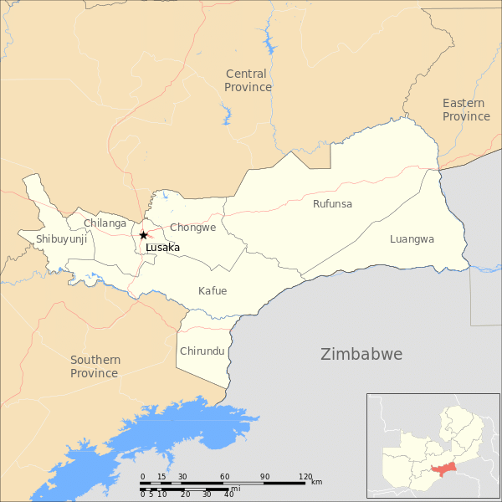
Figure 3.1: Map of Lusaka Province

3.2 Research design
The study is an ecological study which looked at swabbing environmental surfaces. A cross-sectional study design was used, to investigate Staphylococcus aureus bacteria at the two correctional centres in Lusaka Province (Mwembeshi Maximum and Lusaka Central). Swabs from the kitchen preparation surfaces were collected and subjected to laboratory analysis that included isolation, antimicrobial susceptibility testing (AST) and molecular identification of some target genes.

3.3 Sampling techniques
The study employed probabilistic sampling technique for equal selection of sampling units. Stratified random sampling was used for selection of both sampling frame and units. Stratified sampling allows the researcher to obtain an effect size sample from each strata separately as if it was a different study (Elfil and Negida, 2017).

3.4 Sample size
The overall design of the study was an ecological design, where the kitchen environments in two facilities were sampled. Samples were correlated, and the whole idea behind the design was to allow enough samples to observe a variability among isolates found.

As a starting point we wanted to get at least 30 positive samples from each facility. Expecting that 2/3 of samples were positive for S. aureus, we aimed at a total of 100 swabs to be collected with 50 from each facility. From each kitchen, 10 swabs were to be taken from 5 critical sites of the kitchen.

3.5 Sampling
Sampling was done in the two correctional selected kitchens in Lusaka which are the most crowded correctional facilities in Lusaka Province. The areas where samples were collected, were from the table tops, food preparation tables, sink washing area, from cutlery and effluent discharge points in the kitchen.

3.6 Bacteriological analysis of samples

3.6.1 Sample collection and preparation
Sterile swabs were used to swab the table tops, food preparation tables, sink washing area, from cutlery and effluent discharge points in the kitchen in the correctional facility kitchens. After collecting the swabs, the collected samples were placed in Brain Heart infusion broth and then put in a cooler box in readiness for bacteriological analysis.

3.6.2 Bacteria isolation and identification of Staphylococcus aureus
The isolation and identification of S aureus from the environmental surface was done according to previous methods described by (Carter, 1984) and (Quinn et al., 1999). The collected swabs in BHI broth were incubated at 37ºC overnight. Following overnight incubation the broth was streaked on Mannitol Salt Agar (MSA, Himedia) selective for Staphylococci bacteria. The presence of growth and change of pH in MSA media (red to yellow color) was regarded as presumptive identification of S. aureus. Colonies that developed weak or delayed yellow color after 24 hours of incubation were considered as other species of Staphylococci. The staphylococcal suspected colonies were further cultured on 5% sheep blood agar plates. The colonies were provisionally identified on the basis of their staining reaction with Gram’s stain, morphology and hemolytic pattern (typical and atypical). The identified colonies were placed and stored on nutrient agar slants till further analysis.

The isolated Staphylococcus species of bacteria were segregated into species using conventional biochemical tests that included catalase, coagulase, acetoin production, methyl red, indole production, urease production, oxidase and sugar fermentation (arabinose, dextrose, fructose, galactose, lactose, maltose, mannitol, mannose, salicin, sucrose, trehalose, turanose, xylitol and xylose). The reference strain BfR ST-0129 (S. aureus) was used as a positive control and reference strain BfR ST-0886 (S. epidermidis) as negative control (coagulase negative). These were used to validate some reactions.

The species that were presumptively identified as Staphylococcus aureus were further subjected to PCR for the presence of the mecA (a marker gene for MRSA mediating methicillin resistance) and the presence of the Staphylococcus aureus protein A (spa) gene which is an important virulence factor that enables the bacteria evade the host immune responses using primer sets indicated in Table 3.1.

Table 3.1: Showing PCR Primers used in the study
Gene | Name of Primer | Sequence 5’to 3’ | Amplicon (bps) | Reference
mecA | MECA P4 | TCCAgATTACAACTTCACCAgg | 162 | Milheirico et al., 2007a; 2007b
mecA | MECA P7 | CCACTTCATATCTTgTAACg | 162 | Milheirico et al., 2007a; 2007b
Spa | 1095F | AgACgATCCTTCggTgAgC | ~ 240 to 320 | Shopsin et al., 1999
Spa | 1517R | gCTTTTgCAATgTCATTTACTg | ~ 240 to 320 | Shopsin et al., 1999

The DNA was extracted using the heat extraction method where a loopful of Staphylococcus bacteria cells were suspended into 0.5 ml of water followed by heat treatment at 95ºC for 10 min. Following heat treatment, the extract was placed on ice after which it was centrifuged at 10,000 xg. The supernatant was then used for PCR as DNA template. The PCR (FinnzymesOy, Espoo, Finland) was performed in a total reaction volume of 10 µL consisting of 5µL Phusion master mix, 2µL sterile distilled water, 2µL primers (forward and reverse indicated in Table 1) and 1µL bacterial DNA template. The PCR was performed using the rapid cycle DNA amplification method comprising of an initial denaturation step at 98 ̊C for 30 s, followed by 35 cycles of template denaturation at 98 ̊C for 1 s, primer annealing at 60 ̊C for 5 s and 72ºC for 1 s with final extension at 72ºC for 10 s. The PCR products were later viewed with ethidium bromide after electrophoresis through 1.5percent agarose gel.

3. 7 Antimicrobial Susceptibility Testing
The Staphylococcal cultures isolated from the environmental swabs in the study were tested for antimicrobial susceptibility using the disc diffusion method (Kirby-Bauer et al., 1966). The antimicrobial susceptibility testing was determined on Mueller Hinton Agar (Himedia, Mumbai, India) based on the Clinical Laboratory Standard Institute (CLSI) guidelines (Steinke, et al., 2001). Eight (8) antibiotic discs were used and these included Nalidixic-acid (Na30), Ampicillin (AMP10), Chloramphenicol (C 30), Ciprofloxacin (CIP 5), Amoxicillin/Clavulanic acid (AMC 30), Tetracycline (TE 30), Gentamicin (GEN10) and Cefotaxime (CTX 30) (Himedia).

Each pure bacterial culture was emulsified in 5 ml sterile physiological saline (0.85% NaCl) to make a bacterial suspension of turbidity 0.5 McFarland of barium chloride. Prior to bacterial inoculation, the surfaces of Muller-Hinton agar plates were dried at 37ºC. This was followed by dipping a sterile swab into the bacterial suspension, removed excess fluid by pressing the swab against the wall of the test tube and then applied the swab contents evenly on to the surface of the agar. Test culture plates were incubated at 37ºC for 24 hour and followed by determination of susceptibility or resistance profiles according to the breakpoints as described in the guidelines of the Clinical and Laboratory Standards Institute (CLSI, 2010).

3.8 Data collection and analysis
3.8.1 Data Analysis
In order to answer the objectives of the study, data was analysed based on the generated laboratory results. Data collected was analysed using WHONET version 5.6. Bar charts were used to present the data using 95% confidence interval and 5% as the standard error. A 95% Confidence Interval was also given when appropriate

3.9 Ethical consideration
This study was undertaken in accordance with the ethical recommendations UNZABREC. Permission to collect samples from the prisons / correctional centres was obtained from Zambia Correctional Service (ZCS).

CHAPTER FOUR

RESULTS

4. 1 Sampling, Isolation and identification of Staphylococcus aureus
The isolation of Staphyloccocus aureus was done on Mannitol Salt Agar where 75 samples were subjected to isolation and identification. The total sample of swabs from each sampling locality are indicated in Table 4.1. Out of Seventy five (75) swab samples, 39 were found with Staphylococcus aureus, giving 52 percent of contamination on the surfaces sampled, from Lusaka Central (n=26, 66.6 %) and Mwembeshi Maximum Correctional (n=13, 33.3 %) facilities (Table 4.1 and Figure 4.1) Staphylococcus aureus was identified on Mannitol Salt Agar as a result of colour change to yellow.

Table 4.1: Staphyloccocus aureus isolated from the sampling sites
Area sampled | Lusaka Central Correctional Facility |  | Mwembeshi Maximum Correctional Facility
Area sampled | Total samples | Positive Samples | Total samples | Positive Samples
Table Tops | 5 | 4 | 5 | 4
Food preparation Table | 10 | 4 | 5 | 1
Sink washing area | 20 | 15 | 10 | 0
Cutlery | 5 | 3 | 5 | 3
Effluent Discharge Point | 5 | 0 | 5 | 5
TOTAL | 45 | 26 | 30 | 13

All isolates from both correctional facilities were tested biochemically as previously described, and 39 isolates presenting yellow colonies were probably identified as S. aureus. Staphylococcus aureus was further identified using biochemical reactions as indicated in Table 4.2.

Table 4.2: Biochemical Test and Identification of Staphylococcus aureus
Characteristic | Property
Catalase | Positive
Citrate | Positive
Coagulase | Positive
Indole | Negative
Motility | Negative
Methyl Red | Positive
Oxidase | Negative
Urease | Positive
Fructose | Positive
Galactose | Positive
Glucose | Positive
Lactose | Positive
Maltose | Positive
Mannitol | Positive
Raffinose | Negative
Sucrose | Positive
Trehalose | Positive

4.2 Molecular Detection of Significant Genes

The biochemically identified Staphylococcus aureus were subjected to PCR for detection of two significant genes mecA (a marker gene for MRSA mediating methicillin resistance) and the presence of the Staphylococcus aureus protein A (spa) gene which is an important virulence factor that enables the bacteria evade the host immune responses. Of the 39 isolates, the Staphylococcus aureus protein A (spa) gene was detected in 12 (30.8%) isolates, while the gene for MRSA mediating methicillin resistance was not detected (Figure 4.1).

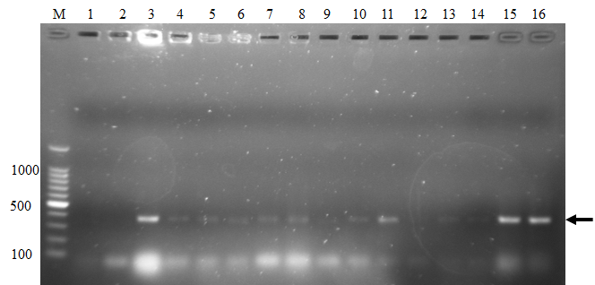
Figure 4.1: Staphylococcus aureus protein A (spa) gene was detected by PCR in the isolate DNA. Lane M; 100 bp ladder, Lane 1, 2 and 12 were negative while the rest were positive as indicated by the arrow with the 320bp amplicon.

4. 3 Antimicrobial Susceptibility Pattern
Antibiotic susceptibility of the identified strains was carried out by disk diffusion method against the commonly used antibiotics. The figure 4.2 below shows the testing of isolates using the disk diffusion method. All the 39 isolates identified as S. aureus were subjected to antimicrobial susceptibility testing and obtained patterns indicated in Table 4.3. The isolates had different resistance and susceptibility profiles.
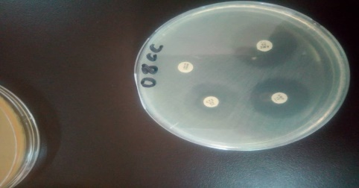 | 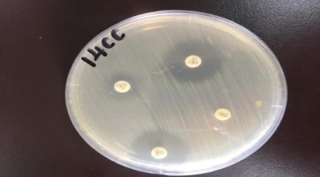 | 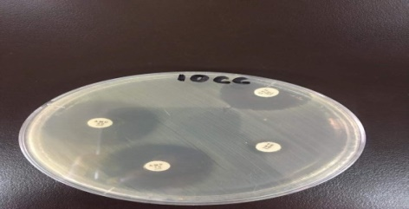 | 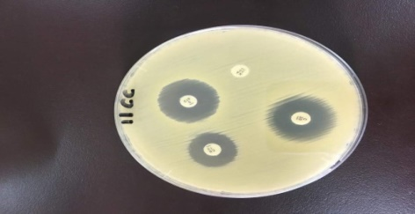
Figure 4.1: Mueller hinton agar plates showing antimicrobial testing results
Amoxicillin and ampicillin exhibited higher sensitivities, with nalidixic acid exhibiting100 percent resistance.

Table 4.3: Antimicrobial resistance and susceptibilities of isolated S. aureus.
Antibiotic | Resistant | Intermediate | Susceptible | Resistant (95% C.I.)
Amoxicillin | 3 (6.8%) | 1 (2.2%) | 35 (91%) | 0.0-11.2%
Ciprofloxacin | 13 (33.3%) | 0 (0 %) | 26 (66.7%) | 19.6-50.3%
Cefotaxime | 18 (46.2%) | 0 (0 %) | 21 (53.9%) | 30.5-62.7%
Tetracycline | 12 (30.8%) | 16 (41%) | 11 (28.2%) | 17.6-47.8%
Chloramphenicol | 6 (15.4%) | 12 (30.8%) | 21 (53.8%) | 6.4-31.2%
Gentamicin | 21 (53.8%) | 10 (25.6%) | 8 (20.5%) | 37.3-69.5%
Ampicillin | 1 (2.6%) | 0 (0%) | 38 (97.4%) | 84.9-99.9%
Nalidixic acid | 39 (100%) | 0 (0%) | 0 (0%) | 88.8-100%

The resistance and susceptibilities to each antibiotic was demonstrated further in Figures 4.3.
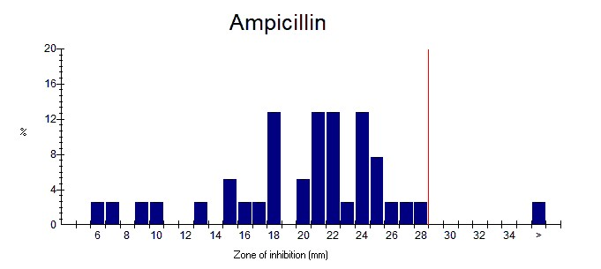 | 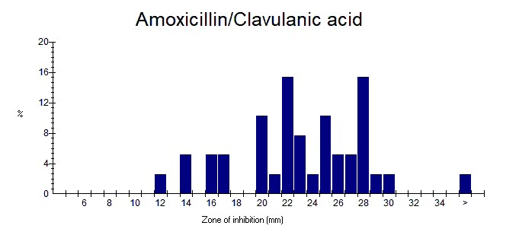
 | b.
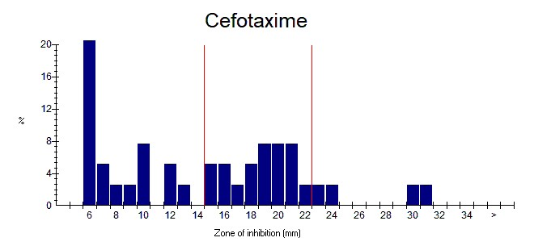 | 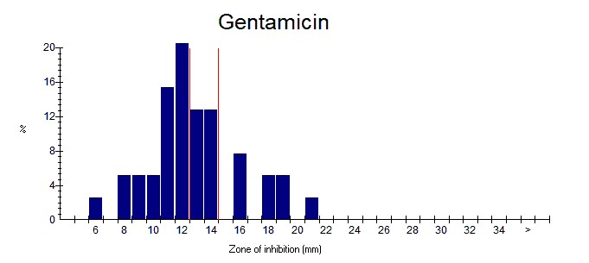
c. | d.
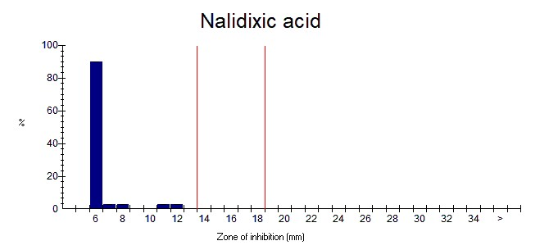  e. | 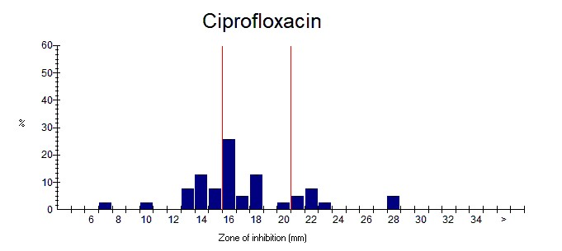  f.
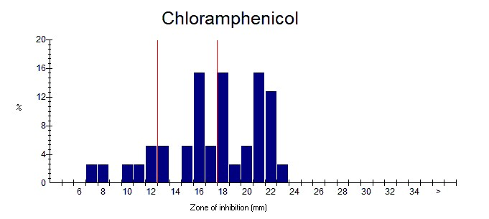  g. |   h.
Figure 4.3: Resistance and sensitivity profiles of isolates to selected antibiotics (a to h)

4. 4 Summary of the isolated Staphylococcus aureus complete analysis
All the 39 isolates from the two correctional facilities had exhibited various traits and characteristics in terms of antibiotic sensitivity and possession of the Staphylococcus aureus protein A (spa) gene which is an important virulence factor that enables the bacteria evade the host immune responses, The information obtained is summarized in Table 4.4 below. Isolates from Lusaka Central exhibited resistance to amoxicillin while resistance in one isolate was noted from the Mwembeshi facility. Generally, a wider resistance with all antibiotics was observed at Lusaka Central correctional facility. All the isolates detected with the Staphylococcus aureus protein A (spa) gene were from the Lusaka central facility.

Table 4.4: Summary of antibiotic resistance profile of each isolate isolated in the study
Isolate No: | Correctional facility/Source | Spa gene | Antibiotic Susceptibility
Isolate No: | Correctional facility/Source | Spa gene | Amox | Ciprox | Cef | Tetracy | Chlor | Gent | Amp | Nalidixic
 | LC – TT | Negative | S | R | R | I | S | R | S | R
 | LC – TT | Negative | S | R | R | I | I | R | S | R
 | LC – FPT | Positive | S | R | R | R | R | R | S | R
 | LC – FPT | Positive | R | R | S | R | S | I | S | R
 | LC – FPT | Positive | S | S | R | S | S | S | S | R
 | LC – SWA | Positive | S | R | R | S | S | R | S | R
 | LC - SWA | Positive | S | R | R | R | S | R | S | R
 | LC – SWA | Positive | S | R | S | R | R | I | S | R
 | LC – SWA | Positive | R | R | R | S | S | R | S | R
 | LC – SWA | Positive | S | R | R | R | S | R | S | R
 | LC – SWA | Positive | S | R | R | R | S | R | S | R
 | LC – SWA | Positive | I | R | R | R | S | R | S | R
 | LC – C | Positive | S | R | R | R | S | R | S | R
 | LC – SWA | Negative | S | S | R | S | I | I | S | R
 | LC – SWA | Negative | S | R | R | I | S | R | S | R
 | LC – FPT | Positive | S | S | R | S | S | I | S | R
 | LC – FPT | Negative | R | S | S | S | I | R | S | R
 | LC – SWA | Negative | S | S | S | I | I | R | S | R
 | LC – SWA | Negative | S | S | S | I | S | R | S | R
 | LC – SWA | Negative | S | S | S | I | S | R | S | R
 | LC – SWA | Negative | S | S | S | I | S | I | S | R
 | LC – SWA | Negative | S | S | S | S | S | R | S | R
 | LC – C | Negative | S | S | S | S | I | R | S | R
 | LC – C | Negative | S | S | R | S | I | R | S | R
 | LC – SWA | Negative | S | S | R | I | I | S | S | R
 | LC – TT | Negative | S | S | S | I | S | S | S | R
 | MM – TT | Negative | S | S | S | R | I | I | S | R
 | MM – TT | Negative | S | S | R | I | I | R | S | R
 | MM -TT | Negative | S | S | R | I | R | I | S | R
 | MM – TT | Negative | S | S | S | I | S | S | S | R
 | MM – FPT | Negative | S | S | S | I | S | R | S | R
 | MM – EDP | Negative | S | S | S | I | R | S | S | R
 | MM – EDP | Negative | S | S | S | I | I | I | R | R
 | MM – EDP | Negative | S | S | S | R | R | I | S | R
 | MM – C | Negative | S | S | S | S | R | S | S | R
 | MM – C | Negative | S | S | S | I | S | I | S | R
 | MM – C | Negative | S | S | S | R | I | S | S | R
 | MM – EDP | Negative | S | S | S | R | I | R | S | R
 | MM – EDP | Negative | S | S | S | S | S | S | S | R
NOTE: LC – Lusaka Central, MM – Mwembeshi Maximum
TT: Table tops, FPT: Food preparation table, SWA: Sink washing area, C:Cutlery, EDP: Effluent discharge point

CHAPTER FIVE

DISCUSSION

5.1 Isolation of Staphylococcus aureus from study places
Staphylococcus aureus was isolated from both correctional facilities as reported in other facilities like in the USA where they were outbreaks of skin infections (Maree et al., 2010; CDC, 2003; 2000). In the two correctional facilities, Lusaka Central and Mwembeshi Maximum in Lusaka 75 samples were collected and 39 were positive on Mannitol Salt Agar (MSA) denoting the presence of Staphylococcus aureus. This study shows that Staphylococcus aureus has been detected in both correctional facilities. The isolated Staphylococcus aureus had antibiotic susceptible variability. Detecting antimicrobial resistance (AMR) S. aureus contaminated surfaces on selected environmental surfaces in the absence of an evident outbreak, underlines that correctional facilities must have protocols for environmental cleaning as a component of both AMR Staphylococcus and MRSA prevention.

A Study conducted in Texas and published in 2009, by Marilyn Felkner, on detection of S. aureus on environmental surfaces in a prison setting revealed that out of 132 surface swabs, 10 (7.6%) had AMR S. aureus while eight (6.1%) isolates were MRSA. This is a similar situation with the finding of our study where antimicrobial resistance was found in both facilities. As observed with other workers, like Felkners (2009) who isolated AMR from environmental surfaces of a Texas prison. Our study also isolated AMR S aureus from environmental surfaces in both correctional facilities.

The sink washing area at Lusaka central correctional facility had more isolated S. aureus positive than other areas sampled at the facility. This can be attributed to the large population of inmates that were found at the time of the study where Lusaka central had an inmate population of 1, 365 compared to Mwembeshi with 504 inmates. The sink facilities were used by many people and is a similar situation as reported by other studies, also indicating that overcrowding is a predisposing factor for Staphylococcus (Borg, 2003). The other reason could be attributed to the poor kitchen infrastructure at Lusaka central where the kitchen was observed to have no running water compared to Mwembeshi which is a newly constructed with a good kitchen infrastructure with running water used for washing kitchen utensils at the sink washing area.

5.2 Comparison of Antimicrobial resistance between Lusaka Central and Mwembeshi Maximum
Lusaka Central Correctional facility (LCCF) was observed to have a higher AMR compared to Mwembeshi Maximum Correctional Facility (MMCF). Almost all the 26 isolates that came from LCCF were at least resistant to one antibiotic. On the other hand, all isolates from MMCF susceptible to chloramphenicol. This picture of AMR pattern could be as a result of Lusaka Central Correctional Facility being more overcrowded, compared to MMCF. Most correctional facilities all over the world are usually crowded (Felkner et al., 2009). The other reason could be attributed to the unavailable kitchen cleaning protocols. In other correctional facilities, kitchen protocols are embedded into the kitchen operations. In correctional facilities there is a standard way of how kitchen facilities must be arranged. Correctional facilities are public places and should be in conformity with the public health Act (PHA) Cap 295 and the Food and Drugs Act (FDA)Cap 303 of the laws of Zambia which stipulates that: food should be prepared in a clean place, the building should be well lit and adequately ventilated where food is prepared, food should be stored well and free from possible contamination. Food preparation places should have adequate running water, food handlers should be medically examined and certified fit to handle food for public consumption.

5.3 Antimicrobial Resistance of commonly used antibiotics to treat Staphylococcus aureus
Out of the 39 isolates, Nalidixic-acid (Na30) was 100% not effective while Gentamicin (GEN 10) 53.8%, Cefotaxime (CTX 30) 46.2% and Ciprofloxacin (CIP 5) showed 33.3% non-effectivity. Chloramphenicol (C 30) 15.4%, Ampicillin (AMP 10) 2.6 %, and in my opinion Nalidixic should never be the drug of choice in the treatment of Staphylococcus infection in Zambia’s correctional facilities. On the other hand, ampicillin and chloramphenicol were highly effective and similarly would be the best drug of choice in treating Staphylococcus aureus infection in the correctional setups. Although S. aureus and its antimicrobial resistance pattern have been extensively studied in livestock and foods (Bantawa et al., 2019) in other countries, no studies have been done in correctional facilities in Zambia.

In our study, isolates showed susceptibility to ampiciline 97.4%, amoxicilline 91%, ciproflaxine 66%, cefotaxime 53.9% and chloramphenicol 53.8%. Studies in other countries show highly variable results (Malcolm, 2011). Our result reported a higher resistance rates of isolates than in studies of correctional facilities reported in other countries like Eastern Nepal (Kamana et al, 2019). The increased resistance of isolates against commonly used antibiotics may be due to the indiscriminate use of common antibiotics. For instance, a study by Akbar et al. reported that 73% Staphylococcus isolates were resistant to tetracycline, 18.48% resistant to chloramphenicol, 36% to Nalidixic acid and 27% resistant to ciprofloxacin. Similarly, Odoch et al. reported 50% isolates were resistant to ciprofloxacin, 5.1% to tetracycline and 5.1% to chloramphenicol. Osaili et al., reported all of the Staphylococcus isolates were resistant to most of the antibiotics a few isolates were sensitive to some of the tested antibiotics which is a similar pattern with our findings. The variation on the rate of resistance can be related to the difference in time and place, as in our case correctional facilities.

In our study, the higher prevalence rates might be due to unhygienic prison conditions, improper cleaning, deficient handling of food, and post- contamination from the polluted environment. The widespread incidence of antibiotic resistance across S. aureus, or across different species of Staphylococcus has been attributed to horizontal gene transfer of genes encoding antibiotic resistance and virulence (Kamana et al., 2019). A recent study done by Kamana et al., (2019) demonstrated the extent of horizontal gene transfer among Staphylococcus to be much greater than previously thought, and encompasses genes with functions beyond antibiotic resistance, virulence, and beyond genes residing within the mobile genetic elements (Kamana et al., 2019). Resistance enables bacteria to escape from being killed by antibiotics and reduces the ability to treat infections. Therefore, antibiotics resistance has been considered to be one of the greatest threats to medicine and if antibiotic use is not regulated the problem of resistance could worsen and fighting bacterial infection could prove very difficult. (Kamana et al., 2019).

5.4 Polymerase Chain Reaction (PCR)
In our study, PCR was used to confirm antimicrobial resistance (AMR) and detect methicillin resistant Staphylococcus aureus (MRSA). The results obtained reveled and confirmed that the isolated S. aureus was not MRSA, but resistant to commonly used antibiotics and hence could be referred to as antimicrobial resistant Staphylococcus aureus. The Staphylococcus aureus present in the two correctional facilities can be said or referred to as non MRSA. The resistance to a number of antibiotics must be worrying as an outbreak of Staphylococcal infections may be disastrous. Of interest was the detection of the Staphylococcus aureus protein A (spa) gene which is an important virulence factor that enables the bacteria evade the host immune responses (Timothy, 2015). This demonstrates the possible virulence of the Staphylococcus found in Lusaka Central prison. This is a clear indication that inmates may be predisposed to such infections. Other facilities in other parts of the world have had such outbreaks.

5.5 Public Health and Economic significance of the results
Fighting antimicrobial resistance of infections such as Staphylococcus will also reduce on the cost of treating the inmates thereby channelling the resources for other health activities like improving their nutrition and diet as well as improving environmental hygiene in correctional facilities. The current findings also indicate that antimicrobial resistance is high and once an outbreak occurs treatment would be difficult.

According to the study conducted by Maree in 2010 in Los Angeles, community-associated methicillin resistant Staphylococcus aureus (MRSA) infections and AMR outbreaks have occurred in correctional facilities. In this study, Methicillin- Resistant Staphylococcus aureus was documented in the Los Angeles County Jail (Maree, 2010). This indicates the significance of this study in our own jails and prisons in Zambia. Spread of Staphylococcus contamination can be extremely difficult to control in congested places like correctional jail setups and therefore development of effective prevention protocols requires an understanding of antimicrobial resistance (AMR) and MRSA risk factors in incarcerated persons according to a study done by (Maree, 2010).

5.6 Possible Prevention Measures
Our study shows some strength with regards to our investigation, in that, to the best of our knowledge, this is the first study to investigate AMR Staphylococcus aureus, isolation as well as conduct antimicrobial resistance profile on Staphylococcus aureus in correctional facilities in Zambia. Our findings also pave way for further study, while further investigation is needed to better understand the transmission and pathogenicity of AMR S. aureus and MRSA within closed environments such as correctional facilities. Such knowledge will be critical in selecting key areas in which to invest resources to end the transmission of the pathogen in these closed populations such as S. aureus.

CHAPTER SIX

CONCLUSIONS AND RECOMMENDATIONS

6.1 Conclusions
1. The environmental surfaces of both correctional facilities sampled were contaminated antibiotic-resistant S. aureus.
2. The isolated S. aureus demonstrated multidrug resistance even though no MRSA was isolated.
3. The Staphylococcus aureus protein A (spa) gene was detected in some isolates from the Lusaka central facility.

6.2 Recommendations
The Study recommends the Zambia Correctional Service to:
1. Put in place written food safety guidelines and protocols in all correctional facilities in Zambia, which are in line with the Food & Drugs Act Cap 303 as well as the Public Health Act Cap 295 of the laws of Zambia.
2. Study to Further characterize the isolated pathogens be done to determine antimicrobial resistance genes and their transfer.
3. A more broad based research on the prevalence of AMR Staphylococcus species in all Zambian Correctional facilities as well as a comparative study on food safety and hygiene should be conducted.
4. Close monitoring and public health awareness on the importance of food safety and hygiene in correctional setups.
5. Decongest Correctional Facilities in Zambia to avert disease outbreak

REFERENCES

- Acha N. P. and Szyfres B (2001). Zoonoses and Communicable Diseases common to man and animals, third edition Volume I, Bacterioses and Mycoses. Scientific and Technical Publication No: 580 PAN AMERICAN HEALTH ORGANIZATION Pan American Sanitary Bureau, Regional Office of the WORLD HEALTH ORGANIZATION 525 Twenty-third Street, N.W. Washington, D.C. 20037 U.S.A.

- Anonymous (2019). S. aureus HMIS Report. Lusaka District.

- Baillargeon J., Kelley M. F., Leach C. T., Baillargeon G. and Pollock B. H (2004). Methicillin-Resistant Staphylococcus aureus infection in the Texas Prison System. Clinical Infectious Diseases: 38: e92-5.

- Bantawa K., Sah S. N. and Subba L. D (2019). Antibiotic resistance patterns of Staphylococcus aureus, Escherichia coli, Salmonella, Shigella and Vibrio isolated from chicken, pork, buffalo and goat meat in eastern Nepal. BMC Res Notes: 12: 766. https://doi.org/10.1186/s13104-019-4798-7.

- Becker K., Heilman C. and Peters G (2014). Coagulase-negative staphylococci. Clin Microbiol Rev: 27: 870-926.

- Begier E. M., Frenette K., Barrett N.L., Mshar P., Petit S., Boxrud D.J., Watkins-Colwell K., Wheeler S., Cebelinski E. A., Glennen A., Nguyen D. and Hadler J.L (2004). Connecticut Bioterrorism Field Epidemiology Response Team, a high-morbidity outbreak of methicillin resistant Staphylococcus aureus among players on a college football team facilitated by cosmetic body shaving and turf burns. Clin Infect Dis: 39: 1446-1453.

- Bick J (2007). Methicillin-resistant Staphylococcus aureus in the correctional setting, Infectious Diseases in Corrections: 9: 1-6 Burdens of Invasive Methicillin-Susceptible and Methicillin-Resistant Staphylococcus aureus Disease, Minnesota, USA.

- Borg M. A (2003). Bed occupancy and overcrowding as determinant factors in the incidence of MRSA infections within general ward settings. J Hosp Infect: 54(4):316-8. doi: 10.1016/s0195-6701(03)00153-1.

- Catarina Milheiriço C., Oliveira C. D. and de Lencastre H (2007a). Multiplex PCR Strategy for Subtyping the Staphylococcal Cassette Chromosome Mec Type IV in Methicillin-Resistant Staphylococcus aureus. SCCmec IV Multiplex. J Antimicrob Chemother: 60(1) 42-8.

- Catarina Milheiriço C., Oliveira C. D. and de Lencastre H (2007b). Update to the Multiplex PCR Strategy for Assignment of Mec Element Types in Staphylococcus aureus. J Antimicrob Chemother: 51(9) 3374-7.

- Centers for Disease Control and Prevention (2003a). Methicillin-resistant Staphylococcus aureus infections among competitive sports participants, Colorado, Indiana, Pennsylvania, and Los Angeles County, MMWR: 52:793-5.

- Centers for Disease Control and Prevention (2003b). Outbreaks of community-associated methicillin-resistant Staphylococcus aureus skin infections -Los Angeles County, California. MMWR: 52:88.

- Centers for Disease Control and Prevention (2003c). Methicillin-Resistant Staphylococcus aureus Infection in Correctional Facilities - Georgia, California, and Texas. MMWR: 52:992-996.

- Centers for Disease Control and Prevention (2003d). Methicillin-Resistant Staphylococcus aureus infections among competitive sports participants - Colorado, Indiana, Pennsylvania, and Los Angeles County. MMWR: 52:793-795.

- Centers for Disease Control and Prevention (2003e). Methicillin-resistant Staphylococcus aureus infections in correctional facilities - Georgia, California, and Texas, MMWR Morb Mortal Wkly Rep: 52(992-6).

- Centers for Disease Control and Prevention (2003f). Public health dispatch: outbreaks of community-associated methicillin-resistant Staphylococcus aureus skin infections - Los Angeles County, California, MMWR Morb Mortal Wkly Rep: 52pg 88.

- Centers for Disease Control and Prevention (2001a). Methicillin-Resistant Staphylococcus aureus skin or soft tissue infections in a state prison - Mississippi, MMWR: 50:919-922.

- Centers for Disease Control and Prevention (2001b). Methicillin-resistant Staphylococcus aureus skin or soft tissue infections in a state prison Mississippi, MMWR Morb Mortal Wkly Rep 50:919-22).

- Chan V., Sherman P. and Bourke B (2006). Bacterial genomes and infectious diseases Totowa N.J., : Humana Press: https://doi.org/10.1007/978-1-59745-152-9.

- Clardy J., Fischbach M. A. and Currie C. R (2009). The natural history of antibiotics. Curr Biol: 19: R437-R441.

- Deyno S., Toma A., Worku M. and Bekele M (2017). Antimicrobial resistance profile of Staphylococcus aureus isolates, isolated from ear discharges of patients at University of Hawassa comprehensive specialized hospital. BMC Pharmacology & Toxicology: 18(1): 35. https://doi.org/10.1186/s40360-017-0141-.

- Faoagali J., Fong J., George N., Mahoney P. and O’Rourke V (1995). Comparison of the immediate, residual and cumulative antibacterial effects of Novaderm R, Novascrub, Betadine Surgical Scrub, Hibiclens, and liquid soap. Am J Infection Control: 23:337-343.

- Federal Bureau of Prisons (2009). Clinical practice guidelines for the management of methicillin-resistant Staphylococcus aureus (MRSA) infections. https://doi.org/10.1177/1078345809340425.

- Felkner M., Andrews K., Field L.H., Jeffery P., Taylor T.B., Valle – Rivera A.M., Presley P., Sky N. and Casey E (2009). Detection of Staphylococcus aureus including MRSA on environmental surfaces in a jail setting. J Correct Health Care: 15(4):310‐317. doi:10.1177/1078345809340425.

- Food and Drugs (FDA)Act Cap 303 of the laws of Zambia.

- Goh S. H., Byrne S. K., Zhang J. L. and Chow A. W (1992). Molecular typing of Staphylococcus aureus on the basis of coagulase gene polymorphisms. J Clin Microbiol: 30: 1642-1645.

- Ghebremedhin B., Layer F., König W. and König B (2008). Genetic classification and distinguishing of Staphylococcus species based on different partial gap, 16S rRNA, hsp60, rpoB, sodA, and tuf gene sequences. Journal of Clinical Microbiology: 46 (3):101925. doi:10.1128/JCM.0205807. PMC 2268370. PMID 18174295.

- Hartman B.J., Tomasz A. and Bacteriol J (1984). Low-affinity penicillin-binding protein associated with beta-lactam resistance in Staphylococcus aureus, 158(2):513-6.

- Hansen H (2019). Prevalence and Characterization of Staphylococcus species, including MRSA, in the home environment, San Marcos, Texas honors thesis presented to the honors college of Texas State University.15(4):268-79. doi: 10.1177/1078345809340422.

- Hussein H. A (2011). Multidrug-Resistant Staphylococci in the Environment. International Conference on Biotechnology and Environment Management IPCBEE: 18 IACSIT Press, Singapore Department of Biology, Faculty of Sciences, Umm Al-Qura University, Saudi Arabia.

- Jeffrey A. W., Czachor J. S., Jones F., Kellum M.E., Porter S. S., Bell M. and Schaffner W (2002). An oubreak of community acquired foodborne illness caused by methicillin resistant Staphylococcus aureus. Emerg Infect Dis: 8:82-84.

- Joseph A., Bick J., Kazakova S. V., Hageman J.C. and Matava M (2005). A clone of methicillin-resistant Staphylococcus aureus among professional football players. N Engl J Med: 352:468-475.

- Kamana B., Shiv N. S., Dhiren S. L., Prince S. and Arjun G (2019). Antibiotic resistance patterns of Staphylococcus aureus, Escherichia coli, Salmonella, Shigella and Vibrio isolated from chicken, pork, buffalo and goat meat in eastern Nepal BMC Research Notes:12: 766 .

- Kilic A., Muldrew K. L., Tang Y. W. and Basustaoglu A. C (2010). Triplex real-time polymerase chain reaction assay for simultaneous detection of Staphylococcus aureus and coagulase-negative staphylococci and determination of methicillin resistance directly from positive blood culture bottles. Diagn Microbiol Infect Dis: 66: 349-355.

- Kim Hyun-J and Se-Wook Oh (2010). Performance comparison of 5 selective media used to detect Staphylococcus aureus in foods. Food Sci. Biotechnol: 19 (4): 1097-1110.

- Kraushaar B., Ballhausen B., Leeser D., Tenhagen B. A., Kasbohrer A. and Fetsch A (2017). Antimicrobial resistances and virulence markers in Methicillin-resistant Staphylococcus aureus from broiler and turkey. A molecular view from farm to fork. Vet Microbiol: 200: 25-32.

- MacKenzie F.M., Greig P., Morrison D., Giles E. and Ian M. G (2002). Identification and characterization of teicoplanin intermediate Staphylococcus aureus blood culture isolates in NE Scotland. Journal of Antimicrobial Chemotherapy: 50: 689 - 697.

- Maree C., Samantha L., Eells J., Tan J., Bancroft E. A., Malek M., Harawa N.T., Lewis M.J., Elaine S. and Miller L. G (2010). Risk factors for infection and colonization with community-associated methicillin-resistant Staphylococcus aureus in the Los Angeles County jail: a case-control study. Clin Infect Dis: 51(11): 1248-m1257. doi:10.1086/657067.

- Malcolm B (2011). The Rise of Methicillin-Resistant Staphylococcus aureus in U.S. Correctional Populations. J Correct Health Care: 17(3): 254 - 265. doi: 10.1177/1078345811401363.

- Marilyn F., Kiersten A. and Leanne H. F (1998). Methicillin-resistant Staphylococcus aureus outbreak: a consensus panel's definition and management guidelines. J Infect Control: 26(2): 102-10.

- Mitsuda T., Arai K., Ibe M., Imagawa T., Topmono N. and Yokota S (1999). The influence of methicillin-resistant Staphylococcus aureus (MRSA) carriers in a nursery and transmission of MRSA to their households. MRSA Prevention and Control in County Correctional Facilities in Southwestern Ohio. J Hosp Infect: 42:45-51.

- Moser A., Stephan R., Corti S. and Johler S (2013). Comparison of genomic and antimicrobial resistance features of latex agglutination test-positive and latex agglutination test-negative Staphylococcus aureus isolates causing bovine mastitis. Journal of Dairy Science: 96: 329-34.

- Muto C.A., Jernigan J.A. and Ostrowsky B.E (2003). SHEA guidelines for preventing nosocomial transmission of multidrug-resistant strains of Staphylococcus aureus and enterococcus, Infection Control Hosp Epidemiology: 24:36-86.

- Mwanza T (2012). Parole as a way to reduce overcrowding in Zambian Prisons: A communicative and participatory approach, University of Zambia, Lusaka Zambia.

- Neel R (2012). multidrug resistance of isolates of methicillin resistant staphylococcus aureus (MRSA) in paper currency notes from meat sellers in Tanga, Tanzania Int. J. LifeSc. Bt & Pharm. Res: 1:1-14.

- Sarkin J (2009). Prisons in Africa: An Evaluation from a Human Rights Perspective Sur International Human Rights Journal: 9 :22-49, Hofstra Univ. Legal Studies Research Paper No: 9: 22 - 49.

- Scott E., Duty S., Callahan M., Phillips S.A. and McGeer E.A (2007). Randomized controlled trial of chlorhexidine gluconate for washing, intranasal mupirocin, and rifampin and doxycycline versus no treatment for eradication of methicillin-resistant Staphylococcus aureus colonization, Clin Infect Dis: 44:78-85.

- Schaumburg F., Alabi A.S., Peter G. and Becker K (2014). New epidemiology of Staphy lococcus aureus infection in Africa. Clinical Microbiology and Infection: 20: 589-596. https://doi.org/10.1111/1469-069112690.

- Lowy F. D (2003). Antimicrobial resistance: the example of Staphylococcus aureus. The Journal of clinical investigation :111(9): 1265-1273. https://doi.org/10.1172/JCI18535.

- Public Health Act (PHA) Cap 295 of the laws of Zambia.

- Shopsin B., Gomez M., Montgomery S. O., Smith D. H., Waddington M., Dodge D. E., Bost D. A., Riehman M.,, Naidich S. and Kreiswirth B. N (1999). Evaluation of Protein A Gene Polymorphic Region DNA Sequencing for Typing of Staphylococcus aureus Strains. J Clin Microbiol: 37(11) 35: 56-63.

- Stelfox H.T., Bates D.W. and Redelmeier D.A (2003). Safety of patients isolated for infection control, JAMA:290:1899-905).

- Timothy J. Foster and Joan A. Geoghega (2015). Staphylococcus aureus in Molecular Medical Microbiology (Second Edition). DOI: 10.1016/B978-0-12-397169-2.00037-8, In book: Molecular Medical Microbiology :2 :655-674

- Tokue Y., Shoji S., Satoh K., Watanabe A. and Motomiya M (1992). Comparison of seven coagulase tests for identification of Staphylococcus aureus. Antimicrobial Agents Chemotherapy: 36(1):6-9.

- Tong, S. Y., Davis, J. S., Eichenberger E., Holland T. L. and Fowler V. G., Jr (2015). Staphylococcus aureus infections: epidemiology, pathophysiology, clinical manifestations, and management. Clinical Microbiology Reviews: 28(3): 603–661. https://doi.org/10.1128/CMR.00134-14.

- Turabelidze G., Lin M., Wolkoff D., Gladback D. and Zhu B (2006). Personal hygiene and methicillin-resistant Staphylococcus aureus infection. Emerg. Infect Dis: 12 :422-427.

- Weers-Pothoff G., Moolhuijzen C.E. and Bongaerts G.P (1987). MRSA prevention and control in county correctional facilities in South Western Ohio. Eur. J. Clin. Microbiol: 6: 589-591.

- Wu S., Duan N., Gu H., Hao L., Ye H., Gong W. and Wang Z (2016). A review of the methods for detection of Staphylococcus aureus enterotoxins. Toxins (Basel): 8 (7): 176.

