INFLUENCE OF MOBILE MONEY SERVICES ON ZAMBIA’S BANKING SECTOR - A CASE STUDY OF Zanaco
LIVINGSTONE
BY
LOUIS MWANSA
Computer # 717823927

A RESEARCH REPORT SUBMITTED TO THE UNVERSITY OF ZAMBIA IN FULFILLMENT OF THE REQUIREMENTS FOR `THE AWARD OF MASTER OF BUSINESS ADMINISTRATION

2020/2021

DECLARATION
I hereby declare that this submission is my own work towards the Master of Business Administration general and that, to the best of my knowledge, it contains no material which has been accepted for the reward of any other degree of the University, except where due acknowledgement has been made in the text.

Louis Mwansa ………………………… ………………………….
717823927 Signature Date

APPROVAL FORM
The undersigned certify that they have read and recommended to the University of Zambia and Zimbabwe Open University for acceptance; a thesis entitled influence of mobile money services on Zambia’s banking sector - a case study of Zanaco Livingstone in partial fulfilment of the requirements for the Master of Business Administration (MBA) Degree.

…………………………………………………………………. DR. VICTOR MUCHEMWA
SUPERVISOR

DEDICATION
This research is dedicated to my wife Lynda Kaunda Mwansa and our children: Mwaba,Mwengwe and Malumbo.
Most of my most valued time that we should have spent together was instead expended carrying out this study.

ABSTRACT

This study examined the influence of mobile money services on Zambia’s banking sector - a case study of Zanaco Livingstone. The objectives of the study were to establish the influence of mobile money services on Zambia’s banking sector with focus on Zanaco, to determine whether mobile money penetration has outpaced traditional bank account opening. To establish whether people prefer mobile money to traditional bank accounts and to establish whether mobile money customer touch points (Kiosks and Nthembas) have an influence on traditional banking on Zanaco. A research design using qualitative and quantitative data collection methods was appropriate for this study. A descriptive research design was adopted in this study. Purposive Sampling procedure was used to select the 60 questionnaire participants. Quantitative data resulting from the questionnaires was analyzed using excel, Likert scale analysis and explanatory method on the collected data. Based on the findings on accessibility, reliability and convenience and safety of mobile money services , the resulting average mean score of 4.8 which on the Likert scale is between strongly agreeing and agreeing to the statement showing that the majority agreed that mobile money services are more accessible, more reliable and more convenient to use than banks. Furthermore, the findings on Zanacos’ revenue and profitability indicated that, the majority strongly disagreed, that Zanaco ventured into mobile money (Xapit and Agency banking) to grow its revenues and remain profitable, the resulting average mean score of 2.7 which on the Likert scale is between disagreeing and undecided to the statement. However, majority agreed on introduction of Xapit and agency banking (Zanaco Express) is a way to remain competitive and grow market share in the wake of a large number of kiosks that have been deployed across the city by mobile money service providers with the average mean score of 4.4 which on the Likert scale is between strongly agreeing and agree to the statement. From the findings this study recommends that, Zanaco to continue collaborating with mobile money service operators for continued revenue and profit realization because mobile money services are more attractive to customers for being easily accessible, reliable, and convenient.

ACKNOWLEDGEMENTS
No undertaking of a project as intense as this study is possible without the contribution of many people. The process of writing it has been long and challenging, but also very rewarding. It is not possible to single out all those who offered support and encouragement during what at times seemed to be a “never-ending journey”. However, there are individuals without whom this project would not have been completed, and to them go my special thanks and acknowledgment of their contributions.
I am indebted to my supervisor Dr. Victor Muchemwa for his expert guidance, Nawa Liswaniso for his continued guidance and mentorship and my supervisor at work Belekiya Sakala and course mates Geoffrey Sibalwa, Mike Kasongo, Peter Kapapi and Aaron Kapunula for their encouragements.

Table of Contents
Release Form…………………………………………………………………………….…… II
Approval Form ….………………………………………………….……..…………….……… III
Dedication ………………………………………………………………………………..…….. IV
Abstract …………………………………………………………………………………………..V
Acknowledgements ………………………………………………………………………………VI
List of Acronyms ………………………………………………………….……….…………….X
List of Tables …………………………………………………………………………………….XI
List of Figures ……………………………………………………………………………………XII
List of Appendices ………………………………………………………………………………XIII
CHAPTER ONE
Introduction……………………………………………………………………………………….. 1
Background……………………………………………………………………………………….. 1
Statement of the Problem…………………………………………………………………………. 3
Research objectives …………..………………………………………………………………….. 3
Research Question...…………………………………………………………………………….... 3
Significance of the study ………………………………………………………………………… 4
Theoretical Framework…………………………………………………………………………... 4
Study Delimitation ………………………………………………………………………………. 5
Limitation of the study ………………………………………………………………………….. 5
Definition of operational terms ………………………………………………………………….. 6
CHAPTER TWO
Literature review………………………………………………………………………………… 8
Introduction……………………………………………………………………………………… 8
Global Perspective ……………………………………………………………………………… 8
Regional Perspective …………………………………………………………………………… 9
Basic Phone Usage …………………………………………………………………………….... 10
Mobile Money efficiency ……………………………………………………………………...... 11
Mobile Money partnership ….………………………………………………………………...... 11
Revolution in information and communication technologies ………………………………...... 12
Role of mobile phone in un-banking the poor………………………………………………...... 12
Information communication tech and improved productivity………………………………...... 12
Local Perspective ……………………………………………………………………………...... 13
Adoption of Mobile Money by Zanaco………………………………………………………...... 14
Bill Payment ……………………………………………………………………………………... 14
Agri Pay ……….……………………………………………………………………………...... 15
Research Gap …..……………………………………………………………………………...... 16
CHAPTER THREE
Research Methodology
Introduction ……………………………………………………………………………...... 17
Research Design ……………………………………………………………………………… 17
Study Site ……………….…………………………………………………………………… 17
Target Population …………………………………………………………………………….... 17
Sample Size ……………………………………………………………………………............. 18
Sampling Techniques ……..………………………………………………………………........ 18
Data Collection Instrument ……………………………………………………………………... 18
Data Analysis ………..………………………………….………………………………………. 18
Reliability and Validity…………………………………………………………………………. 19
Ethical considerations…………………………………………………………………………… 19

CHAPTER FOUR
DATA PRESENTATION, INTERPRETATION AND ANALYSIS
Introduction ................................................................................................................................ 21
Demographic data ........................................................................................................................... 21
Presentation on Age........................................................................................................................... 21
Presentation on gender....................................................................................................................... 22
Presentation on Accessibility of mobile money services.................................................................. 23
Presentation on Reliability of Mobile Money services..................................................................... 26
Presentation on Convenience and safety of mobile money services................................................. 27
Presentation on Demographic data ................................................................................................. 30
Presentation on Revenue and profitability ....................................................................................... 33
Presentation on Customer acquisions and service delivery.............................................................. 35
Presentation on Loans ............................................................................................................ 37
Presentation on Partnerships with mobile service provider............................................................... 38
CHAPTER FIVE
SUMMARY, DISCUSSION, CONCLUSIONS AND RECOMMENDATIONS
Introduction................................................................................................................................... 40
Summary of Key Findings............................................................................................................. 40
Demography ................................................................................................................................. 40
Accessibility of mobile money services.......................................................................................... 40
Reliability of Mobile Money services.............................................................................................. 41
Convenience and safety of mobile money services........................................................................... 42
Revenue and profitability ................................................................................................................... 43
Customer acquisions and service delivery....................................................................................... 43
Loans ................................................................................................................................... 44
Partnerships with mobile service provider...................................................................................... 44
Conclusion ……………………………........................................................................................ 44
Recommendations....................................................................................................................... 45
References …………………………………………………………………………………......... 46

List of Acronyms
IFC: International Financial Cooperation
M-Money: Mobile Money
ZANACO: Zambia National Commercial Bank
IT: information technology
SADC: Southern African Development Community
CCRED: Centre for Competition, Regulation and Economic Development
(ATU), Attitudes towards Usage
(PU) Perceived Usefulness
(PEOU) Perceived Ease of Use

List of Tables
4.1 Age distribution ………………………………………………………. …………………...21
4.2 Gender distribution ………………………………………………………………………….22
4.3 Findings on accessibility of mobile money services ………………………………………..24
4.4 Findings on reliability of mobile money services …………………………………………..26
4.5 Findings on convenience & safety of mobile money services ……………………………...27
4.6 Most visited for transaction …………………………………………………………………28
4.7 Have adequate float & cash …………………………………………………………………29
4.8 Age distribution Zanaco Staff ……………………………………………………………….30
4.9 Gender distribution Zanaco Staff ……………………………………………………………31
4.10 Occupation distribution for Zanaco ………………………………………………………..32
4.11 Findings on revenue ……………………………………………………………………….33
4.12 Findings on customer acquisitions & service delivery ……………………………………35
4.13 Findings on loans ………………………………………………………………………….37
4.14 findings on partnerships with mobile money service provider ……………………………38

List of Figures
4.1 Age distribution ……………………………………………………………………………..21
4.2 Gender distribution ………………………………………………………………………….23
4.3 Most visited for transaction …………………………………………………………………29
4.4 Have more adequate float and cash …………………………………………………………30
4.5 Age distribution for Zanaco Staff …………………………………………………………...31
4.6 Gender distribution Zanaco Staff ……………………………………………………………32

List of Appendices
Appendix 1 (Research Consent) …………………………………………………………….....52
Appendix II (Questionnaire) ……………………………………………………………………53
Appendix II (Questionnaire II) …………………………………………………………............55
Proposed budget ………………………………………………………………………………..58

CHAPTER ONE
INTRODUCTION
- Overview
According to the International Financial Cooperation (IFC), mobile money (m-money) refers to the use of mobile phones to perform financial and banking functions. Mobile money has also been defined as electronic money accounts that can be accessed through mobile phones. It can embrace all the various initiatives covering long distance remittance, micro payments and informal airtime battering schemes aimed at bringing in financial services to the unbanked using mobile technology.
Mobile money is a substitute both for paper-based money transactions or sending your Kwacha via a bus driver. It enables people who cannot get to a branch or ATM to use financial services. The service basically allows non-banks to issue electronic money and an array of other financial services. The service requires minimal or no sign-up details and takes advantage of the huge mobile-phone ownership in the country. Consumers can access and withdraw funds from a network of outlets by simply providing the vendor with a verification code. This secure code is sent on request to the user’s mobile phone by the service provider. Once verified by the vendor, cash can then be handed over instantly. This simply means that so long as your Mbuya (Grandparent) in the village has a cell phone, they can send or receive money.
1.1 Background
Africa has in the recent past years witnessed the growth of mobile money within the telecommunications industry. Mobile money is a service that enables mobile phone users to send and receive money anywhere by facilitating transactions through their mobile phones. This is very important in Africa which is characterized by poor infrastructure and a huge population that do not have bank accounts.
1.1.1 Access to Financial Services
Developing countries, Zambia inclusive are constrained by limited infrastructure and the difficult to access financial institutions. Statistics indicate that more than 2.5 billion adults about half of the world’s adult population are unbanked (World Bank 2014). The reason behind the exclusion of such many people are related to barriers such as costs, travel distances and documentation required for opening a new bank account. It must however be mentioned that of the world’s 7 billion people, there are now six billion phone subscribers and at the same time over 1 billion of the unbanked people in the world have access to a mobile phone, (Kearney 2013).
1.1.2 Mobile Phone Penetration
It is undeniable that most Zambians are not banked or do not use products of the formal financial sector. The high mobile phone penetration and the advent of mobile based payment solutions is thus an opportunity to tap into this vast market without requesting customers for the rigorous Know Your Customer Requirements (KYCs). Statistics from the Bank of Zambia show that users of mobile money stand at 3.4 million while statistics from ZICTA shows that Zambia has over 10.5 million mobile network subscribers. The 7 million differences is a huge market that is still untapped.
It is imperative to mention that the rapid spread of mobile phones on the continent means that the number of users may already have exceeded the number of banked people in low income countries like Zambia. As such, every bank in Zambia is either migrating or has already migrated to providing services to customers through mobile phones being one of the ways of retaining the current banked and also tap into the larger market of the unbanked mobile phone users.
It is against this background that we seek to determine the influence of mobile money on Zambia’s backing sector citing Zanaco as a case study. Zambia National Commercial Bank Plc now rebranded Zanaco was established in 1969 to service the financial needs of the Zambian economy and it has since evolved into a leading bank nationwide. In 2007 the Government of the Republic of Zambia (GRZ) sold a 49% stake in the bank to Rabo Financial Institutions Development B.V (RFID) a subsidiary of the AAA rated Cooperative Centrale Raiffeisen -Boerenleebank B.A, (Rabobank) of The Netherlands. Subsequently, RFID sold a 3.41% stake to Lizara Investments Limited (a nominee of the Zambia National Farmers Union(ZNFU) followed by the Bank’s initial Public Offering in 2008 and Employee Share Ownership Programme (ESOP).The bank remains majority owned by Zambians and thus considered “citizen owned”, Zambia National Commercial Bank 2009 Annual Report
  - Statement of the Problem
According to Malakata (2020) mobile money payments in Zambia have grown to an annual average of 126% in value, from K2.07 billion in 2015 to K 49.45 billion in 2019. This is according to the country’s Central Bank which confirms significant growth in digital financial services. The draft National Financial Inclusion Strategy of 2018 reports that Zambia had 6 million mobile money registered accounts compared to 3 million registered bank accounts. The majority of commercial banks have developed and deployed mobile money applications that their customers use to access financial services, and e-money issuers are capitalizing on smart and feature phones to offer these services
Despite the above measures that have been made by commercial banks, there is no clear indication on the influence that mobile money has on commercial banks. Thus, the study seeks to establish the influence of mobile money services on Zambia’s baking sector focusing on Zanaco as a case study.
1.3 Main Objective
- To establish the influence of Mobile Money Services on Zambia’s banking sector with focus on Zanaco-Livingstone
1.3.1 Specific Objectives
- To determine whether mobile money penetration has outpaced traditional bank account opening
- To establish whether people prefer mobile money to traditional bank accounts
- To establish whether mobile money customer touch points (Kiosks and Nthembas) have an influence on Zanaco
    - Research Questions
- Has mobile money penetration outpaced traditional bank account opening?
- Do people prefer mobile money to traditional bank accounts?
- What is the influence of mobile money customer touch points (Kiosks/Nthembas) on Zanaco?
1.4 Significance of the study
This study may provide top management at Zanaco with insights into key strategic decisions that may enable them still remain competitive even in the advent of an increase in mobile money subscriber penetration and placement of customer touch points (Kiosk & Nthembas) by mobile money service providers namely MTN Zambia, Airtel, Zamtel and Zoona as compared to traditional bank accounts.
  - Theoretical framework - Technology Acceptance Model (TAM)
The Technology Acceptance Model (TAM) is built on the understanding that three things; Attitudes towards Usage (ATU), Perceived Usefulness (PU) and Perceived Ease of Use (PEOU) are crucial determinants of system (or service) adoption and use. A positive ATU lays a favorable foundation or intention toward using the service that consequently affects its use. Perceived Usefulness (PU) is the degree to which a person believes that using a service will enhance his or her performance and Perceived Ease of Use (PEOU) is “the degree to which a person believes that using a particular system will be free of effort” (Aritejo, 2008).
Mobile money, simultaneously referred to as mobile payment, mobile money transfer and mobile wallet generally refer to payment services operated under financial regulation and performed from or via a mobile device.
In using the TAM therefore, the research concentrates on the following assumptions;
• If mobile money users perceive the service as useful and easy to use, they are likely to have a more positive attitude towards using it
• If mobile money users have a positive attitude towards the service, they may use the service more frequently. The assumptions are illustrated in Figure 1.
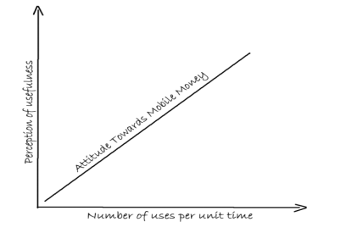
Figure 1: Factors that influence user attitude towards mobile money
1.6 Study delimitation
Mobile money service providers in their quest to drive financial inclusion have not just limited themselves to facilitating withdraws and deposits for their customers but have gone further to innovate by providing other value added services such as bill payment, airtime and data purchase ,merchants services and loans .That said, the importance of researching on the influence of mobile money services on Zambia’s banking sector was to find out what strategies and innovations commercial banks are putting in place to serve their customers. It must further be stated that this research was confined to Livingstone residents owning active mobile money accounts, management and staff from Zanaco, mobile money agents, Xapit customers and Zanaco Express Agents. Further, semi structured questionnaires were used to collect data using purposive sampling method
1.7 Limitations of the Study
One of the limitations that the researcher faced was conducting the research work whist working. In addition, some respondents such as mobile money agents had to be visited more than three times during questionnaire collection as they have a tendency of closing their outlets whenever they go to fetch float or cash
1.8 Operational Definition of Terms
Banking Sector: This is the section of the economy devoted to the holding of financial assets for others, investing those financial assets as leverage to create more wealth and the regulation of those activities by government.
Financial Inclusion: This is defined as the availability and equality of opportunities to access financial services. It refers to processes by which individuals and business can access appropriate, affordable and timely financial products and services. These include banking, loan, equity and insurance products
Mobile Money: This is the use of a mobile phone in order to transfer funds between banks or accounts, deposit or withdraw funds, or even pay bills. This term is also used for the broader realm of electronic commerce, it can refer to the use of a mobile device to purchase items, whether physical or electronic.
Mobile Banking: It is a service provided by a bank or other financial institution that allows its customers to conduct financial transactions remotely using a mobile device such as a phone or tablet. The transactions on the mobile banking app including checking of balances, lists of latest transactions ,electronic bill payments as well as funds transfers between a customer’s and other accounts
Zanaco Express: This is a partnership with a large number of agents in urban and rural areas through which zanaco customers can deposit cash into a zanaco account or can withdrawal money from their own account at zanaco
Xapit: This is zanaco’s mobile banking platform that gives you all traditional banking services conveniently packaged on ones’ mobile device. It allows one to manage their bank accounts and perform transactions that are also available in the various zanaco branches.
Telecommunication: This is basically the communication over a distance by cable, telegraph, telephone or broadcasting. It is the communication at a distance using electrical signals or electromagnetic waves. Four examples of telecommunications systems are the telephone network, radio broadcasting system, computer networks and the internet.
MNOs: This is a telecommunications service provider organization that provides wireless voice and data communication for its subscribed mobile users. MNOs are also known as carrier service, mobile phone operator and mobile network carriers
Financial Services: This is the professional service involving the investment, lending and management of money and assets. Financial services are concerned with the design and delivery of financial instruments and advisory services to individuals and businesses within the area of banking and related institutions, personal financial planning, investment, real assets, and insurance etc.
Non- bank Financial Sector: The non-financial services sector includes economic activities, such as computer services, real estate, research and development, legal services and accounting. These include insurance firms, venture capitalists, currency exchanges, some microloan organizations, pawn shops. These non- banking financial institutions provide services that are not necessarily suited to banks and specialize in sectors of groups.

CHAPTER TWO
LITERATURE REVIEW
2.1 Introduction
The University of Wolverhampton (2018) defines literature review as a comprehensive review of the literature available for any given research question. It is a summary, analysis and evaluation of the literature and an explanation of what research has already been performed for a research area. Cooper and Schindler (2016) state that literature review is an account of what has been published on a topic by accredited scholars and researchers.
That having been said, it is imperative to state that the structure of the Literature Review is based on three perspectives namely global, regional and local. In today’s time and age, mobile phones have become a major transacting tool in almost all business sectors and the banking sector has not been left out. This study seeks to explore literature on the influence of mobile money services on Zambia’s banking sector, a case study of Zanaco-Livingstone
2.1.1 Global Perspective
Berger (2003) found information technology (IT) innovations to have a positive impact on overall economic growth through positive effects on banking systems and bank efficiencies. Waverman et al (2005) find investments in mobile telecommunication infrastructure to have a positive and significant impact on economic growth. Specifically, they find that a unit increase in mobile phone penetration increased economic growth of a country by 0.039 percent. They further conjecture this impact may be twice as large in developing countries as compared to developed countries due to the absence of landline infrastructure.
According Adams (2019) globally, the Philippines were the first adopters of the mobile money when Smart Communication introduced Smart Cash in 2001. The first services used sim tool kits which has the capacity for consumers to purchase airtime and other service domestically and internationally. In 2004, Globe Telecom launched G Cash which offers services such as cashless method for simplifying money remittances, settle loans, disburse salaries or commissions and pay bills, products and services via text messages. Mobile money has done more to extend the reach of financial services in the last decade than traditional brick and mortar banking hall done has in the last century.
Whereas the study by Adams (2020) focused on how mobile money has outpaced traditional brick and mortar banking, it was however silent on identifying reasons why most telecommunications companies have diversified to mobile money services other than providing data and voice services to their customers or subscribers
Onwuaso (2020) reports that for over a decade, mobile money has been driving financial inclusion, opening access to digital transactions and giving people the tools to better manage their financial lives. Today, there are more than a billion registered mobile money accounts globally, spread across 290 mobile money deployments that are live in 95 countries. In Africa over 50.7 million new registered mobile money accounts were opened in 2019-2020 alone, taking the total number of registered accounts in the region to 481 million. The total transaction volume and value for mobile money during this period was 24 billion and $461 billion (up by 20% and 27%) respectively, the organization stated.
It must however be mentioned that the study by Onwuaso(2020) concentrated on the benefits that people are able to derive from mobile money such as bettering their lives through financial inclusion and did not give a background of what could have prompted commercial banks to embark on mobile banking
In addition, the COVID 19 global pandemic has accelerated the need for mobile money and digital technology on the African Continent. This has created a platform for innovation. New companies are emerging with service offerings aligned to a new way of transacting, further unlocking employment opportunities but also highlighting a need for skills development as the world digitally transforms. This is evident that payment technology and telecommunication infrastructure investments independently have shown positive effects on economic growth, it is expected that coupled together there would be an even greater positive effect for an economy.
2.1.2 Regional Perspective
The 2015 GSMA report states that Sub-Saharan Africa accounted for more than half of the 255 live mobile money services across the globe in 2014. Further, the report mentions that of all the regions, Sub Saharan Africa records the highest level of mobile money penetration. The SADC regional block hosts some of the most developed mobile markets in Sub Saharan Africa, including South Africa, Mauritius and Angola
According to Mutsonziwa and Beyene (2016) South Africa is the largest mobile market, accounting for nearly one third of total subscribers with 38 million unique subscribers as of June 2015. The GSMA report further states that the SADC region has the second biggest smartphone penetration market in the region, and the highest smartphone adoption rate at a quartet of total connections. The total number of smart phones is forecast to reach 198million by 2020, taking the adoption rate to nearly 60 %( GSMA2015)
However the study did not mention some of the benefits that subscribes enjoy when they activate their simcards on mobile money some of which are easy of use, speedy of registering as a subscriber (KYCs), payment of bills, access to affordable loans and purchase of goods and services
2.1.3 Basic Phone Usage
In an increasing number of developing countries, it is imperative to state that millions of poor people are using basic mobile phones to transfer money, paying for goods and accessing sophisticated financial services such as credit, insurance and savings accounts Donavan (2012).
According to Mutsonziwa (2016), the Finscope data has seen an increase in the usage of mobile money across the SADC region but the usage differs significantly from country to country. Fincope research has further shown that mobile money has become an important contributor for financial inclusion.
According to the World Bank, mobile financial services are among the most promising mobile applications in the developing world. Undoubtedly, mobile money (m-money) could become a general platform that transforms the entire economies, as it is being adopted across commerce, health care, agriculture and other sectors.
The story of mobile money story is not complete without mentioning the M-Pesa story of Kenya. Mutsonziwa and Maposa (2016) have stated that the M-Pessa story is a well-known and documented success of mobile money service offered by Safaricom that helped other markets to learn from it. It is therefore not surprising that mobile money is increasingly becoming one of the key drivers of financial inclusion especially in the emerging
2.1.4 Mobile Money Efficiency
Mutsonziwa (2016) states that the Boston Consulting Group(BCG) shows that US1billion in remittances flow out of South Africa to other countries in the Southern African Development Community (SADC) annually. Further the BCG research shows that of the total amount, more than $650 million reaches recipients through informal channels such as private agents or family and friends travelling between locations. Taking into account the risks associated with informal channels of remitting, mobile money becomes a very important, secure and efficient alternative to be used in the SADC region
Research by Fin Mark Trust on remittances shows the remittances across the South African borders is very expensive for using the formal channels like banks and other formal agents line MoneyGram and Western Union. Taking the coverage of mobile network operators (MNOs) in the SADC region, mobile money is a cheaper alternative.
Research has shown that mobile money has revolutionized financial services in several African countries, lowering transaction costs and thus providing consumer and small businesses with easy, cheap and safe ways to transact more effectively. An article by the Centre for Competition, Regulation and Economic Development (CCRED) researcher uses the experience in Kenya to demonstrate that mobile money can be instrumental in bringing people into the formal economy, generating information on individuals’ transacting behaviour and thus creating better risk profiles and a credit record which can be used to offer them financial services that would otherwise be inaccessible. The success of M-Pesa in Kenya is often attributed to the friendly and flexible regulatory approach of the central bank of Kenya.
2.1.5 Mobile Money Partnerships
The research by BCG mentions that banks and mobile network operators should consider partnerships, as neither has everything required for it to succeed on its own. Further the research argues that banks have the back-office systems and the understanding of risk and financial industry regulations while the mobile network operators have the access to customers and large distribution networks. Developments in the SADC region have started these partnerships. An example of such partnerships is the Eco Cash Diaspora product which is a partnership between World remit and Econet Wireless of Zimbabwe launched in June 2014.
2.1.6 Revolution in Information and Communication Technologies
Tchouassi (2012) states that empirical evidence from selected Sub Saharan African Countries) shows that access to mobile phone technology has revolutionized just about every aspect of Sub Saharan African lives. Revolutions in information and communications technology (ICTs), the emergence of innovation and knowledge societies, the eradication of poverty, vulnerability and inequality, among others, have been identified in 2010 as major challenges of the 21st century. Electronic banking (E-Banking) enables customers to do their banking 24 hours a day, 7 days a week. E-Banking customers are able to check their account balances, pay bills, apply for a loan, trade securities and conduct other financial transactions.
E-Banking can be divided into five major categories, internet banking, telephone banking, TV based banking, Mobile phone banking, personal computer (PC) banking.
Ibid(2012) further argues that the increasing competition for customers in the banking sector, the need to decrease cost of providing banking services and the need to bank those who do not have access to bank accounts ,known as the “un-banked”, have led banks to integrate these changes.
2.1.7 Role of Mobile Phone in Unbanking the Poor
In this regard, certain questions arise. For instance, do mobile phones play an important role in the process of unbanking the poor and the vulnerable in Sub Saharan Africa at the turn of the millennium? Poor vulnerable and low-income households in Sub Saharan Countries often lack access to bank accounts and face high costs for conducting basic financial transactions through check cashers and other alternative financial service providers
2.1.8 Information communication technology and improved productivity
The positive effect of information communication technology (ICT) on improved productivity in medium and large firms is well documented in developed countries through a myriad of firm and sector case studies. However, the literature on the effects of ICT on micro and small enterprises is limited. On the basis of field research in Botswana, Duncombe and Heeks (2002) find that poor rural entrepreneurs rely heavily on informal, social and local information systems. While highly appropriate in many ways, these systems can also be constrained and insular. Greater access to shared telephone services can help break this insularity. Additionally, Duncombe (2007) finds the poor may benefit more from ICT if it is applied to strengthen a broader range of social and political assets and if it is used to build more effective structures and processes that favour the poor. Subsequently, Donner (2007) finds mobile phone use by micro-entrepreneurs in Kigali, Rwanda enables new business contacts and amplifies existing social relationships. Summarizing 14 research studies for micro and small enterprises (MSEs) Donner (2010) finds mobile phone use alone even without the payment services helps many MSEs become more productive through improvements in sales, marketing and procurement processes. Consequently, there is an opportunity to investigate the marginal impact of mobile money on low-income household enterprises in the least developed countries, which as the literature shows traditionally have not had access to such transformative technology.
2.1.9 Local Perspective
Zambia information and Communication Technology Authority (ZICTA 2015) reports that around 64.5 percent of the households in Zambia had access to mobile phones determined by at least one member of the household owning a mobile phone. Zambia was one of the pioneers of mobile money in Africa when Celpay was introduced in 2001.Celpay introduced a payment network connecting post offices in the country. Other entrants to the market include Mobile Transaction (MT) now called Zoona in 2009, which targeted to aid companies in the agriculture product market make payments to the unbaked rural farm suppliers. Bank led mobile payment system like Zanaco Bank’s Xapit in 2008 and Standard Chartered Bank also introduced Mobile Banking in 2011.
Mwiza and Eliya (2019)) reports that Zambia has three Mobile Network Operators(MNO’s) providing mobile communication and telecommunication services namely Bahati Airtel (Airtel), MTN (Mobile Telecommunication Network) and Zamtel. When MNO Mobile Money was introduced in Zambia, Airtel had the largest share of mobile phone subscribers with about 51.8 percent of the total subscribers, MTN had 33.1 percent while Zamtel had 15.1 percent. Airtel Money was launched by Airtel in September 2011. In January 2012, MTN Zambia the second largest MNO at the time also introduced mobile money service under the name”MTN Mobile Money”. As at March 2015, there were over 9,107,538 mobile phone subscribers while 5,234,129 had mobile money subscriptions representing 57.6% of the mobile phone subscribers. Be that as it may, the above study was silent on what led the three Telcos in Zambia namely Airtel Networks Zambia and Zamtel to provide mobile money services in the country
2.1.10 Adoption of Mobile Money by Zanaco
Zanaco introduced Xapit in Zambia in 2008 to help bank the unbanked by providing a low cost service through combining traditional banking (a normal account) with Self Service Banking Technologies (SSBTs) which include, mobile banking, online banking and access to Automated Teller Machines (ATMs)(Zanaco,2010;Wiessin 2010). The year of introduction makes Xapit the first service in Zambia to introduce a full range of SSBTs to clients in the Zambian banking market.
Kaulu and Sichinsambwe (2018) state that upon introduction, the uptake of the product was “highly successful” according to Kruger (2011). He further assets that Zanaco decided to launch Xapit using an Unstructured Supplementary Service Data (USSD) cell phone banking application for Airtel customers and as WAP and J2ME cell phone banking applications for MTN customers. The varying applications made and still make it possible for customers to use various networks to access their accounts and do their banking effortlessly. Habeenzu (2010) asserts that Xapit is “a transformative mobile banking solution.” which provides a low-value low-risk banking account with an internet enabled visa debit card combined with SMS-banking.
Based on the foregoing, it can be deduced that Xapit was designed with a “customer centric” focus and came to provide affordable but useful banking services to both the banked and unbanked
The findings above are however silent on what could have prompted Zanaco to diversify to mobile banking (Xapit) and set up Zanaco Express Agents countrywide besides the normal bank account savvies that they still continue providing through their brick and mortar branches
2.1.11 Bill Payment
This is another feature that Zanaco has adopted as part of their mobile money services. According to Mas and Almazan (2014), this is a facility that allows a corporate entity (the biller) to receive payments from a broad base of users of mobile money. It can be thought of as a structured collection of individual wallet-based or over the counter P2P payments, with the following enhancements such as high transactionality accounts were the biller need a collection account with higher balance and transactional limits, to accommodate potentially high transaction volumes. The biller is at the same time subjected to more stringent KYC requirements
2.1.12 Agri Pay
User (2020) reports that the average rural farmer in Zambia lives several kilometers away from the nearest settlement where shops ,agro-dealers and other services such as agency banking and mobile money booths would be located. Because the farmers live in remote locations, making payments, sending and receiving money are activities not done at their convenience.
Zambia has over two million small holder farmers and a rural population of about 9.7million people with approximately 40 percent of them being financially excluded. These rural people do have the adequate access to financial infrastructure and services. No being able to make payments for supplies, receive digital payments or send money as needed means farmer’s productivity is limited. Subsequently, they cannot plan their next growing season, are unable to manage the shocks they may experience and cannot reach their potential. Therefore, providing small holder farmers with the services they need to improve their productivity has a ripple effect on their livelihoods and the rural community.
It must therefore be pointed out that Zanaco Bank recognized that smallholder farmers are an important segment of Zambia’s economy and partnered with the UN Capital Development Fund (UNCDF) and Agriffin Accelerate (AFA) Mercy Corps to develop and test the go to market strategy for an account that offers farmer’s services to transact, save, send and receive money.
The first research conducted by AFA to understand precisely what the farmers needed and what their specific financial challenges were. This research informed the human -centred design process of product development undertaken by Zanaco.
A product was available, strategies were designed to bring the product to the rural market. This strategy involved applying the Booster Team Model-a concept from UNCDFs work in Uganda with a coffee value chain. UNCDF championed the use of Booster Team to onboard agents that would enhance last-mile service delivery and build a strong ecosystem around the use of the Agri Pay account.
By the end of the pilot, 50 percent of the Xpress Agents on boarded were a result of the partnership with Musika (a non-profit organization that aims to support private sector development in small scale agriculture) and 60 percent of the activated farmers accounts were members of the cotton Association of Zambia. Zanaco piloted the product in six provinces. The Booster Teams, comprising 15-20 youths, received adequate training in sales and product knowledge, and approached potential customers with a product they could demonstrate
In May 2019, Zanaco and UNCDF deployed the Booster Team to undertake their sensitization and on-boarding activities, beginning in Central and Lusaka Provinces, continuing to Copperbelt, Eastern, Luapula and Southern.
By September 2019, 3030 customers, 53percent female and 31percent youth had been on boarded onto AgriPay and farmers were pleased with the introduction of the account designed with their specific needs in mind. The Agri Pay pilot achieved what it aimed to do-increase access and usage of digital inclusive services by undeserved segments of the population. Agri Pay is also successful because it provides a platform to increase farmers’ financial inclusion, and the account also allows digital expansion for the smallholder farmer and the community in which they live. Schools, hospitals, district or provincial offices can leverage the digital platform to carry out other activities in the community. Fashion, where customers purport to be depositing in their account but actually deposit it in someone else´s, thereby bypassing the P2P charge.
2.2 Research Gap
For all these past years, mobile money literature is still limited and there is no research study conducted on the influence of mobile money services on Zambia’s Banking Sector, A case Study of Zanaco. Therefore, this study seeks to explore this area.

CHAPTER THREE
RESEARCH METHODOLOGY
- Introduction
This chapter presents the research methodology that was used for this study under the following sub-headings: research design, target population, sampling techniques, sample size, data collection instruments, and data analysis techniques
  - Research design
The case study research design using qualitative and quantitative data collection methods was appropriate for this study because it made it possible to secure evidence on the effects of mobile money Services on Zambia’s banking sector with particular focus on zanaco.
According Sturman (1997) a case study is a general term for the exploration of an individual, group or phenomenon. It is a comprehensive description of an individual case and its analysis i.e. the characterization of the case and the events as well as a description of the discovery process of these features that is the process of the research itself.
3.2 Study Site
Located in Southern Province, Livingstone Town is a Tourist capital of Zambia. It is also a nerve centre for visitors to the mighty Victoria Falls. The adjoining the Victoria falls is the Mosi- Oa-Tunya National Park which surrounds the Zambian side of the falls lying 10 km (6.2 mi) to the north of the Zambezi River. The town is a border town with road and rail connections to Zimbabwe on the other side of the Victoria Falls. The border post is located about 15 kilometers South-East of the central business Town.
3.3 Target Population
The research targeted 100 Livingstone residents who have mobile money accounts. Data got from a sample of 60 from the targeted population was used to generalize the findings to this research. According to Borg and Gall (1989), target population is the number of real hypothetical set of people, events or objects to which a researcher wishes to generalize his findings.
3.4 Sample Size
As indicated above, a sample size composed of 50 participants from Livingstone town who also have mobile money accounts and 10 participants who work in Zanaco bank making total of 60.
3.5 Sampling Techniques
Purposive Sampling procedure was used. As indicated above, a sample size composed of 60 participants from Livingstone town who also have mobile money accounts.
3.6 Data collection instruments
The research instruments that was used to collect data were questionnaires. This was the most time efficient and flexible tool in collecting data. The questionnaires included both open and closed ended questions. The inclusion of open-ended questions was intended to dig into as much insight as possible while answering the questions of the questionnaire.
3.7 Data analysis
This research used both qualitative and quantitative techniques to analyze the data obtained. These types of data were purposely used to ensure accuracy and completeness. Data was analyzed using excel, Likert scale analysis and explanatory method on the collected data. Shamoo and Rensik (2003) define data analysis as a process of systematically applying statistical and or logical techniques to describe and illustrate, condense and recap, and evaluate data. Various analytical procedures provide a way of drawing inductive inferences from data and distinguishing the signal (the phenomenon of interest) from the noise (statistical fluctuations) present in the data. Marshall and Rossman (2016) describe data analysis as the process of bringing order, structure and meaning to the mass of collected data .It is described as messy, ambiguous and time consuming, but also as a creative and fascinating process. One can therefore conclude that data analysis requires some sort or form of logic applied to research.
Verma and Mallick (2009) on the other hand state that the interpretive approach which involves deduction from the data obtained, relies more on what it feels like to be a participant in the action under study, which is part of the qualitative research. Very often, the researchers rely on their experience of a particular setting to be able to read the information provided by the subjects involved in the study
3.8 Validity and Reliability
Camines and Zeller (1979) state that reliability concerns the extent to which a measurement of a phenomenon provide stable and consistent result. It is also conferenced with repeatability. For example, a scale or test is said to be reliable if repeat measurement made by it under constant conditions will offer the same results. Taherdoost (2016) mentions that the most commonly used internal consistent measure is the Cronbach Alpha coeffient. A scale is said to have high internal consistence reliability if the items of a scale “hang together” and measure the same construct.
According to Drost (1995), validity is concerned with the meaningfulness of research components. When researchers measure behavior, they are concerned with whether they are measuring what they intended to measure. For example, does the IQ test measure intelligence?
That having been said, it is imperative to state that, the reliability of the questionnaires was therefore tested using Cronbach alpha coefficient. All this was done to validate the research instrument which we was used so as to ensure content validity and reliability.
3.9 Ethical consideration
According to Roshaidai and Arifin (2018), the protection of human subjects through the application of appropriate ethical principles is important in any given research study. In a qualitative study, ethical considerations have a particular resonance due to the in-depth nature of the study process. According to Schuman, (2002), confidentiality and secrecy is important in the method in which data is collected and how the participant is identified.
It must therefore be mentioned ethics were adhered to with a focus to ensuring that the credibility of the research is promoted at the highest degree.
- Permission was obtained both from Zanaco and the Research Ethics Committee. Participants were informed in advance before approaching them in answering the questionnaires.
- The researcher worked to ensure that everything done at each and every step was within the confines of the law. For example none of the Participants was bribed as a way of inducing them to be part of the sample or give information in a pre-determined manner.
- The researcher strove for honesty at each and every stage of this study. It reports data, results, methods and procedures, and publication status in an honest manner by avoiding fabrication, falsifying, or misrepresentation of data. The study also avoided bias in research design, data analysis and data interpretation.
- The researcher strove to maintain his integrity throughout this research process for example by keeping appointments with Participants.
- The works that do not belong to this author of the paper have been acknowledged using Harvard Referencing System in an appropriate format.
- The researcher avoided careless errors and negligence by keeping good records of research activities, such as data collected correspondences and journals. All data was backed up on both the computer and external drives

CHAPTER FOUR
DATA PRESENTATION
4.0 Introduction
This research study was aimed at highlighting the influence of mobile money services on Zambia’s banking sector - a case study of Zanaco Livingstone. Data was collected through the use of questionnaires from who were gotten from a sample size of 60 respondents which was represented from the staff at Zanaco and mobile money subscribers/agents and Zanaco Express agents
Section A
Presentation of data from the mobile money subscribers/agents and Zanaco express agents
4.1 Demographic data
The demographic characteristics of participants are important. The omission of even the basic or minimal of this information would have restricted the researchers' ability to draw valid conclusions. The demographic characteristics of the participants were gender and age. These were included in order to have a valid population group from which to derive the sample. Gender and age are important factors in assessing economic aspects of a population.
4.1.1Presentation of findings on Age
Table 4.1; Age distribution
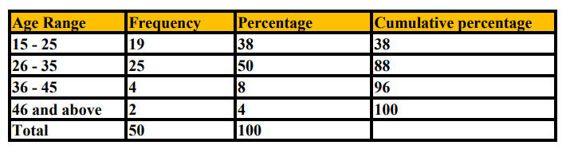
Source: field work 2020
Figure 4.1 Age Distribution
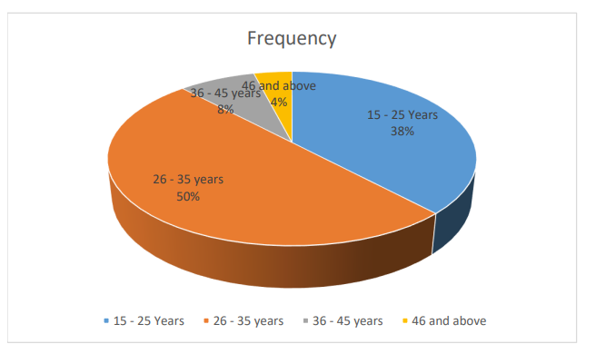
In terms of age distribution of the Participants, Table 4. 1. and Figure 4. 1. Show that the majority were aged 26 to 35 years (50%) and 15 to 25 years (38%). Others were aged 36 to 45 years (8%) while the minority were those aged above 45 years (4%).
4.1.2 Presentation of findings on Gender
Table 4.2; Gender distribution
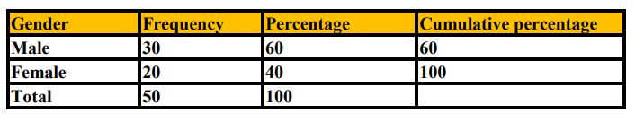
Source: field work 2020
Figure 4.2 Gender distribution
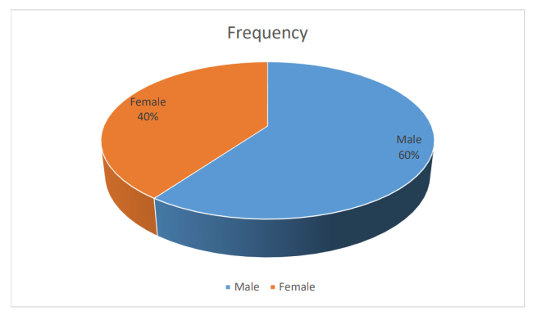
Table 4. 2. and Figure 4. 2. Show that by gender, the majority of Participants, that is
60% were males while 40% were female.

Section B
4.3 Presentation of findings on Accessibility of Mobile Money Services
In live with the objective of this study to ascertain the accessibility of mobile services. The rating scale was 5= strongly agree, 4= Agree, 3=Undecided, 2= Disagree, 1= Strongly Disagree.
The findings are presented in table 4.3 below.
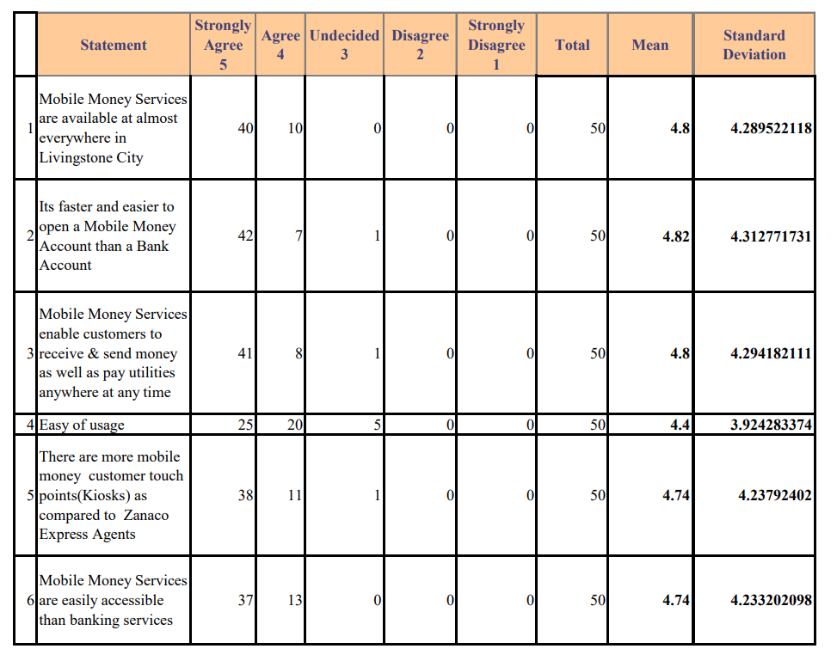
Source: field work 2020
The findings presented using Likert Scale Average in table 4.3. On Accessibility of Mobile Money Services, the majority (40) strongly agreed, on the statement that mobile money services are available at almost everywhere in Livingstone. (10) Respondents also agreed and none of the respondents were undecided, disagreed or strongly disagreed to the statement and the resulting average mean score of 4.8 which on the Likert scale is between strongly agreeing and agreeing to the statement.
On the statement that its faster and easier to open a mobile money account than a bank account, of, the majority (42) strongly agreed, on the statement, (7) respondents also agreed, (1) respondent was undecided and none of the respondents, disagreed or strongly disagreed to the statement and the resulting average mean score of 4.82 which on the Likert scale is between strongly agreeing and agreeing to the statement.
On the statement that mobile money services enable customers to receive and send money as well as pay utilities anywhere at any time, the majority (41) strongly agreed, on the statement, (8) respondents also agreed, (1) respondent was undecided and none of the respondents, disagreed or strongly disagreed to the statement and the resulting average mean score of 4.8 which on the Likert scale is between strongly agreeing and agreeing to the statement.
On the statement that mobile money services is easy to use, the majority (25) strongly agreed, on the statement, (20) Respondents also agreed, (5) respondent were undecided and none of the respondents, disagreed or strongly disagreed to the statement and the resulting average mean score of 4. 4 which on the Likert scale is between strongly agreeing and agreeing to the statement.
On the statement that, there are more mobile money customer touch points (Kiosks) as compared to Zanaco express agents, the majority (38) strongly agreed, on the statement, (11) Respondents also agreed, (1) respondent was undecided and none of the respondents, disagreed or strongly disagreed to the statement and the resulting average mean score of 4. 74 which on the Likert scale is between strongly agreeing and agreeing to the statement.
On the statement that Mobile Money Services are easily accessible than banking services, the majority (37) strongly agreed, to the statement, (13) Respondents also agreed and none of the respondents were undecided, disagreed or strongly disagreed to the statement and the resulting average mean score of 4.74 which on the Likert scale is between strongly agreeing and agreeing to the statement.
4.4 Reliability of Mobile Money Services
In live with the objective of this study to ascertain the reliability of mobile services. The rating scale was 5= strongly agree, 4= Agree, 3=Undecided, 2= Disagree, 1= Strongly Disagree.
The findings are presented in table 4.4 below.
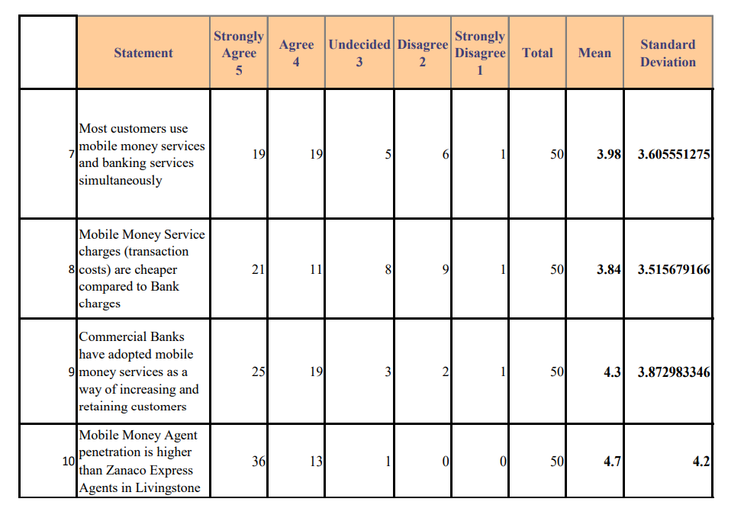
Source: field work 2020
The findings presented using Likert Scale Average in table 4.4. On reliability of Mobile Money Services, the majority (19) strongly agreed and (19) agreed, on the statement that most customers use mobile money services and banking services simultaneously. (6) Respondents disagreed, (1) strongly disagreed and (5) were undecided on the statement and the resulting average mean score of 3.98 which on the Likert scale is between agreeing and undecided to the statement.
On the statement that mobile money services charges (transaction costs) are cheaper compared to bank charges, the majority (21) strongly agreed, (11) agreed, (9) disagreed, (8) were undecided and (1) strongly disagreed on the statement and the resulting average mean score of 3.84 which on the Likert scale is between agreeing and undecided to the statement.
On the statement that commercial Banks have adopted mobile money services as a way of increasing and retaining customers, the majority (25) strongly agreed, (19) agreed, (2) disagreed, (3) were undecided and (1) strongly disagreed on the statement and the resulting average mean score of 4.3 which on the Likert scale is between strongly agreeing and agree to the statement.
On the statement that mobile money agents penetration is higher than Zanaco Express agents in Livingstone, the majority (36) strongly agreed, (13) agreed, (1) was undecided and none of the respondents disagreed, or strongly disagreed on the statement and the resulting average mean score of 4.7 which on the Likert scale is between strongly agreeing and agree to the statement.
4.5 Convenience and safety of mobile money services
In live with the objective of this study to ascertain the convenience and safety of mobile services. The rating scale was 5= strongly agree, 4= Agree, 3=Undecided, 2= Disagree, 1= Strongly Disagree
The findings are presented in table 4.5 below.
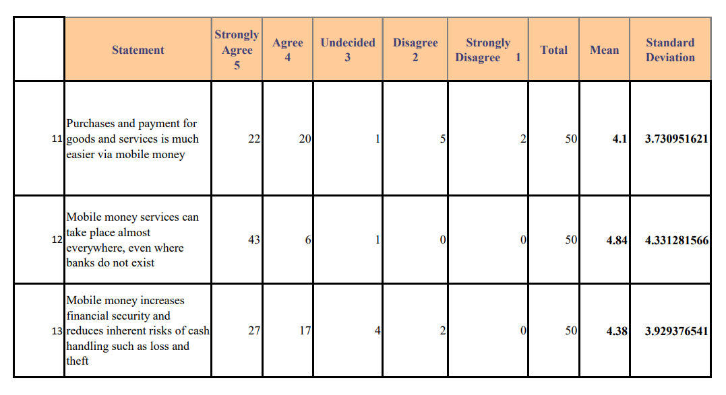Source: field work 2020
The findings presented using Likert Scale Average in table 4.5. On convenience and safety of mobile money services, the majority (22) strongly agreed and (20) agreed, on the statement that purchases and payment for goods and services is much easier via mobile money, (5) Respondents disagreed, (2) strongly disagreed and (1) respondent was undecided on the statement and the resulting average mean score of 4.1 which on the Likert scale is between strongly agreeing and agree to the statement.
On the statement that mobile money services can take place almost everywhere, even where banks do not exist, the majority (43) strongly agreed, (6) agreed, (1) was undecided, and none of the respondents disagreed, or strongly disagreed on the statement and the resulting average mean score of 4.84 which on the Likert scale is between strongly agreeing and agree to the statement.
On the statement that mobile money increases financial security and reduces inherent risks of cash handling such as loss and theft, the majority (27) strongly agreed, (17) agreed, (4) were undecided, (2) disagreed and none of the respondents strongly disagreed, on the statement and the resulting average mean score of 4.38 which on the Likert scale is between strongly agreeing and agree to the statement.
14.0 Most of the respondents outlined that they do visit mobile money kiosks more than they visit commercial banks. Findings presented in the below table 4.6
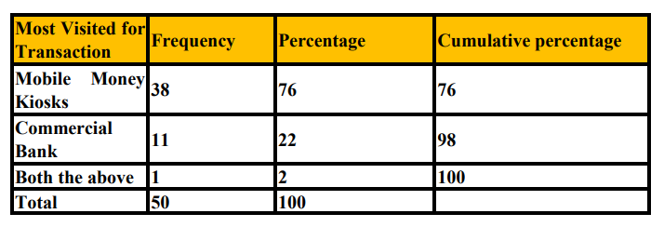
Source: field work 2020

Figure 4.3
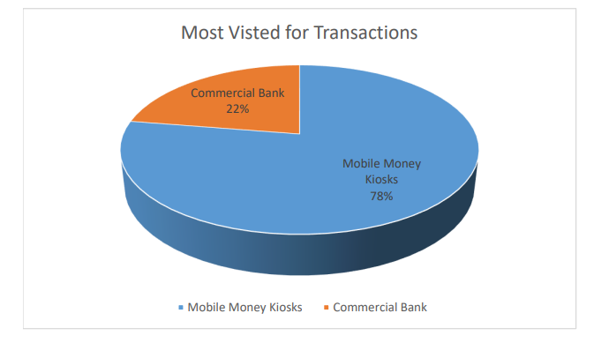
15. 0 Most of the respondents outlined that mobile money agents always have adequate float and cash all the time. However, some respondents outlined that Zanaco express agents have more float cash and working capital compared to mobile money agents.
Findings presented in the below table 4.7
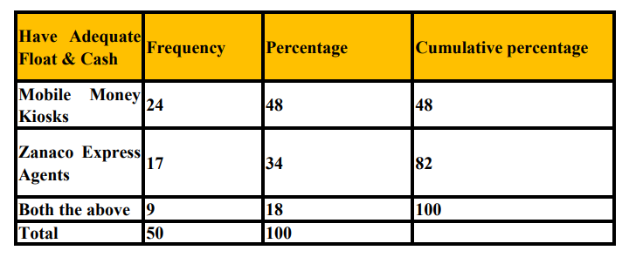
Source: field work 2020
Figure 4.4
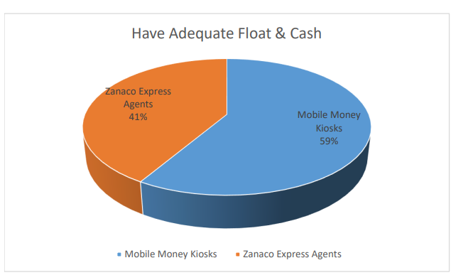
Section C
Presentation of data from Zanaco Staff - Livingstone
The demographic characteristics of the participants were gender and age and occupation
16.0 Presentation of findings on Age
Table 4.8: Age distribution
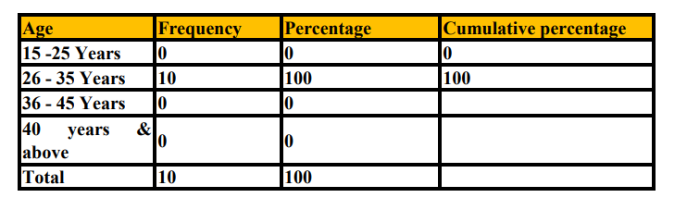Source: field work 2020
Figure 4.5
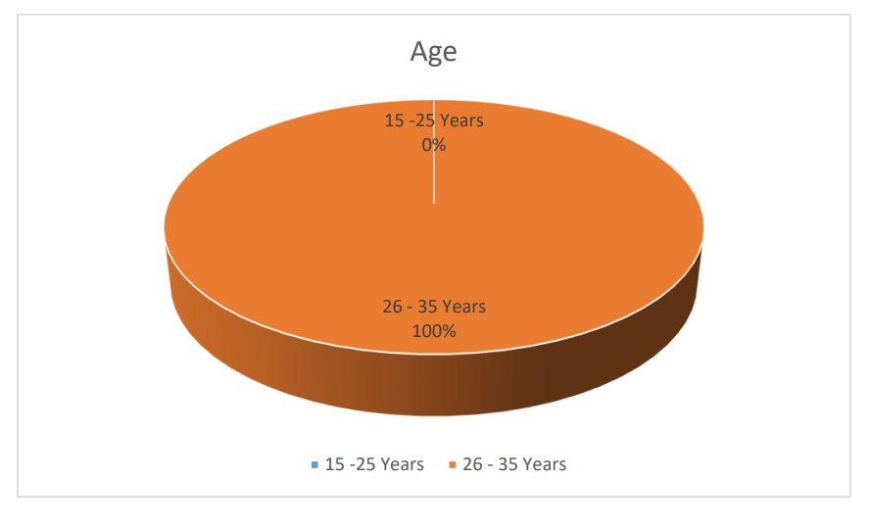
In terms of age distribution of the Participants Zanaco Staff, Table 4.8. And Figure 4. 5. Show that the all the participants were aged 26 to 35 years (100%)
17.0 Presentation of findings on Gender
Table 4.9: Gender distribution
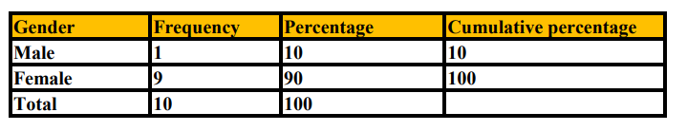
Source: field work 2020

Figure 4.6
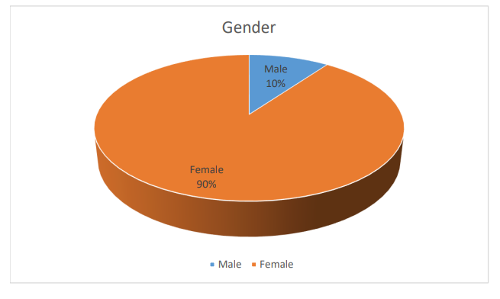
Table 4. 9. and Figure 4. 6. Show that by gender, the majority of Participants, that is
90% were females while 10% were males
18.0 Presentation of findings on Occupation
Table 4.10: Occupation distribution
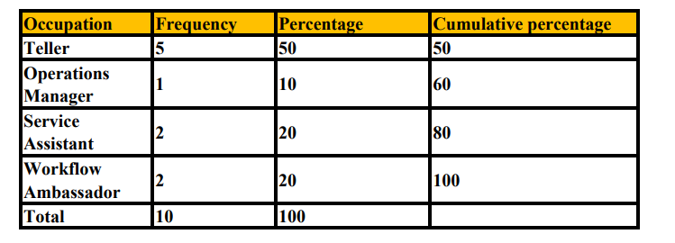Source: field work 2020
Figure 4.7
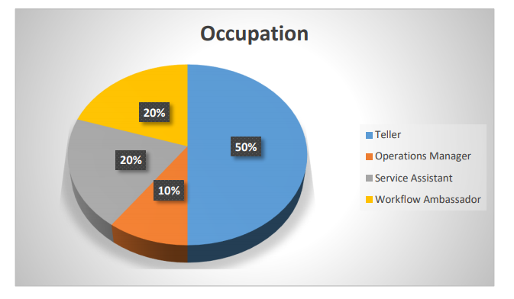
Table 4. 10. and Figure 4. 7. Show that by occupation, the majority of Participants, that is
50% were bank tellers while 20% representing the service assistants and workflow ambassadors, 10% the operation manager.
19.0 Revenue and Profitability
The level of agreement on the statements in the table to the effect of mobile money on Zanaco’s revenue, profitability, loans and market share. The rating scale was 5= strongly agree, 4= Agree, 3=Undecided, 2= Disagree, 1= Strongly Disagree
The findings are presented in table 4.11 below.
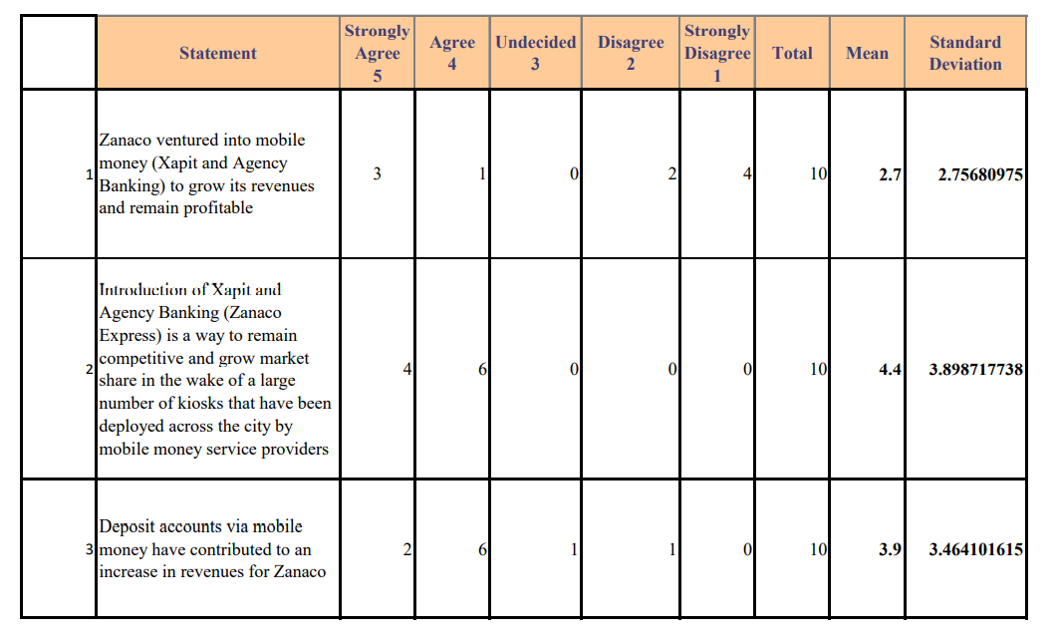Source: field work 2020
The findings presented using Likert Scale Average in table 4.11. On revenue and profitability, the majority (4) strongly disagreed, and (2) disagree on the statement that Zanaco ventured into mobile money (Xapit and Agency banking) to grow its revenues and remain profitable. (3) Respondents strongly agreed, (1) agreed and none of the respondents were undecided, to the statement and the resulting average mean score of 2.7 which on the Likert scale is between disagreeing and undecided to the statement.
On the statement that introduction of Xapit and agency banking (Zanaco Express) is a way to remain competitive and grow market share in the wake of a large number of kiosks that have been deployed across the city by mobile money service providers, the majority, (6) agree and (4) strongly agree and none of the respondents were undecided, disagreed or strongly disagreed to the statement, and the resulting average mean score of 4.4 which on the Likert scale is between strongly agreeing and agree to the statement.
On the statement that deposit accounts via mobile money have contributed to an increase in revenues for Zanaco, the majority, (6) agree and (2) strongly agree, (1) undecided, (1) disagree and none of the respondents strongly disagreed to the statement, and the resulting average mean score of 3.9 which on the Likert scale is between agreeing and undecided to the statement.
20.0 Customer Acquisions & Service Delivery
The level of agreement on the statements in the table to the effect of mobile money on Zanaco’s customer acquisions and service delivery. The rating scale was 1= strongly agree, 2= Agree, 3=Undecided, 4= Disagree, 5= Strongly Disagree.
The findings are presented in table 4.12 below.
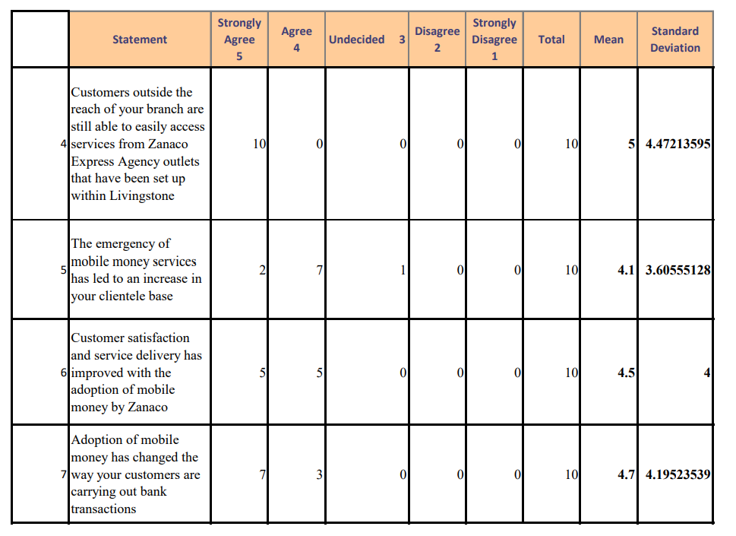
Source: field work 2020
The findings presented using Likert Scale Average in table 4.12. On Customer Acquisions and Service Delivery, the majority (10) strongly agreed to the statement that customers outside the reach of your branch are still able to easily access services from Zanaco Express agency outlets that have been set up within Livingstone, and none of the respondents disagreed, strongly disagreed or were undecided, to the statement and the resulting average mean score of 5 which on the Likert scale is strongly agreeing to the statement.
On the statement that the emergency of mobile money services has led to an increase in Zanaco bank clientele base, the majority, (7) agree and (2) strongly agree, (1) undecided, and none of the respondents strongly disagreed or disagreed to the statement, and the resulting average mean score of 4.1 which on the Likert scale is between strongly agreeing and agree to the statement.
On the statement that customer satisfaction and service delivery has improved with the adoption of mobile money by Zanaco bank, the majority, (5) agree and (5) strongly agree, and none of the respondents were undecided, strongly disagreed or disagreed to the statement, and the resulting average mean score of 4.5 which on the Likert scale is between strongly agreeing and agree to the statement.
On the statement that adoption of mobile money has changed the way Zanaco customers are carrying out bank transactions, the majority, (7) strongly agreed and (3) agreed, and none of the respondents were undecided, strongly disagreed or disagreed to the statement, and the resulting average mean score of 4.7 which on the Likert scale is between strongly agreeing and agree to the statement.
21.0 Loans
The level of agreement on the statements in the table to the effect of mobile money on Zanaco’s Loans. The rating scale was 1= strongly agree, 2= Agree, 3=Undecided, 4= Disagree, 5= Strongly Disagree.
The findings are presented in table 4.13 below.
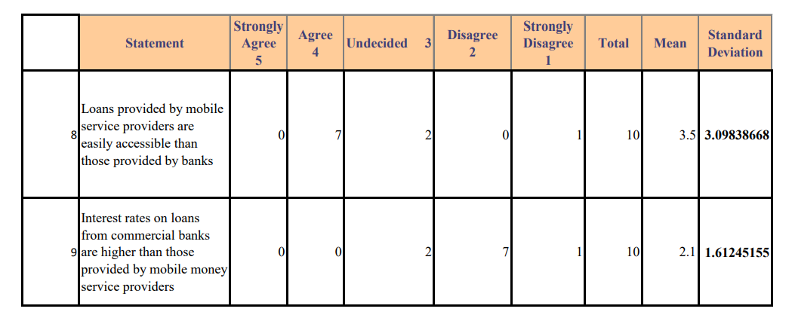
Source: field work 2020
The findings presented using Likert Scale Average in table 4.13. On loans, the majority (7) agreed to the statement that loans provided by mobile service providers are easily accessible than those provided by banks, (2) were undecided, (1) strongly disagreed and none of the respondents disagreed, strongly agreed or disagreed, to the statement and the resulting average mean score of 3.5 which on the Likert scale is agreeing and undecided to the statement.
On the statement that interest rates on loans from commercial banks are higher than those being provided by mobile money service providers, the majority (7) disagree, (2) undecided and (1) strongly disagree, and none of the respondents strongly agreed or agreed to the statement and the resulting average mean score of 2.1 which on the Likert scale is strongly disagreeing and disagreeing to the statement.
22.0 Partnerships with Mobile Service Provider
The level of agreement on the statements in the table to the effect of mobile money on Zanaco’s Partnerships with Mobile Service Provider. The rating scale was 1= strongly agree, 2= Agree, 3=Undecided, 4= Disagree, 5= Strongly Disagree.
The findings are presented in table 4.14 below.
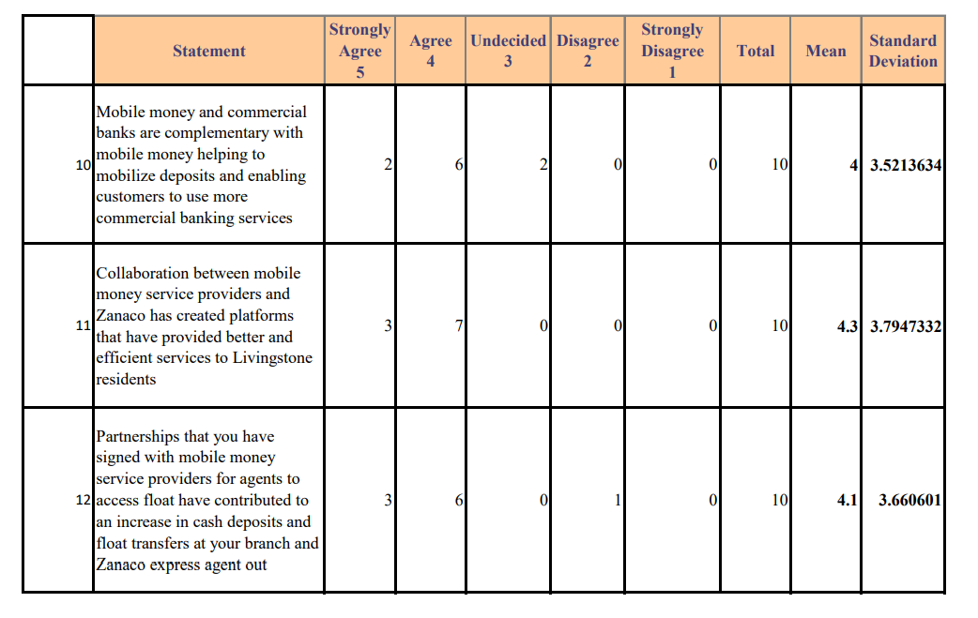
Source: field work 2020
The findings presented using Likert Scale Average in table 4.14 Partnerships with Mobile Service Providers, the majority (6) agree, (2) strongly agree to the statement that mobile money and commercial banks are complementary with mobile money helping to mobilize deposits and enabling customers to use more commercial banking services. (2) Respondents were undecided and none strongly disagreed or agreed to the statement and the resulting average mean score of 4 which on the Likert scale is agreeing to the statement.
On the statement that collaboration between mobile money service provide and Zanaco has created platforms that have provided better and efficient services to Livingstone residents, the majority (7) agree, (3) strongly agree, and none of the respondents strongly disagreed, disagreed or were undecided to the statement and the resulting average mean score of 4.3 which on the Likert scale is strongly agreeing and agreeing to the statement.
On the statement that partnership that Zanaco have signed with mobile money service providers for agents to access float have contributed to an increase in cash deposits and float transfers at Zanaco branches and across Zanaco express agent outlets, the majority (6) agree, (3) strongly agree, (1) disagreed and none of the respondents strongly disagreed, or were undecided to the statement and the resulting average mean score of 4.1 which on the Likert scale is strongly agreeing and agreeing to the statement.

CHAPTER FIVE
SUMMARY, DISCUSSION, CONCLUSIONS AND RECOMMENDATIONS
5.0 Introduction
The purpose of this study was to establish the influence of mobile money services on Zambia’s banking sector - a case study of Zanaco, a summary of findings obtained during the study are discussed, the findings are then related to the research questions, the researcher general conclusion about the results and recommendations based on the research objectives. The research objectives were to:
- determine whether mobile money penetration has outpaced traditional bank account opening
- establish whether people prefer mobile money services to traditional bank accounts
- establish whether mobile money services money customer touch points (Kiosks and Nthembas) have an effect on traditional banking on Zanaco
5.1 Summary of Key Findings
5.1.2 Demography
The findings on the demography for this study as outlined that most of the mobile money users and agents are in the age of 26 to 35 years old and more males are involved in the mobile money services. The demography is very important to this study because gender and age are important factors in assessing economic aspects of a population. The study has outlined that there is a youthful response to the mobile money services compared to the elderly population.
5.1.3 Accessibility of mobile money services
The findings on the accessibility of mobile money services showed that there is high levels of accessibility as most of the respondents outlined that, that mobile money services are available at almost everywhere in Livingstone, that its faster and easier to open a mobile money account than a bank account, that mobile money services enable customers to receive and send money as well as pay utilities anywhere at any time, that mobile money services is easy to use, that, there are more mobile money customer touch points (Kiosks) as compared to Zanaco express agents, and that Mobile Money Services are easily accessible than banking services.
The above is in line with the literature review study by Mutsonziwa (2016), were the Finscope data has seen an increase in the usage of mobile money across the SADC region but the usage differs significantly from country to country. Fincope research has further shown that mobile money has become an important contributor for financial inclusion. According to the World Bank, mobile financial services are among the most promising mobile applications in the developing world. Undoubtedly, mobile money (m-money) could become a general platform that transforms the entire economies, as it is being adopted across commerce, health care, agriculture and other sectors.
5.1.4 Reliability of mobile money services
The findings on the reliability of mobile money services showed that there is great reliability of mobile money services, On reliability of Mobile Money Services, the majority strongly agreed on the statement that most customers use mobile money services and banking services simultaneously, that mobile money services charges (transaction costs) are cheaper compared to bank charges, that commercial Banks have adopted mobile money services as a way of increasing and retaining customers, and that mobile money agents penetration is higher than Zanaco Express agents in Livingstone.
This is in line with the study by Mwiza and Eliya (2019) reports that Zambia has three MNO providing mobile communication and telecommunication services namely Bahati Airtel (Airtel), MTN (Mobile Telecommunication Network) and Zamtel. When MNO Mobile Money was introduced in Zambia, Airtel had the largest share of mobile phone subscribers with about 51.8 percent of the total subscribers, MTN had 33.1 percent while Zamtel had 15.1 percent. Airtel Money was launched by Airtel in September 2011. In January 2012, MTN Zambia the second largest MNO at the time also introduced mobile money service under the name” MTN Mobile Money”. As at March 2015, there were over 9,107,538 mobile phone subscribers while 5,234,129 had mobile money subscriptions representing 57.6% of the mobile phone subscribers. Be that as it may, the above study was silent on what led the three Telcos in Zambia namely Airtel Networks Zambia and Zamtel to provide mobile money services in the country
5.1.5 Convenience and Safety of mobile money service
The findings on the convenience and Safety of mobile money service showed that, majority agreed that purchases and payment for goods and services is much easier via mobile money, that mobile money services can take place almost everywhere, even where banks do not exist, and that mobile money increases financial security and reduces inherent risks of cash handling such as loss and theft.
This is in line with the study by Mutsonziwa (2016) who states that the Boston Consulting Group (BCG) shows that US1billion in remittances flow out of South Africa to other countries in the Southern African Development Community (SADC) annually. Further the BCG research shows that of the total amount, more than $650 million reaches recipients through informal channels such as private agents or family and friends travelling between locations. Taking into account the risks associated with informal channels of remitting, mobile money becomes a very important, secure and efficient alternative to be used in the SADC region.
5.1.6 Revenue and Profitability
The findings on Revenue and profitability showed that, majority disagreed that Zanaco ventured into mobile money (Xapit and Agency banking) to grow its revenues and remain profitable, but majority agreed that introduction of Xapit and agency banking (Zanaco Express) is a way to remain competitive and grow market share in the wake of a large number of kiosks that have been deployed across the city by mobile money service providers, and majority agreed that deposit accounts via mobile money have contributed to an increase in revenues for Zanaco,
This is in line with the study by Tchouassi (2012) states that empirical evidence from selected Sub Saharan African Countries shows that access to mobile phone technology has revolutionized just about every aspect of Sub Saharan African lives. Revolutions in information and communications technology (ICTs), the emergence of innovation and knowledge societies, the eradication of poverty, vulnerability and inequality, among others, have been identified in 2010 as major challenges of the 21st century. Electronic banking (E-Banking) enables customers to do their banking 24 hours a day, 7 days a week. E-Banking customers are able to check their account balances, pay bills, apply for a loan, trade securities and conduct other financial transactions. E-Banking can be divided into five major categories, internet banking, telephone banking, TV based banking, Mobile phone banking, personal computer (PC) banking.
5.1.7 Customer Acquisitions and Service Delivery
The findings on customer acquisions and service delivery showed that, the majority strongly agreed that customers outside the reach of Zanaco bank branch are still able to easily access services from Zanaco Express Agency outlets that have been set up within Livingstone, that the emergency of mobile money services has led to an increase in Zanaco bank clientele base, that customer satisfaction and service delivery has improved with the adoption of mobile money by Zanaco bank, and that adoption of mobile money has changed the way Zanaco customers are carrying out bank transactions.
This is in line with the study by Onwuaso (2020) reports that for over a decade, mobile money has been driving financial inclusion, opening access to digital transactions and giving people the tools to better manage their financial lives. Today, there are more than a billion registered mobile money accounts globally, spread across 290 mobile money deployments that are live in 95 countries. In Africa over 50.7 million new registered mobile money accounts were opened in 2019-2020 alone, taking the total number of registered accounts in the region to 481 million. The total transaction volume and value for mobile money during this period was 24 billion and $461 billion (up by 20% and 27%) respectively, the organization state.
5.1.8 Loans
The findings on loans showed that, majority agreed to the statement that loans provided by mobile service providers are easily accessible than those provided by banks, however, most respondents disagreed that interest rates on loans from commercial banks are higher than those being provided by mobile money service providers.

This is in line with the study literature that research has shown that mobile money has revolutionized financial services in several African countries, lowering transaction costs and thus providing consumer and small businesses with easy, cheap and safe ways to transact more effectively. An article by the Centre for Competition, Regulation and Economic Development (CCRED) researcher uses the experience in Kenya to demonstrate that mobile money can be instrumental in bringing people into the formal economy, generating information on individuals’ transacting behavior and thus creating better risk profiles and a credit record which can be used to offer them financial services that would otherwise be inaccessible. The success of M-Pesa in Kenya is often attributed to the friendly and flexible regulatory approach of the central bank of Kenya.
5.1.9 Partnerships with mobile money service providers
The findings on partnerships with mobile service providers showed that majority agreed to the statement that mobile money and commercial banks are complementary with mobile money helping to mobilize deposits and enabling customers to use more commercial banking services. Agreed that collaboration between mobile money services providers and Zanaco has created platforms that have provided better and efficient services to Livingstone residents, and that partnership that Zanaco have signed with mobile money service providers for agents to access float have contributed to an increase in cash deposits and float transfers at Zanaco branches and across Zanaco Express Agent outlets.
According to the research by BCG mentions that banks and mobile network operators should consider partnerships, as neither has everything required for it to succeed on its own. Further the research argues that banks have the back-office systems and the understanding of risk and financial industry regulations while the mobile network operators have the access to customers and large distribution networks. Developments in the SADC region have started these partnerships. An example of such partnerships is the Eco Cash Diaspora product which is a partnership between World remit and Econet Wireless of Zimbabwe launched in June 2014.

5.2 Conclusion
Accessibility of mobile money services is very high compared to bank services hence banks should be able to work with mobile service providers to be able to remain profitable in the industry. Mobile money services are also very reliability and they are attracting a lot of customer because of the flexibility they provide. Mobile money services are also convenient and Safety to use and they are found almost every in the city of Livingstone. Furthermore, Zanaco bank can benefit from the revenue and profitability by incorporating mobile money services. This is a way to remain competitive and grow market share in the wake of a large number of kiosks that have been deployed across the city by mobile money service providers, and majority agreed that deposit accounts via mobile money have contributed to an increase in revenues for Zanaco.
Furthermore, this study has concluded that, collaboration between mobile money services providers and Zanaco has created platforms that have provided better and efficient services to Livingstone residents, and that partnership that Zanaco have signed with mobile money service providers for agents to access float have contributed to an increase in cash deposits and float transfers at Zanaco branches and across Zanaco express agent outlets. Zanaco bank and mobile network operators have partnered, and this is required for the success of the bank and the mobile money service operators. The mobile money services are more accessible, more reliable, more convenient hence can help the bank reach out to more customers who prefer mobile money services.
5.3 Recommendations
- Zanaco bank to continue collaborating with mobile money service operators for continued revenue and profit realization.
- Zanaco to invest more on mobile money Zanaco money express agents so that the number of kiosks increases.
- Zanaco should increase its accessibility, reliability and become more convenient making sure the Zanaco Express money are found everywhere in the Livingstone city
- Zanaco should start giving out loans using the Zanaco money express just like the way mobile money service providers do, to attract more customers.
- Recommendation for a further study on what could have prompted Zanaco to diversify to mobile banking (Xapit) and set up Zanaco Express Agents countrywide besides the normal bank account savvies that they still continue providing through their brick and mortar branches.

References
(2012) Interpretation Note on Small and Medium Enterprises and Environmental and Social Risk Management, IFC, January.
Altonji, J. G., Conley, T., Elder, T. E., & Taber, C. R. (2011). Methods for Using Selection on Observed Variables to Address Selection on Unobserved Variables (Preliminary and Incomplete).
Aker, J. C., Boumnijel, R., McClelland, A., & Tierney, N. (2011). Zap It to Me: The Short-Term Impacts of a Mobile Cash Transfer Program. Center for Global Development working paper, 268.
Akhtar Inaam (2016), Research In Social Sciences, Interdisciplinary Perspectives, New Delhi
Angrist, J. D., & Pischke, J. S. (2009). Mostly harmless econometrics: An empiricist's companion. Princeton university press.
Batista, C., & Vicente, P. C. (2013). Introducing Mobile Money in Rural Mozambique: Evidence from a Field Experiment*.
Bank of Zambia, Banking institutions. (Online). Available from; http://www.boz.zm/ 2013. (Accessed December 2013)
Berger, A. N. (2003). The economic effects of technological progress: evidence from the banking industry. Journal of Money, Credit, and Banking, 35(2), 141-176.
Carmines E.G and Zeller R.A (1979), Reliability and Validity Assessment, Newbury Park, SAGE
Catherine Marshall and Gretchen B Rossman (2016), Designing Qualitative Research, Thousand Oaks, Carlifornia
Chen J & Arijeto BA(2008). Service Quality and Customer Satisfaction Measurement of Mobile Value-Added Services: A Conceptual Review. International Journal of Mobile Communications
Chiti Mwatula (2018). Time is Money. The Mobile Money Revolution in Zambia. Lusaka Times

De Mel, S., McKenzie, D. J., & Woodruff, C. (2009). Measuring microenterprise profits: Must we ask how the sausage is made? Journal of Development Economics, 88(1), 19-31.
Doko Tchatoka, F. (2012). On the validity of Durbin-Wu-Hausman tests for assessing partial exogeneity hypotheses with possibly weak instruments.
Donald C and Schindler P, McGraw-Hill, Higher Education-VST E+P,
(Donovan, K. P. (2012). Mobile money, more freedom? The impact of M-PESA’s network power on development as freedom. International Journal of Communication, 6(2012), 2647-2669.
Donner, Jonathan. (2007). “The use of mobile phones be micro-entrepreneurs in Kigali Rwanda.” The Massachusetts Institute of Technology Information Technologies and International Development, Vol. 3, No. 2, Winter 2006, 3–19
Donner, Jonathan and Escobari, Marcela X. 2010. A Review of Evidence on Mobile Use by Micro and Small Enterprises in Developing Countries. Journal of International Development, 22, 641-658.
Drost E (1995), Education Research and Perspectives, Volue.38, No.1 105, Department of Management, Los Angeles
Duncombe, R. (2007). Using the Livelihoods Framework to Analyze ICT Applications for Poverty Reduction through Microenterprise. Information Technologies & International Development, 3(3).
Dupas, P., & Robinson, J. (2009). Savings constraints and microenterprise development: Evidence from a field experiment in Kenya (No. w14693). National Bureau of Economic Research
Gajendra K Verma and Kanka Mallick (2009), Researching Education: Perspectives and Techniques, Falmer, London
Gerard Tchouassi (2012), International Journal of Developing Societies, Vol 1 NO 2, and Can Mobile Phones really work to Extend Banking Services to the Unbanked?
Lwizi G (2020), Zambia Business Times, MoMo Posts 126% Growth
Hamed Taherdoost (2016) Validity and Reliability of Research Instrument, How to Test the Validation of Questionnaire/Survey In a Research ,International Journal of Academic Research in Management (IJARM) Vol. 5, No. 3, 2016, Page: 28-36, ISSN: 2296-1747 © Helvetic Editions LTD, Switzerland, Kuala Lumpur,Malaysia
International Finance Corporation IFC (2015), Country Report Zambia, World Bank Group
Kajubi Michael (2018) Analysis of the Effects of Mobile Banking on the Activities of Commercial Banks, Kyambogo University
Katema Sheena and Dyson Lungu (2019), an Investigation of Factors Influencing the Adoption of Mobile Banking Services Among Bank Customers: A Case of Kitwe District, the International Journal of Multi-Disciplinary Research
Kaulu and Sihinsanbwe(2018) ,Investigation of the Effectiveness of Xapit Electronic and Mobile Banking Product In Zambia, International Journal of Business and Management Invention (IJBMI) ISSN (Online): 2319 – 8028, ISSN (Print): 2319 – 801X www.ijbmi.org || Volume 7 Issue 10 Ver.
Kearney T (2013), The Mobile Economy ,Lansdowne House, Berkeley Square ,London
Kruger PJH (2011), Cell Phone Banking at the bottom of the Pyramid: A Case Study of South Africa, International Telecommunications Union
Ludewig K and Must B (2010),”Mobile Money: Cell Phone Banking in Developing Countries”, Permission of Policy Matters
Malakata M, (2020).IT Web.Africa, Zambia Records 126% growth of Mobile Money Payments
Mbiti Isaac and Weil David N, (2011) Mobile Banking, the Impact of M-Pesa in Kenya, Volume 17129

Mas Ignacio and Almazan (2014), Product Innovations on Mobile Money, European Journal of Business and Mnagement, Vol.6, No.19
Mutsonziwa K and Beyene A (2016), the Role of Mobile Money in Financial Inclusion in the SADC Region, Policy Research Paper No.3
Mutsonziwa, K., & Maposa, O. K. (2016). Mobile money - A catalyst for financial inclusion in developing economies: A case study of Zimbabwe using FinScope survey data. International Journal of Financial Management.
Mwiza Norina and Dani Eliya (2019) Investigating Mobile Money Usage Patterns in Zambia: A Case of Mobile Network Operator Systems, International Journal of Advanced Studies in Computers, Science and Engineering, Gothenburg, VOL8
National Financial Inclusion Strategy 2017-2022, Ministry of Finance, Economics Management Dept Wolver Hampton (2018, Skill for Learning, Guide to report writing,)
National Financial Inclusion Strategy Zambia (2018)
Onwuaso (2020, the Guardian, GSMA Launches Mobile Money Interoperability Test Platform)
Paelo A (2014), Mobile Money, Taking on the Big Banks
Shamoo .A.E and Resnik B.R (2003), Responsible Conduct of Research, Oxford University Press
Simbarashe Adams (2019) Effects of Mobile Money Innovation on the Performance of Commercial Banks: Case Study of Steward Bank
Skills for Learning (2018), Guide to report writing (online) University of Wolverhampton, Wolverhampton
Super User (2020), Agri Pay introduces Digital Banking to Zambian Farmer)
Sturman, A. (1997).Case Study Methods. In: J. P.Keeves (ed.). Educational research,
Methodology and measurement: an international handbook (2nded.).Oxford: Per-
Gamon, pp.61–66
Siti Roshaidai Mohd Arifin (2018) Special Care Nursing Department, International Journal of Care Scholars, Faculty of Nursing, International Islamic University, Pahang, Malaysia.
Taherdoost H, (2016), Validity and Reliability of Research Instrument, How to Test the Validation of a Questionnaire/Survey in A Research, International Journal of Academic Research in Management, Vol.5, Kualua Lumpur, Malaysia
Onwuaso (2020, the Guardian, GSMA Launches Mobile Money Interoperability Test Platform)

World Bank (2018) Mobile Money at the base of the Pyramid: Zambia. Washington DC, World Bank, License, Creative Commos Attribution
World Bank 2014 Global Financial Development Report: Financial Inclusion, International Bank for Reconstruction and Development / the World Bank, 2014
ZICTA, ICT survey report (2015) – households and individuals survey on access and usage of information and communication technology by households and individuals in Zambia

APPENDIX I
PARTICIPANT INFORMATION LEAFLET
Dear Respondent
RESAERCH TOPIC: INFLUENCE OF MOBILE MONEY SERVICES ON ZAMBIA’S BANKING SECTOR. A CASE STUDY OF Zanaco -LIVINGSTONE
Dear Sir/Madam
This questionnaire aims at seeking information for the purpose of research work on the topic” Influence of Mobile Money Services on Zambia’s Banking Sector. Case Study of Zanaco Livingstone”. In this endeavor your kind cooperation is solicited. I shall be grateful if you could kindly fill in the questionnaire. You are requested to respond to each question. Please be fair and frank while responding to the statements. The information collected will be strictly for academic purpose and no information partnering to individuals or office bearers will be revealed
Thanking you

APPENDIX II: QUESTIONNAIRE
For Mobile Money Subscribers/Agents and Zanaco Express Agents
SECTION A
DEMOGRAPHIC DATA
For Mobile Money Subscribers, Agents and Zanaco Express Agents
(1) What is your age?
(a) 15-25 (b) 26-35 (c) 36-45 (d) 46 and above
(2) What is your gender?
(a) Female (b) Male
SECTION B
ACCESSIBILITY OF MOBILE MONEY SERVICES
To what extent to do you agree with the? Mark (X) where appropriate in the table below.
No | Statement | Strongly Agree | Agree | Undecided | Disagree | Strongly Disagree
1 | Mobile Money Services are available at almost everywhere in Livingstone City
2 | Its faster and easier to open a Mobile Money Account than a Bank Account
3 | Mobile Money Services enable customers to receive & send money as well as pay utilities anywhere at any time
 | Easy of usage
5 | There are more mobile money customer touch points(Kiosks) as compared to Zanaco Express Agents
6 | Mobile Money Services are easily accessible than banking services

RELIABILITY OF MOBILE MONEY SERVICES
To what extent to do you agree with the? Mark (X) where appropriate in the table below.
No | Statement | Strongly Agree | Agree | Undecided | Disagree | Strongly Disagree
7 | Most customers use mobile money services and banking services simultaneously
8 | Mobile Money Service charges(transaction costs) are cheaper compared to Bank charges
9 | Commercial Banks have adopted mobile money services as a way of increasing and retaining customers
10 | Mobile Money Agent penetration is higher than Zanaco Express Agents in Livingstone

CONVENIENCY AND SAFETY OF MOBILE MONEY SERVICES
To what extent to do you agree with the? Mark (X) where appropriate in the table below.
No | Statement | Strongly Agree | Agree | Undecided | Disagree | Strongly Disagree
11 | Purchases and payment for goods and services is much easier via mobile money
12 | Mobile money services can take place almost everywhere, even where banks do not exist
13 | Mobile money increases financial security and reduces inherent risks of cash handling such as loss and theft

(14) Which one do you visit most for transactions, mobile money Kiosks or your respective commercial bank branch ……………………………………………………………………
(15) Which one between mobile money Kiosks/Nthembas and Zanaco Express Agents always have adequate float and cash ………………………………………………………………

APPENDIX III: QUESTIONNAIRE
SECTION A
DEMOGRAPHIC DATA
FOR Zanaco STAFF-LIVINGSTONE
(1) What is your age?
(a) 15-25 (b) 26-35 (c) 36-45 (d) 46 and above
(2) What is your gender?
(a) Female (b) Male
(3) What is your job tittle………………………………………………………………………
SECTION B
REVENUE AND PROFITABILTY
What is you level of agreement on the following statement relating to the effect of mobile money on Zanaco’s revenue, profitability, loans and market share?
No | Statement | Strongly Agree | Agree | Undecided | Disagree | Strongly Disagree
1 | Zanaco ventured into mobile money(Xapit and Agency Banking) to grow its revenues and remain profitable
2 | Introduction of Xapit and Agency Banking (Zanaco Express) is a way to remain competitive and grow market share in the wake of a large number of Kiosks that have been deployed across the city by mobile money service providers
3 | Deposit accounts via mobile money have contributed to an increase in revenues for Zanaco
CUSTOMER ACQUISIONS & SERVICE DELIVERY
What extent to do you agree with the? Mark (X) where appropriate in the table below
No | Statement | Strongly Agree | Agree | Undecided | Disagree | Strongly Disagree
4 | Customers outside the reach of your branch are still able to easily access services from Zanaco Express Agency Outlets that have been set up within Livingstone
5 | The emergency of mobile money services has led to an increase in your clientele base
6 | Customer satisfaction and service delivery has improved with the adoption of mobile money by Zanaco
7 | Adoption of mobile money has changed the way you customers are carrying out bank transactions

LOANS
What extent to do you agree with the? Mark (X) where appropriate in the table below
No | Statement | Strongly Agree | Agree | Undecided | Disagree | Strongly Disagree
8 | Loans provided by mobile service providers are easily accessible than those provided by banks
9 | Interest rates on loans from commercial banks are higher than those being provided by mobile money service providers

PARTNERSHIPS WITH MOBILE SERVICE PROVIDERS
To what extent to do you agree with the? Mark (X) where appropriate in the table below
No | Statement | Strongly Agree | Agree | Undecided | Disagree | Strongly Disagree
10 | Mobile money and commercial banks are complementary with mobile money helping to mobilize deposits and enabling customers to use more commercial banking services
11 | Collaboration between mobile money service provides and Zanaco has created platforms that have provided better and efficient services to Livingstone residents
12 | Partnerships that you have signed with mobile money service providers for agents to access float have contributed to an increase in cash deposits and float transfers at your branch and across Zanaco Express Agent Outlets

Thank you

- Proposed budget
Quantity | Items | Amount
2 | Binding | $$500.00$$
2 | Ream of paper | 160.00
20 | Ball Pens | $$20.00$$
3 | Note Books | $$50.00$$
- | Typing | $$200.00$$
- | Photocopying | $$500.00$$
- | Transport | $$1000.00$$
- | Contingency | $$570.00$$
 | TOTAL | $$3000.00$$

