Impact of Corona Virus (COVID-19) Pandemic on Engineering Laboratory Lessons: A Case Study of Selected Higher Education Institutions in Zambia.

CHOLA NOBLE BWEUPE

A dissertation submitted to the University of Zambia in partial fulfilment of the requirements of the degree of Master of Engineering in Information and Communication Technology Policy, Regulation and Management.

THE UNIVERSITY OF ZAMBIA,
LUSAKA
2023

COPYRIGHT DECLARATION
All rights reserved. No part of this dissertation may be reproduced without prior consent of the author and all information derived should be fully acknowledged.

DECLARATION
I, CHOLA NOBLE BWEUPE, declare that this dissertation represents my own work and that it has not been previously submitted by any other person for a degree at the University of Zambia or any other university and it does not incorporate any published work or material from another dissertation. Except where otherwise stated. Other sources are acknowledged by given explicit references. A complete list of references is appended.

Signature: Date:

Supervisor: Signature: Date:

CERTIFICATE OF APPROVAL

This dissertation by CHOLA NOBLE BWEUPE is approved as fulfilling the partial requirements for the award of the degree of Master of Engineering in Information and Communications Technology (ICT) Regulation, Policy, and Management by the University of Zambia.

Examiner 1: Signature: Date:

Examiner 2: Signature: Date:

Examiner 3 Signature: Date

Chairperson
Board of Examiners: Signature: Date:

ABSTRACT
COVID-19 pandemic prevented physical converging of lecturers and students. Lessons that do not include laboratory sessions went on virtually, but there is need to know through this research what alternative was implemented for engineering laboratory lessons at Higher Education Institutions (HEI). Did students and lecturers just forego their engineering laboratory sessions during the pandemics lockdown and hope to have them after the pandemic eased off? The research aimed at investigating the possible use of virtual tools and platforms in the delivery of engineering laboratory lessons as an alternative to the physical laboratory lessons. Thereafter, investigate the effectiveness of delivering engineering laboratory lessons by virtual tools and platforms, investigate if the delivery of engineering laboratory lessons by virtual tools and platforms compromises on the quality of education and to investigate the best method engineering laboratory lessons can be undertaken when physical engagement between lecturers and student is limited. The mixed method approach was used that allowed collecting reliable data, the data was analysed and presented in numbers. Open-ended communication was also used to achieve clarity. It was vital to first assess what prevailed regarding the delivery of engineering laboratory lessons during the pandemic and hence, the following findings: 23.41% of students viewed virtual tools and platforms as an alternative to the traditional face to face engineering laboratory lessons as effective and 76.59% viewed them as not being effective. If virtual engineering laboratory lessons compromise on the quality of education 70.68% of students said they compromise while 29.32% responded that they do not compromise on the quality of education. Interview findings from lecturers indicated that a majority of laboratory lessons did not take place during the pandemic due to university infrastructure not able to accommodate the demand for virtual learning, cost of internet, slow internet speed and lack of financial capacity by universities to provide the needed virtual tools and platforms. For courses that can allow virtual laboratory sessions, the study recommends implementation of virtual tools and platforms as alternative to physical laboratory lessons. This can be successfully achieved provided that the virtual tools are procured with assistance from relevant stakeholders, the tools meet the required specifications and when constraints such as infrastructure, cost of internet and slow internet speed are addressed. For courses that cannot do without physical interaction with laboratory apparatus, the blended approach is recommended with laboratory lessons being held physically.

DEDICATION
I thank God almighty for the grace granted to me and my wife for her endless encouragement and support throughout the research process. I am grateful to my father and mother who put in a lot to educate me and my siblings.

ACKNOWLEDGEMENTS
I thank my supervisor, Dr. Simon Tembo. Thank you for your guidance, assistance, belief in my potential to succeed and leading me to a mindset of, “If possible, do it now and not tomorrow”.
I thank the Ministry of Education (MOE)-Zambia, Higher education Authority (HEA) and all the Higher Education Institutions (HEIs), namely the University of Zambia (UNZA), Copperbelt University (CBU) and Mulungushi University that were part of the research scope for their corporation and interest in participating in the research. I trust the research findings will help improve the delivery of engineering laboratory lessons at the HEIs.

ACRONYMS
MOE - Ministry of Education- Zambia
HEA - Higher Education Authority
HEI- Higher Education Institution
SSA- Sub-Saharan Africa
ICT- Information and Communication Technology
ODel- Open Distance and eLearning
ZSG-QA- Zambia Standards and Guidelines for Quality Assurance in higher education
LMS- Learning Management System
UNZA- University of Zambia
CBU- Copperbelt University
CA- Continuous Assessment
ASG- African Standards and Guidelines
DRGS- Directorate of Research and Graduate Studies

LIST OF FIGURES
Figure 1.1: Conceptual framework 6
Figure 4.1: Engineering students participation per university 53
Figure 4.2: Engineering student participation per year of study 54
Figure 4.3: Percentage of students that attended scheduled lab lessons 55
Figure 4.4: Factors leading to students not attending scheduled virtual laboratory 56
Figure 4.5: How effective are virtual laboratory lessons 57
Figure 4.6: Engineering students view on virtual labs compromising on the quality of education. 58
Figure 4.7: Preparedness of lectures in administering virtual labs 59
Figure 4.8: Student academic performance during the pandemic 60
Figure 4.9: Method of delivering laboratory lessons during the pandemic 61
Figure 4.10: Students view on best method of delivering engineering practicals 61

LIST OF TABLES
Table 4.1: Overview of the Period when UNZA was Closed and Re-opened. 41
Table 4.2: UNZA Guideline on Required Lab Time and Percentage of Lab Lessons on Students’ Continuous Assessment (CA) 44
Table 4.3: Overview of the Actual Lab Time Students had During the Pandemic for Selected Courses at UNZA 46
Table 4.4: Khans global eLearning framework on dimensions and sub-dimensions that can be used to evaluate virtual education. 64
Table 4.5: Evaluation of HEI’s Compliance to the Dimensions of the eLearning Framework 68

TABLE OF CONTENT

COPYRIGHT DECLARATION i
DECLARATION ii
CERTIFICATE OF APPROVAL iii
ABSTRACT iv
DEDICATION v
ACKNOWLEDGEMENTS vi
ACRONYMS vii
LIST OF FIGURES viii
LIST OF TABLES ix
TABLE OF CONTENT x
CHAPTER ONE: INTRODUCTION 1
1.2 Statement of the Problem 4
1.3 Aim 5
1.4 Research Objectives 5
1.5 Research Questions 5
1.6 Conceptual Framework 6
1.7 Importance of the Study 7
1.8 Scope of the Thesis 7
1.9 Chapter Outline 7
1.10 Chapter Summary 8
CHAPTER TWO: LITERATURE REVIEW 9
2.0 Introduction 9
2.1 Evolution of eLearning 9
2.2 Methods of learning 11
2.2.1 Face to Face Learning 11
2.2.2 Online Learning and Virtual Technologies 11
2.2.3 Blended Learning 13
2.3 The Nature, Purposes, and Importance of Virtual Laboratories 15
2.4 Requirements for virtual laboratory learning 17
2.5 Effectiveness of eLearning 17
2.6 Effective Distance Learning in the Context of a Developing Nation 21
2.7 Pros and Cons of Virtual Learning 22
2.8 Related Work to Virtual Learning in Zambia 25
2.9 University Support During the Pandemic in Zambia 28
2.10 Areas to be Addressed if More Study Programmes are Pushed to Online/Remote Platforms 28
2.11 Impact of the COVID-19 crisis on Engineering in Sub-Saharan Africa (SSA) 29
2.12 Factors Affecting the Quality of Online Learning 30
2.13 The Khan Global eLearning Framework 30
2.13.1 Resource Support Dimension 31
2.13.2 Technological Dimension 31
2.13.3 Pedagogical Dimension 32
2.14.4 Ethical Dimension 32
2.13.5 Evaluation Dimensions 32
2.13.6 Interface Design 32
2.14 Education Quality Standard by the Zambian Education Authority 33
2.14.1 The ZSG-QA guideline on Vision, Mission and Strategy 33
2.14.2 The ZSG-QA on Supporting its Learning Programmes 34
2.14.3 The ZSG-QA on Assessment of Standards 34
2.14.4 The ZSG-QA on Learner Support 34
2.15 Chapter Summary 35
CHAPTER THREE: METHODOLOGY 36
3.0 Introduction 36
3.1 Research Design 36
3.2 The Mixed Methods Approach 37
3.3 Data Collection 38
3.4 Research Population 38
3.5 Sampling Technique 39
3.6 Ethical Clearance and Study Approval 39
3.7 Data Analysis 39
3.8 Chapter Summary 39
CHAPTER FOUR: RESULTS AND DISCUSSION 40
4.0 Introduction 40
4.1 Results 40
4.2 Results from engineering lecturers 52
4.2.1 Lecturers perspective- Methods of Delivering Laboratory Lessons During the Pandemic 52
4.2.2 Tools Used by Lecturers During the Pandemic 53
4.3 Results from engineering students 53
4.3.1 Demographic Characteristics of Respondents 53
4.3.2 Percentage of Students that Attended Scheduled Lab Lessons 55
4.3.3 Factors Leading to Students not Attending Scheduled Virtual Laboratory Lessons 55
4.3.4 Effectiveness of Virtual Laboratory Lessons 56
4.3.5 Do Virtual Labs Compromise on the Quality of Education 57
4.3.6 Preparedness of Lectures in Administering Virtual Labs During the Pandemic 58
4.3.7 Student Academic Performance During the Pandemic 59
4.3.8 Students perspective-Methods of Delivering Laboratory Lessons During the Pandemic 60
4.3.9 Student’s Views on the Best Method of Delivering Engineering Practical’s 61
4.4 Results from the Ministry of Education 62
4.5 Results from the Higher Education Authority 63
4.6 Comparison of results against the Khan eLearning framework and the ZSG-QA 63
4.6.1 Comparison of Lecturer Research Results to Khan’s eLearning Framework 66
4.6.2 Comparison of Research Results to Khan’s eLearning Framework 68
4.6.3 Comparison of Research Results to the ZSG-QA 74
4.7 Discussion 75
4.8 Chapter Summary 78
CHAPTER FIVE: CONCLUSION RECOMMENDATION AND FUTURE WORK 79
5.1 Conclusion 79
5.2 Recommendations 80
5.3 Future Work 80
REFERENCES 81
APPENDICES 86
Appendix A: Questionnaire 86
Appendix B: Students Thoughts as to Why Virtual Labs are not Effective at the HEI 93
Appendix C: Why Students Thought Virtual Labs Compromise on the Quality of Education at the HEI 94
Appendix D: Students Views on Why Universities Couldn’t Provide Virtual Tools and Platforms 95
Appendix E: Methodology 95
Appendix F: Published Journal 96
Appendix G: Ethical Clearance Certificate 97

CHAPTER ONE: INTRODUCTION
This chapter gives the background that will put the research problem into context. The chapter will bring out the research problem, objective of the research while elaborating on the purpose, justifying the study and existing assumptions. This chapter will also bring out the order that the research is organised.
1.1 Background
Coronaviruses are a type of virus. There are many different kinds, and some cause disease. A coronavirus identified in 2019, SARS-CoV-2, caused a pandemic of respiratory illness, called COVID-19. The coronavirus spread through droplets and virus particles released into the air when an infected person breathes, talks, laughs, sings, coughs, or sneezes. Larger droplets may fall to the ground in a few seconds, but tiny infectious particles can linger in the air and accumulate in indoor places, especially where many people are gathered and there is poor ventilation (What Is Coronavirus? | Johns Hopkins Medicine).
Countries had taken very strict restrictions such as vacation for schools, universities, working from home, quarantine for regions with high number of cases, and most importantly, lockdown to slow down the COVID 19 outbreak. Countries had set the days when the lockdown started and ended according to the COVID-19 effect on their public (Atalan, 2020). Refer to table 4.1 in Chapter four (4) that shows when the University of Zambia UNZA was closed and re-opened due to the COVID-19 pandemic.
The Corona-virus pandemic affected a lot of industries, and the delivery of education by Higher Education Institutions (HEI) worldwide was no exception. HEIs were greatly affected in a way that the traditional physical face to face method of learning that we are all used to that allows face to face interaction between lecturers and students drastically reduced due to the enforced lockdowns. One thing that may be overlooked is the impact the pandemic had on engineering laboratory lessons. It is a well-known matter that most HEIs resorted to alternative methods of education delivery by virtual tools and platforms for courses that did not involve laboratory lessons. This research is interested in uncovering how engineering laboratory lessons took place at selected HEIs in Zambia during the pandemic’s lockdowns. Most research looks at how theoretical lessons took place but what makes this research unique is its focus on what transpired with regards to engineering laboratory lessons during the pandemic lockdowns. The lockdowns affected engineering students in a way that they experienced a lack of interaction with laboratory apparatus and their lecturers. Denied students the ability to feel, touch and experience laboratory lessons as they would normally do. The lack of engineering laboratory lessons during the pandemics lockdowns brings to attention the following challenges: A negative effect on engineering students’ academic performance and HEIs risked producing low calibre engineering graduates that may not be adequately skilled for the industry. This would in turn negatively affect Zambia’s engineering industry workforce and eventually affect the economy in one way or another. All the challenges just go to show the possible negative impact that the lack of engineering laboratory lessons could have on students and a country at large. Rather than completely not having laboratory lessons there exist alternative ways of delivering engineering laboratory lessons especially during a pandemic and beyond, there is a possibility of utilising virtual laboratories. A virtual laboratory can be defined as a simulated lab environment typically implemented as a software program which allows the users to perform their experiments (What is Virtual Lab | IGI Global). The research is motivated by the fact that not much is known about the quality and effectiveness of engineering laboratory lessons offered virtually in Zambia. Engineering departments, administrators, and policymakers need to know how their "customers" that is the student, on how they view the quality and effectiveness of virtually administered engineering laboratory lessons based on their personal learning experiences and that is why this research had to extensively get views from students. Therefore, the research will enquire on administering engineering laboratory lessons based on the following context.
- Effectiveness of delivering engineering laboratory lessons by virtual tools and platforms.
- If the delivery of engineering laboratory lessons by virtual tools and platforms compromises on the quality of education.
- The best method that engineering laboratory lessons can be undertaken when physical engagement between lecturers and student is limited.
The research collected results will be compared against Khans global eLearning framework for evaluation of eLearning. The framework was chosen due to its flexibility of being applied to eLearning of any scope. Results will also be compared against the Zambia Standards and Guidelines for Quality Assurance (ZSG-QA) in higher education in Zambia. This will be done in order to address and make conclusion on the above-mentioned context of the research. The research was based on selected universities of Zambia namely the University of Zambia (UNZA), Copperbelt University (CBU) and Mulungushi University. A mixed method approach was used to collect data from students and lecturers. The research population size which is the total number of engineering students from the HEI under the scope of the study. The population size was three thousand two hundred and seventy-four (3,274) engineering students. Population size was used to calculate the sample size giving a sample size of 344 engineering students required to participate in the research. The study managed to collect data from 392 participating engineering students, this response rate is more than enough to allow for the generalization of findings from the targeted population and allow for the conclusions of the study. Eleven (11) lecturers took part in the research, lectures who taught in courses that ranged from Mining engineering, Electrical engineering, Information and Communication Technology (ICT), Mechanical engineering, Civil and Environmental engineering and Geomatics.
The terms eLearning and pedagogical will be used in this paper and it would be good to define them beforehand. eLearning refers to electronic technologies for learning and teaching. The learning takes place either or partially online (What Is Virtual Learning? | VEDAMO). It is a process where a set of lessons is provided on digital devices like computers or any mobile devices that supports the learning. eLearning is interactive learning in which the learning content is available online and provides automatic feedback to the student's learning activities. One of the main goals of eLearning is to develop professional skills and understanding to help learners to achieve their learning objectives. In an era where educational and technological modernizations are redefining the standards of higher education, the converging point of interconnection is eLearning (Bezhovski & Poorani, 2016).
Pedagogical refers to the method and practices of a teacher. When people refer to the pedagogy of teaching, it means how the teacher delivers the curriculum to the class. It would be interesting to see how lecturers have adapted or modified their pedagogical in relation to virtual engineering laboratory lesson at the HEIs under the scope of study. For virtual learning brings new pedagogical techniques into the traditional forms of education and makes learning more personalized and convenient. A well thought out pedagogy can improve the quality of teaching and the way that students engage in different activities. This increases the likelihood of students achieving their goals as they are more likely to participate in the classroom. Pedagogy will be a determining factor on the quality aspect of virtual labs in the case of our research. (What Is Virtual Learning? | vedamo, n.d.), (What Are the Different Pedagogical Approaches to Learning?)

1.2 Statement of the Problem
Engineering laboratory lessons did not take place during the COVID-19 pandemic due to technological issues that impaired virtual learning and there is not much research on this topic within our country, Zambia. The pandemic left a negative impact such as the lack of delivery of engineering laboratory lessons, which in turn affected student’s academic performance. Alternative means of delivering engineering laboratory lessons in situations where lecturer and student interaction is reduced have not been explored and favourable methods not concluded upon. Alternative methods other than the traditional physical face to face of delivering engineering laboratory lessons have not been analysed to see if they would be effective and if they would compromise on the quality of education. The research focuses on what transpired in the delivery of engineering laboratory lessons at selected HEIs in Zambia during the time the pandemic began up until when it eased off. With interest on how the engineering laboratory lessons took place during the pandemic bearing in mind the little or no physical contact between the lecturers and students. The research has further interest in knowing if students did not have engineering laboratory lessons at all during the pandemic. The research will investigate the effectiveness of virtual tools and platforms for engineering laboratory lessons as an alternative to the traditional physical face to face laboratory lessons and if the virtual tools and platforms can in anyway compromise on the quality of education. The investigation on the use of virtual tools and platforms as an alternative to the traditional physical face to face is important to know, for virtual tools and platforms have the potential of elevating the impact the pandemic had on HEI particularly on engineering laboratory lessons hence, the need to investigate their potential use at selected HEI in Zambia. There is scarcity of research measuring the quality of online education from the point of view of the students. Not much is known about the quality of programs offered virtually therefore the research has the task of having the below questions answered:

- We do not know the effectiveness of delivering engineering laboratory lessons by virtual tools and platforms.
- We do not know if the delivery of engineering laboratory lessons by virtual tools and platforms compromises on the quality of education.
- We do not know the best method engineering laboratory lessons can be undertaken when physical engagement between lecturers and student is limited.

1.3 Aim
The research intends to establish the effectiveness of delivering engineering laboratory lessons by virtual tools and platforms. Further the research intends to determine if the delivery of engineering laboratory lessons by virtual tools and platforms compromises on the quality of education and to determine the best method engineering laboratory lessons can be undertaken when physical engagement between lecturers and student is limited. The results obtained will be compared for compliance with eLearning guidelines of the global eLearning framework and against the Zambia Standards and Guidelines for Quality Assurance (ZSG-QA) in higher education in Zambia.

1.4 Research Objectives
- To investigate the effectiveness of delivering engineering laboratory lessons by virtual tools and platforms.
- To investigate if the delivery of engineering laboratory lessons by virtual tools and platforms compromises on the quality of education.
- To investigate the best method engineering laboratory lessons can be undertaken when physical engagement between lecturers and student is limited.

1.5 Research Questions
- What is the effectiveness of delivering engineering laboratory lessons by virtual tools and platforms?
- Does the delivery of engineering laboratory lessons by virtual tools and platforms compromise on the quality of education?
- What is the best method that engineering laboratory lessons can be undertaken when physical engagement between lecturers and student is limited?

1.6 Conceptual Framework
The conceptual framework will illustrate the expected relationship between our research variables. It defines the relevant objectives for our research process and maps out how they come together to draw logical conclusions (What Is a Conceptual Framework? | Tips & Examples).

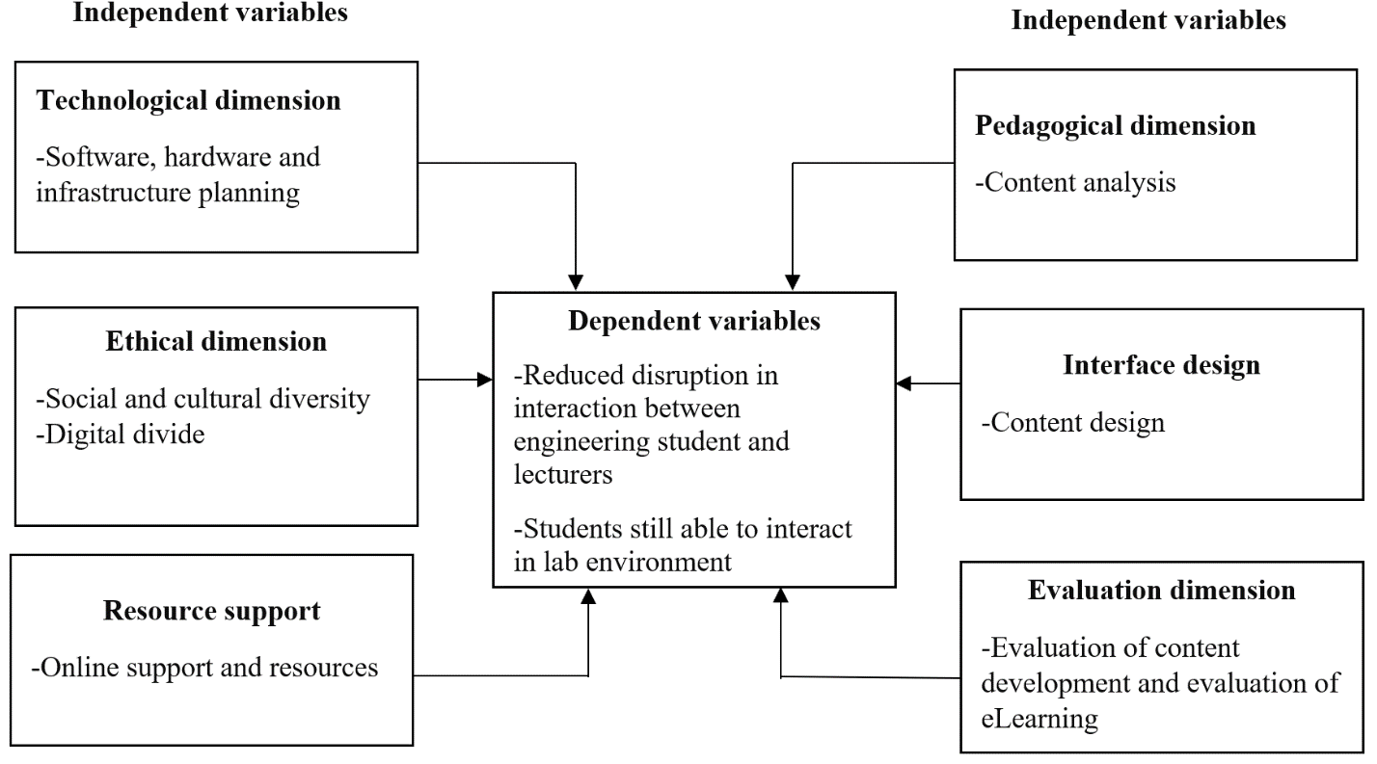
Fig. 1.1: Conceptual framework
Amended model to initial framework of evaluation in virtual education based on the proposed model by Khan (Dastjerdi).
With reference to the conceptual framework above. The conceptual framework above is described as follows: The independent variables if available are the factors that allow for virtual labs to take place, they also influence both the effectiveness and quality of virtual lab lessons. If a HEI has a majority of the independent variables available, it will influence the dependent variables in a way that the HEI will have reduced disruption in interaction between engineering student and lecturers and students would still be able to interact in a lab environment in a situation where lecturer and student interaction is reduced. The research results will be compared against the conceptual frameworks independent variables dimensions in order to establish if they had positively or negatively affected the dependent variable at the HEI that are under the scope of the study.

1.7 Importance of the Study
The study beneficiaries are the Ministry of Education (MOE)- Zambia, Higher Education Authority (HEA), HEIs engineering students and lecturers, HEIs Information and Communications Technology (ICT) centres, HEIs ICT quality assurance and quality assurance departments. Seeing that there is not much research on this topic within our country, the research results will give the study beneficiaries knowledge on what transpired in the delivery of engineering lab lessons during the pandemic. Study will give answers based on the research objectives on issues that interested parties are unsure about when it comes to the delivery of engineering lab lessons virtually. Based on the research results, the research will guide in the discussion section on how best engineering laboratory lessons can be undertaken when physical engagement between lecturers and student is limited. The named study beneficiaries will have information on the effective ways to conduct engineering lab lessons effectively without compromising on the quality of education when lecturer and student interaction is limited. Additionally, the study results will influence through its recommendations on how best lab lessons can be conducted when interaction between lecturer and student is limited and that virtual laboratory lessons can enable the many schools and HEIs in Zambia that presently do not have physical laboratories to teach through virtual laboratory lessons. The study will also act has a starting and reference point for further research on virtual engineering labs even beyond the COVID-19 pandemic.

1.8 Scope of the Thesis
The study scope includes the Ministry of Education (MOE)- Zambia, Higher Education Authority (HEA), HEIs engineering students and lecturers from the University of Zambia (UNZA), Copperbelt University (CBU) and Mulungushi University. The named HEIs Information and Communications Technology (ICT) centres, HEIs ICT quality assurance and quality assurance departments.

1.9 Chapter Outline
This dissertation is organized into five (5) chapters; chapter one brought out the background and introduced the study. The chapter consists of the statement of the problem, research objectives, research questions, importance of the study, scope of the study and how chapters are arranged. Chapter two (2) presents all the reviewed literature from secondary sources, examining work and documented knowledge of the impact COVID 19 had on the delivery of engineering lab lessons. Chapter three (3) brings to attention the methodology of the study. Chapter four (4) explains the research results and discusses them while chapter five (5) showcases the conclusions, recommendations and future works.

1.10 Chapter Summary
Education was one of the worst affected by the COVID 19 pandemic. We cannot ignore what transpired and what can be done better in future regarding engineering lab lessons. For engineering lab lessons are an important aspect of every engineering student course and makes up a good percentage of their academic assessment as you will see from table 4.2 in Chapter four (4). Lack of engineering lab lessons has already mentioned could lead to HEIs producing graduates that do not have the appropriate skill sets to perform in the real-world industry. This can only be avoided by HEIs delivering quality and effective lab lessons by alternative methods and adhering to the global eLearning framework and standards and guidelines for quality assurance in higher education in Zambia. Failure to which would affect the nation’s economy for the economy relies on the innovation and creativity of its engineers.

CHAPTER TWO: LITERATURE REVIEW

2.0 Introduction
At the peak of the pandemic, forty-five (45) countries in Europe and Central Asia region closed their schools, affecting One hundred eighty-five (185) million students. Given the abruptness of the situation, teachers and administrations were unprepared for this transition and were forced to build emergency remote learning systems almost immediately (The Impact of COVID-19 on Education–Recommendations and Opportunities for Ukraine).

2.1 Evolution of eLearning
The electronic learning (eLearning) considered as computer assisted learning has been around since the 1960s, but its adoption and popularization mainly started after the popularization of the internet and the web. Since its introduction till present days the eLearning rapidly evolved regarding the technology and the eLearning methods/tools used. Having in mind that it has many benefits for the teacher/instructors from one side and the learners on the other, the eLearning found its application in education, business and the military or wherever is needed. There is abundance of available technology and eLearning tools that foster and support the learning process. It is evident that eLearning is widely used in education and business, and it is expected to grow further. On the other hand, there is insufficient evidence of the effectiveness of the various pedagogical methodologies used for eLearning (Bezhovski & Poorani, 2016). Our study is in line with Bezhovski and Poorani’s (2016) identification of insufficient evidence of the effectiveness of the various pedagogical methodologies used for eLearning. Indeed, it is good to see that other literature identified that a gap exists in the context of insufficient evidence of the effectiveness of the various pedagogical methodologies used for eLearning and our research has one of its objectives being to investigate the effectiveness of delivering engineering laboratory lessons by virtual tools and platforms which is in line with the identified gap by Bezhovski and Poorani (2016). Bezhovski and Poorani (2016) also mentioned that one of the main goals of eLearning is to develop professional skills and understanding to help learners to achieve their learning objectives. Our research agrees with Bezhovski and Poorani (2016) line of thought of eLearning helping development of professional skills and achieving learning objectives. This just goes to show that the issue of eLearning is a great concern, and this research is in tune to that fact. eLearning has its origins from mail-learning method through correspondence courses. As the origin of the word eLearning is not certain it is proposed that the term probably originated during 1980. eLearning can be considered as natural evolution of distance learning. It has always taken advantage of the modern technology to develop and adapt the framework of educational tool for shaping education. eLearning has its origins from mail-learning method through correspondence courses. Sir. Isaac Pitman’s mail courses used shorthand technique to teach in 1840. It is said to be the first distance learning course. Later in 1980, the era of personal computers began which paved the way for eLearning. Over the past 50 years several new approaches have been in practice to aid the instructor's role in the classroom.
When internet and personal computers became phenomenal and started to flourish in the late 20th
century, was when the concept of eLearning began to take form. The technology, the concept and the device complemented each other well, providing new learning trend. The first web-based Learning Management System (LMS) named Cecil was launched in 1996. LMS is a software application that organizes, documents, records, and delivers eLearning courses. The modern LMS are mainly web based and enable hosting and or delivering of different types of learning content including but not limited to reading materials, video and audio, wikis, web conferencing, chats, forums, blogs, learning games, testing, grading etc. Corporations, business and military took advantage and adapted the eLearning concepts to their necessities. The new eLearning methods gave open access to information and provided communicative and interactive features. The learner experience became cohesive with upgraded pedagogy. Having gone through numerous diverse evolutionary phases, eLearning is still evolving mutually alongside the upsurge in modern technology. Advancement in new technology makes it practical to blend synchronous and asynchronous training into one. Modern eLearning methods are revolutionizing contemporary learning systems.
The learning content in the eLearning environment is presented/distributed to the learner through eLearning tools or learning objects enabled by the LMS. These tools can be roughly divided in two groups as tools for synchronous and tools for asynchronous learning. Tools for asynchronous learning can be used for self-paced learning and include, reading materials, audio and video, forums, wikis etc. The synchronous tools where both the instructor and learner are present at the same time include virtual classrooms, webinars, video conferencing and similar methods. Choosing the right pedagogy is vital, it must be neutral to all learners, considering not all learners are the same. The pedagogy is designed in a way to adapt various potential uses according to the need of the course. This research is agreeing to what has been pointed out that pedagogy aspect being designed to adapt various potential uses according to needs of a course. Agreeable in a way that some engineering courses that require students to physically touch and feel laboratory apparatus for example, a course that requires a student to learn how to process mineral ores or key steps in foundation stability (construction) would require that their practical’s are done physically. Hence, the pedagogy is designed according to the needs of a course as was also found out by our research and will be discussed in more detail in the results and discussion chapter of this paper. It is proposed by Clarke, Mayer (2008) that the principals for enhancing eLearning’s effectiveness are broad in scope and based on extensive empirical research. For example, “The contiguity principle” states that when text is used to explain a graphic or vice versa, the text and graphics should be placed next to each other on the same screen. The reviewed literature stated that in higher education, 65% of the students consider that ‘compatibility’ of e-learning platforms is the most important positive consequence of using eLearning (Clark, R.C.,& Mayer, R.E (2008) (Bezhovski & Poorani, 2016),

2.2 Methods of learning

2.2.1 Face to Face Learning
Can be defined as teaching a group of students learning material and course content by the instructional method. In this type of learning, there is a live interaction between the instructor and the learner. Also, the students learn from each other. This type of learning is one of the most popular and traditional ways of imparting knowledge. In face-to-face learning, there is a fixed time and date to conduct the session, and students are responsible for their progress. This type of learning helps students get a better understanding and recollecting the lessons given in the classroom (Face to Face Learning - Meaning and Definition - Teachmint, n.d.).

2.2.2 Online Learning and Virtual Technologies
Is education that takes place over the Internet. It is often referred to as “eLearning” among other terms. However, online learning is just one type of “distance learning”. The umbrella term for any learning that takes place across distance and not in a traditional classroom. Distance learning has a long history and there are several types available today, including:
- Correspondence courses: conducted through regular mail with little interaction.
- Telecourses: where content is delivered via radio or television broadcast.
- CD-ROM courses: where the student interacts with static computer content.
- Online learning: internet-based courses offered synchronously and/or asynchronously.
- Mobile Learning: by means of devices such as cellular phones, PDAs and digital audio.
players (iPods, MP3 players), (Stern, n.d.).
When discussing experiential learning, it would be important to consider one of the pioneers who articulated the philosophy of experiential learning, John Dewey. Dewey wrote about the benefits of experiential education by explaining that experience and education were intimately related (Sá-Oliveira, C.E.C.Campos, Araújo, & Alberto, 2017) . As an instructional tool, computers have been used successfully in education for many years. Computer-Aided Instruction (CAI) is derived from programmed instruction, based on behaviourist psychology (Villamil-Casanova & Molina, 1996). This kind of instruction is capable of branching a student’s instruction to different frames of information based on responses to carefully designed questions. Within the area of CAI lies the technology of computer-aided simulations. They are interactive and can give the user the feeling of presence in the environment and, thus, enhance the user’s learning experience (Pantelidis, 1993). Computer-assisted simulations allow users to try different options and then decide which option completes the task at hand most effectively. Computer-assisted simulations can be highly motivating since there is no room for users to be passive. Virtual simulations have the potential to enhance and improve learning by enabling the user to interact with the virtual environment. These interactions can provide an experience that is transferable to non-virtual reality. (Virtual Reality in the Classroom on JSTOR). Virtual realities can be divided into three groups: immersive, non-immersive and hybrid systems. An immersive virtual reality system is one in which the user becomes immersed in the activities of the virtual world with computer generated images. Non-immersive virtual reality system, the user is aware of the real world and is able to observe the virtual world through the aid of a display device such as a computer workstation. In this environment, while being aware of his or her surrounding, the user can navigate the virtual environment by way of using devices such as a computer mouse which allows interaction with the devices being used (Bowman, Hodges, Allison, & Wineman, 1999). Hybrid Virtual Reality System is the idea of seamlessly merging real world objects into virtual space. It involves the integration of computer-generated virtual objects into the physical world and makes them an equal part of the natural environment. A hybrid system allows the user to view the real world having virtual images superimposed over his or her view (Topping & Bittnar, 2002) . Virtual reality can be defined as the human experience of observing and relating with the help of sensors and visual aids with a simulated environment, and with simulated objects in it, making the user feel their presence in the virtual environment by means of a communication medium acting as if they were real. The main goal of virtual realities is to try creating an illusion for the user to think that he or she is in a tangible environment with enough interactivity and comfort (Gutiérrez A., Vexo, & Thalmann, 2008) . There are many applications for virtual realities in the world today. In engineering and design, virtual realities are used as part of the design process in the manipulation of 3D modelling tools and visualization techniques. This technology allows designers to first see their project in 3D, understand how it works and detect any errors or potential problems before implementation (Vince, 2004). By doing so, engineering design teams can observe their project from a safe environment and make the necessary alterations where needed. With the advent of mobile devices which can be accessed anywhere and at any time, the e-learning industry has also sought to use the potential of mobile devices to expand their markets. What is good about mobile gadgets like smartphones, mini laptops, and tablets is that they are easy to carry, and they are convenient due to their direct access to online learning resources. Mobile devices make it convenient for people who are busy working at a given work site to have training and support at times that are convenient to them (Yokuş & Yelken, 2016). The apps are easy to use, and their navigation and exploration are also very simple and enjoyable in such a way that once a user has them on his or her mobile device, the content on them is always available to the user with or without access to the internet. With the continued expansion of mobile learning capabilities, the evolving of newer forms of learning will continue (Nikolopoulou & Kousloglou, 2019)

2.2.3 Blended Learning
Is generally applied to the practice of using both online and in-person learning experiences when teaching students. In a blended-learning course, for example, students might attend a class taught by a teacher in a traditional classroom setting, while also independently completing online components of the course outside of the classroom. In this case, in-class time may be either replaced or supplemented by online learning experiences, and students would learn about the same topics online as they do in class i.e., the online and in-person learning experiences would parallel and complement one another (Blended Learning Definition, n.d.).
Blended learning can be defined as the process of combining two or more teaching methods such as web-based technologies, pedagogical approaches, and instructional technologies. Blended learning has been used to imply to “training that combines traditional classroom sessions with eLearning and self-study”. Blended learning technique uses different teaching medium to create a training course for learners. Traditional teaching method and digital teaching method complements each other according to the course needs.
The above is in line with what was discovered in our research at the HEIs that are under the scope of our research that blended learning can be used by engineering students in the following way:
- Theoretical lessons done virtually, and lab lessons done physically or,
- Theoretical lessons done virtually, and lab lessons done partly virtually and partly physically.
The objective of blended learning is to make training media into a combined unit to create great impact. eLearning significantly evolved in parallel with the development of the Information and Communication Technologies (ICT). The real growth and development of the eLearning technologies and methodology started after the introduction of the web and still is developing coping with the new challenges. At the beginning, the main concerns for the eLearning process were focused on the reliability of the technology that supports it. Nowadays, the focus is on the usability of the platforms and tools and their pedagogical considerations. However, in a developing nation such as Zambia the main concerns for the eLearning process are still focused on the reliability of the technology that supports it. This will be seen in more detail in the results and discussion chapter of our paper that the technological aspect that supports eLearning adversely affected the delivery of virtual engineering lab lessons at the three (3) HEIs under the scope of the study (Bezhovski & Poorani, 2016).

2.3 The Nature, Purposes and Importance of Virtual Laboratories
Virtual labs are interactive, digital simulations of activities that typically take place in physical laboratory settings. Virtual labs simulate the tools, equipment, tests, and procedures used in chemistry, biochemistry, physics, biology, and other disciplines. Virtual labs allow students to participate in lab-based learning exercises without the costs and limitations of a physical lab. Virtual labs can be an important element in institutional efforts to expand access to lab-based courses to more and different groups of students, as well as efforts to establish contingency plans for natural disasters or other interruptions of campus activities. Virtual labs are interactive, digital simulations of activities that typically take place in physical laboratory settings. Virtual labs simulate the tools, equipment, tests and procedures used in engineering, chemistry, biochemistry, physics, biology and other disciplines that include a laboratory component in the curriculum.
A key characteristic of virtual labs is their interactivity. Virtual labs operate online, often embedded into a Learning Management System (LMS). As with a physical lab, faculty members determine which lab assignments are required to support learning objectives at various points in the syllabus. Students have access to virtual representations of the equipment and supplies they would find in a physical lab. In a virtual chemistry lab, for example, students might find beakers, pipettes, cylinders and other glassware, a collection of acids, other solutions, bunsen burners, scales and other needed hardware. Students follow the steps of an assigned procedure and observe and record the results. Students see digital simulations of the results of their actions or of their missteps if they make a mistake. Most virtual labs allow users to stop, start, and replay an activity. Many virtual labs integrate with a course’s curriculum, recording students’ progress and assigning credit toward learning goals and grading. Virtual lab applications and the content within them can be bought from vendors or developed in-house. Some vendor tools allow instructors to add or adjust the content to suit their courses and other systems enable faculty to co-develop resources with a commercial developer. Virtual labs allow students to participate in lab-based learning exercises without the costs and limitations of a physical lab. If an institution enrols several hundred students in an introductory chemistry course, for example, the ability to send at least some of those students to an online lab could decrease the amount of physical lab space needed and/or significantly increase flexibility for students, given that they could do the work at their convenience. Virtual labs can provide access for students in online programs or who are unable to attend physical labs due to illness or injury. Institutions in areas prone to severe weather, wildfires, or earthquakes use virtual labs to support continuity of education when such events occur and as was demonstrated during the COVID-19 pandemic. Virtual labs can fill gaps in education at any institution due to a public-health crisis or other disruption. For some lab activities, the consequences of a mistake can be significant, and virtual labs relegate that risk to the online environment. In some ways, virtual labs can offer more functionality than a physical lab, such as the ability to include quizzes and access to additional educational resources within the simulation.
Virtual labs are not a novel technology, but the COVID-19 pandemic has created significantly more demand, as institutions scramble to maintain learning in lab-based courses. This new level of attention will lead to new developments in the applications and content that allow virtual labs to operate. Some virtual lab applications already include augmented reality or Virtual Reality (VR) elements, which can deepen the engagement and thus the learning. Another area of potential growth is the incorporation of gamification and role-playing elements into virtual lab experiences. Virtual labs can be an important element in institutional efforts to expand access to lab-based courses to more and different groups of students, as well as efforts to establish contingency plans for natural disasters or other interruptions of campus activities. At the same time, a virtual lab can provide different and additional re-sources for courses that have traditionally been particularly difficult for some students to comprehend. Making mistakes is an important part of learning and virtual labs create a wider margin for errors than a physical lab. Virtual labs are often not a good substitute for sophisticated, highly complex lab activities, but in many contexts, they are an increasingly viable alternative to physical labs for introductory and midlevel courses for advance economies that can afford the simulation software and technological demands of virtual labs (Virtual Labs Scenario, 2020).

2.4 Requirements for virtual laboratory learning
The concept of virtual laboratory has to be supported by the following main requirement classes:
- Remote operation : in order to have access and manipulate tools and equipment located at a remote workshop.
- Information management : to store information and data generated by the experiments realized.
- Simulation : to visualize and reproduce the actions on the remote workshop
- Collaborative tools : in order to share and coordinate the experiments among different partners around the world.
Virtual learning requires at least network bandwidth of > 150Kb/sec per learner. If participating with other learners in a physical classroom, it is important that there is sufficient bandwidth for multiple connections (e.g. > 1.5Mb/sec for 10 learners) (Components of a Virtual Laboratory.| Download Scientific Diagram), (Technical and virtual lab FAQ : Atlassian).

2.5 Effectiveness of eLearning
Effectiveness is defined as the fact of producing the result that is wanted or intended, the fact of producing a successful result (Effectiveness Noun - Definition, Pictures, Pronunciation and Usage Notes | Oxford Advanced Learner’s Dictionary at OxfordLearnersDictionaries.Com, n.d). Most authors believe that the origins of educational effectiveness research can be traced to the reaction of the researchers on the findings of fundamental research on equality of educational opportunities. The first phase encompasses the period of the beginning of 1980's when the principal objective was to show and prove that different characteristics of teachers and school environment have a specific impact on students’ educational outcomes. The second phase of research dates back to the end of 1980's and early 1990's when educational effectiveness research primarily focused on identifying the correlates of educational effectiveness and positive students' educational outcomes. The third phase occurred during the 1990's and during the first years of the new century and it is characterised by the development of several models of educational effectiveness and their robust empirical examination. The fourth phase came about at the beginning of the new century and lasts to date.

In order to design and deliver effective online instruction, instructors should know what qualifications they must have, they need to upgrade their technical skills in order to keep abreast of technological developments. Secondly, instructors need to know how to design interactive activities and course syllabi, how to operate the learning platform and troubleshoot with problems online learners may encounter. Therefore, faculty receiving training before actually delivering online education courses is crucial (Yang & Cornelious, n.d.).
A study was reviewed which looked at the effectiveness of using virtual labs to train students in computer networking skills when real equipment is limited or unavailable. The study was conducted in the developing country of Zambia, where there is an acute shortage of network lab equipment. Effectiveness was determined by the transfer of skills learned in a virtual lab to a real lab. From the results there was evidence that the use of virtual labs contributes positively to the transfer of practical computer networking skills from the virtual to the real lab environment. Hence, virtual labs were found to be effective in the teaching of computer networking skills relating to configuration and troubleshooting. The results of this study are similar to the results of our study for majority of ICT related courses were able to be conducted online during the pandemic at UNZA (Lampi, Price, Burton, Cartwright, & Lockee, 2013).
Literature was reviewed on a study that explored science teachers’ views about the nature and
frequency of virtual lab implementation conducted by students and its contribution to
developing science instruction and research in the United Arab Emirates (UAE). The results showed that virtual labs had reasonable effects on students’ knowledge, skills, attitudes and achievement as well as innovation. Nonetheless, virtual labs were not used regularly and were only used at a narrow scale however, they increased students’ engagement, motivation, and achievement. The research recommendations were that schools should be provided with virtual lab applications and all the needed technology and teachers need professional development programs to enhance their digital and professional experience in virtual labs apps (Alneyadi, 2019).
A study was reviewed that aimed to reflect on and make sense of the events related to South African HEIs at the onset of the COVID-19 pandemic. lesson learnt is that people demonstrated resilience. During the COVID-19 pandemic and HEIs were able to adapt quickly. Whilst many universities were still thinking of blended and online learning approaches, the COVID-19 pandemic fast-tracked learning and the execution of remote emergency learning and online learning by a number of years. Academic staff demonstrated resilience by fast-tracking online teaching and learning, administrative staff adapted by employing online processes, and students adapted by upskilling and using laptops and software to facilitate learning (du Plessis et al., 2022).
An article that dealt with problematics of laboratory learning in the state of total lockdown of educational institutions which was caused by COVID-19 pandemic was reviewed. It is necessary to realize that laboratory work is of irreplaceable importance in the teaching of many subjects.
and disciplines. Not only do school experiments help students understand the presented theoretical knowledge, when working in laboratories, students acquire a range of skills and these skills are often more valuable for the student than theoretical knowledge in terms of their applicability in
life. It can be said that the educational methods known as blended learning are very significantly applied, however, it is not appropriate to talk only about the use of the principles of this method in the teaching of laboratories, it is more appropriate to use a combination of virtual laboratories with practical teaching of small groups at school, so that each student will try at least some experiment in practice (Major, Hubálovská, & Loskot, 2022)
An article was reviewed that stated that observation and experimentation are part of education in science-based disciplines and provide necessary skills for professional and academic careers. In an effort to solve this disruption to experimental observations, they designed a set of home-based experiences related to chemistry and biochemistry. Online solutions carry some disadvantages for student learning, including technical problems such as a poor internet connection failure due to overloaded servers and communication platforms as was also found to be a challenge in our research study at UNZA, few opportunities for face-to-face interaction with teachers, peers and difficulties engaging such as problems with concentration, motivation, and isolation (Velarde, Casado-Barragán, Thamar, Rands, & Gonzalez, 2022).
Literature was reviewed that looked at the context of suspended face-to-face teaching, the study explored the role of virtual laboratories as Massive Open Online Courses (MOOCs) in ensuring the continuity of teaching– learning, providing alternative ways for skill training from home. Due to the rapid spread of COVID-19 and the delay in finding vaccine, prompted online mode of learning strategy during the semester of the academic year 2020–2021. Even though, theory classes were conducted online, education institutes were still facing problems in conducting laboratory classes which were integral component in engineering and biosciences disciplines, causing extreme stress and anxiety in the academic world (Almaiah, Al-Khasawneh, & Althunibat, 2020). These virtual laboratories had been used as a complement learning resource to in-person laboratories for both teacher and students since the early 2000. There have been efforts to estimate how effectively virtual laboratories could be utilized for overcoming difficulties of laboratory course. Recently, in order to assess the learning level of virtual laboratories among mechanical engineering discipline, a faculty development program was conducted among teachers of mechanical engineering, who then trained students in fluid mechanics virtual laboratories. Majority of teachers supported role of virtual laboratories in enhancing their teaching skills and helping students to complete their laboratory practices without affecting the quality of learning (Vasiliadou, 2020a), (Mishra, Gupta, & Shree, 2020), (Kapilan, Vidhya, & Gao, 2021).
Another study indicated changes in traffic patterns due to lockdown measures and the rapid switch to online e-learning collaborative platforms. It was observed that traffic for online learning had doubled to cope up with social distancing in classroom education. Universities in India and abroad had been implementing virtual laboratories based online examination platforms for not delaying semester laboratory examinations. Augmented usage of virtual education tools in colleges and universities have attributed to the pandemic lockdowns (Radhamani et al, 2021), (Vasiliadou, 2020b), (Ray & Srivastava, 2020).
Review was done on work which looked at benefits and challenges associated with the use of virtual labs to teach students, as well as solutions to overcome the challenges. This study was done because of the need to develop and implement virtual labs in Zambian institutions of learning. There are plans in Zambia to use virtual labs to supplement the existing laboratory infrastructure and their application would be in a blended type of setting. It can be noted that today, because the internet is an almost universally available communications infrastructure for learning, virtual instruction has become a popular alternative method of course delivery to assist schools, colleges, and universities in expanding access to instruction at both national and international levels (Shelton & Saltsman, 2004). Not only does this type of instruction allow educational institutions to expand access to their courses, but it also provides individuals an opportunity to improve their financial and societal well-being while raising their educational attainment at the same time. Although educators are beginning to gain more experience with using virtual course delivery tools, the use of virtual labs is relatively new and the true costs of high-quality virtual instruction and potential economies of scale are unclear (Davis, Rose, & Associates). Conclusion of this reviewed research was that both administrators and teachers identified the same benefits associated with using virtual labs. A major advantage of virtual labs is that of convenience. It also provides flexibility for Career and Technical Education (CTE) teachers to offer courses and lab experiences which are not otherwise readily available to students who need them (Ngoyi, Burton, Cartwright, & Lichtenberger, 2013).
Researchers at the University of Ghana are helping design a project that will create virtual laboratories to help African students obtain valuable lab experience. The university is one of several African partners working with the Open University in the United Kingdom on the Open STEM Africa Laboratory app. The app will allow teachers and students to access onscreen science experiments and simulations, helping them overcome the dire lack of laboratory space and equipment in many schools and universities (University of Ghana helps build virtual labs for Africa - Research Professional News).

2.6 Effective Distance Learning in the Context of a Developing Nation
The following are 3 pedagogical rules which were reviewed and may apply to our country Zambia. The rules guide effective distance learning in the context of a developing nation.
- Establish online presence, instructor’s role: The success of an effective distance learning program depends on the instructor. Online instructors must know their content and must also know how to help learners develop a deeper understanding of the content in a distance learning environment.
- Quality time on tasks, student engagement: Engaging students in an online classroom involves teaching them how to plan for quality time on tasks.
- Peer interaction, the golden rule in distance Learning:
According to Tony bates (2015), timely and appropriate feedback from the instructor to the learner is an important aspect of interaction in distance learning (Bates, 2015). In disadvantaged communities in developing countries, the worst-case scenario is much worse. Access to the internet creates a significant gap in remote education between developing and developed countries. This situation changes the global access to knowledge and exaggerates the disparities between internet-accessible communities and communities that struggle for this basic necessity. Governments, policymakers and educators must know the extent to which differences in remote education widen these gaps, and how Covid-19 made the situation worse. Additionally, they need to prepare for how they will make up for their losses (Commentary: Many Students in Developing Countries Cannot Access Education Remotely | The University of Chicago Harris School of Public Policy, n.d.)

2.7 Pros and Cons of Virtual Learning
The benefits of virtual learning include an individualized learning process that takes into consideration the personal level of competence, individual needs and different learning styles, flexible learning in terms of time, location, and pace. Virtual learning can overcome many drawbacks of the physical environment such as time, facilities, location, etc. Online environments allow teachers to work with larger numbers of students and optimize their routine tasks. eLearning has several advantages but also some disadvantages when compared to traditional learning. A study found that organizations can accomplish numerous benefits from implementing eLearning programs, including consistency in training, reduced cycle time, increased convenience for learners, improved tracking capabilities, and reduced cost.
Proponents of virtual schooling have concluded that there are a number of benefits associated with virtual schooling. These benefits can be summarized into five main areas:
(a) expanding educational access
(b) providing high-quality learning opportunities
(c) improving student outcomes and skills
(d) allowing for educational choice and
(e) achieving administrative efficiency (Barbour & Reeves).
The main advantage of virtual laboratories is that students are in a safe environment, allowing them to practice and make mistakes without risk. In addition, students can access the virtual labs directly from their Learning Management System (LMS), repeat experiments as often as needed, and practice anytime. Generally, a virtual laboratory complements the physical lab. Students can start by learning procedures and experimenting in a digital environment and then continue testing and developing their manual skills in a real lab. It is how virtual laboratories contribute to creating the future of education (Virtual Laboratories and the Future of Education).

Potential drawbacks include higher up-front cost, lack of trainee interaction, etc. Some of the disadvantages of eLearning are compensated with the introduction of blended learning, a combination of eLearning and traditional learning (Bezhovski & Poorani, 2016). More limitations include hardware requirements at the instructor end, a laptop with core i5 processor and Windows 10 operating system (or above) can be considered as minimum requirement for conducting online classes as per today. Some of the free online teaching tools have limitations. For example, the free Zoom session allows only 40 minutes class duration. Similarly, the free version of Microsoft Teams can host only 50 students. Internet bandwidth availability, broadband internet is the best option to support online remote classrooms and virtual labs. However, sufficient internet bandwidth must be available for conducting online classes, which is hard to manage in developing nations. It is required that the faculty members and lab engineers conducting labs must be trained by the university for online teaching. As in normal teaching practice, these faculty members are accustomed to teaching only in face-to-face mode, online/distance learning teaching becomes a nightmare for some of the technology deprived faculty members as was the case too for the HEIs under the scope of our research (Khan, Zeashan H.I, 2001).
Some of the challenges associated with online learning include lack of social interaction (social presence), instructor immediacy, equity and accessibility to technology, learning styles, and high cost of equipment. Social presence is a construct which pertains to the extent of interpersonal contact that exists among learners and between learners and instructors which is associated with comfortable and increased learning (Bair & Bair, 2011). For learners who are not technologically savvy, they find their virtual programs to be a bit of a technological burden especially if a given virtual program comes with need for a lot of technological manipulation. If such moments are encountered, technology becomes a barrier as opposed to an enabler because it delays the learning process and learners with weak technological knowledge suffer a lot of frustrations. These frustrations can lead to students failing to turn in assignments on time and may even lead to dropping the course (Fayez, Ghabban, & Ameerbakhsh, 2021). To be successful in the virtual learning environment, both the learners and the instructors must have access to computer technology and possess a certain minimum level of computer literacy (McNair, 2015). Virtual programs are expensive, so expensive that schools find virtual learning can be costlier than campus-based learning. Although virtual programs have cost savings such as not needing physical buildings, equipment, materials and other facilities the savings is augmented by the initial and continual costs of hardware, software, internet connectivity and other infrastructure elements. As a consequence, for many virtual students, studying virtually imposes a financial burden, which translates into a drain on family finances or a student loan debt (‘Blended learning models (Staker & Horn, 2012) | Download Scientific Diagram’). Although a virtual laboratory may not be entirely equivalent to a physical laboratory, the benefits that it offers cannot be easily ignored. Although virtual learning has many benefits, technical challenges are some of the disadvantages of entirely relying on the use of this medium to teach (Sitzmann, Ely, Bell, & Bauer, 2010), (Warschauer & Healey, 1998).
Despite their increasing levels of realism and fidelity to the physical world, virtual labs cannot equal the full experience of being in a physical lab. The actual risks of working with physical solutions are part of the learning, and a student who wants to be a chemist must study in a physical lab. Commercial products for virtual labs can be expensive, and some don’t allow customizations. When they do, making and testing those customizations can be time consuming and add further costs, meanwhile, developing new labs from scratch is even more resource intensive. In some disciplines, virtual labs don’t provide a compelling, effective experience. Virtual labs require students to have reliable internet access, and the applications that run the labs sometimes experience glitches. Notably, most of the virtual lab tools available today are not accessible to students or faculty with disabilities even as such tools extend access to certain groups of users, they disenfranchise others. (Virtual Labs Scenario, 2020)
Other challenges of simulators are that finding a simulator that provides all of the characteristics a user desires can be challenging. Simulators that do possess all of the desired qualities are very expensive. Adding plugins is usually very challenging and the only good frameworks that may be available are very expensive. Simulation is computationally intensive and often requires specialized hardware, such as Graphics Processing Units (GPUs). Hardware requirements contribute strongly to the expense of simulation (Simulators pose 10 challenges for developing, testing robots)

2.8 Related Work to Virtual Learning in Zambia
Educational institutions both private and public (schools, colleges, and universities) in Zambia are predominantly based on traditional methods (face to face) of teaching and learning. Education systems across the world, including Zambia, were forced to switch to remote teaching based on online platforms overnight. According to a reviewed study, majority of the lecturers had a negative attitude towards the introduction of online learning in the initial stages of its introduction. lecturers’ experiences and their interactions with students were both desirable and undesirable. The undesirable experiences included, technical difficulties, students’ low capabilities, confidence levels, time management, distractions during classes caused by connectivity issues and lack of physical interactions with the students. In addition, lecturers indicated that poor ICT infrastructure, students’ economic status, digital illiteracy, digital divide, unsatisfactory online teaching training and lack of it and technology cost resulting in learning loses which subsequently affected the quality of education. While lecturers faced challenges, they also stated that online teaching was good for them as they could teach from anywhere at any time. In addition, they indicated that the pandemic was a blessing in disguise. Lecturers revealed that they were exposed to online teaching skills and competencies and had the opportunity to develop productive and versatile qualities. As a result, their teaching experiences were improved due to their exposure to 21st-century ICT skills.
To see the strategic plans one of the HEIs that are under the scope of our study had and how far they had gone in their implementation in readiness for any eventualities. At the University of Zambia (UNZA), plans to roll out online teaching and learning go back several years. The plans are stated in the University of Zambia’s strategic plans 2013-2017 and 2018-2020. In the strategic plan 2013-2017 particularly strategic direction 7, the goal was to expand and promote the use of Information and Communication Technologies (ICT) across campuses by improving among other things internet connectivity. In the 2018-2020 strategic plan, objective number 1.2 stated that by 30 June 2020, the University would have implemented a fully-fledged eLearning platform for all university programmes. Despite the University’s efforts of introducing eLearning platforms like the Moodle platform, the findings by the reviewed literature were indicative of the fact that lecturers did not easily warm up to the idea of teaching online before the COVID-19 pandemic. The lecturers also bemoaned the inability of students to attend class due to a lack of ICT gadgets and money to connect to the internet. Students in rural parts of Zambia described online learning as a financial burden associated with the cost of mainly their inability to buy good Android operating system-based smartphones and laptops. The cost was also mainly incurred from buying internet data bundles (Mwila, Mudenda et al., 2021). Despite its devastating effects on humanity in general and specifically on education systems globally, COVID-19 has been a blessing in disguise. For the School of Education at UNZA, the pandemic had been a catalyst at ensuring that UNZA achieved its strategic plan 2018-2020, objective number 1.2 which states that by 30 June 2020, the University would have implemented a fully-fledged eLearning platform for all University programmes. The pandemic forced lecturers to move from their traditional forms of teaching to new innovative online methods, instructions, and pedagogies (Lufungulo et al., 2021).
Zambia, a sub-Saharan country is not exempt from the problems of training effective engineers. Faced with economic and social challenges, engineering students are limited in their ability to effectively train remotely. Therefore, a reviewed paper that took Zambia as a case study to analyse the effects and challenges of effectively educating engineers in times of COVID-19. with the arrival of COVID-19 on the continent, almost all governments in Sub-Saharan African countries responded by partial and full lockdown, closure of borders plus shutting down educational institutions in order to help slow down the rapid spread of COVID-19. The lockdown and closure of education institutions by governments created several challenges for universities more especially practical delivery for those courses that require structured practical activities or hands on practical in the laboratories such as engineering, science, technology, etc. Moreover, the lockdown and closure resulted in suspensions in laboratory or field works particularly with regards to practical activities in the engineering, science, and technology. The universities were further forced to rapidly transition from the traditional face to face to online virtual teaching and staff working from home without any proper contingency plans put in place. These exposed the weakness within the education systems of most Sub-Saharan African (SSA) countries. However, despite the efforts by many governments in Sub-Saharan African countries to ensure education continuity, the transitions posed a greater challenge for most universities in Sub-Saharan African countries more especial those that offer practical courses such as engineering. As most universities or engineering schools in Sub-Saharan African countries lacked the capacity to move from face-to-face laboratories to the online virtual laboratories. This meant delaying or postponement of several critical practical laboratory activities for students in engineering courses.
Literature review was done whose research focused on the University of Zambia (UNZA), Copperbelt University (CBU) and Mulungushi University. The research was based on the time the first diagnosis of the COVID 19 in Zambia was made. On how assessments were carried out during the pandemic at the three institutions of learning overall, eighty five percent 85% of students had some form of assessment with eighty six percent 86% and eighty four percent 84% representing CBU and Mulungushi universities, respectively. The most common tool of assessment for CBU and Mulungushi during the pandemic was assignments, followed by online quizzes/tests and open book examinations and mini projects being the least tool being used for assessment. The main tools used were Moodle, google forms, WhatsApp and email. Moodle was extensively utilised at Mulungushi, with Edmodo, WhatsApp and email being the preferred platforms at CBU. The main challenges experienced during online assessment were power cuts, poor internet connectivity and browser problems arising from the use of smart phones. Eighty percent 80% of the faculty members sampled indicated that they did not teach practical aspect of the courses, seventy percent 70%, sixty two percent 62% and hundred percent 100% at Mulungushi, UNZA and CBU, respectively did not have practical aspects of the courses. Virtual laboratory simulations were the dominant method of teaching practical aspects of the programmes followed by physical labs in small groups and dry labs. UNZA had varied methods while Mulungushi only utilised virtual simulations (Dr. Mabvuto Mwanza, n.d 2020).
In other related work to our research, Farida Saleem (2022), who saw it necessary to investigate the students’ perceptions regarding their online learning experience during the COVID-19 pandemic to assess the quality of online learning in the context of a developing economy. Farida Saleem’s study is different from the other studies in the area in many ways. Firstly, the study had been conducted in a country with limited energy resources that restrict the continuous flow of online learning. Secondly, the study was conducted during the COVID-19 pandemic lockdown. Similarly, Zambia is a developing country and faces challenges of power. The reviewed study highlights the various factors influencing online learning during the COVID-19 pandemic. It also provides insights for educational institutions to help them effectively manage the quality of learning and facilitate the students’ educational journey. The literature review highlighted a scarcity of research measuring the quality of online education from the point of view of the students. Our research paper agrees with Farida on the scarcity of research measuring the quality of online education and is one of the reasons our research was conducted. Not much is known about the quality of programs offered through the internet. Faculty, administrators and policymakers need to know how their "customers" view the quality of eLearning education programs based on their personal learning experiences. Farida identified the factors affecting the quality of online learning as university support, instructors support and quality of eLearning, motivational factors and quality of eLearning and situational factors (Tarman et al., 2022).

2.9 University Support During the Pandemic in Zambia
At the time when COVID-19 was being considered a hoax, COVID-19-induced changes came as a shock to some teaching staff. Institutions had to be closed to protect lecturers and students from the pandemic. Before they could recover from the shock, their management teams were issuing instructions for them to continue teaching online while simultaneously requesting those who had not attended online teaching training to do so. Hurriedly, some attended a one-day online teaching course after which they were expected to start executing their duties with excellence. For institutions where training was offered, the training window closed too soon. Needless to say, there were those who never received training because of lack of technological facilities or equipment necessary for online teaching. Whatever the case was, teaching had to continue. University support affects the quality of online learning, and we can see from the above that most lecturers went into online teaching unprepared which could affect the quality and effectiveness of online learning. (‘The-State-of-Higher-Education-in-Zambia-2020’)

2.10 Areas to be Addressed if More Study Programmes are Pushed to Online/Remote Platforms
The potential medium-term risks to teaching and learning (until 2025) are both numerous and significant. If one of the impacts of the pandemic is a permanent movement of more study programmes to online/remote platforms, then the areas that will need to be urgently addressed will include:
- Supporting teaching staff in adapting their curriculum and methods to online
teaching. Ensuring the well-being of teaching staff and administrative staff in such turbulent changes.
- Supporting students in being better prepared for online learning.

- Avoiding the risk of disengagement and drop-out of students who face difficulties in
the online environment.
- Adapting assessment processes to safeguard quality standards and academic
integrity in the context of online learning.
- Adapting quality assurance regulations for a more flexible approach to address the
online and blended delivery of study programmes.
- Addressing potential negative consequences on the recognition of qualifications on
the labour market due to the lack of confidence in online learning.
Despite the many risks facing higher education in the medium and long term due to COVID-19, many reports and expert opinions focus on how this also represents an opportunity to rethink and reconceptualise the nature and methods of teaching and learning in higher education (Farnell et al., n.d.).

2.11 Impact of the COVID-19 crisis on Engineering in Sub-Saharan Africa (SSA)
The COVID-19 crisis had exposed existing vulnerabilities in , connectivity and communications infrastructure in sub-Saharan Africa (SSA). The crisis had negative impacts on engineering education and research, including reduced opportunities to carry out laboratory work. Key lessons from the COVID-19 crisis include the need for engineers to be more adaptable and deliver solutions quickly. Engineers also need to maintain tighter links, with policymakers so they can contribute to anticipating similar crises and designing responses hand-in-hand with governments. More critically, engineering higher education was disrupted and had moved online because of the pandemic, with varying levels of success between countries. One of the reasons why teaching engineering online is difficult is the practical and hands-on nature of the curricula. Furthermore, training within companies and on construction sites had been paused, and technical checks couldnt be carried out remotely. Engineers and Professional Engineering Institutions (PEIs) have been supporting efforts to transfer education and training online during the crisis. For example, the Nigerian Institution of Mechanical Engineers (NIMechE) moved all its activities to an online bootcamp (funded by the Royal Academy of Engineering), thereby creating a virtual school on engineering and entrepreneurship called ENGentrepreneur. Teaching in Kenya and all over the world has been moved online and many Kenyan universities (especially public universities) are unable to provide efficient e-learning systems for their students. Moreover, state funding for public universities in Kenya has been on the decline, as the government expects universities to generate their revenues internally. The pandemic has highlighted the urgent need to embrace information technologies (IT) and the use of technology in engineering in order to avoid a gap in engineering education and subsequently, a shortage of engineers in the workforce (Geymond et al., 2020).

2.12 Factors Affecting the Quality of Online Learning
Quality refers to how good something is compared to other similar things. In other words, its degree of excellence (What Is Quality? Definition and Examples - Market Business News, n.d.).
Factors affecting the quality of Online Learning include:
- University support: These include equipping the faculty members with the required knowledge, skills, and abilities contributed towards the delivery of quality education and support regarding admission, registration.
- Instructors support and quality on eLearning: This includes lecturers who are responsive and enthusiastic.
- Motivational factor and quality of eLearning: This includes the ease of access to eLearning by students.
- Situational factors: These include issues such as students lacking hands-on training which shatters their confidence and restricts their forward mobility (Tarman et al., 2022)

2.13 The Khan Global eLearning Framework
Describes eLearning as an innovative approach for delivering well designed, learner-centred, interactive, and facilitated learning environment to anyone, anyplace, anytime, by utilising the attributes and resources of various digital technologies along with other forms of learning materials suited for open and distributed learning environment. This definition of eLearning raises the question of how various attributes of eLearning methods and technologies can be utilised to create learning features appropriate for diverse learners in an open, flexible, and distributed environment. It is a flexible form of education because it creates options for learners in terms of where and when they can learn. The more open the learning environment, the more complex the planning, management, and evaluation of it (Land & Hannafin,1996). For example, the instructor cannot monitor who helps the student on tests unless proctored. The issue of plagiarism, not being able to monitor how students conduct their test has been highlighted by our research results too as one of the reasons lecturers thought virtually delivered lessons are not effective and compromise on the quality of education. It is important to ensure that in as much as we wish to have flexible eLearning it comes with its own issues that need to be addressed by ensuring compliance with frameworks such as this one. Numerous factors help to create a meaningful learning environment, and many of these factors are systemically interrelated and interdependent. A systemic understanding of these factors can help designers create meaningful learning environments. Khan clustered these factors into the following dimensions: resource support, technological, pedagogical, ethical, evaluation and interface design (e-learning 43, -a). The collected results from the research will be compared against the mentioned dimensions in order to establish if the HEIs under the scope of our study adhered to the guidelines of the Khan eLearning framework in the delivery of virtual labs during the pandemic. The eLearning Framework can be applied to eLearning of any scope. This "scope" refers to eLearning activities and information resources designed for face-to-face instruction in educational and training settings (e.g, blended learning activities).
2.14 Khans five (5) Dimensions for the Evaluation of Virtual Education
According to Negin Barat Dastjerdi the main question of his works was, what are the main components and sub-components of quality evaluation of virtual education? The answer was the evaluation in virtual education based on the proposed global eLearning framework model by Khan 2005. Negin Barat Dastjerdi goes on to describe the components and of the framework as

2.13.1 Resource Support Dimension
This dimension examines the online support and resources required to foster meaningful learning environment.

2.13.2 Technological Dimension
This dimension addresses technical infrastructures and assets that form the backbone of an eLearning entity. The technological infrastructure is viewed as the ensemble or ‘web’ of equipment, techniques, applications whose efficiency can be characterized in terms of availability and reliability, the adequate functionalities, usability and integration into the existing infrastructure. Its subdimensions include software, hardware, and infrastructure planning.

2.13.3 Pedagogical Dimension
This dimension addresses the process of learning and teaching in terms of how learning and teaching is carried out (communication, collaboration, and interaction), it’s at the core of eLearning environments. Accordingly, the pedagogical dimension is considered to be most critical when constructing a high-quality eLearning. It subdimensions include content analysis, audience analysis, goal analysis, design approach and blending strategies.

2.14.4 Ethical Dimension
This dimension of eLearning is related to subdimensions such as social and cultural diversity, bias and political issues, geographical diversity, digital divide and the legal issues.

2.13.5 Evaluation Dimensions
This dimension centres on examining the effectiveness of the institution, program and course. (How and to what extent learning objectives are met), as well as its cost effectiveness from both institutional and educational perspectives. It also addresses the immediate stakeholders’ satisfaction (students and lecturers) and standpoints concerning the services constructed and received. It involves subdimensions of evaluation of content development, evaluation of eLearning environment, evaluation of eLearning at the program and institutional levels and assessment of learners.

2.13.6 Interface Design
This dimension refers to the overall look and feel of eLearning programs. It encompasses subdimensions such as page, site design, content design, navigation, accessibility and usability (e-learning 43, -B), (Dastjerdi).
The results and discussion chapter of this paper will look at Khans global eLearning framework dimensions and sub dimensions, that will be used to determine if the three (3) HEIs under the scope of this research adhered to the above stated guidelines required for the delivery of virtual education.

2.14 Education Quality Standard by the Zambian Education Authority
The paper needs to analyse and understand the regulations that apply in Zambia in order to assess the quality and effectiveness of engineering laboratory lessons at the selected universities relevant to this research. So far, we have introduced Khans global eLearning framework and now the research introduces the Zambia Standards and Guidelines for Quality Assurance in higher education (ZSG-QA). The aforementioned will all be used to examine if the three (3) HEIs under our research scope adhered to the guidelines required for the delivery of virtual learning. Examining will be done in the results and discussion chapter 4 of this paper. Examining will be done by comparing the stipulated guidelines with the research results. That way we will have the research objectives answered. It is important to note that the guidelines that will be used namely the Khans global eLearning framework and ZSG-QA can be used in any field of education including engineering lab lessons.
It is important to note that the country's higher education sector had no consolidated national quality standards. But however, arising from this gap, and in line with its statutory mandate, the Higher Education Authority (HEA) developed standards and guidelines the ZSG-QA to provide a shared understanding of quality among stakeholders in the sector. The guidelines are based on the African Standards and Guidelines (ASG) and have been benchmarked against regional and global best practices. The ZSG-QA standards and guidelines for HEls in Zambia are to be used for registration of HEls, institutional audits and accreditation of learning programmes. The ZSG-QA guidelines are used by HEls for development of their internal quality assurance frameworks.
The standards and guidelines focus on the following essential areas critical to the development of quality assurance mechanism in HEls:

2.14.1 The ZSG-QA guideline on Vision, Mission and Strategy
It is required that the vision statement shall clearly outline what the HEI aspires to be, and the vision and mission statements reflect commitment to quality enhancement.

2.14.2 The ZSG-QA on Supporting its Learning Programmes
Requires that a HEI will have appropriate and adequate number of facilities and equipment. It requires that dedicated, adequate and relevant number of facilities and equipment shall be available for the support of a given learning programme and shall include but not limited to lecture rooms /theatre, seminar/tutorial rooms and for practical based courses appropriate laboratory facilities for each learning programme. This will be probed during the results and discussion chapter to see if the universities under scope of this research applied alternative methods of providing physical labs during the pandemic according to the eLearning guidelines. The ZSG-QA further states that a higher education institution shall have policies and procedures that promote learning and acquisition of appropriate knowledge, competencies and skills and assure fair and transparent assessment. It is required by a HEI to ensure adherence to the teaching and learning environment (e.g., classrooms, laboratories, library etc.) and resources (e.g., study resources, teaching and learning equipment etc) are appropriate and adequate to support each student. In the case of Open Distance and eLearning (ODeL) a HEI must ensure the decision on the medium of delivery shall consider the following: accessibility to the learners, cost of using it, both by the institution and the leaners, teaching strengths in relation to specific content, the training of academic staff in relation to the chosen medium of delivery.

2.14.3 The ZSG-QA on Assessment of Standards
Further the ZSG-QA demands that a higher education institution shall have assessment standards and procedures that are explicit and made available to students and staff. This needs to be achieved by assessment standards being spelled out for each learning programme and are competence or outcome-based, where applicable.

2.14.4 The ZSG-QA on Learner Support
Under the learner support system just as khan framework has a guideline on student support. The ZSG-QA on learner support system states that a higher education institution shall have pre-defined, accessible and consistently applied policies and procedures that ensure fair and equitable recruitment, admission, progression, certification and support services through all phases of the student's lifecycle. On Open Distance and eLearning (ODel) Support Services a higher education institution shall have policies and guidelines for use of virtual learning platforms, a higher education institution shall provide staff and students' access to online learning platforms and a higher education institution shall have reliable internet facilities to facilitate learning processes. (Zambia-standards-and-guidelines-for-quality-assurance-in-higher-education-zsg-qa, n.d.)
With the requirements of the ZSG-QA it would be good to know how HEIs had adjusted and attempted to adhere to the above requirements especially the alternative methods for the provision of labs during the COVID-19 pandemic lockdowns.
The above essential areas critical to the development of quality assurance are relevant to this study, as they are in line with Khan’s framework dimensions on evaluation of virtual learning. Therefore, it is good to see that the Zambian education regulator the Higher Education Authority has stipulated them in their Standards and Guidelines for Quality Assurance.

2.15 Chapter Summary
This chapter discussed observed evidence relating to the research. Key theories and studies were discussed of the global eLearning framework and ZSG-QA. The following chapter will discuss data collection and analysis.

CHAPTER THREE: METHODOLOGY

3.0 Introduction
This chapter presents the methodology for the study which includes the research design, study population, sample size and selection, sampling techniques and procedure, data collection instruments, the procedure of data collection, data analysis and measurement/comparison of research variables. The methods provide a means of bringing the vision into being. The study adopted a mixed method to identify factors affecting the quality and effectiveness of delivering virtual engineering labs.

3.1 Research Design
A Research Design is simply a structural framework of various research methods as well as techniques that will be utilised. The research design will help to pursue the journey into the unknown but with a systematic approach. The way an engineer or architect frames a design for a structure, likewise I will pick the design from various approaches. (Research Design: Definition, Types & Characteristics | Leverage Edu).Research design is a strategy that will be used for answering the research question using empirical data. A well-planned research design will help ensure that methods match the research aims and use the right kind of analysis for the research data. (What Is a Research Design | Types, Guide & Examples).
The methods that were used in the research are the qualitative and quantitative methods. They were chosen because they would make it easy in collecting the results that can be used to evaluate effectiveness and quality of virtually administered virtual labs. Including assessment of results for compliance against the Khan framework and the ZSG-QA guidelines on eLearning. The research design gives a plan that is used to choose data collection procedures, research sites and the subjects involved. It is a general plan to obtain answers from research and a way that tricky situations will be handled during the research. See Appendix E for research methodology.

3.2 The Mixed Methods Approach
Mixed methods research is a research method that will combine and integrate qualitative and quantitative research methods in a single research study. It will involve collecting and analysing qualitative (from lecturers) and quantitative (from students) data to understand if virtually administered engineering lab lessons are effective and if they compromise on the quality of education when administered virtually. The central premise of using mixed methods research is that it will make the most of the strengths of each data type while neutralizing their weaknesses. This research will combine qualitative and quantitative methods to expand the evidence, improve the credibility of the findings and illustrate the results from one method with the results from the other one (‘What is Mixed Methods Research?— Delve’). Mixed methods research will combine elements of quantitative research and qualitative research to answer our research questions.
The mixed method approach will help this research gain a more complete picture than a standalone quantitative or qualitative study, as it integrates benefits of both methods. Mixed methods approach is the right choice for this research process for quantitative or qualitative data alone will not sufficiently answer our research questions. The quantitative method of questionnaires will not be sufficient to gather the much-required information that will be used to compare with the guidelines on eLearning. Comparison will be done in order to establish if the selected three (3) HEIs adhered to the guidelines on delivery of eLearning during the pandemic. That is how the mixed method approach will allow us arrive at a conclusion if engineering labs when administered virtually will compromise on the quality of education and if they are effective. Follow up questions are necessary in order to gain clarification hence the need for interviews which is the qualitative method. The quantitative method is necessary to gain some form of figures and percentages to establish for example, if students thought administering engineering lessons virtually can compromise on the quality of education and if it is effective. We can only make conclusions about certain data that is collected if it is in figure or percentage form. Quantitative method is suitable for a wide audience of respondents and a quick way of collecting data. The two methods complement each other, for the qualitative approach used to collect data from lecturer’s compliments data collected from students in a more elaborative manner (‘Mixed Methods Research | Definition, Guide & Examples’).

3.3 Data Collection
This research will use both quantitative and qualitative data collection methods as earlier mentioned above. Quantitative data was collected using questionnaires filled by engineering students at the three (3) selected HEIs and qualitative data was obtained from lecturers of engineering by pre-determined open-ended questions.
Data was obtained by questionnaires for analysis and discussion in line with the objectives of this research. Survey approach was adopted for this research targeting engineering students and lecturers at the three (3) selected HEIs of Zambia. A questionnaire was used and distributed as the instrument for conducting the survey. A total of 392 questionnaires were administered to engineering students. This response rate is enough to generalise the findings from the target population in addition to arriving at the conclusions of the study.
Interviews are primarily done in qualitative research and occur when researchers ask one or more participants general, open-ended questions and record their answers. Questionnaires have many uses, most notably to discover what the masses are thinking. (Cohen, Manion, & Morrison, 2013)

3.4 Research Population
Research population size is defined as the total number of people in the group one is trying to study (Sample Size Calculator: Understanding Sample Sizes | SurveyMonkey). They need to have common attributes in the field under investigation. The attributes and population size for this study included students and lecturers of engineering. The study areas were selected due to the status of the HEI being one of the biggest in the country and could offer a reliable result of what transpired during the pandemic when it came to administering of engineering laboratory lessons. The study areas were also manageable in terms of budget and required time. In the case of our study, the population size was 3,274 engineering students. Population size was used to calculate the sample size, giving a sample size of 344 engineering students. The study managed to have a total of 392 questionnaires administered to engineering students.

3.5 Sampling Technique
Simple random sampling was deployed in the selection of respondents, purposively sampled according to importance of the study in the effectiveness and quality of delivering virtual labs. This sampling technique aimed to gain knowledge from students and lecturers at the three (3) HEIs.
Confidentiality was of the highest importance because of the nature of the topic on HEIs compliance to the guidelines that influence the delivery of virtual education guided by the global eLearning framework and the ZSG-QA. The questionnaire used did not ask participants for their personal details.

3.6 Ethical Clearance and Study Approval
The research got authorisation from the Ministry of Education (MOE)- Zambia , Higher Education Authority (HEA), universities that were under the scope of the study and UNZA Directorate of Research and Graduate Studies (DRGS). The participants took part in the research on voluntary terms and the study upheld their confidentiality. Participants were assured that the research outcome would not in any way harm their integrity and the research was being done for academic purposes only.

3.7 Data Analysis
Statistical Package for the Social Sciences (SPSS) program was used in data entry. Microsoft Excel was used for data cleaning. Descriptive statistics were used to generate the results from the SPSS which help describe, show and summarize data in a meaningful way. Collected data and the final results are presented in form of charts and graphs because it is easy to interpret and pick data from where relativity is involved (‘Bivariate Analysis Definition & Example - Statistics How To’).

3.8 Chapter Summary
This chapter looked at the methodology of the study and explained the choice of the methods in this study and justified why they are preferred for this study. Data collection, analysis and ethical considerations were highlighted. The next chapter will present the data analysis and study results. It also details the data collection processes and tools utilized including how the data has been analysed, results and interpretations.

CHAPTER FOUR: RESULTS AND DISCUSSION

4.0 Introduction
The chapter will show the results and findings of the research done and will provide a detailed discussion in line with the research objectives. The chapter is arranged as follows: A section will showcase findings from the engineering lecturers’ point of view while another section brings out the main findings from engineering student respondents assessing quality and effectiveness of delivering engineering laboratory lessons by virtual tools and platforms. Khan global eLearning framework and the ZSG-QA will be used to establish whether the HEIs carried out the virtual labs effectively and if the quality of education was compromised .The research findings will be depicted in tables, graphs and charts. Brief summaries under each table, graph and chart will be given.

4.1 Results
The results of the research were collected by the mixed method approach. The results will be discussed in two (2) phases. The first will be from the engineering lecturer’s perspective and secondly from the engineering students.
Table 4.1: Overview of the Period when UNZA was Closed and Re-opened.
The table gives an overview of the period when UNZA was closed and re-opened due to the pandemic and the methods used in the delivery of lessons (including lab lessons). The frequency of opening and closures aims to show the period the research focused on and the impact the pandemic had on UNZA.
No. | Institution | Memorandum release date | Purpose of memorandum | Date of closure | Resumption date | Method used to deliver lessons
1. | UNZA | 29/05/2020 |  |  |  | e-learning to continue and management to continue monitoring progress on strategic milestone achievement in the shift of delivery modes of training from face-to-face to e-learning.
2. | UNZA | 18/06/2020 | Re-opening of the UNZA and graduation |  | Resolved to reopen to all final year undergraduate students on Monday 29/06/2020 | Final year undergraduate students to have face-to-face learning, non-graduating students to continue with online learning until further notice.
3. | Ministry Of Higher Education | 12/01/2021 | Enhanced measures to curb the spread of the COVID-19 virus |  |  | Directed to limit the number of students in class as well as physical classes. Required to implement a blended approach with the bulk of the delivery being done virtually. Meetings to be held virtually.
4. | UNZA | 31/05/2021 | Adherence to measures to mitigate COVID-19 in the face of the third wave of the pandemic |  |  | Teaching to continue using blended learning. Academic staff using online platforms can work from home.
5. | UNZA | 18/06/2021 | Suspension of face-to-face learning at the University |  |  | Resolved to suspend face-to-face learning and continue with online learning.  All students remained and continued with 100% online learning. Additionally, there would be no laboratory and practical sessions that involved face-to-face interactions until further notice
6. | UNZA | 24/06/2021 | Formal communication under the COVID-19 pandemic |  |  | Directive to an increase in the use of electronic mail and related digital platforms for formal communication and meetings
7. | UNZA | 01/07/2021 | Closure of University | 01/07/2021 | 31/07/2021 | All learning activities to continue online, administrative and academic processes carried out online, after 12th July 2021 all members of staff to work from home, essential staff to report physically on rotational basis.
8. | UNZA | 01/07/2021 | Closure of UNZA and continuation of online learning | 01/07/2021 | 31/07/2021 | All students (undergraduate and postgraduate) to continue with 100% online learning
9. | University of Zambia (UNZA) | 03/01 2022 | Fumigation | 05/01/2022 | 11/01/2022

Table 4.2: UNZA Guideline on Required Lab Time and Percentage of Lab Lessons on Students’ Continuous Assessment (CA)
The table contains data that gives an overview of what some engineering courses are supposed to offer in terms of time and what percentage of lab lessons constitute a student’s CA at UNZA, while the next table 4.3 will show what actually transpired and if lab courses were actually administered as per guideline of table 4.2.
Course | Course title | Year | Time allocation for lab /tutorials | Lab percentage of continuous assessment
Agricultural engineering | Farm power | Fourth year | 3 hours/week | 15%
Civil and environmental engineering | Geotechnical engineering | Second year | 4 hrs of lectures + 3 hrs tutorial or lab/week | 15%
Electrical and electronic engineering courses | Principles of electrical and electronic engineering | Second (2nd) year | Laboratory/Tutorials 1.5 hours/week | Laboratories/Mini-Projects: 6-10 15%
Electrical and electronic engineering courses | Introduction to information and communication technology |  | Laboratory/Tutorials 1.5 hours/week | Laboratories/Mini-Projects 15%

(The University of Zambia school of engineering student handbook 2015-2020 new curriculum for the Bachelor of Engineering programme, 2015)

Table 4.3: Overview of the Actual Lab Time Students had During the Pandemic for Selected Courses at UNZA
The table gives an overview of what transpired regarding lab lessons at UNZA.
No. | Department | Number of enrolled Eng students | Eng students whose lab lessons were affected | Lab lessons that lecturers managed to complete | Lab lessons that lecturers did not manage to complete | Lab lessons conducted physically | Lab lessons that were conducted using e-learning.
1. | Civil/Environmental |  | -Eighty (80) students Civil for postgraduate between 2020 and 2022.  -Civil approximately seven hundred and ninety-six (796) undergraduate students up to 5th year. | Faecal sludge management and sanitation. Thirteen (13) labs expected to be done but only did what they could manage to do during weekends. |  | All lessons went on physically. Wet and dry areas. Structures tests that include crash tests, cube tests, slab tests. Environment tests include water, sanitation for both undergraduate and postgraduate. Site visits and labs were affected. Number of labs cut and only gave students basics. Required to have thirteen (13) labs for faecal sludge management and sanitation. Done only on weekends
2. | Mechanical | Five hundred (500) for 2nd (second) year students. The class was too large even before the pandemic. Hence, Split the 2nd (second) year students into groups one (1) and two (2) | Two hundred (200) students in 2021  Five hundred (500) students in 2022 (did only virtual labs for them) |  |  | Non for 2nd (second) year students. For other years conducted some of them physically. Like Third (3rd year) students had strength of materials class which included bending and twisting of beams. Didn’t complete them, were supposed to be 6-8 labs only did 3-4 | Developed virtual labs for 2nd (second) year students which would be handed in on the portal. They included:  -Properties of engineering materials which includes tensile tests, hardness tests, microstructures of metal.  Didn’t do virtual labs for the higher years. But taught them physically and at end of semester they would physically concentrate on labs over a short period of time .  Used Zoom for teaching for 2nd (second) year students.
3 | Mining | In 2019 18-25 fifth (5th) year undergraduate students |  |  | In 2019 Rock mechanics, geotechnical engineering didn’t have laboratory lessons | University does not have software to perform virtual labs. Hence, ensured students were taught while at university, allowed due to small number of students.
4 | Geomatics |  | All students third (3rd) year to fifth (5th) year  -Third (3rd) year fifteen (15) students  -Fourth (4th) year twenty-three (23) students  Final year eight (8) students |  |  | Had intensive three (3) weeks of labs | Seven (7) were simulation-based labs. Pixel software and already collected data, while the student goes through guided steps and modelling and simulation. GIS for mapping, quantum or global GIS for land resource management image processing and analysis. Moodle and Learning Management System (LMS).
5. | School of Engineering | Close to three thousand (3000) students | 100 % all students from first (1st) year to the last year students | Computer based ones. Second (2nd) year | Introduction to electricity, introduction to civil engineering |  | Engineering drawing, code blocks

4.2 Results from engineering lecturers
Below are results collected from lecturer interviews regarding the methods used for delivering engineering laboratory lessons during the pandemic. They also show what transpired with engineering laboratory lessons during the COVID-19 pandemic seen from the lecturer’s perspective.

4.2.1 Lecturers perspective- Methods of Delivering Laboratory Lessons During the Pandemic
Lecturer 1(one)- Lectures in computer engineering introduction 2nd year students, computer engineering 3rd year students, postgraduate ICT security, postgraduate network security, cyber security testing, cyber forensics and investigation.
For postgraduate students, lecturer would send links to the software (open source) relevant for lab practice. The students would be required to practice at home. Aside for the labs the theoretical lessons were taught by zoom which had limited number of participants per session. Lecturer would have to record and upload the lecture for students that didn’t attend zoom lectures. Done in order for other students to have a chance of watching and listen to the lecture.
Lecturer 2(two)- Lectures in Electrical engineering practise and Electrical instrumentation
Done by students undertaking their experiments at the labs but with adherence to the COVID-19 guidelines. Done only when pandemic had eased off.
Lecturer 3(three)- Lectures in computer engineering.
Done by both virtual and physically (blended), some students had challenges having the lab lessons virtually, so lecturers had to administer them physically at some point when the pandemic eased off. Used code blocks and C++ for both on campus university and virtually.
Lecturer 4(four)- Coordinates lab lessons in Civil and Environmental engineering.
Done physically by observing the COVID 19 restrictions of the 5(five) golden rules.
Lecturer 5(five)- Lectures in Electrical power system one (1) for forth (4th) year undergraduate students, Electrical engineering practise for third (3rd) year students, Power systems design and planning (postgraduate) and Power electronics. Done physically for hands on based laboratory lessons.

4.2.2 Tools Used by Lecturers During the Pandemic
Lecturer 1(one) For computer engineering. Used physical electrical tools, by code blocks and C++ for both on campus university and virtually.
Lecturer 2(two) For Electrical power system one (1) for fourth (4th) year undergraduate students. Used PowerWorld (not internet dependent) which provides an interactive power systems simulation package for high voltage power systems operation on a time frame ranging from several minutes to several days. Work instructions were sent to student while at home. Electrical engineering practice for third (3rd) year students used Multisim which is both offline and online based.

4.3 Results from engineering students
The below will showcase results from engineering students.

4.3.1 Demographic Characteristics of Respondents
The figure below shows the distribution of engineering student respondents by university.
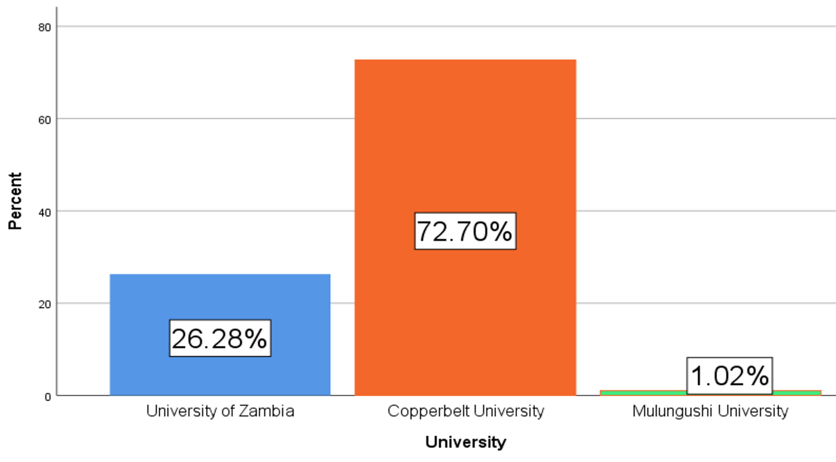
Fig. 4.1 Engineering students’ participation per university.
The figure below shows the distribution of engineering student respondents by their year of study. The student respondents came from the following courses: Environmental engineering, Civil engineering, Electrical and electronics, Electromechanical engineering, Architecture engineering, Construction management, Geology and Mechanical engineering . It is important to note that the pedagogy used by lectures with regards to how engineering laboratory lessons are delivered is dependent on the year of study of their students. Reason being that student of first (1st) year, second (2nd) year and third (3rd) year would still be in their earlier engineering development stages trying to grasp engineering concepts especially practical concepts. Therefore, it would not be appropriate for engineering lab sessions to be administered to them virtually during their early academic development years. This information and dependency were brought to the attention of the research by one of the UNZA engineering lecturers who was interviewed. The highest percentage of respondents were fifth (5th) year students and followed by third (3rd) year students. 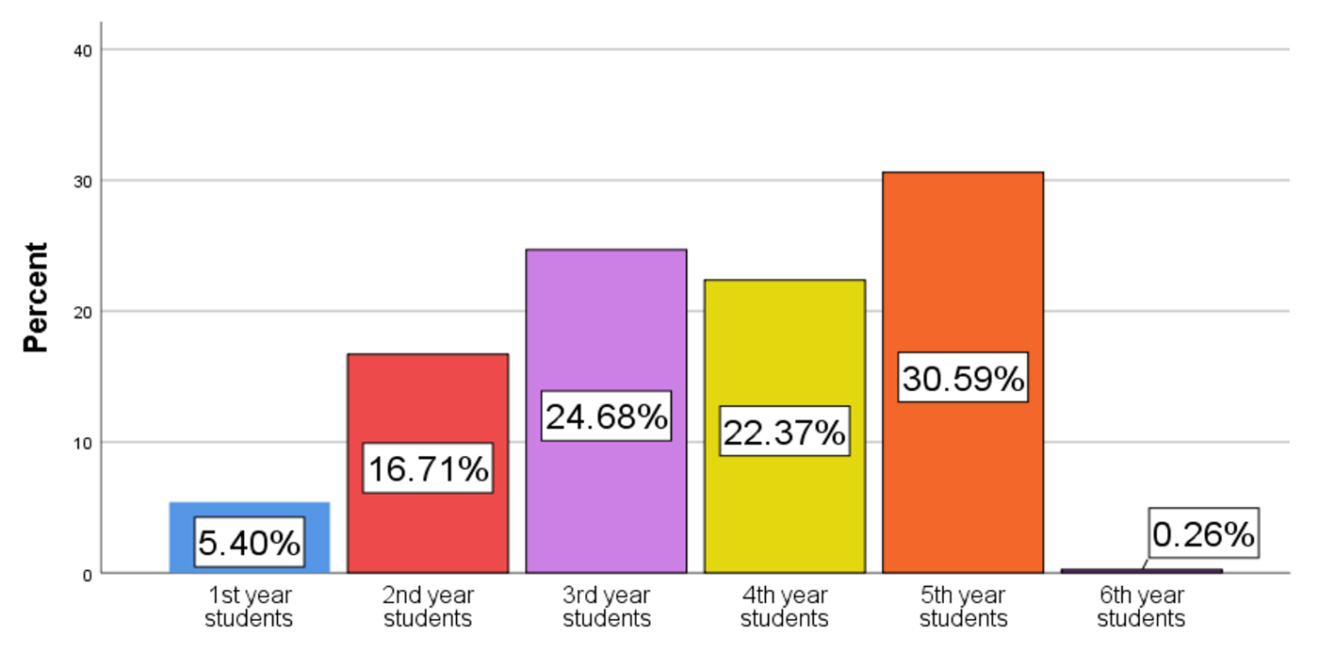
Fig. 4.2 Engineering students participation per year of study.

4.3.2 Percentage of Students that Attended Scheduled Lab Lessons
The figure below shows the percentage of students that attended their scheduled virtual engineering laboratory lessons during the pandemic. This statistical data just goes to show the impact the pandemic had on engineering laboratory lessons. As mentioned earlier in the abstract, background and literature review that engineering students poorly attending their lab lessons would negatively impact on the calibre of graduates released into the industry. This would in turn negatively impact on the economic growth of the nation. The virtual labs that were conducted include courses such as geomatics simulation-based labs with pixel software, computer-based courses using code blocks and mechanical engineering using virtual labs for second (2nd) year.
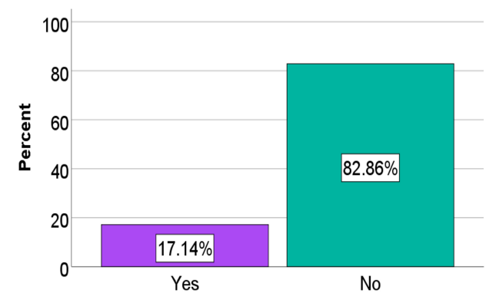
Fig. 4.3. Percentage of students that attended scheduled lab lessons.

4.3.3 Factors Leading to Students not Attending Scheduled Virtual Laboratory Lessons
The figure below shows statistical data of reasons as to why students didn’t attend all scheduled virtual engineering practical’s that is linked to the previous Fig. 4.3. The previous Fig. 4.3 showed the percentage of students that attended scheduled lab lessons. Fig. 4.4 shows reasons of the low attendance rate of scheduled virtual lab lessons by engineering students. The dominant reason being unstable internet connection at thirty seven percent (37%). Results of Fig. 4.4 are attributes that influence the success or failure of virtually administered lessons. As mentioned earlier in this research conceptual framework and Khans global eLearning framework. The technical attributes below of unstable internet connection, unavailable resources, lack of equipment, unavailability of power and university’s ability to provide needed virtual tools and platforms did not conform to the requirements of global eLearning framework that guide how virtual learning should be conducted, for they were not completely available to students.
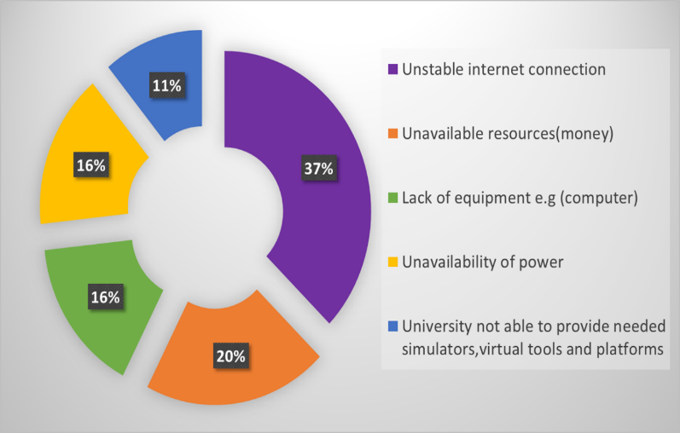
Fig. 4.4 Factors leading to students not attending scheduled virtual laboratory.

4.3.4 Effectiveness of Virtual Laboratory Lessons
For the sake of future improvement and to know if virtual labs were effective. The figure below shows engineering students view on the effectiveness of virtual labs administered by virtual tools and platforms. Most students at seventy-six-point five nine percent (76.59%) felt they were not effective. Reasons for this are unstable internet connection, lectures not able to create clear and audible online lessons. Another reason students gave of virtual labs not being effective is that engineering is a practical program which requires hands on practice. According to Farida Saleem,(2022) this lack of hands-on training shatters one’s confidence and restricts one’s forward mobility. Other reasons given by students and lecturers for ineffectiveness of virtual education included plagiarism, see appendix B for more reasons as to why students had the view that virtual labs are not effective. So far at this stage of the data analysis the technical and pedagogy aspect of testing these attributes shows that virtual labs are not effective unless if the constraints depicted in the previous figure are dealt with.
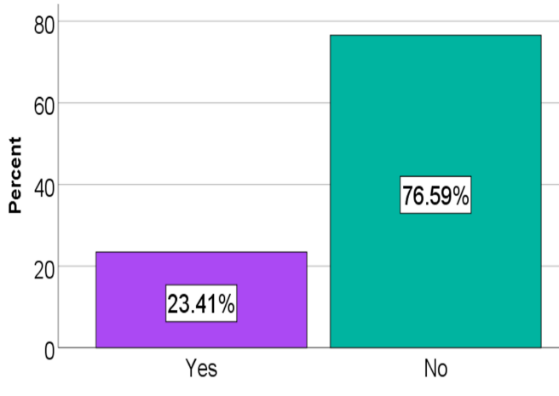
Fig. 4.5 How effective are virtual laboratory lessons.

4.3.5 Do Virtual Labs Compromise on the Quality of Education
The figure below shows engineering students view if virtual labs compromise on the quality of education. Most students saw virtual labs has been a compromise on the quality of education which stood at seventy-point six eight percent (70.68%). One of the reasons for this was due to the following: Some practical lessons require guide from lecturer or supervisor. When guides are just sent as instructions its cumbersome for students to follow and achieve desired results. See appendix C for more reasons as to why students felt virtual labs compromise on the quality of education.
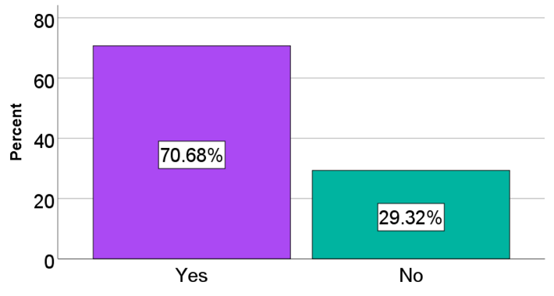
Fig. 4.6 Engineering students view on virtual labs compromising on the quality of education.

4.3.6 Preparedness of Lectures in Administering Virtual Labs During the Pandemic
The figure below shows the students view on how prepared their lecturers were in the delivery of virtual labs in courses that involve labs such as geomatics simulation-based labs with pixel software, computer-based courses using code blocks, mechanical engineering during the pandemic. From the results below thirty six percent (36%) of lectures were fairly well prepared this was a higher percentage than below expectation at twenty four percent (24%) and not well prepared at twenty eight percent (28%). It is key that lecturers are prepared in the manner in which they deliver the virtual labs.

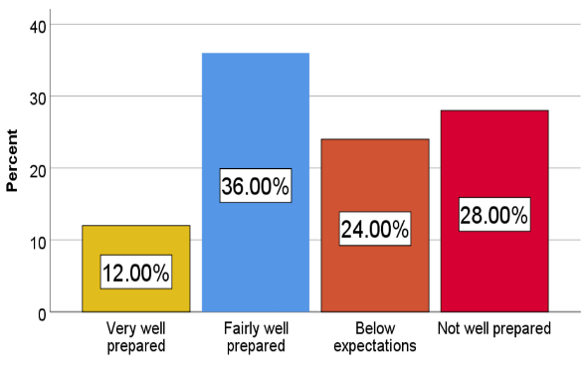
Fig. 4.7 Preparedness of lectures in administering virtual labs.

4.3.7 Student Academic Performance During the Pandemic
The figure below shows student academic performance during the pandemic. It is evident from the below findings that a majority seventy-two-point five zero percent (72.50%) of students had poor performance in their tests/ continuous assessments /exams. This falls under Khan’s assessment subdimension and it is evident that the pandemic had a negative effect on students’ academic performance during the pandemic. This data is supported by data collected from lecturers as depicted by table 4.3.
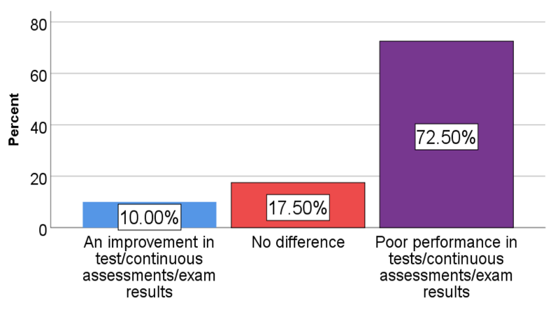
Fig. 4.8 Student academic performance during the pandemic.

4.3.8 Students perspective-Methods of Delivering Laboratory Lessons During the Pandemic
The figure below shows the methods that were used in the delivery of labs at the three (3) HEIs during the pandemic. The most dominant method was physical at fifty-one point zero two percentage (51.02%) followed by blended at thirty-two-point six five percent (32.65%) and the least was by virtual tools and platforms at sixteen-point three percent (16.33%). The notable virtual tools are MATLAB which combines a desktop environment tuned for iterative analysis and design processes with a programming language that expresses matrix and array mathematics directly. It includes the live editor for creating scripts that combine code, output, and formatted text in an executable notebook (‘MATLAB - MathWorks’), and Simulink which is a block diagram environment used to design systems with multidomain models, simulate before moving to hardware and deploy without writing code. It can be used for wireless communication, electrification, control systems, signal processing e.t.c (‘Simulink - Simulation and Model-Based Design’) and PowerWorld was also a notable virtual tool used.

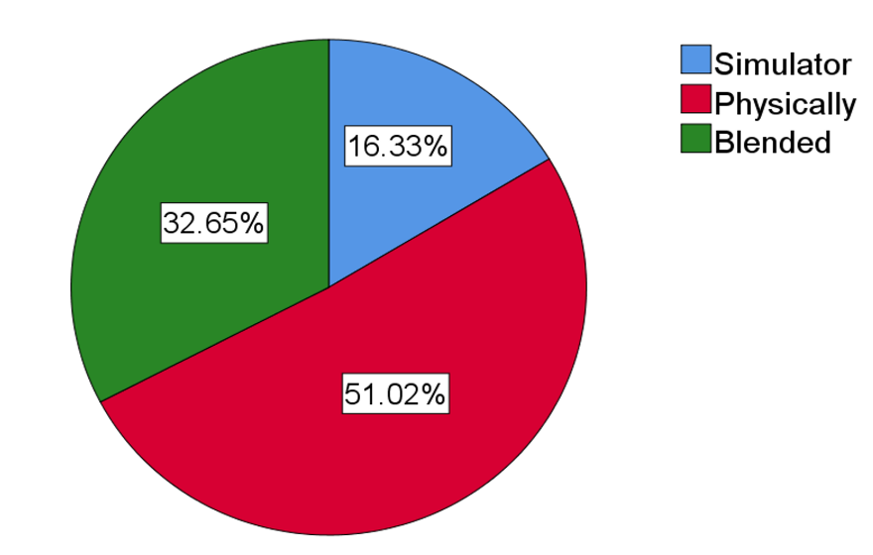
Fig. 4.9 Method of delivering laboratory lessons during the pandemic.

4.3.9 Student’s Views on the Best Method of Delivering Engineering Practical’s
The figure below shows the view of students on best method of delivering engineering practicals. Some notable reasons for students’ choice were that traditional physical face to face practicals allows for a good interaction between students and their lab instructors, students can clarify where they aren't clear, other students’ reasons were that blended would be best for some lecturers were not very conversant in hosting virtual labs.
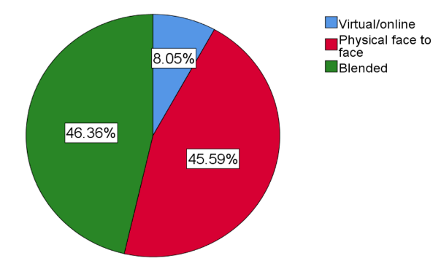
Fig. 4.10 Students view on best method of delivering engineering practicals.

4.4 Results from the Ministry of Education
The Ministry of Education is the principal arm of government that formulates and implements policy and regulations related to university education. The aim of the policies and regulations are to ensure citizens have equal access to quality university education. Besides the higher education policy, the Ministry assures quality and standards through the provisions of the higher education Act of 2013 as amended in 2021. On how the pandemic affected delivery of education by Zambian universities, the Ministry responded by saying, to deliver quality online learning, universities needed to invest in quality ICT infrastructure which required a lot of resources. Due to prolonged closures, universities could not generate required finances through fees, therefore, they had to rely on extra funding from the treasury. When asked what measures had been put in place to combat the effects of COVID-19 on education delivery at Zambian universities, the Ministry responded by saying that to continue delivering quality education, all Universities had migrated to blended modes of learning.
The Ministries view on the use of alternative platforms such as simulators, virtual tools and platforms in the delivery of engineering practical lessons by Zambian universities in the wake of COVID-19 was that using alternative platforms to offer university education in general can be a positive thing because universities can increase their enrolments without worrying about physical infrastructure capacity such as classrooms and accommodation thereby, increasing on their revenues. The Ministry was asked if amending the curriculum of courses that include engineering lab lessons due to the pandemic was necessary. The response was that there was no need to amend the curriculum just because of the pandemic. What is needed is to help the universities invest in reliable ICT tools and re-train their staff to allow continued offering of quality education. When asked what the Ministry was doing to help students that found challenges attending virtual lessons such as high cost of bundles, unstable or no power connections in some areas (seeing that online/virtual learning would be with us for a while). The ministry’s response was that they are engaging various partners to find a solution to it. When the Ministry was asked if an evaluation was done and what where the results to measure the adherence levels by Zambian universities on the delivery of virtual learning against set of quality standards. The response was that quarterly evaluations were done since the outbreak of the pandemic. Adherence varied between forty five percent (45%) for the newer smaller universities located in rural areas to over eighty five percent 85% for the bigger older universities.

4.5 Results from the Higher Education Authority
The Higher Education Authority (HEA) of Zambia was visited, whose mandate is regulation of the higher education sector in Zambia and providing external quality assurance in higher education. The authority encouraged use of virtual platforms as an alternative to the traditional face to face method during the outbreak of the pandemic. The HEA view on the quality of education delivered by virtual methods was that the quality of education offered through eLearning is just as comparable to that offered through conventional learning. However, institutions are required to put safeguards in place in order not to compromise on quality. The authority had been encouraging HEIs to use online platforms to teach and learn even before the arrival of COVID-19 and systems had already been put in place through standards on Open Distance Learning (ODel) which provide quality standards for online learning. On the aspect of lab lessons being conducted by virtual tools and platforms compromising on the quality of education the HEAs view was that virtual learning, if conducted properly cannot compromise on quality. The HEA said virtual learning and engineering labs by virtual tools and platforms do not affect the curriculum of higher education institutions.

4.6 Comparison of results against the Khan eLearning framework and the ZSG-QA
Under Chapter two (2) of the literature review we discussed Khan’s framework dimensions that can be used to evaluate virtual education which are resource support dimension, technological dimension, pedagogical dimension, ethical dimension, evaluation dimension and interface design dimension. We also reviewed the ZSG-QA which are local guidelines on how eLearning is to be conducted as stipulated by the Higher Education Authority of Zambia. The research results will now be compared for adherence to the guidelines stipulated by Khans global eLearning framework and the ZSG-QA. This will be done to see if the virtual labs were conducted effectively and if they compromised on the quality of education. The eLearning Framework can be applied to eLearning of any scope.

Table 4.4: Khans global eLearning framework on dimensions and sub-dimensions that can be used to evaluate virtual education.
Below is a recap on Khans eLearning framework dimensions and subdimensions that can be used to evaluate virtual education.
DIMENTION | DESCRIPTION | SUB-DIMENTIONS
Resource support | Examines the online support and resources required to foster meaningful learning environment. | Online support and resources
Technological | This dimension addresses technical infrastructures and assets that form the backbone of an eLearning entity. | Software, hardware and infrastructure planning.
Pedagogical | This dimension addresses the process of learning and teaching in terms of how learning and teaching is carried out (communication, collaboration, and interaction) | Content analysis, audience analysis, goal analysis, design approach and blending strategies
Ethical | This dimension of eLearning is related to social and cultural diversity issues. | Social and cultural diversity, bias and political issues, geographical diversity, digital divided and the legal issues
Evaluation | This dimension centres on examining the effectiveness of the institution, program and course. | Evaluation of content development, evaluation of eLearning environment, evaluation of eLearning at the program and institutional levels and assessment of learners and academic affairs.
Interface design | This dimension refers to the overall look and feel of eLearning programs | It encompasses subdimensions such as page and site design, content design, navigation, accessibility and usability.

(Khan & Abid, 2021)

4.6.1 Comparison of Lecturer Research Results to Khan’s eLearning Framework
1. When asked if lecturers underwent some sort of training to equip them to deliver lessons virtually during the pandemic. The response was No, the lecturers did not go under any training to equip them to deliver lessons virtually during the pandemic.
Compliant or / non-compliant:
The above was not compliant to institutional dimension, administrative subdimension of Khans framework on evaluation of eLearning.
2. When asked if students were motivated in attending their virtual classes. The response was students were affected by increase in the cost to attend virtual classes as compared to physical classes as they were supposed to buy internet data every day and have in possession either a smart phone, laptop or desktop including those living in an area with no easy access to internet which was not possible in rural areas and in some peri-urban areas.
Compliant or / non-compliant:
The above was found not to be compliant with the ethical dimension, digital divide sub dimensions of Khans eLearning framework. This is due to digital divide that was evident from the lecturer’s response.
3. When asked about how exams and assessments were administered to students during the pandemic. Response was that exams were conducted physically while assignments and tests were administered online. However, plagiarism was a concern by both lecturers and students.
Compliant or / non-compliant:
The above was found to be non-compliant to Khans global framework on evaluation of eLearning based on the evaluation dimension, assessment subdimension. As plagiarism was mentioned as a concern by lecturers during tests that were conducted virtually during the pandemic.
4. When asked about how lecturers' preparation of content was done regarding delivering the lessons virtually. (Was the content well analysed to ensure virtual lessons are delivered to students in a way that they can understand). The response was the lecturers did their best to prepare the contents according to the required course contents and were able to deliver the classes virtually although with hardships as they had to bear all the costs.

Compliant or / non-compliant:
The above was not compliant to the ethical, digital divide sub dimensions and resource support, resource sub dimension of the khan eLearning framework.
5. When asked if lesson objectives were met by the delivery of lessons virtually. The response was YES on the theoretical part but not on the practical part because laboratory work was missing. Since engineering is a hands-on subject thus, students are expected to conduct practicals after learning the theory. Therefore, in the absence of practical’s the objectives are difficult to meet.
Compliant or / non-compliant:
The above was not compliant to the pedagogical dimension, goal analysis subdimension of the Khan eLearning framework as the teaching goals/objectives of lecturers were not met fully because not all laboratory lessons were conducted.
6. When asked about how the enthusiasm of students and lecturers was during the delivery of lessons virtually. The response was that it was great for both parties in the beginning, but as time progressed and costs increased it became difficult and the enthusiasm reduced.
Compliant or / non-compliant:
The above was not compliant to the ethical dimensions, digital sub dimension of Khans eLearning evaluation framework, for students could not sustain the cost of internet bundle hence, their participate in the virtual labs became unbearable, a sign of digital divide. The above was also not compliant to the pedagogical dimension, audience analysis sub dimension. For eLearning is more effective when both students and lecturers are responsive, enthusiastic and student centred.

4.6.2 Comparison of Research Results to Khan’s eLearning Framework
Table 4.5: Evaluation of HEI’s Compliance to the Dimensions of the eLearning Framework
The table below shows whether HEIs complied to the guidelines of Khans eLearning framework or not.
No. | Dimensions of e-learning framework | HEI’s compliance to framework guidelines | Evidence
1. | Technological | Not compliant | Reference is made to questionnaire results depicted by Fig. 4.4. It shows that thirty seven percent (37%) of students gave unstable internet connection as the most dominant reason as to why they didn’t attend their scheduled lab lessons.
2. | Technological | Not compliant | Reference is made to questionnaire results depicted by Fig. 4.4. It shows that sixteen percent (16%) of students gave the lack of equipment as one of the reasons they didn’t attend their scheduled lab lessons.
3. | Technological | Not compliant | Reference is made to questionnaire results depicted by Fig. 4.4. It shows that eleven percent (11%) of students gave the reason of universities not able to provide needed simulators, virtual tools and platforms as one of the reasons they didn’t attend their scheduled lab lessons.
4. | Technological | Not compliant | With reference to Fig. 4.5. It shows that seventy-six-point five nine percent (76.59%) of students had the view of virtual labs not being effective. Reference is also made to appendix B that shows some reasons as to why they had this view of virtual labs not being effective. Some of the reasons being technical challenge of unstable internet connection.
5. | Pedagogical | Not compliant | With reference to appendix B, one of the reasons students gave for virtual labs not being effective was that “at times it’s difficult to understand practical’s by watching online, one has to physically engage in practical’s”.
6. | Pedagogical | Not compliant | With reference to Fig. 4.6, which shows that seventy-point six eight percent (70.68%) students viewed virtual labs as a compromise to the quality of education. With reference to appendix C, one of the reasons for their view is that “when guides instructions are just sent its cumbersome for students to follow and achieve the desired results”.
7. | Ethical | Not compliant | With reference to appendix B, students gave a reason of “unstable internet connection, lack of data bundles” for virtual labs not being effective. This shows that a digital divide exists, and digital divide is a sub dimension of the ethical dimension of the eLearning framework for evaluation of virtual learning.
8. | Ethical and resource support | Not compliant | Reference is made to appendix D, which gives reasons as to why universities do not have virtual tools and platforms being that “Most government universities are underfunded and licenses to use some of these tools can be quite expensive”. Reference is also made to section 4.6.1 number four (4) regarding lecturers facing hardship in ensuring they have bundles for them to conduct their virtual lessons.
9. | Interface design | Not compliant | With reference to Fig. 4.5 that shows seventy six percent (76%) of students viewed virtual labs as not effective. Reference is made to appendix B that shows student reason for their views, which is “lecturers are not able to create clear and audible online lessons”
10. | Resource support | Not compliant | With reference to Fig. 4.4, it shows that twenty percent (20%) of the respondents had the reason for not attending their scheduled virtual labs as being unavailable resources.
11. | Evaluation | Not compliant | Reference is made to appendix C that shows reasons students gave for their view on why virtual labs compromise on the quality of education. One of the reasons being plagiarism which falls under evaluation dimension and assessment sub dimension of the learner in the eLearning framework. Reference is made to section 4.6.1 number 3 where lecturers responded of noticed plagiarism during their assessment of students.
12 | Evaluation | Not compliant | Reference is made to Fig. 4.8 that shows that seventy-two point five zero (72.50%) of respondents had poor performance in their tests/ continuous assessments during the pandemic.

4.6.3 Comparison of Research Results to the ZSG-QA
The comparison is done to see the level of adherence by the HEIs in ensuring an effective delivery of lab lessons virtually that does not compromise on the quality of education.
1. The ZSG-QA Guideline on Supporting its Learning Programmes
Requirement: A HEI will have dedicated, adequate and relevant number of facilities and equipment shall be available for the support of a given learning programme and shall include but not limited to lecture rooms /theatre, seminar/tutorial rooms and for practical based courses appropriate laboratory facilities for each learning programme
Compliant or not: Not fully compliant
Evidence: The HEIs were not able to provide the relevant virtual tools and platforms as alternative method to the required physical laboratory facilities. This is evident from results of Fig. 4.4, showing universities not able to provide the needed virtual tools and platforms.
2. ZSG-QA on Assessment Standards
Requirement: The ZSG-QA demands that a higher education institution shall have assessment standards and procedures that are explicit and made available to students and staff. This needs to be achieved by assessment standards being spelled out for each learning programme and are competence or outcome-based, where applicable.
Compliant or not: Not compliant
Evidence: Lectures and students brought out the issue of plagiarism during student online assessments as one of the reasons they thought virtual learning compromised on the quality of education. It shows that the assessment standards were compromised.
3. ZSG-QA on Learner Support
Requirement: A higher education institution shall provide staff and students' access to online learning platforms. A higher education institution shall have reliable internet facilities to facilitate learning processes.
Compliant or not: Not compliant
Evidence: Fig. 4.4, shows all the technological constraints that students faced when labs were administered to them virtually. Unstable internet connection was the dominant reason amongst the constraints of virtual learning.

4.7 Discussion
Comparison between the research results and dimensions of Khans global eLearning framework above in table 4.5 shows a lot of concern. Most of the results collected from students and lecturers show a major gap when compared against Khan’s sub dimensions of the eLearning framework and ZSG-QA. This is more especially in the technology dimension where HEIs had several non-compliances. Most non-compliances were attributed to the constraints that were faced in the delivery of virtual labs as depicted in Fig. 4.4 of the results chapter. Other non-conformances to the guidelines are as follows:
Research results from lecturers showed non-adherence to Khans eLearning guidelines in the following ways: lecturers didn’t undergo training to equip them to deliver lessons virtually during the pandemic, students were not motivated due to increase in the cost of buying internet data every day, exams were conducted physically while assignments and tests were administered online. However, plagiarism was a concern by both lecturers and students, lecturers did their best to prepare the contents according to the required course contents and were able to deliver the classes virtually although with hardships as they had to bear all the costs and lesson objectives were met on the theoretical part but not on the practical part because laboratory work was missing.
Research results from students showed non-adherence to Khans eLearning guidelines in the following ways: Unstable internet connection was the most dominant reason as to why they didn’t attend their scheduled lab lessons, sixteen percent (16%) of students gave the lack of equipment as one of the reasons they didn’t attend their scheduled lab lessons, students gave the reason of universities not able to provide virtual tools and platforms as one of the reasons they didn’t attend their scheduled lab lessons, reasons as to why universities do not have virtual tools and platforms being that “Most government universities are underfunded and licenses to use some of these tools can be quite expensive”
The result findings compared to the requirements of the ZSG-QA are summarised as follows: It was found that HEIs were not fully compliant to the ZSG-QA technological aspect in ensuring that infrastructure, software and hardware are made available for the effective delivery of virtual labs and lessons. Virtual tools and platforms not available at HEIs as evidenced from findings from Fig. 4.4. The issues of plagiarism during assessment were also found to be an issue too.
In order to answer our first two (2) research questions of what is the effectiveness of delivering engineering laboratory lessons by virtual tools and platforms and if the delivery of engineering laboratory lessons by virtual tools and platforms compromises on the quality of education. The questions stated emanated from the research objectives. From the above-mentioned constraints relating to the delivery of virtual education it can be concluded that the delivery of virtual labs by virtual tools and platforms during the pandemic at the three (3) HEIs was not done effectively and compromised on the quality of education for the majority of the guidelines under the Khans eLearning framework and ZSG-QA were not adhered to. To answer the third and final research question that emanated from the research objective of what is the best method that engineering laboratory lessons can be undertaken when physical engagement between lecturers and student is limited. It is advised that students are to have blended lessons as follows:
- Theoretical lessons done virtually, and lab lessons done physically or,
- Theoretical lessons done virtually, and lab lessons done partly virtually and partly physically.
In short, the blended method of delivering virtual labs would be the best to use at the selected HEIs that are under the scope of this study in scenarios that student and lecture interaction is limited. Especially considering that our economy is a developing one where most infrastructure still requires a lot of attention. But of course, this method will still demand an improvement on the technological dimension of Khan eLearning framework. A determining factor on what method should be used in the delivery of virtual lab lessons is the nature of the course and availability of tools. A civil and environmental engineer lecturer was interviewed and indicated that his course involves lab sessions. The lecturer however, indicated that it would be quite difficult to shift the labs virtually in a situation where there is limited contact between lecturer and student. This is because the nature of the civil engineering labs cannot be done virtually hence such a course lab can only be done physically. Hence, blended is advised for labs of such difficult nature.

It should be noted that what came out pronounced from the Ministry of Education (MOE)-Zambia, Higher Education Authority (HEA) of Zambia and UNZAs department of quality assurance was the need to ensure staff that are delivering the virtual lessons are conversant with the tools and platforms, this can only be done if training is administered to the lecturers.
With reference to the conceptual framework depicted in chapter one (1) Fig. 1.1. When it came to putting the variables of the conceptual framework to the test the results are as follows: The hardware, software and infrastructure were identified as factors that influence effectiveness and quality of virtual labs. The hardware, software and infrastructure were seen from the research results that they had the biggest gap. HEIs must tackle the technological backbone if they are to deliver virtual labs successfully. It came to the research attention that lectures with the required knowledge on how to conduct virtual labs generally require to be improved on however, institutions such as UNZA responded that their lecturers had knowledge on delivery but did not undergo training. If content was analysed by lecturers in their delivery of virtual lessons, lectures confirmed that lecturers did their best to prepare the contents according to the required course contents and were able to deliver the classes virtually although with hardships as they had to bear all the costs. Digital divide was very evident where students could not afford to procure bundles and the lack of laptops and Personal Computers (PCs) to allow them have virtual learning. It can be concluded that the conceptual frameworks independent variables have a huge gap at the selected HEIs and hence have a negative impact on the conceptual frameworks dependent variables and it would mean not achieving the following dependent variables namely: not achieving reduced disruption in interaction between engineering students and lecturers and students still not being able to interact and practice in lab environment whether class is blended or virtual. The conceptual frameworks dependent variables can only be achieved once all the constraints in the research are addressed. When it came to comparing the research results against literature that was reviewed. The research results were similar to those of Lufungulos (2021) in a way that both identified the undesirable experiences of online learning during the pandemic as technical difficulties and distractions during classes caused by connectivity issues. In addition, lecturers indicated that poor ICT infrastructure, students’ economic status, digital divide and technology cost resulting in learning loses which subsequently affected the quality of education.

4.8 Chapter Summary
This chapter showed results of the study and it discussed the constraints faced by HEIs and factors that influenced the non-compliance to the eLearning framework and the ZSG-QA. The following chapter will present the conclusion and recommendations.

CHAPTER FIVE: CONCLUSION RECOMMENDATION AND FUTURE WORK
The previous chapter showed the results of the study. The chapter also summarized the findings and presented them in charts, graphs, tables and brief narrations. This chapter will provide a conclusion of the research findings. The general objective of the study is to investigate the effectiveness of delivering engineering laboratory lessons by virtual tools and platforms, to investigate if the delivery of engineering laboratory lessons by virtual tools and platforms compromises on the quality of education and to investigate the best method engineering laboratory lessons can be undertaken when physical engagement between lecturers and student is limited.

5.1 Conclusion
The results from the study were compared against Khan’s eLearning framework and the local guidelines on quality assurance from the ZSG-QA. The comparison showed obvious gaps, prominent were technological issues. It is the research conclusion that engineering lab lessons that were conducted virtually compromised on the quality of education and were not effective during the COVID-19 pandemic. This conclusion is taken from the comparison of the research results with the requirements of Khan’s eLearning framework, with most HEIs not performing well against the eLearning frameworks dimensions and the local ZSG-QA requirements. On which is the best method engineering laboratory lessons can be undertaken when physical engagement between lecturers and student is limited. The answer is not cast and concrete. It is dependent on the nature of the course, availability of tools and the year a student is in. It would be best practice that if students are in their early engineering learning stages, they are to have blended lessons that is theoretical lessons done virtually and lab lessons done partly physically and partly virtually. In short, the blended method of delivering virtual labs would be best at the selected HEIs that are under the scope of this study in scenarios that student and lecture interaction is limited. Going forward there is a serious need for universities to improve on their technological infrastructure for this is the backbone of virtual learning. Universities and government need to work together in ensuring students never lag behind again when student and lecturer interaction is limited as the COVID 19 pandemic had presented.

5.2 Recommendations
The issuance of guidelines by the Higher Education Authority (HEA) the arm of government when it comes to education quality assurance is a step in the right direction. However, more needs to be done in ensuring HEIs are familiar and compliant with the guidelines. The research recommends the following measures in addition to existing strategies by the education regulator:
- The Higher Education Authority (HEA) should conduct an in-depth assessment of all HEIs in Zambia and ensure the HEIs provide their road map in ensuring there is no disruption to students learning especially when it comes to laboratory.
- The Ministry of education should establish a central repository for the storage of HEIs road maps and stages they have reached in their quest to slowly shift to eLearning platforms.
- Local education authorities and HEIs should raise awareness and create a shared responsibility for ensuring that they are able to acquire the much-needed virtual tools and platforms by collaboration. Done by contributions to a pool of funds by the HEIs students which would make procurement of the virtual tools cheaper and accessible to the HEIs that are contributing to the pool of funds.
- A technical team should be constituted in spearheading non disruption to higher education learning both normal lessons and lab lessons when a natural occurrence such as the one the pandemic presented. The team will also ensure availability of infrastructure at HEIs in the country and preserve funds for expansion of infrastructure for HEIs.
- All processes involved in the formulation of pedagogies for virtual learning deployment and management must be reviewed to reflect the current environment and regulatory framework.
- HEIs should design pedagogies to be used as an alternative backup to the traditional face to face learning.

5.3 Future Work
In the future, this work could assess how HEIs can have road maps in ensuring there is no disruption to student’s laboratory lessons. How HEIs can develop eLearning pedagogies for a developing country such as Zambia. How a technical team could be constituted in spearheading non disruption to higher education learning and ensuring availability of infrastructure at HEIs in the country and preserve funds for expansion of infrastructure for HEIs.

REFERENCES

Almaiah, M. A., Al-Khasawneh, A., & Althunibat, A. (2020). Exploring the critical challenges and factors influencing the E-learning system usage during COVID-19 pandemic. Education and Information Technologies, 25(6), 5261–5280. https://doi.org/10.1007/s10639-020-10219-y
Alneyadi, S. S. (2019). Virtual lab implementation in science literacy: Emirati science teachers’ perspectives. Eurasia Journal of Mathematics, Science and Technology Education, 15(12). https://doi.org/10.29333/ejmste/109285
Atalan, A. (2020). Is the lockdown important to prevent the COVID-19 pandemic? Effects on psychology, environment and economy-perspective. Annals of Medicine and Surgery, 56, 38–42. https://doi.org/10.1016/J.AMSU.2020.06.010
Bair, D. E., & Bair, M. (2011). Paradoxes of Online Teaching. International Journal for the Scholarship of Teaching and Learning, 5(2). https://doi.org/10.20429/ijsotl.2011.050210
Barbour, M., & Reeves, T. C. Barbour, M. K., &amp; Reeves, T. C. (2009). The reality of virtual schools: A review of the literature. Computers and Education, 52(2), 402-416. Retrieved from https://www.academia.edu/2311478/Barbour_M_K_and_Reeves_T_C_2009_The_reality_of_virtual_schools_A_review_of_the_literature_Computers_and_Education_52_2_402_416
Bezhovski, Z., & Poorani, S. (2016). Information and Knowledge Management The Evolution of E-Learning and New Trends, 6(3). Retrieved from www.iiste.org
Bivariate Analysis Definition & Example - Statistics How To. Retrieved 08/10/2022 from https://www.statisticshowto.com/probability-and-statistics/statistics-definitions/bivariate-analysis/
Blended learning models (Staker & Horn, 2012) | Download Scientific Diagram. Retrieved 05/02/2023 from https://www.researchgate.net/figure/Blended-learning-models-Staker-Horn-2012_fig5_275535019
Bowman, D. A., Hodges, L. F., Allison, D., & Wineman, J. (1999). The educational value of an information-rich virtual environment. Presence: Teleoperators and Virtual Environments, 8(3), 317–331. https://doi.org/10.1162/105474699566251
Clark, R. C., & Mayer, R. E. (2008). Retrieved 05/11/2022 from https://www.scirp.org/(S(lz5mqp453edsnp55rrgjct55))/reference/ReferencesPapers.aspx?ReferenceID=1944052
Cohen, L., Manion, L., & Morrison, K. (2013). Research Methods in Education. Research Methods in Education. https://doi.org/10.4324/9780203720967
Components of a Virtual Laboratory. | Download Scientific Diagram. Retrieved 28/02/2023 from https://www.researchgate.net/figure/Components-of-a-Virtual-Laboratory_fig17_220061923
Dastjerdi, N. B. QUALITY IN VIRTUAL EDUCATION: THE QUALITY EVALUATION MODEL FOR EDUCATIONAL ACTIVITIES IN VIRTUAL INSTITUTIONS. Retrieved from www.tojqih.net
Davis, N., Rose, R., & Associates, R. S. National Standards of Quality for Online Courses Professional Development for Virtual Schooling and Online Learning Written by.
du Plessis, M., Jansen van Vuuren, C. D., Simons, A., Frantz, J., Roman, N., & Andipatin, M. (2022). South African Higher Education Institutions at the Beginning of the Covid-19 Pandemic: Sense-Making and Lessons Learnt. Frontiers in Education, 6. https://doi.org/10.3389/feduc.2021.740016
E-LEARNING 43. (-a).
Fayez, A. N., Ghabban, F. M., & Ameerbakhsh, O. (2021). Advantages and Challenges of Smart Learning in Higher Education Institutions in Saudi Arabia. Creative Education, 12(05), 974–982. https://doi.org/10.4236/CE.2021.125071
Geymond, O., Amaral, B., Broughton, A., France, J., Hanka, S., Rizzo, S., … van Es, D. (2020). COVID-19 crisis and engineering in sub-Saharan Africa.
Gutiérrez A., M. A., Vexo, F., & Thalmann, D. (2008). Stepping into virtual reality. Stepping into Virtual Reality, 1–214. https://doi.org/10.1007/978-1-84800-117-6/COVER
Kapilan, N., Vidhya, P., & Gao, X. Z. (2021). Virtual Laboratory: A Boon to the Mechanical Engineering Education During Covid-19 Pandemic. Higher Education for the Future, 8(1), 31–46. https://doi.org/10.1177/2347631120970757
Khan, Z. H., & Abid, M. I. (2021). Distance learning in engineering education: Challenges and opportunities during COVID-19 pandemic crisis in Pakistan. International Journal of Electrical Engineering Education. https://doi.org/10.1177/0020720920988493/ASSET/IMAGES/LARGE/10.1177_0020720920988493-FIG5.JPEG
Lampi, E., Price, W. T., Burton, J. K., Cartwright, D. L., & Lockee, B. B. (2013). The Effectiveness of Using Virtual Laboratories to Teach Computer Networking Skills in Zambia.
Lufungulo, E. S., Mwila, K., Mudenda, S., Kampamba, M., Chulu, M., Hikaambo, C. N., … Hikaambo, C. N. (2021). Online Teaching during COVID-19 Pandemic in Zambian Universities: Unpacking Lecturers’ Experiences and the Implications for Incorporating Online Teaching in the University Pedagogy. Creative Education, 12(12), 2886–2904. https://doi.org/10.4236/CE.2021.1212216
Major, S., Hubálovská, M., & Loskot, R. (2022). Alternative Forms of Laboratory Teaching during the Lockdown Period Caused by the COVID-19 Pandemic. International Journal of Information and Education Technology, 12(11), 1137–1147. https://doi.org/10.18178/ijiet.2022.12.11.1731
McNair, D. E. (2015). Palloff, R. M., & Pratt, K. Lessons From the Virtual Classroom: The Realities of Online Teaching. Http://Dx.Doi.Org/10.1177/1521025115578237, 17(2), 264–269. https://doi.org/10.1177/1521025115578237
Mishra, L., Gupta, T., & Shree, A. (2020). Online teaching-learning in higher education during lockdown period of COVID-19 pandemic. International Journal of Educational Research Open, 1. https://doi.org/10.1016/j.ijedro.2020.100012
Mixed Methods Research | Definition, Guide & Examples. Retrieved 08/10/2022 from https://www.scribbr.com/methodology/mixed-methods-research/
Ngoyi, L., Burton, J. K., Cartwright, D. L., & Lichtenberger, E. J. (2013). Benefits and Challenges Associated with Using Virtual Laboratories and Solutions to Overcome Them.
Nikolopoulou, K., & Kousloglou, M. (2019). Mobile Learning in Science: A Study in Secondary Education in Greece. Creative Education, 10(06), 1271–1284. https://doi.org/10.4236/CE.2019.106096
Pantelidis, V. S. (1993). Virtual Reality in the Classroom. Educational Technology, 33(4), 23–27.
PowerWorld » The visual approach to electric power systems. Retrieved 28/02/2023 from https://www.powerworld.com/
Radhamani, R., Kumar, D., Nizar, N., Achuthan, K., Nair, B., & Diwakar, S. (2021). What virtual laboratory usage tells us about laboratory skill education pre- and post-COVID-19: Focus on usage, behavior, intention and adoption. Education and Information Technologies, 26(6), 7477–7495. https://doi.org/10.1007/s10639-021-10583-3
Ray, S., & Srivastava, S. (2020). Virtualization of science education: a lesson from the COVID-19 pandemic. Journal of Proteins and Proteomics, 11(2), 77–80. https://doi.org/10.1007/s42485-020-00038-7
Research Design: Definition, Types & Characteristics | Leverage Edu. Retrieved 08/10/2022 from https://leverageedu.com/blog/research-design/
Sample Size Calculator: Understanding Sample Sizes | SurveyMonkey. Retrieved 08/10/2022 from https://www.surveymonkey.com/mp/sample-size-calculator/
Sá-Oliveira, J. C., C. E. C. Campos, A., Araújo, A. S., & Alberto, A. A. D. (2017). The Influence of Dewey’s Pedagogy in the Training of Basic Education Teachers of the Federal University of Amap&#225;-Brazil. Creative Education, 08(08), 1213–1222. https://doi.org/10.4236/CE.2017.88086
Shelton, K., & Saltsman, G. (2004). Tips and Tricks for Teaching Online: How to Teach Like a Pro! Retrieved from http://www.itdl.org/journal/oct_04/article04.htm
Simulators pose 10 challenges for developing, testing robots. Retrieved 01/03/2023 from https://www.therobotreport.com/10-challenges-simulators-robotics-testing/
Sitzmann, T., Ely, K., Bell, B. S., & Bauer, K. N. (2010). The effects of technical difficulties on learning and attrition during online training. Journal of Experimental Psychology: Applied, 16(3), 281–292. https://doi.org/10.1037/A0019968
Tarman, B., Khan, M. S., Saleem, F., Alnasrallah, W., Malik, M. I., & Rehman, S. U. (2022). Factors Affecting the Quality of Online Learning During COVID-19: Evidence From a Developing Economy. https://doi.org/10.3389/feduc.2022.847571
Technical and virtual lab FAQ : Atlassian. Retrieved 28/02/2023 from https://university.atlassian.com/student/activity/850257-lab-faqs
The Impact of COVID-19 on Education – Recommendations and Opportunities for Ukraine. Retrieved 04/10/2022 from https://www.worldbank.org/en/news/opinion/2021/04/02/the-impact-of-covid-19-on-education-recommendations-and-opportunities-for-ukraine
THE UNIVERSITY OF ZAMBIA SCHOOL OF ENGINEERING STUDENT HANDBOOK 2015-2020 NEW CURRICULUM FOR THE BACHELOR OF ENGINEERING PROGRAMME. (2015). Retrieved from http://www.unza.zm
The-State-of-Higher-Education-in-Zambia-2020.
Topping, B. H. v., & Bittnar, Z. (2002). Engineering computational technology, 315.
University of Ghana helps build virtual labs for Africa - Research Professional News. Retrieved 05/02/2023 from https://www.researchprofessionalnews.com/rr-news-africa-partnerships-2019-2-university-of-ghana-helps-build-virtual-labs-for-africa/
Vasiliadou, R. (2020a). Virtual laboratories during coronavirus (COVID-19) pandemic. Biochemistry and Molecular Biology Education, 48(5), 482–483. https://doi.org/10.1002/bmb.21407
Velarde, V., Casado-Barragán, F., Thamar, M., Rands, V. F., & Gonzalez, A. A. (2022). Home-based laboratory experiences during COVID-19 pandemic in undergraduate biochemistry students. Frontiers in Education, 7, 859. https://doi.org/10.3389/FEDUC.2022.965438/BIBTEX
Villamil-Casanova, John., & Molina, Louis. (1996). An interactive guide to multimedia, 239.
Vince, J. (2004). Introduction to Virtual Reality. Introduction to Virtual Reality. https://doi.org/10.1007/978-0-85729-386-2
Virtual Laboratories and the Future of Education. Retrieved 28/02/2023 from https://observatory.tec.mx/edu-bits-2/virtual-labs-contribution-to-the-future-of-education/
Virtual Labs Scenario. (2020).
Virtual Reality in the Classroom on JSTOR. Retrieved 05/02/2023 from https://www.jstor.org/stable/44428033
Warschauer, M., & Healey, D. (1998). State of the art article Computers and language learning: an overview. Retrieved from http://osu.orst.edu/~healeyd/
What Are the Different Pedagogical Approaches to Learning? Retrieved 22/10/2022 from https://learningjournals.co.uk/what-are-the-different-pedagogical-approaches-to-learning/
What Is a Conceptual Framework? | Tips & Examples. Retrieved 04/10/2022 from https://www.scribbr.com/methodology/conceptual-framework/
What Is a Research Design | Types, Guide & Examples. Retrieved 08/10/2022 from https://www.scribbr.com/methodology/research-design/
What Is Coronavirus? | Johns Hopkins Medicine. Retrieved 09/09/2022 from https://www.hopkinsmedicine.org/health/conditions-and-diseases/coronavirus
What is Mixed Methods Research?<br/> — Delve. Retrieved 08/10/2022 from https://delvetool.com/blog/mixedmethods
What is Virtual Lab | IGI Global. Retrieved 20/09/2022 from https://www.igi-global.com/dictionary/virtual-lab/31699
What Is Virtual Learning? | VEDAMO. Retrieved 22/10/2022 from https://www.vedamo.com/knowledge/what-is-virtual-learning/
Yokuş, G., & Yelken, T. Y. (2016). The adoption of mobile devices as digital tools for seamless learning. In Digital Tools for Seamless Learning (pp. 297–324). IGI Global. https://doi.org/10.4018/978-1-5225-1692-7.ch015

APPENDICES

Appendix A: Questionnaire
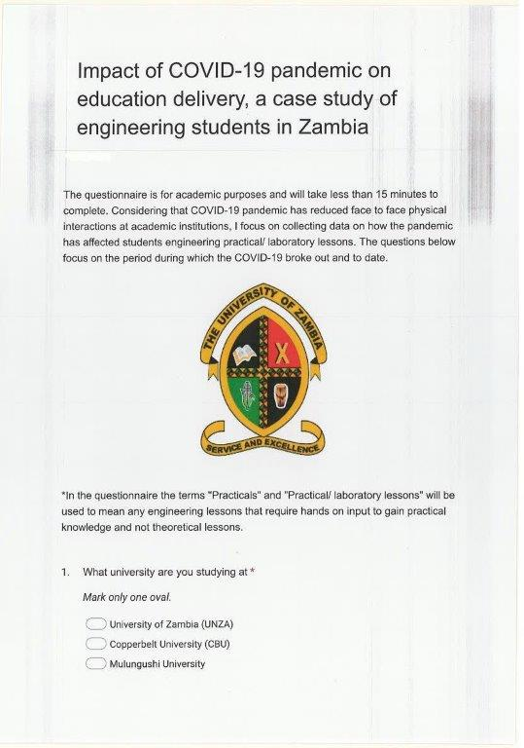
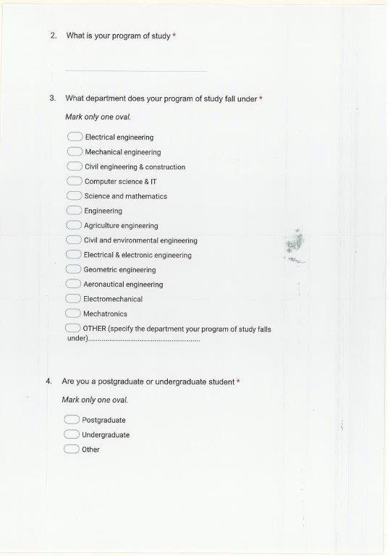

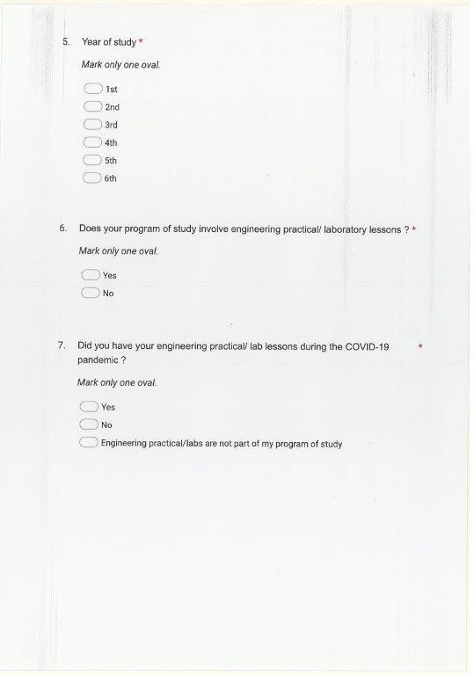

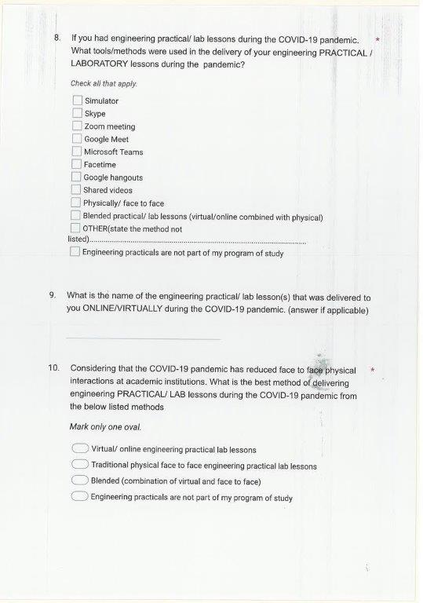

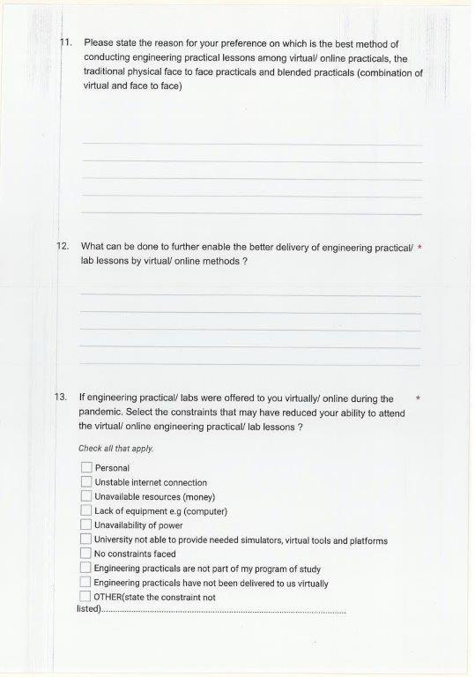
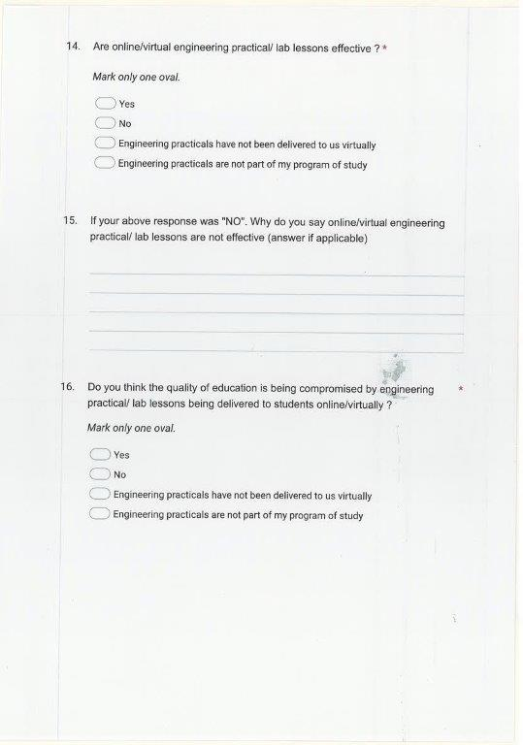
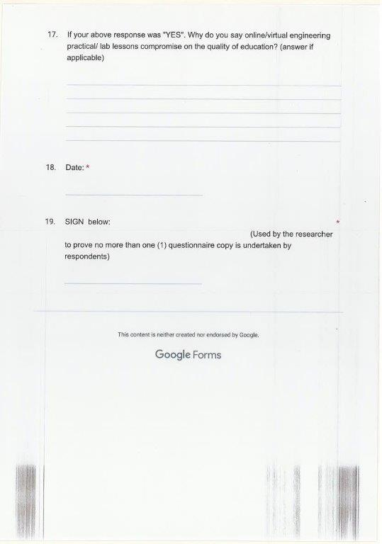

Appendix B: Students Thoughts as to Why Virtual Labs are not Effective at the HEI

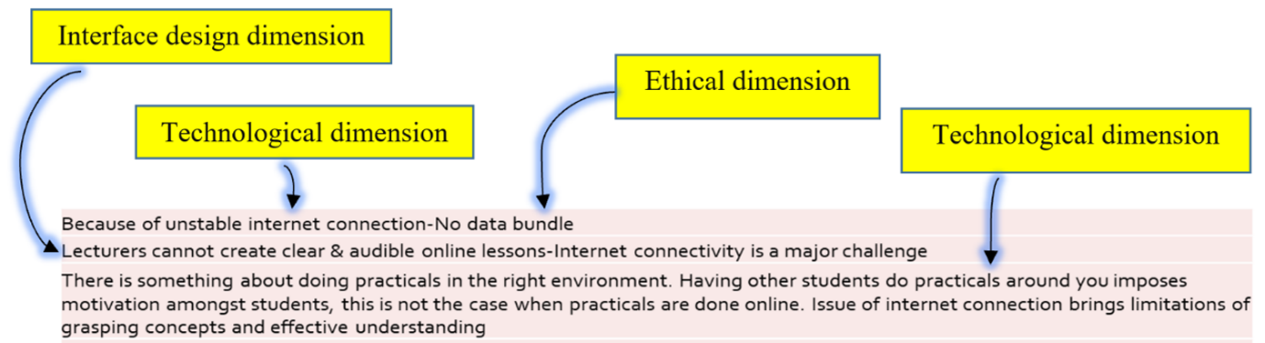
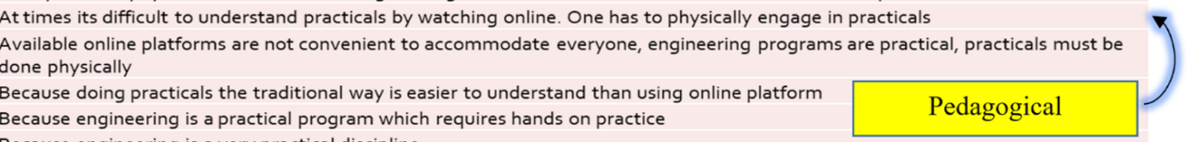
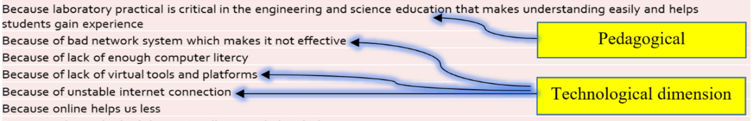

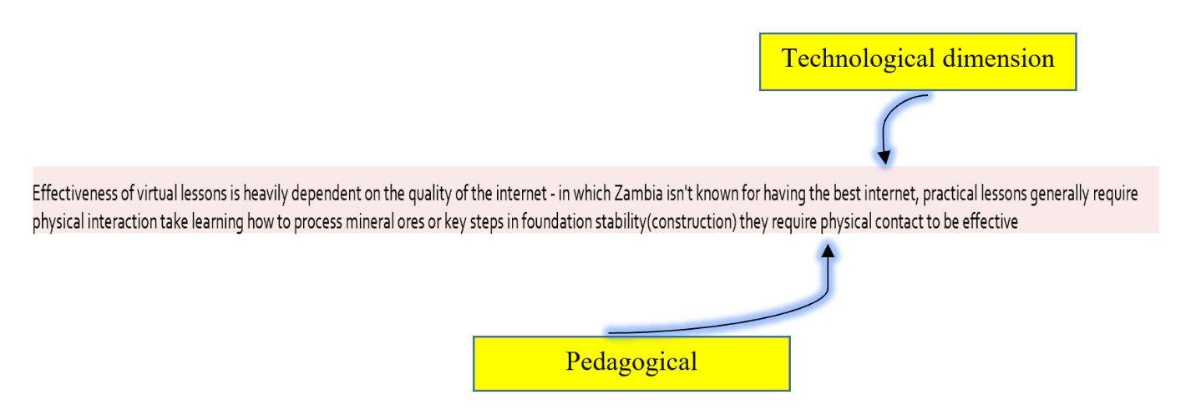

Appendix C: Why Students Thought Virtual Labs Compromise on the Quality of Education at the HEI
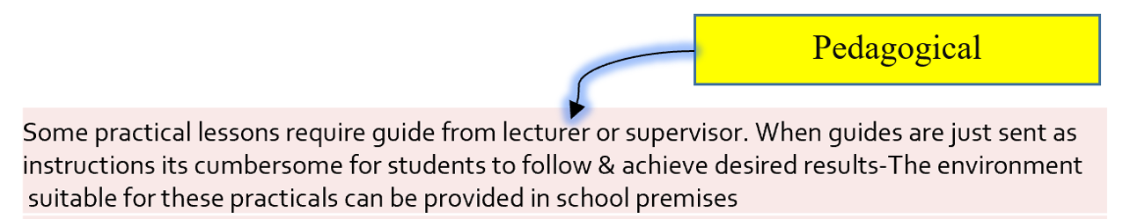
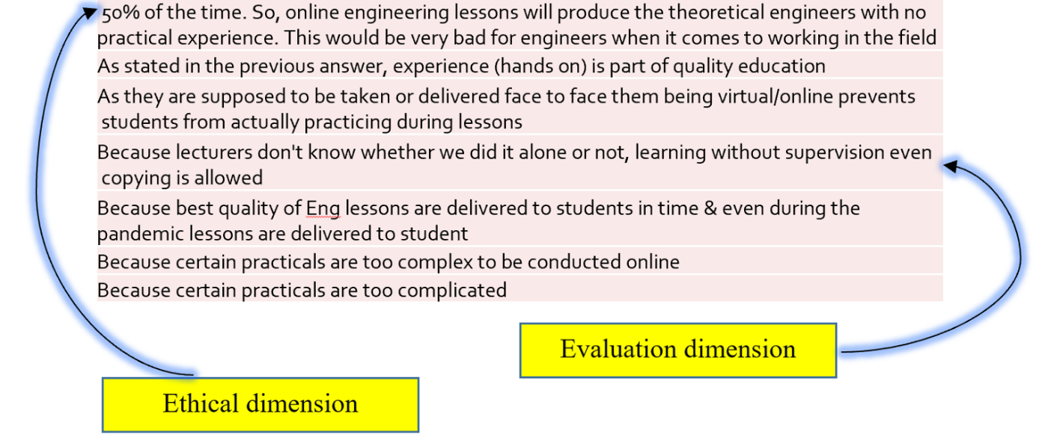

Appendix D: Students Views on Why Universities Couldn’t Provide Virtual Tools and Platforms

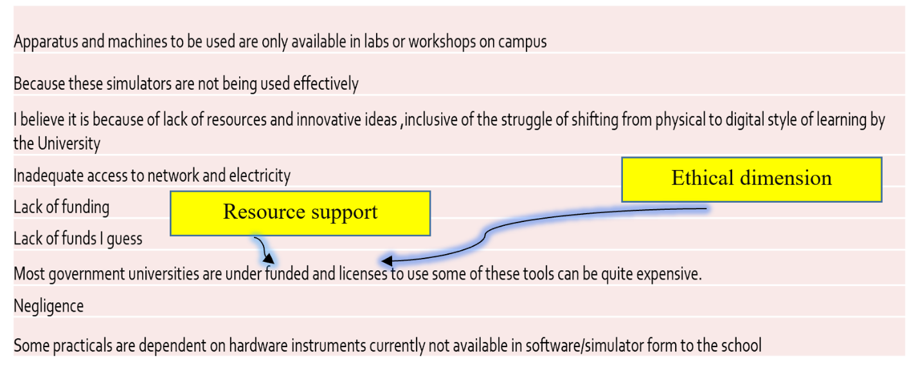

Appendix E: Methodology

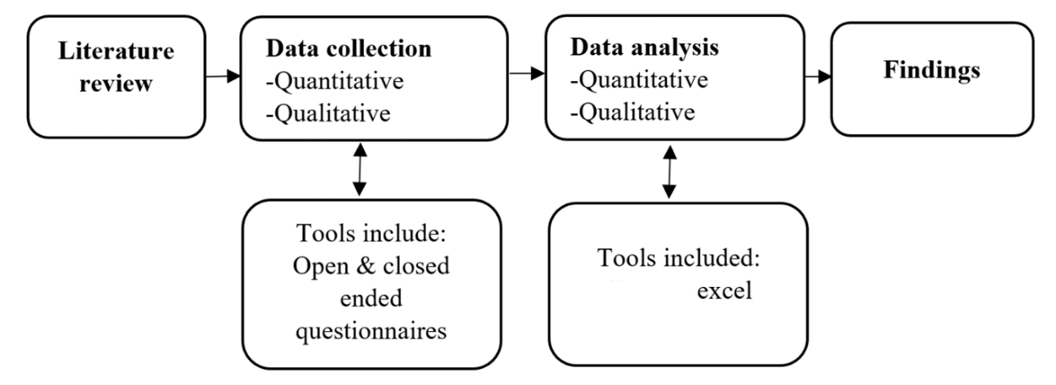

Appendix F: Published Journal



Appendix G: Ethical Clearance Certificate

