Economic Life of Zambia's University Students: The Case of University of Zambia

Daniel Ndhlovu, Sophie Kasonde-Ng'andu, Madalitso K. Banja and Janet Serenje

Abstract

The University of Zambia has a cross section of students which includes school leavers, non-school leavers and in-service. Some of these students are on Government bursary sponsorship scheme while others, are sponsored by their employers or are self-sponsored. However, students indicated that they face economic challenges in pursuit of university education. This study found that 85% of the respondents rated the cost of living at the University of Zambia as high, even though the majority are on Government sponsorship. In order to cope with the high cost of living, 21% of the respondents engage in business activities, 15% in vacation employment while 64% do not engage in any activities to raise extra funds. The high cost of living at the University of Zambia has a negative effect on the academic performance of most students.

I Introduction

While university education continues to be considered a largely public enterprise, students and their families are making substantial contributions both to the cost of tuition and other expenses associated with studying. For instance, a study by the Department for Employment, Education, Training and Youth Affairs (1998) indicates that the share of expenditure of tertiary education covered by students and their families ranges widely from a negligible amount of the gross domestic product in Denmark, Sweden and Austria to almost 40% in the United States, and over 50% in Korea and Japan. The share of spending has been increasing in different ways in different countries, such as new imposition of fees, reduction in subsidies to goods and services bought by students.

In Zambia like other countries, private participation in university education has grown to the extent that individuals have to contribute more than in the past to the cost of tuition and living expenses. However, very little is known about how the student general populace in tertiary institutions rate the cost of living at the institutions, how various categories of students manage to meet the cost of living and the effects of cost of living on their academic performance. It was necessary therefore, to conduct a study of this nature to determine the economic life of students in tertiary institutions with a specific case of the University of Zambia and its effect on their academic performance.

THE BOZ READER, ISSUES ON THE ZAMBIAN ECONOMY | 29

Statement Problem

The University of Zambia has a cross section of students which includes school leavers, non-school leavers and in-service. Some of these students are on the Government of the Republic of Zambia (GRZ) bursary sponsorship scheme, others especially in-service students are sponsored by their specific employers while others still are self-sponsored. However, students lament that there are a lot of economic challenges and responsibilities faced in pursuit of university education. For instance, all students have to meet the urgent demands of photocopying data, cost of meals, accommodation, tuition and transport just to mention but a few. What is not clear is how the students' general populace at the University of Zambia rates the cost of living at the university, how various categories of students meet the cost of living and the effects of cost of living on their academic performance. In order to determine answers to these questions a study of this nature was necessary.

Purpose of the study

The study sought to determine the economic life of students at the University of Zambia in regards to how students rate the cost of living at the university, how they cope with the cost of living and the effects of cost of living on their academic performance.

Objective of the study

The following objectives guided the study:

- To determine the sponsorship status of students at the University of Zambia;

- To establish cost areas that students spend money on and levels of expenditure;

- To establish how students rate the cost of living at the University of Zambia;

- To determine how students cope with the cost of university education at the University of Zambia; and

- To determine effects of cost of living on academic performance of students at the University of Zambia.

Research questions

The following research questions were used to guide the study:

- What is the sponsorship status of students at the University of Zambia?

- Which cost areas do students at the University of Zambia spend money on and levels of expenditure?

- How do students rate the cost of living at the University of Zambia?

- How do students cope with the cost of university education at the University of Zambia?

- What are the effects of cost of living on academic performance of students at the University of Zambia?

II Literature Review

As early as 1998, the Department for Employment, Education, Training and Youth Affairs in the United States of America noted an increase in the forms of university education available to a growing number of students. To this effect, there was a growing demand for university education. The demand for university education was not simply driven by 'supply-side' decision by governments to fund places but also by demand – the choice made

- Economic Life of Zambia's University Students: The Case of University of Zambia

by learners. The choice by young people and adults to pursue university education was influenced partly by economic considerations – notably the trade-off between earnings forgone while studying and the greater prospective future earnings that result. This situation is similar to that of the supporters of the Human Capital Theory such as Sakamota and Powers (1995) who found that an educated population was also a productive population. Robert (1991) had also developed a Human Capital Model to explain that education and human capital were the drivers of high labour productivity and levels of technology that influences the world today. Countries such as Korea, Taiwan, Singapore and Hong Kong were cited to have made large investments in education and achieved unprecedented rates of economic growth.

Similar approaches have been practiced in the United States of America. State Higher Education Executive Officers (SHEEO) (2011) reported that enrolments of students have increased and created competition over the available resources to the point of relying on families to sponsor their children. Studies in other African countries such as Nigeria (Ndagi, 1983), South Africa (Gaurly, 1995), Ghana, (Daniel, 1995) reveal that universities faced a challenge of how to generate additional resources to cope with such numerical expansion of students. The challenge caused respective governments to adopt cost sharing practices in education. The student' loan scheme has been the most popular one of the threefold approach. Barr, (2005) reported that loan scheme had been used in many countries in the region as well as internationally, and relieved students from the stress of looking for money to meet educational related costs. As a result, students concentrated on studies.

Similarly, because of the centrality of knowledge, skills and technology in shaping organisation and productivity of the economy, the Zambian Government considers education a productive investment. To this effect, the Ministry of Education (1996), stated that education is a right for each individual and a means for enhancing the well-being and quality of life for the entire society. In 1964 at independence and some years thereafter, Zambia was faced with a challenge of inadequate human resource. In order to meet the demand for human resource, the government came up with a deliberate policy of free education. This meant that learners at whatever level including university students, had their school fees and other personal requirements paid for by the government. If anything, they contributed very little towards their education. Since then, the Government of the Republic of Zambia (GRZ) has been supporting the provision of education in both public and private learning institutions. For instance, it has been providing sponsorship to many students in public learning institutions and provides legislative framework for both public and private learning institutions in Zambia.

As demand for university education grew, the Zambian government embarked on reforms to liberalise entry into the universities, which included allowing more self-sponsored students into the institutions of higher learning. The move was intended to expand and diversify student enrolment and cut down on excess demand for bursaries from government.

In 1989, the then Ministry of Higher Education announced measures that required university students to contribute towards the cost of their education (GRZ: Ministry of Higher Education, Science and Technology, 1989). This economic and financial policy framework reasserted that in order to strengthen the financial base for education, Zambia had to introduce user fees for the beneficiaries of secondary schools and higher education as cost effective measures.

In case of escalating cost of education, the Government of the Republic of Zambia enacted the 2011 Education Act in which article 120 (2) states, ‘the Minister may establish a bursary and scholarship scheme to assist orphans and vulnerable learners at any public, aided or community educational institution.'

THE BOZ READER, ISSUES ON THE ZAMBIAN ECONOMY | 31

On the basis this literature, a threefold approach should be encouraged in Zambia; one approach is the government's position on cost sharing with students and their families; second one is the Public-Private Partnerships and the third approach to encourage is the GRZ Students' Loan Scheme. It is hoped that when stakeholders in education realise the value of education and embrace these three cost sharing approaches to education, nations and Zambia inclusive would achieve the assumptions of the Human Capital Theory.

To a larger extent therefore, the government's position on the cost of education, especially tertiary education has since then shifted from being primarily the responsibility of the state to that of sharing with students and their families. However, there exist knowledge gap about how students in tertiary institutions rate the cost of living and its effect on their academic performance. This study therefore, sought to fill up this knowledge gap.

III Methodology and Empirical Results

Since the researchers sought to have an in-depth understanding of the situation, a case study design was used. In addition, both qualitative and quantitative methods were used. Scheduled interviews and non-participant observations were conducted to yield qualitative data while quantitative methodology made use of questionnaires. Three hundred and forty-eight (348) students participated in the study. This number consisted of 144 females and 204 males. See table 1 for the distribution of the sample by school.

Table 1: Distribution of sample by School (N=348)

School | Male | Female | Total
Agricultural Science | 19 | 18 | 37
Education | 37 | 25 | 62
Engineering | 28 | 8 | 36
Humanities | 17 | 21 | 38
Law | 27 | 30 | 57
Mines | 34 | 12 | 46
Natural Science | 29 | 16 | 36
Veterinary Medicine | 22 | 14 | 36
Total | 204 | 144 | 348

The disparity in the numbers of males and females in table one was due to the fact that the actual numbers in schools varied greatly. In addition, the response from female students was lower compared to their male counterparts.

In order to provide each element in the population an equal chance to be selected and included in the study sample, simple random sampling procedure was used. As a result, 348 students participated in the study. Interview schedules, non-participants observation checklist and semi-structured questionnaire were used to collect data from the respondents in the sample.

The quantitative data were analysed using the Statistical Package for Social Sciences (SPSS) to obtain frequencies and percentages. Thematic analysis was used to analyse qualitative data.

Regarding issues of ethical nature, consideration was made to keep the names of respondents anonymous. Consent was also obtained from the respondents before allowing them to participate in the study.

- Economic Life of Zambia's University Students: The Case of University of Zambia

IV Presentation and Discussion of Findings

The presentation begins with the admission status of the respondents. It was found that 80% of the respondents were school leavers and the rest were non-school levers (See Chart 1).

Chart 1: Admission status of respondents at the University of Zambia (N=348)
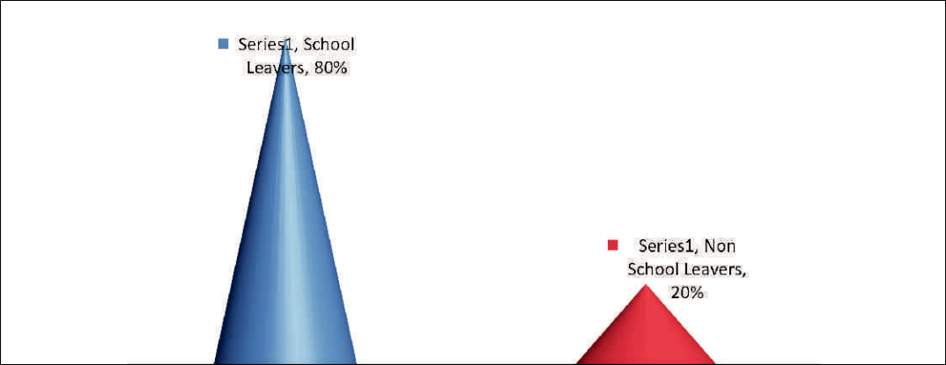

Regarding the sponsorship status of respondents, Government is the largest sponsor at 72.1% (see chart 2).

Chart 2: Students' Sponsorship Status at the University of Zambia (N=348)
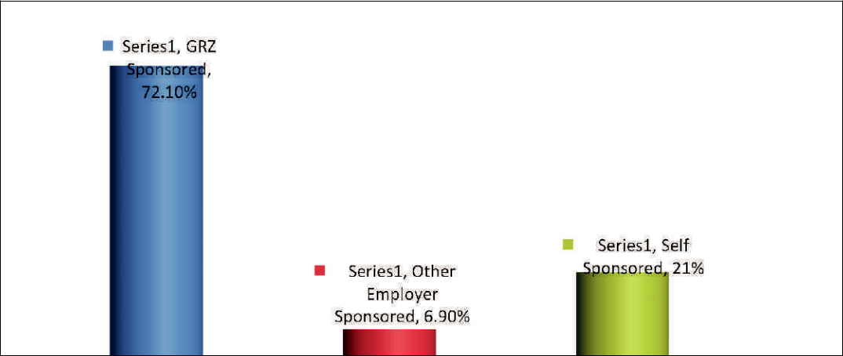

This situation where apart from students being sponsored by government, other sponsors have embraced the cost sharing approach to education is encouraging. Similarly, this is what Sakamota and Powers (1995) the proponents of Human Capital theory encouraged and when they argued that an educated population was also a productive population.

As how respondents allocated their income, it was found that they spent their money in several cost areas which include: tuition fees, savings, food, accommodation, books and magazines, clothing, church or associations, transport, personal care, mobile phones, internet services, photocopying and printing (see Table 2).

THE BOZ READER, ISSUES ON THE ZAMBIAN ECONOMY | 33

Table 2: Income Allocation per Semester

Description | N | Average levels of expenditure per semester
Tuition fees | 185 | 3,149,614.38
Savings | 80 | 491,687.50
Food | 348 | 461,535.34
Accommodation | 147 | 425,972.79
Books and Magazines | 237 | 257,848.10
Clothing | 248 | 255,625.00
Church/Associations | 35 | 198,285.71
Entertainment | 138 | 183,985.51
Transport | 246 | 134,186.99
Personal care | 277 | 123,032.49
Mobile phone | 273 | 119,106.23
Photocopying and Printing | 310 | 104,270.97
Internet Services | 249 | 91,445.78

As how students rated cost of living at the University of Zambia, 85.1% of the respondents, indicated that it was expensive (see Chart 3).

Chart 3: Students' rating of cost of living at the University of Zambia (N=348)
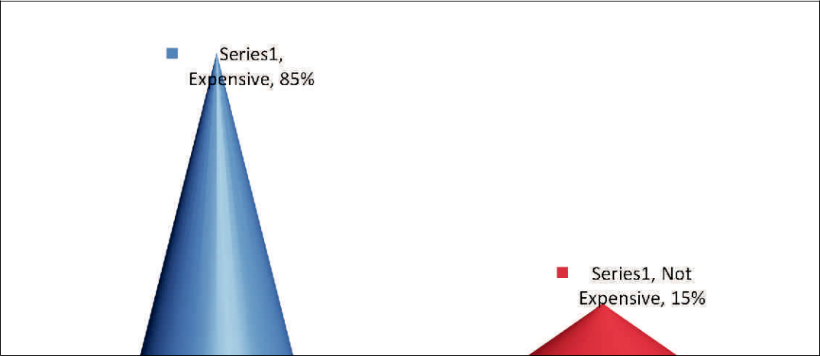

Further analysis of the data regarding students' rating of cost of living at the University of Zambia by gender is shown in Table 3

Table 3: Students' rating of cost of living at the University of Zambia by gender (N=348)

Rating | Gender of respondents |  |  | Total
 | Male |  | Female
Expensive | 169 |  | 127 | 296
Not expensive | 35 |  | 17 | 52
Total | 204 |  | 144 | 348

Interestingly, although on face value data in Table 3 show more males than females indicated cost of living at the University of Zambia to be expensive, the Chi-square test shows that there was no significant difference between male and female ratings (see Table 6).

- Economic Life of Zambia's University Students: The Case of University of Zambia

Comparison between how school leavers and non-school leavers rated the cost of living at the University of Zambia, revealed that although on face value more school leavers than non-school leavers rate the cost of living to be high (Table 4), no significant difference was found by the Chi-square test.

Table 4: Students' rating of cost of living at the University of Zambia by admission status (N=348)

Rating | Admission Status |  |  | Total
 | School Leavers |  | Non-School Leavers
Expensive | 236 |  | 60 | 296
Not expensive | 43 |  | 9 | 52
Total | 279 |  | 69 | 348

Although it is clear that the cost of living at the University of Zambia is considered to be high, no significant difference between male and female students and between school leavers and non-school leavers was found by the Chi-square test. There is need therefore, to mitigate the situation to the advantage of the students' academic welfare. One of the measures to mitigate the cost of living at the University of Zambia is to put in practice the intentions of government in the 2011 Education Act, article 120 (2) which states, 'the Minister may establish a bursary and scholarship scheme to assist orphans and vulnerable learners at any public, aided or community educational institution.'

As regards the specific category of students (government, other employer sponsored or self-sponsored) that finds life more expensive at the University of Zambia, all the categories indicated that it was expensive. (see Table 5).

Table 5: Students' rating of cost of living at the University of Zambia by Sponsorship category (N=348)

Rating |  | Sponsorship status |  |  | Total
 | Government | Other Employer |  | Self
Expensive | 212 | 18 |  | 66 | 296
Not expensive | 39 | 6 |  | 7 | 52
Total | 251 | 24 |  | 73 | 348

Regardless of their gender, admission and sponsorship status, most students felt the cost of living at the University of Zambia was expensive. However, concerning which specific category felt that cost of living at UNZA was more expensive, no statistical significant differences were found (see Table 6).

Table 6: Chi-square Test Result on Students' rating of Cost of Living at UNZA

 | Alpha | X² | Df | P. value | Comment
Cost of Living Vs. Gender | 0.05 | 1.902 | 1 | .168 | P> 0.05 accept H0
Cost of Living Vs. Admission Status | 0.05 | 0.244 | 1 | .621 | P> 0.05 accept H0
Cost of Living Vs. Sponsorship Status | 0.05 | 3.626 | 2 | .163 | P> 0.05 accept H₂

As how respondents coped with high economic demands at the University of Zambia, 21% of them were engaged in business and 15% in vacation employment. They engaged in business activities and vocational employment in order to raise extra funds to meet the high cost of living at the University. However, it was also noticed that the majority (64%) of the students did not engage themselves in any activity to raise extra funds for their school needs. Comparatively as shown in Table 7, more school leavers than non-school leavers engaged themselves in other activities to raise funds to meet the high cost of living at the University of Zambia.

THE BOZ READER, ISSUES ON THE ZAMBIAN ECONOMY | 35

Table 7: Activities Students Engaged in to Raise Extra Funds at UNZA

 | Activities Students participated in to raise funds |  |  | Admission Status
 |  |  |  | School Leaver | Non-School Leaver | Total
Vacation |  | Gender of Respondents | Male | 21 | 11 | 32
Employment |  |  | Female | 13 | 7 | 20
 |  | Total |  | 34 | 18 | 52
Business |  | Gender of Respondents | Male | 32 | 11 | 43
 |  |  | Female | 23 | 7 | 30
 |  | Total |  | 55 | 18 | 73
No activities |  | Gender of Respondents | Male | 99 | 11 | 110
 |  |  | Female | 91 | 22 | 113
 |  | Total |  | 190 | 33 | 223

The situation on whether students engaged in business activities to raise extra income or not raises concern with regard to its negative effect on their academic performance. As rightly alluded to by the students themselves, instead of studying, they spent time raising funds. Those who did not engage themselves in income generating activities failed to concentrate on studies because of worrying about inadequate resources at their disposal. As rightly put by one of them, 'you cannot concentrate on studies with an empty stomach. This is where the student loan scheme reported by Barr, (2005 would help to address the situation. It has worked in in many countries in the region as well as internationally, and relieved students from the stress of looking for money to meet educational related costs.

Concerning how respondents felt the effect of high cost of living at the university affected their academic performance, 49% of them felt they were negatively affected, 21% felt they were positively affected and 30% did not feel the effect. As regards to how each gender felt about the effect of high cost of living, more males (67%) compared to 33% females felt that it negatively affected their academic performance (see Table 8).

Table 8: How the Effect of Cost of Living at UNZA Affects Academic Performance of Students

Effect | Gender of respondents |  |  |  | Total
 |  | Male |  | Female
Positively | 35 | (49%) |  | 37 (51%) | 72
No Effect | 54 | (51%) |  | 51 (49%) | 105
Negatively | 115 | (67%) |  | 56 (33%) | 171
Total |  | 204 |  | 144 | 348

An analysis of these findings on the Pearson Chi-Square test revealed that the differences between each gender were statistically significant. However, what still remains unclear is why more males than females seem to have been negatively affected.

Concerning those who felt the high cost of living at the University of Zambia negatively affected their academic performance, the following were some of the reasons given to justify their response;

“I worry, where to get money for photocopying and printing learning materials;

I cannot afford most of the prescribed learning materials because they are expensive;

I waste time looking for money instead of studying, it is difficult to study on hungry stomach, even with 75% tuition sponsorship by GRZ;

I still struggle to pay the balance and instead of concentrating on studies, I am busy looking for money to meet the cost of living at campus.”

- Economic Life of Zambia's University Students: The Case of University of Zambia

The students who felt the cost of living at the University of Zambia did not negatively affect their academic performance attributed it to the meal allowance given to them by GRZ that have helped them meet other financial needs. Additionally, one of them said, 'the challenge of high cost of living at the University of Zambia has motivated me to work hard and become a better person in future.'

Interestingly, other students felt that the high cost of living at the University of Zambia had no effect on their academic performance. One of them said, 'money or no money, I still study and pass.' Another student said, 'I manage to study because I want to redeem myself from poverty. I do not depend on extrinsic but intrinsic motivation, therefore, whether in financial trouble or abundance, my desire is to graduate.'

The cases here are clear aspects of extrinsic and intrinsic motivation. Students driven by extrinsic motivation rely more on outside motivators such as resources, praise or encouragement to do their work. On the other hand students driven by intrinsic motivation are self-driven. Whether the cost of living is high or not their desire is to emancipate themselves by doing well in school.

IV Conclusion

Based on the findings, the study concludes that despite 72% of the respondents being on GRZ sponsorship, 21% self-sponsorship and 7% sponsored by other employers, the cost of living at the University of Zambia was considered high. This is evidenced by 85% of the respondents rating the cost of living at the University of Zambia as high. The cost areas where they spent the money included: tuition fees, savings, food, accommodation, books and magazines, clothing, church or associations, transport, personal care, mobile phones, internet services, photocopying and printing. In order to cope with the high cost of living at the university, some respondents engage in business activities and vacation employment. However, the majority (64%) of the respondents do not engage in any activities to raise extra funds to meet the high cost of living at the university. The high cost of living at the University of Zambia has a negative effect on the academic performance of most students. It is therefore, necessary that the recommendations are considered to address the situation.

V Recommendations

Based on the findings, the following is recommended;

- The position of the government on the cost of education, especially tertiary education which emphasises sharing with students and their families need to be supported.

- GRZ should increase bursary schemes but inform of loans to students to enable them meet the high cost of living at the university.

- Public-Private Partnerships must be encouraged in meeting the cost of education.

- Students should be encouraged to participate in vacation employment in order to supplement efforts of government and or other sponsors.

THE BOZ READER, ISSUES ON THE ZAMBIAN ECONOMY | 37

References

- Barr, N, (2005) Financing Higher Education: Answers From the U.K. London and New

York: Routledge

- Daniel, D. (1995) University Education in Ghana. ACU Bulletin of Current Documentation Number 20, p13

- Department for Employment, Education, Training and Youth Affairs (1998). Learning for Life. Canberra

- Gaurly, J. (1995) A Menu of Issues and Challenges: Seven Years as a Canadian University President. AUC Bulletin of Current Documentation, Number 120, p2

- Ministry of Higher Education, Science and Technology, (1989).Economic and Financial Policy Framework Paper. Lusaka.

- Ministry of Education (1996).Educating Our Future - National Policy on Education. Lusaka: Zambia Publishing House.

- Robert, B. (1991). Economic Growth in a Cross Section of Countries. Quarterly Journal of Economic Survey, Volume 106, number 2 pp 407 – 414

- Sakamota, A and Powers, P.A (1995) Education and the Dual Labour Market for Japanese Men in American Sociological Review. 60 (2) p. 222 – 246

- The Government of the Republic of Zambia (2011) Education Act, 2011. Lusaka: Government Printer.

Citation

Ndhlovu, D., Kasonde-Ng'andu,S.,Banja, M.K. & Serenje, J.(2012). Economic Life of Zambia's University Students: The Case of University of Zambia. The BOZ READER, 01(08), 28-37

