EVALUATING STAKEHOLDER PARTICIPATION IN PLANNING FOR SUSTAINABLE TOURISM DEVELOPMENT IN KASAMA AND SHIWA NG’ANDU DISTRICTS IN THE NORTHERN TOURISM CIRCUIT, ZAMBIA.

By

SIMUMBA JACKSON

A dissertation submitted to the University of Zambia, School of Natural Sciences in partial fulfilment of the requirements of the degree of Master of Science in Spatial Planning.

THE UNIVERSITY OF ZAMBIA,
LUSAKA
2020

DECLARATION
I, Jackson Simumba, computer number (2016145689) declare that this dissertation represents my own work and that it has not been submitted for a degree, diploma or other qualification at this or any other University. All materials used have been fully acknowledged and referenced.

Signature: _______________________________________

Date: ___________________________________________

COPYRIGHT
All rights reserved. No part of this dissertation may be reproduced, stored in retrieval system, or transmitted in any form or by any means; electronic, mechanical, photocopying, recording, or otherwise, without the prior permission in writing from the Author or the University of Zambia.
© Jackson Simumba 2020

CERTIFICATE OF APPROVAL
This dissertation of Jackson Simumba (2016145689) is approved as fulfilling for the requirements for the award of Master of Science in Spatial Planning by The University of Zambia.

……………………....………. …………………….. ……………
Examiner I Signature Date

……………………....………… ……………………….. ………………
Examiner II Signature Date

……………………....…. …. ………………………… ………………...
Examiner III Signature Date

…………………………………… ………………………. …………………
Chairperson –
Board of Examiner’s Signature Date

…………………………………… ………………………. …………………
Supervisor Signature Date

ABSTRACT
The Zambian government has recognised tourism as a major contributing sector towards economic development. In order to attain sustainable tourism development, the Zambian government enacted the 2015 Hospitality and the Tourism Act and formulated Tourism Policy which have both recognised the engagement of various players (stakeholders) in tourism planning, development and project implementation. The development of tourism in Zambia has not reached its full potential due to inadequate and non-transparent involvement of stakeholders in tourism planning. However, far too little attention has been paid to ascertain the level of stakeholder participation in planning for sustainable tourism development in Kasama and Shiwa Ng’andu Districts. The study used a case study research design with a qualitative research approach. Constructivism/Interpretivism paradigm guided this study. Purposive, snowball and convenient sampling techniques were used to select 55 participants. An interview guide, Focus Group Discussions (FGDs) and an Observation check list were instruments used to collect primary data. The results showed that 58.8 % of respondents mentioned a cultural market, 20.6% mentioned art theatre, 11.8 % mentioned additional archaeological sites, 5.9% mentioned game viewing, 2.9% boat cruising and hiking trails as notable tourism potentials at Chishimba falls, Mwela Rocks and Shiwa Ng’andu. Furthermore; the study demonstrated that the level of tourism development is low due to low investment, poor marketing strategies, limited tourism packages and poor transport connectivity among sites. The results suggests that top down approaches dominates tourism planning which excludes the majority of stakeholders from participating in tourism planning processes. This hinders attainment of sustainable tourism development. The results of the study further show that the level of stakeholder’s participation in tourism planning was more of tokenistic (minimal) and displayed some elements of passive (non- participation). Furthermore, the study revealed options for increased stakeholder’s participation in tourism planning as stakeholder’s sensitization, stakeholder’s empowerment, active tourism associations, provision of questionnaires and having a Visitor information website. The study concludes that there is minimum participation, engagement and involvement of stakeholders in planning for sustainable tourism development in Kasama and Shiwa Ng’andu Districts in the Northern tourism circuit which has slowed the growth and development of tourism industry in the region. A collaborative and participatory mix of bottom up and top down approaches to planning is recommended for effective stakeholder’s participation. Furthermore, a mix of bottom up and top down approaches to planning can be actualised through a “collaboration framework” which has been formulated and proposed by this study. This can be adopted by government for attainment of sustainable tourism development as it will increase effective collaboration, linkages and participation of various stakeholders in tourism planning, development and project implementation and also it will enhance forward and backward linkages in the tourism industry.
Key Words: Stakeholders, Collaboration, Tourism Planning, Bottom up, Sustainable tourism

ACKNOWLEDGEMENTS
There are a number of people who have been instrumental and aided the completion of this dissertation. I certainly could not have completed this large task without their help.
Firstly, I would like to thank my dedicated supervisor Dr. Nchito Wilma for her invaluable support, guidance, encouragement, inspiration and expertise. Mostly importantly I must acknowledge her timely response despite having so many post graduate students she was supervising. I would also like to thank Prof. Babatunde Agbola my Co-supervisor at proposal stage for the direction he rendered to me.
I would also like to recognise the advice and comments from lecturers in the Department of Geography and Environmental studies during departmental presentations which yielded this fantastic work to this level of academic standard.
Thanks also go to my course mates 2016 to 2018 academic year master of Science in Spatial Planning for their support.
On a personal note, I would like to thank my wife Lucy and my children Chimwemwe and Lukundo for their endurance, moral support and encouragement and financial support rendered to me during my course of my study.
Finally, the completion of this dissertation would not have been possible without the support and cooperation of Tourism stakeholders in Kasama and Shiwang’andu Districts who participated in the interviews and so generously devoted their time to this study.

DEDICATION
I dedicate this work to my late in-law Mr Sichizya Ladwell who supported my education from primary to tertiary. I also dedicate it to my wife Lucy, my children’s Chimwemwe and Lukundo who persevered my absence when they needed me most when I was away at the University of Zambia doing my studies.

TABLE OF CONTENTS

DECLARATION i
COPYRIGHT ii
CERTIFICATE OF APPROVAL iii
ABSTRACT iv
ACKNOWLEDGEMENTS v
DEDICATION vi
TABLE OF CONTENTS vii
LIST OF TABLES xi
LIST OF FIGURES xii
ABBREVIATIONS AND ACRONYMS xiii
CHAPTER ONE: INTRODUCTION 1
1.0. Introduction 1
1.1. Statement of the Problem. 3
1.2. Aim of the study. 4
1.3. Research Objectives. 4
1.4. Research Questions. 4
1.5. Significance of the study 5
1.6. Structure of Dissertation 5
1.7. Chapter Summary 6
CHAPTER TWO: LITERATURE REVIEW 7
2.1. Introduction 7
2.2. The concept of sustainable Tourism. 7
2.3. Tourism development at global level 8
2.4. Models for tourism development 9
2.4.1. The plantation model of tourism development 9
2.4.2. The Enclave model of tourism in developing countries 10
2.4.3. The Diffusion model of Tourism Development 12
2.4.4. Butlers Tourism Area Life Cycle model. 12
2.5. Tourism planning Process 16
2.6. Collaborative and participatory Planning debate 18
2.7. Tourism development in Africa. 19
2.8. Tourism in Zambia 20
2.8.1. History of tourism in Zambia 20
2.8.2. Tourism potentials and the state of tourism development in Zambia 22
2.9. The Legal Framework guiding tourism development in Zambia 24
2.9.1. Tourism and Hospitality Act of 2015 24
2.9.2. Constitution of Zambia (Amendment) No. 2 of 2016 25
2.9.3. The Environmental Management Act, No.12 of 2011 25
2.9.4. The Urban and Regional Planning Act No. 3 of 2015 25
2.9.5. The National Museum Act, 1966 25
2.9.6. Zambia Wildlife Act No. 14 of 2015 26
2.9.7. Vision 2030 26
2.9.8. The Seventh National Development Plan (2017-2021) 26
2.10. Chapter Summary 27
CHAPTER THREE: DESCRIPTION OF THE STUDY AREA 28
3.0. Introduction 28
3.1. Geographical location of Kasama and Shiwa Ng’andu District. 28
3.1.1. Geographical location of Chishimba falls and Mwela Rocks in Kasama District 28
3.1.2. Geographical location of Shiwa Ng’andu estate in Shiwa Ng’andu District 29
3.2. Selection of the study area 30
3.3 Physical characteristics 30
3.3.1 Relief, Soils and Drainage 30
3.3.2. Vegetation 31
3.4. Socio-economic characteristics 32
3.4.1. Economic livelihoods of the local Communities 32
3.4.2 Population 32
3.5. Chapter Summary 32
CHAPTER: FOUR: RESEARCH METHODOLOGY 33
4.1. Introduction 33
4.2. Research Paradigm 33
4.3. Theoretical Framework 34
4.4. Case study as the adopted research design 36
4.5. Qualitative research methodology 37
4.6. Study population 38
4.7. Study sample and Sampling techniques. 38
4.7.1. Study Sample 38
4.7.2. Sampling techniques. 39
4.8. Data collection methods 41
4.9. Data collection procedure 44
4.9.1. Primary Sources 44
4.10. Data processing and analysis 44
4.11. Validity and Reliability of research findings 45
4.12. Ethical Consideration 45
4.13. Summary 45
CHAPTER: FIVE: PRESENTATION OF RESULTS 46
5.0. Introduction 46
5.1. Demographic characteristic of respondents 46
5.1.1. Age of respondents 46
5.1.2. Gender of respondents 47
5.1.3. Tourist arrivals 48
5.2. Tourism Potentials and Current Levels of Development 49
5.2.1. Identified Tourism potentials 49
5.2.2. Levels of Tourism development 55
5.3. Existing Tourism Planning Process 64
5.4. Levels of Stakeholders Participation in Tourism Planning 66
5.4.1. Tokenistic participation 66
5.4.2. Passive or Non-participation 67
5.5. Parameters That Can Increase Stakeholder’s Participation in Tourism Planning 68
5.6. Chapter summary 70
CHAPTER: SIX: DISCUSSION OF RESULTS 71
6.0. Introduction 71
6.1. Identified tourism potentials 71
6.1.2. Levels of tourism development 73
6.1.3. Factors for low tourism development 75
6.2. Existing tourism planning process 77
6.3. Levels of stakeholders participation in tourism planning 78
6.4. Parameters for increased stakeholder participation in tourism development 82
6.5. Chapter Summary 89
CHAPTER: SEVEN: CONCLUSION AND RECOMMENDATION 90
7.0. Conclusion 90
7.1. Implications of the study results 92
7.2. Recommendations 92
7.3. Suggestions for Future research 93
REFERENCES 94
APPENDICES 108
Appendix A: Key informant semi-structured interview 108
Appendix B: Hospitality and tourism enterprises Proprietors’ semi-structured interview 110
Appendix: C: Tourists semi-structured interview 112
Appendix: D: Focus Group Discussion for Residents in Host community 114
Appendix: E: Observation checklist 115
Appendix: F: Stakeholders invitation letter 116

LIST OF TABLES
Table 1: Summary of sample and sampling technique 41
Table 2: Respondents age. 46
Table 3: Gender of respondents 47
Table 4: Tourist arrivals by Continent/country of origin 48

LIST OF FIGURES
Figure 1: Antiqua stages of tourism development 10
Figure 2: Enclave model of tourism in developing countries 11
Figure 3: The Tourism Area Life Cycle development 13
Figure 4: Location of study area in Kasama District. 28
Figure 5: Location of study area in Shiwa Ng’andu District. 30
Figure 6: Anstein ladder of citizen participation 35
Figure 7: Categories of tourists 48
Figure 8: Curio and craft trade along a road in Kasama 50
Figure 9: Kasama art theatre performing in Kasama 51
Figure 10: ZESCO dam at Chishimba falls. 54
Figure 11: Entry point shelter at Mwela rocks. 55
Figure 12: Visitor information Centre at Chishimba Falls 57
Figure 13: A restaurant at Chishimba Falls 57
Figure 14: Locally owned Kaela guest house near Chishimba falls. 58
Figure 15: Manor house with researcher and domestic tourists taking photos 59
Figure 16: Swimming pool at Kapishya hot spring lodge 60
Figure 17: Local clinic serving local people within Shiwa Ng’andu tourist site. 61
Figure 18: A researcher conducting a Focus Group Discussion 61
Figure 19: Parameters for increased stakeholder’s participation in tourism planning. 69
Figure 20: Collaboration Framework for Sustainable Tourism 86

ABBREVIATIONS AND ACRONYMS

CSO Central Statistical Office
EEA European Environmental Agency
GRZ Government of the Republic of Zambia
HCAZ Hotel and Catering association of Zambia
IDP Integrated development plans
MOTA Ministry of Tourism and Arts
NHCC National Heritage Conservation Commission
NTC Northern Tourism Circuit
ST Sustainable Tourism
STD Sustainable Tourism Development
TALC Tourism Area Life Cycle
UNEP United Nations Environment Programme
UNWTO United Nations World Tourism Organisation
WCED World Commission on Economic Development
WEF World Economic Forum
WTO World Tourism Organization
ZDA Zambia Development Agency.
ZTA Zambia Tourism Agency

CHAPTER ONE

INTRODUCTION

1.0. Introduction
Tourism has been recognized as a major growth engine for socio-economic development and poverty alleviation especially in rural destinations (Fun et al., 2014). This statement has been supported by Ismail (2009) who argued that tourism has been recognized for its vast contribution to the economy in many countries in which it contributes to economic diversification, profitability, and employment opportunity for a country. In Africa, Zambia stands out as one of the prime tourism destinations offering a wealth of natural tourism assets (Zambia Development Agency, 2014). In view of this, Zambia has not lagged behind in recognition of tourisms contribution to economic development. Tourism contribution to Zambia’s GDP moved from 2.4% in 2012 to 3.1% in 2015 (GRZ, 2017). The ZDA (2014:1) points out that “The Government of the Republic of Zambia has identified tourism, including arts and culture as one of the priority growth sectors of the national economy”.
Tourism development can have both positive and negative impacts on destinations. Walter (2006) asserts that although it is recognized that tourism can be beneficial to the natural environment by promoting environmental conservation, it also has negative impact on the environment and therefore it is increasingly a concern of the public sector to pay more attention to the protection of the natural environment. In view of this, Sustainable tourism development attempts to find a balance between these impacts to create an improved quality of life for the host community and the destination. The World Commission on Economic Development (WCED), (1987:37) defined sustainable development as “development that meets the needs of the present without compromising the ability of future generations to meet their own needs. Yu et al. (2011) define sustainable tourism as that which increases the quality of life of the local people, improves the quality of the tourist's experience, and preserves the environment on which both visitors and the community depend. On the other hand, GRZ (2015a) defines sustainable tourism development as one that is economically, culturally, socially and environmentally sustainable and maximizes socio-economic benefits, job creation and local investment opportunities for Zambian livelihoods and national heritage.
The United Nations Environment Programme (UNEP) and World Tourism Organization (WTO) (2005) point out that globally, tourism planning has been viewed as a key to achieve sustainable tourism development. There has been a growing recognition in many tourist destinations that current management practices which do not involve stakeholders may lead to undesirable impacts on the environment and society, which in turn can threaten both tourism development itself and the economic viability of host communities and nations (World Tourism Organization, 1996). These problems are exacerbated where there is a lack of well-designed planning for and effective management of tourism development (Huybers and Bennett, 2003). On the other hand, Williams (1998:125) explain that “in the absence of planning, there are evident risks that tourism development will become unregulated, formless or haphazard, inefficient and likely to lead directly to a range of negative economic, social and environmental impacts”.
According to Nhuta (2015:2), “The goal of the sustainable tourism planning and development is to prepare current and future leaders with knowledge necessary to build and shape a successful, sustainable visitor destination. Furthermore, Paskeleva-Shapira (2001) cited in Timur and Getz (2008:446) explain that “the development of tourism that is sustainable in economic, environmental, social and cultural terms has been repeatedly recommended but researchers have found that the management and implementation of sustainable tourism requires the involvement of many partners”. The engagement of these stakeholders in the sustainable tourism development process is an important component in helping to realize attainment of sustainable tourism. In order to allow tourism to continue to grow in a sustainable way, it is generally assumed that tourism is preferably planned and managed in such a way as to minimise social deterioration and environmental impacts, while providing a variety of benefits that contribute to sustainable economic growth (Sharpley and Telfer, 2002). Furthermore, Currier et al.; (2009) assert that strategic planning in the tourism industry is crucial in so far as it integrates multiple stakeholders, and remains adaptable to changing environmental, social and economic conditions. In addition, WTO (2004) observed that sustainable tourism development requires the informed participation of all relevant stakeholders, as well as strong political leadership to ensure wide participation and consensus building. On the other hand, African Union Commission (2015) in its agenda 2063 has recognised that all the citizens of Africa will be actively involved in decision making in all aspects of development, including social, economic, political and environmental. Thus, stakeholder participation offers a channel through which the public can give inputs into decision-making in terms of the making and implementation of policy (Azizan et al., 2012). Vogt et al (2016) explain that collaborative tourism planning process allows for the many stakeholders in tourism destinations to consider tourism development and how their well-being will be affected by no, slow, or rapid growth. This is essential in Zambia's case as the country looks at diversifying the economy and tourism has been seen as a potential sector to revive the country’s economy (Dixey, 2005). It is in this regard that this study was undertaken by evaluating the level of stakeholder participation in planning for sustainable tourism development in Kasama and Shiwa Ng’andu Districts in the Northern tourism circuit of Zambia.

1.1. Statement of the Problem.
The Northern tourism circuit of Zambia which covers Northern, Luapula and part of Muchinga Provinces is well placed to offer tourists a unique experience, which is centred on wildlife, waterfalls and heritage sites all of which need to be conserved to achieve sustainable tourism. The overall research problem addressed is that in recent years, development of tourism in Zambia has not reached its full potential due to inadequate and non-transparent involvement of stakeholders in tourism planning and project implementation (GRZ, 2017). Additionally, the attainment of sustainable tourism leaves much to be desired due to lack of involvement of stakeholders in tourism planning as stakeholders are rarely consulted. Furthermore, the attainment of sustainable tourism development in Zambia through stakeholder’s collaboration is still a distant reality due to weak inter-ministerial and inter-agency collaborations and linkages on tourism-related issues which have slowed down growth and understanding of tourism in other related ministries and agencies (GRZ, 2015a). Besides, Akama (1999) as cited in Manyara and Jones (2007:629) point out that “local communities are hardly involved in tourism development.” This however creates mixed feelings, negative attitudes and hostility towards tourism development. Thus, if stakeholders are neglected and are not involved and incorporated in tourism planning, the benefit of achieving sustainable tourism development in Kasama and Shiwa Ng’andu districts will be foreclosed. In view of the above, the Government of Zambia has developed the National Tourism Policy of 2015, Tourism and Hospitality Act N0. 13 of 2015 which underpins the involvement of stakeholders in tourism planning. However, despite the enactment of Tourism and Hospitality Act N0. 13 of 2015 and formulation of National Tourism Policy of 2015 which advocate for tourism planning and involvement of different stakeholders, the level, extent and benefits of involving stakeholders in tourism planning in Kasama and Shiwa Ng’andu Districts still remain unexplored. If the situation is left unchecked, it has the potential of affecting the attainment of sustainable tourism development and benefits which would have accrued from stakeholder’s participation in planning for tourism development will also be foreclosed. There is need to study how participatory tourism planning is undertaken and implemented in order to evaluate the level of stakeholder’s involvement in tourism planning and project implementation.

1.2. Aim of the study.
To assess stakeholder participation in planning for sustainable tourism development in Kasama and Shiwa Ng’andu Districts in the Northern tourism circuit.

1.3. Research Objectives.
The research was guided by the following Research objectives:
- To identify the tourism potentials in selected tourist sites in Kasama District and Shiwa Ng’andu Districts.
- To assess the level of tourism development in selected tourist sites in Kasama District and Shiwa Ng’andu Districts.
- To investigate the efficiency of the existing process of planning for tourism development in Kasama and Shiwa Ng’andu Districts.
- To assess the level of stakeholder participation in tourism planning process in Kasama and Shiwa Ng’andu Districts.
- To examine options for increasing stakeholder participation in planning and development of tourism in the study areas.

1.4. Research Questions.
The research was guided by the following Research Questions:
- What are some of the tourism potentials in selected tourist sites in Kasama and Shiwa Ng’andu Districts?
- What is the level of development in selected tourist sites in Kasama and Shiwa Ng’andu Districts?
- What is the existing process of planning for tourism development in Kasama District?
- What is the existing process of planning for tourism development in Shiwa Ng’andu District?
- What is the level of stakeholder participation in tourism planning in Kasama District?
- What is the level of stakeholder participation in tourism planning in Kasama District?
- What parameters can increase the levels of stakeholder participation in planning and development of tourism in the study areas?
- Is there a collaborative or participatory framework to enhance active participation of stakeholders in tourism planning?

1.5. Significance of the study
This study is significant in that its findings can inform the Ministry of Tourism, Zambia Tourism Agency, private sector tour operators and other Government agencies dealing with tourism and avail necessary information and knowledge on how to involve various stakeholders in planning for sustainable attainment of tourism development. The findings of this study will help Local Authorities in the formulation of integrated development plans. The study is also important in that its findings will provide information regarding possible measures which can help increase stakeholder’s participation in tourism planning.

1.6. Structure of Dissertation
This dissertation comprises seven chapters. Chapter one, the introductory chapter, gives an overview of the area of focus of this dissertation. The chapter introduces the topic and background, the research problem, the objectives of the study, the research questions and significance of the study. The second chapter presents literature relevant to the study with gaps which this study sought to fill. The chapter also presents models of tourism development which this study tries to explain in relation to the current study and legislation framework which guides the development of tourism in Zambia has been presented. The third chapter presents the study’s area profile. The chapter has provided the relief, climatic, environmental and socio-economic characteristics of the area. The fourth chapter presents research methodology adopted in this dissertation and gives an outline and justification of the qualitative research approach, social constructivism as a philosophical underpinning taken for the study. The chapter discusses the different types of data collection methods used to collect and analyse the research data.
Chapter five presents the research findings and interprets the results in relation to the information collected from respondents. The chapter presents results according to research objectives. Chapter six presents results discussion according to objectives. The chapter discusses the impact, implication of the results and how results are applied to the theoretical framework guiding this study. Finally, Chapter seven is the conclusion and gives a summary of the findings of this study. The chapter discusses contribution of the study to the body of knowledge. The chapter ends by giving recommendations and suggestions for future research.

1.7. Chapter Summary
This chapter has provided background information on the concept of tourism, tourism planning, tourism development and main ideals underpinning this study. The chapter provides the aim of the study, objectives of this study, statement of the problem and the significant of the study. The chapter also presents the structure of this dissertation

CHAPTER TWO

LITERATURE REVIEW

2.1. Introduction
This chapter is aimed at reviewing literature which is relevant to the present study according to themes. An attempt has been made to review literature on the concept of sustainable tourism development at global scale, models of tourism development, tourism planning process and tourism development in Africa. Furthermore, the historical development of tourism in Zambia and the state of tourism development in northern tourism circuit has been examined. Finally, the research gap has been identified which this study is trying to fill up.

2.2. The concept of sustainable Tourism.
The sustainable tourism discourse has emanated from the sustainable development concept and as such the concept of sustainable development has had a considerable impact on the study of tourism development, planning and management (Ruhanen-Hunter, 2006). Paunovic and Jovanovic (2017) define sustainable development as a concept of introducing structural change to a society so that the development does not physically and socially overwhelm the local community in the sense that it threatens growth through social unrest, environmental pollution or resource depletion. On the other hand, Yu et al. (2011) define sustainable tourism as that which increases the quality of life of the local people, improves the quality of the tourist's experience, and preserves the environment on which both visitors and the community depend. The concept of sustainable tourism was introduced in 1988, about a year after the concept of sustainable development was coined. WTTC (2012) cited by Bac (2014) explain that tourism during the second half of the twentieth century grew rapidly generating total revenue of $1000 billion and direct employment of over 70 million people. However, this growth by the tourism industry presented problems and challenges created by the tourism activity. Therefore, a new form of tourism called “Sustainable tourism” emerged as an alternative to the classic mass tourism (BAC, 2014).
Tourism discourse has witnessed the emergency of eco-tourism which is one of the fastest growing sectors of the tourism industry worldwide (Saha, 2014). Weaver (2001) explain that ecotourism developed ‘within the womb’ of the environmental movement in the 1970s and 1980s. Thus, within the tourism literature, ecotourism is commonly regarded as a form of ‘alternative tourism’ that places its emphasis on natural rather than cultural attractions (Weaver, 2001). Ecotourism is often seen as a type of nature-based tourism and has attracted a lot of attention from tourists as an alternative type of tourism. Tran and Do (2011) explain that ecotourism emerged under the banner of alternative tourism when the developed world started to travel to Third World Countries (Asia and Africa) to explore unexploited nature with fresh cultures. In order to minimize the negative impact of such travelling to local nature, culture and heritage and to turn such movement into a beneficial opportunity for economic development of the local people and motivate them to the conservation and preservation, ecotourism was coined widely and popularly as the most viable and sustainable manner of developing tourism.

2.3. Tourism development at global level
Globally, statistics have shown that tourism development will keep on improving in that by 2020 there are expected to be 1.6 billion international tourists worldwide, this is up from 1 billion in 2010 (Christie et al, 2014). Similarly, Hatipoglu et al. (2016) explains that tourism has experienced a tremendous growth worldwide in the last few decades since it is increasingly viewed as a possible solution to many of the economic and socio-cultural problems affecting certain regions. Tourism is a powerful vehicle for economic growth and job creation all over the world. It is directly and indirectly responsible for 9.4 percent of the world’s jobs (277 million); 9.8 percent of the world’s GDP (US$7.6 trillion); 5.7 percent of the world’s exports (US$1.4 trillion); and 4.3 percent of the world’s investment (US$814.4 billion) (Christie et al., 2014).
Various studies have attempted to explain the development of tourism at global level ranging from different perspective. One of these studies include Keovilay (2012) who looked at tourism and development in rural communities of Luang Namtha province in Lao People's Democratic Republic (PDR) and its findings was that two communities (Nalan and Nam Eng) the level of tourism development appeared to fall within Butler’s (1980)early stage of ‘exploration. The findings of Keovilay study were similar to that of Prangli (2013) study which looked at destination development on Prangli Island in Estonia. On the other hand, Keovilay (2012) study also revealed that providing training on tourism service-related skills, raising awareness of potential tourism impacts on the communities, and offering government technical assistance would enable residents in the community to reach higher participation level. On the other hand, a study by Mak et al (2017) focused on Community participation in the decision-making process for sustainable tourism development in rural areas of Hong Kong in China and found that the level of local community participation in tourism development was tokenistic (consultation) of Anstein ladder of citizen participation. The study has further highlighted that local community had low participation in public consultation activities because it was not well informed about these activities and because of the timing of these activities.

2.4. Models for tourism development
Models of tourism development have been developed to provide a theoretical base and a general framework for examining the dynamics of tourism. The development of tourism in various regions has been explained using various tourism models such as the plantation tourism model (Weaver, 1988), the Enclave model (Britton, 1982), diffusion model of Tourism Development (Miossec, 1977) and Butlers Tourism Area Life Cycle model (Butlers, 1980). These models try to explain how tourism at various tourist destinations developed.

2.4.1. The plantation model of tourism development
Weaver (1988) developed a plantation model of tourism development composed of three stages namely pre-tourism, transition and tourism dominant (Figure,1). This model was first applied in Antiqua in West Indies in which the growth and development of the tourism industry was evaluated. Each stage in this model is characterised by the distinct cultural landscape reflecting the changing balance between agriculture and tourism. The pre-tourism stage is a stage in which agriculture is the main dominant component of the economy and tourism is negligible both in relative and absolute terms. The transition stage is a stage in which agriculture and tourism co-exist as the two most important economic sectors. The tourism dominant stage is the last stage in this model in which tourism stands alone as the dominant economic component of the country’s economy (Weaver, 1988).

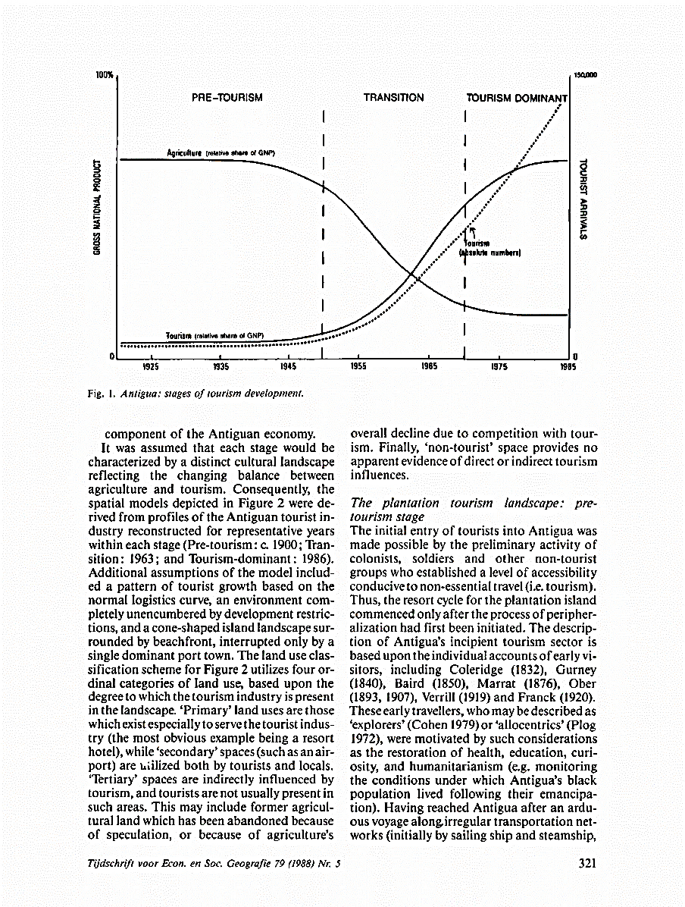
Figure 1: Antiqua stages of tourism development
Source: Weaver, (1988:321).
The main criticism of plantation model of tourism development is that not all agricultural regions will become tourist destinations as put forth by Weaver but only agricultural regions with tourism potentials will develop into tourism economy.

2.4.2. The Enclave model of tourism in developing countries
The Enclave model of tourism development is a dependence paradigm which was developed by Briton in 1982 (Figure, 2). Briton (1982) illustrated his enclave model of tourism in developing countries and indicated that tourism in developing countries is spatially concentrated and organised in the metropolitan economies where the headquarters of metropolitan tourism corporation and associated non-tourism companies are located (Britton, 1982:341).
The Enclave model of tourism development exhibit a non-participatory approach to tourism planning in that the locus of control over the development process and local resources shifts from the people that are most affected by development, the host community, to the tourism-generating regions, with adverse effects on the environment, the society and the economy (Hall, 1996). It is worth mentioning that the Enclave model of tourism development ignores and excludes local stakeholders in decision making process and local community cannot exercise control as top down decision-making is done by elitist bodies exogenous to the community (Brohman, 1996).
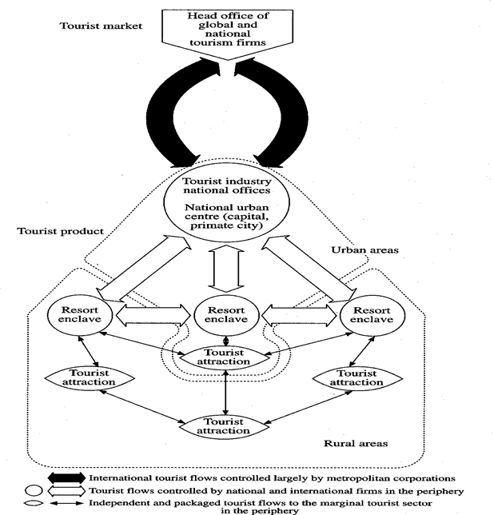
Figure 2: Enclave model of tourism in developing countries
Source: Britton (1982:344)
The main criticism of Enclave model of tourism development is that this model only concentrates on one segment of the tourism market, the package tour. Consequently, it disregards the significance of individual and domestic tourists for the economy and welfare of a destination area (Andriotis, 2000). In addition, the Enclave model neglects the importance of domestic institutions, particularly local and national governments, and consequently those bodies influencing the industry's development process. It fails to formulate alternative prescriptions for tourism development in developing countries (Oppermann and Chon, 1997). Furthermore, the Enclave model ignores the fact that in some cases local firms of developing countries control major facets of their tourism industry (Wilkinson, 1997).

2.4.3. The Diffusion model of Tourism Development
The diffusion model of tourism development was developed by Miossec (1977) and it depicted the structural evolution of a destination through time and space and noted changes in the provision of resort and transport facilities and subsequent behaviours and attitudinal changes amongst tourist, decision makers and the host population. Furthermore, Miossec (1977) cited in Andriotis (2000) has argued that diffusion happen in five phases (0, 1, 2, 3 and 4) from isolation with no development to the creation of a pioneer resort together with the necessary transport means for the accessibility of the resort, to a multiplication of resorts and further transportation links and to saturation through an even distribution of resorts across the country. The process of diffusion from the developmental core to the periphery can be easily materialised through tourism due to the increasing demand by modern tourists for new destinations. Pearce (1989) explains that through these phases’ changes in the local attitudes occur that may lead to the complete acceptance of the tourism, the adoption of planning controls or even reflection of tourism.
However, the Diffusion model of Miossec has been criticised in that the model fail to recognise that tourism cannot develop in an 'empty space' but usually develops "within an existing socioeconomic structure where some form of urban hierarchy and some transport networks are already found" (Pearce, 1989).

2.4.4. Butlers Tourism Area Life Cycle model.
The Tourism Area Life Cycle (TALC) was first proposed by Richard Butler (1980) as a means of explaining how many tourism destinations move through a cycle beginning with (almost) nil tourism, to massive development and boom times and, oftentimes, to eventual stagnation and decline. This cycle can be represented as an S-shaped curve (Figure; 3). According to Butler (1980) cited in Hunt and Stronza (2014:282) applied the product life cycle model from marketing research to tourism destinations. Butlers considers the application of the business concept of Tourism area life cycle to the product of tourism destination and resort in that since tourist destination sites are regarded as products, they could be expected to have a life cycle. Furthermore, according to Agarwal (1992) the tourism area life cycle model describes tourism areas evolving through the stages of exploration, involvement, development, consolidation and stagnation, at which point the area either falls into decline or is rejuvenated.
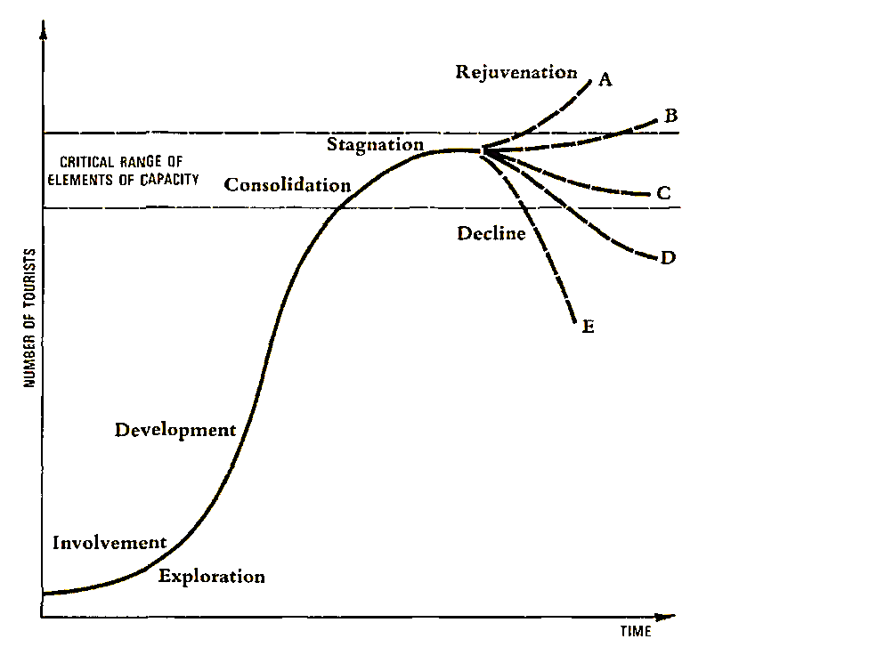
Figure 3: The Tourism Area Life Cycle development
Source: Butler (1980: 8).
The phases are briefly explained below:

2.4.4.1. The exploration stage.
The exploration stage begins when a small number of adventurous visitors who are attracted by the natural and cultural features at the destination visit the site in order to explore what the site offers. In this phase of development, there is low access to the destination and rudimentary facilities for the visitors (Butler, 1980).

2.4.4.2. The involvement phase.
Involvement takes place when tourists visit an area in growing numbers, and some of the inhabitants begin to draw their livelihood from accommodation, gastronomy, health services. The inhabitants’ involvement proceeds through becoming active in the tourist economy, or even focusing their activities exclusively on visitors (Johnston and Snepenger, 1993; Butler, 1980).

2.4.4.3. The development phase.
The development phase begins at the moment when the tourist area becomes one of the main sources of income, and the number of tourists is either equivalent to or exceeds the number of permanent residents. As this stage progresses, local involvement and control of development will decline rapidly. Some locally provided facilities will have disappeared, being superseded by larger, more elaborate, and more up-to-date facilities provided by external organizations, particularly for visitor accommodation (Butler, 1980).

2.4.4.4. The consolidation phase
The consolidation phase marks the full development of the tourism functions in a given area. It is characterized by a reduced growth in numbers of tourists, and by tourism becoming the dominant industry in the local economy. Uysal et al. (2012) point out that during the consolidation stage, tourism has become a major part of the local economy. The local community in tourist destination sites perceives some negative effects and some opposition to tourism may emerge (Buttler, 1980).

2.4.4.5. The Stagnantation phase
Butlers (1980) explain that stagnation phase brings a decisive halt to the growth dynamic of the number of visitors, Furthermore, the area will have a well-established image but it will no longer be in’ fashion. There will be a heavy reliance on repeat visitation and on conventions and similar forms of traffic. Surplus bed capacity will be available and strenuous efforts will be needed to maintain the level of visitation.

2.4.4.6. The decline or rejuvenation phase.
The last phase of the cycle is either the rejuvenation or decline of the area’s tourist function; the destination will not be able to compete with newer attractions and will face a declining market. The place will no longer appeal to vacationers. Property turnover will be high, and tourist facilities and accommodation begin to be converted to non-tourist-related structures (Butler, 1980). The services on offer are reduced, making the location increasingly unattractive, which makes it draw less and less tourists. Several tourists’ facilities disappear as the area becomes less attractive to tourists. The rejuvenation stage corresponds to the renovation phase or the reintroduction of the product with new features phase in the product life cycle. This can be achieved through introducing artificial attractions (e.g. by turning buildings into a network of casinos) or by using unexploited natural resources. An alternative approach to rejuvenation is to take advantage of previously untapped natural resources (Butler, 1980). Furthermore, Stansfield (1978) argue that a tourist destination can be rejuvenated by the influence of advance in technology. Butler suggests that although tourists may be attracted to an area initially by the mere presence of attractions and natural resources, without careful management and planning, over time tourism development will stagnate and decline. The model acts as a warning against complacency and of regarding tourism areas as ‘finite and timeless’ resources (Butler, 2006: 11). This observation is emphasised by Hovinen (2002) who explains that the Tourism Area Life Cycle has value in suggesting that destinations have the potential to experience significant overall decline if appropriate planning, development and management decisions are not made. Thus, the tourism potentials and level of tourism development in Kasama and Shiwa Ng’andu Districts was analysed using Tourism Area Life Cycle (TALC) model as expounded by Butler (1980).
TALC model received criticism from scholars like Wall’s (1982) comments on the concept of carrying capacity of tourist areas and its application to the development cycle. Other researchers have argued for the abandonment or rejection of the TALC, although few perhaps as strongly as the late Leiper (2004: 135) who stated that the model “should now be assigned to the archives of history as a former theory, now discredited, shown to be false”. There have been a number of other criticisms about the model’s non-validity or failings and alternative approaches (Prideaux, 2000). On the other hand, Aguilol et al (2005) argued that the model was essentially only theoretical. The model does not apply in all destinations as expounded by Butler (Choy, 1992). Despite many criticisms of Butlers (1980) model, many scholars such as Keovilay (2012)., Prangli (2013) and Mbewe (2015) have continued to apply Butlers model in many tourist destinations signifying its continued relevance in the academic cycle.
The main focus of this study is to evaluate the participation of tourism stakeholders in the development of tourism through tourism planning. Butler’s model suited this study because the model demonstrates what can happen in an area if tourism development is not planned and managed which is lacking in other models. Additionally, Butler (1980) suited this study because the model acknowledges participatory and collaboration between local stakeholders and foreign investors. Further the model identifies the role of local entrepreneurs and local developers at the involvement and development stages in supplying services to tourist.

2.5. Tourism planning Process
Planning essentially refers to thinking and making decisions about current and future activity (Wilkinson, 1997). In the context of tourism, planning broadly refers to the anticipation and regulation of change to mitigate negative development issues through the promotion of orderly development and increasing the social, economic and environmental benefits of tourism to an area, while satisfying the needs of residents and guests (Murphy, 1985; Timothy, 1999). Sustainable tourism planning has been seen by many as a means of maximising the positive and minimising the negative impacts of tourism activity on destination communities (Ruhanen-Hunter, 2006). Without planning, tourism may generate several unwanted and unexpected impacts (World Tourism Organization, 1994). On the other hand, Inskeep (1991) explains that planning for tourism is a step-by-step process which should be continuous, comprehensive, integrated, and environmental, focusing on achieving sustainable development and community involvement. Tourism planning is centred towards sustainable use of resources, enhanced visitor satisfaction, integration of local community and improved economy and business (Gunn, 2002; Tavallaee et al, 2014)). However, the tourism planning process involves the national planning process, regional planning process and district or local (destination) planning process. It is also worth mentioning that during tourism planning process, it is argued that stakeholder’s participation in tourism planning assist in reducing any possible conflicts as all stakeholders have the opportunity to understand the viewpoints of others (Reid et al., 2004; Berlin Declaration, 2017). However, it is worth mentioning that there is a tendency for core planning teams not to involve certain stakeholders in planning in many destinations in which marginalized groups, poor rural community members, minorities and others are often left out because planners assume that these groups are not well informed or educated enough to contribute to the planning process (UNDP, 2009; Berlin Declaration, 2017).
Local government in particular has a key role to play in tourism destination planning and management, often because it is at the local level where the impacts of tourism are felt most acutely and it is the local authority that deals with land use planning (Conlin, 1996; Godfrey, 1998; Hunter, 1995). On the other hand, GRZ (2017) has expounded that Integrated Development Plans of the municipal and district councils will be the basis for designing district-specific programmes while recognizing the need to mainstream national programmes contained in the 7NDP and other international development agendas. Thus IDPs plans include rural areas which were once left underdeveloped and largely unserviced. Since tourist destinations are mainly rural, tourism development planning strategies will be captured in IDP plans (GRZ, 2019).
Furthermore, a study by Bello et al (2016a) looked at enhancing community participation in tourism planning associated with protected areas in Malawi. The study revealed that decentralisation of both protected area and tourism administration is critical to the success of community participation in protected area-based tourism planning. The study further found that the department of tourism and Department of National Parks and Wildlife (DNPW) were not decentralised. The centralized public administration affected the coordination of various stakeholders’ programmes during the tourism planning process. Another study by Bello et al (2016b) found that Public awareness and education in tourism is one of the most important parameter for increased stakeholder’s participation in Malawi. The study stressed the need for all stakeholders involved in tourism planning to have some basic understanding of issues associated with tourism development emerged as a major prerequisite for effective participation. Furthermore, Bello et al (2016b) study revealed that local based organisation facilitated the participation of local people in tourism planning because an organisation provided points of contact within the villages.
A study by Monther and Zain (2017) provides precedence for a successful bottom-up approach for tourism management in the old city of As-Salt, Jordan. As-Salt is a Jordanian historic city known for the richness of its cultural and historical urban context that deserves to be an attractive tourist destination. As-Salt was suffering degradation in its traditional urban fabric due to the pressure of modernization, pollution, low levels of maintenance, and pressures on infrastructures. Thus a “bottom-up approach” for the assessment of the existing tourism situation with the goal of promoting and enhancing tourism management in the city of As-Salt was employed to ensure the conservation and protection of As-Salt’s tangible and intangible heritage. A participatory approach to sustainably manage tourism in cultural sites in the old city of As-Salt in Jordan was adopted to ensure a shared vision with the local community about how As-Salt could be managed to enhance the tourism status and sustain its resources. The process followed four stages of identification of representatives from stakeholders from government and private, evaluation, implementation and monitoring. Furthermore, Monther and Zain (2017) study revealed that participatory and bottom-up approach significantly enhanced the sustainable management of cultural tourism in As-Salt city because different stakeholders were systematically involved.
Pike et al. (2006) cited by Ascani et al, (2012) describe bottom-up development planning principles as strategies that fundamentally aim at unleashing indigenous economic potential by favouring local competitive advantage, and where the involvement of local actors in designing, implementing and managing development strategies is crucial. In so doing, bottom-up development initiatives are built on an in-depth analysis of local characteristics in terms of economic and socio-institutional conditions, in order to embed economic activity in the territory. On the other hand, Zambia national planning process is structured to follow a top-down and bottom-up decentralised approach which connects the national, provincial, district and community levels. However, various reviews have consistently shown that the planning process has not operated as intended due to structural and institutional inadequacies (GRZ, 2017).

2.6. Collaborative and participatory Planning debate
The idea of collaborative planning has gained widespread acceptance among
planning scholars and practitioners. Tewdwr-Jones and Allmendinger certify
that communicative/collaborative planning has enjoyed an ‘enthusiastic recep-
tion’ (2002: 207); Innes and Booher observe that ‘collaborative planning is
moving forward and spreading as a method’ (2003: 24);
The idea of collaborative planning has gained widespread acceptance among
planning scholars and practitioners. Tewdwr-Jones and Allmendinger certify
that communicative/collaborative planning has enjoyed an ‘enthusiastic recep-
tion’ (2002: 207); Innes and Booher observe that ‘collaborative planning is
moving forward and spreading as a method’ (2003: 24);
The idea of collaborative planning has gained widespread acceptance among planning scholars and practitioners. Tewdwr-Jones and Allmendinger (2005) explains that collaborative planning has enjoyed an enthusiastic reception. Similarly, Innes and Booher (2003) observe that collaborative planning is moving forward and spreading as a method. Collaborative planning, which emerged as a distinct planning paradigm in the 1990s, is a logical extension of alternative dispute resolution (Gunton and Day, 2003). Participatory planning is an approach to designing active, livable cities, which makes urban planning accessible, community-driven, and fun. It is grounded in the belief that blend local knowledge and expert knowledge leads to strong outcomes (Fainstein, 2000). Collaborative approaches to planning are well-established in policy and practice. Underpinning such approaches are different strands of theory, including participatory, deliberative (Forester, 2009) and collaborative planning (Healey 1997; Innes and Booher, 2003), often gathered under the umbrella term communicative planning theory (CPT). Similarly, Healey (1998) elucidate that Sustainable development is also highly valued by collaborative planners in the area of environmental sustainability. In particular, Maginn (2007) indicates that collaborative planning can provide policymakers with more effective community participation. Participatory development planning has received a major fillip on account of the decentralization reforms that seeks to bestow local governments with more responsibilities and makes them more accountable to their citizens. While participatory development planning is generally initiated by the government or development agency involved, there are also opportunities for Civil Society Organisations (CSOs) to take the lead (Wates, 2000).
Participatory planning is also credited with creating cohesiveness within a community and overcoming the problems of centrally formed, top-down policies, which have been criticised for favouring dominant stakeholders (Wates, 2000). Collaborative planning’s inherent impulse for grassroots democracy that gives ‘voice to the voiceless’ (Sarkissian, 2005).

2.7. Tourism development in Africa.
Africa’s share of world arrivals, though still small, is growing. In 1995 Africa received just 3.6 percent of world tourist arrivals; by 2010, Africa’s market share had increased to 5.2 percent. Sub-Saharan Africa received 3.3 percent of world tourist arrivals. Longer-term forecasts provided by the United Nations World Tourism Organization (UNWTO) predict that the region will receive 77 million arrivals by 2020 (Christie et al, 2014). Furthermore, Gisore and Ogulu (2015) point out that tourism is a principal export for many African countries and a significant source of foreign exchange. Africa accounted for about 5.8 % of the 1133 million international tourist arrivals and 3.5 of the US$1245 billion international receipts in 2014. Furthermore, World Economic Forum (WEF) (2015) takes cognizance of the fact that Africa has significant tourism potential, notably due to richness in natural resources and the potential to further develop cultural resources. However, it is still mostly in the early stages of development and strongly connected with more general and longstanding development challenges, including infrastructure as well as health and hygiene. Kenawy (2015) conducted a study in Egypt with a focus on the collaborative approach for developing a more effective regional planning framework. The study revealed that the tourism administration and its planning system in Egypt is described as highly centralised where ecotourism initiatives were initiated and managed by central government through the Tourism Development Agency (TDA) which created lack of collaboration among stakeholders. The study further revealed that the level of stakeholder participation in all case studies was tokenism. On the other hand, Teshome et al, (2018) study focused to identify the major challenges hampering destination development in the Amhara Region in Ethiopia. The study revealed that major tourist destination in Amhara Regional State has been challenged by different factors such as poor community participation in tourist destination area; lack of benefit sharing; the lack of knowledge about the importance of tourism by a large segment of the society, insufficient investment incentives, lack of community leadership and good governance, lack of stakeholders collaboration, low/lack incentive to tourism investment, poor tourist facility and infrastructure and weak policy implementation were the major challenges in the four destination areas. Another study by Chami (2018) at Amboni Limestone Caves in Tanga region, North Eastern Tanzania focused on proposing ways to be used in Amboni Limestone Caves to ensure sustainable management and tourism development. The study revealed that manufacturing of the cultural tourism products by the Kiomoni Villagers was a proper way in which to promote cultural heritage. The study also revealed the potential for game viewing at Amboni caves as the cave had potential for wild animals, birds which were available within the Amboni forests but were not utilised. On the other hand, Worku and Tessema^{’s} (2018) study in North West Ethiopia assessed public- private collaboration in the tourism industry. The study revealed that top-down approach in planning created challenges in developing tourism in Bahir Dar and Gondar in Ethiopia.

2.8. Tourism in Zambia

2.8.1. History of tourism in Zambia
Historically, tourism in Zambia during colonial times concentrated on the city of Livingstone which was named after the famous Scottish missionary and explorer, Dr David Livingstone. Norris (1954) cited in Magombo (2011) explains that during the federal period (Colonial time) tourist infrastructure was developed primarily in (Zimbabwe) as the main focus country of the federal government. However, Teye (1988) explains that tourism was not recognized as a sector worth developing until 1965 after Zambia gained its independence. Teye (1988) explains that in 1965 after Zambia got independence, the First National Development Plan was developed. The Plan projected 155,000 foreign visitor arrivals and $6 million in foreign exchange receipts by 1970, basing its estimation on tourist arrivals and revenue during the early 1960s. In the First and Second Republics, the Government of Zambia promoted the growth of tourism industry through creation of national parks and game reserves as at that time game viewing was the main tourist attraction. In 1997 the Zambian government formulated the first tourism policy which became the guiding principle for the development of tourism in Zambia. GRZ (1997) explains that the government of Zambia decided that the tourism industry development should be led by the private sector with the public sector providing the necessary enabling environment through appropriate policy measures and support infrastructure improvements. Furthermore, GRZ (1997) explains that in 1996, the Government had reclassified the tourism sector from a social to an economic category and this was in recognition of the sector's potential to contribute to economic development in terms of foreign exchange earnings, employment and income generation, contribution to Government revenues, promotion of rural development. The Tourism Levy is meant to improve and develop tourism in Zambia. Furthermore, GRZ (2017) highlights the road map in the development of tourism industry from 2017 to 2021 where the focus has been predicated on expanding the tourism industry beyond the traditional tourism sites and products and promoting the integration of destinations that will make Zambia more competitive in the region. GRZ (2016a) explains that Zambia’s tourism industry currently contributes 3.4 percent to GDP and at national level, the tourism sector continues to be recognised as a key economic sector with significant potential to contribute to job creation, rural development and economic development.
International tourist arrivals in Zambia increased from 815,000 to 956,000 between 2010 and 2016, growing 17.3% over the period. Growth rates have however fluctuated year-on-year throughout the period. For instance, Zambia’s International tourist arrivals increased by 3.5 percent in 2014, reaching 946,969 arrivals compared to 2013 that recorded 914,576 arrivals. The increase can be attributed to the influx of people coming to do business and the increase in flights coming to Zambia, improved marketing and public relation campaigns supported by regular participation in international road shows (GRZ, 2014).

2.8.2. Tourism potentials and the state of tourism development in Zambia
The development of tourism in Zambia is spearheaded by the Zambia Tourism Agency which has divided this country into tourism circuits which include the southern tourism circuit and Northern tourism circuit (GRZ, 2017). The Northern part of the country is endowed with numerous investment opportunities and these untapped resources lie in areas of scenic landscapes providing potential investors with rich areas for development such as boat cruises, canoeing, river boarding, water rafting, and Gorge wing (ZDA, 2013b; ZDA, 2014). However, despite the potential of Northern Tourism Circuit, the region remains off the tourist paths and has remained untapped due to lack of investment in infrastructure such as accommodation (Mattoo and Payton, 2007; GRZ, 2015d). This view has been buttressed by GRZ (2017) which has observed that the tourism sector continues to face challenges which include: lack of a comprehensive national tourism plan; underdeveloped tourism-related infrastructure; limited investment in the tourism sector by both local and foreign investors; limited tourism product offering range and scope; inadequate tourism promotion and marketing and low participation by locals in tourism development. Conversely, a study by Kapinga (2006) explored the impact of tourism on local communities focusing on Livingstone and Daghamarskjoild memorial site and found that promotion for the tourism sector in Zambia had improved in the last decade to a level where they match global standards of efficient marketing strategies. It is worth mentioning that government has recognised the development of arts and culture infrastructure with a view to improving the contribution of the country’s unique natural and cultural heritage to diversify the tourism product and as such during the plan period 2017-2021(GRZ, 2017). Nevertheless, scholarly contribution to the development of tourism in Zambia includes a study Himoonde (2007) study explored on opportunities and Constraints of local participation in Ecotourism in Kasanka National Park. The study found that the locals of Kafinda community were not actively participating in the planning and management of the protected area but were seen as passive recipients of benefits from tourism in KNP. Furthermore, Himoonde (2007) study also found that the local community of Kafinda showed resistance to conservation awareness projects promoted by the Kasanka Trust Community Project. Furthermore, Himoonde (2007) argues for the need to increase opportunities for active local participation in protected area management which include an increase in incentives, rights and local power to own, use, and control resources was identified as essential for the Kafinda community in order to participate actively in ecotourism.
Another scholarly contribution to development of tourism in Zambia is a study by Tylor and Thole (2013) which advocated for the exploitation of the potentials and opportunities of the Northern Province of Zambia for sustainable tourism development and rural development. The study was anchored on the premise that tourism is increasingly becoming important to the Zambian economy and there is a huge potential for promoting sustainable rural tourism in the Northern Province of Zambia. The study revealed major tourist potentials in Northern Province which include: historical buildings or monuments, national parks and wildlife, Outstanding Panoramas and Areas of natural beauty, sites and areas of archaeological interest and historical significance, traditional ceremonies. Furthermore, Tylor and Thole (2013) noted that there are vast areas of undeveloped land in Northern Province and this provides investors with an array of site options for the location of entertainment facilities to meet the needs of tourists, especially adjacent to key attractions. Taylor and Thole^{’s} (2013) study recommended the development of visitor website as means to increase effective tourist participation in decision making process. However, the study by Taylor and Thole (2013) did not really show the level at which tourism destination sites have reached in terms of development. The study did not focus on major tourist activities at each individual site in order to ascertain the level of tourism development at various sites sampled in the study.
Liu and Mwanza (2014) observed the absence of documented national development planning policy and fragmented legislation framework of sustainability in Zambia’s national strategies has led to continuing limited involvement of local communities in tourism planning and development of sustainable tourism approaches. Thus Liu and Mwanza (2014) recommend the need for tourism planning through a pro-development policy, as failure to implement a guiding tourism policy will make Zambia lose pace in terms of competitive advantage as a clean, green and sustainable tourism destination.
On the other hand, a study by Mbewe (2015) looked on tourism development of Kafue National park (KNP) and the study revealed that the park lacked a number of services such as banking, health, telecommunication and shopping points like curio and craft shops which have hampered tourism development in the park. Furthermore, the study also revealed lack of publications in both the print media and internet to expose the park to the public led to low inflow of tourists especially the domestic tourists. Mbewe (2015) study also cited lack of adequate funding from the government as another factor that impacted negatively on tourism development in KNP-North because the park could compete vigorously in the tourism industry. Furthermore, Mbewe (2015) study found that the level of tourism development of KNP-North falls in the sixth stage of Butler’s model called declining stage meaning that the area was unable to compete with other or new destinations and thus, faces declining markets both spatially and numerically.
Mubanga and Umar (2016) study looked at whether tourism was an activity for foreigners focusing on resident’s views about community participation in Zambia’s tourist capital. The results showed that over half of the residents (57%) believed that they participated in tourism in Livingstone. They found that participation levels were lowest (32%) in the case of low income households. Any community participation in local governance structures was passive with residents being recipients of information about decisions that had already been made at the center and had then “trickled down” to the periphery. Furthermore, Community representatives were included on development planning committees as a form of tokenism, with no real decision making authority.

2.9. The Legal Framework guiding tourism development in Zambia
Tourism development in Zambia is supported by various legal provisions which guide and enhance tourism investment.

2.9.1. Tourism and Hospitality Act of 2015
The Hospitality and Tourism Act of 2015 is the leading legal framework which provide for the sustainable development of the tourism industry through effective tourism planning, management, promotion and coordination to ensure sustainable tourism. The Act also promotes private sector investment and local community participation in the development of tourism and tourism related services. The act further facilitates consultation with local communities on sustainable tourism planning and development and engages local communities in planning and decision making (GRZ, 2015b). Enactment and implementation of the Tourism and Hospitality Act of 2015 has brought about various progressive changes which include; establishment of tourism development fund to support product development, tourism infrastructure and tourism marketing. This act also promote a participatory and collaborative approach towards development of tourism through tourism planning.

2.9.2. Constitution of Zambia (Amendment) No. 2 of 2016
Article 255 of Constitution of Zambia (Amendment) No. 2 of 2016 addresses the management and development of Zambia’s environment and natural resources. The article is very cardinal as Zambia’s tourism is nature based. On the other hand, Article 256 addresses the protection of environment and natural resources. The Article ensures that there is inherent in sustainable development definition. The Article further stresses that natural resources must be used in a sustainable manner by protecting and safeguarding the environment (GRZ, 2016b).

2.9.3. The Environmental Management Act, No.12 of 2011
Section 91 of Environmental Management Act, No.12 of 2011 addresses Public participation in environmental decision making. This article empowers stakeholders to participate in the development of tourism in their respective host communities where the public have the right to be informed of the intention of public authorities to make decisions affecting the environment and of available opportunities to participate in such decisions (GRZ, 2011).

2.9.4. The Urban and Regional Planning Act No. 3 of 2015
The Act establishes procedures for a planning authority to prepare an integrated development plan (IDPs) for its area which is the principal planning instrument to guide and inform all planning and development in the area of the local authority and all planning decisions of a planning authority. Thus it is through an integrated development plan that a local authority must plan for local economic development (Tourism development), environmental management, and protection of ecologically sensitive areas, heritage and cultural sites (GRZ, 2015c).

2.9.5. The National Museum Act, 1966
The National Museum act allows for the establishment of the National Museums Board which is a statutory body created by an Act of Parliament, Chapter 174, of the Laws of Zambia. The principle role of the museum board is collecting, documenting, preserving and presenting Zambia’s movable heritage for public benefit, education, enjoyment and posterity. Museums have a significant role in cultural tourism as museums houses artistic, history, and local lore which traditionally attract both local and foreign tourists. Museum are a center of cultural and natural heritage which plays a significant role in defining the nation's cultural identity and pride. The visit of tourists to museums will help the growth of tourism as revenue collected will be used to further collect and document other cultural and artistic materials not housed in museums.

2.9.6. Zambia Wildlife Act No. 14 of 2015
This act provides for the establishment, control and management of National Parks, bird and wildlife sanctuaries and for the conservation and enhancement of wildlife eco-systems, biological diversity and objects of aesthetic, pre-historic, historical, geological, archaeological and scientific interest in National Parks. The Act further provides for involvement of local communities in the management of Game Management Areas; provide for the licensing of hunting and control of the processing, sale, import and export of wild animals and trophies (GRZ, 2015e). Since Zambia’s tourism is nature based and wildlife in most national parks and game management areas continue to attract a large number of tourists, Wildlife management is necessary as wildlife watching activities play a signiﬁcant and growing part in the tourism industry as it create direct and indirect economic beneﬁts for many countries and communities.

2.9.7. Vision 2030
The government has positioned the country to be a major destination of choice with unique features by 2030 through development, rehabilitation and maintenance of tourism related infrastructures. Additionally, the government during this period will diversify tourism products and increase local participation in tourism development (GRZ, 2006).

2.9.8. The Seventh National Development Plan (2017-2021)
Government has projected to diversify the tourism sector by promoting tourism related infrastructure, diversification of tourism products, promotion of tourism source market segmentation, promotion of domestic tourism and restocking of national parks (GRZ, 2017).
Despite having in place existing pieces of legislation, the development of tourism in Zambia still lags behind on account of weak, limitations and gaps in existing policies and legislation due to weak inter-ministerial and inter-agency collaborations and linkages on tourism-related issues which have slowed down growth and understanding of tourism in other related ministries and agencies (GRZ, 2015a).

2.10. Chapter Summary
This chapter has explored literature which is relevant to this study. The chapter discusses how tourism has grown at the global perspective. Furthermore, models explaining the development of tourism have been explained. The chapter discusses major scholarly work pertaining to tourism planning process and state of tourism development in Zambia.
Despite the numerous studies such as those which has been highlighted above on tourism development and stakeholder participation in the development of tourism may be of use in this study, these studies have limitations in their application in that factors fostering tourism development and level of stakeholder participation in the development of tourism may not cross over to other countries like Zambia. Furthermore, most of these studies were done in different areas.
Additionally, the Government of Zambia has developed the National Tourism Policy of 2015, Tourism and Hospitality Act N0. 13 of 2015 which underpins the involvement of stakeholders in tourism planning. However, despite the enactment of Tourism and Hospitality Act N0. 13 of 2015 and formulation of National Tourism Policy of 2015 which advocate for tourism planning and involvement of different stakeholders, the level and extent of involving stakeholders in tourism planning in Kasama and Shiwa Ng’andu Districts still remain unexplored. This study is necessary in Zambia in that it attempts to ascertain the level of stakeholder’s participation in tourism planning.

CHAPTER THREE

DESCRIPTION OF THE STUDY AREA

3.0. Introduction
This chapter presents the description of study area Kasama and Shiwa Ng’andu Districts in the Northern tourism circuit. The chapter describe the geographical location of the study area, selection of study area, soils, vegetation, climate, drainage and socio-economic characteristics.

3.1. Geographical location of Kasama and Shiwa Ng’andu District.

3.1.1. Geographical location of Chishimba falls and Mwela Rocks in Kasama District
Kasama District is located in Northern Province of Zambia (Figure 4). It is located between latitude 10º 9’ S and 10º 15’ S and longitude 31º 7’ and 31º 12’ E. The town is primarily an administrative centre of Northern Province
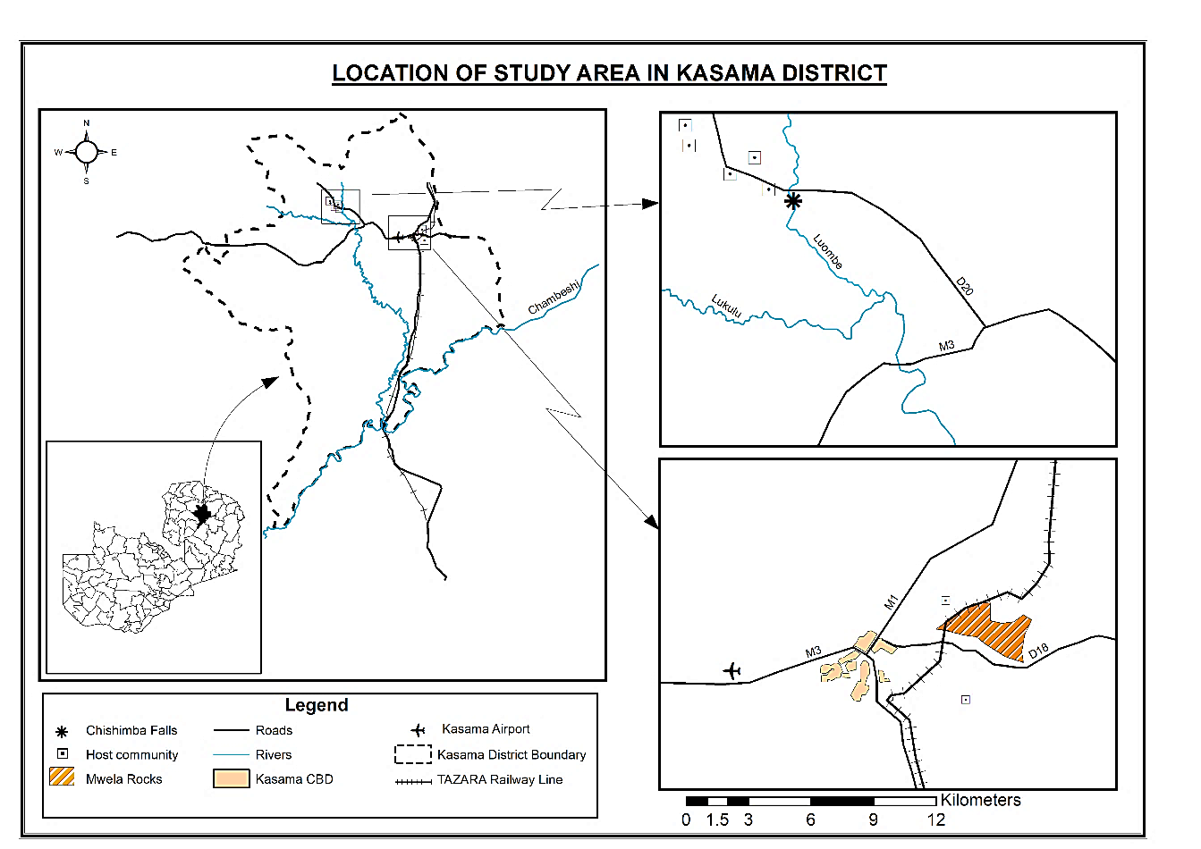
Figure 4: Location of study area in Kasama District.
Source: Researcher, 2018
Kasama grew considerably in the 1970s and 1980s after construction of the TAZARA Railway through the city and the tarring of the Great North Road from Mpika through Kasama to Mbala. It shares its boundary with Mpika District to the South, Chinsali to the South East, Mungwi to the East, and Mbala to the North East, Mporokoso to the North and Luwingu to the North East. In Kasama research was carried out within the CBD, Chishimba falls and Mwela Rocks. Chishimba falls is located 35km from Kasama along D20 road (Kasama-Mporokoso road) as shown in Figure; 4. Chishimba falls consist of three successive falls namely Mutumuna falls, Kaela rapids and Chishimba falls found on the Luombe River and on the eastern side of Luombe River there is a thick mist forest with plenty of small game animals and birds (Katanekwa, 2011). The falls is surrounded by Chishimba village as host community. On the other hand, Mwela Rocks is located along D18 road (Kasama-Isoka road) about 5 km from Kasama CBD (Figure; 4). The Twa hunters and gatherers settled at Mwela rocks before Bantu communities arrived in the area. The Twa people painted almost all rocks in the area (Katanekwa, 2011).

3.1.2. Geographical location of Shiwa Ng’andu estate in Shiwa Ng’andu District
Shiwang’andu District is located in Muchinga Province. It was initially part of Chinsali District until in 2012 when it was declared a District. It is named after Lake Ishiba Ng’andu which means lake of the loyal Crocodile in the local Bemba language. It is located between longitude 320, 50’ east and 320, 30’ East and has a latitudinal range of 100, 30’ to 110, 40’. The District shares its boundary with Mpika district to the South, Chinsali to the North, Kasama to the West, Mungwi to the Northwest and Chama to the East. In Shiwa Ng’andu research was carried out within the CBD and Shiwa Ng’andu tourist estate. Shiwa Ng’andu estate is located along D53 road which stretches from Great north road to M1 road (Mpika-Kasama road as shown in Figure; 5. The estate was established in 1920 by Stewart Gore-Browne a British army officer during his duty in Northern Rhodesia. Gore Browne made a model of the house he wished to build (Manor house) using local materials. Currently, the estate has expanded to include Kapishya hot spring which is managed by Stewart Gore-Browne grandchildren.
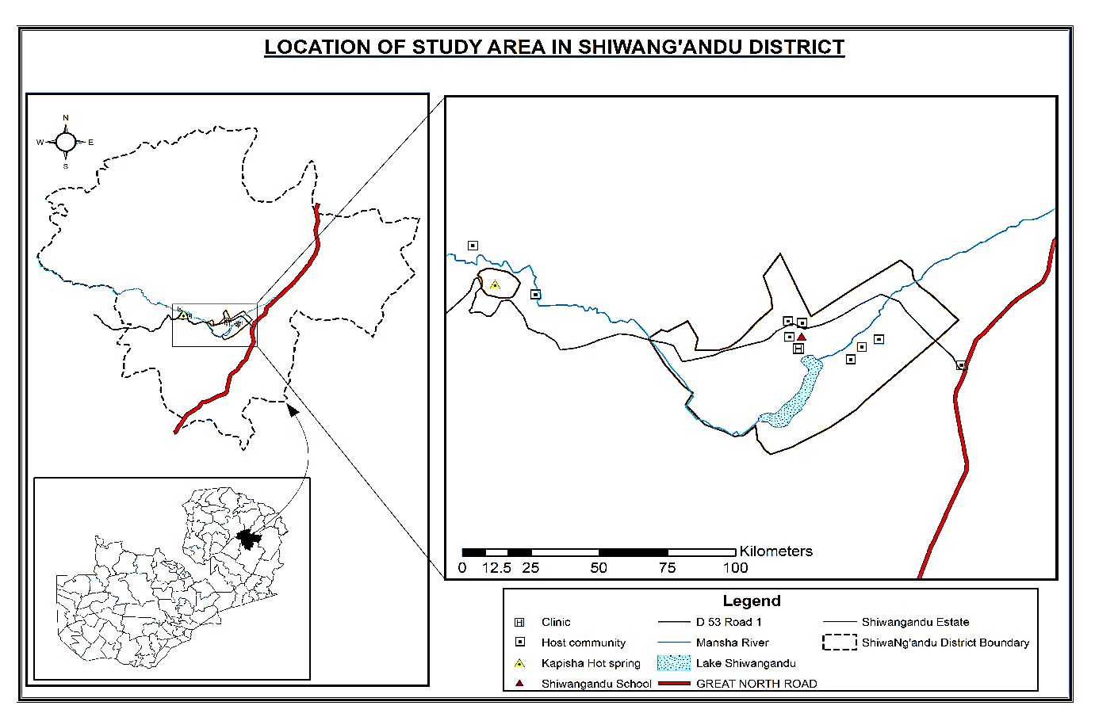
Figure 5: Location of study area in Shiwa Ng’andu District.
Source: Researcher, 2018

3.2. Selection of the study area
Chishimba Falls was purposively selected because it receives the highest tourist arrivals second to Victoria Falls (GRZ, 2016a). Shiwa Ng’andu tourist site was purposively selected because it is the only privately owned tourist site. As for Mwela rocks, it was purposively selected because of being a tourist site locate within a radius of 5 km from the Central Business District of Kasama District. The tourist sites are not isolated from human settlements but they are surrounded by host communities which include Kungu Village (Mwela rocks), Chishimba village (Chishimba falls) and Shiwa Ng’andu Village (Shiwa Nga’ndu site).

3.3 Physical characteristics

3.3.1 Relief, Soils and Drainage
Kasama District lies in altitude between 1320 to 1535 meters above sea level while Shiwang’andu District lies in altitude of between 1500m-1800m above sea level. In terms of climate, Kasama and Shiwa Ng’andu Districts experience a tropical type of climate characterized by three distinct seasons which include the rain season from November to April, the cool dry season, which stretches from May to August and the hot dry season from September to November. The region receives rainfall which ranges between 1000-1500mm. Kasama temperature ranges from 15°C to 35°C while in Shiwang’andu temperatures ranges from 18 to 24 degrees Celsius.
Soils found in the study area are Acrisols which are highly leached due to high rainfall received (GRZ, 2016c). The soils are mainly acidic with very low content of calcium and magnesium. The geology of Shiwa Ng’andu District is described as Kibaran and Karroo system while the geology of Kasama consists of quartzites, sandstones and grit of the pre-cambium Kibaran system (De Waele et al, 2006). GRZ (1978) cited by Chileshe (2004) explains that the presence of extensive horizons of quartzites is largely responsible for the existence of the plateau of the area.
In terms of drainage, the main rivers found in Kasama District are the Chambeshi, Lukulu and Luombe. Other Rivers in the district include Lualuo, Mulilansolo, Lukashya and Chafwa streams. As for Shiwang’andu District, the major rivers in the district are the Chambeshi and Lubu. The Chambeshi forms the boundary in the West and flows into Nashinga flood plain. Other Rivers in the District include Luchindashi, Chimpundu, Manshya, Lwanya and Chinamabuwe. Lake Shiwang’andu also forms as the major drainage system where Manshya River drains.

3.3.2. Vegetation
Miombo woodland is the common vegetation type in sub-types of the savannah vegetation in central Africa and as such Miombo type of woodlands tends to dominate in the study area. In Shiwang’andu, the vegetation is characterised by species such as Brachystegia Isoberlinia, Isoberlinia paniculata, Brachystegia Longfolia and Brachystagia Hockii (GRZ, 1968, Cole, 1963). In Kasama District, the vegetation is characterised by Pterocarpus angolensis, Brachystegia paniculata, Brachystegia Spiciformis and Isoberlina angolensis. Fanshawe (1971) cited by Chileshe (2004) that the vegetation is characterised by species such as Brachystagia boehmii, Julbermardia paniculata, Isoberlina angolensis, Burkesa Africana and Brachystagia Utilis curatellifolia. Grass is found in dambos near rivers. According to Chidumayo (1997) cited in Chileshe (2004) the dominant grass species include loudetia simple and Andropogon schrensis.

3.4. Socio-economic characteristics

3.4.1. Economic livelihoods of the local Communities
The study area is occupied by ethnic Bemba people. The most prominent economic activity among the local communities is subsistence crop agriculture which is dependent on rain-fed agriculture as the source of livelihood with maize, cassava, beans, peas and millet being the main crops. However, for Kasama some local community are employed in industries such as Kalungwishi Estate which produce Kasama sugar and Kateshi coffee plantation while other local community residents depend on selling of various merchandise during periodic markets as a means of livelihood. Additionally, Mwela rocks residents also depend on stone crushing as a source of livelihood. As for Shiwang’andu District, some local community residents are employed in the newly established soft wood plantation by Zambia Forestry and Forests Industrial Corporation (ZAFFICO) and Shiwa Ng’andu estate while most of the people are engaged in informal businesses such as selling of groceries, fish, caterpillars, mushrooms and other merchandise. Other economic and land use activities in the study areas include gathering of wild products, brick making and sand mining.

3.4.2 Population
The population of Kasama District as of 2010 census was 231,824 of which 117, 616 are female representing 50.4% while that of male was 114,208 representing 49.6% (CSO, 2012). The population annual growth rate stands at 3.1%. By 2035 the population of Kasama is projected to be 478,934 (CSO, 2013). Shiwang’andu District had a total population of 96,100 of which 47,408 were male and 48,702 were female (CSO, 2012). The projected population of Shiwang’andu will be 180, 179 (CSO, 2013).

3.5. Chapter Summary
The chapter has presented the study’s area profile. The relief is mainly plateau with moderate climatic characteristic. The chapter has established that Miombo woodland is the common vegetation and the inhabitant ethnic Bemba people depend on rain fed agriculture as the main economic activity of the area. The chapter has presented main tourist attraction areas Chishimba falls, Mwela Rocks and Shiwa Ng’andu estate as research areas.

CHAPTER: FOUR

RESEARCH METHODOLOGY

4.1. Introduction
This chapter examines the research methodology adopted by the study. It first outlines the interpretivist research paradigm that underpins the approach taken in this study, theoretical framework guiding the study, discussing the significance of choice of a qualitative approach.

4.2. Research Paradigm
A research paradigm is a set of common beliefs and agreements shared between scientists about how problems should be understood and addressed (Kuhn, 1962). On the other hand, Bryman (2012) explains that a paradigm influences what should be studied, how research should be done and how results should be interpreted. The primary focus of this study is to evaluate stakeholder’s participation in planning for sustainable tourism development; this emphasises gaining a deeper understanding of the nature and level of stakeholder participation in tourism planning process. Since qualitative research is linked to a subjective and interpretivist approach, this study adopted constructivism/interpretivism as a research paradigm. Creswell (2005) explains that a constructivist/interpretivist researcher tends to rely on the participants views of the situation being studied. Thus researchers adopting constructivism/interpretivist research use qualitative research methodologies to investigate and describe social realities (Tuli, 2010). Furthermore, interpretivism argues that reality is relative and so there can be many different, valid realities and the task of research is to interpret and understand those realities rather than to determine cause effects relationships for general, predictive purposes (Fellows and Liu, 2015). This brings one to the conclusion that reality is constructed by the person’s involved (social constructivist). Therefore, truth and reality are social constraints, rather than existing independently and so researchers should endeavour to determine truth and reality from participant’s collective perspectives (Fellows and Liu, 2015). Furthermore, Creswell (2003:8) cited by Chiwira (2017) elaborates that a researcher operating in the constructivist paradigm tends to rely upon the participants views of the situation being studied. Tuli (2010) supports this view and says that researchers within this paradigm are naturalistic since they apply to real-world situations as they unfold naturally, more specifically, they tend to be non-manipulative, unobtrusive and non-controlling. This study is therefore framed within constructivist/interpretative research paradigm as it sought to make sense of the subjective and socially constructed meanings expressed by tourism stakeholders about the nature and level of their engagement and participation in the development of tourism. This view has been buttressed by Saunders et al (2012:546) that “Social constructivism indicates that meanings are dependent on human cognition-people’s interpretations of events that occur around them.

4.3. Theoretical Framework
The study adopted Collaborative Planning Theory propagated by Healey (1997) as theoretical framework. The aim of collaborative planning theory is to involve all stakeholders in the process of planning for achieving consensus policy outcomes (Kumar and Paddison, 2000). Collaborative Planning considers planning as an interactive process (Healey, 2007). Stakeholders are individuals, groups and organisations which have the right to participate in a joint structure plan making process and who may affect or get affected by the outcomes of structural planning process (Kumar and Paddison, 2000). Healey (1996) explains that collaborative planning is fundamentally all-inclusive. Kumar and Paddison (2000) explain that stakeholders may include local people, regional, national and international investors, public and private and non-governmental organisations. Clarke (1996) argues that stakeholders have the right to participate in decision making process.
Healey (1997) explains that in order to achieve the goal of including all stakeholders in policy formulation and implementation, collaboration planning theory considers planning as an interactive process in which all planning knowledge is produced through interaction. Arenas for interaction and discourse are designed by the stakeholders themselves with the view to include all stakeholders in a friendly and supportive environment (Bryson and Crosby, 1989; Healey, 1996). Furthermore, collaboration planning theory advocate that all stakeholders must be involved in planning because they will present different knowledge and reasoning (Healey, 1998). Collaboration planning theory advocate trust among stakeholders as a trigger for joint operation of stakeholders in achieving a particular purpose. Kumar and Paddison (2000) explains that collaborative planning theory advocates that stakeholders entrust powers and tasks to new structures. Delegation of power and tasks in this context represents a degree of trust. In the light of the above, this study considers tourism development stakeholders to be people or communities associated with tourism development and therefore have the potential to affect or be affected by tourism development activities.
Another theory which this study used to supplement Collaboration Planning theory is Arnstein ladder of Citizen Participation (Figure,6). According to this typology, Arnstein (1969) postulate that the eight (8) level of citizen participation is categorised into three categories.
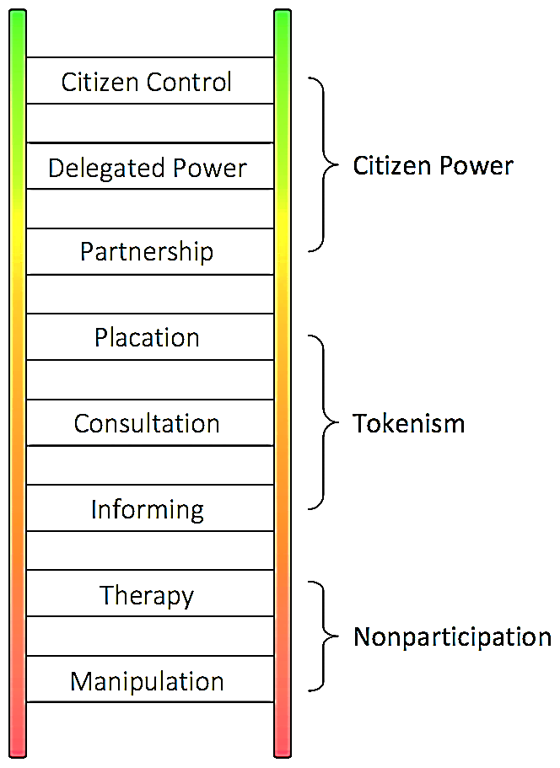
Figure 6: Anstein ladder of citizen participation
Source: Arnstein (1969: 217).
The first category is Non-participation and consist of Manipulation and Therapy. Manipulation is the first (1) rung in which People are placed on rubberstamp advisory committees or advisory boards for the express purpose of educating them or engineering their support. The second rung of the ladder is therapy which assumes that the public is incapable of decision making and those in power subject citizens to paternalistic education exercises, or clinical group therapy, as a form of enlightenment. The second level of stakeholder’s participation is the Degree of Tokenism which consist of informing and Consultation as forms of participation. Degree of Tokenism is a form of participation in which stakeholders are allowed to voice their interests, consulted but has no power to influence the decisions that were made (Arnstein, 1969). Furthermore, Rung (5) Placation, is simply a higher level tokenism because the ground rules allow have-nots to advice, but retain for the powerholders the continued right to decide. The last level of stakeholder’s participation is the Degree of citizen power. This level of participation consists of rung (6) Partnership that enables citizens to participate in joint policy boards, planning committees and systems to solve conflicts. Power is shared equally between citizen groups and local policy makers. At the topmost rungs, (7) Delegated Power where citizens are given some authority to make decision. This gives citizens a sense of ownership over the state of their community. This often looks like majority presence in decision-making committees and involvement from the beginning of a project while rung (8) is Citizen Control where citizens obtain the majority of decision-making seats, or full managerial power. This category of participation allows stakeholders to voice their interests and also influence directly the decisions being made (Arnstein, 1969).
Other typologies of participation such as that of Pretty (1995) have been developed, however, this study adopted Arnstein typology as it suited this study as it reminds us that participation is ultimately about partnership, power and control. Additionally, Arnstein typology of citizen participation main ideas correlate with collaborative planning theory ideas which stresses active participation of citizens in decision making. As for Arnstein typology, partnership, delegated power and citizen control is a key to real project formulation and implementation. Thus, Arnstein typology of citizen participation was used to ascertain the level of stakeholder participation in the development of tourism in Kasama and Shiwa Ng’andu District.
However, there are criticisms of Arnstein’s Ladder of Citizen Participation. According to Arnstein (2019:25) explains that it should be noted that the typology does not include an analysis of the most significant roadblocks to achieving genuine levels of participation. These roadblocks lie on both sides of the simplistic fence. On the powerholders’ side, they include racism, paternalism and resistance to power redistribution. On the have nots’ side, they include inadequacies of the poor community’s political socioeconomic infrastructure and knowledge-base, plus difficulties of organizing a representative and accountable citizens’ group in the face of futility, alienation, and distrust. However, this limitation was mitigated in this study through the use of collaborative planning theory which advocate trust and knowledge sharing among stakeholders as a trigger for joint operation of stakeholders in achieving a particular purpose which is lacking in Arnstein typology of citizen participation.

4.4. Case study as the adopted research design
Kothari (2004: 31) defines research design as “the arrangement of conditions for collection and analysis of data in a manner that aims to combine relevance to the research purpose with economy in procedure”. The study used a case study research design. Kombo and Tromp (2006) explains that a case study seeks to describe a unit in detail, in context and holistically. Additionally, a case study has the ability to explore and generate a holistic, in-depth investigation and intensive knowledge about a particular community (Yin, 2003; Saunders et al., 2012; Vissak, 2010). Conversely, Punch (2005:145) elaborates that common criticism of the case study approach is its generalizability. However, for the purpose of this study, generalization is not the objective because the intention of this study is not to generalize the results to the entire geographical area but rather to understand the case in its complexity and it’s entirely as well as in its context. However, for the purpose of this study, the researcher avoided bias by ensuring that key informants (stakeholders) who included the host community, tourists found visiting tourist destination, proprietors of lodges and tourism enterprises, planners from Local Authorities and Ministry of tourism officials were included in the study.

4.5. Qualitative research methodology
The study adopted a qualitative research approach as opposed to quantitative because the nature of research takes a social dimension. Additionally, qualitative research approach was adopted because of its ability to provide abundant data about real life people and situations (De Vaus, 2014), it is also worth mentioning that tourism development is characterized by a number of tourism stakeholders having different interests and as such qualitative methods are a useful way of proceeding when a researcher is interested in a multiplicity of meanings, representations and practices (Limb and Dwyer, 2001). Thus in this study, qualitative methods were used to ensure that the research generated data that reflected the divergent knowledge of different stakeholders involved in tourism planning in Kasama and Shiwa Ng’andu District. Walliman (2011) explains that qualitative research aims to collect qualitative data which is a record of qualities concerning people’s judgments, feelings, emotions, ideas, beliefs and attitudes described in words. Sharma (2010) says despite the strengths attributed to qualitative research approaches, it has been criticized for lack of reliability, validity and generalizability. For this study, the limitations of qualitative research were mitigated through triangulations as it provided a basis to overcome problems, weakness and limitations of methods adopted in the study. Triangulations was done by collecting Data through multiple sources such as in-depth interviews, observations, Focus Group Discuss (FGDs) and application of theories and models to confirm and interpret the results.

4.6. Study population
Bryman (2012: 187) explains that “Population is basically the universe of units from which the sample is to be selected”. Thus, the respondents of this study were drawn from the Ministry of Tourism, Kasama Municipal Council, Shiwang’andu District Council, Hotel and catering association of Zambia, Tourists (domestic and international) and the Local community in host tourist destinations.

4.7. Study sample and Sampling techniques.

4.7.1. Study Sample
A sample is “the segment of the population that is selected for investigation. It is a subset of the population” (Bryman, 2012:187). Therefore, the actual sample that was used in this study was determined using various sampling techniques during data collection. Guest et al. (2006) cited in Bryman (2012) explains that if theoretical considerations guide selection of participants, qualitative researchers have difficulties to establish at the outset how many people will be interviewed. It is impossible to know, for example, how many people should be interviewed before theoretical saturation has been achieved. To a certain extent, this is not helped by the fact that the criteria for recognizing or establishing when or whether saturation has been achieved are rarely articulated in detail. The study sample included stakeholders who were directly or indirectly involved in tourism activities and these stakeholders have the potential to affect or be affected by the development of tourism in various tourist destination. The distribution of study sample (respondents or participants) included: Tourists who were visiting Chishimba falls, Mwela Rocks heritage site and Shiwa Ng’andu during the period of research; Head of Departments at Ministry of Tourism at the provincial level who are involved in driving the development of tourism in the region; Site Managers at tourist sites; Planners from Kasama Municipal and Shiwang’andu District Councils, Guest house/Lodge proprietors; tourism enterprises proprietors and finally the local community in host tourist destination. The local community in this study constitute settlements surrounding the tourist destination.

4.7.2. Sampling techniques.
Purposive sampling was used in this study to collect data from ministry of tourism officials and planners from Local Authorities so that a detailed understanding of how best stakeholders could be involved in sustainable tourism planning can be achieved. Purposive sampling is a non-probability sampling technique in which the sample members are selected on the basis of their knowledge, relationships and expertise regarding the research subject (Freedman et al., 2007). On the other hand, Mcmillan and Schumacher (2010: 326) assert that researchers search for information rich key informants, groups, places or events to study and these samples will be chosen because they are likely to be knowledgeable and informative about the phenomenon the research is investigating. In the current study the sample members who were selected had special relationship with the phenomenon under investigation, sufficient and relevant work experience in the field of tourism activities and partnerships and understanding of raw data concerning tourism destinations. Thus, purposive sampling was used to select key respondents such as Ministry of Tourism officials and planners from Local Authorities at Kasama Municipal Council and Shiwa Ng’andu District Council. A total of six Ministry of Tourism officials from the Department of tourism, Department of Culture, National heritage conservation commission and department of National parks and wildlife were purposively selected because it is the ministry responsible for planning, management and implementation of programmes for the growth of tourism. Two (2) planners from Local Authorities were purposively selected because Local Authorities are mandated to have an Integrated Development Plans (IDPs) through which tourism stakeholders are expected to participate in the planning process for the growth of tourism in respective districts as public/stakeholder participation is a pre-requisite for the formulation of IDPs.
As for tourists the sample size was selected using convenience sampling technique. Bryman (2012: 201) explains that “A convenience sample is one that is simply available to the researcher by virtue of its accessibility”. Thus, in this study the researcher used convenience sampling to select tourists who were found visiting tourist destination sites at the time of the research. Tourists were selected because they are key stakeholders who can affect or could be affected by tourism development at the destination site. A total number of 14 tourists (10 international and 4 domestic) participated in the study. Tourists were sampled from Mwela rocks, Chishimba falls and Shiwangandu tourist sites. This number was determined upon reaching saturation point. Although tourists were selected by convenient sampling, they had experienced the sites offered in Zambia which were part of the study. Information from tourists was also used to triangulate information from other sources.
Managers of hospitality and tourism enterprises were selected using snowball sampling. Initially, the researcher had intended to apply purposive sampling technique to select managers/proprietors of hospitality and tourism enterprises. However, during data collection, the researcher used snowball sampling due to the unavailability of a comprehensive list of hospitality and tourism enterprises. Proprietors in some cases recommended who could be interviewed. The snowball sampling technique was applied where the chairperson for Hotel and Catering Association (HCAZ) of hotels and lodges was selected first who in turn suggested other members of the hospitality and tourism association. Similarly, Ministry of Tourism and Arts officials also proposed tourism stakeholders who could be interviewed from hospitality and tourism enterprises. Thus, a sample size of 12 managers/proprietors of hospitality and tourism enterprises (9 from Kasama and 3 from Shiwangandu) were selected to participate in the study before reaching saturation point.
As for residents in host tourist destination, participants were also selected using snowball sampling. Since the study involved residents of three (3) host tourist destinations in Kasama (residents surrounding Chishimba falls and residents surrounding Mwela rocks heritage site) and in Shiwa Ng’andu District (residents surrounding Shiwa Ng’andu tourist site), a snowball sampling technique was applicable in which the village headman was selected first who in turn nominated other members of the village committee which make decisions on behalf of the community. Thus, 8 members of the Village Committee from Shiwa Ng’andu, 7 from Mwela rocks and 6 from Chishimba were selected to be part of Focus Group Discussions (FGDs). Thus a total of 21 members from host tourist destination participated in the study through FGDs.
A total of 8 key informants and 47 respondents making a total of 55 research participants (Table; 1) were interviewed before reaching theoretical saturation which is simply defined as data satisfaction, a point where no new information is obtained from further data (Glaser and Strauss, 1967). Saturation point determines the sample size in qualitative research as it indicates that adequate data has been collected for a detailed analysis. A large sample size does not guarantee one will reach data saturation, nor does a small sample size rather, it is what constitutes the sample size (Burmeister and Aitken, 2012). However, there are no fixed sizes or standard tests that can be used to determine the required data for reaching saturation (Kendall, 2008).
Table 1: Summary of sample and sampling technique
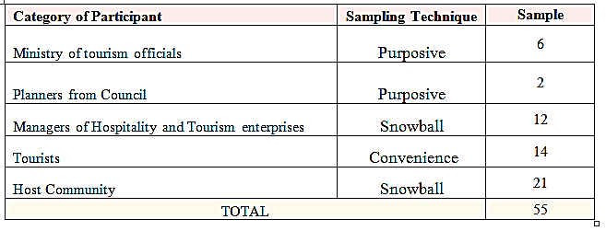
Source: Field survey, 2017

4.8. Data collection methods
Since this study is a qualitative research inquiry, qualitative methods of data collection were applied. Creswell (2009) explain that qualitative researchers typically gather multiple forms of data, such as interviews, observations, documents, and audio visual information rather than rely on a single data source. In addition, this view is buttressed by Cohen et al (2007) who put forward that each method checks and reinforces the other. Since qualitative research is closely associated with words, sounds, feeling, emotions, colours and other elements that are non-quantifiable, this study employed three qualitative data collection instruments which include the interview, Focused Group Discussions and observation check list.
(i) Interview guide
The interview method was employed in this study due to its ability to yield rich insights into people’s experiences, opinion, aspirations, attitudes and feelings about the research problem (Cohen et al, 2007) Furthermore, Bryman (2012:209) explains that the research interview is a prominent data collection strategy in both quantitative and qualitative research. Punch (2005:168) elaborates that “interview is one of the main data collection tools in qualitative research. It is a very good way of accessing people’s perceptions, meanings, definitions of situations and construction of reality”. Furthermore, Sharma (2010:4) says the interview method takes the form of a dialogue in which the researcher seeks to elicit information from the participant about how the latter thinks and know. The main advantage of personal interviews is that they involve personal and direct contact between interviewers and interviewees, as well as eliminate non-response rates. The objective of this research is to evaluate stakeholder’s participation in planning for sustainable tourism development. Thus, this requires in-depth information from each respondent. Burns and Bush (2010) explain that respondents in an in-depth interview are not influenced by other participants. Thus, this gave less bias in terms of data collection. In order to ensure the creditworthiness of the interviews through its flexibility as data gathering instruments as stressed by Sharma (2010), prior appointments were made and the participants were visited at their work places (Ministry of Tourism officials, Planners from the local Authority and managers of lodges) while tourists were visited at tourist sites to have face to face in- depth interviews. The study used in- depth interview to collect data from key informants, tourists and Tourism and hospitality proprietors. Three set of interview guide were used.
The interview guide (Appendix; A) collected data from Ministry of tourism officials and Local Authorities while the other set of interview guide (Appendix; B) collected data from Hotel/Lodge proprietors, Private tourist site proprietor and Tour operators while another set of interview guide (Appendix; C) collected data from tourists. Welman et al. (2005) explains that in- depth interviews offer versatile way of collecting data which allow an interviewer to use probes with a view of clearing up vague responses or to ask for elaboration of incomplete answers. Furthermore, Kombo and Tromp (2006) explain that interviews are good as they contain open-ended questions approach which enables a researcher to get a complete and detailed understanding of the issue under research. Thus for this study an interview guide was preferred because it enabled the researcher to probe deeper for more information and clarification of the answers provided. Furthermore, it also allowed each respondent to express his/her views, opinion, experience and feelings in his or her own words about the nature of their involvement in tourism planning.
(ii) Focus Group Discussions (FGDs)
Marczyk et al (2005) explain that Focus groups are formally organized, structured groups of individuals brought together to discuss a topic or series of topics during a specific period of time. FGDs have served as a principal method of qualitative research among social scientists for many decades. The presence of a trained moderator is critical to the focus-group process (Hoyle et al., 2002). As for this study, the researcher was the moderator during discussion sessions and guided the participants. In FGDs, participants are normally selected because they have certain characteristics in common that relate to the topic of the focus group (Mcmillan and Schumacher, 2010). Thus three (3) Focus Group Discussion were held to collect data from local community members in host tourist destinations to ascertain the level they are involved in tourism planning. As for Chishimba FGDs discussants were 6, Mwela rocks (Kungu Village) were 7 and Shiwangandu were 8. The age range was from 35 yrs to 60 and 9 women and 12 men participated in FGDs. A FGDs (Appendix; D) was used to guide the discussion. The researcher took notes of the proceedings of discussion. Since the 2015 tourism policy emphasize to involve local community, FGD was important as it empowered participants to speak out their own words whether they are involved in tourism planning or not. To build a positive rapport among the participants and encourage free participation of every participant, the researcher conducted the focus group discussions in a congenial environment (Village headman’s residence) for Chishimba and Mwela Rocks while in Shiwa Ng’andu it was held at Charles Harvey farm. Mcmillan and Schumacher (2010) stresses that creating a social environment in which group members are stimulated by one another perceptions and ideas, the researcher can increase the quality and richness of data through a more efficient strategy. The FGDs were done in Icibemba, the local language of the Bemba speaking people of Kasama and Shiwang’andu Districts. This allowed a researcher to pursue the topic by getting more detail during the FGD process as participants were able to express themselves and as a result a collective view/response on local community as tourism stakeholder’s participation in tourism planning was gathered. The participants were informed of the purpose of the study and were assured of confidentiality. The researcher led the FGD and frequently reaffirmed answers from the participants. Each focus group discussion took between 30 to 40 minutes. A recording of each FGD was done with permission from participants. Summaries of the focus group interviews were transcribed from digital sound records. Discussions on a particular topic continued until no further new opinions were expressed, after which the interviewer proceeded to the next question.
(iii) Observation checklist
In order to meet the requirements of triangulation in qualitative research, the researcher also used observation in addition to interviews. Degu and Yigzaw (2006:63) cited in Chawira (2017:168) have observed that an observation strengthens case study research because the researcher can observe not only the participants but also the environment. Similarly, Walliman (2011:101) says observations can yield information which the participants are normally unwilling to provide through interviews. This was very significant for the purpose of this study because the researcher was interested to understand more about tourism potentials and current level of development in selected tourist sites. Thus an Observation checklist (Appendix E) was used to check for available amenities and tourist products offered at tourist sites in order to ascertain the tourism potentials and current level of tourism development at Chishimba Falls, Mwela Rocks heritage site and Shiwa Ng’andu private tourist site using Butler’s area life cycle model ( Figure;3).

4.9. Data collection procedure
The researcher requested for a research permit from the Ministry of Tourism at Northern tourism circuit Regional office in Kasama. After granting of permission the researcher took introduction letter to the participating stakeholders to make appointment. The researcher then administered the research instruments such as Semi-structured interview guide to Ministry of tourism officials, Local Authorities, Tour operators, Tourists, Hostels Proprietors, Private tourist site proprietors and held Focus Group Discussions to Host community residents in tourist destination sites.

4.9.1. Primary Sources
Hox and Boeije (2005) define primary data as data that is collected for the specific research problem at hand using procedures that fit the research problem first. Thus, data from the primary source was collected through field trip visits to Ministry of Tourism offices, Tourism stakeholders, and host tourist destinations sites by applying personal interview, Focus Group Discussions (FGDs) and site observations check lists. Hox and Boeije (2005) explain that in a qualitative research design, the data collection strategy typically involves collecting a large amount of data on a rather small, purposive sampling using techniques such as in-depth interviews, participant observations or focus groups.

4.10. Data processing and analysis
Qualitative data was analysed using thematic and content analysis. The first step in the process of thematic analysis involved transcribing the data, coding and then clustering of data into categories according to objectives (Richards, 2009). On one hand, the analysis comprised discovering of themes and sub-themes, building hierarchies of themes and linking themes according to theoretical understanding of the problem (Ryan and Bernard, 2003). Finally, Anstein typology of citizen participation (Figure; 6) was used to ascertain the level of stakeholder’s participation in tourism planning. On the other hand, the level of tourism development at Chishimba falls, Mwela rocks and Shiwa Ng’andu was determined using Butlers area life cycle model (TALC) (Figure; 3).

4.11. Validity and Reliability of research findings
Studies in either quantitative or qualitative strive to attain reliability and validity of research results. Reliability refers to consistency or repeatability of research findings while validity concerns legitimacy, correctness, relevance and soundness of research findings (Ritchie and Lewis, 2003). For this study, validity and reliability of research findings was ascertained through triangulations as it provided a basis to overcome problems, weakness and limitations of methods adopted in the study. The use of multiple data gathering techniques to investigate the same phenomenon is defined as methodological triangulation, which is a process of mutual confirmation of measures and validation of findings (Berg, 2001). In this study, triangulations was done by collecting Data through multiple sources such as in-depth interviews, observations, Focus Group Discuss (FGDs) and application of theories and models to confirm and interpret the results.

4.12. Ethical Consideration
The researcher obtained an introductory letter from department of geography and environmental studies for introduction to research participants. The participants were informed of the purpose of the study and were assured of confidentiality. Permission was sought from each research participant before use of digital data capture gadgets such as camera and voice recorder. The information from the respondents was obtained without cohesion and verbal consent was sought from all respondents.

4.13. Summary
The chapter has provided the research methodology adopted in this dissertation and gives an outline and justification of the qualitative research approach, social constructivism as a philosophical underpinning taken for in the study. The chapter has discussed different types of sampling and data collection methods used through triangulation. Data was transcribed into themes and categories for further interpretation based on the research questions by thematic and content analysis.

CHAPTER: FIVE

PRESENTATION OF RESULTS

5.0. Introduction
This section presents the results of the study. Data presentation is in form of pie charts and tables with percentages. The findings of the study have been presented in five sections. The first section presents the demographic characteristics of the respondents. The second section presents tourism potentials and current levels of development of selected tourist sites in Kasama and Shiwa Ng’andu Districts. The third section presents the existing tourism planning process in Kasama and Shiwa Ng’andu Districts. The fourth section presents the level of stakeholder’s participation in tourism planning in Kasama and Shiwa Ng’andu Districts and the last section presents parameters which can increase stakeholder’s participation in tourism planning.

5.1. Demographic characteristic of respondents

5.1.1. Age of respondents
The age of respondents who participated in this study have been presented in categories as shown in table 2 below:
Table 2: Respondents age.
Age Cohort | Key informants  (n=8) | Proprietors/managers of tourism entity  (n=12) | Host community  (n=21) | Tourists  (n=14) | TOTAL  (N=55)
20-29 | -- | -- | 3 | 4 | 7
30-39 | 5 | -- | 5 | 1 | 11
40-49 | 3 | 1 | 5 | 6 | 15
Above 50 | -- | 11 | 8 | 3 | 22
TOTAL | 12.5% | 8.8% | 42.9% | 28.6% | 100

Source: Field Survey, 2017.
Respondents were asked to select their age cohort which was divided into four categories as indicated in table 2: It is clear that the largest age group of respondents is in the category of above 50 with 22 respondents which comprised proprietors of hospitality and tourism establishments, host community and tourists. The second age category of respondents was between 40-49 age with 15 respondents comprised of key informants, proprietors of hospitality and tourism establishments, host community and tourists. The third age category of respondents was 30-39 with 11 respondents comprised of key informants, host community and tourists and the least age category is 20-29 with 7 respondents comprising mainly of host community and tourist.

5.1.2. Gender of respondents
The gender of respondents who participated in this study have been presented in categories as shown in table 3 below:
Table 3: Gender of respondents
Gender | Key informants  (n=8) | Proprietors/managers of tourism entity  (n=12) | Host community  (n=21) | Tourists  (n=14) | TOTAL  (N=55)
Male | 7 | 11 | 12 | 10 | 40
Female | 1 | 1 | 9 | 4 | 15
TOTAL | 8 | 12 | 21 | 14 | 55
Source: Field Survey, 2017.
The disproportional ration in respondent’s gender is probably caused by the fact that the majority of managers and proprietors running tourism enterprise were men as evidenced in this study in which only 1-woman respondent representing 8.3% was running a tourism enterprise compared to 11 men representing 91.7%. On the other hand, this disproportional ratio was also exacerbated by the fact that in host tourist destination, many village committees also constitute of more men with less women. Among the key informants there were fewer women holding key position in government as compared to men, therefore contributing to the low representation of women participants in the study.

5.1.3. Tourist arrivals
Tourists who participated in this study have been presented in categories as shown in table 4 below:
Table 4: Tourist arrivals by Continent/country of origin
Tourist Place of Origin | Chishimba Falls | Mwela Rocks | Shiwangandu | TOTAL
Europe | 4 |  | 2 | 6
South Africa |  | 3 |  | 3
Australia |  |  | 1 | 1
Zambia (Domestic) | 2 | 1 | 1 | 4
TOTAL | 6 | 4 | 4 | 14
Source: Field Survey, 2017
Table 4 Shows tourists of different origins who were interviewed at Chishimba fall (n=6), Mwela rocks (n=4) and Shiwa Ng’andu (n=4). Only 14 tourists were interviewed because the flow of tourists from October to December was slow as it was not a peak season. The results show that fewer numbers of Domestic tourists frequent these sites, an indication that Domestic tourists are bored to see same kind of activities at these sites.
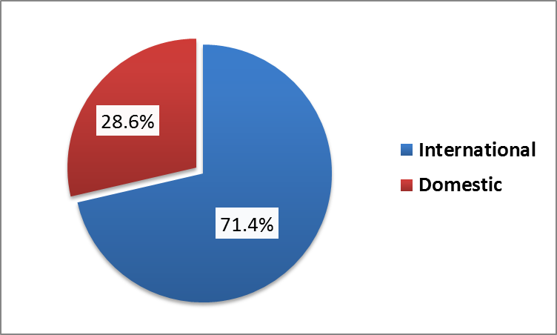
Figure 7: Categories of tourists
Source: Field Survey, 2017.
Figure 7 shows categories of tourist who visited Chishimba fall (n=6), Mwela rocks (n=4) and Shiwa Ng’andu (n=4). Majority of the 10 visitors were international tourists representing (71.4%) while Domestic tourists were the minority at 4 representing (28.6%). This indicates that very few Domestic tourists visited these sites as compared to international tourists at the time of research.

5.2. Tourism Potentials and Current Levels of Development

5.2.1. Identified Tourism potentials
The study revealed a number of tourism potentials at Chishimba Falls, Mwela Rocks and Shiwa Ng’andu which if fully developed could lead to an increase in tourism arrivals. When asked to name tourism potentials at various sites, the most notable tourism potentials stated by respondents was the cultural market, game viewing, art theater, archeological sites, boat cruising and hiking trail which have been explained in detail below:

5.2.1.1. Cultural Market
The results from interviews shows that cultural market was the most tourism potential which most tourist sites needed to introduce in order to increase tourist arrivals. Majority of respondents representing 58.8 % expressed the need to introduce a cultural market at tourist destination in order to add value addition. For instance, one proprietor noted:
Chishimba falls has a lot of potential if we can provide value addition by providing other packages at the falls it can increase resident and international tourist arrival. [Hotel and tourism Proprietor, 9th November, 2017].
Cultural market is viewed to be a driving factor which can make local community members to take part and benefit from tourism activities taking place. This was so evident by the local community members at Chishimba Falls who have been pushing to establish a local cultural market. For instance, the need for cultural market to be introduced at various tourist sites is necessary as evidenced by the significant number of people selling crafts and curios in streets of Kasama as shown in figure; 8 due to absence of cultural market.
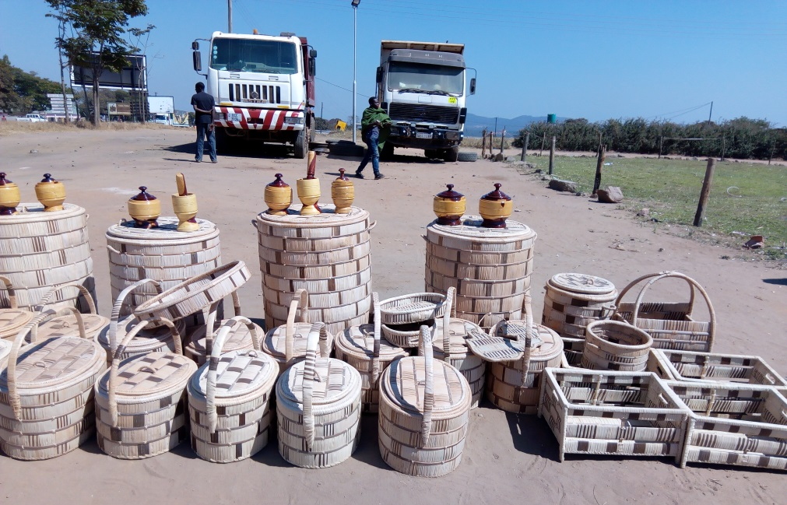
Figure 8: Curio and craft trade along Kasama-Mbala road in Kasama
Source: Fiel Survey (2017)
The results further showed that having a cultural market will increase tourist arrivals at Chishimba falls, Mwela Rocks and Shiwa Ng’andu. Respondents revealed that having a cultural market was important to change the outlook of the tourist site. The view is encapsulated by one participant during the focus group discussion where the discussant noted that:
Cultural market kuti chawama ukuti babika pa Mwela rocks apakuti bamona utuma traditional tumo tumo nama traditional food apakuti balya Bantu baleisa baisalyako ifyakula ifyo taba monapo
It’s important to introduce a cultural market at Mwela rocks so that visiting tourists can see certain traditional products and eat traditional foods which have never been seen by them [Focus Group discussion Participant, Mwela Rocks, 26th November, 2017].
Furthermore, the above view has been buttressed by a key informant from Ministry of Tourism official who also noted that:
There is need to put trading centres at tourist sites so that local people can showcase their products and selling without any charge so that they can benefit and this will encourage their participation. [Ministry of Tourism official, 13th, December, 2017].
In view of the foregoing, introduction of trading centres or markets will increase amount spent by international tourists at the site which in turn will increase local revenue and contributing to local economic development through sale and production of local crafts and local foods.

5.2.1.2 Art Theatre
The importance of drama and performing arts to the community and visiting tourist cannot be emphasized because it is a tool that can be used to educate people about their current conditions. During interviews with key informants, proprietors and tourists, 20.6% of respondents revealed that art theatre was another important tourism potential which can be provided within a tourism package in Kasama and Shiwangandu. Thus music, dance and other performing arts teach the society where society examines itself in a mirror. In addition, Theatre, dance and other performing arts teach the society to change people’s mindset of the way they view and act within the society. A key informant from ministry of tourism said…….
Both Chishimba falls and Mwela Rocks have potential for art theatre just to add value where we get musicians and make performances while people are watching the falls, they can be entertained. [Ministry of Tourism official, 27th October, 2017].
It was found that Kasama has potential for performing art like Kasama arts Zambia (Figure; 9) a locally performing art club which has been performing in Kasama but it seems lack of specific infrastructure where various art groups can perform has hampered the development of performing arts.
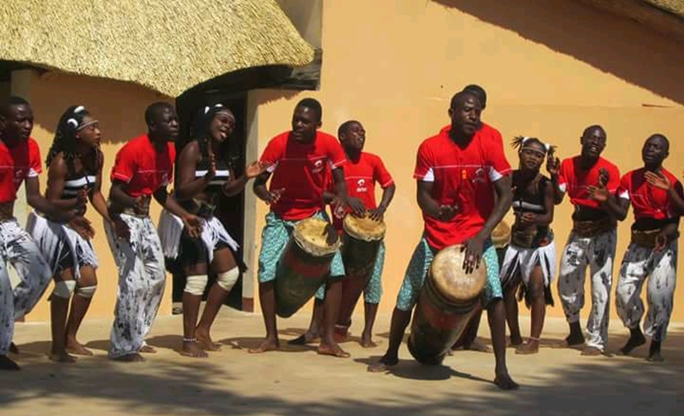

Figure 9: Kasama art theatre performing in Kasama
Source: Kasama arts Zambia (2013).
It is in these tourist destination sites in which power of African music and dance can be showcased at the art theatre. During interviews with key informants, proprietors and tourists the study revealed that introduction of art theatre will promote interaction between visitors and hosts and also helps the local residents to preserve their cultural heritage.

5.2.1.3. Promotion of Historical and Archeological sites
Archaeological sites and historic places are major tourist attractions worldwide and a source of revenue. Furthermore, archeological sites provide social, historical, educational, and economic potential to residents and international tourists. Out of 34 respondents, 11.8 % of respondents mentioned archaeological sites as another tourism potential for all tourist sites which if fully exploited, these archaeological sites can give opportunities for tourists to take part in excavations. A key informant from Ministry of tourism remarked that:
We have over 10 archeological sites and when we are talking about these specific sites they have a lot of potential like areas used for iron smelting. [Ministry of Tourism official, 13th November, 2017].
Furthermore, during Focus Group Discussion with host community members at Mwela Rocks heritage site, it was clearly stated that Mwela rock art has a lot of potential for various attraction such as additional paintings which are not known by National Heritage Conservation Commission. A discussant noted:
Kwaliba Namwenya, Mwankole, Selebuka, fyonse ifi tabafishiba ba Heritage. Bena baishibafye Mwela. Kanshi namayanda yatatu uko baleyikala ba mwela tabaishiba, tabapamona ba Heritage, balienda balinaka lelo teti mbalange.
There is Namwenya, Mwankole; Selebuka all these are not known by the National Heritage people, all they know about is Mwela rocks. Additionally, they don’t even know the three houses in which Mwela used to stay, Heritage have not seen that place and they have walked searching but they have failed and I can’t show them. [Focus group discussion Participant at Mwela Rocks, 26th November, 2017].
As expressed above by a participant during FGDs, this study revealed that host community members showed no interest towards tourism development by disclosing other potential sites because of frustration of not benefiting from revenue collected from tourists who visits the site.

5.2.1.4. Game viewing.
Another tourism potential which emerged from the interviews with 34 respondents was game viewing in which 5.9% of respondents were of the view that addition of extra tourism activities such as game viewing will add value to tourist sites which in turn will increase tourist arrivals. The idea of adding game viewing was more emphasized by respondents in Kasama who felt that a nature reserve will give an opportunity to tourists to view animals at Chishimba Falls and Mwela Rocks. One respondent noted that:
The other side of Chishimba falls can accommodate animals where visitors can also view animals apart from falls viewing [Hotel and tourism Proprietor, 15th November, 2017].
Thus, the introduction of non-predatory game animals can be of great benefit to the area and game ranch is a way of doing this.

5.2.1.5. Boat Cruising and Fishing
Boat cruises in Zambia are a familiar activity on its major lakes and rivers, especially on Lake Kariba, the Zambezi River and its tributary, Kafue River. During interview with key informants, hotel and tourism proprietors and tourists, 2.9% of respondents revealed that small boat cruising can be done at Zesco dam built below Chishimba falls. A key informant noted:
We also have dams there for ZESCO; those artificial lakes can be used for small boating and angling. (Ministry of Tourism official, 27th November, 2017).
Thus, small boat cruises at Zesco dam (Figure 10) down the stream have the potential to add value and will make a trip to Chishimba falls an exciting venture. This may increase the length of stay at the falls. Additionally, the study also revealed that boat cruise will also provide another best opportunity of watching Mutumuna falls especially during evening time.
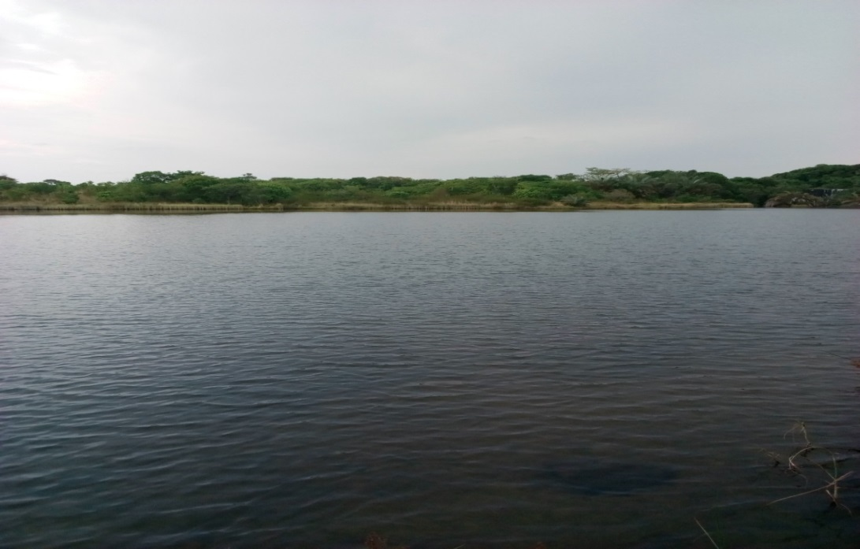
Figure 10: ZESCO dam at Chishimba fall in Kasama District.
Source: Field Survey, 2017.

5.2.1.6. Hiking trails
Hiking trails are exceptionally well suited to helping visitors become more physically active. During interviews with key informants, hotel and tourism proprietors and tourists, respondents revealed that Mwela rocks and Shiwa Ng’andu have potential for hiking trails owing to the geographical nature of these two sites having hilly landscape. During interview, a proprietor running a lodge noted that:
Looking at the landscape of this area, this place also has potential for hiking trails [Hotel and tourism proprietor, 13th December, 2017].
Furthermore, another key informant from Ministry of Tourism also noted that:
Mwela Rocks has potential for hiking trails and a lot of people who are dating usually visit Mwela rocks during weekends [Ministry of Tourism official, 20th November, 2017].
It was also noted in this study that despite host tourist destination having aforementioned tourism potentials; the potential has not been exploited despite government introducing many taxes which limit tourism and hospitality proprietors to exploit other tourism potentials as most of the profits was channeled to paying taxes of various kinds. This assertion has been buttressed by one respondent who noted that:
Potential is the most utilized word in Zambia, you can have a Benz but if it has no wheels, it can’t go anywhere. You can talk of potential and potential, this is the thing that makes me angry. What is happening is taxation and taxation, where does the money go? [Hotel and tourism proprietor, 23rd, December, 2017].

5.2.2. Levels of Tourism development
The study evaluated the level of tourism development at Chishimba falls, Mwela Rocks and Shiwa Ng’andu using Butlers area life cycle model (TALC). The study checked on amenities and products offered at these sites.

5.2.2.1. Levels of Tourism development at Mwela Rocks heritage site.
The level of tourism development at Mwela Rocks site is low owing to the site lacking any meaningful supporting infrastructure and limited tourism activities. In this regard, Mwela Rocks site during field observation exhibited that it is at Exploration stage in terms of tourism development according to Butler’s classification of area life cycle model. Despite the site being within 5 km from CBD of Kasama town along tarred Kasama Mungwi road, the site only offers rock art as the only tourism package. Tourists visit the site just to see the rock paintings as it’s the only tourist activity at the site. At the time of field work, the site has no visitor information centre and the site does not have brochures to explain the paintings.
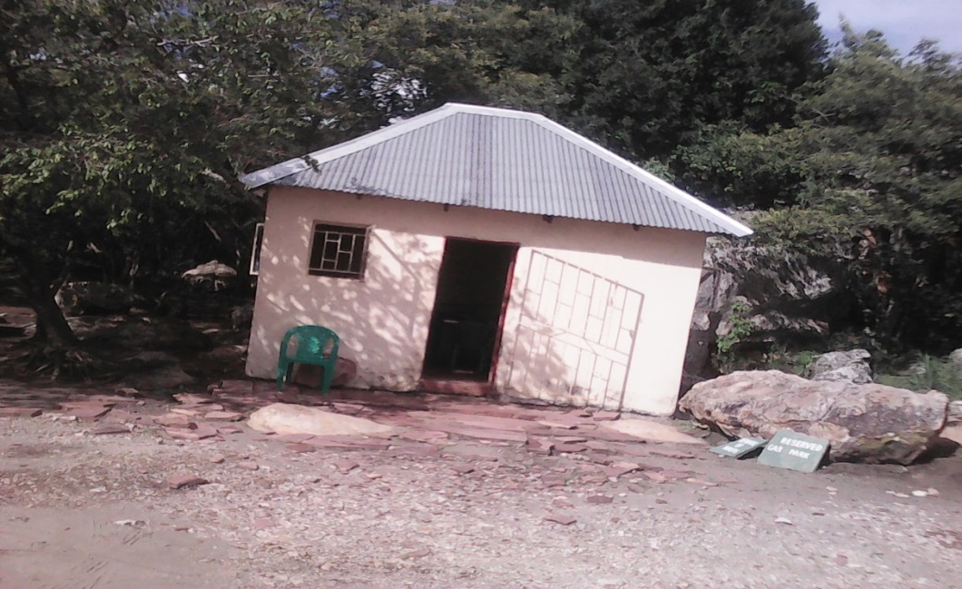
Figure 11: Entry point shelter at Mwela rocks.
Source: Field Survey, 2017.
Figure 11 depicts the kind of infrastructure found at Mwela Rocks site. This shelter acts as an office for six (6) guides employed by the Ministry of Tourism under the National Heritage Conservation Commission. The proximity of Mwela Rocks to the CBD of Kasama town makes it a potential site for a cultural market, art theatre and game viewing for entertainment during weekends. Furthermore, most tourists who visited Mwela Rocks site expressed unsatisfied with the products and services provided but promised to come back because the site has a lot of paintings which they could not visit owing to busy schedule of their planned holiday especially for international tourists.
Furthermore, the study revealed that the average length of stay at Mwela Rocks is one (1) day (a day trip) because the site lack other tourism activities to necessitate longer stay and the main reasons of tourists found visiting the site was because it was a planned holiday for international tourists while for domestic tourists it was mainly for business but they took off time to visit the site. Furthermore, the study revealed that international tourists found visiting Mwela rock art used camping in order to spend a night while domestic tourists did not spend any nights (day trippers). In terms of entry charges, domestic tourists pay ZMW18 for adults, ZMW 4 for children, ZMW5 for vehicle while camping they only pay ZMW 33. As for international tourists, adults pay U$$ 15, children pay U$$ 5, and vehicle entry is U $$ 7 while camping is U $$15. In view of this, International tourists considered the charges paid for various activities as not being competitive as they felt they were too expensive while domestic tourist felt the charges were competitive as they were affordable. Tourists were further asked whether they had bought any curios at the site and the study revealed that both international and domestic tourists did not buy any curios because there were no curios to buy. Thus using Butlers Area Life Cycle Model, Mwela Rocks is at Exploration stage in terms of levels of tourism development.

5.2.2.2. Levels of Tourism development at Chishimba falls
The results of the study revealed that the level of tourism development at Chishimba falls site is still low despite the site being ranked third in terms of tourist arrivals after Victoria Falls. Before the creation of Embassy Park which is ranked second after Victoria Falls in terms of tourist arrivals, Chishimba falls used to be ranked second until 2015 when it was relegated to third place. During field observation, the study revealed that the site has a functional visitor information Centre which has documented what the site offers as shown on Figure 12.
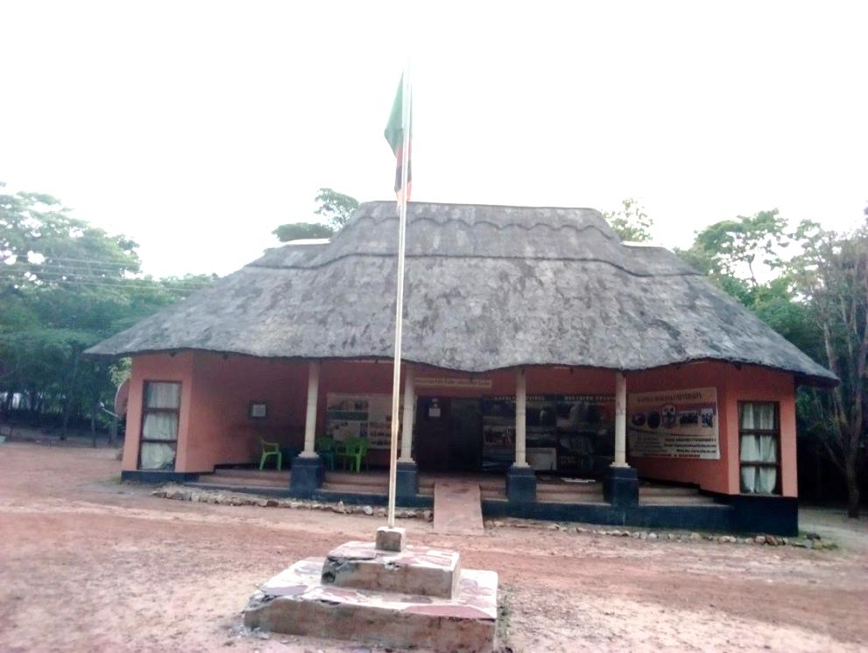
Figure 12: Visitor information Centre at Chishimba Falls, Kasama district.
Source: Field Survey, 2017
It was found that the average length of stay at Chishimba falls is one (1) day because of lack of other tourism activities to necessitate longer stay at the site and the main reasons given by tourists for visiting the site was because it was a planned holiday for international tourists while domestic tourists mainly came for business but took time off to visit the site. In addition, the study found that visitors are serviced with food and drinks at the restaurant (Figure 13) located within the vicinity of the falls.
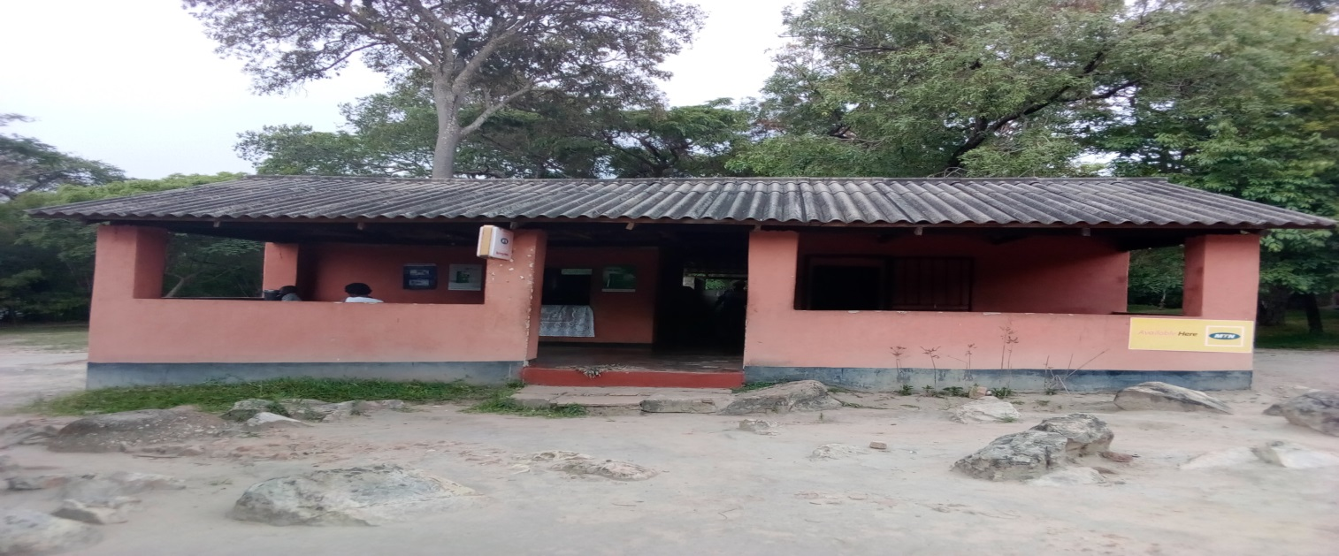
Figure 13: A restaurant at Chishimba Falls, Kasama district
Source: Field Survey, 2017
Moreover, the study revealed that both international and domestic tourist found visiting at Chishimba falls did not spent a night. Furthermore, the results of the study revealed that 83% of tourists who visited Chishimba falls expressed dissatisfaction with products and services but promised to come back because of the magnificent nature of three successive falls. This was evident to Lovos tourists who usually have four planned regular visits to Chishimba Falls every year before proceeding to Tanzania and Kenya.
The results of the study revealed that despite the magnificent beauty of Chishimba falls which boast of its three successive falls, the site lacked meaningful supporting infrastructure and had limited tourism amenities. The results from interviews, Focus group discussion and field observation revealed that there is some aspect of local community participation in the provision of services to tourists such as accommodation (Figure; 14) and a restaurant (Figure; 13). However, the participation in the provision of services is very minimal. In terms of entry charges both domestic and international tourists pay same charges as those at Mwela Rocks. In view of this, international tourist viewed charges paid for various activities were not competitive as they were too expensive while domestic tourist felt the charges were competitive as they were affordable. Tourists were further asked whether they bought any curios at the site and the study revealed that both international and domestic tourists did not buy any curios because they were not sold at the site.
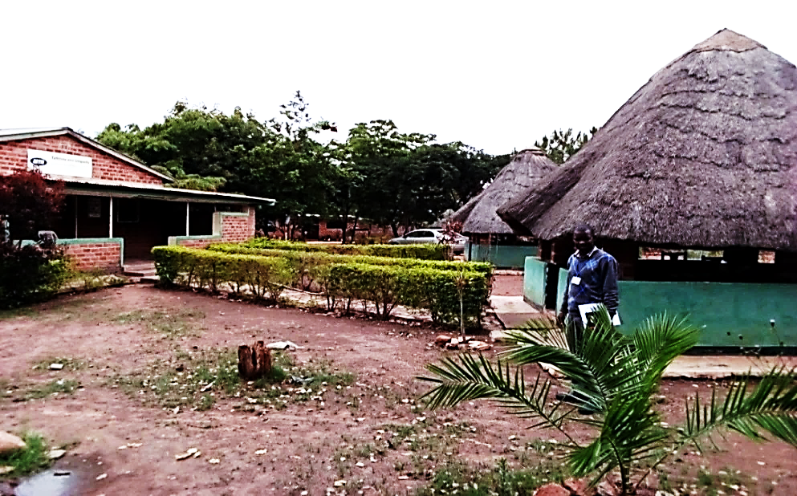

Figure 14: Locally owned Kaela guest house near Chishimba falls.
Source: Field Survey, 2017
In this regard, Chishimba falls exhibited that it is at Involvement stage in terms of tourism development according to Butler’s classification of area life cycle model. However, despite Chishimba falls being is at Involvement stage, the involvement of local community in the provision of services to tourists is still very minimal.

5.2.2.3. Levels of Tourism development at Shiwa Ng’andu.
The results of the study revealed that despite Shiwa Ng’andu offering a diverse of tourist packages to tourist the level of tourism development at Shiwa Ng’andu tourist site is still low owing to poor road connectivity to the site. The dilapidated manor house (Figure; 15) has five (5) rooms which houses overnight tourists.
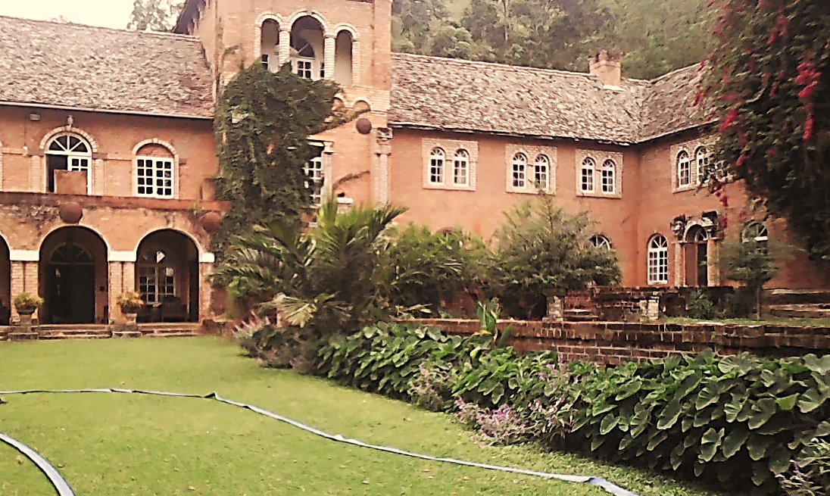
Figure 15: Manor house at Shiwangandu
Source: Field Survey, 2017
However, Shiwa Ng’andu site also boasts of the famous Kapishya hot spring lodge which offers good standards services to tourist. The study revealed that most international tourist visiting Shiwa Ng’andu like spending night at Kapishya hot spring lodge due to its modern infrastructure of international standards such as swimming pool (Figure; 16). The average length of stay at Shiwa Ng’andu was found to have been three (3) days because the site has a variety of tourist activities and the main reasons for tourists found visiting the site was because it was a planned holiday for international tourists while domestic tourists had mainly come for business but took time off to visit the site for a day. The study revealed that international tourists used Kapishya hot spring lodge and Manor house for overnight stay while domestic tourists did not spend any nights. In terms of tourist products and services, the study revealed that Shiwa Ng’andu offers game viewing, horse safaris, historical manor house tours, boat cruising, accommodation, spa, transport, cycling/quad biking and water rafting.
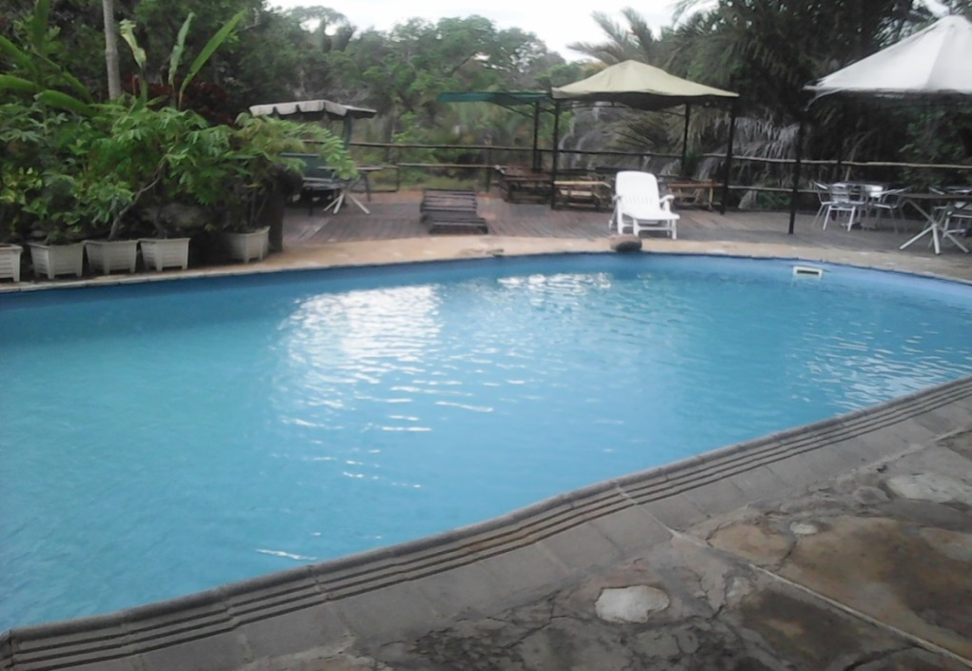
Figure 16: Swimming pool at Kapishya hot spring lodge
Source: Field Survey, 2017.
In this regard, Shiwa Ng’andu tourist site exhibited that it is at the Development stage in terms of tourism development according to Butler’s classification of area life cycle model owing to fact that an investor has developed the site and a variety of tourist amenities and activities are offered to tourist. The site is at development stage owing to benefits to local communities such as employment in tourism related activities and other benefits accrued from entrance earnings which have trickled down to local people such as building a school and a clinic (Figure; 17) which is serving the community which can be said to be a form of corporate social responsibility (CSR).
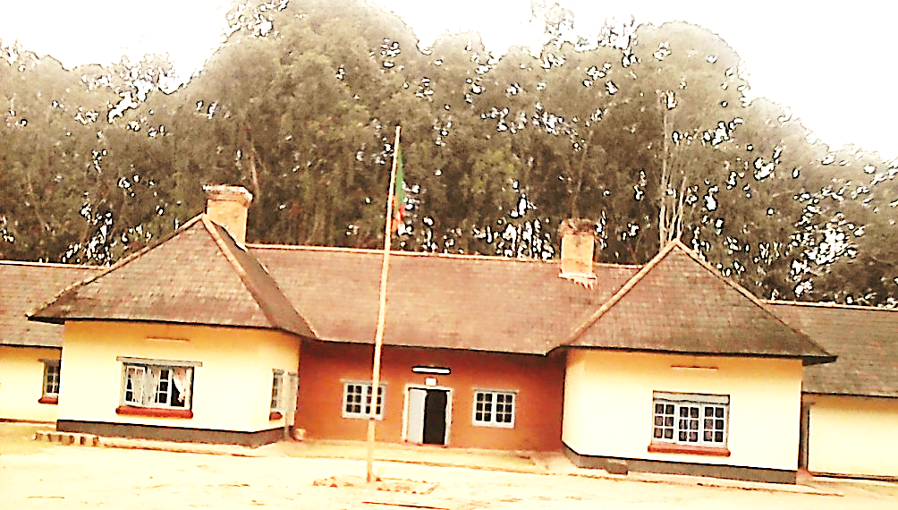
Figure 17: Local clinic serving local people within Shiwa Ng’andu tourist site.
Source: Field Survey, 2017.
Furthermore, the study revealed that both international tourist and domestic tourists viewed charges paid for various activities as too expensive. Tourist were further asked whether they bought any curios at the site and the study revealed that both international and resident’s tourists did not buy any curios because they were not sold at the site.
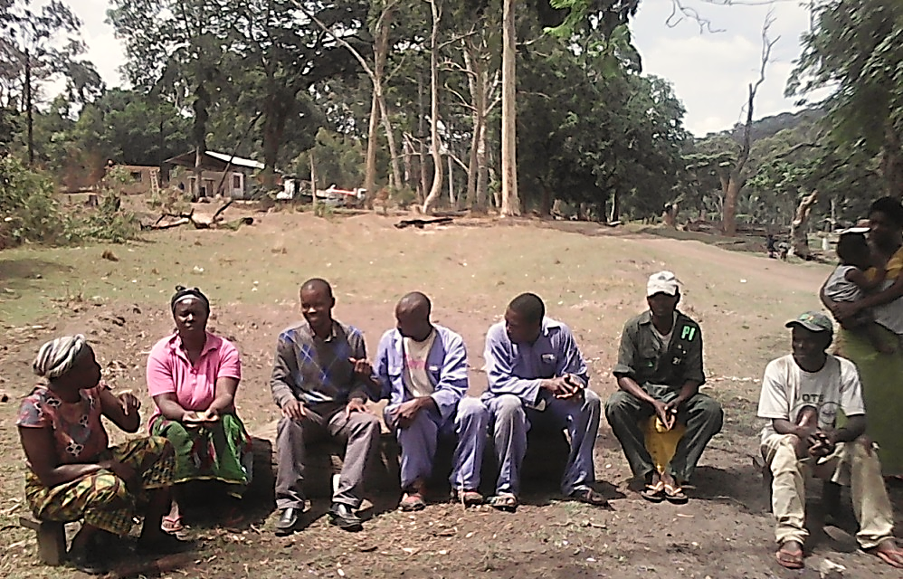
Figure 18: The researcher conducting a Focus Group Discussion
Source: Field Survey, 2017
Figure 18 shows a group of local community members who are employed at Shiwa Ngandu tourist site and participated in FGDs. Shiwa Ng’andu can be characterized as being at development stage because tourism proprietors are able to employ about 10 temporary workers during peak season of which most of these workers are wives and children of farm workers from the local community. The results of this study further reveals that tourism proprietors in Kasama district do not employ temporary workers during peak season because of poor business and the total number of people working in tourism and hospitality establishments were 67 of which 47 are female while 20 are male indicating that the majority of workers in hospitality industry are female. Salaries vary drastically among different job positons. Salaries range from 1,500 ZMK (lowest average) to 5,500 ZMK (highest average). The results of the study further revealed that most tourism establishments in the study area are registered with Ministry of Tourism.

5.2.5.4. Factors contributing to slow growth of tourism development in Kasama and Shiwa Ng’andu.
During interviews with key informants, factors which impede tourism development emerged as low investment, poor marketing strategies, limited tourism packages and poor connectivity among sites. These are explained in detail below.

5.2.5.4.1. Low investment in infrastructure
Tourism infrastructure is the basis of tourism development and utilization of existing destination resources. When asked to explain factors which have contributed to the slow growth of tourism development, key informants thought that low investment in the tourism infrastructure sector has made the tourism industry not to grow. When asked further to explain what kind of investment is lacking, respondents mentioned lack of supporting infrastructure such as hotels and other accommodation facilities which inhibit the region from hosting big international conferences. One respondent noted that:
There is lack of supporting services such as health services which can guarantee tourist health [Hotel and tourism Proprietor, 27th December, 2017].
Furthermore, another key informant also noted that:
Chishimba needs a lot of infrastructure development because what it has cannot warrant visitors to stay longer there [Ministry of tourism official, 17th November, 2017].

5.2.5.4.2. Poor Marketing strategies.
In any business, a solid marketing strategy is critical to brand, attracting new customers and maintaining loyalty. The hospitality and tourism industry is no different. However, this study reveals that, poor marketing strategies came out as another factor affecting the growth of tourism industry. Managers of hospitality and tourism proprietors were asked to state means used to market their products, the results of the study revealed that most tourism enterprises do not advertise but used service quality (word of mouth) in itself as the advert to customers, while others use brochures and radio adverts but at minimal level. Furthermore, key informants revealed that Zambia Tourism Agency (ZTA) has failed to market the tourism potential which exists in the Northern tourism circuit. A key informant from Ministry of Tourism noted that:
Lack of awareness has been hampered by poor marketing strategies. For instance last year we have not seen any Zambia National Broadcasting Cooperation crews or Zambia Tourism Agency representatives coming to document what the site can offer and those documentaries they are using are very old [Ministry of Tourism official, Chishimba falls, 20th, November, 2017].
Furthermore, a domestic tourist at Mwela Rocks also noted that:
Information is not adequate, mapping of the site is not there, signage is very poor, labelling of trees is not supposed to be done like that, the labels must be very clear, so if visitors are not given enough information, it becomes difficult [Domestic tourist at Mwela rocks, 16th, December, 2017].

5.2.5.4.3. Poor connectivity among sites.
Connectivity is an essential element to make destinations more accessible to tourists. However, this study revealed that poor connectivity among sites was another factor affecting the growth of tourism in the districts. This problem was making difficult to access may sites. A key informant during interview observed that:
Tourism is greatly affected by the quality of roads to the sites. Most of the roads are bad and this has negatively affected tourism growth [Ministry of Tourism Official, 23rd October, 2017].
The study further revealed that lack of a national airline has really hampered the growth of tourism as sites which can’t be accessed by air transport are rarely visited by tourists. It was also revealed that Proflight Zambia used to operate at Kasama airport but due to the ongoing upgrade of Kasama airport, Proflight Zambia suspended flights to Kasama. A respondent noted that:
Absence of good roads to tourist attractions. For instance if you land at Kasama airport, reaching Lumangwe falls is a challenge due to poor roads [Lodge and tourism proprietor, 16th November, 2017].

5.2.5.4.4. Limited tourism products
Offering a variety of tourist products at the destination provides a very good competitive advantage and at the same time it enhances increase in profits and attracts more tourists to visit the site. However, for this study, it came out clear from respondents that there is limited provision of tourism products especially at Mwela Rocks and Chishimba Falls which has affected the growth of tourism at these two sites. Tourists were asked whether they had bought any curios and the results of the study revealed that none of the tourists who visited destination sites bought any curios. A respondent noted that:
There is nothing sold, generally the place has potential for such amenities but the area is poorly maintained, advertised and limited products [Domestic tourist at Mwela Rocks, 13th January, 2018].

5.3. Existing Tourism Planning Process
The study sought to examine the existing process of tourism planning. Furthermore, this objective sought to understand whether the existing process of tourism planning can enhance sustainable tourism development and if not propose an alternative process of planning for attainment of sustainable tourism development.
Key informants were asked whether planning for tourism development exists in Kasama and Shiwa Ng’andu District. Respondents affirmed that planning for tourism exists. When asked further to explain the existing tourism planning process, it was found that the existing tourism planning process is a centralized “Top down planning” process. The study demonstrated that tourism planning process is fragmented as key informants from different departments in the Ministry of Tourism expressed disjointed views in respect to the nature and tourism planning process. For instance some departments in the Ministry of Tourism revealed that tourism planning is done at Ministry of Tourism and Arts headquarters in Lusaka while other departments felt they receive funds and plan on tourism activities for the region. However, key informants revealed that the provincial administration at the office of permanent Secretary drives the planning and development of tourism under the Provincial Planning Unit (PPU). One key informant noted that:
Planning at National Heritage Conservation Commission is done at National level and when they plan that’s when it comes at province and then it comes to the sites for implementation [Ministry of Tourism Official, 26th October, 2017].
Furthermore, another key informant noted that:
Tourism planning is done at provincial administration where there is a vault for tourism development fund for tourism development. When people talk about decentralization, it is easy to talk on paper but implementation is a challenge. Here tourism department has not been decentralized, we are still at regional level and there is a very big gap and it will not be easy to develop tourism [Regional Tourism official, 20th October, 2017].
In terms of attainment of sustainable tourism development, the study revealed that the current Top down tourism planning process which is currently in operation cannot enhance sustainable tourism development due to the fact that major decision making process excludes key stakeholders. Another key informant noted that:
Any planning process which is either done at the national or province is a disaster because majority of stakeholders at local level who really face these challenges may resist what comes but sometimes they may accept because it’s a government decision [Ministry of Tourism official, 30th October, 2017].
Furthermore, when asked to propose an alternative tourism planning process which can enhance sustainable tourism development, key informants proposed a bottom up decentralized tourism planning process as an alternative tourism planning process to top down. The decentralized and bottom up tourism planning process is viewed to increase stakeholders participation in tourism planning and development as the process will be driven at local level as opposed to top down which seem to exclude a number of key stakeholders. A key informant from National heritage conservation commission noted:
We need a decentralized system and I think there is a local government decentralization policy and if you look at this policy it encourages local participation and if that can be done at local level, it can cut on bureaucracy and we can invest on what is appreciated by the local people instead of implementing programs, ideas planned a thousand miles away, so if the system was to be decentralized at least provincial and district level it can be of help to us[Ministry of Tourism official, 2nd November, 2017].

5.4. Levels of Stakeholders Participation in Tourism Planning
The study evaluated the level of stakeholder’s participation in tourism planning using Arnstein’s typology of citizen participation.

5.4.1. Tokenistic participation
The results of the study shows that the level of stakeholder’s participation in tourism planning was more of tokenistic (minimal) according to Arnstein typology of citizen participation. Consultation and attending a meeting came out to be the most means government engage tourism stakeholders. A proprietor running a lodge showed the researcher a letter (Appendix,6) from the permanent Secretary which he was invited for a consultation tourism development meeting and noted that:
For me Iam actually for the opinion that we are consulted, I have proof and evidence that government consults us as stakeholders when formulating the national policy and everything related to tourism especially for the Northern tourism circuit [Lodge and tourism proprietor, 21st November, 2017].
Key respondents were asked who should make decisions in terms of tourism development. Majority of respondents said that the decision process must be a collaboration one between government and all tourism stakeholders. It came out clear from respondents that making of decision in respect to tourism development cannot be left in one particular stakeholder to decide. A key informant from regional tourism office noted:
It should be a joint effort involving government, the private sector and local communities [Ministry of Tourism Official, 22nd November, 2017].
Respondents were also asked whether they were aware that the current 2015 Tourism Policy and 2015 Hospitality and Tourism Act demand that stakeholders must be involved in tourism planning, project implementation and development of tourism. The study reveals that the majority of key respondents answered in the affirmative. However local communities in host tourist destination responded that they were not aware that the Policy and Tourism Act says so. Concerning community participation, a discussant from Chishimba Focus Group Discussion noted that:
Tapaba abatweba kanshi tatwaishiba nangu chimo
No one has informed us; in this regard we don’t know
Anything [Focus Group Discussion Participant at Chishimba village, 16th December, 2017].
In terms of making suggestions towards development of tourism, most participating stakeholders revealed that they make suggestions through associations such as Hotel and Catering Association of Zambia (HCAZ) and Tourism Council of Zambia (TCZ). However, the study revealed that despite making these suggestions to government, government usually does not implement what stakeholders suggest. One participant noted that:
As stakeholders we suggest to government to grade lodges but the government is very slow to implement stakeholder’s submissions. For me since I worked in government as Permanent secretary, the problem of government is to periotize. The implementation has failed due to government lack of prioritising. [Hospitality and tourism proprietor, 23rd December, 2017]

5.4.2. Passive or Non-participation
Furthermore, the results of the study revealed few element of passive (non - participation) in tourism planning process exist. This came out when participants were asked if government involve them in tourism planning and development of tourism. One respondent observed that:
I have not seen any Zambia Tourism Agency (ZTA) official for the last 10 years to visit me and ask me what should be done in terms of tourism development [Hospitality and tourism proprietor, 2nd November, 2017].
In contrast, another respondent noted:
Government does not consult every stakeholder and government choose who to consult because some stakeholders lack necessary knowledge [Hospitality and tourism proprietor, 8th November, 2017].
In terms of rating stakeholder participation in planning and decision-making process in respect to tourism development, the study revealed that the participation was low and minimal as most decision making and project implementation is entirely done by the government. On the other hand, tourists were not asked on how best to improve services at destination site. Furthermore, the study revealed that most stakeholders running tourism enterprises blamed government for not involving them towards coming up with Tourism Levy Statutory Instrument (SI) 35 of 2017. Most respondents revealed that the trickledown effect goes to customers through increase in charges. A respondent noted:
We are not consulted in any way, just recently we received a statutory instrument signed by the minister which request lodges to contribute 1.5% on what they realise from accommodation and conferences. We just received information that we need to pay every month [Hospitality and tourism proprietor, 24th November, 2017].
The results of the study further revealed that despite local Authorities given mandate in the Urban and Regional Planning Act. No. 3 of 2015 to plan for tourism development through an Integrated Development Plans (IDPs), Kasama Municipal Council (KMC) and Shiwa Ng’andu District Council (SDC) do not have an IDP an avenue where various tourism stakeholders could be involved in planning and development of tourism. For instance a planner from Kasama Municipal Council noted:
Not only through IDP preparation, but there is some aspects of planning for tourism at the province not only in Kasama but at the province. But it is not mandatory that in the absence of IDP then tourism should not take place. I don’t think there is any tourism planning at the Local Authority; the tourism sector is managed by the Ministry of Tourism and Arts [Local Authority Planner, 8th January, 2018].
Furthermore, the study revealed that Local Councils do not engage tourism stakeholders running hospitality and tourism entities in decision making process and this came out strongly as most stakeholders complained of too many taxes levied to them by both Ministry of Tourism and Local Councils. A respondent in Shiwa Ng’andu noted that:
For instance here in Shiwa Ng’andu, we need a Local Authority to involve us. Where is the decentralization policy? [Hospitality and tourism proprietor, 23rd December, 2017]

5.5. Parameters That Can Increase Stakeholder’s Participation in Tourism Planning
The study set out to identify parameters that can increase stakeholder’s participation in tourism planning and development process and the results of the study shows the following factors as important parameters that needed to be strengthened in order to promote stakeholders participation in tourism planning and development process;
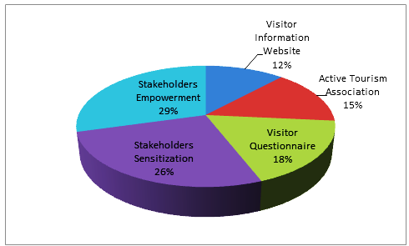
Figure 19: Parameters for increased stakeholder’s participation in tourism planning.
Source: Field Survey, 2017.
Figure 19 Shows responses from interviews with key informants, hospitality and tourism proprietors and tourists and the results shows that Stakeholders empowerment representing was mentioned as the most effective parameter which can increase stakeholder’s participation in tourism planning. Other parameters for increased stakeholder’s participation were stakeholder’s sensitization, having a Visitor questionnaire, having active tourism association while having a Visitor information website came out as the least parameter.
When discussing parameters which can increase their participation in tourism planning, local community members in host tourist destination disclosed that they were willing to participate in tourism related activities if they are allowed to make a cultural market which will be a form of empowerment to them. One participant during a FGD at Chishimba Village noted that:
Ifwe nga abekala mushi muno mu Chishimba twaliyanshika ukuti tuipangile market apo kuti twashitisha ifyakubasa lelo ubuteko bwalitukanya bufwaya ukuti tuleshitisha mukati mu heritage. Nomba ifwe tulelomba kubuteko ngachakuti batusuminisha ifwe abekala mushi ukupanga cultural market iyi ekututungilila ukukalamba kabili kuti chatusansamusha ukuyibimba mumilimo iyabuteko iya kutungilila iyi tourism mulelanda
As local people of Chishimba, we have planned to set up a cultural market so that we can be selling some crafts and curios but the government has objected to our proposal but governments want us to be selling inside heritage area. As local people we plead to government to consider allowing us setting up a cultural market as this will be the greatest empowerment which will enable people to willfully engage and participate in various programs of tourism development. [Local Male participant, Chishimba village, 16th, December, 2017].
However, at Mwela rocks heritage site during Focus Group Discussion, participants disclosed that informing them in everything the National Heritage intends to do was important and a woman discussant noted that:
Kabili ifwe tulelombako ku buteko tulefwaya ukuti baletuchinkulako kufyo filechitika kabili ngatabaletweba tapali ifyo tungampana nabo
We appeal to government to be informing us on what is happening because if they are not informing us, collaboration with government is difficult. [Local female, participant, Mwela rocks, 26th November, 2017].

5.6. Chapter summary
This chapter has explored that the main tourism potentials at Chishimba falls, Mwela rocks and Shiwa Ng’andu were having a cultural market, game viewing, art theatre, boat cruising and hiking trails. The chapter has highlighted that tourism planning process follows a top down centralised tourism planning process and the level of stakeholder’s participation in tourism planning process is tokenistic (consultation) and passive participation. The chapter has further highlighted that stakeholder’s sensitization, stakeholder’s empowerment, active tourism associations, provision of visitor questionnaires and having a visitor information website are parameters which will increase stakeholder participation in planning and development of tourism.

CHAPTER: SIX

DISCUSSION OF RESULTS

6.0. Introduction
This section discusses the results of the study while comparing it with previous studies. The results of the study have been discussed in four sections as follows: The first section discusses tourism potentials and current levels of development in selected tourist sites in Kasama and Shiwa Ng’andu Districts. The second section discusses the existing tourism planning process in Kasama and Shiwa Ng’andu Districts. The third section considers the level of stakeholder’s participation in tourism planning in Kasama and Shiwa Ng’andu Districts and the last section discusses parameters which can increase stakeholder’s participation in tourism planning.

6.1. Identified tourism potentials
Cultural market came out to be the most popular product with tourism potential in all the three sites. It is imperative to state that the establishment of cultural markets at various tourist sites as emphasized in this study will add value, create authenticity and distinctiveness at various tourist destinations as cultural markets will be able to connect host community and visitors to local cultures. Keovilay (2012) findings noted that the presence of cultural tourism in the village of Nalan and Nam Eng in Luang Namtha Province, Lao PDR had not only improved the local communities life quality through selling of crafts to tourists, but the local communities of Nalan and Nam Eng felt also that tourism had a positive impact on the promotion and revival of local culture and traditions. Thus the involvement of the local communities in the provision of tourism services through curio trade at the tourist destination site is an important factor for visitor satisfaction and further forms as a catalyst and prerequisite for products development as a number of local communities will benefit through curios trade which will be a source of livelihood. This study further argues that the presence of art theatre infrastructures at host tourist destinations will add value to the tourism industry as it will enhance tourism arrivals since entertainment of various kinds will be performed in which visitors will have a variety of options for leisure apart from the usual package which the site offers. This assertion has been buttressed by GRZ (2017) which has emphasized on the development of arts and culture infrastructure to improve the contribution of the country’s unique natural and cultural heritage to diversify the tourism product. This study argues that the development of cultural market centres at tourist destinations will improve income among the locals as well as reducing conflict of site management between the host community and government. The conflict that exist between host community and government can be reduced through community sensitization and initiating community developmental projects to benefit the community and dialogue. At Chishimba village the conflict of who to manage a cultural market at Chishimba falls emerged. It is imperative to state that the conflict that exist between host community and government can be reduced through collaboration which will foster dialogue between host community and government. Additionally, initiating community developmental projects to benefit the community will reduce conflict. This view has been supported by Purbani (2017) who has explained that collaborative planning is a new paradigm of planning for a complex contemporary society which usually mediates conflicts between parties through consensus-building processes. It encourages people to be engaged in a dialogue in a situation of equal empowerment and shared information. On the other hand, the development of archeological sites into full tourism activity is necessary because archaeological sites have great social, cultural, and economic value. This calls for the Ministry of Tourism through National Heritage conservation commission to collaborate with local communities to reveal all archeological sites so that the existing archeological sites can be developed. It has been observed in this study that local communities have a lot of knowledge on archeological sites and since time in memorial local communities have been taking care of these sites which are not known by the government and lack of collaboration may hinder the exploitation of archeological sites into meaningful tourist attraction areas. The findings, thus, reinforces Healey (1997) Collaboration planning theory which advocate trust among stakeholders triggers for joint operation of stakeholders in achieving a particular purpose. This means that without proper collaboration between local community members and Ministry of tourism officials, conflict may rise which may affect the growth of tourism.
This study further show that game viewing has potential at Chishimba Falls and Mwela rocks which if full developed could provide a variety of activities to tourists. For instance the presence of ZESCO dam at Chishimba Falls present the best game viewing opportunities as tourist do boat cruise, they will be able to view animals and birds on the western side of the water fall as the site has birds and animals such as monkeys. It is worth noting that non-exploitation of the available forests for wildlife and birds reserve at Chishimba Falls and Mwela Rocks may hinder the development of tourism as the site may experience decline stage of Butlers (1980) area life cycle model (Figure 3) due to lack of variety of tourist activities at the sites which in turn may affect tourist arrivals.
Owing to the presence of ZESCO dam at Chishimba Falls, This study argues that the introduction of boat cruising at Chishimba Falls ZESCO dam will add value as cruise tourism is one of the fastest growing segments in the tourism industry and can make a significant contribution to a destination’s economy by increasing the average length of stay to cruise tourists. The finding, thus, reinforces ZDA (2014) assertion that the Northern part of the country is endowed with water resources and these water resources provide opportunities such as boat cruises, canoeing river boarding, jet boating, white-water rafting. It is therefore important to state that the potential for small boat cruising at Chishimba Falls ZESCO dam may additionally influence other tourism activities like angling during boat cruises which may increase tourism revenue to the state as well as increasing the average length of stay from the current 1 day to 2 days because the site lack additional services to enable visitors stay longer.
Hiking trails was identified as tourism potential mainly at Mwela Rocks and Shiwa Ng’andu tourist sites due to the hilly terrain of these two sites. This study argues that the development of hiking trails will increase tourism arrivals more especially international tourists who in most cases like hiking trails as they love to experience nature. In addition, due to great diversity of visitors who visit tourist sites, some visitors may want to explore nature outside the normal tourist attraction at the site but may desire to explore nature as a way of doing exercise and relaxing through mountain climbing and the absence of hiking trails in areas like Mwela rocks and Shiwa Ng’andu may not satisfy some visitors and as such it is important that such tourism potentials are exploited for value addition, job creation, increased opportunities for guests to spend their money. The results of this study are reinforced by Mnguni and Giampiccoli (2017) study findings which stressed that rural trails or heritage routes has been used, particularly in the context of promoting rural tourism routes seem to be a particularly good opportunity for the development of less mature areas with high cultural resources that appeal to special interest tourists, who often, not only stay longer, but also spend more to pursue their particular interest.

6.1.2. Levels of tourism development
The level of tourism development at Mwela Rocks was assessed to be at ‘Exploration stage’ of Butlers (1980) area life cycle model. Despite the fact that Mwela Rocks are 5km away from Kasama^{’s} CBD which could have given its potential to attract investment, the site has no supporting infrastructure and as such visitors visit Mwela Rocks just for its nature of Bushmen paintings and this further explains that people just visit Mwela Rocks just for exploration purposes. The current state of affairs which has been exhibited at Mwela Rocks is worrying considering the potential which Mwela Rocks has to offer but the potential such as cultural market go to waste without exploitation. Thus the proximity of Mwela rocks near the CBD of Kasama presents a great privilege for the development of curio trade to both international and domestic tourists if a cultural market like the one at Victoria Falls in Livingstone was established. There is need to market the potential that can be exploited at Mwela Rocks such as establishment of cultural market, game viewing and art theatre if the site is to develop for it to attract more domestic and international tourist. Thus, in order for Mwela Rocks to become an attractive destination, this study argues that there is need to invest in destination's infrastructure and introduction of other tourist activities such as game viewing. Apart from exploiting other tourism potentials at Mwela Rocks, there is also need to protect and preserve the paintings which are the main tourist attractions to the site as erosion and weathering seem to be destroying these paintings which may completely lead Mwela Rocks to reach the decline stage of Butlers (1980) area life cycle model. In terms of the community benefiting from revenues collected from the site, no revenues collected from gate charges channeled towards community development. This may create a serious conflict which already is happening at Mwela Rocks.
As for Chishimba Falls, the level of tourism development was assessed to be at ‘involvement’ stage of Butlers (1980) area life cycle model. However, despite Chishimba Falls transitioning into involvement stage in terms of tourism development, the level of involvement of the local community people in the provision of tourism related services is very minimal due to limited number of locals who are involved in the provision of tourism related services. The study found that only two people from the local community were offering services to tourists which include accommodation by Kaela guest house (Figure 14) and a food centre operating as a restaurant at the falls (Figure 13). The study found that most visitors who visit Chishimba Falls don’t sleep at the lodge as visitors sleep in Kasama town but the lodge is full to capacity during celebration of annual traditional ceremony of the Bemba speaking people. If the current state of affairs continues, Kaela lodge may completely collapse and Chishimba Falls may return to “Exploration stage” of Butler Area Life Cycle. Additionally, at Chishimba Falls, residents expressed a very positive attitude towards development of tourism as the local community expressed support towards development of tourism as evidenced from community self-mobilization in trying to set up a local village cultural market where they want to sell their curio products. The results are consistence with the findings of Keovilay’s (2012) study which revealed that residents in in Nalan village and Nam Eng village expressed a very positive attitude towards further tourism development in their community areas. It is worth mentioning that the current level of tourism development at Chishimba falls has been affected by non-investment in various tourism activities which would increase the average length of stay of tourist.
As for Shiwa Ng’andu tourist site, the level of tourism development is at development stage of Butlers (1980) area life cycle model owing to investments made by foreign owners of Shiwangandu tourist site. The investment made by Shiwangandu tourist site like a school and a clinic (Figure 17) indicate that the local community members of Shiwangandu benefit from tourism revenue generated. The findings of this study are supported by Himoonde (2007) study which found that the local community of Kafinda accrued benefits from tourism revenues and employment opportunities from the national park. Other forms of benefits accruing to community development were in the provision of social services such as the local health centres and community schools in the GMA. This study also has shown that Shiwangandu jumped from exploration to development and skipped involvement stage as espoused by Butler in his 1980 model. In view of this, this study also argues that although Butler’s model of tourism destination area life cycle could be practically realized in many tourism areas, not all areas would experience the different stages of the cycle as outlined by Butlers and this was exhibited by Shiwa Ng’andu tourist site which seemed to have jumped involvement stage and moved straight from exploration stage to development stage. This in itself does not mean Butler’s model is insignificant but the model is worth valid as the model places and examines every site accordingly. It is also worth mentioning that a tourist site may move from exploration to decline if no investment to the site is done.

6.1.3. Factors for low tourism development
Chansa and Muzamba (2014) posit that efforts to develop the Kasaba Bay-Luapula-Northern Province areas have not yet yielded positive results and the area still remains undeveloped. This assertion has been confirmed by the results of the study which exposed a number of factors hampering the development of tourism. These results accord with the observation of GRZ (2017) in the Seventh National Development plan 2017-2021 that the tourism sector continues to face challenges which include: underdeveloped tourism-related infrastructure; limited investment in the tourism sector by both local and foreign investors; limited tourism product offering range and scope; inadequate tourism promotion and marketing; low participation by locals in direct and indirect tourism development. On the contrary the findings of this study disagrees with Kapinga’s (2006) study which found that promotion for the tourism sector in Zambia had improved in the last decade to a level where they match global standards of efficient marketing strategies. This study disagrees with Kapinga’s (2006) findings because this study found that there is a poor marketing strategy of products which has resulted in low tourist arrivals. However, this study argues that marketing strategies by Zambia Tourism Agency (ZTA) are very poor. These results further suggest that the present state of affairs and the future of Kasama and Shiwa Ng’andu Districts are not encouraging if the situation remains the same without being addressed. This calls for planning, marketing and investment in various tourism potential if tourism is to develop in the much talked region of Northern tourism circuit. These findings have been supported by Weaver and Opermann (2000) cited by Keovilay, (2012) who noted that factors that can result in further growth of tourism include effective marketing campaigns directed by the local tourism organisation, infrastructure upgrading, and the decision by local authorities to proceed with a growth pole type strategy based on tourism.
In addition, since there is a limited product base, much of Zambia’s tourism products will continue to be wildlife based and underdeveloped, yet if Zambia is to derive maximum benefit from tourism, it is important that the country develops a wide product range and bring products to a level where they can be easily accessible, attractive, saleable and abundant. Furthermore, if the current rate of underdevelopment remains the same, the region may experience massive exodus of tourism enterprises to other tourist destinations which are doing fine as exemplified by Thorn Tree Safaris relocation in 2016 from Kasama to Livingstone due to loss of business and as such most tourist destinations may move to decline stage without necessarily following the stages as expounded by Butlers (1980) area life cycle model.

6.2. Existing tourism planning process
The enactment of the Hospitality and Tourism Act of 2015 and formulation of Tourism policy of 2015 strengthened the development of tourism in a sustainable manner through tourism planning. The legislations give power to state institutions to plan for tourism development. This study found that top down centralized tourism planning processes dominate tourism planning. The planning process for tourism is done at the Ministry headquarters through the Planning and Information Department (PID) which is charged with the responsibility of coordinating, monitoring and evaluating the development and implementation of ministerial policies, devising sectoral plans based on the national plans and governments long term vision on the sector and monitoring and management in order to facilitate resource mobilization and effective implementation of the Ministry's objectives. This study also revealed that Planning for tourism is also done at Provincial administration under the office of the permanent secretary through the Provincial Planning Unit (PPU) department. For instance, the 2018 Northern tourism expo an event meant to develop tourism in Northern Province was organized and spearheaded by provincial administration which did all the planning activities for the event. The event was characterized by minimal engagement of stakeholder as most of preparatory meetings were organized by technocrats at provincial administration. Thus the top- down centralized tourism planning process has a negative effect towards the attainment of sustainable tourism development as the planning process excludes the majority of stakeholders from being engaged and reduces their participation in tourism planning processes which in turn hinders the attainment of sustainable tourism development. This assertion is supported by Worku and Tessema (2018) whose work in Ethiopia revealed that a top-down approach in planning created challenges in developing tourism in Bahir Dar and Gondar in Ethiopia as tourism planning was cascaded from the region which limited private sector participation in annual and bi-annual organized government meetings for introducing of plans and evaluating performances.
In this regard, this study argues for the integration of both bottom up decentralized tourism planning process and top down planning process as it will stimulate collaborative and participatory principles and approaches. Healey (1996) explains that collaborative planning is fundamentally all-inclusive. While participatory development planning is generally initiated by the government or development agency involved, there are also opportunities for Civil Society Organisations (CSOs) to take the lead (Wates, 2000). This expounds that the integration of decentralized bottom up and centralized top-down tourism planning process is viewed to increase stakeholders participation in tourism planning and development as the process will be driven at local level as opposed to top down which seem to exclude a number of key stakeholder. This view is in accord with Monther and Zain (2017) work which provide precedence for a successful bottom-up approach for tourism management in the old city of As-Salt, Jordan. This study argues that the current top down centralised planning process will not help to sustainably develop tourism as most implementation stakeholders at local level are excluded from decision making which is against the agenda 2063 of the Africa We Want of not leaving anyone behind in decision making (Africa Commission, 2016). It is therefore imperative to mention that there is need for government to actualise the adoption of both bottom up approach to planning and top down approach for tourism development as the approaches are in line with new regionalism to planning as well as coproduction principles which support multi-sectoral engagement and participation of stakeholder in decision making. This view has been supported by Wates (2000) ideas that participatory planning is also credited with creating cohesiveness within a community and overcoming the problems of centrally formed, top-down policies, which have been criticised for favouring dominant stakeholders. Additionally, the adoption of bottom up and top down planning approaches is in line with Anstein (1969) typology of citizen participation as the integration of both bottom up and top down will create synergy of partnership, collaboration and delegation of power and authority to lower stakeholders. Kumar and Paddison (2000) explains that collaborative planning theory advocates that stakeholders entrust powers and tasks to new structures and the delegation of power and tasks in this context represents a degree of trust. It is imperative to state that the adoption of both bottom-up and top-down is expounded in the seventh National Development plan as the development framework is anchored on participatory and collaborative planning approaches running from wards to national level (GRZ, 2017).

6.3. Levels of stakeholders participation in tourism planning
Considering that participation of stakeholder in tourism planning is seen as a key principle in attaining sustainable tourism development, the level of stakeholder participation in tourism planning in Kasama and Shiwangandu was observed to be tokenistic which is through attending meetings. It is imperative to state that Appendix F represent tokenistic level of stakeholder’s participation in planning for tourism. The findings of this study are in line with the findings of Mubanga and Umar^{’s} (2016) work which found that community representatives in Livingstone were included on development planning committees as a form of tokenism, with no real decision making authority. Thus, tokenistic participation of stakeholders in tourism planning has less impact toward the attainment of sustainable tourism development because most views put forward by stakeholders during consultative meetings are rarely considered as most decisions such as coming up with tourism levy and other tourism taxes are made by government at National level. This prevent stakeholder from implementing government decisions which they do not understand. Furthermore, this study argues that decisions making process must be a collaborative one for both government and stakeholders. This assertion is in accord with Ruhanen-Hunter (2009) study which found that the majority of respondents (51.6%) were of the opinion that responsibility for tourism planning should be a collaborative effort, with responsibility shared amongst the various stakeholder groups of the destination. This study argues the need for continuous Stakeholder participation throughout the programming cycle as this will ensure ownership, learning and sustainability of results. Thus inadequate stakeholder involvement is one of the most common reasons programmes and projects fail. This study also found that there is bias in the participation of stakeholders in hospitality and tourism services in Kasama and Shiwa Ng’andu Districts with more men than women participation in the tourism industry. This indicates a low participation of women in the tourism sector in this study. This scenario is worrisome as it is against what is emphasized in the 2015 Tourism Policy of Zambia which has stressed the need to promote equal opportunities for both men and women in the tourism industry.
Furthermore, this study further showed that passive or non-participation was another level of stakeholder’s participation in tourism planning. This is exemplified by non-participation of stakeholders towards formulation of Statutory Instrument (SI) number 35 (Tourism Levy) of 2017 which government through Ministry of Tourism and Arts just imposed on tourism stakeholders owning lodges, hotels and guest houses. Tourism levy requires that customers spending a night in lodges, guest houses and hotels should pay an additional 1.5% and this levy must be collected by proprietors running hospitality industries by levying their customers by including 1.5% on the charge of the room. Due to non-participation of stakeholders in coming up with this Statutory Instrument, many tourism stakeholders initially had challenges where to remit the tourism levy since no specific guidelines were spelled out. Furthermore, non-participation of stakeholders in coming up with different tourism related decisions such as formulation of statutory instruments is heavily affecting business of stakeholders running tourism enterprises.
This study argues that lack of participation of stakeholders most directly affected may result into conflicts if resources that are crucial to their livelihoods are tempered with. Thus the practice of not including local community members in host tourist destination in tourism planning is abortive as it is against what is stipulated in the 2015 tourism policy which advocates involving local communities in sustainable tourism planning and conservation, including training on local management of tourism (GRZ, 2015a). These results further suggest that local community interests in development of tourism in these areas have been overlooked. A case in point is where local community at Chishimba village have a disagreement conflict with National Heritage Conservation Commission over the location of a cultural market. If this scenario continues, it has the potential of affecting the development of tourism at Chishimba falls since one section of stakeholders (local community) are aggrieved. This call for dialogue between National Heritage Conservation Commission and the local community so as an interactive consensus is reached on the location of a cultural market. This concurs with Healey (1997) collaboration planning theory view that stakeholders must participate in policy formulation and implementation where planning take an interactive process in which all planning knowledge is produced through interaction.
This study also demonstrated that local authorities (councils) in Kasama and Shiwa Ng’andu do not involve tourism stakeholders in tourism planning. The results of this study collaret with Chami (2018) study in Tanzania who found that the Amboni local community in Tanga region were not involved by the local Authorities at the site in different activities such as management, conservation and tourism activities at the site despite the community having strong association with the site long time which caused conflict between local community and site managers. It is worth stating that failure by Shiwa Ng’andu District Council and Kasama Municipal Council to have Integrated Development Plans (IDPs) has hampered the participation of various tourism stakeholders to participate in tourism planning and development of tourism. This assertion has been buttressed by GRZ (2015a:9) which point out that the rest of the areas with tourism potential do not have IDPs. “The absence of IDPs in these areas excludes them from being packaged for investment purposes”. On the other hand, the Urban and Regional Planning Act of 2015 posits that a planning authority shall prepare an integrated development plan (IDPs) for its area and an integrated development plan shall be the principal planning instrument to guide and inform all planning and development in the area of the local authority and all planning decisions of a planning authority to plan future development in their areas. GRZ (2017) has expounded that Integrated Development Plans of the municipal and district councils will be the basis for designing district-specific programmes while recognizing the need to mainstream national programmes contained in the 7NDP and other international development agendas. Thus IDPs plans include rural areas which were once left underdeveloped and largely unserviced. Since tourist destinations are mainly rural, Tourism development planning strategies will be captured in IDP plans (GRZ, 2019). The IDP is based on community needs and priorities. Communities have the chance to participate in identifying their most important needs. It is worth stating that IDP process encourages all stakeholders who reside and conduct business within a municipal area to participate in the preparation and implementation of the development plan. Local government in particular has a key role to play in tourism destination planning and management, often because it is at the local level where the impacts of tourism are felt most acutely and it is the local authority that deals with land use planning (Conlin, 1996; Godfrey, 1998; Hunter, 1995). Thus it is through an integrated development plan that a local authority must plan for local economic development (Tourism development), environmental management, and protection of ecologically sensitive areas, heritage and cultural sites.
From the foregoing, it is evident that lack of IDPs by Kasama Municipal Council and Shiwa Ng’andu District Council has affected the effective participation of stakeholders in tourism planning. If this situation of not having an IDP remains the same, local Authorities will fail to have a tourism plan a situation which will affect the development of tourism and lack of stakeholder involvement in tourism development process cannot bring about any form of sustainability. The findings are consistent with the findings of Gunter (2005)’s study which noted that while IDPs were a legal requirement for all municipalities by 2000 in South Africa, not all municipalities produced such an IDP and even fewer municipalities felt that IDPs were an integral part of municipal policy. Further to this, many tourism stakeholders from the hospitality sector felt that taxes were affecting the growth of tourism industry and most of these taxes were from local authorities. This study argues that if local authorities through their IDPs try to engage tourism stakeholder in developmental planning, there will be reduction or minimal taxes imposed on tourism stakeholder as stakeholder will be able to share their challenges to local authorities and this process will create a situation where both local authorities and stakeholders will agree for the benefit of both stakeholder and local authorities.

6.4. Parameters for increased stakeholder participation in tourism development
Considering that participation of stakeholder in tourism development and planning is seen as a key principle in attaining sustainable tourism development, parameters that can increase stakeholder participation in tourism planning and development process is investigated.
Stakeholder empowerment emerged as the most parameter that can increase stakeholder participation in the development of tourism. This study argues that stakeholder empowerment will help stakeholder to move towards the higher rungs of the Arnstein’s ladder of degree of citizen power which will make stakeholder to more active participation and empowerment in decision-making. This assertion has been buttressed by the Berlin Declaration (2017:7) which points out that empowerment and capacity building is important to ensure meaningful participation in planning and decision-making, in business activities, and in managing and monitoring tourism in the destinations. In this regard, empowerment will include incentives which are viewed as one way in stakeholder can be encouraged to participate in the development and planning of tourism. Furthermore, this study contends that in order to provide quality service for visitors, tourism stakeholders need to be equipped with necessary facilities and resources. This point to the fact that stakeholder empowerment may be in form of reducing tax, provision of funds to invest in tourism related services. This view is in accord with Fabricius (2002: 32) cited by Himoonde (2007)) who states that ‘incentives also encourage local residents to engage in the planning, to participate in the creation of new local institutions and rules, and, generally, to engage and sacrifice their time for many years or even decades. The foregoing results indicate that lack of empowerment has been a hindrance in most developing countries to successfully engagement of tourism stakeholder in the development of tourism. This points to the fact that Zambian government can adopt the idea to reduce or waiver on some taxes as stakeholders have been complaining which in itself is a form of empowerment. Thus without empowerment, it is very difficult for stakeholder to be engaged in the development of tourism. However, the local communities in the study area are willing to participate in tourism development if they are empowered.
Stakeholder’s sensitization emerged also as one of the parameters to increase stakeholder participation in tourism development. The study found that stakeholder sensitization was lacking. In view of the aforementioned result, this study argues that lack of awareness among many tourism stakeholders is causing difficulties in comprehending complex and technical tourism issues. The results are consistence with previous studies such as Bello et al (2016a) and Chami (2018) which found that public awareness and education in tourism was identified as a major prerequisite to effective participation of local communities in tourism planning as well-informed participants can effectively contribute to deliberations during the tourism planning process. There is need for government and tourism associations to be holding sensitization meetings to all stakeholders so that stakeholders are equipped with knowledge associated with tourism development which form as a major prerequisite for effective stakeholder’s participation in the development of tourism. The need for stakeholder’s sensitisation has been emphasized by GRZ (2015a) that there is need to promote appropriate tourism education, training, create awareness and capacity building programmes for local communities and all key stakeholders towards tourism development. There is need therefore to ensure that trainings and sensitisation meetings are conducted if Zambia is to attain sustainable tourism development because sensitisation and trainings will increase the knowledge capacity of stakeholders and this will increase stakeholder’s participation towards the development of tourism. However, in most cases this study discovered that local community in host tourist destinations expressed lack of information from Ministry of Tourism on various activities and this incapacitated most tourism stakeholders from participating in decision making process in respect to tourism development. Furthermore, for local stakeholders to participate effectively in tourism related activities, they need to understand the current dynamics of the tourism industry through education sensitization meetings as a number of stakeholders running tourism and hospitality services are not learned to handle tourism services to visitors.
Visitor questionnaire came out as another parameter for increased stakeholder’s participation in planning and development of tourism. It is important to mention that the participation of visitors towards the development of tourism can only be achieved through Customer Engagement (CE) (Simumba and Nchito, 2018). It is imperative to mention that tourist destinations cannot develop without the positive perceptions of visitors who visit these places and because of this, it is vital that tourism establishments create effective visitor satisfaction surveys in order to identify which areas of their service can be continuously improved so as to continue to attract more visitors. This view has been buttressed by Taylor and Thole’s (2013) study which recommended that for a country to achieve its tourism development goals, it is important to incorporate tourist needs and expectations as knowing and taking advantage of these needs and expectations will assist to evolve strategies for tourism development. In view of this, this study argues that a visitor satisfaction survey questionnaire is an appropriate avenue which can enhance the participation of visitors towards the development of tourism. It is important to mention that visitor feedback through questionnaire is very essential to improving the products, delivery and fundamental understanding of visitors. The involvement of visitors in the development of tourism is a must as emphasized by Healey (1997) Collaboration planning theory that all stakeholders must be involvement as failure to engage even a single stakeholder may have negative implications on the outcomes of structural planning process. Therefore, the engagement of visitors through questionnaire survey is a vital parameter that allows visitors to participate in the development of tourism and visitor feedback adds value because visitors have extensive travel experience in Zambia, Africa and Europe.
Besides visitor questionnaires being an important parameter to increase stakeholders participation in the development of tourism, having active tourism associations also emerged among respondents to aid their effective participation in the development of tourism. The findings affirms the position of Bello et al (2016a) study that found that engaging the local communities through Community Based Organisations (CBOs) within the villages improved local people’s participation in tourism planning as such organisations provided points of contact within the villages which enabled the voices of local communities to be heard and taken seriously and as such it is important to build up local CBOs around tourist destinations areas to facilitate better and effective local community participation in planning. It is therefore vital to state that tourism associations must be strong and active to ensure effective collaborations among tourism stakeholders as weak tourism associations as identified in this study proved to have contributed to low participation of stakeholders in tourism planning and development of tourism. Most proprietors running lodges and guest house expressed disappointment towards Hotel and Catering Association (HCAZ) failure to organise its members. The findings, thus, reinforces Worku and Tessema (2018) findings that the existing weak hotel owners association in Bahir Dar and Gondar were not strong enough to call members to meetings regularly, discuss issues with government and play their part for tourism development. The foregoing results suggest that government through the Ministry of Tourism and Arts may have problems to engage stakeholder in the development of tourism and at the same time stakeholder may find it difficult to engage government due to weakness of tourism associations to effectively mobilise themselves.
Visitor information website was perceived as the least parameter to increase stakeholder participation in the development of tourism and mostly was expressed by tourist. Visitor information website is a very vital parameter that destinations use to engage visitors. Most tourists viewed visitor information website to be an appropriate means of effectively engaging visitors due to busy schedules tourists usually have. Additionally, tourists also viewed visitor information websites as a source of information for the services provided by the establishment. The findings of this study are in line with Taylor and Thole (2013) who recommended the development of visitor websites as means to increase effective tourist participation in decision making process. They further stated that stakeholder participation cannot only be face to face interaction through research but it can also be conducted at a digital level by providing a link on the website at various tourist destinations which will allows visitors to express their views and give feedbacks of their trips. The foregoing results indicate that Visitor Information Websites play a key role as the interface linkage between tourists and service providers. It is of great importance that tourist destination sites need to create visitor information website as avenues for engagement in which visitors will be able to comment and advise on quality of products and services. Thus the absence of a visitor information website has negative consequences on the development of tourism as customer engagement among visitors will be abortive. Finally, in view of the results of the study in which the level of stakeholders participation in tourism planning is tokenistic and passive “a “Collaboration framework” (Figure; 20) has been formulated which will ensure that there is a multi-Sectoral stakeholder linkages which will enable collaboration of government ministries and other stakeholders. Absence of planning frameworks to drive tourism development may affect the development of sustainable in a sustainable manner. This view has been buttressed by Ruhanen-Hunter (2006) who has pointed out that the negative impacts of tourism activity have primarily been attributed to inadequate or non-existent planning frameworks for tourism development. On the other hand, Faulkner (2003) have claimed that the achievement of sustainable development objectives hinges on the adoption of a participatory model, involving the meaningful engagement of the community, along with industry stakeholders and relevant government agencies, with the objective of generating agreement on planning directions and goals.
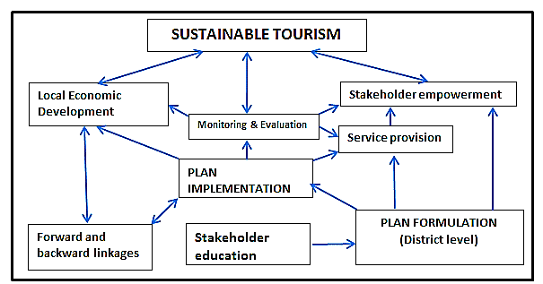

Figure 20: Collaboration Framework for Sustainable Tourism
Source: Researcher, 2019.

The key component of proposed collaboration framework has been explained as follows:
Stakeholder’s education
The proposed collaboration framework consider stakeholder’s education as an important component in that well informed participants will effectively contribute to deliberations during tourism planning process as well as enhance service delivery. Berlin Declaration (2017) explains that capacity building, training and skills development are preconditions for stakeholder’s meaningful involvement. The framework fits well as the proposals are in line with the findings of this study on the need for stakeholder education for their effective participation in tourism planning and development. Furthermore, for local stakeholders to participate effectively in tourism related activities, they need to understand the current dynamics of tourism industry through education provision. Thus this proposed collaboration framework advocates that public awareness or sensitization programmes for stakeholder should be a prerequisite and an ongoing exercise for meaningful tourism development and planning process.

Stakeholder Empowerment
The proposed collaboration framework has recognised the need for stakeholder empowerment. Berlin Declaration (2017) points out that empowerment and capacity building is important to ensure meaningful participation in planning and decision-making, in business activities, and in managing and monitoring tourism in the destinations. Participants in tourism planning process need to have access to financial resource to facilitate their effective participation in the planning and tourism development process. In view of this, empowerment will help stakeholders to move towards the higher rungs of the Arnstein’s typology ladder, to more active participation and empowerment of stakeholders in decision-making. Here Public stakeholders at district level will receive grants from central government for their departments to plan for various tourism developments according to their mandate. As for private stakeholders, the empowerment comes through applying for Tourism Development Fund (TDF) as stipulated in the Hospitality and Tourism Act of 2015 so that stakeholders can have access to the fund to help them start up or invest in already existing tourism based enterprise. Stakeholder’s empowerment will enable various tourism enterprises to introduce new tourist activities which in turn will increase tourism arrivals. The devolution of power to local stakeholders needs to be realized to enable them to actively participate in the development of tourism. Furthermore, empowerment will include incentives which are viewed as one way in which stakeholders can be encouraged to participate in the development and planning of tourism. Fabricius (2002: 32) cited by Himoonde (2007) states that ‘incentives also encourage local residents to engage in the planning.
Plan Formulation
The proposed collaboration framework advocates that tourism planning to be done at district level which takes the Bottom up approach to planning. A planning team from the local authority is expected to work collectively with other stakeholder to determine the scope and nature of tourism development needed. The planning process will consist of representatives of stakeholders from tourism associations such as HCAZ and Tourism Council of Zambia which entails a participatory approach which will facilitate sustainable tourism development and the adoption of this proposed collaboration framework is necessary as it is within the principles of new regionalism approach to planning and co-production principles which support bottom up approach to planning. ‘Co-production is a relationship where professionals and citizens share power to plan and deliver support together, recognising that both have vital contributions to make in order to improve quality of life for people and communities. Siame (2017) explains that Co-production challenges the dominant power of the state and seeks to shift power towards local communities in the decision-making processes. It can therefore be argued that the idea of adopting this proposed ‘collaboration framework” will support the idea of reciprocity in tourism industry which is a Co-production element. This ensures that key stakeholders take part without leaving any one behind in tourism planning.
Collaboration framework also has recognised that once plan is formulated, various hospitality and tourism proprietors will begin offering services to customers. Better service provision to customers require that service providers are enlightened with the current trends in the tourism and hospitality sector. Training is critical to ensuring quality service and meeting these objectives. In the tourism and hospitality industry, the success or failure of businesses and destinations depends on service. Collaboration framework advocate that the attainment of sustainable tourism development depend on the provision of good service as it stimulates guest satisfaction.
Plan Implementation
The framework advocates that all stakeholders will implement the plan with ease since the formulation of the plan would have been a collective decision. Plan implementation in the proposed collaboration framework is considered to be pivotal to attainment of sustainable tourism development. For instance, plan implementation will enhance multi-dimensional forward and backward linkages between the tourism sector and none tourism industries. This assertion has been buttressed by ZDA (2016) where tourism has also been singled out by government as one of the priority areas for investment due to its numerous forward and backward linkages to various other sectors of the economy. Furthermore, the ‘collaboration framework’ will promote Local Economic Development (LED) due to its emphasis on the promotion of dialogue between local-level stakeholder and promoting decentralisation of projects and programmes for better employment and a higher quality of life of the local people. Meyer (2014) explains that LED initiative is partnership formation by local stakeholders. Local developmental projects driven by local business and local communities have more chance to succeed than projects attempted by government alone. Thus when there is ownership of tourism development strategies by local stakeholder, there will be a tendency of sustainability in the tourism sector.
Monitoring and Evaluation
The proposed collaboration framework proposes that the participation of ordinary stakeholders should not end at planning formulation but all stakeholders to be involved in the implementation, monitoring and evaluation process of any tourism development taking place. Plog (1991) cited in Bello et al., (2016) explain that the development of a sustainable tourism requires the participation of all stakeholders from predesign stage to evaluation of any tourism plan or strategy. Furthermore, collaboration planning theory advocate that all stakeholders must be involved in planning because they will present different knowledge and reasoning (Healey, 1998). Monitoring and evaluation will determine whether the benefits meet the aspirations of the local community as well as visiting tourists.
Finally, the proposed collaboration framework positions the Local Authority working in collaboration with the office of district commissioner to coordinate planning and developmental projects at district level. This idea is in line with the observation of Monther and Zain (2017) study which suggested that at the managerial level there is need for an umbrella organization responsible for identifying and addressing the specific issues related to tourism planning, rehabilitation and implementation of strategies, as well as coordination among existing institutions. This proposal is feasible as it will fit well as it is supported by 2015 Urban and Regional Planning Act which emphasize that all local authorities to prepare an integrated development plan which is an avenue where tourism stakeholder are supposed to participate in tourism planning and development process.

6.5. Chapter Summary
This section has discussed the results of the study by comparing it with previous studies used in the study. The chapter has revealed that the observed low levels of tourism development has negative effect on the development of tourism. The study has further revealed that top down centralised tourism planning process and tokenistic and passive participation of stakeholders in tourism development is abortive towards attainment of sustainable tourism. Finally, the chapter concludes by formulating a ‘collaboration framework’ which has been proposed for adoption as it supports bottom up approach to planning.

CHAPTER: SEVEN

CONCLUSION AND RECOMMENDATION

7.0. Conclusion
The purpose of this study was to evaluate the level of stakeholder participation in tourism planning. In trying to achieve the aim, this study provided answers to the four objectives which included identifying all tourism potentials and current level of development at tourist sites, examining the existing tourism planning process, the level of stakeholder participation in tourism planning and finally parameters which can increase stakeholder’s participation in tourism planning.
This study has shown that the additional tourism activities with potential at Chishimba Falls, Mwela Rocks and Shiwa Ng’andu were having a cultural market, game viewing, art theatre, boat cruising and hiking trails and using Butlers (1980) Area life cycle model, Chishimba Falls exhibited that the site is transitioning into involvement stage in terms of tourism development and the level of involvement of the local community people in the provision of tourism related services is very minimal. Thus, the level of tourism development at Chishimba Falls is deemed to be at Involvement stage. As for Mwela Rocks, the level of tourism development was considered to be at exploration stage as the site has no supporting infrastructure and as such visitors visit Mwela Rocks just for its unique Bushmen paintings and this further explains why people visit Mwela Rocks for exploration purposes to see the paintings.
Finally, Shiwa Ng’andu site on the other hand can be considered to be at development stage. Shiwa Ng’andu site is owned by locals the Harvey family who have invested on the site with modern world class infrastructure at Kapishya Hot Spring Lodge and the tourist site offer a variety of tourist amenities like game viewing, horse safaris, historical manor house, boat cruising, accommodation, spa, transport, cycling/quad biking, water rafting which attracts a lot of international tourist. This study also argues that although Butler’s model of tourism destination area life cycle could be practically realized in many tourism areas, not all areas would experience the different stages of the cycle as outlined by Butlers and this was exhibited by Shiwa Ng’andu tourist site which seemed to have jumped involvement stage and moved straight from exploration stage to development stage. Additionally, despite the fact that different sites exhibited different levels of development, the study has demonstrated that the level of tourism development is low due to low investment, poor marketing strategies, limited tourism packages and poor connectivity among sites.
In terms of the second objective, this study found that top down centralized tourism planning processes dominate tourism planning in the region. The planning process for tourism is done at the Ministry headquarters through the Planning and Information Department (PID) and provincial administration under provincial planning unit. The foregoing results indicated that the top- down centralized tourism planning process has the negative effect towards the attainment of sustainable tourism as the planning process excludes the majority of stakeholder from being engaged and reduces their participation in tourism planning processes which in turn hinders the attainment of sustainable tourism development.
In terms of the third objective, Using Arnstein^{’s} (1970) ladder of citizen participation (Figure 6), the general level of stakeholder participation in tourism planning is tokenistic (consultation) which is through attending meetings which has a reduced impact towards the attainment of sustainable tourism development because most of views put forward by stakeholder during consultative meetings are rarely considered as most decisions are made by government at National headquarters.
Furthermore, the study showed that passive or non-participation was another level of stakeholder participation present in tourism planning in which tourism stakeholders sometimes just received what to do. This level of participation was exemplified by none participation and engagement of stakeholder towards formulation of Statutory Instrument (SI) number 35 (Tourism Levy) of 2017. This study also demonstrated that local Authorities (councils) in Kasama and Shiwa Ng’andu do not have IDPs and as such local authorities do not involve tourism stakeholder in tourism planning despite been mandated by law under the 2015 Urban and Regional Planning Act no. 3 of 2015 to prepare IDPs which is an avenue where tourism stakeholders are supposed to participate in the planning process.
Parameters for increased stakeholder participation in planning and development of tourism for the fourth objective were identified as stakeholder empowerment in terms of financing and providing capacity for stakeholder to make decisions, stakeholder sensitization in terms of policy issues and other related matters in terms of tourism development, provision of visitor questionnaire in form of feedback form to visitors in order to get visitor opinion on products and services offered at various sites, having an active tourism associations to enhance collaboration between private and public stakeholder and finally having a visitor information website where visitors can communicate their views with site managers.
The overall conclusion of this study is that there is minimum participation and engagement of stakeholder in planning for sustainable tourism development in Kasama and Shiwa Ng’andu Districts owing to the top-down centralised tourism planning process. This situation has slowed the growth of tourism industry in Kasama and Shiwangandu Districts. In view of this scenario, this study has argued for the adoption of participatory and collaborative approach that is adopting both Bottom up approach to tourism planning as well as top down approach as a means to attain sustainable tourism development as it is in line with the emphasis of ‘Agenda 2063 of the Africa we want’ in which every stakeholder must be involved in decision making process (African Union Commission., 2015). Furthermore, this study advances the adoption of proposed ‘Collaboration Framework’ developed in this study because it will increase effective participation of multi- stakeholder in tourism planning, development and project implementation as the framework supports the decentralised participatory and collaborative approach which integrates both Bottom-up approach to planning as well as top down approach. In addition, the application of the ‘collaboration framework’ is necessary as it is within the principles of participatory and collaborative planning theory (Healey, 1997). In addition, the collaboration framework’ fit in within new regionalism approach and Co-production principles which support multi-sectoral stakeholders participation in planning of local community led interventions.

7.1. Implications of the study results
The study established that the level of stakeholder’s engagement and participation in tourism planning is very minimal and the planning process is characterised by top down which has a negative effect towards the attainment of sustainable tourism development.

7.2. Recommendations
Based on the results of the study, the following recommendations are made:
- There is need for the Government to decentralise the operation of Zambia Tourism Agency and Ministry of Tourism at each provincial capital and at district level. This will help to position Zambia as a destination of choice as the agency will be able to market tourism potentials. Furthermore, decentralizing operation of Ministry of Tourism and ZTA will help ZTA and Ministry of Tourism officials to work closely with tourism stakeholders to package attractions together and provide sites trends in terms of tourist activities, expectations and other needs.
- There is need for the government to decentralize tourism planning taking a bottom-up approach. This will create a platform for close collaboration with stakeholder on tourism marketing and research.
- There is need for the government to adopt a ‘collaboration framework’ similar to the one developed in this study as the framework supports the integrating of both bottom-up approach and top down approach to planning. The adoption of this framework will increase and empower the capacity of stakeholder to plan for the development of tourism.
- There is need for Tourism associations and Hotel and Catering Association of Zambia (HCAZ) to partner with the government to provide training sessions for stakeholder in order to help raise their awareness and understanding of what government is planning in terms of development of tourism. Raising awareness amongst stakeholder is necessary as it will enable stakeholder to provide quality service delivery as well as increase their participation in the development of tourism.
- There is also need for the government to provide loans to citizens running hospitality and tourism enterprises and other citizens with a registered tourism enterprise. This will encourage a number of domestic investors to exploit many tourism potentials which have remained unexploited due to lack of necessary capital.

7.3. Suggestions for Future research
On the basis of the findings of this study that participation of stakeholder in tourism planning is tokenistic (minimal) in nature and passive, there is need for further researcher to determine the effects of the observed levels of participation on the process of planning and development of tourism. Further research is needed to find out why Local Authorities do not have IDPs as mandated by the 2015 Urban and Regional Planning Act as IDPs are platforms in which various stakeholder are supposed to be engaged in coming up with a local area tourism development plan and how lack of IDPs is affecting the growth and development of tourism.

REFERENCES
African Union Commission., 2015. Agenda 2063: The Africa We Want. Addis Ababa, African Union Commission.
Agarwal, S., 1992. The resort cycle revisited: implications for resorts. In: Cooper, C.P. and Lockwood, A. (eds). Progress in Tourism, Recreation and Hospitality Management, London: Belhaven Press, 5, 194–208.
Aguilo, E., Alegre, E and M. Sard, 2005. Tourism Management 26(2):219-231.
Allmendinger, P and Tewdwr-Jones, M. 2005. Planning futures: New directions for planning theory. Routledge
Andriotis, K., 2000. Local Community perceptions of tourism as a development tool: The island of Crete. Ph.D. Thesis, Bournemouth University.
Arnstein, S. R., 1969. A Ladder of Citizen Participation. Journal of the American Planning Association., 35 (4), 216-224.
Arnstein, S. R, 2019. A Ladder of Citizen Participation, Journal of the American Planning Association, 85(1), 24-34.
Ascani, A., R. Crescenzi and S. Iammarino, 2012. Regional Economic Development: A Review, London, European Community Framework Programme,
Azizan, M. B., I. Hay and J. James. 2012. Public Participation Shortcomings in Tourism Planning: The Case of the Langkawi Islands, Malaysia. Journal of Sustainable Tourism.,20 (4), 585-602.
Bac, D., 2014. The emergency of Sustainable tourism: A literature review. Quaestus multidisciplinary research journal (4), 131-140.
Becker, H., 1963. Outsiders: Studies in the Sociology of Deviance. New York: The Free Press.
Bello, F.G., B. Lovelock and N. Carr, 2016a. Enhancing Community participation in tourism planning associated with protected areas in developing countries: Lessons from Malawi, Tourism and Hospitality Research, 0(0), 1–12
Bello, F.G., N. Carr and B. Lovelock, 2016b. Community participation framework for protected area-based tourism planning, Tourism Planning & Development, 1-17.
Berg, B. L. 2001. Qualitative Research Methods for the Social Sciences, 5th edn, Allyn
and Bacon, Boston.
Berlin Declaration., 2017. Transforming Tourism: Tourism in the 2030 Agenda. Berlin, ECPAT Deutschland.
https://www.tourismconcern.org.uk/wp-content/uploads/2017/03/Berlin_Declaration. [Accessed, 17th December, 2017]
Britton, S.G., 1982. The political economy of tourism in the third World. Annals of Tourism Research., 9(2), 331-358.
Brohman, J. 1996. New directions in tourism for third world development. Annals of Tourism Research. 23(1), 48-70.
Bryman, A., 2012. Social research Methods. 4th ed. Oxford: Oxford University Press.
Bryson, J and B. Crosby, 1989. The design and use of strategic planning arenas, Planning outlook, 32(1), 5-13.
Burmeister, E., and L. M. Aitken, L, 2012. Sample size: How many is enough? Australian Critical Care, 25, 271-274
Burns, A.C and R.F. Bush, 2010. Marketing research 6th ed. Upper saddle River, N.J: Prentice Hall.
Butler, R., 1980. The concept of a tourist area life cycle of evolution: Implications for management of resources. Canadian Geographer, 24(1), 5-12.
Butler, R.W., 2006. The Tourism Area Life Cycle: Conceptual and Theoretical Issues. Toronto: Channel View Publications.
Byrd, E.T., 2007. Stakeholders in Sustainability tourism development and their roles: Applying Stakeholders theory to sustainable tourism development. Tourism Review., 62 (2), 6 – 13.
Central Statistical Office., 2012. 2010 Census of population and housing; Population summary report. Lusaka: CSO.
Central Statistical Office., 2013. Population and demographic projections 2011-2035. Lusaka: CSO.
Chami, M.F., 2018. Community involvement and sustainable tourism development in heritage management: Amboni limestone caves, Tanzania. African Journal of hospitality, tourism and leisure, 7(2), 1-13.
Chansa, C and C.S. Muzamba, 2014. Tourism and tourist attractions in Zambia: Have we fully harnessed the potential in the last fifty years of independence, 1964-2014?, Journal of Sustainable Development in Africa., 16 (8), 122-163.
Chawira, M., 2017. Constructing an enabling learning environment for the development of critical thinking skills in history teaching. Ph.D. Thesis, University of the Free State.
Chileshe, B., 2004. The impact of urban growth on indigenous wood vegetation in Kasama Town and its Environs, Zambia. Msc. Thesis, The University of Zambia.
Choy, D., 1992. Life cycle models for Pacific Island Destination. Journal of Travel Research 30(3): 26-32.
Christie, I. T., E. Fernandes., H. Messerli and L. Twining-Ward, 2014. Tourism in Africa: Harnessing tourism for growth and improved livelihoods. Washington, D.C: The World Bank.
Cohen, L., L. Manion and K. Marrison, 2007. Research methods in education. London: Routledge.
Clarke, P.B. 1996. Deep Citizenship, London, Pluto Press.
Cole, M.M., 1963. Vegetation and geomorphology in Northern Rhodesia: An aspect of the distribution of the vegetation of the Savanna of Central Africa. The geographical journal., 129(3), 290-310.
Creswell, J.W., 2009. Research design: qualitative, quantitative and mixed methods approach. 3rd ed. Thousand Oaks, CA: Sage Publications.
Currier, R., S. Seaton and F .Wesley. 2009. Determining stakeholders for feasibility analysis. Annals of Tourism Research. 36 (1), 41-63.
De Vaus, D. A. 2014. Surveys in Social Research. (6th ed). Australia: UCL Press.
De Waele, B., Kampunzu, A.B., Mapani, B.S.E and F. Tembo .2006. The Mesoproterozoic Irumide belt of Zambia., Journal of African Earth Sciences 46 (1), 36–70.
Dixey, L., 2005. Inventory and Analysis of Community Based Tourism in Zambia. Lusaka: A USAID Private Sector Development Programme.
Fainstein,S. 2000. New Directions in Planning Theory, Urban Affairs Review 35(4):451–78
Fellows, R and A. Liu, 2015. Research methods for construction. 4th ed. Southern gate, John wisely and Sons Ltd.
Forester, J. 2009. Dealing with Differences – Dramas of Mediating Public Disputes. Oxford: Oxford University Press
Freedman, D., R. Pisani and R. Purves, 2007. Statistics, 4th ed, New York, Norton Publications
Fun, F., L.Chiun., P. Song and N .Vikneswaran. 2014. The impact of local communities’ involvement and relationship quality on sustainable rural tourism in rural area, Sarawak: The moderating impact of self-efficacy. Procedia Social and Behavioral Sciences, 144, 60 – 65.
Gisore, R and H. Ogulu. 2015. Sustainable Tourism in Africa: Standards as Essential Catalysts. Nairobi, ARSO Central Secretariat.
Gunton, T. I., and J. C. Day, 2003. The Theory and Practice of Collaborative Planning in Resource and Environmental Management. Environments 31(2): 5-19.
Gunter, A., 2005. Integrated Development Plans and their effect on local economic development: A case study of Mpumalanga. MA. Thesis, University of Witwatersrand.
Government of the Republic of Zambia (GRZ), 1968. Chinsali District Forestry Department File, Chinsali.
Government of the Republic of Zambia (GRZ), 1997. National Tourism Policy. Lusaka, Ministry of Tourism and Arts.
Government of the Republic of Zambia (GRZ), 2006. Vision 2030: A prosperous middle-income nation by 2030. Lusaka, Government printers.
Government of the Republic of Zambia (GRZ), 2011. Environmental Management Act [No. 12 of 2011. Lusaka, Government printers
Government of the Republic of Zambia (GRZ), 2014. Tourism Statistical Digest. Lusaka, Ministry of Tourism and Arts.
Government of the Republic of Zambia (GRZ)., 2015a. National Tourism Policy. Lusaka, Ministry of Tourism and Arts.
Government of the Republic of Zambia (GRZ)., 2015b. Tourism and Hospitality Act, No. 13 of 2015. Lusaka, Government printers.
Government of the Republic of Zambia (GRZ)., 2015c. The Urban and Regional Planning Act . No. 3 of 2015. Lusaka: Government Printers.
Government of the Republic of Zambia (GRZ)., 2015d. Foreign Private Investment and Investor Perceptions in Zambia: Rethinking, Refocusing and Implementing Investment and Export Diversification Strategies. Lusaka, Government printers.
Government of the Republic of Zambia (GRZ)., 2015e. Zambia Wildlife Act No. 14 of 2015, Lusaka: Government Printers.
Government of the Republic of Zambia (GRZ)., 2016a. 2015 Tourism Statistical Digest, Lusaka, Ministry of tourism and Arts.
Government of the Republic of Zambia (GRZ)., 2016b. Constitution of Zambia (Amendment) No. 2 of 2016, Lusaka, Government printers.
Government of the Republic of Zambia (GRZ)., 2016c. Integrated Land Use Assessment Phase II – Report for Zambia. The Food and Agriculture Organization of the United Nations and the Forestry Department, Ministry of Lands and Natural Resources, Lusaka, Zambia.
Government of the Republic of Zambia (GRZ), 2017. Seventh National Development Plan 2017- 2021, Lusaka, Ministry of National Development Planning.
Government of the Republic of Zambia (GRZ), 2019. Guidelines for Integrated Development Plan implementation, vol. 1., Lusaka, Ministry of Local Government.
Glaser, B., and A. Strauss. 1967. The Discovery of Grounded Theory: Strategies for Qualitative Research. New York, NY: Aldine.
Gunn, C. A., 2002. Tourism Planning. London: Routledge.
Hall, C.M. 1996. Political effects of tourism in the Pacific. In: Hall, C.M. and Page, S.J. Tourism in the Pacjflc: Issues and Cases. London: Thomson, 81-90.
Hatipoglu. B., D. Alvarez and B. Ertuna. 2016. Barriers to stakeholder involvement in the planning of sustainable tourism: the case of the Thrace region in Turkey, Journal of Cleaner Production., 111, 306-317.
Healey, P. 1996. Consensus building across difficult divisions: New approaches to collaborative strategy making, Planning practice and research, 11(2), 207-216.
Healey, P. 1997. Collaborative Planning, shaping places in fragmented societies, London, Macmillan Press.

Healey, P. 1998. Collaborative Planning in a stakeholder’s society, Town planning review, 69(1), 1-21.
Himoonde, T., 2007. Opportunities and Constraints of Local Participation in Ecotourism: A Case of Kasanka National Park, Zambia. MPhil. Thesis, Norwegian University of Science and Technology.
Hovinen, G.R., 2002. Revisiting the Destination Life-Cycle Model, Annals of Tourism Research., (1), 209-30.
Hox, J.J and H.R. Boeije, 2005. Data collection, Primary vs. Secondary. Encyclopedia of social Measurement., 1, 593-599.
Hoyle, R. H., M. J. Harris and C. M. Judd, 2002. Research methods in social relations.7th
ed. Pacific Grove, CA: Wadsworth.
Hunt, C and A. Stronza. 2014. Stage-based tourism models and resident attitudes towards tourism in an emerging destination in the developing world. Journal of Sustainable Tourism., 22(2), 279–298.
Huybers, T., and J. Bennett. 2003. Environmental Management and the Competitiveness of Nature-Based Tourism destination. Environmental and Resource Economics., 24 (3), 213–233.
Innes, J. and Booher, D. 2003. Consensus Building and Complex Adaptive Systems –A Framework for Evaluating Collaborative Planning’, APA Journal 65(4): 412–23
Inskeep, E., 1991. Tourism Planning: An Integrated and Sustainable Development Approach. New York, NY: Van Nostrand Reinhold.
Ismail, F., 2009. The Development of small island tourism in Malaysia. Ph.D. Thesis, Victoria University
Jones, T.M., 1995. Instrumental Stakeholders theory: A synthesis of ethics and economics. The academy of management Review., (18), 208-218.
Johnson, J and D. Snepenger. 1993. Application of the tourism life cycle concept in the greater Yellowstone region. Society and Natural resources, (6) 127-148.
Kasama arts Zambia., 2013. Photos, https://www.facebook.com/kasamaarts.katp, [accessed, 30th April, 2018]
Katanekwa, N.M., 2011. Zambia^{’s} outstanding Natural, cultural and historical sites: A heritage legacy for all. Livingstone, Lendekwa heritage consultancy and services.
Kapinga, K., 2006. Impact of tourism on local communities: A case study of Livingstone and Daghamarskjoild memorial site. Un Published MBA. Thesis, Copperbelt University.
Kenawy, M., 2015. Collaborative approach for developing a more effective regional planning framework in Egypt: Ecotourism development as a case study, Ph.D. Thesis, University of Liverpool.
Kendall, L., 2008. The Conduct of Qualitative Interview: Research Questions, Methodological Issues, and Researching Online. In J. Coiro, M. Knobel, C. Lankshear and D. Leu (Eds.), Handbook of Research on New Literacies (pp. 133-149). New York: Lawrence Erlbaum Associates.
Keovilay, T., 2012. Tourism and Development in Rural Communities: A Case Study of Luang Namtha Province, Lao PDR, Master of Tourism Management. Thesis, Lincoln University.
Khun, T., 1962. The structure of scientific revolution. Chicago: University of Chicago Press.
Kombo, D.D and D.L.A. Tromp, 2006. Proposal and Thesis Writing: An introduction. Nairobi, Pauline’s publications Africa.
Kothari, C.R., 2004. Research Methodology: Methods and Techniques, 2nd ed, New age international publishers, New Delhi.
Kumar, A and R. Paddison, 2000. Trust and collaborative planning theory: The case of the Scottish planning system, International Planning studies, 5(2), 205-223.
Leiper, N. 2004. Tourism management, Perth, Pearson Education Australia.
Limb, M. and C. Dwyer, 2001. Qualitative Methodologies for Geographers: Issues and Debates. New York, Oxford University Press.
Liu, B and F. Mwanza, 2014. Towards Sustainable Tourism Development in Zambia: Advancing Tourism Planning and Natural Resource Management in Livingstone (Mosi-oa-Tunya) Area. Journal of Service Science and Management., (7), 30-45.
Maginn, P. 2007. Towards more effective community participation in urban regeneration: the potential of collaborative planning and applied ethnography. Qualitative Research, 6(4), 25-43.
Magombo, A., 2011. The Development of Tourism and the Accommodation Sector in Malawi since Independence, Master of Arts thesis, University of the Witwatersrand.
Mak, B. K. L., L. T. O. Cheung and D.L. H. Hui, 2017. Community Participation in the Decision-Making Process for Sustainable Tourism Development in Rural Areas of Hong Kong, China. Sustainability., 9(10), 1-13.
Manyara, G.,and E. Jones. 2007. Community-based tourism enterprises development in Kenya: an exploration of their potential as avenues of poverty reduction, Journal of Sustainable Tourism., 15(6), 628-644.
Marczyk, D., D. DeMatteo and D. Festinger, 2005. Essentials of research Design and Methodology. New Jersey, John Wiley & Sons.
Mbewe, A., 2015. An assessment of tourism development in Kafue National Park-North, Master of Science in Geography, University of Zambia.
McMillan. J.H and S. Schumacher, 2010. Research in education: evidence-based inquiry, 7th ed, Pearson, Boston.
Meyer, F.D., 2014. Local Economic Development (LED), Challenges and Solutions: The Case of the Northern Free State Region, South Africa. Mediterranean Journal of Social Sciences., 5 (16), 624-634.
Miossec, J.M., 1977. Model of tourism development: A Geographical perspective. 6(1), 41-48.
Mnguni, E.M and A. Giampiccoli, 2017. Community-based tourism development: A Hiking Trails perspective; African Journal of Hospitality, Tourism and Leisure, 6 (1), 1-17.
Monther, M. J and A.H. Zain. 2017. A bottom-up approach for cultural tourism management in the old city of As-Salt, Jordan. Journal of Cultural Heritage Management and Sustainable Development., 7(1), 91-106.
Mubanga, H.K and B. .B. Umar. 2016. Tourism is for foreigners”: Resident views about community participation in Zambia’s tourist capital. Tourism, Culture & Communication, 16, 75–89.
Murphy, P. E. 1985. Tourism: A Community Approach, Routledge, London.
Nhuta., S. 2015. Tourism and Sustainable development: Perspectives and learning for a sustainable future, Victoria Falls, Paper presented at the Midlands State University International Conference in Victoria Falls, July, 14-15, 2015. Victoria falls, Graduate School of Business Leadership.
Norris, E., 1954. The New Federation of Rhodesia and Nyasaland, Federal Information services, Zimbabwe.
Opperrnann, M. and K.S. Chon. 1997. Tourism in Developing Countries. London: Thompson.
Paunovic, I and V. Jovanovic. 2017. Implementation of Sustainable Tourism in the German Alps: A Case Study, Sustainability., 9 (2), 1-15.
Paskeleva-Shapira, K., 2001. “Promoting partnership for effective governance of sustainable urban tourism”, paper presented at the INTA International Seminar “Tourism in the City Opportunity for Regeneration and Development”, Turin, February.
Pearce, D.G., 1989. Tourist Development. 2nd ed, New York: Longman.
Pike A., A. Rodríguez-Pose and J. Tomaney, 2010. Handbook of Local and Regional Development. Routledge.
Prangli, T., 2013. Destination development on Prangli Island, Master Thesis, Umea University.
Pretty, J., 1995. Participatory learning for sustainable agriculture, World Development, 23 (8), 1247–1263.
Prideaux, B., 2000. The resort development spectrum: A New approach to modelling the resort development. Tourism management 21 (3): 225-240.
Punch, K., 2005. Introduction to Social research: Quantitative and Qualitative approaches. 2nd ed, London, Sage publications Ltd.
Purbani, K. 2017. Collaborative planning for city development. A perspective from a city planner, Engineering and Environmental Sciences.,26 (1), 136–147.
Richards, L., 2009. Handling qualitative data: A practical guide. Thousand Oaks, CA. Sage Publications.
Ritchie, J. and J. Lewis. (ed.), 2003. Qualitative Research Practice: A Guide for Social Science Students and Researchers. Sage Publications, London
Reid, D.G., H. Mair and W. George. 2004. Community tourism planning. Annals of Tourism Research., 31(3): 623–639.
Ruhanen-Hunter, L.M., 2006. Sustainable tourism planning: An analysis of Queensland local tourism destinations. Ph.D. Thesis, University of Queensland.
Ryan, G.W., and H.R. Bernard. 2003. Techniques to identify themes. Field methods., 15(1), 85-109.
Saha, J., 2014. Sustainable development in ecotourism: Perspective of Bangladesh, Unpublished Master thesis, Centria University of Applied Sciences.
Sarkissian, W. 2005 Stories in a Park: Giving Voice to the Voiceless in Eagleby, Australia, Planning Theory and Practice 6(1): 103–17.
Saunders, M., P, Lewis and A. Thornhill, 2012. Research Methods for Business Studies, Edingburg, Pearson Education limited.
Saulter, T.E and B. Leisen., 1999. Managing stakeholder: A Tourism planning model, Annals of tourism research, 26,(2), 312 – 328.
Sharma, S., 2010. Qualitative methods in statistics education research: Methodological problems and possible solutions. International Association of Statistical Education. pp. 1-6. Iase-web.org/documents/papers/icots8/ICOTS8-8F3-SHARMA.pdf Retrieved: 24 March, 2018.
Sharpley, R. and D. J. Telfer, 2002. Aspects of Tourism, Tourism and Development: Concepts and Issues. Ontario, Channel View Publication.
Siame, G., 2017. Understanding conflicting rationalities in city planning: A case study of co-produced infrastructure in informal settlements in Kampala, Ph.D. Thesis, University of Cape Town.
Simumba, J and W. Nchito. 2018. Customer engagement in tourism and hospitality services in Kasama and Shiwa Ng’andu District, Zambia, African Journal of Hospitality, Tourism and Leisure, 7(2), 1-14.
Stansfield, C.A., 1978. Atlantic City and the resort cycle. Background to the legalisation of gambling. Annals of tourism research., 5 (2), 238-251.
Tavallaee, S., A. Asadi., H. Abya and M. Ebrahimi. 2014. Tourism planning: an integrated and sustainable development approach, Management Science Letters., 4, 2495–2502
Taylor, T.K and C, B., Thole. 2013. Tourism Development Potential of the Northern Province of Zambia. American Journal of Tourism Management., 2(1A): 10-25
Teshome, E., S. Woreta and T. Meskele. 2018. Challenges of Tourism Development in the Amhara National Regional State, Ethiopia. African Journal of Hospitality, Tourism and Leisure., 7(3), 1-16
Teye, V., 1988. Geographic Factors affecting tourism in Zambia, Annals of Tourism Research., 15,487-503,
Timothy, D. J. 1999. Participatory planning: A view of tourism in Indonesia, Annals of Tourism Research, 26(2), 371-391.
Timur, S and D. Getz. 2008. A network perspective on managing stakeholders for sustainable urban tourism., International Journal of contemporary Hospitality management, 20 (4), 445-461.
Tuli, F., 2010. The Basis of Distinction between Qualitative and Quantitative Research in Social Science: Reflection on Ontological, Epistemological and Methodological Perspectives. Ethiopian Journal of Education and Sciences., 6(1). 97-108.
Tran, L. and A. Do. 2011. Impact of Ecotourism: A Study on the Environmental Impact of Ecotourism in Can Gio Mangrove Biosphere, Kerava, Laurea University of Applied Sciences.
United Nations Development Programme (UNDP)., 2009. Handbook on planning, Monitoring and evaluating for development results, UNDP, New York.
United Nations Environment Programme and World Tourism Organization., 2005. Making Tourism more Sustainable: A Guide for Policy Makers, Madrid, Spain: World Tourism Organization.
United Nations World Tourism Organisation., 2017. International year of Sustainable Tourism. Madrid, United Nations World Tourism Organization .
Uysal. M., E. Woo and M. Singal, 2012. The Tourist Area Life Cycle (TALC) and Its Effect on the Quality of Life (QOL) of Destination Community, International Journal of Culture Tourism and Hospitality Research. 10, 423-443.
Vissak, T., 2010. Recommendations for Using the Case Study Method in International Business Research, The Qualitative Report. 15 (2), 370-388.
Vogt, C., Jordan, E., Grewe, N., and L. Kruger, 2016. Collaborative tourism planning and subjective well-being in a small island destination. Journal of Destination Marketing & Management, 5(1), 36–43.
Wall, G.,1982. Cycles and capacity: Incipient growth or theory” Annals of Tourism Research, 9 (2), 52-56.
Walliman, N., 2011. Research methods: The basics. London. Routledge.
Walter, J. (ed), 2006. Community destination Management In developing Countries, New York, Routledge.
Weaver, D., 1988. The evolution of a plantation tourism land scape in the Caribbean islands of Antiquea, 79 (5), 319-331.
Weaver, D., 2001. The Encyclopedia of Ecotourism, New York, CABI Publishing.
Welman.C., F. Kruger and B, Mitchel. 2005. Research Methodology, 3Rd (Ed), Cape Town, Oxford University Press South Africa.
Wilkinson, P.F. 1997. Jamaican tourism: from dependency theory to a world-economy approach. In: Lockhart, D.G. and Drakakis-Smith, D. (eds). Island Tourism: Trends and Prospects. London: Pinter, 182-204.
Williams, S., 1998. Tourism Geography, London, Routledge
Worku, Y.G and G. A. Tessema. 2018. Public-Private collaboration in the tourism industry in North Western Ethiopia. African Journal of hospitality, tourism and leisure., 7(2), 1-12.
World Commission on Economic Development (WCED).,1987. Our common future. Oxford: Oxford University Press.
World Economic Forum (WEF)., 2015. The Travel & Tourism Competitiveness Report 2015: Growth Through Shocks Geneva, Switzerland: World Economic Forum (WEF). Retrieved from
http://www3.weforum.org/docs/TT15/WEF_Global_Travel &Tourism_Report_2015.pdf.
World Tourism Organization., 1994. National and Regional Tourism Planning: Methodologies and case studies. London: Routhledge.
World Tourism Organization (WTO)., 1996. What Tourism Managers Need to Know: A Practical Guide to the Development and Use of Indicators of Sustainable Tourism. Madrid, WTO
World Tourism Organization., 2004. Indicators of Sustainable Development for Tourism Destinations: A Guidebook. Madrid, Spain: World Tourism Organization.
Yin, R.K., 2003. Case study Research: Design and Methods, Sage Publications Inc.
Yu, C.P., C .Chancellor and S.T., Cole. 2011. Measuring residents' attitudes towards sustainable tourism: A re-examination of the sustainable tourism attitude scale. J. Travel Res. 50 (1), 57-63.
Zambia Development Agency (ZDA)., 2013a. Tourism Sector Profile, Lusaka, ZDA.
Zambia Development Agency (ZDA)., 2013b. Investment opportunities in Zambia’s tourism sector, Lusaka, ZDA.
Zambia Development Agency (ZDA)., 2014. Tourism Sector Profile, Lusaka, ZDA.
Zambia Development Agency (ZDA)., 2016. Tourism Sector Profile, Lusaka, ZDA.

APPENDICES

Appendix: A: Key informant semi-structured interview
Dear Respondent, Interview N0………….
1. Age ---- <19 { }, 20- 29 { }, 30- 39 { }, 40- 49, >50 { }
2. Sex of respondents Male { } Female { }
3. What position do you currently hold in the Ministry?................................................
4. How long have you been in that position………………………………………….
5. Can I quote you in my dissertation? YES [ ] NO [ ]
Tourism potential and level of development
6. What kind of tourism products is provided at Chishimba falls and Mwela rocks heritage site?
Tourism product/Service | Chishimba falls | Mwela Rocks
Transport
Accommodation
Fishing
Boat Cruising
Horse Safaris
Game viewing
Falls viewing
Historical site
Cultural activities (Dancing)
7. What benefits have been realized in terms of tourism revenue for community development? ................................................................................................................................................................
8. How is the ministry marketing tourism products offered at tourist destination to tourist?
(i) TV adverts (ii) Radio Adverts (iii) Print adverts (iv) Brochure
9. What are some of the tourism potentials and level of development at?
(A) Chishimba falls……………………………………………………………………………………
(B) Mwela rocks………………………………………………………………………………………
10. What are the factors which have affected the growth and development of tourism at Chishimba falls and Mwela rocks? ………………………………………………………………………………….
Existing Tourism planning process.
11. As government do you plan for tourism development and at what level?
YES [ ] NO [ ] National, province or district
12. If YES to question 15, Explain briefly the existing tourism planning process which is done ……………………………......................................................................................................................
13. In your own view do you think the existing process of tourism planning can enhance sustainable tourism development?
YES [ ] How?...................................................................................................................................
NO [ ] Suggest an alternative planning process and give reason...........................................
Level of stakeholder’s participation in tourism planning process.
14. In your own view who should make decisions on tourism development?.......................
15. As government, do you involve tourism Stakeholders in tourism planning and development? ………………………………………………………………………………………………………….
16. If answer to question 15 is No, Do you just instruct stakeholders on what they are supposed to do? …………………………………………………………………………………………………………
17. As government, do you conduct training or sensitization sessions to equip tourism stakeholders with skills so that they can offer quality services to tourist?...............................................................
18. Do tourism stakeholders make suggestions on how tourism can be developed?
19. If yes to question 18, are these suggestions implemented by the government?
YES [ ] How? ..............................................................................................................
NO [ ] Why? ...........................................................................................................................
20. Are tourism stakeholders able to influence/overturn the decision made by the government in respect to tourism development? ………………………………………………………………………
21. In your view, how do you generally rate the level of stakeholder’s involvement in the decision-making process regarding tourism development?
22. What other ways can increase Stakeholders participation in the planning and development of tourism in this area? ............................................................................................................... ………….

Appendix B: Hospitality and tourism enterprises Proprietors’ semi-structured interview
Name of entity/Establishment…………………………… Interview N0………….
1. Age ---- <19 { }, 20- 29 { }, 30- 39 { }, 40- 49, >50 { }
2. Sex of respondents Male { } Female { }
3. Designation of interviewee. (What is your position?)………………………………………..
4. How long have you worked for this establishment?................................................................
5. How long have you worked in the tourism industry………………………………………
6. Location of establishment……………………………………………………………….
7. Year opened…………………, If purchased, year purchased…………………
Tourism potential and level of development.
8. What is the total number of permanent employees/ Male . . . ….. Females . . . ……….
9. Does the establishment employ temporary workers during peak season?
10. How many on average?..............................................
11. For how many months?.........................................
12. Where do most of them come from?..........................................................
13. Do you have other tourist business in the a) District [ ] , b) Province [ ], c) Country [ ], Continent [ ].
14. Have you registered you tourism enterprise with the Ministry of Tourism?
YES [ ] NO [ ]
15. What kind of tourism products do you provide to tourist?
16. Do you have any plans to add more activities in future?......................................................
17. If Yes, name the activities you are thinking of adding……………………………………...
18. Does this area have potential for tourist activities which are not currently available? ......................................................................................................................................
19. Name the activities which are possible in this area in your opinion ……………………..
20. Do you partner with local residents (villagers) in any way? e.g using them as guides for tourists.
21. How do you market your tourism services to tourist? (i) TV adverts (ii) Radio Adverts (iii) Print adverts [ ] (iv) Friends [ ] (v) Family (vi) Travel agents advise vii) Hotel brochure (viii) Other explain . . . . .
22. What are the factors which have affected the growth and development of tourism in this area? ……………………………………………………………………………………………
Level of stakeholder’s participation in tourism planning process.
23. In your view who should make decisions on tourism development?...............................
24. Are you aware that the current tourism policy demands that you should be involved in tourism planning at Local level? ……………………………………………………………..
25. As an entrepreneur in tourism, does government involve you in tourism planning and development? ……………………………………………………………………………..
26. What is the nature of your involvement? a) Meetings b) Consultation c) Information dissemination d) Others, (explain). .. . .
27. Are you satisfied with the level of involvement?..........................................................
28. Suggest ways you would want to be involved…………………………………………..
29. As an entrepreneur in tourism, does government conduct training sessions to equip you so that you offer quality services to tourist?..................................................................................
30. As a tourism stakeholder, do you make suggestions on how tourism should be developed in your area?................................................................................................................................
31.If yes to question 30, are these suggestions implemented by the government?
YES [ ] How?.......................................................................................................................
NO [ ] Why?.............................................................................................................................
32. In your view are you able to influence decision made by the government in respect to tourism development?.................................................................................................................
33. If yes give examples……………………………………………………………
34. In your view, how would do you rate the level of your involvement as a tourism stakeholder in the decision-making process regarding tourism development?
Parameters to increase stakeholder’s participation in tourism planning.
35. What other ways can increase your participation in the planning and development of tourism in this area

Appendix: C: Tourists semi-structured interview
Interview N0………….
Section A: Personal details
1. Age ---- <19 { }, 20- 29 { }, 30- 39 { }, 40- 49, >50 { }
2. Sex of respondents Male { } Female { }
3. Are you a domestic or international tourist?
Domestic [ ] International Tourist [ ]
4. If international, what is your country of origin (where you live and work)? ……………………………………
5. Did you come from a destination other than your country of origin before you came to Zambia?
6. Which country/countries are these?. . . . ………………………………………
7. Are you going to another destination before you go back to your country of origin?
8. Name the country…………………………………………..
Tourism Potential and level of development
9. Duration of stay at a) the current location………… b) In the province/district………
c) In the country…………… d) On the continent………
10. Main reason for being in the country a) planned Holiday. b) Business but took time off
c) Holiday visiting relatives and friends
11. How many people are you traveling with... (Actual number), b) N/A Travelling alone
12. How did you know this tourist destination?
(i) TV adverts (ii) Radio Adverts (iii) Print adverts [ ] (iV.) Friends [ ] (v) family (Vi) Travel agents advise (vii) Hotel brochure other explain . . . . .
13. What accommodation are you using during your stay at this destination?
- Not spending any nights, b) Lodge/Guest house, c) Hotel, d) Family/friends, e) other
Other explain…………………….
14. How do you rate the products offered at the destination site?
Very Satisfactory Satisfactory Un satisfactory
15. Do you think the charges you have paid for various activities are competitive? Yes/No
16. Give reason for answer.
17. What activities do you think can be added to enhance the attractiveness of this site?
18. Are there any other activities/sites you plan to visit in the district?
19. Have you bought any crafts or curios?
20. If yes are prices competitive?
21. Would you tell your family or friends about this destination? Yes/No
22. Give reasons for your answer.
23. Would you come back to this a) destination b) Country?
24 .In your opinion is information about this tourist site adequate?
Level of Stakeholder’s participation in tourism planning process.
25. As tourists have at any point during your stay in Zambia been asked to fill in a form requesting basic details like: age; country of origin; reason for visit; Length of stay, among other things?
26. If you did at which point of your stay did you fill in the form? a) Port of arrival
b) Accommodation c) upon entry into tourist activity
27. As a tourist, have you been asked how best to improve services at the destination site?
How? a) Suggestion box, [ ] b) Feedback Form,[ ] c) Other [ ]
28. Do you believe your suggestions can change already made decisions by the government?
YES [ ] NO [ ] Give a reason for your answer.
29. If answer is NO, do you just receive information on what you are expected to do at the destination site? YES [ ] NO [ ]
30. In your view, how do you rate the level of your involvement as a tourist in the decision-making process regarding tourism development?
Parameters to increase stakeholder’s participation in tourism planning.
31. In your view, what are the suitable means which can increase your participation in the planning and development of tourism in this area?

Appendix: D: Focus Group Discussion for Residents in Host community
1. Age ---- <19 { }, 20- 29 { }, 30- 39 { }, 40- 49, >50 { }
2. Sex of respondents Male [ ] Female [ ]
3. How long have you lived in this (a) village?............................. (b) Area?..........................
Tourism potential and level of development.
4. What kind of tourism activities are you engaged in?.eg providing food, accommodation.
5. Are local people here employed in tourism activities? Mention examples
6. What benefits have been realized in terms of tourism revenue for community development?
7. What are some of the tourism potentials at this tourist site?
8. What factors have affected the growth and development of tourism in this area?
Level of stakeholder’s participation in tourism planning process.
11. Have you ever heard of CBNRM?
12. Do you have a CBNRM in your village?
13. Are you involved by the government in CBNRM?
14. What benefit do you obtain by participating in CBNRM?
15. If there is no CBNRM are there any local initiative (eg by the chief/headman) to do community based tourism?
16. Are you aware that the current tourism policy demands that you should be involved in tourism planning at Local level? Have you been informed?
17. Does government consult you on how best tourist destination sites must be managed?
18. Are your suggestions being implemented by the government?
19. Does government conduct training sessions to equip you with skills to enable you take care of the environment near and around this tourist site?
20. How do you rate the level of Local community’s involvement in the decision-making process regarding tourism development?
Parameters to increase stakeholder’s participation in tourism planning. 21. What are some of the ways which can increase your participation in the planning and development of tourism in this area?

Appendix: E: Observation checklist
To check on tourism products offered at selected tourist sites and ascertain the level of development using Butler’s model.
Name of Tourist Site:.................................................................................
Level of development | Activities, Products, services offered at site | Tick
Decline | - Property turnover is high,  - Tourist facilities and accommodation are converted to non-tourist-related structures
Rejuvenation | - Cash injection from government, tourism companies create new products, renovation of facilities (Innovation strategies).
Stagnation | - Loss of original tourist feature  - Resort has stopped growing  - Number of tourist visiting levels off-start to decline, Local businesses are threatened
Consolidation | - Local economy is dominated by tourism  - Local people make money from tourism  - Local people have stopped other activities (such as agriculture) due to tourism.
Development | - Big companies have recognized the potential of the site & began to build large hotels & sell packages holidays (Travel accommodation, food, excursions).  - locally provided facilities will/ have disappeared  - Continued building and expansion of resorts.  - Number of tourist increases massively  - Local people have been employed by these companies.
Involvement | - Local people notice increase of tourist  - Local people start business by providing accommodation, food, guides & transport
Exploration | - Adventurous people visit a place due to its beauty. No tourist services available.eg, accommodation, food, Local people are not involved in tourist money making activities, low access to the destination rudimentary facilities for the visitors

Appendix: F: Stakeholders invitation letter
